
Pennsylvania Western University Residence Life
Waitlist and HOusing Website User Manual

Table of Contents
1 Product Introduction and Description 1
1.1 Waitlist Request 1
1.2 Room Change Requests 1
2 Signing In 2
3 Navigating The Website 2
4 About Page 4
4.1 Using the Interactive Map 4
5 Using the Website 7
5.1 Room Change Request Form 7
5.1.1 Steps to submit a Room Change Request 7
5.2 Waitlist Request Form 10
5.2.1 Steps to submit a Waitlist Request 11
5.3 Viewing Requests 14
5.4 Editing Requests 15
5.5 Deleting Requests 17

(Note: The sections in the table of contents are linked to the sections throughout the document. To go directly to a section, use the key combination Ctrl + Click on a section title)

Product Introduction and Description
The Pennsylvania Western residence life waitlist and housing website is designed to allow students to submit room change requests and waitlist requests for their housing through the university. This website is designed to be more intuitive and efficient than the previous room change and waitlist option that was through the housing portal.

Waitlist Request
Waitlist requests are submitted during active room selection. These are for students who have completed housing applications and tried to pick a room but could not find the room style they wanted to accommodate them and/or their roommate group. Residence Life and Housing will accommodate room requests through the middle of July (the date is posted each year on our webpage www.pennwest.edu/room-selection ). Fulfillment of a waitlist request is not guaranteed. While Residence Life and Housing will do their best to meet all requests, it will depend upon the availability of spaces.

Room Change Requests
Room changes are requested after the semester has started by students who have already moved into a space but would like to move to a different room or room type. Students are welcome to submit a room change request throughout the semester. Our professional staff will review the request and work with the student to find a suitable space. Fulfillment of a room change request is not guaranteed. While Residence Life and Housing will do their best to meet all requests, it will depend upon the availability of spaces. Room changes are also not always free. Typically, there is a free room change period after the first two weeks of a semester (though not always guaranteed to occur). Room changes that are requested after the free room change period will be reviewed on a case-by-case basis and charges determined by the staff.

Signing In
You will use your personal Pennsylvania Western email and password to sign in through the single sign on, and will be brought to the home page upon signing in.
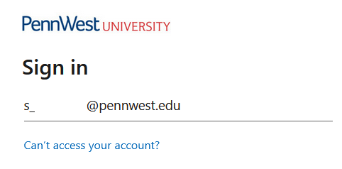
Figure 2-1 SSO login screen using a PennWest email and password.

Navigating The Website
From the home page, the student can navigate the website through the navigation bar at the top of the page. Contact information for each campus’ residence life office will be displayed at the bottom of each page.
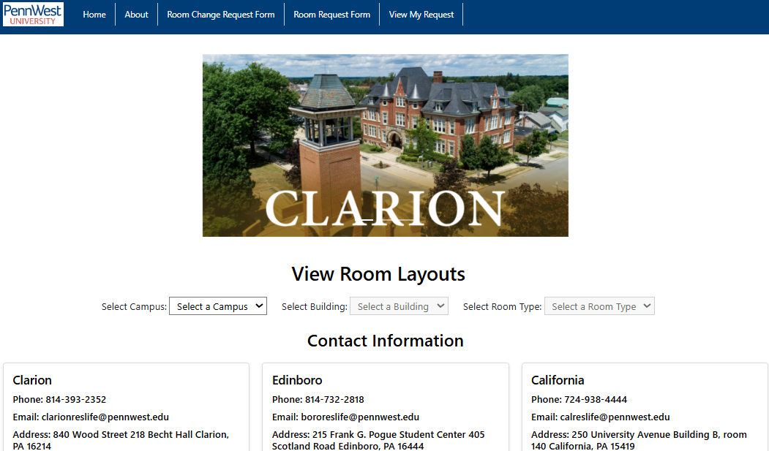
Figure 3-1 Website Home Page with contact information on the bottom.
Links to the Home Page, About Page, Room Change Request Form, Room Request Form and View My Request page will be on the navigation bar.
Figure 3-2 Navigation bar with links to each page.

The home page also displays the layout for each room type for each residence building on the different campuses. To view the layouts for different rooms on each campus, select the campus on the left, then the building, then select the room layout. This will show a picture of the aerial view of the room and also display the dimensions of the room.
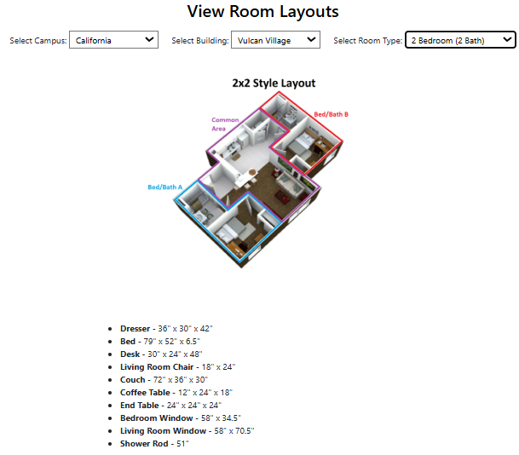
Figure 3-3 Example Room Layout for California Campus, Vulcan Village, 2 bedroom (2 bath).

About Page
The about page contains frequently asked questions about the request forms. Clicking on the question will show the answer. The About page will also include an interactive campus map (see section 4.1 Using the interactive Map), and contain a link to download a word file containing a student guide.
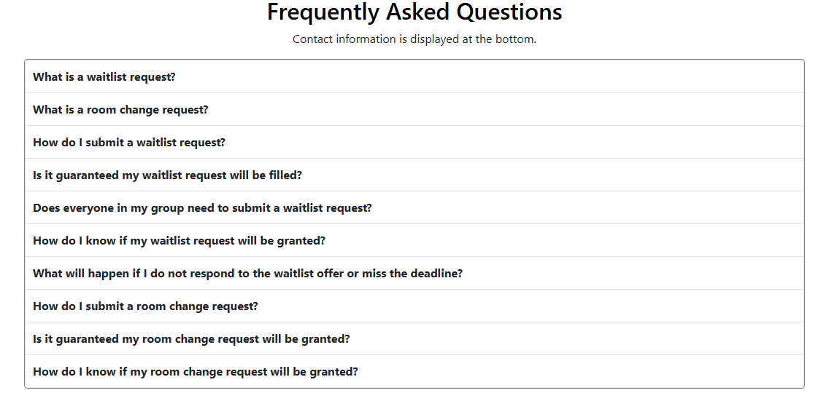
Figure 4-1 Table of frequently asked questions.

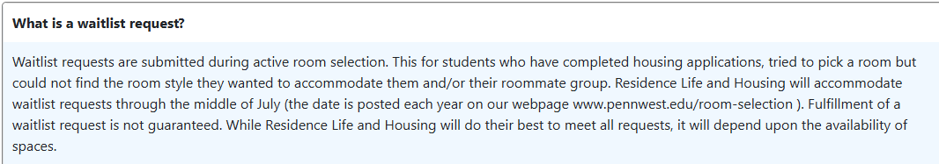
Figure 4-2 The answer to the first question is shown after clicking on the question box.

Using the Interactive Map
The interactive map includes the school buildings for each campus. To bring up the map, click on the blue “Toggle Map” button to the left of the Clarion contact information box on the About page (Figure 4-3).
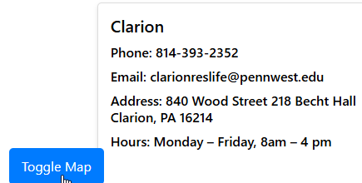
Figure 4-3 Toggle Map button on the About page.

Once the toggle map button is clicked, a map will display on the bottom of the screen (Figure 4-4). At the top of the map are options to select each campus to view their maps, the map defaults to California Campus.
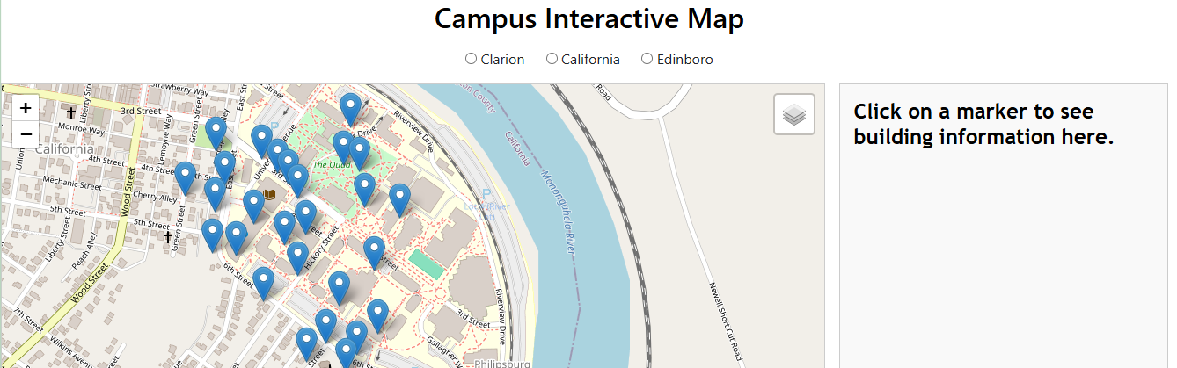
Figure 4-4 Interactive map.

The plus and minus signs on the left are zoom in and zoom out buttons. You can also do this by scrolling in and out on the map.
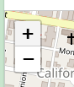
Figure 4-5 Zoom buttons.

The box at the top right of the map allows you to toggle satellite view.
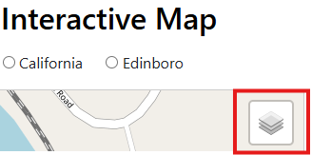
Figure 4-6 Toggle view button is shown in the red box.

Hovering over the toggle view button will bring up the view options.
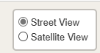
Figure 4-7 View options for the map.

Clicking on the blue location markers will bring up a name and brief description of a campus building.
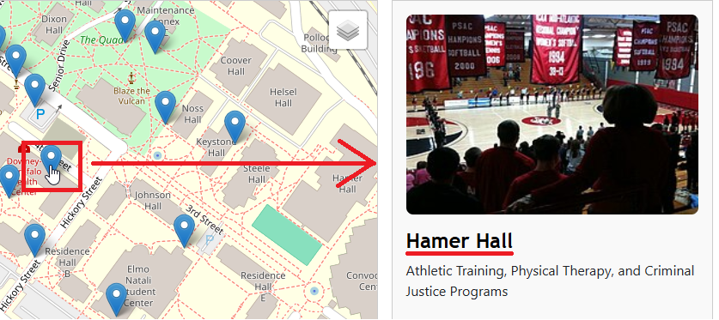
Figure 4-8 Description and name of Hammer Hall from clicking the blue location point on the map.

Using the Website
This section will explain how you can submit your room change requests and waitlist forms as well as how you can edit and delete your requests.

Room Change Request Form
You have the option to fill out the room change request form should you need to change your current room assignment (see: 1.2 Room Change Request for details). The form includes drop-down menus that are dependent on the previous answer. Every box with an orange asterisk must be completed before submitting the form, otherwise the blanks are not required. The form allows you to input three different options for your room change. Your first pick will be under the ”Choose your most preferred Building, Room, and Housing Community:” heading.

Steps to submit a Room Change Request
Step 1: Click the Room Change Request link on the navigation bar at the top of the website.
Figure 5-1 Link to Room Change Request form.

Step 2: Select a campus. This is the campus you are attending and will be living at. Note: A campus must be selected before picking a building or room.
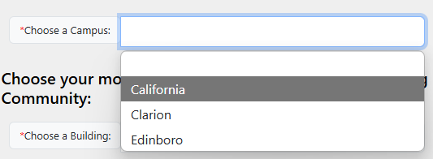
Figure 5-2 Select a campus from the drop-down menu.
No building option shows if no campus is selected.
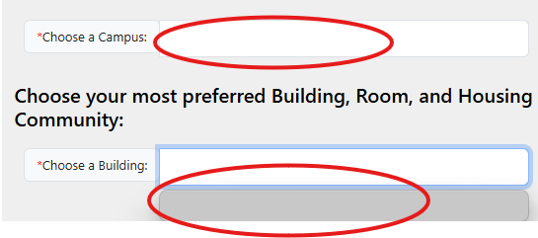
Figure 5-3 No campus selected leaves an empty blank.

Step 3: Pick a building from the drop-down menu after picking a campus. The buildings are dependent on which campus is selected.
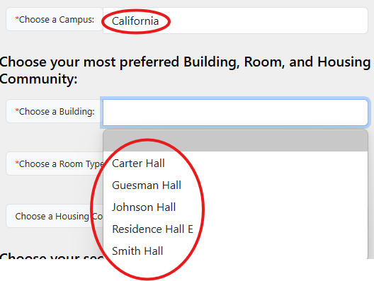
Figure 5-4 Residence building options for California campus.

Step 4: Pick a room type based on the previously selected building.
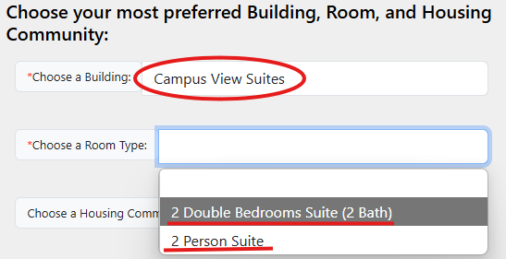
Figure 5-5 Room type options based on the building Campus View Suites.

Step 5: (Optional) Choose a housing community. Not all buildings and room types have a housing community.
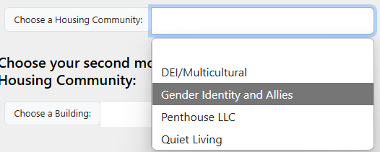
Figure 5-6 Housing community options based on building and room selection.

Step 6: (Optional) Choose your second and third picks for your room change. These are in case your first pick is not available.
Step 7: (Optional) Type in your roommates’ names.
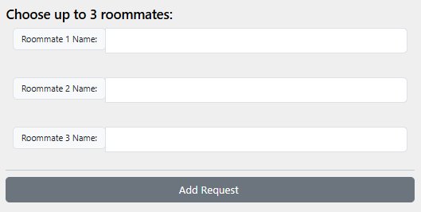
Figure 5-7 Roommate name entry.
Step 8: Fill out the reason you want to change your current room. This is mandatory and must be filled out before the request can be submitted.
Step 9: Click the “Add Request” button at the bottom of the form to submit your request.
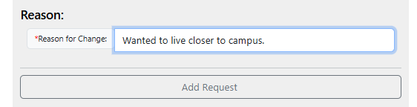
Figure 5-8 The required reason for change entry and the “Add Request” button at the bottom of the form.

Waitlist Request Form
You can fill out the (room) waitlist request form to when you are unable to secure your preferred housing style (see: 1.1 Waitlist Request). The form includes drop-down menus that are dependent on the previous answer. Every box with an orange asterisk must be completed before submitting the form, otherwise the blanks are not required. The form allows you to input three different options for your room change. Your first pick will be under the ”Choose your most preferred Building, Room, and Housing Community:” heading.
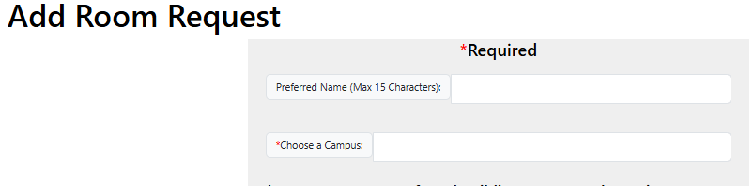
Figure 5-9 The waitlist request form.

Steps to submit a Waitlist Request
Step 1: Click the Room Request link on the navigation bar at the top of the website.
Figure 5-10 Waitlist request form link.

Step 2: Select a campus. This is the campus you are attending and will be living at. Note: A campus must be selected before picking a building or room.
Figure 5-11 Campus selection on the form.

No building option shows if no campus is selected.
Figure 5-12 No buildings show up without picking a campus first.

Step 3: Pick a building from the drop-down menu after picking a campus. The buildings are dependent on which campus is selected.
Figure 5-13 Residence building options for California campus.

Step 4: Pick a room type based on the previously selected building.
Figure 5-14 Room type options based on the building Campus View Suites.

Step 5: (Optional) Choose a housing community. Not all buildings and room types have a housing community.
Figure 5-15 Housing community options based on building and room selection.

Step 6: (Optional) Choose your second and third picks for your room change. These are in case your first pick is not available.
Step 7: (Optional) Type in your roommates’ names.
Figure 5-16 Roommate name entry.

Step 8: Click the “Add Request” button at the bottom of the form to submit your request.
Figure 5-17 “Add Request” button at the bottom.

Viewing Requests
You can view your request through the “View My Request” link on the navigation bar. This page will display the current request that you have submitted. The details will include your legal name, preferred name, email, campus, and your selections for your request.
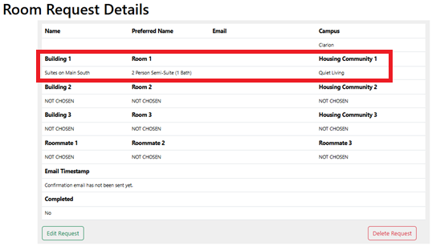
Figure 5-18 Example current request details. In the red box is the student’s first pick.

There are sections at the bottom of the form showing when you are/were contacted via email and the status of your request, whether it was processed or not.
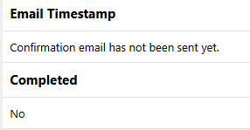
Figure 5-19 Email information and completion status.

If you do not have a request in, you will see the description “You do not have a room request or room change request that hasn't been fulfilled or deleted by an administrator. If you would like to submit a request please do so.”, Note: you can only fill out and submit one form at a time.
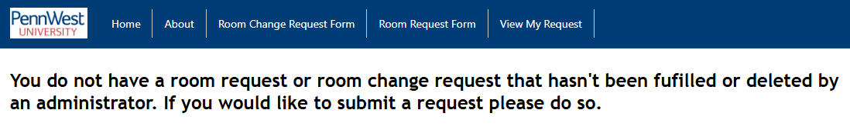
Figure 5-20 Page that is displayed when no request has been submitted.

Editing Requests
At the bottom of the “View My Request” page, you will see a green “Edit Request” button that will allow you to edit your current request.
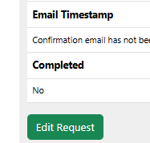
Figure 5-21 Edit Request button below the Email and status information.

The edit button will allow you to go back into the original form and edit any selection and information on the form except for your name and email. Your answers will be the same as your first submitted form, so you don’t have to fill out the entire form again.
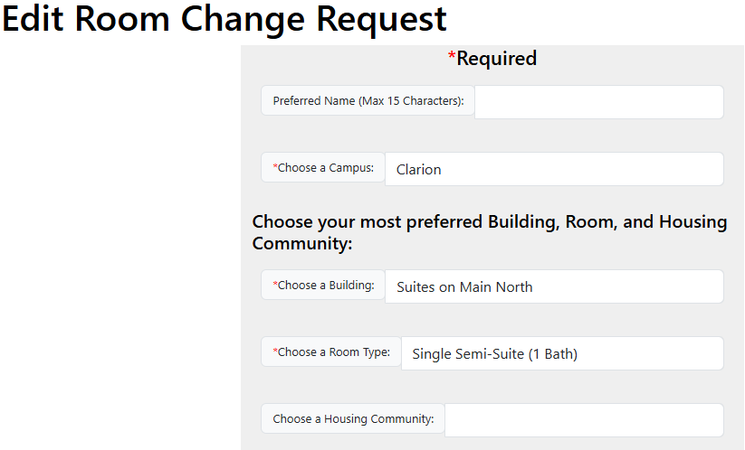
Figure 5-22 Edit screen of the example request from figure 5-9.

To clear the request form, click on the campus selection then click on the “clear drop downs” option.
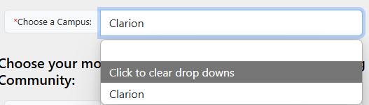
Figure 5-23 Option to clear all information from the form.

To submit your change to your request, click the “edit request" button at the bottom of the form.

Figure 5-24 “edit request” button at the bottom of the form.

If you decide not to submit your change, click the back arrow on the window.
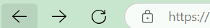
Figure 5-25 Back arrow to cancel editing of your request.

Deleting Requests
At the bottom of the “View My Request page, you will also see a red “Delete Request” button that will allow you to delete your current request.
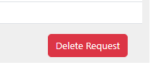
Figure 5-26 Delete Request button at the bottom right of the form.

Clicking the “Deleting Request” button will bring up a confirmation prompt window asking if you are sure you want to delete the request, you will then click yes or no depending on if you want to delete the request or not. After clicking “Yes” in the prompt window, your request will be deleted.
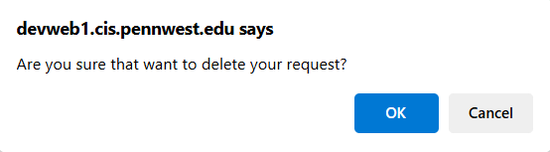
Figure 5-27 Confirmation prompt that is displayed when clicking the delete button.

