# LAB-1 Comprehension Quiz Solution

Student Name – Chengyu Zhang

Student ID – 20124992

Total Marks Obtained – 75

## Format – 20% OBTAINED 20

ZIP file contains the following:

|  |  |  |
| --- | --- | --- |
| All three codes that are named appropriately | 10 | 10 |
| A DOC/PDF file with well formatted answers to questions | 10 | 10 |

## Question 1 10% OBTAINED 8

|  |  |  |
| --- | --- | --- |
| A voltage signal is read in an Arduino analog pin (not current, resistance etc.) | 2 | 2 |
| Digital value after conversion is a number between 0 and 1023 (deduct a mark for 1-1024) | 4 | 4 |
| Conversion relation – Voltage signal is compared with the *Vref* signal (which is 5V by default in an Arduino) and the proportion is expressed as a number between 0-1023 | 4 | 2 |

## Question 2 10% OBTAINED 8

|  |  |  |
| --- | --- | --- |
| We use *Vref*=5V because the Arduino still compares the analog voltage with 5V by default | 4 | 4 |
| The sensed signal is within the range of 0-3.3V but the analog pin can detect up to 5V. So, we are not utilising the complete detectable range of the analog pin | 4 | 2 |
| We can improve this by telling the Arduino to compare the analog voltage with 3.3V instead of 5V | 2 | 2 |
| We can do this by supplying 3.3V on the *ADC_ref* pin of the Arduino (2% bonus if student has lost some marks above) | 2 | 2 |

## Question 3 10% OBTAINED 10

|  |  |  |
| --- | --- | --- |
| Waveform #1 (10% PWM) | 2 | 2 |
| Waveform #2 (25% PWM) | 2 | 2 |
| Waveform #3 (50% PWM) | 2 | 2 |
| Waveform #4 (75% PWM) | 2 | 2 |
| Waveform #5 (100% PWM) | 2 | 2 |
| Each waveform should clearly mark ON and OFF regions (-0.5 marks per waveform if missing) | -2.5 | 0 |
| Each waveform should clearly demonstrate the ON and OFF durations as per the duty cycle percent, e.g., for 25% duty cycle, total ON time should be a quarter (-0.5 marks per waveform if missing) | -2.5 | 0 |
| Each waveform should clearly show zero datum (-0.5 marks per waveform if missing) | -2.5 | 0 |

## Question 4 10% OBTAINED 6

|  |  |  |
| --- | --- | --- |
| OFF – All four switches disconnected (OR only negative switches connected) | 1 | 1 |
| ON (positive) – SW1 and SW4 connected, SW2 and SW4 disconnected | 1 | 1 |
| ON (negative) – SW1 and SW4 disconnected, SW2 and SW4 connected | 1 | 1 |
| One line explanation of difference between positive and negative directions. Student should indicate that the motor has a positive and negative terminal and positive direction means *V_supply* is connected to positive terminal and *GND* to negative terminal, and vice versa for negative direction | 2 | 0 |
| 16Mhz clock runs the Arduino which is pre-scaled by 64 to result in 250kHz, i.e., every program “tick” occurs at 250kHz frequency. The PWM switching duration takes 256 “ticks” which results in a switching frequency of 250kHz/256 ~= 1kHz, i.e., an audible note of 1kHz | 2 | 0 |
| Sketch or photograph of the oscilloscope which shows the time/division and shows the calculation as above that every pulse is observed at around 1ms, i.e., 1kHz. | 3 | 3 |

## Question 5 10% OBTAINED 6

|  |  |  |
| --- | --- | --- |
| Both pulses (A and B) drawn with clearly marked clockwise (CW) and counterclockwise (CCW) | 4 | 0 |
| Clearly marked CH1 (or A) and CH2 (or B). CH1 should be leading rising edge for CW and lagging rising edge for CCW | 4 | 4 |
| Origins drawn on both channels | 2 | 2 |

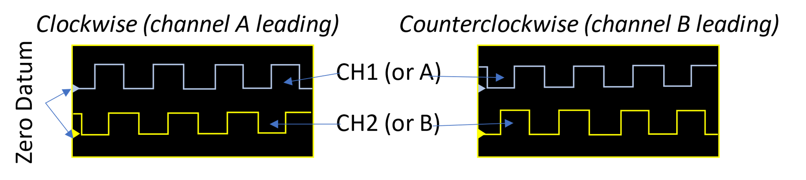

## Question 6 10% OBTAINED 5

|  |  |  |
| --- | --- | --- |
| No, because it only counts a single train of pulses and can’t be used to interpret up-down count of quadrature pulses (check if answer conveys understanding of the concept) | 10 | 5 |

## Question 7 10% OBTAINED 8

|  |  |  |
| --- | --- | --- |
| It missed a lot of counts, gave inaccurate readings etc. | 4 | 2 |
| This is occurring when printing the positions etc. | 3 | 3 |
| So, it cannot act on the input values while it is printing | 3 | 3 |

## Question 8 10% OBTAINED 4

|  |  |  |
| --- | --- | --- |
| Makes use of feedback or closed-loop control | 4 | 2 |
| Compare measured position with desired position | 2 | 2 |
| Decide on control action via control algorithm | 2 | 0 |
| And drive motor forward or backwards at variable speed to implement this action | 2 | 0 |

Overall feedback:

The student showed good understanding throughout the labwork. The student is expected to find more information and elaborate in the last question. All codes were named correctly.