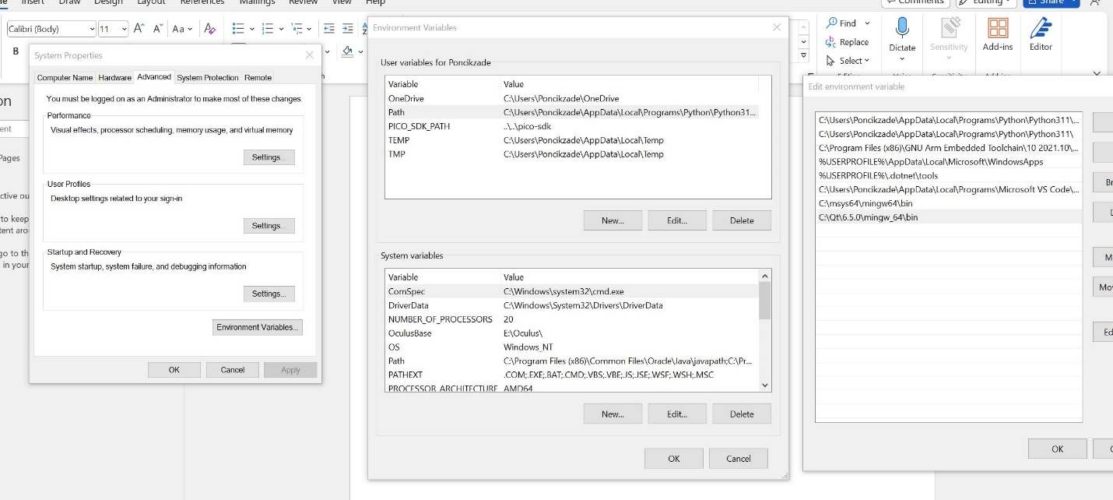

Firstly you need to add relted system envir. Variables path

After that you need to open qt mingw command window

Need to switch to related file folder and run this command

windeployqt IDT_C2.exe