Hello world from docx!!!

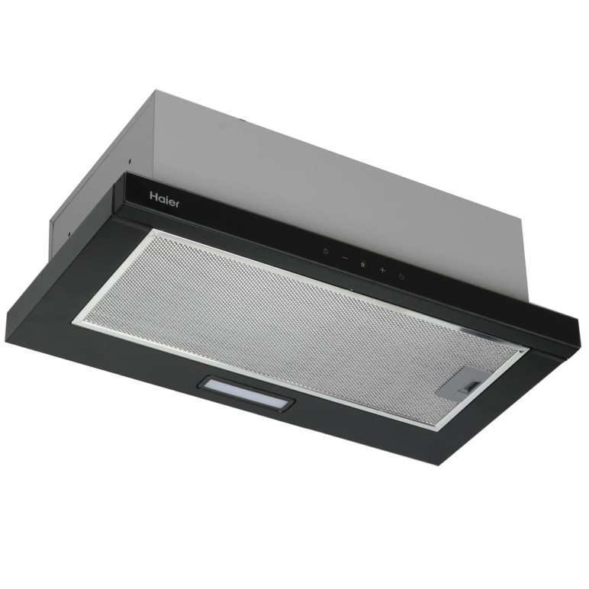

|  |  |  |  |
| --- | --- | --- | --- |
| s |  |  |  |
|  |  |  |  |
|  |  |  |  |
|  |  |  |  |