**Protocol for beh_freeaccess.ino**

Program purpose: free-access consumption for a set session duration.

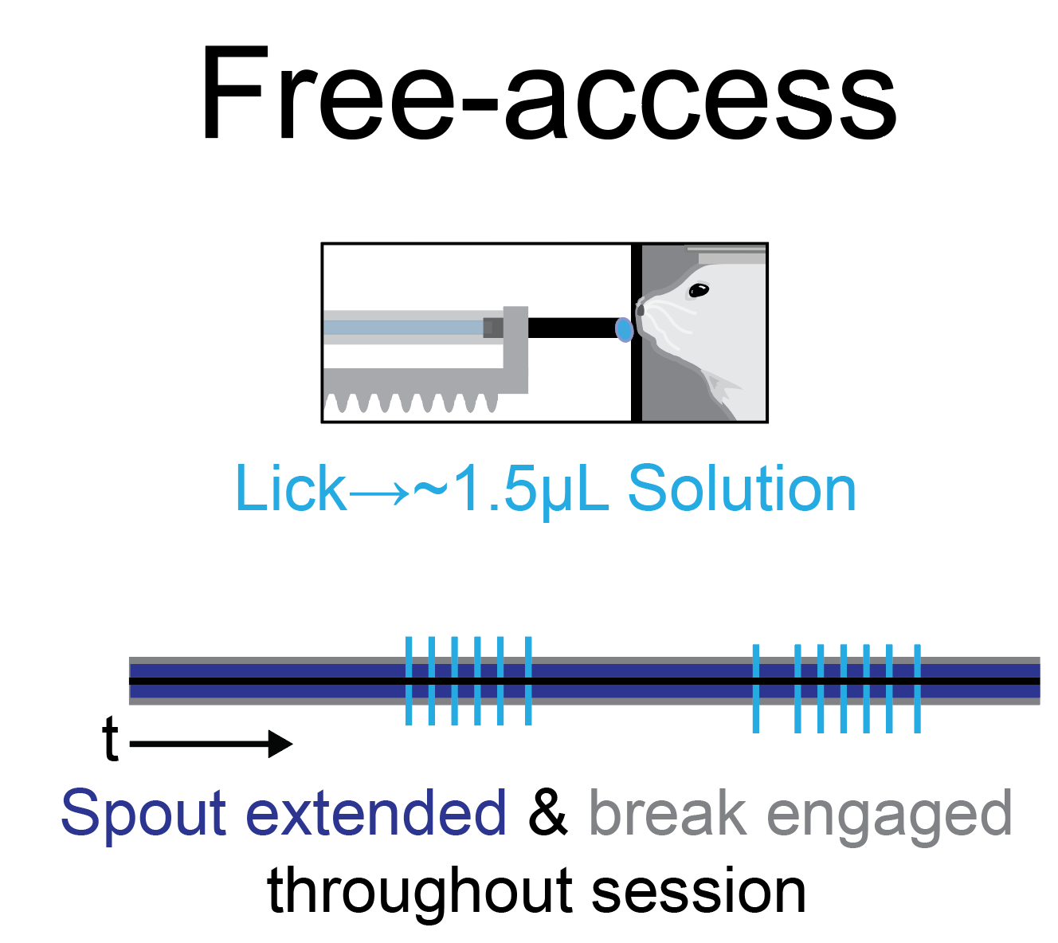

**Preparation Instructions:**

1. Around once per week, calibrate the solenoid open duration by following *protocol_helper_calibratesolenoid*. Save the solenoid open duration(s) somewhere convenient in a vector format with 1 value per solenoid (e.g. 3 vectors for 3 spouts: each vector would look like {*value*, *value*, *value*}).
2. Fill the solution line(s) by following *protocol_helper_opensol*.
3. *Optional: connect BNC or TTL outputs from the arduino console to the external hardware.*

**Arduino Setup Instructions:**

1. Open the program
2. Set the parameters and pins

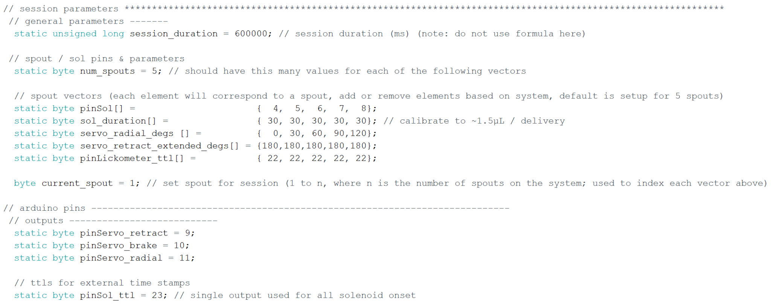

* For spout / sol pins & parameters, you will need 1 value for each of the spout / sol that your system has. This way you can set current_spout to perform free-access licking on any spout (e.g. current_spout 1 uses the first value for each vector, current_spout 2 uses the second value, etc.).
  + Note: If your system only has 1 spout, then change the vectors to be a length of 1 (e.g. pinSol[] = {4}; sol_duration[] ={30}; etc. ).
* It is fine if you do not have a radial servo, as long as nothing is plugged into the corresponding pin
* pinLickometer_ttl is used as an external timestamp for the onset of licks on each spout
* pinSol_ttl is used as an external timestamp for onset of any solenoid opening

1. Upload script to arduino by clicking the “Upload” arrow button on the top left corner.

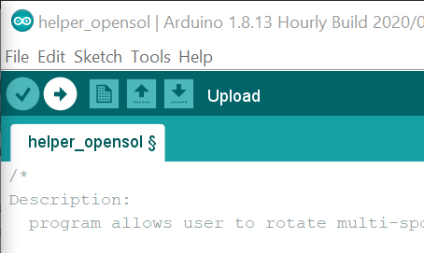

* The arduino will now have the script running on it and it will wait until a start command is sent over serial.

**Arduino Test Instructions:**

Test the program at the start of each day to ensure all hardware is working and events are being recorded correctly.

1. To test the program, open the serial monitor by clicking the “Serial Monitor” button on the top right corner.

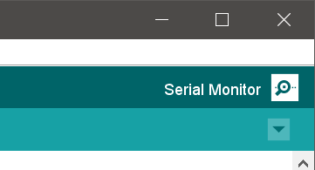

*Note: If you do not see this text printed in the serial monitor, see troubleshooting arduino software document.*

1. Start the arduino program by clicking the button to send an empty string over serial.

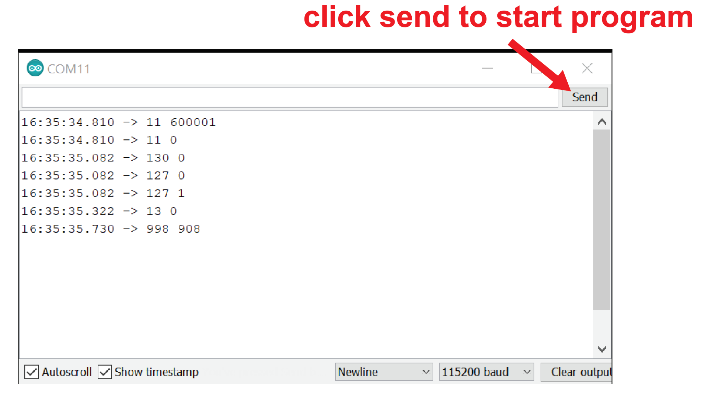

1. Manually touch the spout gently with the tip of an ungloved finger several times to ensure that licks are being detected, solenoids are opening, and liquid is being delivered from the lick spout. Each touch on the current_spout should lead to events printed in the Serial Monitor, opening of the corresponding solenoid (confirmed with concurrent sound, or vibrations when solenoid is touched during opening), and a droplet of liquid emerging from the spout.
   1. The serial code should be 30 + current_spout (e.g. if current_spout = 2, then the code should be 32).
   2. For multi-spout systems, if the intended spout is not detecting touch, check other spouts to see if they are detecting touch. If you find that a spout other than the one rotated towards the mouse is detecting touch, then check the servo_retract_radial_degs vector to ensure the values are correct for your head, and check to ensure the servo is working properly
   3. If liquid is emerging from the wrong spout, then check the pinSol vector to ensure that the correct pins are included for your system.
2. Reset the arduino by closing and reopening the Serial Monitor. Close Serial Monitor prior to the session.

**Arduino Run Instructions:**

1. Open the *write_serial.py* program (shown here using Sublime Text 3)

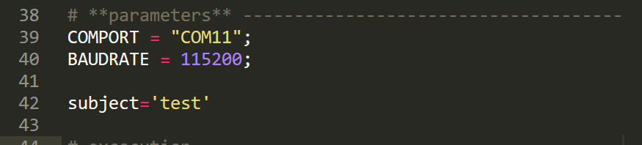

- Set the COMPORT and BAUDRATE to match the arduino script

Arduino comport is shown in the tools drop down menu

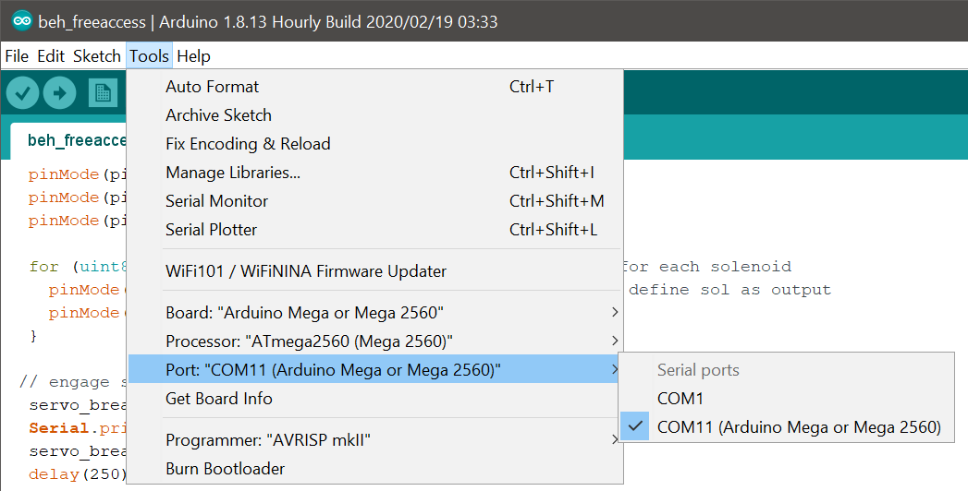

Arduino baudrate is set with “Serial.begin” call

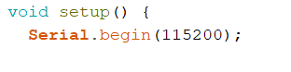

- Set the subject name for the session within the python program



*Note: see general arduino software document for more details about the functionality of the write_serial.py program*

1. After the program and hardware have been tested, head-fix the animal.
2. Set the spout position as shown in this diagram:

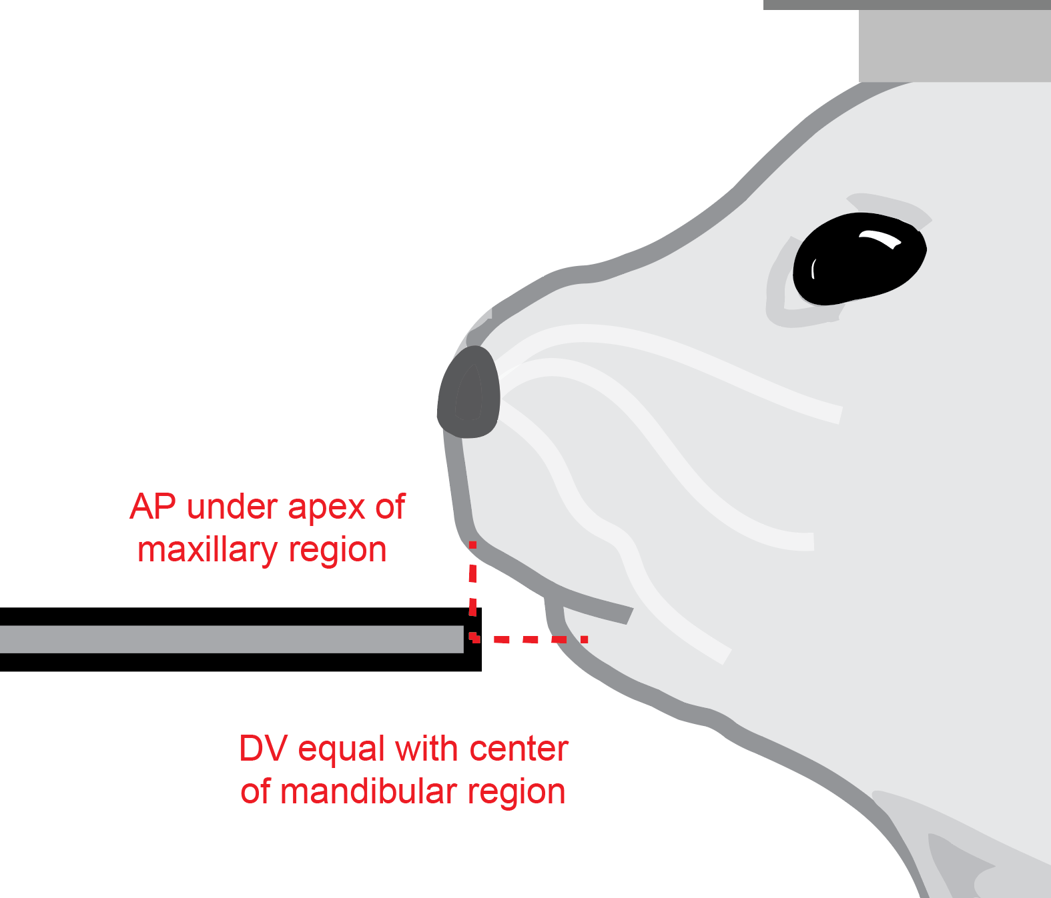

*Note: See* [*link*](https://www.facebase.org/mouseanatomy/) *for examples of mouse face anatomy*

1. Run the python program (Cntrl + B for Sublime Text 3).

* Values should begin to print with the start of the session, and will continue to print during recorded events

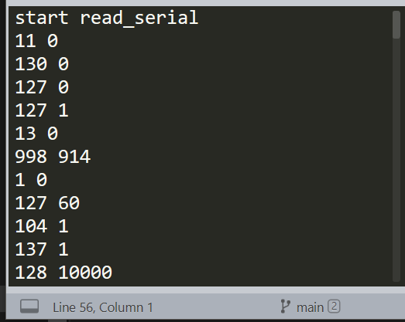

*Note: If you see an error, refer to the general arduino software document for troubleshooting tips*

1. At the end of the session, the spout will retract (if using a retractable spout) and the python script will print “stop read_serial”
2. Remove subject from head fixation
3. Restart arduino prior to subsequent subjects by opening / closing the arduino Serial Monitor. Otherwise, the spout will extend for the next subject and could result in poking the subject

