**Protocol for helper_opensol.io**

Program purpose: helper_calibratebreak.io allows users to test multiple break angles to determine the ideal angle for locking the wheel

**Use Instructions:**

1. Open the program (make sure the program is located in a folder of the same name)
2. Set the parameters and pins

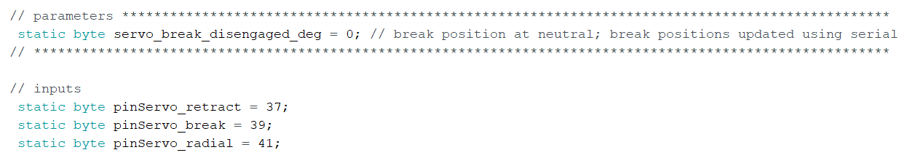

* It is fine if you do not have all 3 servos, so long as nothing is connected to those pins
* Note: servobreak_disengaged_deg is the angle of the servo at the resting (UP) position. This position is the starting position for each of the break engagements

1. Upload script to arduino by clicking the “Upload” arrow button on the top left corner

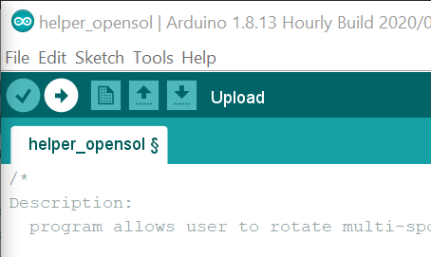

1. Open the serial monitor by clicking the “Serial Monitor” button on the top right corner

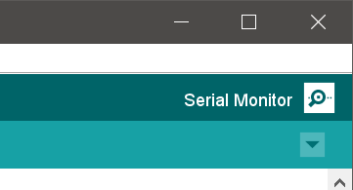

You should then be presented with this screen:

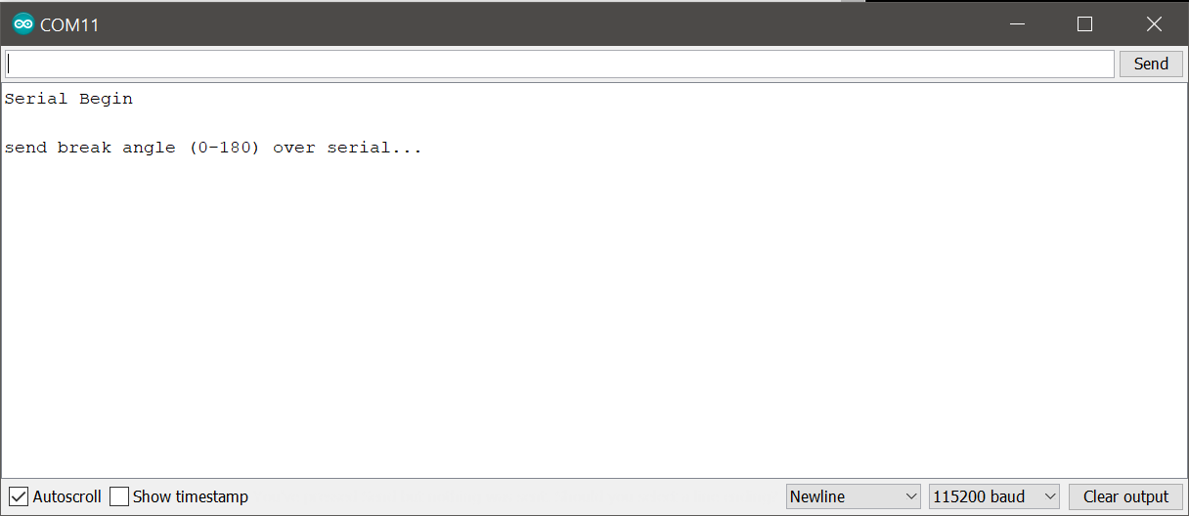

*Note: if you do not see this text printed in the serial monitor, see troubleshooting arduino software document*

1. Starting with low values (~10) and working up to high values (~30+), enter the break degree you wish to test and send to arduino
   1. Typically, angles 15-25 will work well.

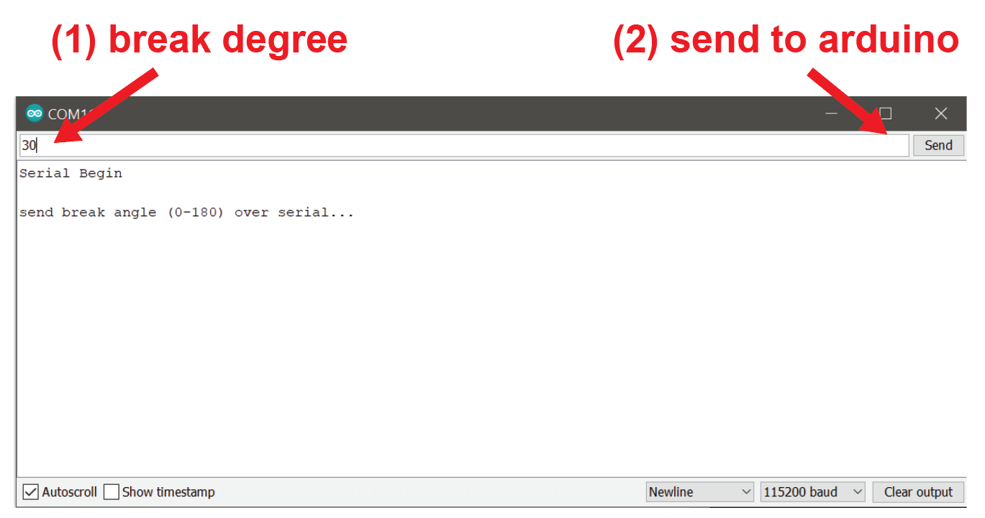

1. The break will engage and remain engaged at the input angle

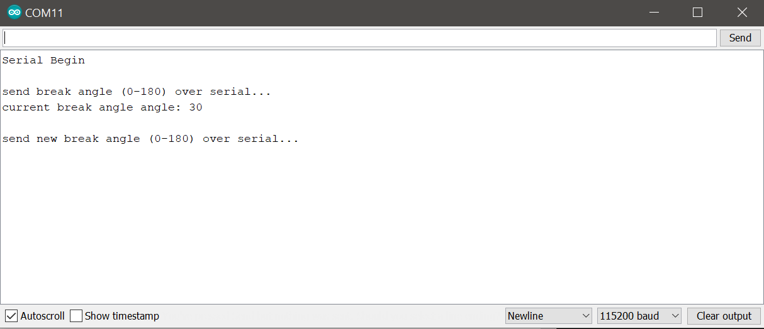

*Note: the serial monitor should show the current angle of the break servo*

1. Check to see if the wheel is able to rotate. If the wheel spins freely, increase the angle by 5 and send again over serial. Repeat this process until you have a break angle that is strong enough to keep the wheel stable with mild force applied by finger. Record the final break angle value for future use.

*Note: ideally, the wheel should only rotate with moderate force. However, do not use an angle larger than you need, as this can cause damage to the wheel to stage adapter and generate unnecessary noise. If you notice that the mouse is able to rotate the wheel when it should be breaked, increase the break angle.*