**Protocol for helper_opensol.io**

Program purpose: helper_calibratesolenoids.io allows users to run a calibration sequence to estimate the volume of each sol opening period.

*Note: default program is setup for a target volume of 200µL total, 1.5µL per sol opening*

**Preparation Instructions:**

1. Prior to following the “Use Instructions”, fill the solution line by following the protocol_helper_opensol instructions.
2. If measuring volume directly: obtain a centrifuge tube that has a volume marker for 200µL.
3. If measuring volume using weight: obtain and record the weight in a small weigh boat.

**Use Instructions:**

1. Open the program (make sure the program is located in a folder of the same name).
2. Set the parameters and pins.

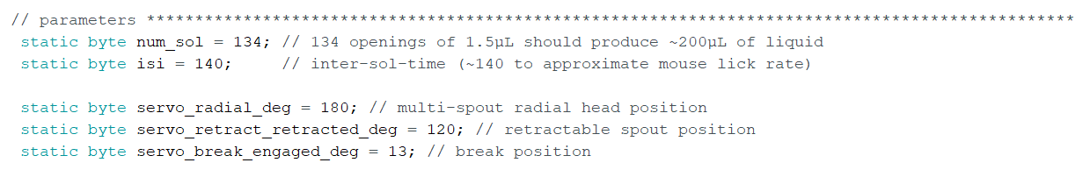

* It is fine if you do not have all 3 servos, so long as nothing is connected to those pins.

1. Upload script to arduino by clicking the “Upload” arrow button on the top left corner

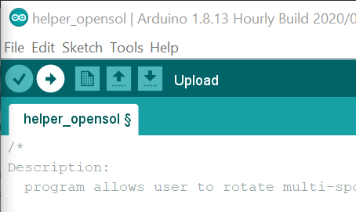

1. Open serial monitor by clicking the “Serial Monitor” button on the top right corner

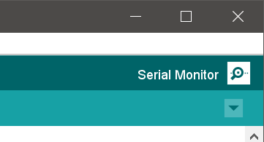

You should then be presented with this screen:

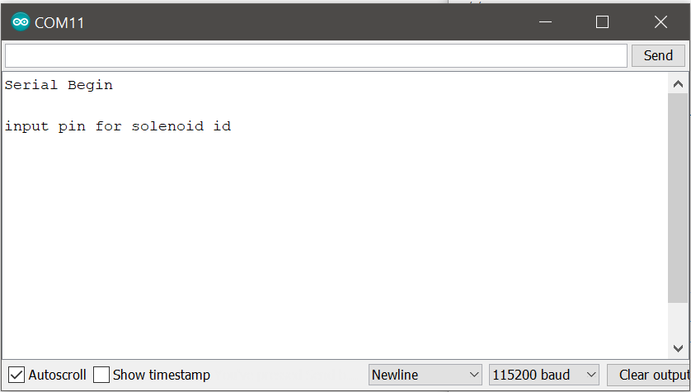

*Note: If you do not see this text printed in the serial monitor, see troubleshooting arduino software document.*

1. Enter the pin number for solenoid into the text box to the left of the “Send” button and then click the button to send the value over serial.

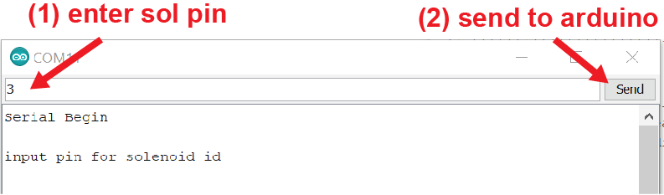

1. Prepare to collect the solution by holding the centrifuge tube or weigh boat under the spout.
2. Enter sol duration into the text box and send value over serial.

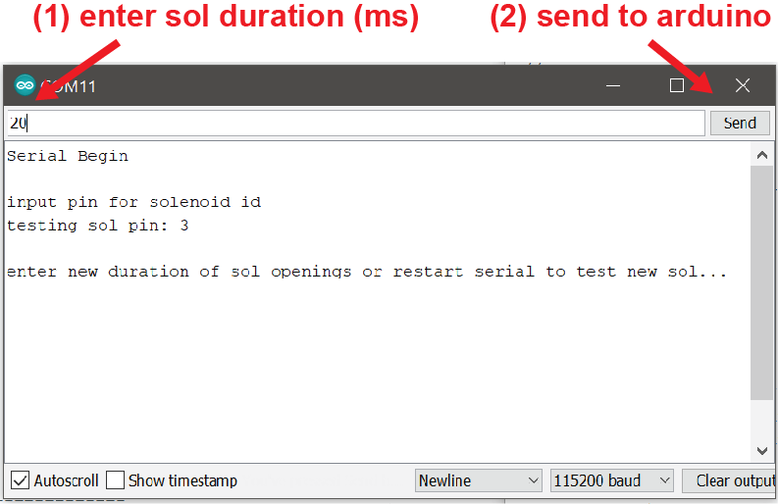

At the start of the sequence, the arduino will print the current parameters. At the end of the sequence, the arduino will indicate that the sequence is complete and prompt you for a new solenoid duration.

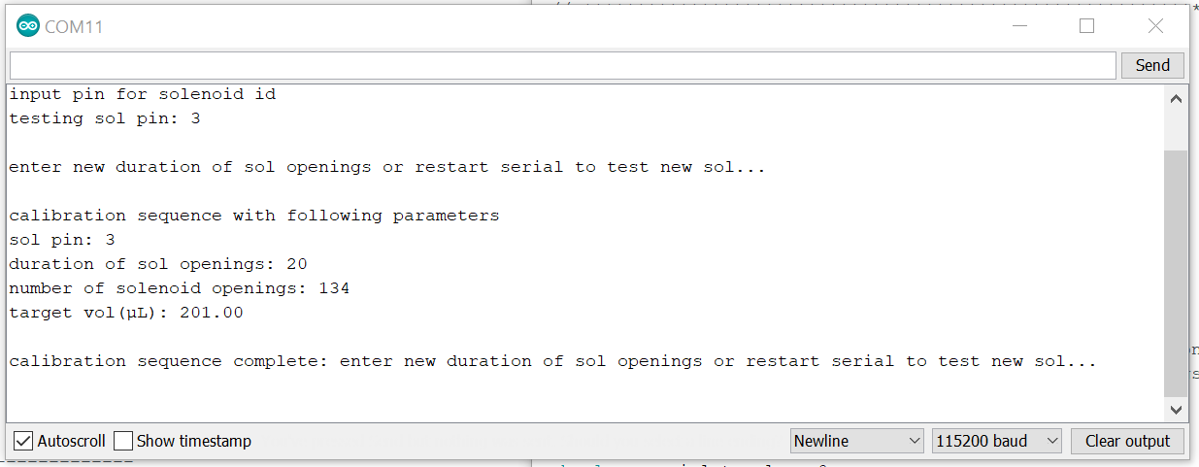

1. Collect and measure the liquid delivered throughout the calibration sequence.
   1. Check volume by referencing the volume markers on the centrifuge tube or
   2. Weigh the weigh boat containing the liquid and subtract out the weight of the weigh boat alone.
2. If you are off your target (200µL) redo previous steps with a new sol duration based on the volume obtained (If the volume is higher than intended, reduce the sol open duration; if the volume is lower than intended, increase the sol open duration).

1. Once you have calibrated the current spout, save the open sol duration for future reference as you will need this value for each of the arduino scripts used for behavior.
2. Repeat the above steps for each solenoid for the system. To set a new spout, close and reopen the serial monitor.