**Protocol for helper_opensol.io**

Program purpose: helper_opensol.io allows users to rotate the Multi-Spout Head and open individual solenoids for set up or cleanup using one of two modes.

* mode 0:
  + touch spout to open corresponding solenoid, touch again to close
  + set multi-spout angle by sending a degree between 1 and 180 over serial
* mode 2:
  + set multi-spout angle using servo_radial_deg
  + open and close solenoids by sending a serial string with an ID between 1 and n, where n is the number of spouts set in pinSol and stateSol

*Note: default program is set up for 5 solenoids / spouts, but can be used for 1 solenoid / spout. See “increasing number of solenoids” section below for instructions for expanding the number of solenoids / spouts.*

**Use Instructions:**

1. Open the program (make sure the program is located in a folder of the same name)
2. Set the parameters and pins

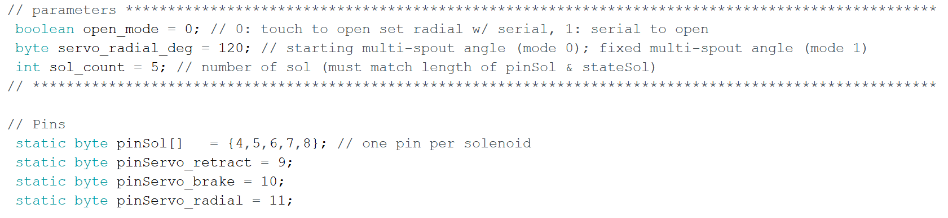

* Check to ensure that all of the pins correspond to the hardware. For pinSol, it is fine to have more pins listed in pinSol than there are sol, so long as those pins are not connected to anything.
* Set open_mode
  + 0: touch to open (touching spouts 1-n will open corresponding sol 1-n); serial input sets angle of multi-spout head
  + 1: serial to open (serial input of digits 1-n will open corresponding sol 1-n); angle of multi-spout head is set using servo_radial_deg
* Set servo_radio_deg
  + Mode 0: starting position
  + Mode 1: set position (reupload script with new value to rotate head)

1. Upload script to arduino by clicking the “Upload” button on the top left corner.
2. Open serial monitor by clicking the “Serial Monitor” button on the top right corner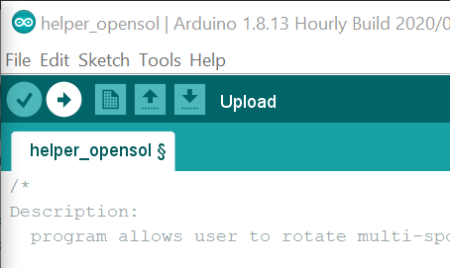

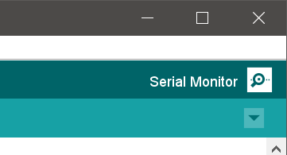

You should then be presented with this screen

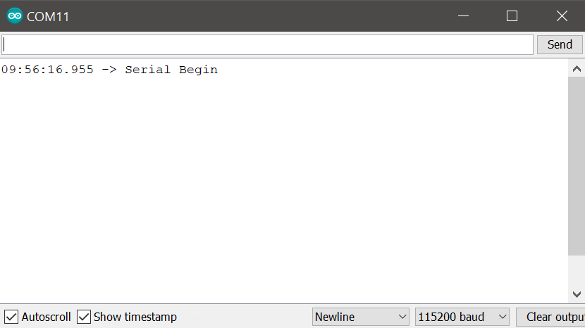

*Note: If you do not see “Serial Begin” printed in the Serial Monitor, see general troubleshooting document.*