Table of Contents
Scrum 1
Scrum Roles 1
Scrum Master - Mieke 1
Tech Lead - Benjamin 1
Product Owner - Corvin 1
Ext.: Dev-Team 2
Ext.: QA 2
Ext.: Stakeholder 2
Project Board 2
Retrospective 2
Planning Tool 2
Scrum vs. V-Model/ Waterfall 2
Open Source vs. Proprietary Software 2
Open Source 2
Proprietary Source 3
CD-Pipeline: Infrastructure and possible lock-in effects 3
Monitoring: Infrastructure and possible lock-in effects 3
Lock-in effects: How to deal with them in the future? 3

Scrum

Scrum Roles

Scrum Master - Mieke
The scrum master organizes and manages the implementation of scrum in the project team. This includes for example schedueling scrum meetings and providing transparency over project processes. He or she helps defining and realizing goals and project values by serving the product owner as well as the dev team.

Tech Lead - Benjamin
The tech lead is responsible for decisions regarding technical aspects. His or her focus is on the leadership of the development team, but in contrast to the scrum master he or she has technical knowledge and the leadership has a different quality.

Product Owner - Corvin
The product owner defines the goal of a project and fills the backlog with tasks for the development team. He or she is in accountability of the realization of the project and his or her decisions are to be respected. He or she can act as a link between the scrum team and the stake holders.

Ext.: Dev-Team
The development team is a team of experts that is actively working on the product or parts of the product. The team decides independently on HOW to solve the tasks provided in the sprint backlog and takes responsibility for the outcome.

Ext.: QA
The QA is usually done by a member of the dev team. He or she ensures that the outcome of the dev teams work is of hight quality by designing test scenarios and executing them.

Ext.: Stakeholder
Strictly speaking, stakeholders do not belong to the scrum team, but they are in close cooperation. They define the requirements for the product and are mainly interested in economical aspects. They are in regularly exchanging with the PO and are presented sprint results by the dev team during review meetings.

Project Board
https://trello.com/b/pyNlYYoE/lf8

Retrospective
https://retrotool.io/l6PioiU_AMzEFdi2vmRFn
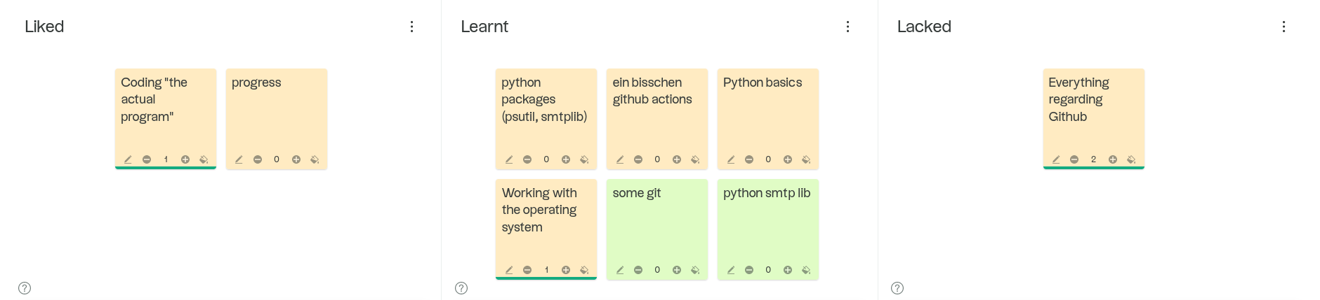

Planning Tool
https://scrumpoker.online/

Scrum vs. V-Model/ Waterfall
The main difference between scrum and older approaches like Waterfall is the agility. When working with the waterfall approach, a project is planned upfront and worked through step by step. Scrum is agile. Instead of a elaborated project plan there is a vision which the team approaches independently. The interdisciplinary works in sprints of a fix period. After every sprint there is a running product.

Open Source vs. Proprietary Software

Open Source

Explanation:

Advantages | Disadvantages

Proprietary Source

Explanation:

Advantages | Disadvantages

CD-Pipeline: Infrastructure and possible lock-in effects
- Git (OSS)
- GitHub Actions (PS) → possible lock-in: GitHub expects payment for Actions or stops service → low impact, pipeline can be adapted e.g. to Jenkins
  - ubuntu (OSS)
  - Python (OSS) and standard libraries like psutil (OSS), pytest (OSS), flake8 (OSS)

Monitoring: Infrastructure and possible lock-in effects
- OS independent
- Python and standard libraries like psutil, pytest
- Outlook as e-mail provider → independent only with own e-mail server

Lock-in effects: How to deal with them in the future?
- OS independent to avoid lock-in
- avoid proprietary software

