MagusTools

*Feature Requirement Specification*

**1. High level description**

MagusTools is a character creation application with the aim to help M.A.G.U.S. players initial preparations. The procedure of character creation is a lengthy and complicated process which requires a lot of calculations and checking of cross references. These can be automated and simplified with the help of this application.

**2. List of features**

* New character creation
* Character export and import
* Generate character based on a template
* Multiple language support
* Settings menu (save directory, custom rule options)
* Internal tools (dice roller)
* Help menu

**3. Detailed description of layout of the GUI**

The application is a simple Windows Forms Application containing one Form containing all the functionalities and resources.

* On the top row there is a Main Menu control with the following items:
* File
* New
* Open
* Save
* Save As..
* Quit
* Character
* Export as Text
* Generate
* Options
* Language
* Custom rule settings
* Tools
* Dice roller
* Help
* View Help
* About MagusTools
* The middle area is populated by a Tab Control and it's pages:
* Basic Information
* Primary Attributes
* Secondary Attributes
* Skills
* Armory
* Equipment
* Summary
* The bottom area is reserved for a Status Bar

**4. Function descriptions**

The main menu houses functions for backup handling, character generation from template, program global settings and help. This menu and it's components are always visible and accessible for the user.

* File
* New

A confirmation window appears asking if we want to discard the current character's values. In case we confirm this then the program sets the default values for all input fields.

* Open

A confirmation window appears asking if we want to discard the current character's values. On accepting this we get an Open Dialog window in which we can find and select the character file we wish to import. Upon selection all the data is loaded and the fields are updated accordingly.

The Status Bar is populated with the result of the opened file's path and name.

* Save

In case the current character has an already existing data file the program saves the current values to this file without asking for permission. In case there is no such file a Save Dialog window appears asking for a proper path and file name. The character data is then dumped to this file. The Status Bar is updated with the saved file's path and name.

* Save As..

A Save Dialog window appears asking for a proper path and file name. The character data is then dumped to this file. The Status Bar is updated with the saved file's path and name.

* Quit

In case there has been a change to the values since the last save of the data a confirmation window appears asking the user if he wishes to save the current data. Upon confirmation the data is saved. The program terminates.

* Character
* Export as Text

A Save Dialog appears for the user to designate a valid path and filename. The default path is the save path (if it exists), the default filename is the filename with the extension 'txt'. The data is then dumped to this file in a readable format.

* Generate

The program generates a random character based on the template the user selects. This is executed as creating random values around the ones which are stored in the template and takes skills from the predefined list accordingly.

* Options
* Change language

The user may change between hungarian and english printouts.

* Custom rule settings

Custom house rules have been added to the program as the years have proved their necessity.

* Tools
* Dice roller

A dice roller is included to help the ones who want to set their stats random.

**5. Screens**

5.1 Main form element layout

The main screen is divided into three parts. A menu bar occupies the top of the window, the middle part is reserved for a tab control providing access to all the controls and fields necessary for the character creating. The bottom part is a simple status bar showing the results of certain actions (e.g. file opening/saving)

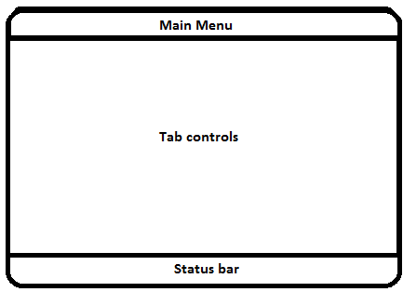

5.2 Tabs' element layout

The middle area houses a tab control, whit the following tabs:

* Basic information
* Primary attributes
* Secondary attributes
* Skills

5.2.1 Basic information tab

You may set the following data fields on this tab:

* Name  
  Unique string identifier for the character
* Gender

Specifies if the character is male or female

* Alignment

One can define Life, Death, Order and Chaos. the first and last two are mutually exclusive.

* Age

The user can specify the age of the character. It has no effect on any of the calculations/fields, but has to be given for role playing purposes. May be any positive integer number above 15.

* Race

M.A.G.U.S. distinguish several different playable humanoid races. Each has it's own advantages and disadvantages. The user may choose from the following list :

* Human
* Half-Orc
* Half-elf
* Dwarf
* Goblin
* Class

Class is similar to a profession a character can choose from. It may be one of the followings:

* Fighter
* Gladiator
* Barbarian
* Cleric
* Paladin
* Psi master
* Thief
* Bard
* Sorcerer
* Fire sorcerer
* Warlock
* Witch
* Birthplace

The user may choose from any of the countries present in the game : Six cities, Predoc, Edorl, Syburr, Enysmon, Sempyer, Viadomo, Lar-Dor, Shadon, Gorvik, Ordan, Trading Princedom, Southern City State, Taba el-Ibara, Al Abadana, El Hamed, El Sobira, Al Madoba, Al Mugaffe, Al Avdal, Abu Baldek, Abu Baldek Shibara, El Qusarma, Al Hidema, Yllinor, Elfendel, Southern ice fields, Southern steppe

* Religion

The world of M.A.G.U.S. contains the following gods and their religions: Adron, Alborne, Antoh, Arel, Darton, Della, Dreina, Ellana, Gilron, Krad, Kyel, Noir, Orwella, Uwel, Ranagol, Domvik, Kyr, Sogron, Tharr, Weila, Igere-Mogena.

* Realms

Clerics have realms which spells they are able to use for their purposes. This is strictly dependent on the religion of the cleric. May be the combination of any of the following values:

* Nature
* Life
* Death
* Spirit

The tab has the following layout:

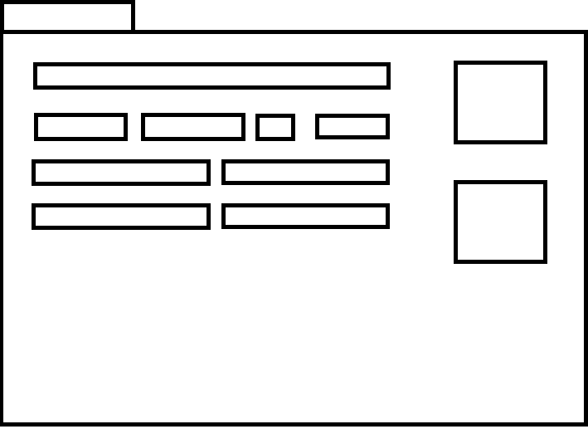

5.2.2 Primary Attributes tab

* Strength

Integer value between 3 and 20. Value above 10 is added to Attack's actual value.

* Speed

Integer value between 3 and 20. Value above 10 is added to the followings :  
- Initiative's actual value.

- Attack's actual value.

- Defense's actual value.

* Agility

Integer value between 3 and 20. Value above 10 is added to the followings :  
- Initiative's actual value.

- Attack's actual value.

- Defense's actual value.

* Endurance

Integer value between 3 and 20. Value above 10 is added to Pain Resistance's actual value.

* Health

Integer value between 3 and 20. Value above 10 is added to Health Point's actual value.

* Charisma

Integer value between 3 and 20. It's value does not affect other values.

* Intelligence

Integer value between 3 and 20. Value above 10 is added to the followings :  
- Actual mana point's value if the character's class is Bard.

- Actual psy point's value.

* Willpower

Integer value between 3 and 20. Value above 10 is added to the followings :  
- Pain Resistance's actual value.

- MMR's actual value.

* Astral

Integer value between 3 and 20. Value above 10 is added to the followings :  
- Pain Resistance's actual value.

- AMR's actual value.

* Perception

Integer value between 3 and 20. It's value does not affect other values.

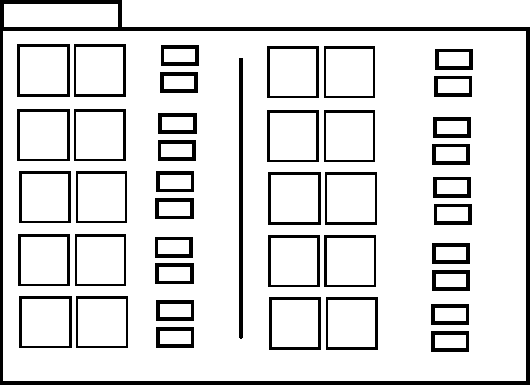

5.2.2 Secondary Attributes tab

* Initiative

Integer value 0 or greater.

* Attack

Integer value 0 or greater.

* Defense

Integer value 0 or greater.

* Aim

Integer value 0 or greater.

* CM/Level

Integer value 0 or greater.

* Health Point

Integer value 1 or greater.

* Pain Resistance

Integer value 1 or greater.

* Pain resistance per level

Integer value 0 or greater.

* KP

Integer value 0 or greater.

* KP/Level

Integer value 0 or greater.



5.2.3 Skills tab

* Available skills

Upon launching the application the database XML is parsed and all skills' names are put into a tree view based on their category and subcategory attribute.

* Collapse all button

Collapses all items in the Available skills tree view.

* Expand all button

Expands all items in the Available skills tree view.

* Expand first level only

Collapses all items, but the first level ones.

* Selected Skills

Skills selected for the character are listed here. Items from Available skills can be dragged and dropped into this window.



**5. Data Structures**

In this section the file formats used by the system are described in detail.

Input file(s):

* An XML file containing all the information (skills, stats, etc.). This file is parsed each time the application is run.
* XML saved character file. The data is stored in an unreadable format for the human eye, but the program is able to load all the values from it and the user may continue editing the data.

Output file(s):

There are two possible output formats:

* XML saved character : The character data is saved for later use/modification as described above.
* Ascii saved character : The character data is printed along with a template describing all the values, listing all the skills.

**5.1 Character file format (.MTC)**

The character file is XML based and has a well defined structure to store all information field's values.

5.1.1 Alapinformaciok tag

Contains generic data of the character found under the Basic Information tab.

The following tags are used (all values are stored as attributes of the specific tag):

* nev
* nem
* jellem
* kor
* faj
* kaszt
* szulofold
* vallas
* szferak
* ame
* mme
* sebzesjarulek
* mana
* manaperszint
* pszi
* psziperszint

5.1.2 ElsodlegesKepessegek tag

Contains data found under the Primary Attributes tab.

* ero
* gyorsasag
* ugyesseg
* allokepesseg
* eletero
* szepseg
* intelligencia
* akaratero
* asztral
* erzekeles
* atlag
* kapkoltseg

5.1.3 MasodlagosKepessegek tag

Contains data found under the Secondary Attributes tab.

* ke
* te
* ve
* ce
* hmperszint
* ep
* fp
* fpperszint
* kp
* kpperszint
* kapkoltseghm
* kapkoltsegegyeb

5.1.4 Kepzettsegek tag

Contains data found under the Skills tab.

* kepzettseg
  + nev
  + szint
  + alkategoria

**5.2 Resource data file format (.RDF)**

All data (races, religions, skills, items, languages, etc.), their relations, dependencies are stored in this file. This is loaded upon the starting of the application. Also these values are treated as constants, their values remain unchanged.

5.2.1 Skills tag

This is a container tag under which we collect all the skills used by the M.A.G.U.S. system.

5.2.1.1 Skill tag

Contains data about a well defined skill. All skills have the following data fields:

Attributes:

* Name

A unique idenfitifer among all skills.

* LearningMethod
* Levels

The skill may be learned on a 1-5 scale each having it's own requirements to meet.

* Percentage

The skill is calculated on a percentage basis, does not have a requirement list to meet.

* Difficulty
* Integer value [1 – 5]

Defines the difficulty to learn the given skill. Might have an effect on how long it took to master the skill.

* Category
* Combat

All the basic fighting skills are listed here

* Social

Skills which are needed for everyday life, finding one's way around cities, knowledge about different cultures are found here.

* Bandit

Shady skills are listed under this tag. Using these skills are usually illegal but immoral at the least.

* Survival

Everyday's skills in the wilderness, they help the character make it easier to survive the harsh conditions which are usually found far from civilized parts of Ynev.

* Theoretical

All higher studies are listed here, maths, magic, you name it.

* SubCategory

Each and every category has at least 3-4 subcategories which group certain skills together based on their similarities.

* InheritsSubtype
* Logical value (true / false)

Some skills require an other skill already taken. This value defines if there is a need for such thing for a specific skill.

* Subtype

5.2.1.1.1 Level tag

Skills for which the learning method is levels 5 distinct Level tag is defined. Each tag defines the requirements for learning the given skill on the given level.

Attribute :

value

Integer value between 1 and 5.

* Requirement

Describes a requirement for taking the given skill on the given level.

Attributes :

type : stat/skill  
name : required name of the stat/skill

value : required value of the stat/skill

5.2.2 Classes tag

One main factor of personalization of the character is choosing a class for it. It describes what lifestyle, school, life choices have been made by that character, what profession it has chosen. All characters have exactly one class, no more no less.

5.2.2.1 Class tag

Each individual playable class is stored in one of these tags. Only one definitive parameter is present for it.

* name

Name of the class.

5.2.3 Races tag

There are several playable humanoid race in the world of Ynev. The player has to choose one and only one of them. This affects origin, backstory, social relations, etc.

5.2.3.1 Race tag

Each individual playable race is stored in one of these tags. Only one definitive parameter is present for it.

* name

5.2.4 Items tag

A character does not only have it's stats and skills upon enbarking on a journey, it also has certain items to be used during the quests. These items can be various including but not restricted to weapons, armors, personal belongings, food, etc.

5.2.4.1 Item tag

All available items are stored in one of the Item tags. One definitive parameter is provided for all items, but taglist provides the needed flexibility.

* name

A unique identifier for the given item.

5.2.5 Languages tag

The imaginary world of M.A.G.U.S. have several languages for the character to be able to learn and use. Different regions have different languages and knowing them might decide the character's fate.

5.2.4.4.1 Language

One specific language is stored in this tag. Only one describing parameter is provided, but the taglist can be used for differentiation between the languages (e.g. dead language).

* name  
  Unique identifier for the language