**6.23**

Tavg_seek​=4ms

Tavg_rotation​=21​∗150001​∗60s/min∗1000ms/s=2ms

Tavg_transfer​=150001​∗8001​∗60s/min∗1000ms/s=0.005ms

T = 6.005ms

**6.27**

**A：**

地址范围：0x08A4~0x08A7  
地址范围：0x0704~0x0707

**B：**

地址范围：0x1238~0x123B

**6.31**

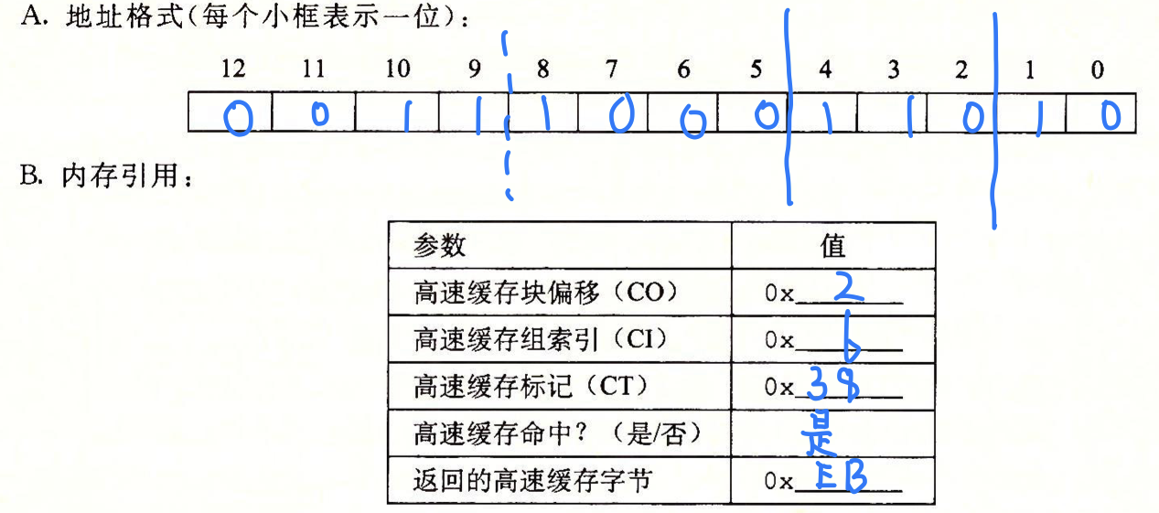

**6.35**

## dst数组

|  |  |  |  |  |
| --- | --- | --- | --- | --- |
|  | 列0 | 列1 | 列2 | 列3 |
| 行0 | m | h | h | h |
| 行1 | m | h | h | h |
| 行2 | m | h | h | h |
| 行3 | M | H | H | h |

## src数组

|  |  |  |  |  |
| --- | --- | --- | --- | --- |
|  | 列0 | 列1 | 列2 | 列3 |
| 行0 | m | h | h | h |
| 行1 | m | h | h | h |
| 行2 | m | h | h | h |
| 行3 | M | H | H | h |

**6.39**

**A：**

16*16*4 = 1024；

**B：**

256

**C：**

256/1024 * 100% = 25%

**6.43**

100%