Study of Graphene and Silicon Heterostructures

Lucas Bittof, Sean George

The University of Tennessee, Math and Science Center

**Review of Literature**

After the discovery of graphene, many possible uses of graphene were tested. It is part of a growing field of two-dimensional electronic materials Graphene has investigated as a possible transparent electrode for solar cells. As part of determining the potential use for graphene as an electrode it has also investigated as a material for layered two-dimensional heterostructures with various materials such as boron nitride and tungsten disulfide. Recently, experiments have been performed on graphene layered with silicon, however to date no computational investigation using density functional theory (DFT) has been performed.

Study of Graphene and Silicon Heterostructures

Graphene is a two-dimensional layer of carbon that has bonds that form a hexagonal pattern. Graphene is a new material that has a lot of potential applications. It was discovered by researchers when they split layers of graphite apart repeatedly until there was just a single layer of carbon that was one atom thick (Alan Chodos. 2004). Silicon can be in a crystalline or amorphous form. The more amorphous the silicon, the glassier it is. Silicon can be used in solar cells, some digital displays, and as a semiconductor in electronics. The application that is being focused on in this study is graphene’s ability to bond to glassy, amorphous, silicon. This can be used in many scenarios. One such use is to make solar cells. The graphene acts as a conductive layer on the glassy silicon. This is needed because solar cells must have a transparent and conductive layer to function. The glassy silicon and graphene heterostructure performs this function better than other options. The study focused on how the graphene bonded to the silicon. This was done with the use of the supercomputer, Newton, at UT and multiple other programs that were all used to simulate the graphene silicon heterostructure. We hypothesized that the graphene that was in a heterostructure with the crystalline silicon would have a lower binding than amorphous silicon, and as the glassiness increases the bonding energy increases.

**Method**

The students downloaded a graphite.cif file from the ICSD (Inorganic Crystal Structure Database). They then used a text editor to make graphene by removing all but one layer of graphite. The file was then converted into a ‘.vasp’ file using the program VESTA (Visualization for Electronic and Structural Analysis). The file was then converted into a rectangular unit cell by calculating the atom placements on a sheet of paper and then using a text editor to change the digital file. The students then used a Python script provided to them by the mentor to then make a four by two supercell. The students then downloaded a silicon.cif file from the ICSD Database. The file was then converted to ‘.vasp’ with VESTA and was changed into a two-dimensional face-centered layer using a text editor. A two by two supercell was then made with the same Python script provided by the mentor. The length of the unit cells were then changed to a length in between the two initial lengths of the supercells to make the cells be of identical lengths and to minimize strain. The graphene was offset to one and a half angstroms above the silicon. VASP (Vienna Ab initio Simulation Package) was then used to calculate the energy of both supercells. The fitted stable layer spacing was calculated to be 2.171513 Angstroms. A series of four supercells of silicon that were progressively more amorphous (glassy) were then generated using a different Python script. The layers of silicon, glassy and crystalline, were then individually combined with layers of graphene to form a layered heterostructure. The energy of these heterostructures was then calculated. The students then took the difference between the energy of the heterostructures and the graphene supercell alone plus the silicon supercell alone. The difference is the binding energy. They then plotted the binding energy versus the glassiness.

**Results**

The results show that the highly glassy silicon had a higher binding energy than the crystalline silicon. In silicon that was crystalline, the binding energy was -5.5899956 eV (electron volts) (see Figure 1). For the barely glassy silicon, the energy was -5.0589389 eV (see Figure 1). For the slightly glassy silicon, the energy was -4.2581974 eV (see Figure 1). For the very glassy silicon, the energy was -3.2056997 eV (see Figure 1). For the entirely glassy silicon, the energy was -2.0784606 eV (see Figure 1).

**Discussion**

These results show potential uses of graphene and silicon heterostructures. It shows that graphene will bond in a stable way to silicon, however graphene bonds the best (most stable) to crystalline silicon and to amorphous the worst (least stable). The graphene does bond to the amorphous silicon in a stable manner. This shows that graphene can be used with silicon to make a material that is both transparent and conductive. There were a few limitations on this study. Having access to more resources, more time, and more people would have all made the study better.

**References**

Chem Soc Rev. (2014). Atlas of 2D Materials

Florian Banhart, Jani Kaokoski, and Arkady V. Krasheninnikov (2011). Structural Defects in Graphene

Graphene as a transparent electrode for amorphous silicon-based solar cells. (n.d.). Retrieved July 06, 2016, from http://scitation.aip.org/content/aip/journal/jap/117/24/10.1063/1.4923232

Neutral-Color Semitransparent Organic Solar Cells with All-Graphene Electrodes. (n.d.). Retrieved July 06, 2016, fromhttp://pubs.acs.org/doi/full/10.1021/acsnano.5b04858

*This Month in Physics History. (n.d.).* Retrieved July 06, 2016, from https://www.aps.org/publications/apsnews/200910/physicshistory.cfm

Two-dimensional materials and their prospects in transistor electronics. (n.d.). Retrieved July 06, 2016, from http://pubs.rsc.org/en/content/articlehtml/2015/nr/c5nr01052g

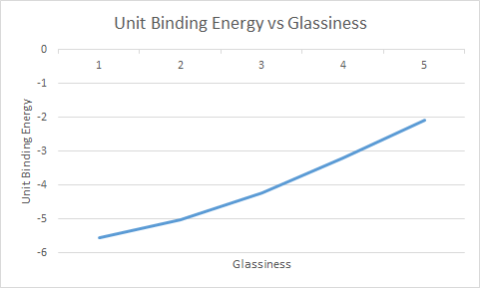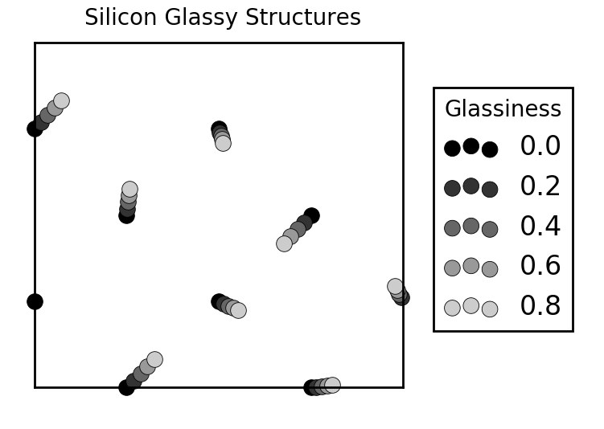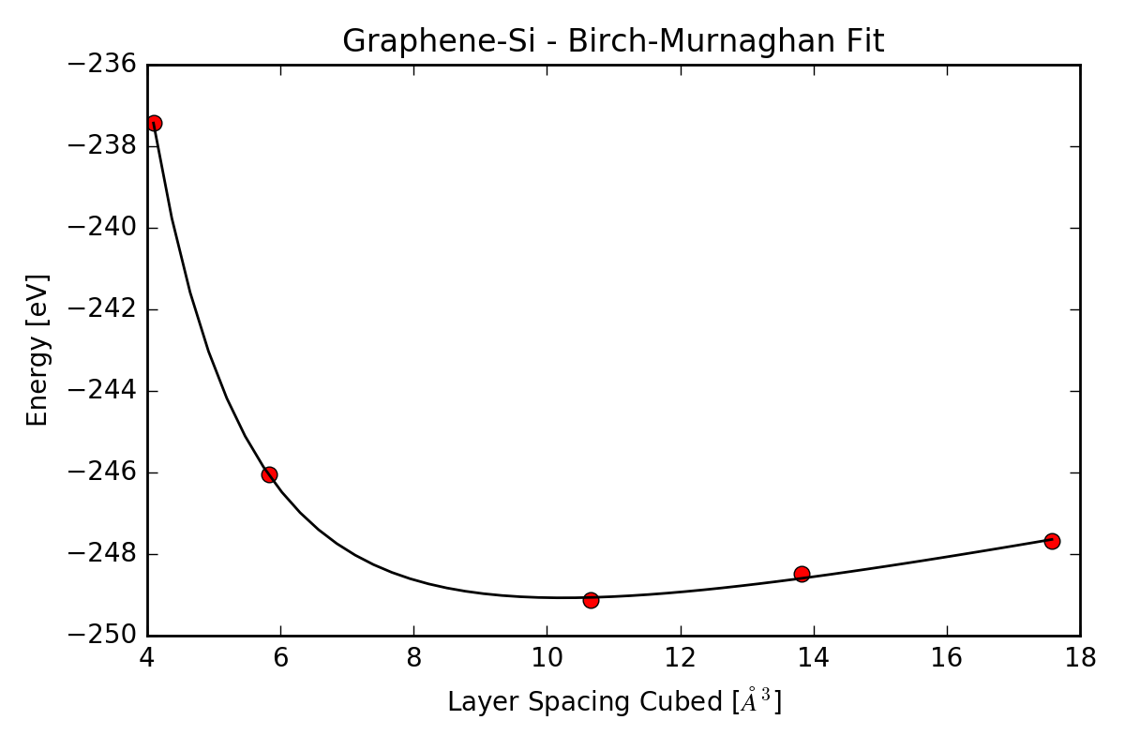

Fig. 3: Unit Binding Energy vs Glassiness

Fig. 2: Silicon Glassy Structures

Fig. 1: Graphene-SI – Birch-Murnaghan Fit