QUEENSLAND INDUSTRIAL RELATIONS COMMISSION
Workers' Compensation and Rehabilitation Act 2003
Cory Lea Shepherd
Appellant
v
Workers' Compensation Regulator
Respondent
Matter No. WC/2024/227
APPEAL AGAINST DECISION OF RESPONDENT PURSUANT TO SECTION 549
APPELLANT'S ELECTION UNDER DIRECTION 5, AND DIRECTIONS REQUESTED
FURTHER TO direction 5 of the Further Directions Order (3) dated 19 August 2026, the Appellant elects to proceed to a second conference under section 552A, and asks that the Commission direct:
1. That the appeal be listed for a second conference under section 552A of the Workers' Compensation and Rehabilitation Act 2003, on a date fixed by the Commission, at which the directions requested at 2 to 6 below may be dealt with.
2. That, at the opening of the conference, the Respondent state whether it maintains the contention in paragraph 27 of its amended statement of facts and contentions of 13 May 2026 and, if it does, that the contention be particularised in accordance with item 5 below.
3. That the proposed Second Amended Statement of Facts and Contentions (Form 9A) enclosed with the Appellant's letter be considered for the purposes of the application for leave and, if leave is granted under section 451(2) of the Industrial Relations Act 2016, that the Appellant be permitted to file and serve it. The proposed Form 9A accepts that the Appellant bears the onus of proof, retains the three stressors, and sets out their particulars by dated event against the facts admitted on 8 September 2026. It adds no new stressor or allegation. The Appellant's list of witnesses filed, and outlines of evidence served, on 9 September 2026 are not amended and stand as filed and served.
4. That the Respondent state, by 4.00 pm on a date fixed by the Commission, whether it maintains its dispute as to the authenticity of each of the ten documents at Annexure A to the Appellant's notice to admit documents served 28 August 2026 that remain outstanding and, for each dispute maintained, particularise the ground on which authenticity is disputed; being Tabs 1, 5, 17, 18, 19, 21, 22, 23 and 31, of which the Respondent said on 24 September 2026 that it had requested copies from Metro South Hospital and Health Service, and Tab 24, which its email of that date did not address. The facts recorded in each, other than the register at Tab 31 (facts 228 to 231), were admitted on 8 September 2026. The Appellant asks that any dispute not so maintained cease to be in issue, and that the Appellant have liberty to apply in relation to any authenticity dispute remaining after that date. No direction as to relevance, weight or admissibility is presently sought.
5. That the Respondent state, for each causal particular in the proposed Second Amended Form 9A, namely 1(b), 1(d), 1(f) to 1(h), 1(k) and 1(l); 2(a) to 2(i), 2(l) and 2(m); and 3(b) to 3(f), whether it contends that the particular was management action and, if so, the facts on which it relies to say that the action was reasonable and taken in a reasonable way, by the date fixed for any amended statement of facts and contentions under 6 below. The other particulars are context, or the record of how the matters were handled, and no answer is sought on them.
6. That, if leave is granted and the Second Amended Form 9A is filed, the Respondent have leave to file and serve an amended statement of facts and contentions, and any amended list of witnesses and outlines of evidence, if it wishes, within 14 days after that filing.
7. Such further directions as the Commission considers appropriate.
Enclosed with this page: the Appellant's letter of explanation, with the schedule of the documents relied on and their status and an index of the particulars; and the proposed Second Amended Statement of Facts and Contentions (Form 9A), provided for the Commission's consideration of the application for leave. The notices to admit, the Respondent's responses and the documents themselves are available to the Commission on request.
Dated 1 October 2026
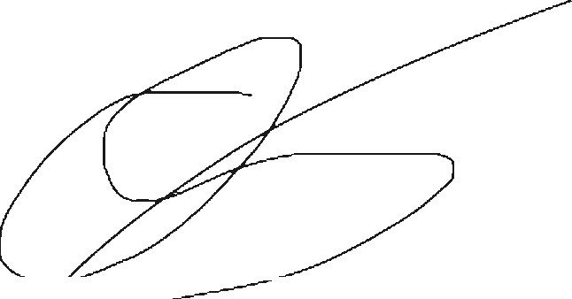
Cory Lea Shepherd
Appellant (self-represented)

