**Cory Wilson & Patrick Halton**

**ASL1503**

**Project/App Title:**

BreakTheIce.com *Provisional Name

**Project/App Summary:**

Our application aims to provide a resource for snowboarders looking to discover the conditions for mountains in the United States of America. Users will have the ability to search for nearby mountains or search for mountains by name. They will then be able to view details for the mountain, which include, snow conditions, current and future weather conditions, and a user generated aggregate score. Each user will have their own user profile page where they can rate mountains, message other users, and create a list of favorite mountains.

**Twist:**

Our application aims to bring a simpler experience to viewing snowboarding conditions on mountains. Our target audience is a more novice snowboarder who may not be looking for exact details and instead simply wants to know if the conditions are favorable. The ability to message with other users, rate mountains, and build a favorite list of mountains will give users an easy to use resource when looking for mountain conditions.

**Example:**

**Week 1 Schedule:**

Monday-Tuesday:

* Research Node.js, Express.js and train with those technologies.
* Begin design process and set up development environment:
  + Directory Structure
  + Node.js
  + Express.js
  + Foundation
  + jQuery
  + SASS

Wednesday-Sunday:

* Set up database
  + MongoDB or MySQL
* Develop MVC structure for application
* Develop functionality
  + Basic Layout
  + Log In/Sign Up
  + Search
    - Proximity (Google Maps API)
    - Enter Location
  + User Profile Page
    - Messaging
    - Rating Mountains
    - Favorite Mountains
  + Mountain Page
    - Snow Conditions (Powderlines API)
    - Weather Conditions (Weather Underground API)
    - Images (Flickr API)
    - Overall User Rating

**Week 2 Schedule:**

Monday-Tuesday:

* Add Final Styling
* Polish and Test

Wednesday-Thursday:

* Deploy application

**Week 1-2 features:**

* Login/Sign Up
  + Allow the User to create and log into an account.
* Search
  + By proximity, aka closest mountains with Google Maps API
  + By entering a location
* Messaging
  + Ability to message between users
* Pull Conditions from Powderlines and Weather Underground APIs
* Pull Images of locations from Flickr API
* Favorite
  + Ability to favorite mountains and create a favorite mountains list

**Wire Diagrams:**

See attached images

**Design Templates:**

Initial Color Scheme Idea



**Database Diagram:**

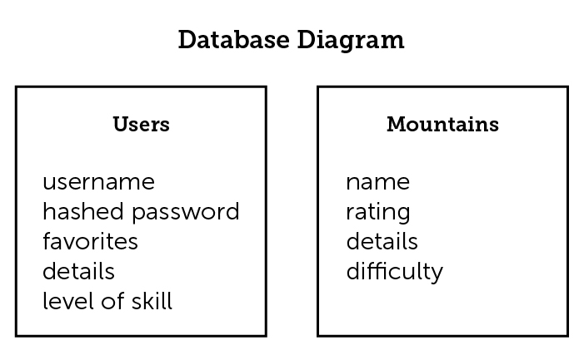

**Language and framework:**

Node JS

Express JS

jQuery

Foundation

SASS

**Version One:**

* Log In/Sign Up
* Search
  + Proximity (Google Maps API)
  + Enter Location
* User Profile Page
  + Messaging
  + Rating Mountains
  + Favorite Mountains
* Mountain Page
  + Snow Conditions (Powderlines API)
  + Weather Conditions (Weather Underground API)
  + Images (Flickr API)
  + Overall User Rating

**Version Two:**

If you had more time what will you add to your application?

* Facebook/Twitter Log In