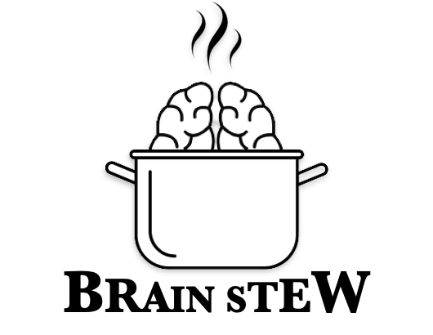

BrainStew!

Request for Proposal  
Version 1.0

Document History

|  |  |  |
| --- | --- | --- |
| Date | Description | Version |
| 01/31/2025 | Inital drafting of RFP | 1.0 |
| 02/07/2025 | Final document and proposal | 2.0 |

Table of Contents

1. Problem description
2. Project Objectives
3. Current System(s) – if any or similar systems
4. Intended users and their interaction with the system
5. Known interactions with other systems inside/outside the client organization
6. Known constraints to development
7. Project Schedule
8. How to Submit Proposals
9. Dates
10. Glossary of terms
11. Problem description / opportunity / expression of need

The Metroidvania genre of game has been in a lull for the past few years and this gap has made way for the next great game. Games like Hollow Knight or Ori and the Blind Forest have shown that the genre is popular, but sequels have gone largely unnoticed or delayed, leaving players looking for the next big hit.

This is a major marketing and profit opportunity that would be incredible to capitalize on. Besides from the monetary aspects, having this be a major hit in the community would put our name on the radar and on the same field as major companies such as Blizzard and Microsoft.

1. Project Objectives

The objective of this project will be to create a run-and-gun game filling the single player Metroidvania niche. Some major objectives will be:

1. Audo-Visual & Style
2. Immersive/diverse enemy design
   1. Satirical with dark humor
   2. Bullet-hell enemy patterns with distinct and complex attack patterns (or stages depending on health), and dodgeable gaps
3. Smooth gameplay
   1. Responsive controls: snappy movement, aiming, and shooting with precise enough hitboxes
4. Multiple weapon powerups to use
   1. Different projectile types (e.g. wide spread shots, explosive rounds, rotten orange ammo, bouncing shots)
   2. Powerups could be having more workers join and improved damage to weapons
5. Bug/Glitch free
6. Multiple unique level designs (at least three)
7. Current system(s) – if any / similar systems

**Contra**

Contra is a linear run and gun style game focused on level design, difficulty, and story. It follows a hero trying to save earth from an alien invasion, traveling across earth and even onto alien planets.

**Hollow Knight**

Hollow Knight is a nonlinear, 2d game based around it’s in depth world building and it’s unique charm stemming from character design and artwork. It has a linear progression of slowly introducing new features and abilities which eases players into the difficult portions of the game.

1. Intended users and their basic interaction with the system

The intended users for this game are gamers aged 13-99 who want to enjoy a fun poke at American capitalists. The users will be the main character, Magnolia, an Amazon worker who is rising up against the big three CEOs. The user should be able to control the main character, meaning they can make Magnolia run, jump, and fight enemies in the game.

1. Known interactions with other systems within or outside of the client organization.

We need 2 more but idk

1. Unity
2. Steam
3. Sample
4. Known constraints to development

Time.  
Constricted to using the Unity game engine.

Budget constraints: no budget.

1. Project Schedule

|  |  |
| --- | --- |
| Date | Description |
| February 22, 2025 | Minimum viable product |
| May 1, 2025 | Final Presentation |
|  |  |

Broad overview. Must agree with the course schedule. Can include some of the potential meeting dates with milestones included.

|  |  |
| --- | --- |
| 8.0 | How To Submit Proposals |
|  | Please email all proposals in pdf format via email to Cory Clairmont, IT Manager for Brain Stew at clai1285@vandals.uidaho.edu.For  Instructions for submitting proposals (i.e. electronically, etc.) |
| 9.0 | Dates |
|  | Deadline for submission and when respondents will be notified that a winner is chosen. |
| 10.0 Glossary of terms | |

Metroidvania: Any game that follows the Metroid style of game design.

Glitch: A feature of the game that does not work as intended and harms the user experience.

Bug: Synonym for a glitch.

*Note: Remember that “system” means product, service, and/or system your group would like to see created, built, upgraded, and/or changed. It is a broad term.