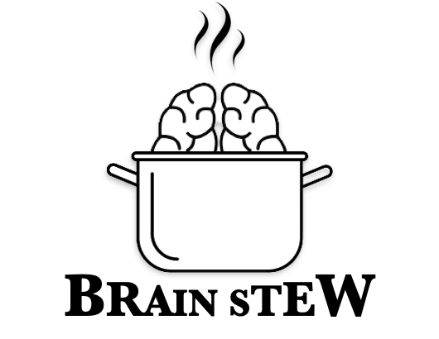

BrainStew!

Request for Proposal  
Version 1.0

Document History

|  |  |  |
| --- | --- | --- |
| Date | Description | Version |
| 01/31/2025 | Inital drafting of RFP | 1.0 |
| 02/07/2025 | Final document and proposal | 2.0 |

Table of Contents

1. Problem Statement
2. Project Objectives
3. Current System(s) – if any or similar systems
4. Intended users and their interaction with the system
5. Known interactions with other systems inside/outside the client organization
6. Known constraints to development
7. Project Schedule
8. How to Submit Proposals
9. Dates
10. Glossary of terms
11. Problem Statement / opportunity / expression of need

The Metroidvania genre of game has been in a lull for the past few years and this gap has made way for the next great game. Games like Hollow Knight or Ori and the Blind Forest have shown that the genre is popular, but sequels have gone largely unnoticed or delayed, leaving players looking for the next big hit.

This is a major marketing and profit opportunity that would be incredible to capitalize on (not sure if this should be the reason since the core of our game is very anti-capitalist). Besides from the monetary aspects, having this be a major hit in the community would put our name on the radar and on the same field as major companies such as Blizzard and Microsoft.

(Other rendition)

In a world increasingly dominated by corporate control, there is growing need for creative outlets that allow people to laugh, reflect, and challenge the status quo – especially through fun and engaging experiences. Many existing 2D platformers and bullet-hell games often stick to classic sci-fi or fantasy themes with subtle nods to various issues (which are enjoyable in their own way) but often didn’t fully explore dark satire and social commentary. What better time to do so?

While there’s a handful of 3D games like *Fallout: New Vegas*, *Bioshock*, and *The Outer Worlds* that express the consequences of unchecked capitalism in their own style, let’s fill the gap with a 2D spin. So clearly there’s an audience to engage with recent modern-day struggles in a meaningful humorous way. Perhaps a game that blends chaotic run-and-gun gameplay, punk aesthetics, and dark humor would resonate. Imagine a dystopian Mars colony seized by tech oligarchs, where players take on the role of a disillusioned worker fighting to break free from a soulless mega-corp. Indie developers seize the moment for creative freedom! There’s lots to explore here in a way that provokes thought. After all, *art should comfort the disturbed and disturb the comfortable.*

1. Project Objectives

The project aims to create an action-packed 2D platformer that is a hybrid of run-and-gun, bullet-hell, and a dash of metroidvania elements set in a dystopian world controlled by tech moguls. Players will navigate through different levels inspired by tech-industrial environments, fighting enemies, completing objectives, and battling bosses. While it’ll follow a linear progression, it should still be engaging and memorable.  
  
Major components should be:

1. Player
   1. Balanced movement controls for the character – e.g. idle, regular running, pushing, wall-running, jumping…
   2. A small inventory for ammo, weapons, or collectibles
   3. Ability to use weapons and interact with enemies
   4. Defined health
2. Enemies
   1. Varied enemy types with distinct behaviors (e.g. drones, guards..)
   2. Enemy drops or powerups upon defeat?
   3. Some bullet-hell mechanics or simple attack
3. Boss
   1. At least 3 bosses with multi-phases (e.g. based on corpo leaders)
   2. Minion spawning?
   3. Ticket to advance to next stage (maybe like a checklist)
4. Levels
   1. Have them be distinct or themed
   2. Self-contained (probably no backtracking?) or clear goal to progress to next stage
   3. Perhaps specified safe zones?
5. Audio & Visual
   1. Sprites, background, platform is clearly defined
   2. Reflective soundtrack (the copyright aspect)
6. Menu/UI
   1. A main menu for starting new game or loading progress
   2. Option to toggle music or sound effects on/off
   3. Pause menu
   4. Checkpoints – save/load capability
7. Glitch/bug free
8. (Optional) Companions
   1. The dystopian world is complex but you are not alone

NOTE: It is rather ambitious given the time, so let’s say the first submission is an all-in effort draft

1. Current system(s) – if any / similar systems

**Contra**

Contra is a linear run and gun style game focused on level design, difficulty, and story. It follows a hero trying to save earth from an alien invasion, traveling across earth and even onto alien planets.

**Hollow Knight**

Hollow Knight is a nonlinear, 2d game based around it’s in depth world building and it’s unique charm stemming from character design and artwork. It has a linear progression of slowly introducing new features and abilities which eases players into the difficult portions of the game.

I researched and metal slug (1996) is similar, katana zero (2019), not a hero (2015), and ruiner (2017)…

1. Intended users and their basic interaction with the system

The intended users for this game are gamers aged 13-99 who want to enjoy a fun poke at American capitalists. The users will be the main character, Magnolia, an Amazon worker who is rising up against the big three CEOs. The user should be able to control the main character, meaning they can make Magnolia run, jump, and fight enemies in the game.

1. Known interactions with other systems within or outside of the client organization.
2. Steam
3. Apple play store (iOS)
4. Google play (Android)
5. Known constraints to development

Time.  
Constricted to using the Unity game engine.

Budget constraints: no budget.

1. Project Schedule

|  |  |
| --- | --- |
| Date | Description |
| February 22, 2025 | Minimum viable product |
| May 1, 2025 | Final Presentation |
|  |  |

Broad overview. Must agree with the course schedule. Can include some of the potential meeting dates with milestones included.

|  |  |
| --- | --- |
| 8.0 | How To Submit Proposals |
|  | Please email all proposals in pdf format via email to Cory Clairmont, IT Manager for Brain Stew at clai1285@vandals.uidaho.edu.For  Instructions for submitting proposals (i.e. electronically, etc.) |
| 9.0 | Dates |
|  | Deadline for submission and when respondents will be notified that a winner is chosen. |
| 10.0 Glossary of terms | |

Metroidvania: Any game that follows the Metroid style of game design.

Glitch: A feature of the game that does not work as intended and harms the user experience.

Bug: Synonym for a glitch.

*Note: Remember that “system” means product, service, and/or system your group would like to see created, built, upgraded, and/or changed. It is a broad term.