* **Steps for installation and crating GitHub account**

1. Create an account online on GitHub by username password with your company mail id.

<https://github.com>

1. Do sign up for Github.

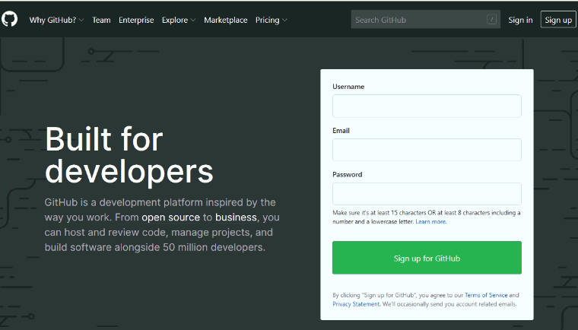

1. Now create your account by filling all necessary details (Username, Company Mail ID etc.).

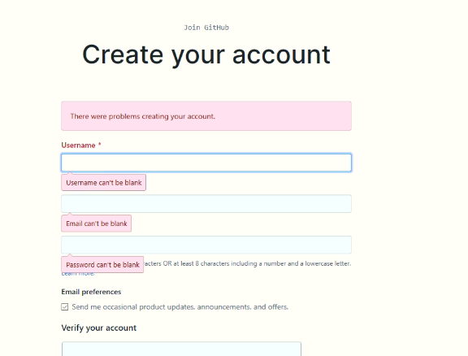

1. Now login with your username and password.

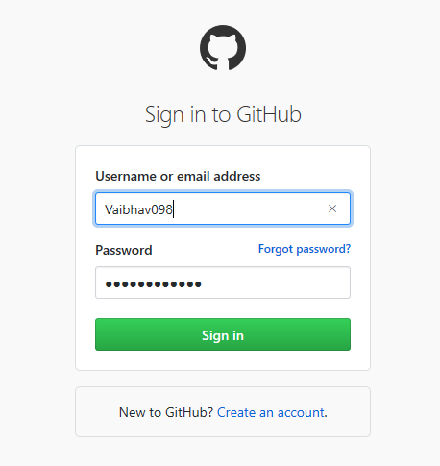

1. Once you done with this, you have to send your username and mail ID to your project creator (Project lead). After that he will add you on GitHub and will send you the project invitation link by email. Below is one of the example of project invitation, just click on view invitation.

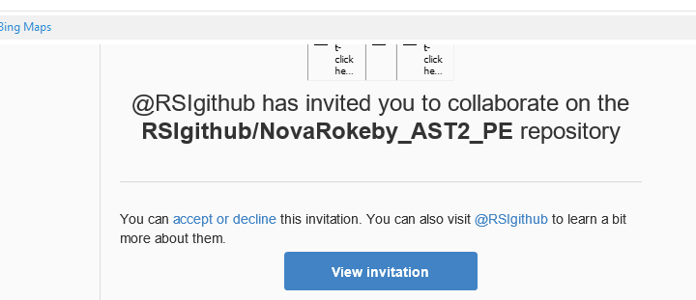

1. After accepting invitation automatically browser will open and you can see on left hand you are added for invited Github project.

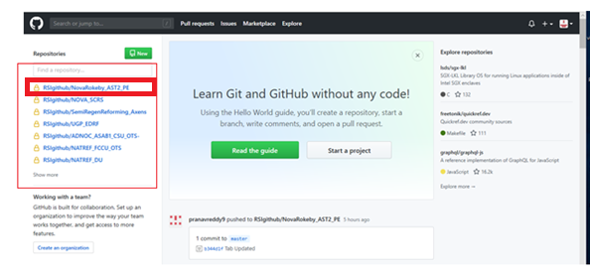

1. Click on project then you will get URL path.

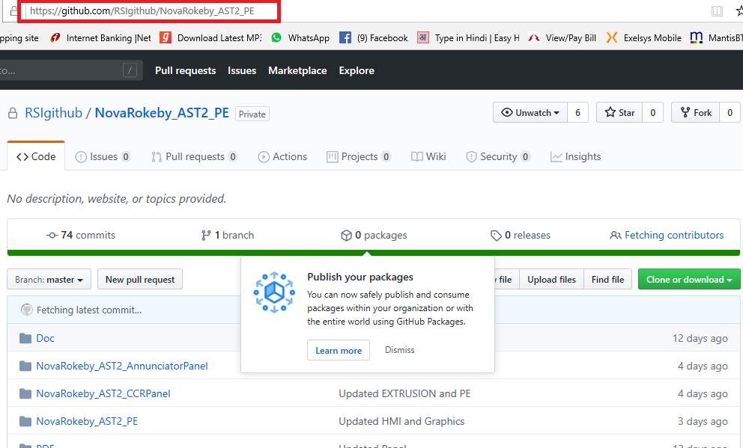

1. Now you can use this URL [**https://github.com/RSIgithub/NovaRokeby_AST2_PE**](https://github.com/RSIgithub/NovaRokeby_AST2_PE)in source tree for cloning the project. Before cloning the project you have to install source tree on your machine, the source tree installation details are given below.

* **Steps for installation for Source Tree**

1. For source tree installation, take online latest setup of source tree. (Search on google).

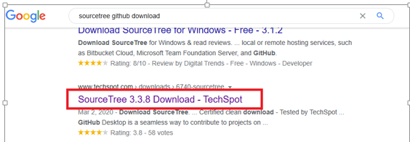

1. Download Source tree Application setup on your machine.

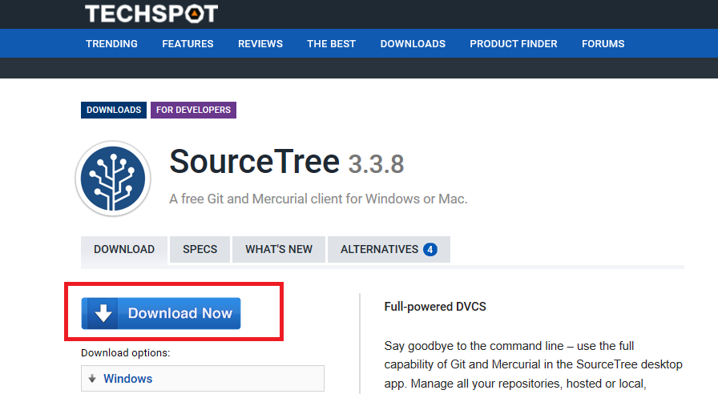

1. Save setup .exe file on your machine





1. Click on set up .exe.

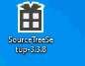

1. Installation will start and pop up will come.

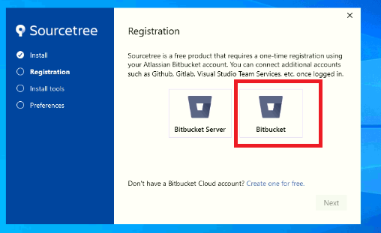

1. Select Bitbucket and set up will start automatically.

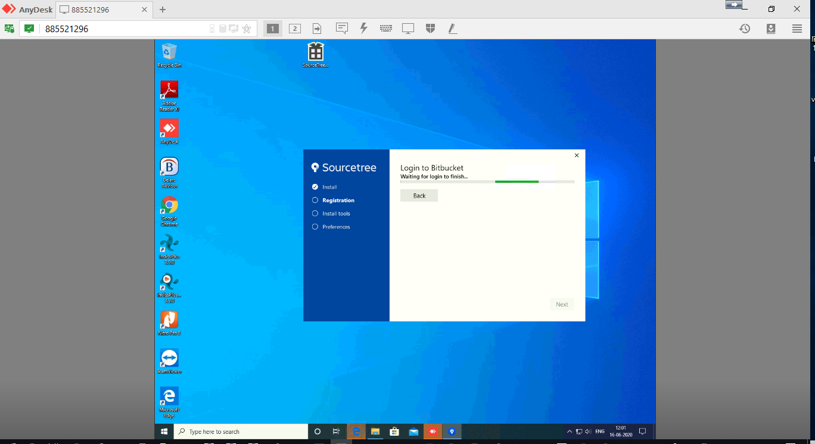

1. First installation will ask you to login in Bitbucket account on internet explorer for Registration so Do all registration procedures which are given below.

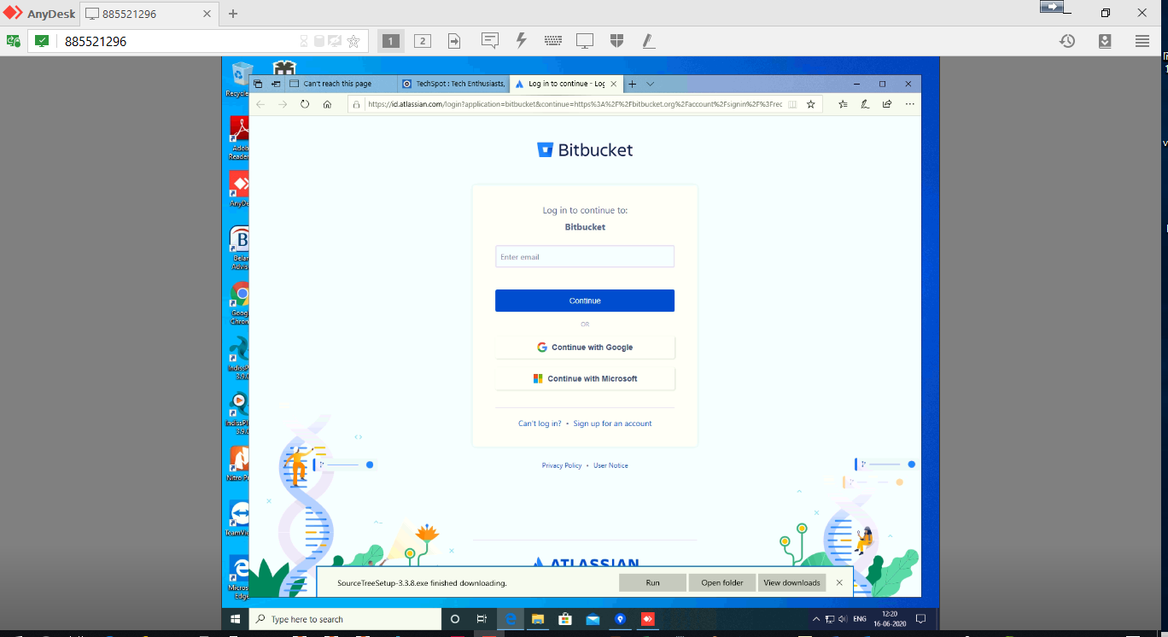

1. Login with your company mail ID.

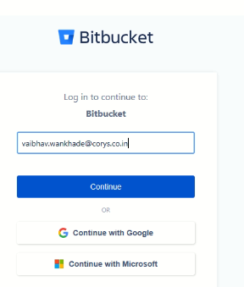

1. Enter your mail ID password and do login.

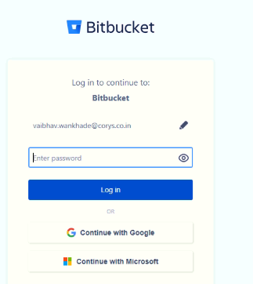

1. This will ask you for recovery link (This is for your Mail ID verification).

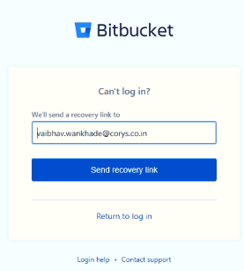

1. Click on recovery link you will get below message, that link has been sent to your mail ID.

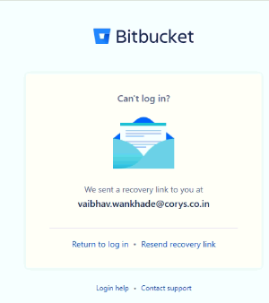

1. Now check your mail id you will get mail from Atlassian account.

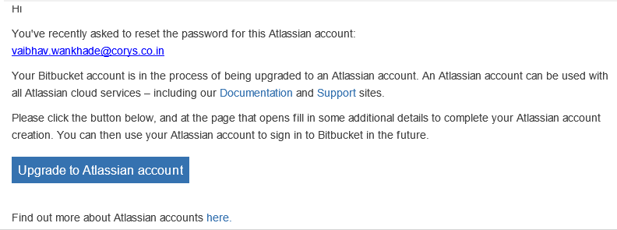

1. Click to upgrade to Atlassian account, this will ask for your full name and create password for your given mail ID.

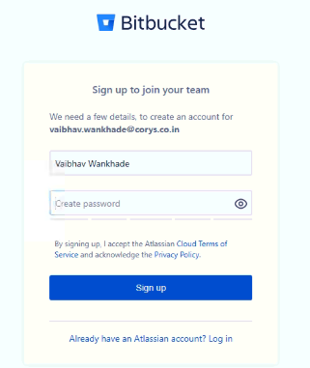

1. Create strong password and sign up.

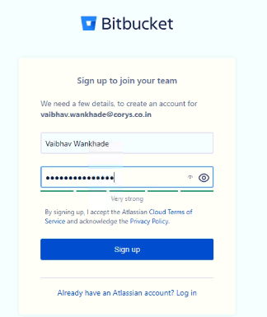

1. Skip introduction



1. It will ask you for VERIFY.



1. After verification it will ask you to create username then create username and continue.

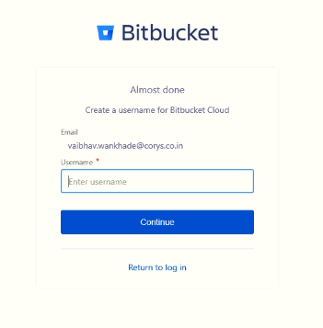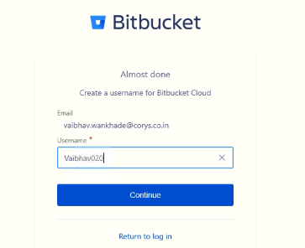

1. Skip introduction.

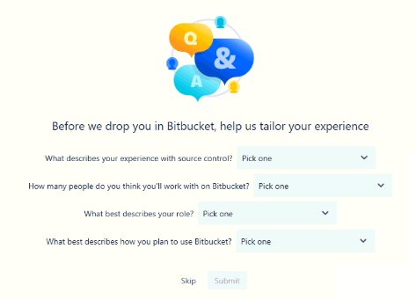

1. You will get message click on grant access.

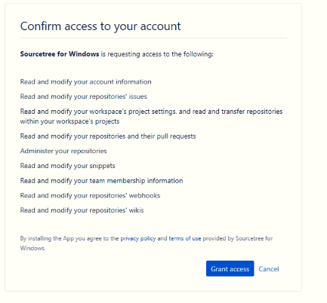

1. After clicking on grant access you will get below message. That means Registration is completed

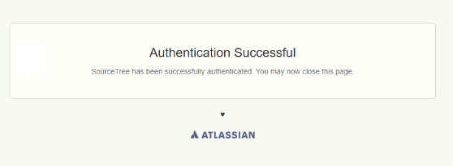

1. Registration is completed, now go to installation window again and do next.

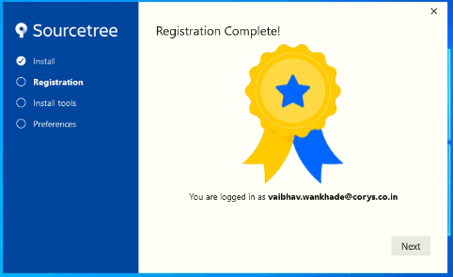

1. Do not uncheck anything do next.

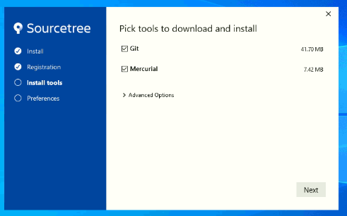

1. After next Downloading will start.

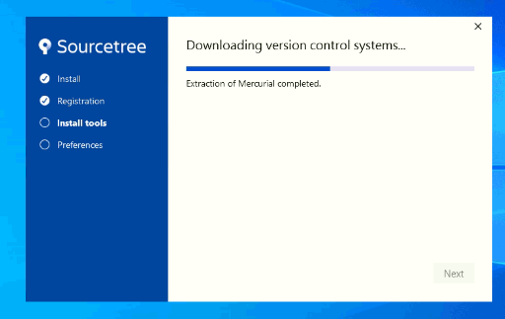

1. Do next to install tools.

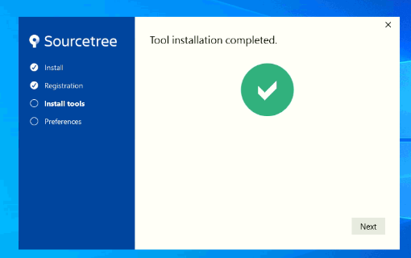

1. Do next for your username and mail ID.

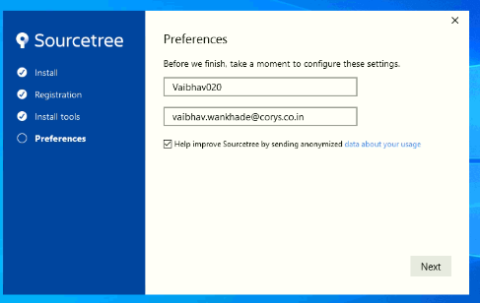

1. It will ask for key say “NO”

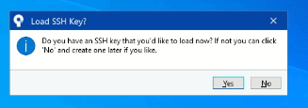

1. Source Tree Application will launch automatically! Now it is ready to use.

How to use source Tree (Cloning etc.) the steps are given below.

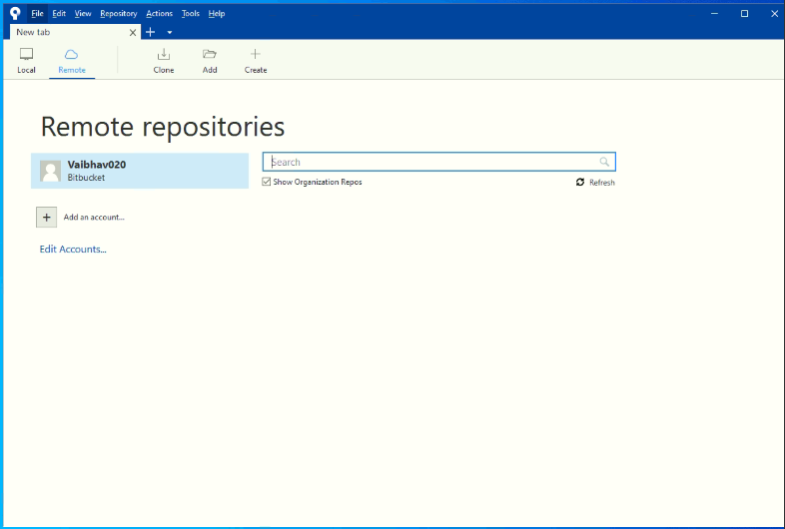

* **Steps for cloning the project repository using Source Tree application**

1. After installation of Source tree.
2. Open the Source Tree application and Click “+” button on the upper toolbar to clone the project/repository.

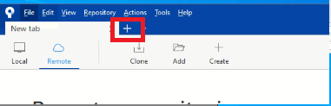

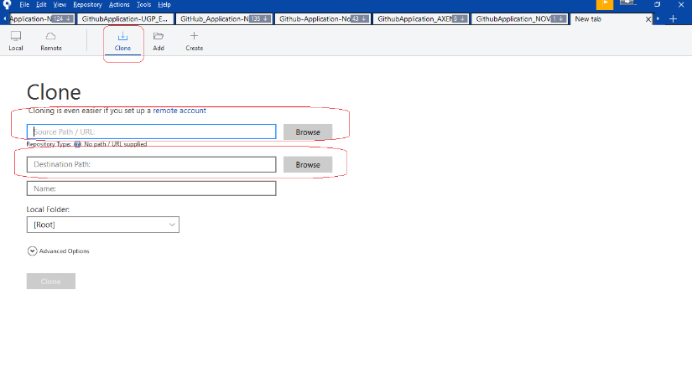

1. Select the Clone option once it is available.
2. Copy the URL (earlier mentioned in Github Installation) from GitHub link and paste in URL path.

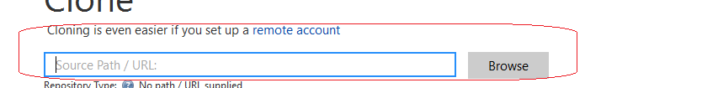

1. Make sure a new folder on the local drive is created for particular GITHUB.
2. Assign the path of this folder.



1. Click CLONE option.

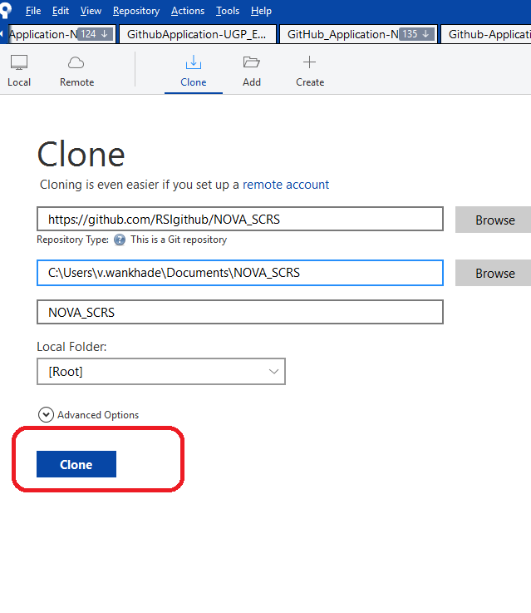

1. Repository cloning will start.
2. Cloning will take some time it depends upon the size of folder.
3. Once the cloning is finished all the data on the repository can be accessed in the GITHUB folder on the local drive.

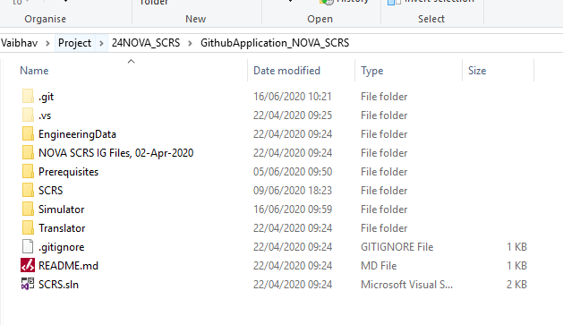

1. We can create different of repository for various different projects.



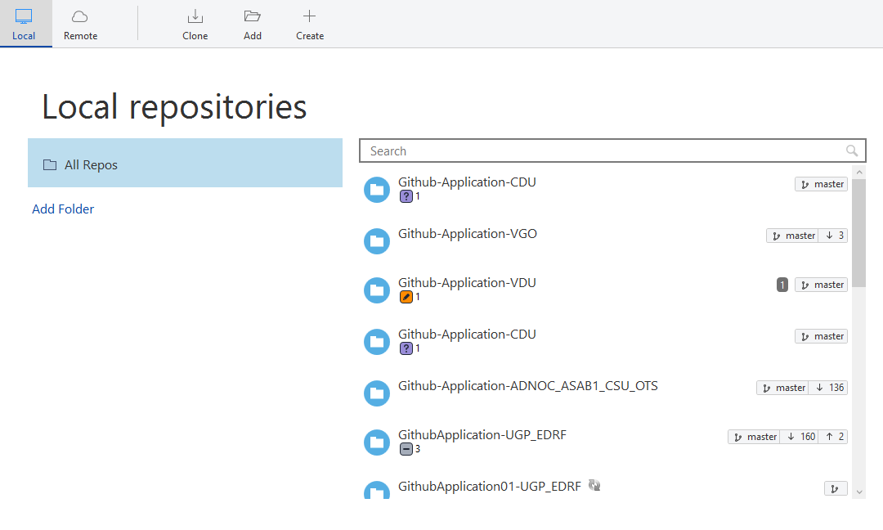

1. Also we can see all repository in Github application as well.

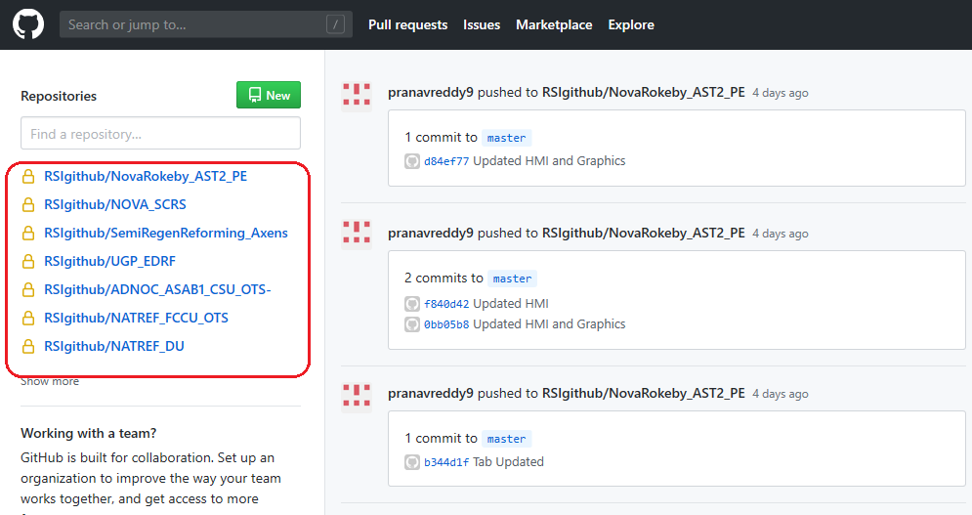

* **How to operate/use the Source tree**

1. **On top bar of source tree you can see the options for commit, push, pull, fetch, branch, merge, stash, discard, tag.**

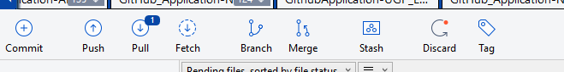

1. **Mostly useful is commit, push and pull only. generally we are not using rest.**
2. **In bottom bar there are three tabs file status, log/history, and search.**

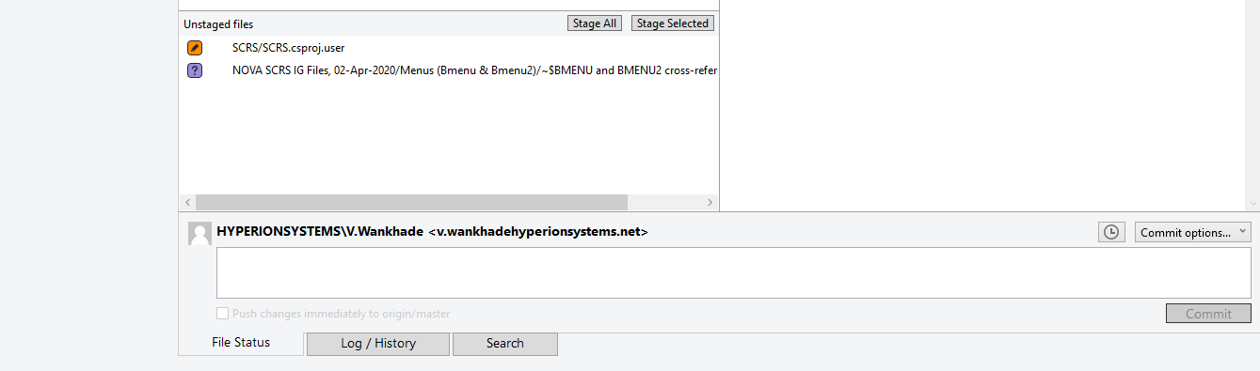

1. **File status showing that on which file you did the changes.**

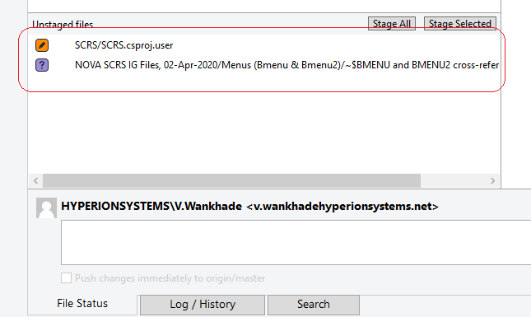

1. **After doing changes in a particular file you can stage single file or stage all files is up to user.**

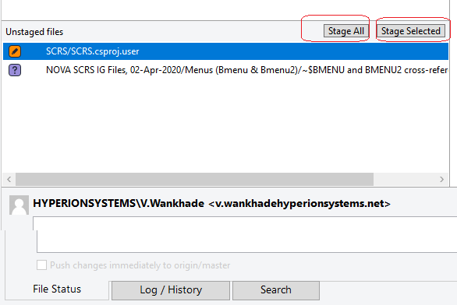

1. **After doing stage, file will come to stage window.**

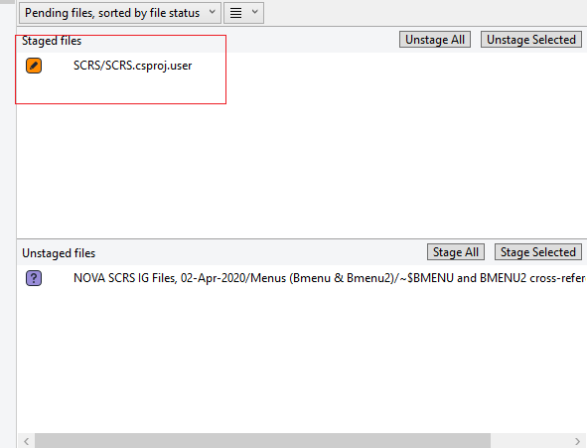

1. **After clicking on unstaged file you can see all the changes you are done with.**

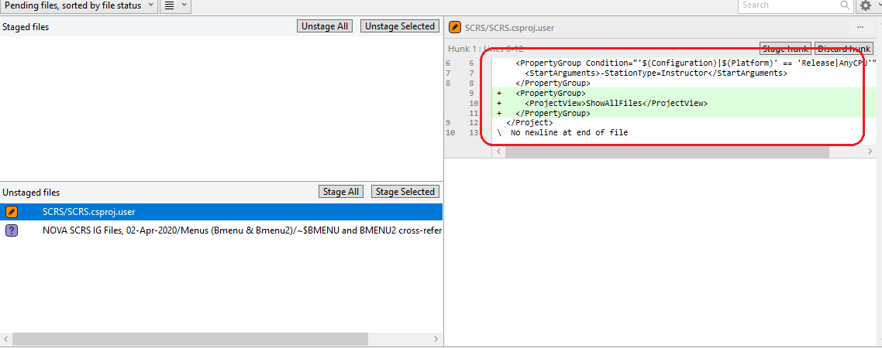

1. **If you are ready for commit. Write in comets in comment part and do commit**

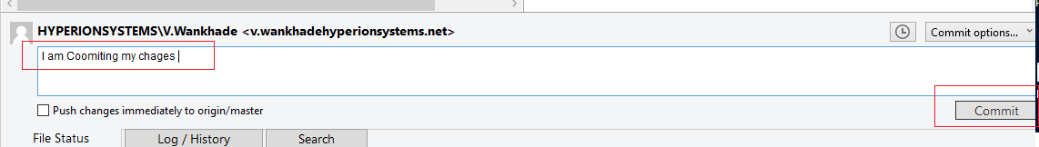

1. **After committing the changes you need to push your changes on master application, by clicking push button.**

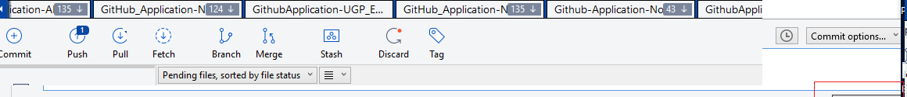

1. **Before push if your window is showing that there is something in pull action then first pull it and then push your changes.**

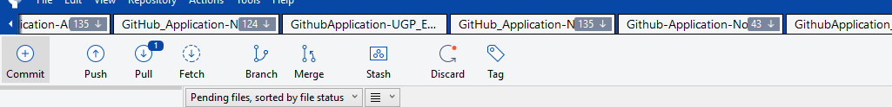

1. **You can remove or discard the changes as well if you don’t want to commit, Just right click on unstaged file you can discard or remove.**

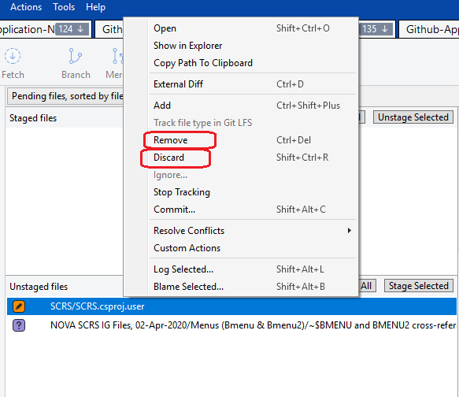

1. **In Log history tab you can see all the commits done by different engineers for your reference.**

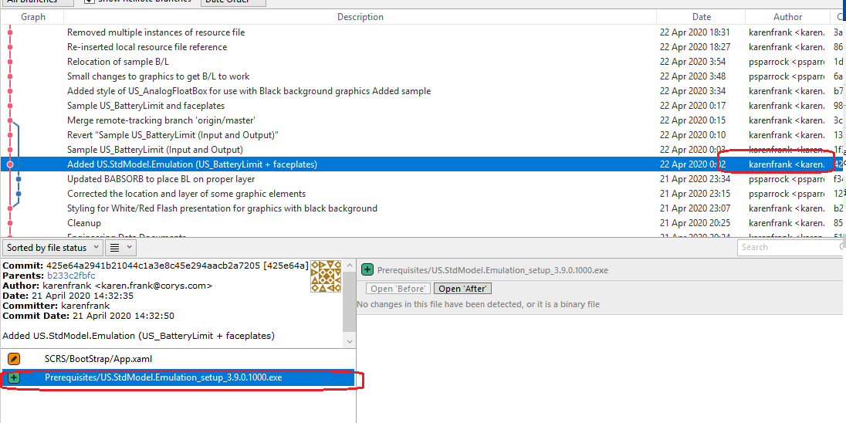

1. **You can track synchronization history and committing activity by tracking line.**

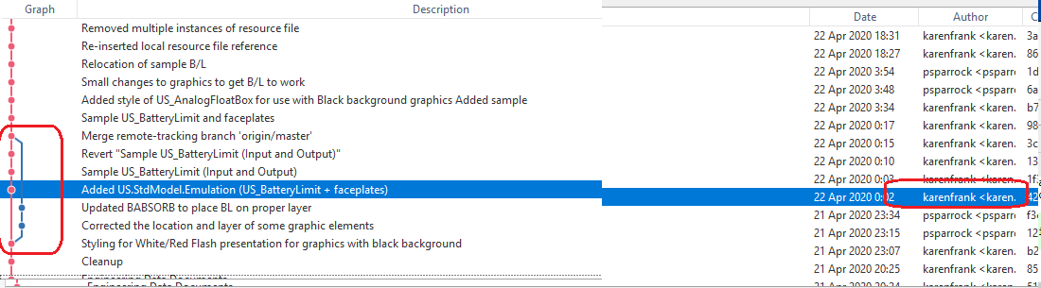

1. **And you can search your all commits in search option tab as well.**

