Project 1: Pick and Place sorting with a fixed based manipulator
Description: In this project, you will control a fixed 7-DoF Jaco v2 manipulator to pick and place multiple objects from a table into color-coded bins. The provided simulation world contains a static table, several movable objects, and three sorting bins placed at predefined positions.
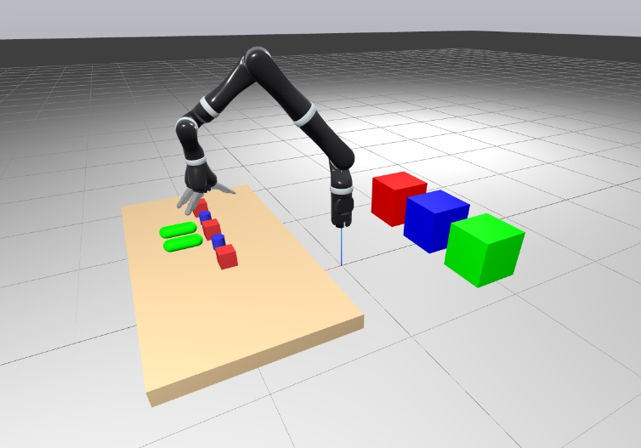.
Objective: Design and implement a control framework that enables the manipulator to autonomously identify, grasp, and place each object in the correct bin as efficiently as possible. The solution should demonstrate consistent performance across different randomized initial object layouts.
Provided material: pick_and_place_sorting_world.sdf containing:
- Jaco v2 manipulator with a 3-finger end-effector
- One static table and seven dynamic objects
- Three sorting bins and a ground plane
Implementation guidelines:
- Load and visualize the SDF world in Drake using the MultibodyPlant and MeshCat visualizer.
- Compute feasible grasp and placement poses for each object using inverse kinematics.
- Generate joint-space trajectories for pick-and-place sequences.
- Execute and visualize the full sorting task.
- Optionally, randomize initial object positions to assess robustness.

Contact person: xx

Project 2 – Robot drawing using a fixed manipulator with a pen-shaped end-effector
Description: This project uses a Franka Emika Panda robot equipped with a pen-shaped end-effector to draw shapes or initials on a fixed whiteboard. The task requires controlling both position and interaction forces during contact.
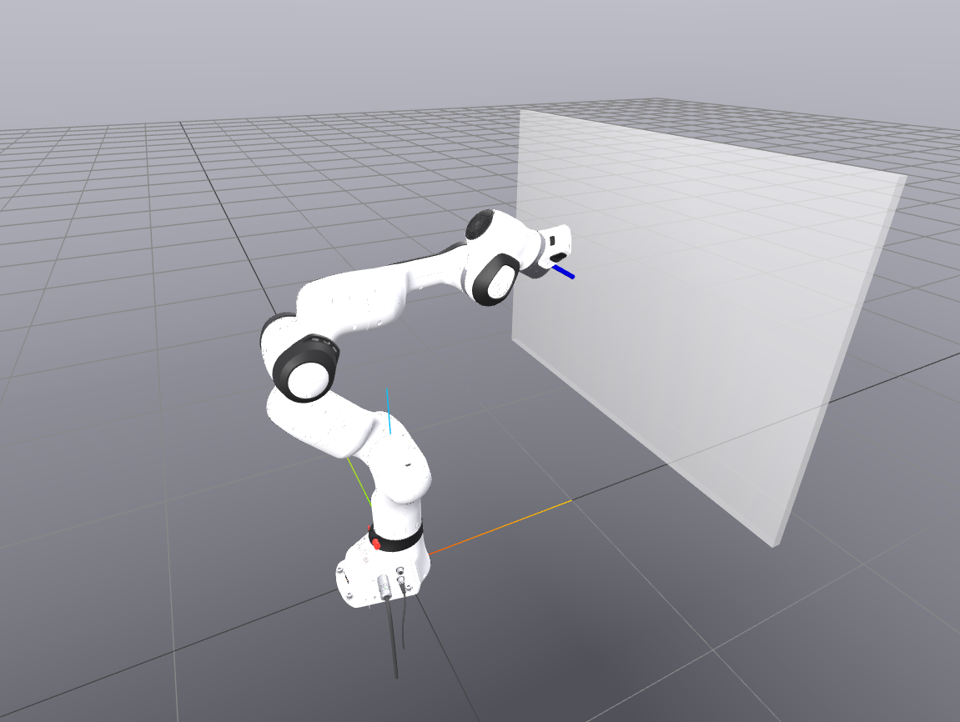
Objective: Develop a control framework that maintains a stable contact with the whiteboard while accurately following a desired drawing path. Students may choose the path to represent letters, shapes, or trajectories of their choice.
Provided material: drawing_robot_world.sdf containing:
- A Franka Emika Panda robot with a pen-shaped end-effector
- A fixed whiteboard mounted on a wall
Implementation guidelines:
- Load and visualize the SDF world.
- Define a desired end-effector trajectory in task space.
- Implement a hybrid position/force controller that maintains a constant normal force on the whiteboard.
- Validate and visualize the drawn paths either in real-time or from logged data.
Notes
- You are not required to modify the SDF structure.
- You can do a positon and force control at the end effector interaction to maintain a desired normal force at the contact while having a good tracking during the drawing.
- Visualization can either be done during the simulation or after the simulation using the logged measurements from the position in a plot.

Contact person: xx

Project 3 – Diffrential drive robot trajectory tracking
Description: You are given a Clearpath Husky A200 mobile robot tasked with following a circular trajectory on a flat surface. The Husky is a non-holonomic, differentially driven robot, requiring careful mapping between wheel velocities and base motion.
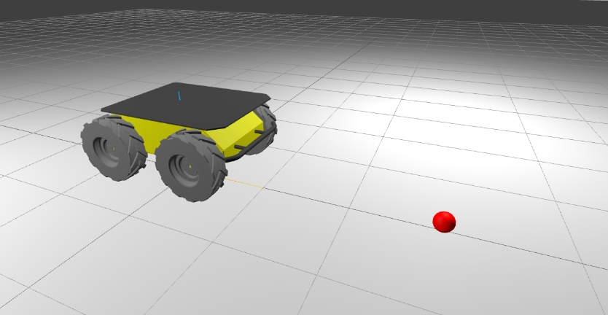
Objective: Design a trajectory tracking controller that ensures stable and accurate tracking of the target trajectory using wheel velocity control.
Provided material and expected implementation: diffrentialdrive_robot_tracking_world
.sdf containing a Clearpath Husky A200 robot and a flat plane.
Implementation guidelines:
- Load and visualize the simulation world.
- The Husky robot is non-holonomic and differentially driven, meaning its base motion is constrained by wheel actuation. Students must reason about the mapping between wheel velocities and robot base pose, designing a feedback controller that reacts dynamically to the moving reference by commanding the torque at each of the wheels.
- Design a feedback controller (PID or Lyapunov-based) to first achiev a desired position
- Then do tracking of a circular path the trajectory.
- Simulate the motion, visualize the robot’s path, and evaluate tracking accuracy using position and velocity metrics.
Notes
- You are not required to modify the SDF structure.
- You can do a positon and force control at the end effector interaction to maintain a desired normal force at the contact while having a good tracking during the drawing.
- Visualization can either be done during the simulation or after the simulation using the logged measurements from the position in a plot.

Contact person: xx

Project 4 – Mobile manipulator boxes stacking.
Description: This project involves a Franka Emika manipulator mounted on a base that can translate linearly along the x-axis. Multiple cubic objects are placed on a table near the robot’s workspace.
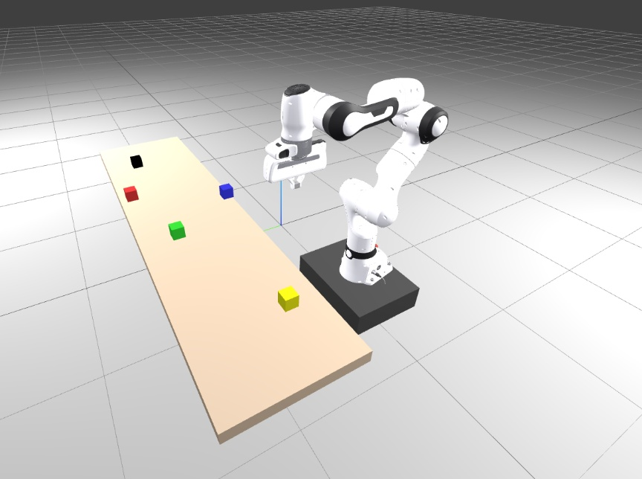
Objective:
Develop a control strategy that coordinates the manipulator and the base motion to sequentially pick and stack all objects into a vertical tower. The system should maintain stable motion coordination between the arm and the base.
Provided material: setpoint_regulation_mobile_manipulation.sdf containing:
- A Franka manipulator fixed to a linear base
- A table with five movable objects
Implementation guidelines:
- Load and visualize the world in Drake.
- Implement coordinated control of the base (for positioning) and the arm (for grasping and stacking).
- Generate a sequence for stacking all objects while maintaining smooth transitions.
- Validate the stacking task visually and verify that all objects remain stable.
Notes
- You can randomize the position of the objective at startup in your py script.
- You can add more objects to your sdf

Contact person: xx

Project 5 – Obstacle avoidance with Omnidirectional mobile robot
Description: In this project, you will control an omnidirectional mobile robot navigating through a cluttered environment toward a goal pose highlighted in red. The robot can move freely in the plane (x, y, yaw), and must avoid collisions with static obstacles.
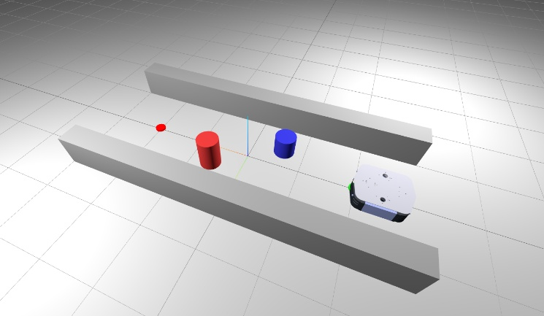
Objective:
Design and implement a motion planning and control framework that enables the robot to navigate safely and efficiently to the goal while avoiding all obstacles.
Provided material: setpoint_regulation_mobile_manipulation.sdf containing:
- An omnidirectional mobile robot
- A set of cylindrical and wall-like obstacles
Expected Implementation
- Load and visualize the SDF world using Drake.
- Implement local navigation strategy and a control strategy in simulation while maintaining obstacle clearance.
- Test your approach in multiple randomized obstacle configurations.
Notes
- Take inspiuraiton form the sdf file to vary the scene and validate your algorithms in those as well.
- You can also add more objects to your sdf

Contact person: xx

