Report

Homework 2

0550193 陳昱瑋

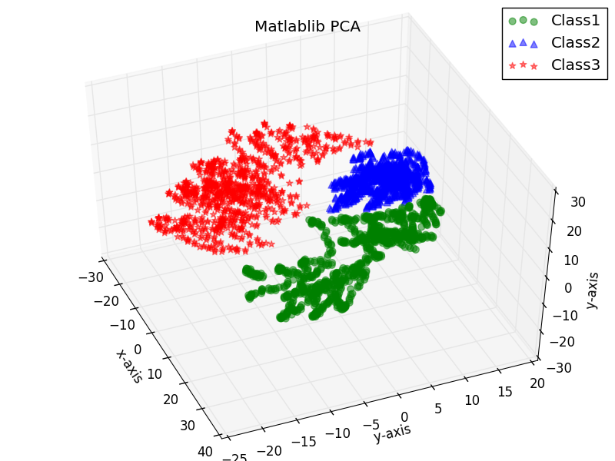2017/4/11

X_train is a 3000x900 matrix (for 3 class, 1000 for each class). Every row contains the gray-level picture we want to classified.

T_train is a 3000x3 matrix. 3000 rows of data and 3 classes of objects.

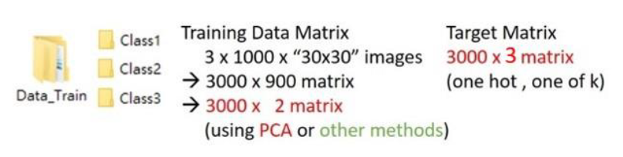Phi_train is a 3000x2 matrix according to the spec

What you can notice that the class 1 is sparser than class 2 or 3. We can let class 1 be the bias dataset to have better solution? I will verify the idea in bias-training part

**Probabilistic Generative Model**

To get generative mode, we need prior and conditional probability to get the posterior distribution.

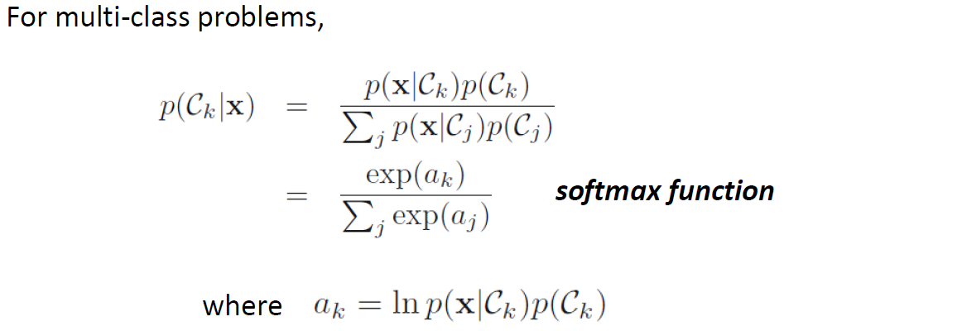

Supposed conditional density is Gaussian, and the COV-matrix is identical across classes, maximum likelihood of $p(x|C_{k})$ can be written as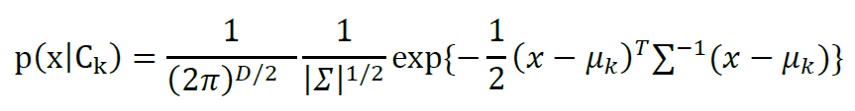

. we can simplify the equation with formula in class note p.20

$p\left(C_{k} | x\right)=\frac{p\left({x|C}_{k}\right)p(C_{k})}{\sum_{j}{p\left({x|C}_{k}\right)p(C_{k})}}= \frac{exp⁡(a_{k})}{\sum_{j}{exp⁡(a_{k})}}$, where

For two classes case For multi-class case

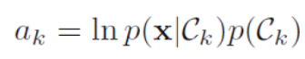

* Result

N: 3000(# of datasets)

M: 900(# of feature of bmp graph; picture vector)

Training dataset number: 2400

Testing dataset number: 600

If I use all the features (900) I have to plot out the decision region, the plot will be like the first page has shown. As for the accuracy calculation, instead of doing error calculate, I chose to cross validation my model by taking out 1/5 of data and do it for five iterations to get average performance.

* For 900 features:

|  |  |  |  |  |  |  |
| --- | --- | --- | --- | --- | --- | --- |
| Cross | 0 | 1 | 2 | 3 | 4 | Average |
| Class1 | 100.0 | 100.0 | 100.0 | 100.0 | 100.0 | 100.0 |
| Class2 | 100.0 | 100.0 | 100.0 | 100.0 | 100.0 | 100.0 |
| Class3 | 100.0 | 100.0 | 100.0 | 100.0 | 100.0 | 100.0 |

* For 5 features: (PCA)

|  |  |  |  |  |  |  |
| --- | --- | --- | --- | --- | --- | --- |
| Class | 0 | 1 | 2 | 3 | 4 | Average |
| Class1 | 87.5 | 84.0 | 92.0 | 90.5 | 83.5 | 87.5 |
| Class2 | 10.0 | 5.0 | 4.0 | 3.5 | 8.5 | 6.2 |
| Class3 | 72.5 | 79.5 | 74.5 | 82.5 | 82.5 | 78.3 |

* For 2 features: (PCA)

|  |  |  |  |  |  |  |
| --- | --- | --- | --- | --- | --- | --- |
| Class | 0 | 1 | 2 | 3 | 4 | Average |
| Class1 | 0.0 | 0.0 | 0.0 | 0.0 | 0.0 | 0 |
| Class2 | 19.5 | 15.5 | 21.5 | 21.5 | 22.5 | 20.1 |
| Class3 | 97.5 | 98.0 | 98.0 | 98.5 | 98.5 | 98.1 |

* Discussion

The feature of 2 will make the result a little bit strange for class 1. I think this is because class 1 has sparser distribution according to the graph on the first page. The spacer distribution might cause serious mis-classified for generative model but not a serious issue in discriminative model. That’s the thing I found this time.

**Probabilistic Discriminative Model**

Supposed posterior is logistic sigmoid function or soft-max function; therefore, we can get:

$$p\left(C_{k} | Φ\right)= y_{k}\left(Φ\right)= \frac{exp⁡(a_{k})}{\sum_{j}{exp⁡(a_{j})}} , where a_{j}=w_{k}^{T}Φ$$

$$\frac{∂y_{k}}{∂a_{k}}=y_{k}(I_{kj}-y_{j})$$

For two classes case For multi-class case

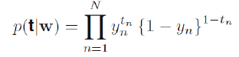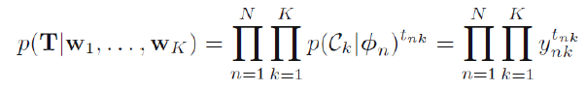

The error function for two / multi- class is

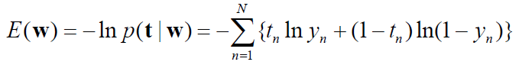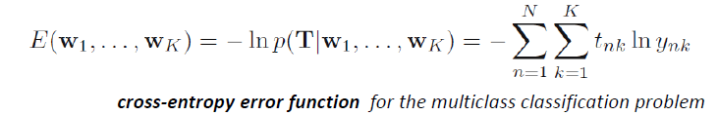

Next, for discriminative case, we are suggested to use Newton-Raphson to get proper w (basically is to iterate until the difference of $w^{(new)}$ and $w^{(old)}$ converged to the expected value.)

$$w^{(new)}= w^{(old)}-H^{-1}∇E(w)$$

N: 3000(# of datasets)

M: 900(# of feature of bmp graph; picture vector)

* Result

|  |  |  |  |  |  |  |  |  |  |  |
| --- | --- | --- | --- | --- | --- | --- | --- | --- | --- | --- |
| Accuracy(Phi) | 2 | 3 | 4 | 5 | 10 | 50 | 100 | 200 | 500 | Average |
| w­­0 | 20.6 | 45.33 | 46.666 | 46.83 | 34.66 | 32.66 | 32.5 | 33.83 | 32.0 | 36.12% |
| No w0 | 41.5 | 42.33 | 40.5 | 41.16 | 32 | 34 | 35 | 38 | 34 | 37.61% |

* Discussion

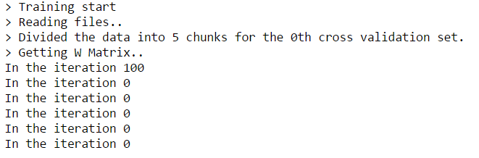I can’t get a converged solution at first for several potential reason

1. 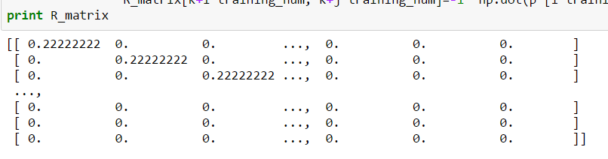R_matrix is too sparse
2. 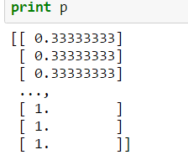For p matrix which store possibility of each class is too small, which might lead to slow convergence.

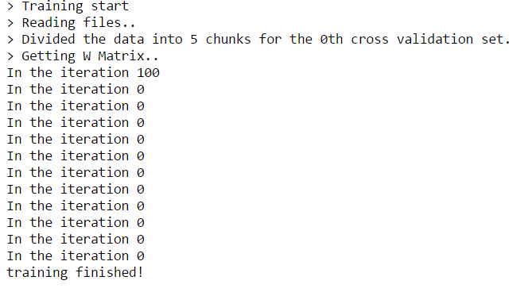After change my approach to R_matrix without divide the number of training set, I have larger R_matrix which will make converge success in this case

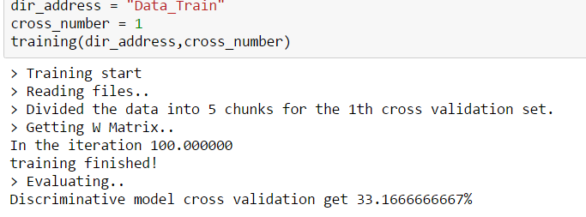Successfully trained the model:

The discriminative model is open form solution which depends heavily on iteration times and computing ability, I didn’t mention that in my case I just iterate for 1000 times and forced to break the loop of computing here. Compare to generative close form, it is suitable for the self-gen data and more applicable for the less-data reality problem.

* **Unbalanced Data training**

As I’ve mention before, the class 1 has sparser dataset than class 2 and class 3. I will shrink the dataset of class 1 and see what would happen.

|  |  |  |  |
| --- | --- | --- | --- |
| generative | Data | Generative(900 features) | Discriminative(3 features) |
| Class 1 | 500 | 50 |  |
| Class 2 | 1000 | 50 |
| Class 3 | 1000 | 100 |
| Total | 2500 | 66.6 | 42.3333333333 |

Therefore, as we can see here for discriminative model improve from 36.12% to 42.33%, and as for generative model it is decreasing for less dataset we trained.