CASE STUDY 1: Population Growth Analysis Using Numerical Methods

Given Data:
Year |  |  |  |  |  |  |  |  |  |  |  |  | Population
2020 |  |  |  |  |  |  |  |  |  |  |  |  | 10,000
2021 |  |  |  |  |  |  |  |  |  |  |  |  | 10,800
2022 |  |  |  |  |  |  |  |  |  |  |  |  | 11,900
2023 |  |  |  |  |  |  |  |  |  |  |  |  | 13,200
2024 |  |  |  |  |  |  |  |  |  |  |  |  | 14,800

STEP 1: Numerical Differentiation (Growth Rate)
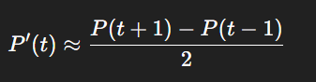
We use central difference formula:
We compute for 2021–2023 only (since endpoints cannot use central difference).

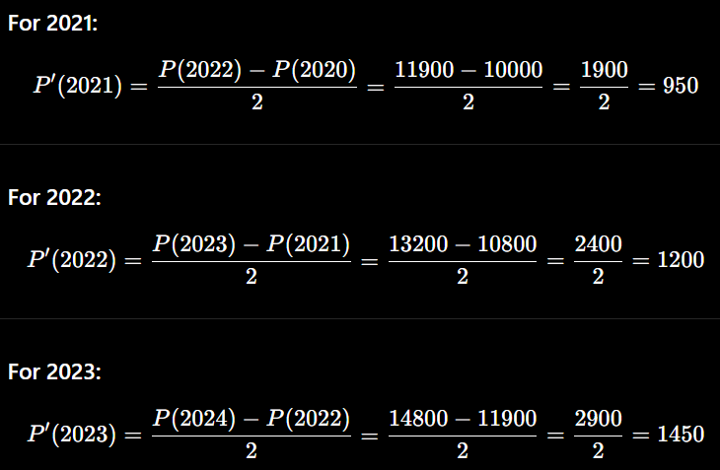
Calculations :

Growth Rate Table:
Year |  |  |  |  |  |  |  |  |  |  | Growth Rate (people/year)
2021 |  |  |  |  |  |  |  |  |  |  | 950
2022 |  |  |  |  |  |  |  |  |  |  | 1200
2023 |  |  |  |  |  |  |  |  |  |  | 1450

STEP 2: Numerical Integration (Total Change)
We use the Trapezoidal Rule:
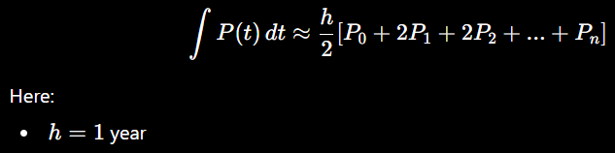

Substitute values:
= ½ [10000+2(10800)+2(11900)+2(13200)+14800]

Compute step-by-step:
- 2(10800)=216002(10800) = 216002(10800)=21600
- 2(11900)=238002(11900) = 238002(11900)=23800
- 2(13200)=264002(13200) = 264002(13200)=26400
Now sum:
10000+21600+23800+26400+14800=96600

Final Answer:
½ ​(96600)=48,300
: Estimated total population accumulation (area under curve) = 48,300

STEP 3: Visualization (What to Plot)
You should create:

1. Population vs Time
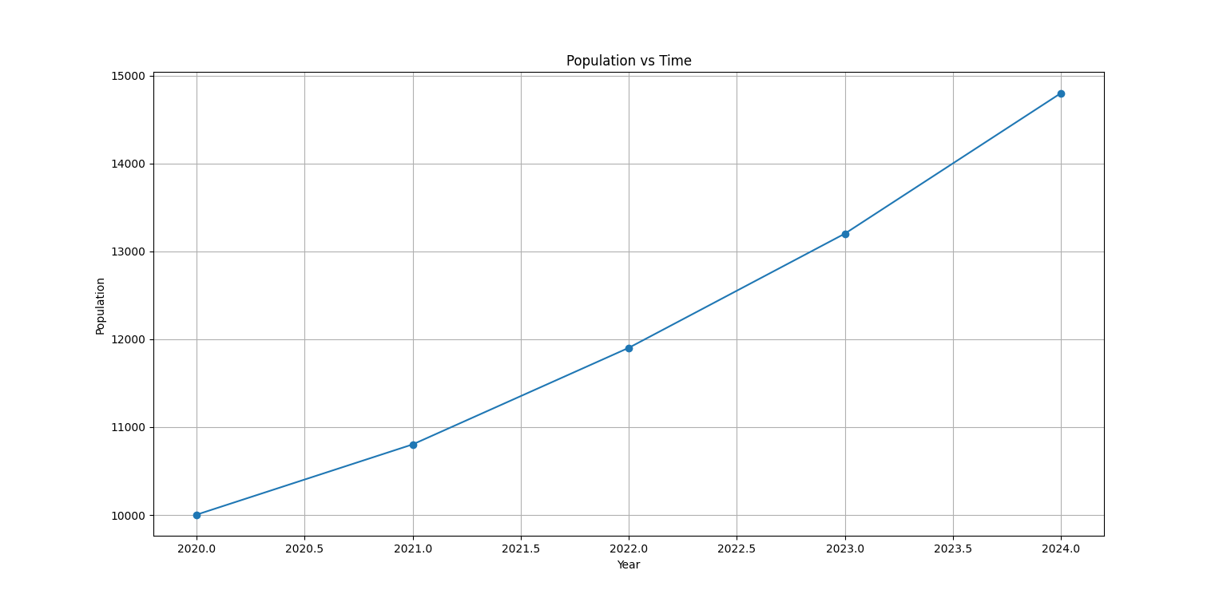
- Increasing curve (not straight line)

2. Growth Rate vs Time
- Values: 950 → 1200 → 1450
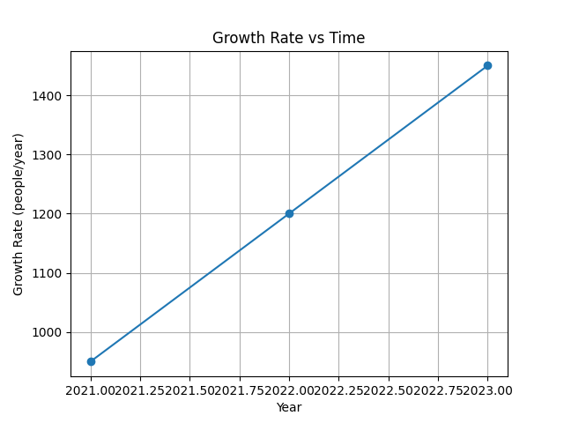
- Clearly increasing trend

CODE:
import matplotlib.pyplot as plt

# Given data
years = [2020, 2021, 2022, 2023, 2024]
population = [10000, 10800, 11900, 13200, 14800]

# Compute growth rates using central difference
growth_years = [2021, 2022, 2023]
growth_rates = []

for i in range(1, len(population) - 1):
rate = (population[i + 1] - population[i - 1]) / 2
growth_rates.append(rate)

# -------------------------------
# Graph 1: Population vs Time
# -------------------------------
plt.figure()
plt.plot(years, population, marker='o')
plt.title("Population vs Time")
plt.xlabel("Year")
plt.ylabel("Population")
plt.grid()

plt.show()

# -------------------------------
# Graph 2: Growth Rate vs Time
# -------------------------------
plt.figure()
plt.plot(growth_years, growth_rates, marker='o')
plt.title("Growth Rate vs Time")
plt.xlabel("Year")
plt.ylabel("Growth Rate (people/year)")
plt.grid()

plt.show()

STEP 4: Analysis Questions

1. When did growth accelerate most?
Growth increases each year:
- 950 → 1200 → 1450
Fastest acceleration is 2023

2. Is growth linear or exponential?
Differences between populations:
- 800 (2020–2021)
- 1100 (2021–2022)
- 1300 (2022–2023)
- 1600 (2023–2024)
Increasing differences → NOT linear
Pattern suggests exponential growth

3. Predict population in 2025
We estimate using recent growth trend.
Latest increase:
- 2023 → 2024 = +1600
Growth is increasing (~+300 each year), so estimate:
1600+300=1900
2025=14800+1900=16,700

Final Prediction:
Population in 2025 ≈ 16,700

