Assignment 12
Pre IB
Similar Shapes, Pythagoras and SOHCAHTOA Trigonometry

Please write your solutions on A4 squared or lined paper. You MUST show the stages of your working out and answer all questions. If you hand in work with insufficient working out, I will hand the assignment back to you to do again. Give your answers to 3 significant figures. To be handed in on Thursday the 23th by 5pm. You can get help from me at the study café on Thursdays.

Similar Shapes

1.




A

B

C

D

E

- Prove that triangle ABC and
triangle ADE are similar. You MUST show all stages of your proof. (Note angle ABC is NOT a right angle)

- If AB = 10 cm, DE = 3 cm and AD = 15 cm, find BC. Show working out.

- Triangle ABC has area 9 cm².
Calculate the area of triangle ADE.

- Find x and y.

x

3

4

y

3

5

- Here are two supermarket price tickets.
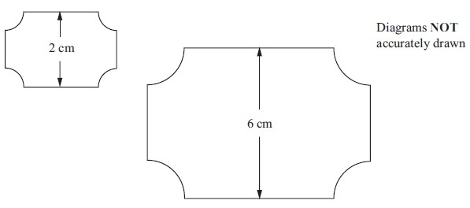
The two supermarket price tickets are mathematically similar.
The area of the smaller ticket is 7 cm².
Calculate the area of the larger ticket.

- The diagram shows two regular hexagons, OABCDE and OFGHIJ.
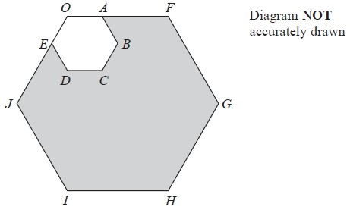

OAF and OEJ are straight lines.
OF = 3 OA.
The area of OABCDE is 4 cm².
Calculate the area of the shaded region.

- Two cups are mathematically similar. The area of the base of the smaller cup is 10 cm² and the area of the base of the larger cup is 15 cm². If the capacity of the smaller cup is 120 ml, what is the capacity of the larger cup?

6.
ABCD and APQR are two similar quadrilaterals.
PQ = 9 cm. BC = 6 cm.
AD = 5 cm.
QR = 12 cm.
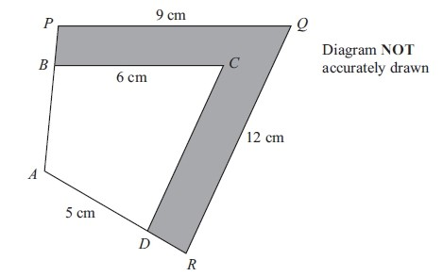
  - Find the length of DC.

  - Find the length of AR.

The area of the quadrilateral ABCD is 32 cm².

  - Calculate the area of the shaded region.

Pythagoras Theorem- Chapter 16

7. Calculate x:

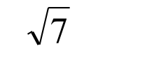
a)
(

b)
(

cm
5

cm
2

x

x

cm
5

cm

(c)
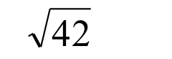

Hint: set up an equation an solve for
x

2
x

5
x

cm

- A rhombus has sides of length 6 cm. One of its diagonals is 10cm long. Find the length of the other diagonal.

- A rhombus has diagonals of length 8 cm and 10 cm. Find its perimeter.

Basic Trigonometry- SOHCAHTOA Chapter 17

- Calculate the following sides to 3 significant figures:

(
)
a

)
(
b

)
c
(

d)
(

31
°

14
cm

x

°
75

cm
19

x



°
52

cm
35

x

m
15

°
25

d

- Calculate the following angles to 3 significant figures:

(a) (b)

10
cm

6
cm

α

7
cm

14
cm

β

- The height of a vertical cliff is 450 m. The angle of elevation from a ship to the top of the cliff is 23°. The ship is x metres from the bottom of the cliff.
  - Draw a diagram to show this information.
  - Calculate the value of x.

- Coming in to land, a small aeroplane starts its decent at a vertical height of h metres above the horizontal land. The aeroplane descends along a straight line at a constant angle of depression of 12°. From its starting descent to touching down, the aeroplane travels through a distance of 6000 m.

- Draw a diagram illustrating the descent of the plane.

- Calculate the vertical height, h, at which the aeroplane starts its descent.

At the start of its decent, the aeroplane is vertically above a point P on the ground. It touches down at a point T.

- Calculate the horizontal distance PT.

