Animal Disease Surveillance, AFBI

Agri-Food and Biosciences Institute

09 October, 2018

# 

# Introduction

Some text here

# Cattle Diseases

## Neonatal Calves (0-1 months)

Table 1 The conditions most frequently diagnosed on *post-mortem* examinations of neonatal calves (0-1 months) in 2017, (n= 610 )

|  |  |  |
| --- | --- | --- |
| Category | Count | Percentage |
| Enteric infections | 254 | 41.6 |
| Respiratory infections | 89 | 14.6 |
| Nutritional /metabolic conditions | 50 | 8.2 |
| Septicaemia / toxaemia | 47 | 7.7 |
| Navel ill /Joint ill | 43 | 7.0 |
| Other diagnoses | 36 | 5.9 |
| Salmonellosis | 23 | 3.8 |
| Diagnosis not reached | 16 | 2.6 |
| CVS/circulatory | 10 | 1.6 |
| GIT torsion /obstruction | 10 | 1.6 |
| Peritonitis | 6 | 1.0 |
| CNS | 6 | 1.0 |
| BNP | 5 | 0.8 |
| Hereditary and developmental abnormality | 5 | 0.8 |
| Fractures / skeletal abnormalities / calving injuries | 4 | 0.7 |
| Urinary tract | 3 | 0.5 |
| GIT ulcers / perforations | 3 | 0.5 |

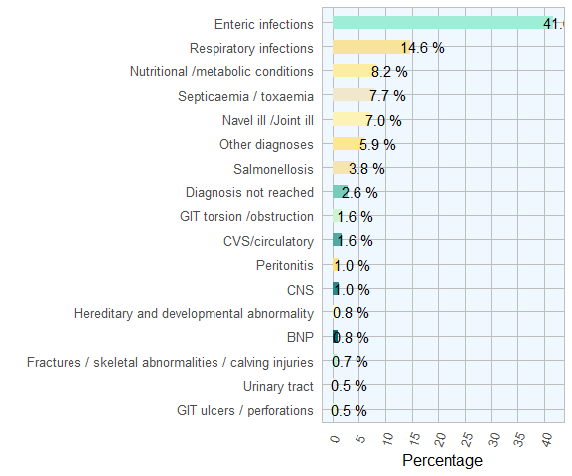

Figure 1 The conditions most frequently diagnosed on post-mortem examinations of neonatal calves (0-1 months) by AFBI during 2017 (n= 610 )

## Calves (1-5 months)

Table 2 The conditions most frequently diagnosed on *post-mortem* examinations of calves (1-5 months) in AFBI during 2017 (n= 369 )

|  |  |  |
| --- | --- | --- |
| Category | Count | Percentage |
| Respiratory infections | 186 | 50.4 |
| Enteric infections | 35 | 9.5 |
| Diagnosis not reached | 19 | 5.2 |
| Nutritional / metabolic conditions | 18 | 4.9 |
| GIT torsions /obstruction | 17 | 4.6 |
| Peritonitis | 15 | 4.1 |
| Other diagnoses | 14 | 3.8 |
| Septicaemia / toxaemia | 13 | 3.5 |
| Clostridial disease | 11 | 3.0 |
| Navel ill / Joint ill | 11 | 3.0 |
| Cardiovascular conditions | 9 | 2.4 |
| Urinary tract conditions | 6 | 1.6 |
| CNS conditions | 6 | 1.6 |
| GIT ulcer / perforation | 5 | 1.4 |
| Poisoning | 2 | 0.5 |
| BVD /Mucosal disease | 2 | 0.5 |

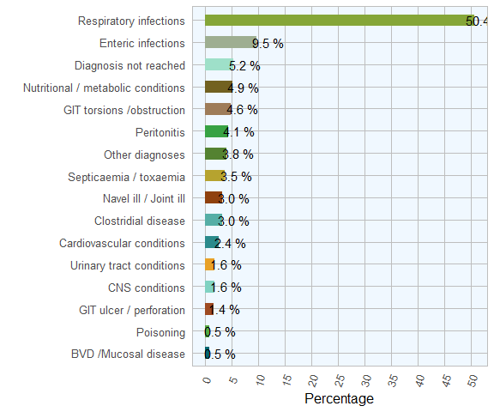

Figure 2 The conditions most frequently diagnosed on *post-mortem* examinations of calves (1-5 months) by AFBI during 2017 (n= 369 )

## Calves (6-12 months)

Table 3 The conditions most frequently diagnosed on *post-mortem* examinations of calves (6-12 months) in AFBI during 2017 (n= 163 )

|  |  |  |
| --- | --- | --- |
| Category | Count | Percentage |
| Respiratory tract infections | 80 | 49.1 |
| Clostridial disease | 18 | 11.0 |
| Diagnosis not reached | 17 | 10.4 |
| Nutritional / metabolic conditions | 11 | 6.8 |
| Enteric infections | 8 | 4.9 |
| Other diagnoses | 6 | 3.7 |
| urinary tract conditions | 3 | 1.8 |
| GIT ulcer, perforation, for body | 3 | 1.8 |
| liver disease | 3 | 1.8 |
| Poisoning | 3 | 1.8 |
| GIT torsion / obstruction | 2 | 1.2 |
| Cardiac conditions | 2 | 1.2 |
| BVD / Mucosal disease | 2 | 1.2 |
| CNS conditions | 2 | 1.2 |
| Skeletal conditions | 2 | 1.2 |
| peritonitis | 1 | 0.6 |

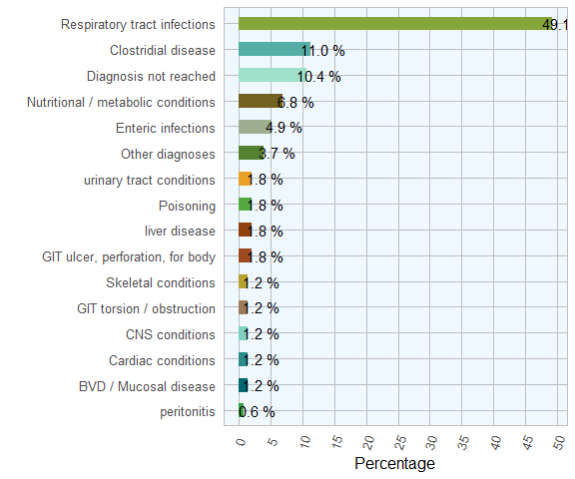

Figure 3 The conditions most frequently diagnosed on *post-mortem* examinations of calves (6-12 months) by AFBI during 2017 (n= 163 )

## Adults (> 12 months)

Table 4 The conditions most frequently diagnosed on *post-mortem* examinations of adults (>12 months) by AFBI during 2017 (n= 464 )

|  |  |  |
| --- | --- | --- |
| Category | Count | Percentage |
| Respiratory infections | 95 | 20.5 |
| Other diagnoses | 56 | 12.1 |
| Diagnosis not reached | 55 | 11.8 |
| Cardiac/ circulatory system | 50 | 10.8 |
| Clostridial disease | 39 | 8.4 |
| Nutritional /metabolic conditions | 36 | 7.8 |
| Liver disease | 29 | 6.2 |
| GIT ulceration / perforation / foreign body | 24 | 5.2 |
| Enteric infections | 19 | 4.1 |
| Reproductive tract infections/Mastitis | 12 | 2.6 |
| Intestinal or gastric torsion /obstruction | 10 | 2.2 |
| Peritonitis | 10 | 2.2 |
| Urinary tract conditions | 9 | 1.9 |
| Poisoning | 9 | 1.9 |
| Tumour | 6 | 1.3 |
| CNS infections | 5 | 1.1 |

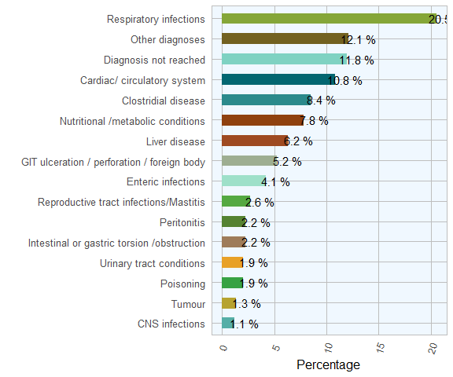

Figure 4 The conditions most frequently diagnosed on *post-mortem* examinations of adults (>12 months) by AFBI during 2017, (n= 464 )

# Ovine Diseases

Table 5 The most commom diagnosic groups on *post-mortem* examinations of ovine by AFBI in 2017 (n= 559 )

|  |  |  |
| --- | --- | --- |
| Category | Count | Percentage |
| Parasitic Disease | 188 | 33.6 |
| Enteritis | 158 | 28.3 |
| Respiratory Disease | 73 | 13.1 |
| Septicemia | 36 | 6.4 |
| Clostridial diseases | 32 | 5.7 |
| CNS | 27 | 4.8 |
| Metabolic | 23 | 4.1 |
| Poisoning | 22 | 3.9 |

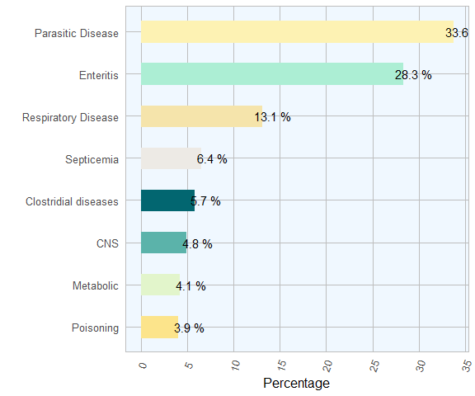

Figure 5 The conditions most frequently diagnosed on *post-mortem* examinations of ovine carcasses in 2017(n= 559 )

Table 6 The frequency of the most commom diagnosic group on *post-mortem* examinations of ovine carcasses by during 2017 (n= 559 )

|  |  |  |  |  |
| --- | --- | --- | --- | --- |
| Category | Disease | Count | Pct within group | Pct |
| Septicemia | Pasteurella septicaemia | 18 | 50.0 | 3.2 |
| Septicemia | Colisepticaemia | 9 | 25.0 | 1.6 |
| Septicemia | Septicaemia NOS | 5 | 13.9 | 0.9 |
| Septicemia | Systemic pasteurellosis | 3 | 8.3 | 0.5 |
| Septicemia | Navel-ill / joint-ill | 1 | 2.8 | 0.2 |
| Respiratory Disease | Pulmonia Adenomatosis - Jaagsiekte | 29 | 39.7 | 5.2 |
| Respiratory Disease | P Haemolytica | 18 | 24.7 | 3.2 |
| Respiratory Disease | Pneumonis Nos | 10 | 13.7 | 1.8 |
| Respiratory Disease | Parasitic pneumonia | 6 | 8.2 | 1.1 |
| Respiratory Disease | Bronchopneumonia | 3 | 4.1 | 0.5 |
| Respiratory Disease | Laryngael Chondritis | 3 | 4.1 | 0.5 |
| Respiratory Disease | Fibrinous Pleurisy | 2 | 2.7 | 0.4 |
| Respiratory Disease | Necrotising Laryngitis | 1 | 1.4 | 0.2 |
| Respiratory Disease | Viral Pneumonia | 1 | 1.4 | 0.2 |
| Poisoning | Poisoning DT pieris | 14 | 63.6 | 2.5 |
| Poisoning | Poisoning DT copper | 4 | 18.2 | 0.7 |
| Poisoning | Poisoning DT plant NOS | 2 | 9.1 | 0.4 |
| Poisoning | Poisoning DT rhododendron | 2 | 9.1 | 0.4 |
| Parasitic Disease | PGE Nos | 69 | 36.7 | 12.3 |
| Parasitic Disease | Chronic Fascioliasis | 50 | 26.6 | 8.9 |
| Parasitic Disease | Coccidiosis | 24 | 12.8 | 4.3 |
| Parasitic Disease | PGE- Nematodiriasis | 24 | 12.8 | 4.3 |
| Parasitic Disease | Acute Fascioliasis | 21 | 11.2 | 3.8 |
| Metabolic | Acidosis | 10 | 43.5 | 1.8 |
| Metabolic | Twin lamb disease | 7 | 30.4 | 1.2 |
| Metabolic | Hypocalcaemia | 3 | 13.0 | 0.5 |
| Metabolic | Pregnancy toxaemia | 2 | 8.7 | 0.4 |
| Metabolic | Hypomagnesaemia | 1 | 4.3 | 0.2 |
| Enteritis | PGE – NOS | 69 | 43.7 | 12.3 |
| Enteritis | Coccidiosis | 24 | 15.2 | 4.3 |
| Enteritis | PGE – nematodiriasis | 24 | 15.2 | 4.3 |
| Enteritis | Diarrhoea NOS | 10 | 6.3 | 1.8 |
| Enteritis | Enteritis NOS | 8 | 5.1 | 1.4 |
| Enteritis | Abomasitis | 6 | 3.8 | 1.1 |
| Enteritis | Colibacillosis – enteric | 3 | 1.9 | 0.5 |
| Enteritis | Colienteritis | 3 | 1.9 | 0.5 |
| Enteritis | Cryptosporidiosis | 2 | 1.3 | 0.4 |
| Enteritis | Johne’s disease | 2 | 1.3 | 0.4 |
| Enteritis | Perforated intestine | 2 | 1.3 | 0.4 |
| Enteritis | Watery mouth | 2 | 1.3 | 0.4 |
| Enteritis | Colibacillosis enteric – K99 positive | 1 | 0.6 | 0.2 |
| Enteritis | Red gut | 1 | 0.6 | 0.2 |
| Enteritis | Tapeworm infestation | 1 | 0.6 | 0.2 |
| CNS | Encephalitis DT Listeria sp | 11 | 40.7 | 2.0 |
| CNS | Meningitis / encephalitis | 6 | 22.2 | 1.1 |
| CNS | Listeriosis | 4 | 14.8 | 0.7 |
| CNS | Cerebrocortical necrosis | 3 | 11.1 | 0.5 |
| CNS | Encephalitis NOS | 2 | 7.4 | 0.4 |
| CNS | Brain hemorrhage | 1 | 3.7 | 0.2 |
| Clostridial diseases | Pulpy kidney diseases | 12 | 37.5 | 2.1 |
| Clostridial diseases | Pulpy kidney | 11 | 34.4 | 2.0 |
| Clostridial diseases | Black disease | 4 | 12.5 | 0.7 |
| Clostridial diseases | Clost Dis NOS | 3 | 9.4 | 0.5 |
| Clostridial diseases | Enterotoxaemia | 2 | 6.2 | 0.4 |

## Diagnoses by Group

### Septicaemia

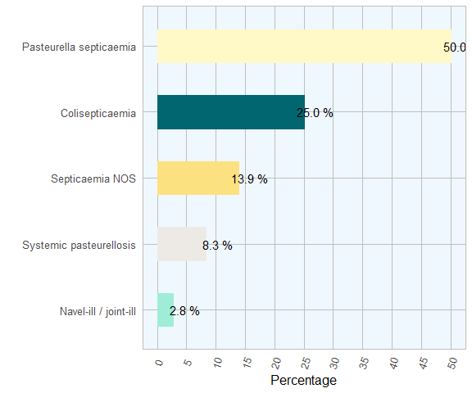

Figure 6 The septicaemic conditions most frequently diagnosed on post-mortem examinations of ovine by AFBI during 2017(n= 36 )

### Respiratory Disease

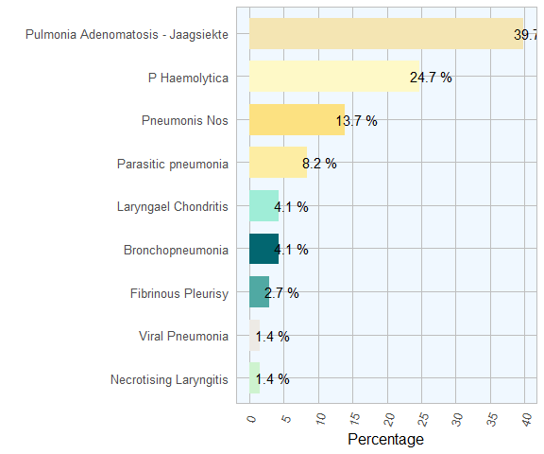

Figure 7 The respiratory conditions most frequently diagnosed on post-mortem examinations of ovine by AFBI during 2017 (n= 73 )

### Poisoning

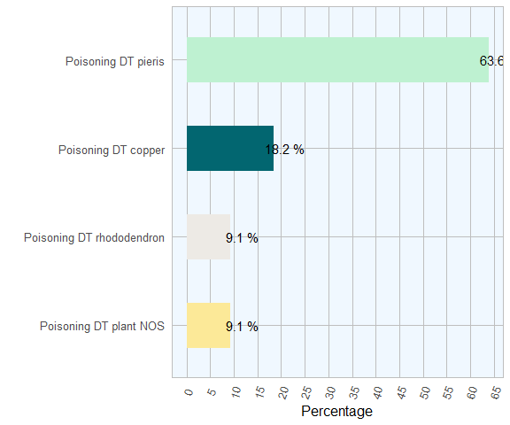

Figure 8 The poisoning agents most frequently diagnosed on post-mortem examinations of ovine by AFBI during 2017 (n= 22 )

### Parasitic Disease

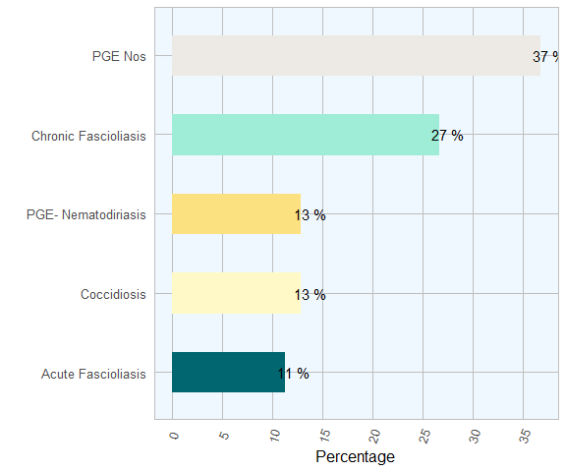

Figure 9 The parasitic conditions most frequently diagnosed on post-mortem examinations of ovine by AFBI during 2017 (n= 188 )

### Metabolic

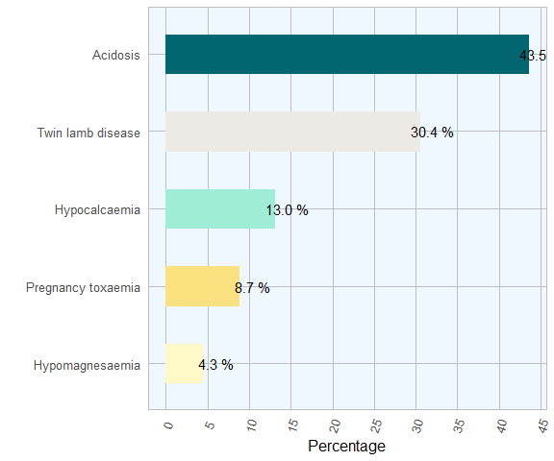

Figure 10 The metabolic conditions most frequently diagnosed on post-mortem examinations of ovine by AFBI during 2017(n= 23 )

### Enteritis

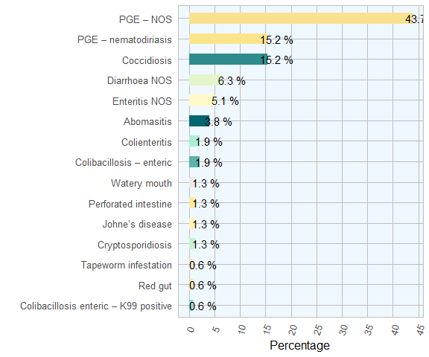

Figure 11 The enteric conditions most frequently diagnosed on post-mortem examinations of ovine by AFBI during 2017 (n= 158 )

### CNS

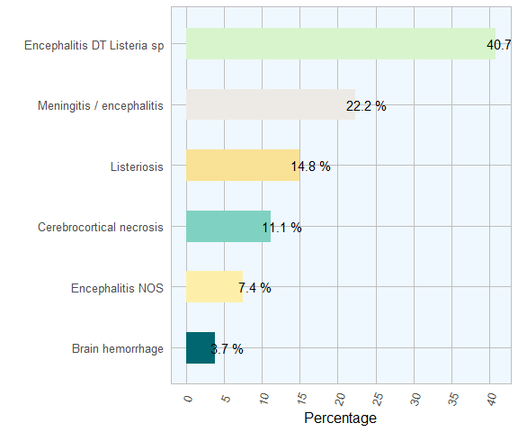

Figure 12 The CND conditions most frequently diagnosed on post-mortem examinations of ovine by AFBI during 2017 (n= 27 )

### Clostridial diseases

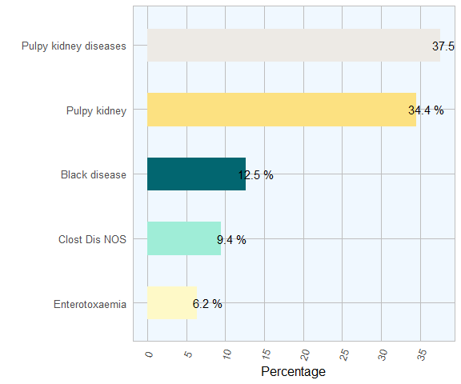

Figure 13 The clostridial diseases most frequently diagnosed on post-mortem examinations of ovine by AFBI during 2017(n= 32 )

# Bovine Respiratory Disease (BRD)

## Diagnoses by Group

Table 7 The most commom diagnosic groups on *post-mortem* examinations of bovine respiratory disease by AFBI during 2017 (n= 391 )

|  |  |  |
| --- | --- | --- |
| Category | Count | Percentage |
| Bacterial | 220 | 56.3 |
| Miscellaneous | 135 | 34.5 |
| Viral | 36 | 9.2 |

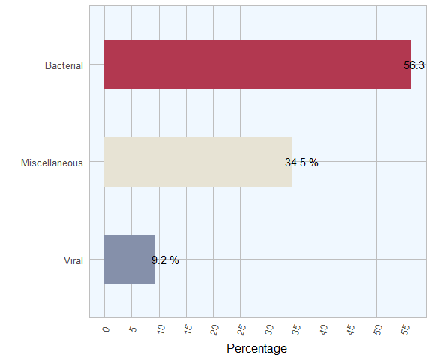

Figure 14 The most commom diagnosic groups on *post-mortem* examinations of bovine respiratory disease by AFBI during 2017 (n= 391 )

### Bovine Respiratory Disease Diagnoses

Table 8 Relative frequency of diagnoses in bovine respiratory disease recorded by AFBI during 2017, (n= 391 )

|  |  |  |
| --- | --- | --- |
| Category | Count | Percentage |
| PNEUMONIA DT MYCOPLASMA BOVIS | 90 | 23.0 |
| PNEUMONIA NOS | 70 | 17.9 |
| PNEUMONIA DT P MULTOCIDA | 45 | 11.5 |
| PNEUMONIA A PYOGENES | 35 | 8.9 |
| PNEUMONIA DT M HAEMOLYTICA | 33 | 8.4 |
| PNEUMONIA - PARASITIC - HUSK | 27 | 6.9 |
| PNEUMONIA - RSV | 15 | 3.8 |
| FIBRINOUS PLEURISY | 14 | 3.6 |
| IBR | 12 | 3.1 |
| PNEUMONIA - H SOMNUS | 10 | 2.6 |
| CHRONIC BRONCHOPNEUMONIA | 6 | 1.5 |
| PNEUMONIA - BVD | 5 | 1.3 |
| PNEUMONIA DT ASPIRATION | 4 | 1.0 |
| SEVERE TRACHEITIS | 4 | 1.0 |
| FRACTURED RIBS | 3 | 0.8 |
| PASTEURELLOSIS | 3 | 0.8 |
| MALIGNANT CATARRH | 2 | 0.5 |
| PNEUMONIA - FUNGAL | 2 | 0.5 |
| PNEUMONIA - P13 | 2 | 0.5 |
| PNEUMONIA DT ACTINO | 2 | 0.5 |
| PULMONARY EMBOLISM | 2 | 0.5 |
| TUBERCULOSIS | 2 | 0.5 |
| ADENOCARCINOMA | 1 | 0.3 |
| ATELECTASIS | 1 | 0.3 |
| PULMONARYHAEMORRHAGE | 1 | 0.3 |

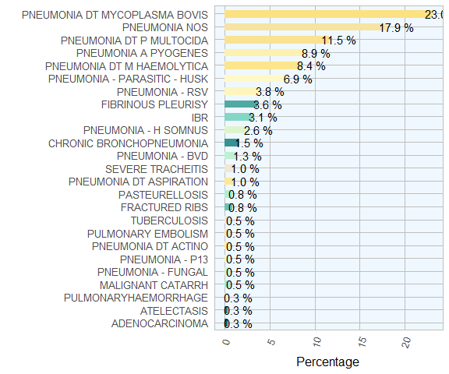

Figure 15 Relative frequency of diagnoses in bovine respiratory disease recorded by AFBI during 2017, (n= 391 )

### Lungworm

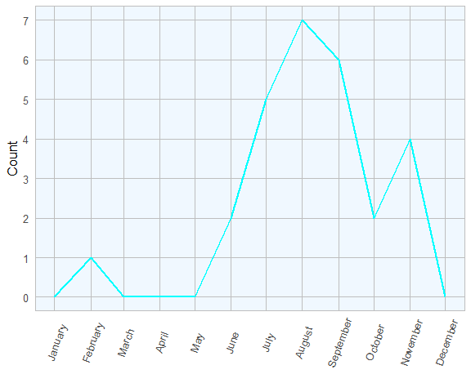

Figure 16 Evolution of the number of lungworm respiratory disease recorded by AFBI during 2017, (n= 27 )

# Bovine Abortions

Table 9 The frequently of the most commom diagnoses in bovine abortion in AFBI during 2017 (n= 427 )

|  |  |  |
| --- | --- | --- |
| Category | Count | Percentage |
| Undiagnosed | 229 | 53.6 |
| T. pyogenes | 37 | 8.7 |
| B. licheniformis | 35 | 8.2 |
| N. caninum | 21 | 4.9 |
| BVDV | 15 | 3.5 |
| E. coli | 15 | 3.5 |
| S. dublin | 15 | 3.5 |
| Leptospirosis | 12 | 2.8 |
| Other | 12 | 2.8 |
| Pasteurellosis | 9 | 2.1 |
| Foetal abnormalities | 8 | 1.9 |
| Schmallenberg Virus | 5 | 1.2 |
| Mummification | 5 | 1.2 |
| Listeria | 4 | 0.9 |
| Campylobacter sp | 3 | 0.7 |
| Aspergillosis | 2 | 0.5 |

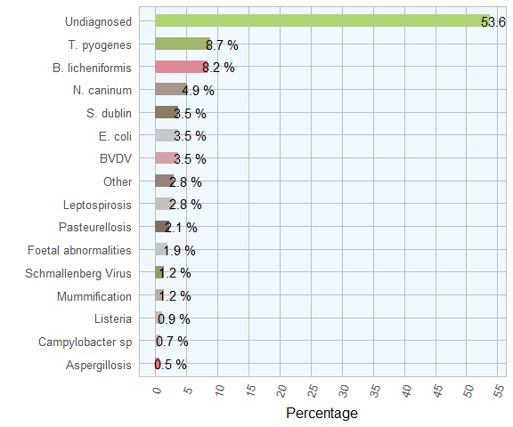

Figure 17 The conditions most frequently diagnosed on post-mortem examinations of ovine carcasses by AFBI during 2017 (n= 427 )

# Ovine Abortions

Table 10 The frequently of the most commom diagnosic group on *post-mortem* examinations ovine by AFBI during 2017

|  |  |  |
| --- | --- | --- |
| Category | Count | Percentage |
| Toxoplasma gondi | 74 | 30.3 |
| No significant agent identified. | 67 | 27.5 |
| Chlamydophilia abortus | 44 | 18.0 |
| E.coli | 20 | 8.2 |
| Campylobacter spp | 12 | 4.9 |
| Streptococcus spp | 9 | 3.7 |
| Leptospirosis | 8 | 3.3 |
| Arcanobacter pyogenes | 5 | 2.0 |
| Listeria monocytogenes | 5 | 2.0 |

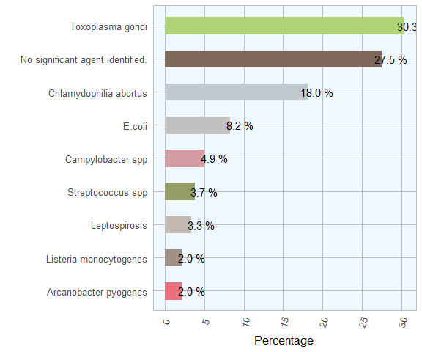

Figure 18 The conditions most frequently diagnosed on post-mortem examinations of ovine carcasses by AFBI during 2017

# Bovine Mastitis

Table 11 hkdhkd in 2017

|  |  |  |
| --- | --- | --- |
| Microorganism | Count | Pct of Total |
| E.coli | 261 | 22.8 |
| Streptococcus uberis | 156 | 13.6 |
| Staphlococcus aureus | 97 | 8.5 |
| Strep dysgalactiae | 28 | 2.4 |
| Contaminated samples | 110 | 9.6 |
| No bacteria cultured | 143 | 12.5 |
| Other | 352 | 30.7 |

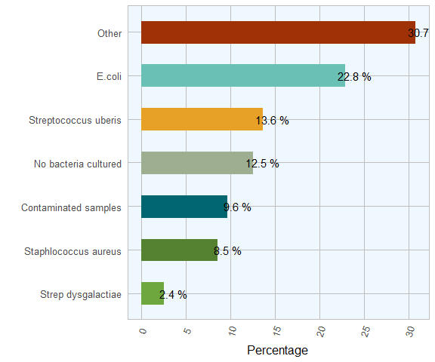

Figure 19 Relative frequency of detection of selected mastitis pathogens by AFBI

# Bovine Parasites

Table 12 Count and percentage of positive results detected in bovine faecal samples examined by AFBI during 2017

|  |  |  |  |
| --- | --- | --- | --- |
| Parasite | Negative | Positive | Pct of Positive |
| Coccidia | 2205 | 814 | 27.0 |
| Fluke eggs | 2483 | 268 | 9.7 |
| Nematodirus epg | 2984 | 36 | 1.2 |
| Paramphistome eggs | 1266 | 1464 | 53.6 |
| Strongyle epg | 2390 | 617 | 20.5 |

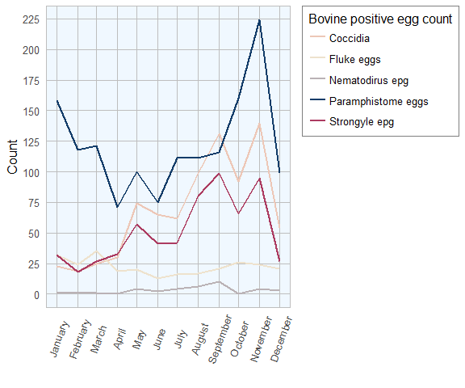

Figure 20 Evolution of the number of positive results in bovine samples in feacal submissions to AFBI during 2017

# Ovine Parasites

Table 13 Count and percentage of positive results detected in ovine faecal samples examined by AFBI during 2017

|  |  |  |  |
| --- | --- | --- | --- |
| Parasite | Negative | Positive | Pct of Positive |
| Coccidia | 533 | 1349 | 72 |
| Fluke eggs | 1564 | 217 | 12 |
| Nematodirus epg | 1635 | 278 | 14 |
| Paramphistome eggs | 1219 | 561 | 32 |
| Strongyle epg | 821 | 1065 | 56 |

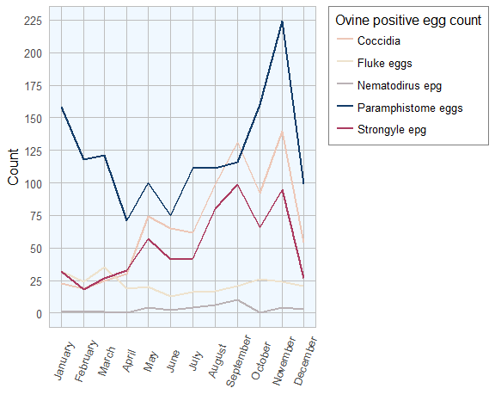

Figure 21 Evolution of the number of positive results in ovine samples in feacal submissions to AFBI during 2017

# Zinc Sulphate Turbidity (ZST) Test

Table 14 Zinc Sulphate Turbidity Test

|  |  |  |  |  |  |
| --- | --- | --- | --- | --- | --- |
| Status | Count | Mean | Median | Minimum | Maximum |
| Adequate | 75 | 33 | 28 | 20 | 93 |