**Marathon Match - Solution Description**

**Overview**

Congrats on winning this marathon match. As part of your final submission and in order to receive payment for this marathon match, please complete the following document.

1. **Introduction**

Tell us a bit about yourself, and why you have decided to participate in the contest.

* Name: Selim Seferbekov
* Handle: selim_sef
* Placement you achieved in the MM:
* About you: During the day I’m a Machine Learning Engineer working on projects aimed to improve maps. As a hobby a participate in a lot of competitions related to Deep Learning (mostly Computer Vision).
* Why you participated in the MM: I participated in all Spacenet challenges starting from Spacenet 3. I would not have an excuse to miss this one.

1. **Solution Development**

How did you solve the problem? What approaches did you try and what choices did you make, and why? Also, what alternative approaches did you consider?

* I solved the task using the same approach as in the winning solution of Data Science Bowl 2018 https://www.kaggle.com/c/data-science-bowl-2018/discussion/54741. Which basically has encoder decoder network like UNet and watershed post processing but instead of predicting just binary masks the CNN predicted 3 masks: (body mask, separations between buildings, building contours). This helped to separate buildings much better than the simple watershed approach.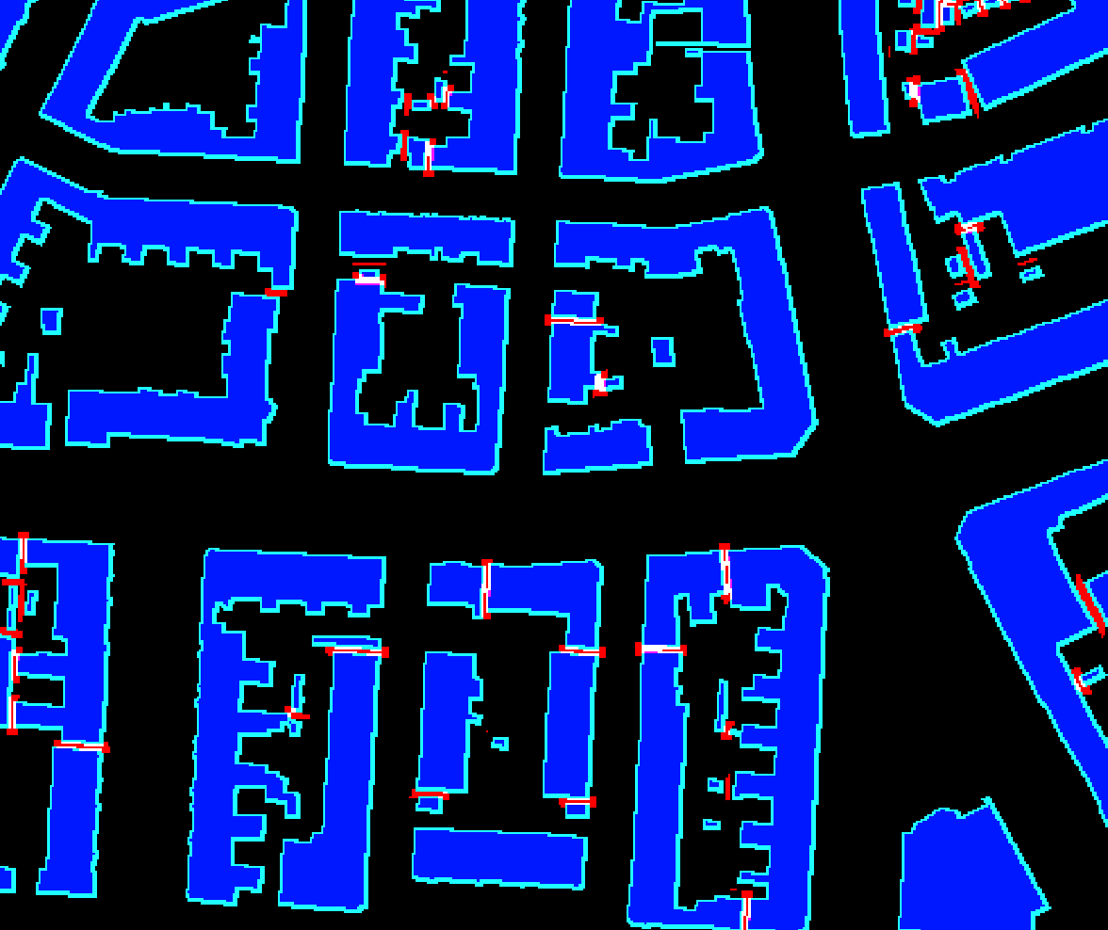
* At first I used a random split for validation holdout. The gap between leaderboard and validation was huge ~40%. That is a clear sign of train data leak to validation. After visualization of the tiles by their coordinates I saw that there were ~15 passes over each location and I prepared a small holdout southeastern part of train data.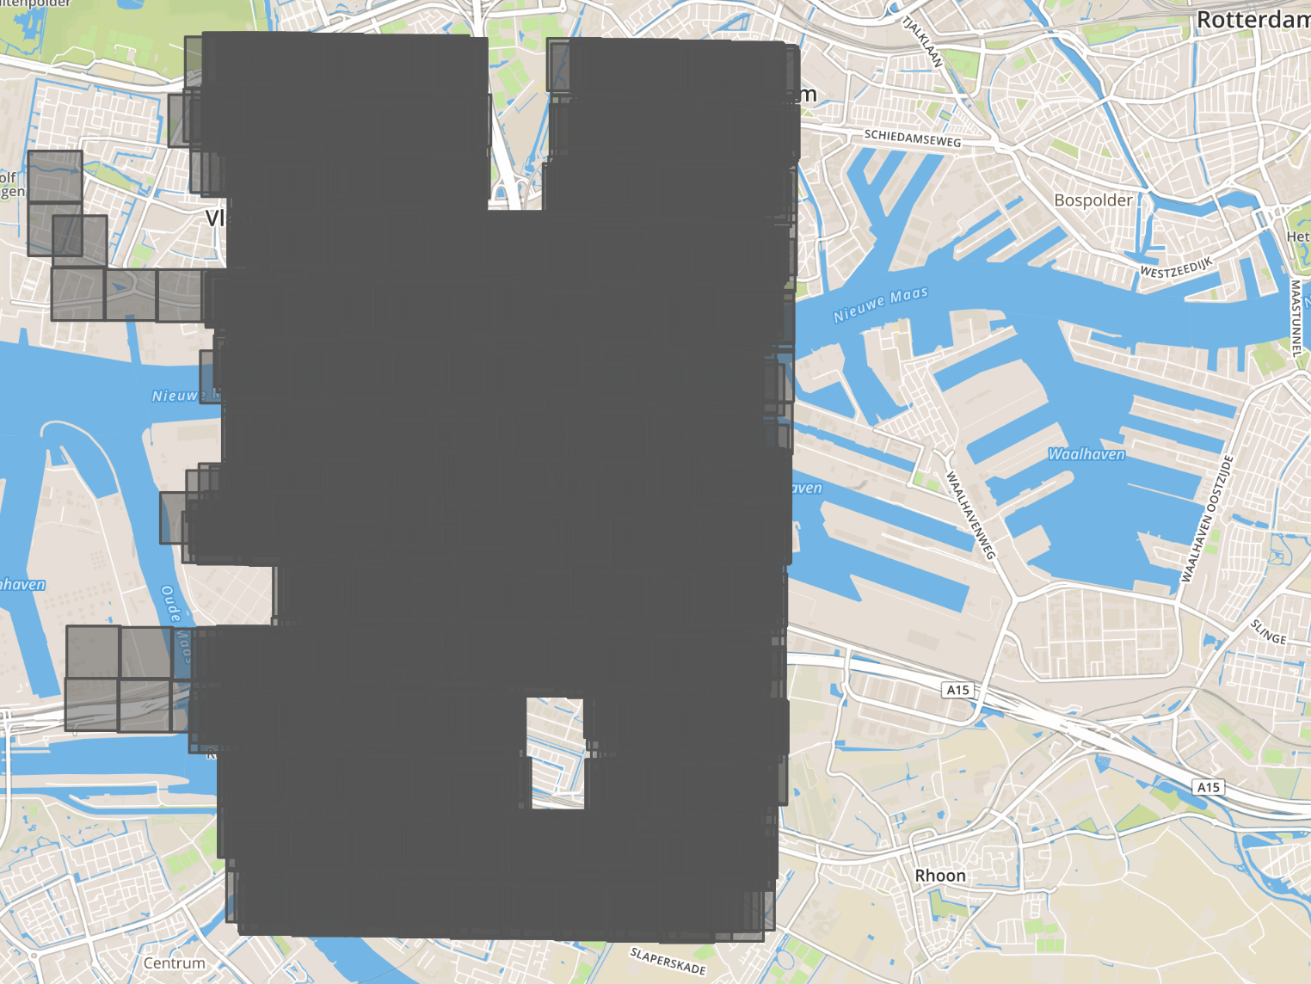
* As the data contained speckle noise I decided to combat that with heavy multiscale test time augmentations (6 scales). The predictions from each scale were quite different and it boosted F1 by 3%.
* I also tried instance segmentation approach with Cascade-RCNN which worked really great on RGB data but produced poor results on SAR images (F1 was around 0.32)

1. **Final Approach**

Please provide a bulleted description of your final approach. What ideas/decisions/features have been found to be the most important for your solution performance:

* I used EfficientNet B5, DPN92, ResneX101 as encoders for semantic segmentation
* To have better batch size/bigger crop I trained all models with Nvidia Apex in mixed precision. That allowed to train 16 models in the given time.
* Preprocessing: images were converted to 0-255 scale
* As a loss function I used combination of soft dice loss + binary cross entropy. BCE was more stable than focal loss in mixed precision mode.
* Augmentations: as the amount of data (geographically) was quite small I applied affine transformations to reduce overfitting.
* Test time augmentations (TTA): used 864, 928, 1024, 1088, 1152, 1280 input sizes

1. **Open Source Resources, Frameworks and Libraries**

Please specify the name of the open source resource along with a URL to where it’s housed and it’s license type:

* Docker, https://www.docker.com (Apache License 2.0)
* Nvidia-docker, https://github.com/NVIDIA/nvidia-docker, ( BSD 3-clause)
* Python 3, https://www.python.org/, ( PSFL (Python Software Foundation License))
* Numpy, http://www.numpy.org/, (BSD)
* Tqdm, https://github.com/noamraph/tqdm, ( The MIT License)
* Anaconda, https://www.continuum.io/Anaconda-Overview,( New BSD License)
* OpenCV, https://opencv.org/ (BSD)
* Pytorch https://pytorch.org/ (BSD)

1. **Potential Algorithm Improvements**

Please specify any potential improvements that can be made to the algorithm:

* Foreshortening, Layover should be addressed somehow to improve detection quality.

1. **Algorithm Limitations**

Please specify any potential limitations with the algorithm:

* Because SAR is side looking tall buildings are not segmented properly. Even medium rise buildings are often shifted far from the ground truth mask.
* Very small buildings are not detected at all as due to speckle noise they cannot be distinguished.

1. **Feedback**

Please provide feedback on the following - what worked, and what could have been done better or differently?

* Problem Statement - problem statement is very detailed
* Data - the actual amount of data is quite small due to multiple passes over the same region. Nevertheless, proper validation had really great correlation with the leaderboard.
* Contest - the contest is great as all Spacenet challenges are
* Scoring - scoring function is well known from previous challenges and is a good proxy metric for measuring building detection quality.

**NOTE**: Please save a copy of this template in word format. Please do not submit a .pdf