Narrative: This database is a listing of Anime Shows. The database will store the Producer(s) and Studio for each show. As well as the genre. For individual show information, the database will also store the show name, rating, the date it both aired an finished airing, the number of episodes and the type of show it is(OVA, Movie, TV etc).

I did not actually enter all of the constraint information into my various documents. I only did the constraints for the 3 of 4 tables. As the constraints will be almost identical across the board. I tried adding an additional constraint to each date field so that the date would not be greater than the system date, but it would not allow me to create the constraint.

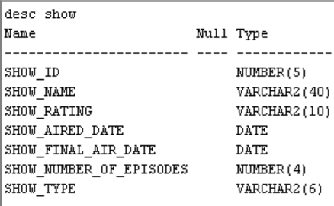TABLE CREATION

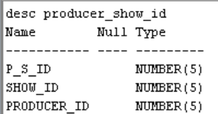

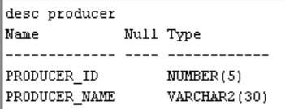

Data Definition Altering



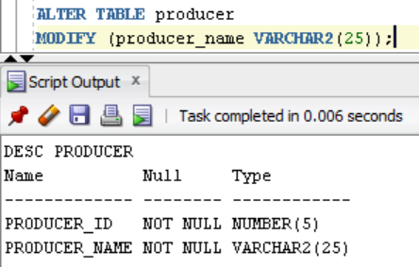

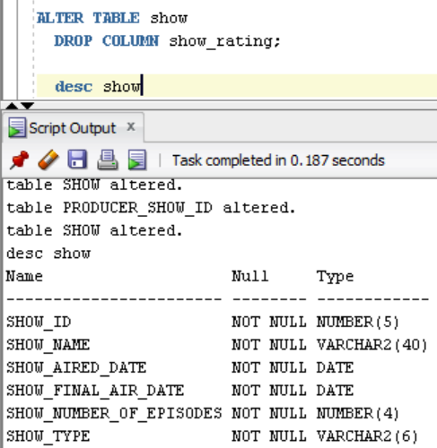Dropping a field