Hardware Documentation: Three-Board Robot Electronics

1. Hardware Overview
Board | Descriptive name | Verified function | Key parts
1 | H-Bridge Motor Driver | Full H-bridge (two half-bridges) for one DC motor, 12 V supply | 2x IR2104PBF, 4x IRF1404PBF
2 | ESP32 Controller / Peripheral Interface | Hosts an ESP32 dev module and breaks out motor-control signals, encoders, servos, IR sensors, ultrasonic sensor and an I2C IMU | ESP32-WROOM-32 dev module
3 | 5 V Buck Regulator | Steps battery voltage down to 5 V; also passes battery voltage to a DRIVER connector | XL4015E1
Architecture summary (Interpretation): Board 3 serves as the system power source. Its DRIVER output is intended to supply the motor driver (Board 1), and its 5 V header is intended to supply the controller board (Board 2), based on connector and net names. The control interface between Board 2 and Board 1 is described in Section 6.

2. Hardware Architecture
Power flow (Interpretation):
- The battery connects to Board 3 BATT.
- Board 3 DRIVER connector is electrically paralleled with the buck input (Confirmed on schematic), so it is a battery pass-through.
- Board 3 5 V header feeds sensors and servos via Board 2 +5V connector.
- Board 1 receives its 12 V (labelled +12V) on U11.
Signal flow (Confirmed per board):
- Board 1 accepts PWM1, EN, PWM2 and GND on a 4-pin header (U4).
- Board 2 outputs the signals listed in Section 4.4 (servo PWM, motor-control signals M1/M2 with PWM4/PWM5, I2C, encoder inputs, IR inputs, ultrasonic TRIG/ECHO).
- Net-name caution: Board 1 nets PWM1/PWM2 and Board 2 nets PWM1/PWM2 are in separate schematics. On Board 2 they drive SERVO1 and SERVO2. Identical names must not be treated as a connection.

3. Board 1: H-Bridge Motor Driver

3.1 Overview
A discrete full-bridge driver: two IR2104PBF half-bridge gate drivers (U1, U2) each drive one high-side and one low-side IRF1404PBF N-MOSFET. U1 with Q1/Q2 forms the M+ leg; U2 with Q3/Q4 forms the M- leg (Confirmed from schematic).

3.2 Functional blocks
Block | Components | Function
Gate drivers | U1, U2 (IR2104PBF) | Half-bridge drivers: IN sets the leg state; SD# pin tied to EN net
Power stage | Q1, Q2 (leg M+), Q3, Q4 (leg M-) | IRF1404PBF N-channel MOSFETs, TO-220
Bootstrap | D1, D6 (UF4007) and C3, C5 (4.7 uF) | Supply for floating high-side drive (VB to VS)
Gate networks | R3 to R6 (10 ohm) with D2 to D5 (1N4148) in parallel | Gate resistor with parallel diode; diode appears to bypass the resistor for fast turn-off
Freewheel | D12 to D15 (HER308) | One diode across each MOSFET drain-source
Motor-side protection | D7 (P6KE18CA bidirectional TVS), R8 (10 ohm) + C7 (100 nF) | TVS across motor terminals; RC snubber across motor terminals
Decoupling / bulk | C1, C6 (100 nF) at driver VCC; C4 (4.7 uF), C8 (470 uF) at input | Supply filtering
Pull-downs | R1, R2 (10 kohm) on U1 SD#; R7 (10 kohm) on U2 SD# | Hold SD# low when EN is not driven
Cooling | U6 to U9 (XSD1226-005-21 heat sinks) | One per MOSFET

3.3 Circuit operation (Interpretation, consistent with schematic)
- Each IR2104 produces complementary HO/LO from a single IN input, so the board needs one PWM signal per leg (PWM1 for the M+ leg, PWM2 for the M- leg), with the shoot-through dead time provided inside the IR2104.
- Each bootstrap capacitor charges through its UF4007 from +12V while the low-side MOSFET conducts. A leg therefore cannot hold 100% high-side duty indefinitely.
- Both drivers share one EN net on SD#. The schematic symbol labels the pin SD# (suggesting active-low), while the 10 kohm pull-downs hold it low. Published IR2104 datasheets describe SD as active-high shutdown; under that behavior, EN high would disable the drivers.
- Heat sinks U6 to U9 are connected to nets Drain1 to Drain4 (Confirmed on schematic). Two sit on +12V and two on the motor switching nodes.

3.4 Power
- Input: U11 (KF126-5.0-2P), labelled +12V and GND on the PCB silkscreen.
- Driver VCC: +12V directly (no on-board regulator). The IR2104 VCC operating range is approximately 10 to 20 V according to published specifications.
- No fuse, reverse-polarity protection or input TVS is present in the schematic or BOM.

3.5 Connectors
Ref | Type | Pins (Confirmed from schematic and silkscreen)
U4 | B4B-XH-A 4-pin | 1 PWM1, 2 EN, 3 PWM2, 4 GND
U11 | KF126-5.0-2P | +12V, GND (pin order)
U12 | KF126-5.0-2P | M+, M- (motor)

3.6 Electrical characteristics
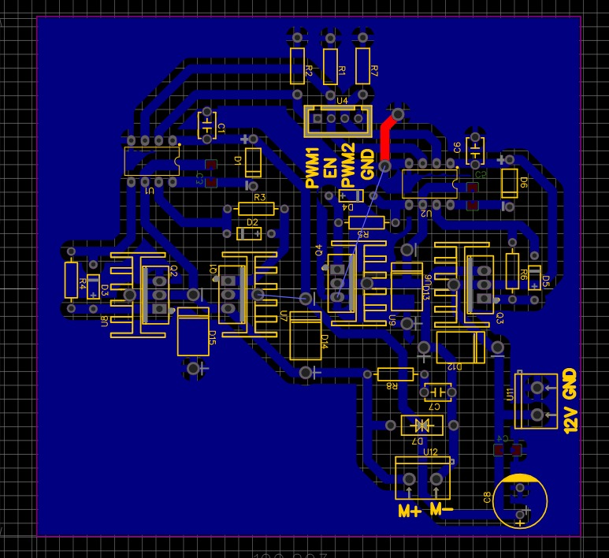
Published specifications identify the IRF1404PBF as a 40 V, low-RDS(on) device with a large gate charge (approximately 160 nC). The IR2104 output drive current is on the order of 130 mA source / 270 mA sink. Together with the 10 ohm gate resistors, these values imply switching times in the low-microsecond range, so PWM frequency selection should account for switching losses. No current-sense element is present on the board.
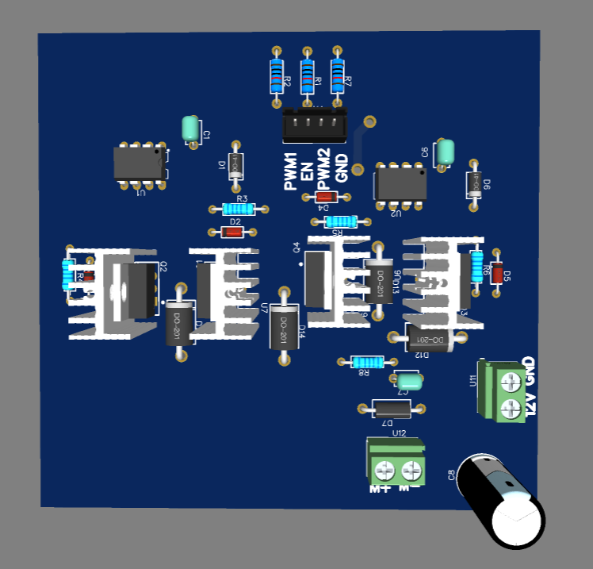

4. Board 2: ESP32 Controller / Peripheral Interface

4.1 Overview
A carrier board for an ESP32 development module (symbol: ESP32-Wroom-32; BOM: ASTE83_AZ-DELIVERY-ESP32-WROOM-32; footprint: AI-THINKER_NODEMCU-32SLUA). It contains no regulator and no power stage. It routes MCU pins to field connectors and provides I2C pull-ups and one decoupling capacitor.

4.2 Functional blocks
Block | Components | Function
Controller | U1 | ESP32 dev module, powered from +5V on its Vin pin
Power input / decoupling | +5V connector (KF127-5.08-2P), C1 (100 nF) | 5 V entry and local decoupling
I2C pull-ups | R1 (1k, SCL), R2 (1k, SDA) | Pull-ups to +3V3
Motor-control connectors | M1, M2 (KF127-5.0-3P) | Three signals each, see 4.4
Encoders | ENCODER1, ENCODER2 (KF2EDGR-3.81-4P) | +5V, GND, channel A, channel B
Servos | SERVO1 to SERVO3 (KF127-5.0-3P) | +5V, PWM signal, GND
Sensors | IR1, IR2 (1x3 header), ULTRASONIC (1x4), IMU (1x4) | Peripheral headers

4.3 Power
- +5V from the external connector feeds the module Vin pin and all peripheral connectors. +3V3 comes from the dev module 3.3 V pin and is used only for the I2C pull-ups.
- No protection or fuse is present. Servo and sensor current is drawn directly through the 5 V connector and board copper.

4.4 Connector pin assignments
Pin assignments are based on the schematic and PCB silkscreen.
Connector | Pin 1 | Pin 2 | Pin 3 | Pin 4
ENCODER1 | +5V | GND | ChannelA1 | ChannelB1
ENCODER2 | +5V | GND | ChannelA2 | ChannelB2
IR1 / IR2 | +5V | IR1 / IR2 signal | GND | n/a
ULTRASONIC | +5V | ECHO | TRIG | GND
IMU | +5V | GND | SCL | SDA
SERVO1 / 2 / 3 | +5V | PWM1 / PWM2 / PWM3 | GND | n/a
M1 | M1+ | PWM4 | M1- | n/a
M2 | M2+ | PWM5 | M2- | n/a
M1 and M2 do not carry motor power. They are 3-signal connectors whose function (for example direction inputs plus a speed PWM to an external driver) is an Interpretation only.

4.5 ESP32 pin mapping (read from schematic)
Signal | MCU pin | Notes
PWM1, PWM2, PWM3 | CLK, SD0, SD1 | See issue C1 below
ECHO, TRIG | SD2, SD3 | See issue C1 below
PWM4 | SVP (GPIO36) | Input-only pin, see C2
M1- | SVN (GPIO39) | Input-only pin
M1+ | Label sits at the EN row | Schematic label adjacent to EN row
M2+ / PWM5 / M2- | P32 / P33 / P25
ChannelA2 / ChannelB2 | P26 / P27
ChannelA1 / ChannelB1 | P18 / P19
IR2 | P14
IR1 | P16 or P4 | Label sits between the two rows
SCL / SDA | P22 / P21
Unused | P34, P35, P12, P13, P0, P2, P5, P15, P17, P23, TX, RX | Marked no-connect

4.6 Findings specific to this board
- C1 (Confirmed on schematic, rule per Espressif documentation): The pins named CLK, SD0, SD1, SD2, SD3 correspond to GPIO6 to GPIO11, which connect to the internal SPI flash on ESP32-WROOM-32 modules and are not available as general I/O. Five signals (PWM1 to PWM3, ECHO, TRIG) are assigned to them. This is likely to prevent normal operation. Highest priority issue.
- C2 (Interpretation): PWM4 is on GPIO36 and M1- on GPIO39, both input-only pins. An output PWM cannot be generated on GPIO36.
- C3 (Potential): ECHO, IR and encoder signals originate from 5 V peripherals and connect directly to 3.3 V GPIOs with no divider or level shifter in the schematic. Safe only if each sensor output is 3.3 V compatible.
- C4 (Potential): The +5V connector feeds Vin; if the dev module is also powered over USB, 5 V sources may contend depending on the module’s Vin/USB isolation.
- C5 (Potential): Servo connector order is +5V / signal / GND. Standard hobby servo plugs are GND / V+ / signal, so a direct plug-in may be reversed.
- C6 (Confirmed discrepancy): Schematic symbol/BOM name is an AZ-Delivery module while the footprint is Ai-Thinker NodeMCU-32S. Header spacing and pin order must be checked against the physical module.
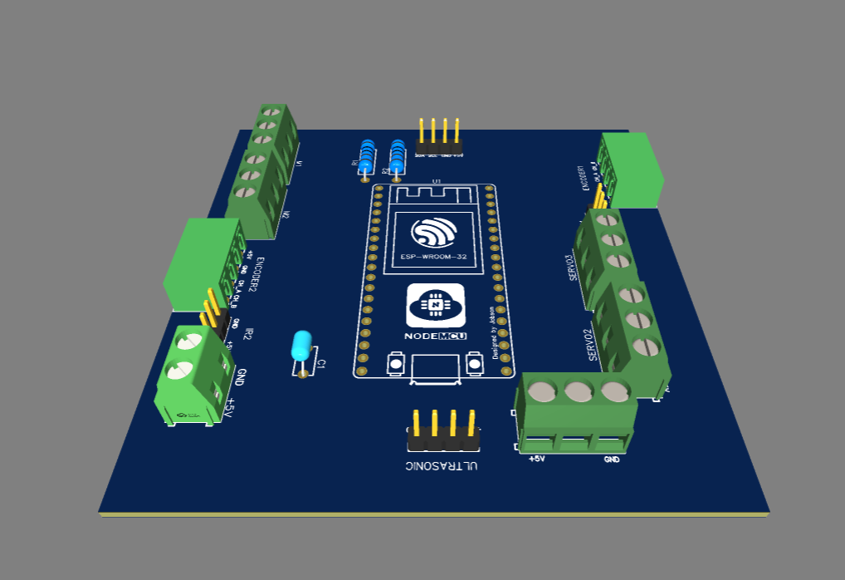
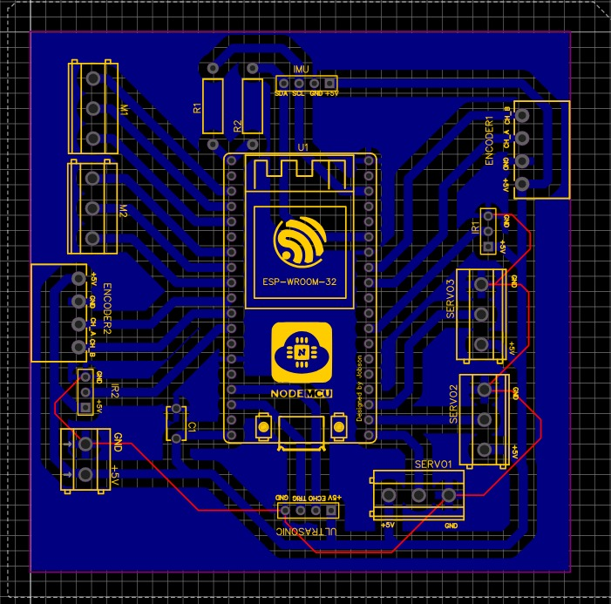

5. Board 3: 5 V Buck Regulator

5.1 Overview
A step-down converter built around the XL4015E1 (TO-263-5), with a 5 V output header and a battery input. A DRIVER connector is paralleled with the input.

5.2 Functional blocks
Block | Components | Function
Converter IC | U1 (XL4015E1) | Monolithic buck regulator
Input filtering | C1 (220 uF), C4 (1 uF), C5 (1 uF) | Input capacitors at VIN
Power inductor | L (toroidal line choke, 15W8 footprint) | Energy storage, switch node to output
Catch diode | D1 (SR540) | Schottky freewheel diode from SW to GND
Output filtering | C7 (330 uF), C6 (1 uF) | Output capacitors
Feedback | R1 (10 kohm), R2 (3.3 kohm), C2 (33 nF) | Output divider with capacitor across R1
Connectors | BATT, DRIVER (KF301-5.0-2P), 5V header (HDR 1x6) | Input, battery pass-through, output

5.3 Circuit operation and output voltage
Using the published XL4015 feedback reference of approximately 1.25 V, the divider gives Vout = 1.25 × (1 + 10k / 3.3k) ≈ 5.04 V (Interpretation, calculated from BOM values and schematic topology). C2 acts as a feed-forward capacitor across the upper resistor.
Schematic pin usage: pin 5 VIN, pins 3 and 6 SW (pin 6 is the tab), pin 2 FB, pin 1 GND, and pin 4 VC, which is wired to the VIN node in the schematic.

5.4 Electrical ratings
The XL4015 is commonly specified for approximately 8 to 36 V input and up to 5 A output; the SR540 is a 5 A, 40 V Schottky diode.

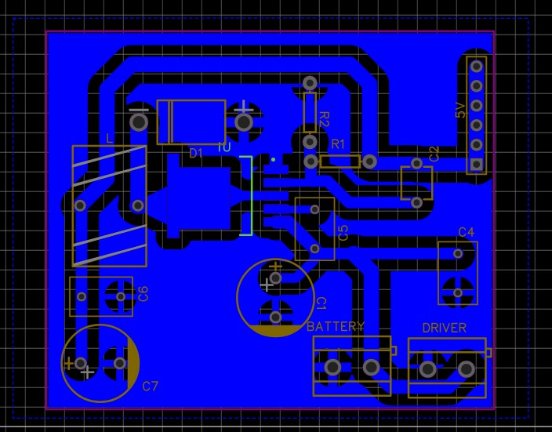
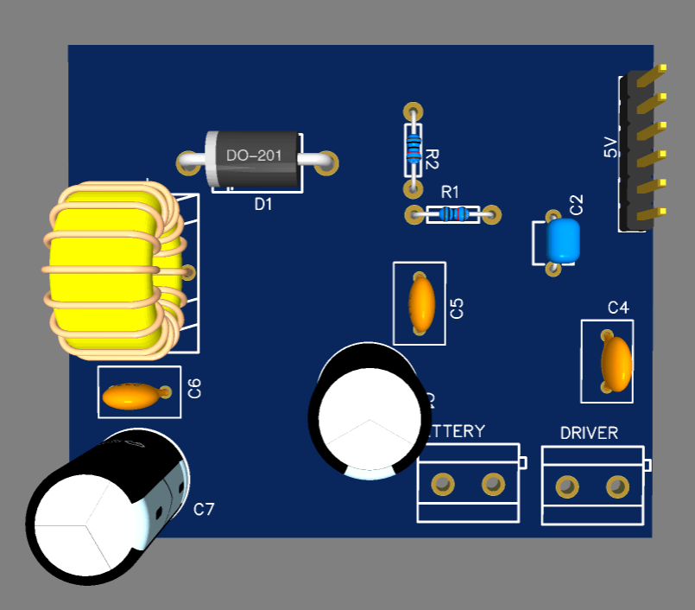
5.5 Connectors
Ref | Function
BATT (KF301-5.0-2P) | Battery input
DRIVER (KF301-5.0-2P) | Battery pass-through to the motor driver (name-based Interpretation)
5V (HDR 1x6) | Six 5 V output pins
GND header | Shown in schematic (1x6), not present in BOM or PCB

6. Hardware Integration
Link | Status | Evidence
Board 3 DRIVER to Board 1 U11 (12 V) | Interpretation | Connector names only; battery voltage must be 12 V-class
Board 3 5V header to Board 2 +5V connector | Interpretation | Net names only
Board 2 to Board 1 control | Not defined | Board 1 requires PWM1, EN, PWM2, GND; no Board 2 net with a matching function and no shared connector type
Common ground | Required | Ground must be common between boards; not documented as a harness
Board 2 M1/M2 (M+, PWM, M−) uses a different signal set from Board 1 U4; the interfaces are not directly equivalent.

7. BOM Documentation
The BOMs are reproduced as supplied, preserving their component names, designators, footprints, and quantities.

7.1 Board 1: H-Bridge Motor Driver
ID | Name | Designator | Footprint | Qty
1 | 4.7uF | C5, C4, C3 | C1206 | 3
2 | 470uF | C8 | CAP-TH_BD10.0-P5.00-D0.6-FD | 1
3 | HER308 | D12, D13, D14, D15 | DO-201AD_BD5.3-L8.4-P12.50-D1.4-RD | 4
4 | KF126-5.0-2P | U11, U12 | CONN-TH_P5.00_KF126-5.0-2P | 2
5 | 100nF | C1, C7, C6 | CAP-TH_L4.8-W3.2-P5.08-D1.2 | 3
6 | XSD1226-005-21 | U9, U8, U7, U6 | HEATSINK-TH_L15.5-W10.5-XSD1226-005 | 4
7 | B4B-XH-A-BK(LF)(SN) | U4 | CONN-TH_B4B-XH-A-BK-LF-SN | 1
8 | IR2104PBF | U2, U1 | DIP-8_L9.9-W6.6-P2.54-LS7.62-BL | 2
9 | 10 ohm | R8, R6, R5, R4, R3 | RES-TH_BD2.2-L6.5-P10.50-D0.6 | 5
10 | 10 kohm | R7, R2, R1 | RES-TH_BD2.5-L6.5-P10.50-D0.6 | 3
11 | IRF1404PBF | Q4, Q3, Q2, Q1 | TO-220-3_L10.0-W4.5-P2.54-L | 4
12 | P6KE18CA_C713672 | D7 | DO-15_BD3.1-L6.7-P10.70-D0.9-BI | 1
13 | 1N4148-C85057 | D5, D4, D3, D2 | DO-35_BD2.0-L4.2-P8.20-D0.5-RD | 4
14 | UF4007_C84067 | D6, D1 | DO-41_BD2.4-L4.7-P8.70-D0.9-FD | 2
Cross-check: all schematic designators (C1 to C8, D1 to D7, D12 to D15, Q1 to Q4, R1 to R8, U1, U2, U4, U6 to U9, U11, U12) appear in the BOM with matching quantities.

7.2 Board 2: ESP32 Controller / Peripheral Interface
ID | Name | Designator | Footprint | Qty
1 | KF2EDGR-3.81-4P | ENCODER1, ENCODER2 | CONN-TH_4P-P3.81_KF2EDGR-3.81-4P | 2
2 | KF127-5.08-2P | +5V | CONN-TH_P5.08_KF127-5.08-2P | 1
3 | 100nF | C1 | CAP-TH_L5.5-W3.2-P5.00-D1.0 | 1
4 | HDR-M-2.54_1x4 | IMU, ULTRASONIC | HDR-M-2.54_1X4 | 2
5 | HDR-M-2.54_1x3 | IR1, IR2 | HDR-M-2.54_1X3 | 2
6 | KF127-5.0-3P | M1, M2, SERVO1, SERVO2, SERVO3 | CONN-TH_3P-P5.00_KF127-5.0-3P | 5
7 | 1k | R1, R2 | R_AXIAL-0.5 | 2
8 | ASTE83_AZ-DELIVERY-ESP32-WROOM-32 | U1 | AI-THINKER_NODEMCU-32SLUA | 1
Cross-check: all schematic parts are present. The power connector uses designator +5V rather than a U-number, which is unusual but consistent between schematic and BOM.

7.3 Board 3: 5 V Buck Regulator
ID | Name | Designator | Footprint | Qty
1 | HDR-M-2.54_1x6 | 5V | HDR-M-2.54_1X6 | 1
2 | KF301-5.0-2P | BATT, DRIVER | CONN-TH_P5.00_KF301-5.0-2P | 2
3 | 220uF | C1 | CAP-TH_BD10.0-P5.00-D1.0-FD | 1
4 | 33nF | C2 | CAP-TH_L4.2-W3.8-P5.08-D0.6 | 1
5 | 1u | C4, C5, C6 | RAD-0.2 | 3
6 | 330uF | C7 | CAP-TH_BD10.0-P5.00-D1.0-FD | 1
7 | SR540_C129837 | D1 | DO-201AD_BD5.3-L8.4-P12.50-D1.4-RD | 1
8 | TOROIDALLINECHOKET15W8 | L | IND-TH_L15.6-W9.3-P7.5-D0.6 | 1
9 | 10k | R1 | R_AXIAL-0.3 | 1
10 | 3.3k | R2 | R_AXIAL-0.3 | 1
11 | XL4015E1 | U1 | TO-263-5_L10.2-W8.9-P1.70-TL | 1

