COSMICFORGE HEALTHNET CENTRALIZED ADMIN

Marketing Intelligence
Phase 2
  - Complete Architecture and Implementation
Canonical engineering, deployment, live-validation, operations, risk, and acceptance reference
REVISION | 1.0 / 19 July 2026
RELEASE POSTURE | Engineering complete / Live provider validation pending
STAGE 1 DARK LAUNCH ONLY
Provider enablement remains gated by explicit permission, validated credentials, and one-platform-at-a-time evidence.

Document control
Repository: ADMIN-Backend | Canonical source: CosmicForge_Marketing_Intelligence_Phase2_Complete_Architecture.md
Revision | Date | Scope | Status
1.0 | 2026-07-19 | WP0 through Sections 22-26 | Controlled release candidate

Table of contents
This static contents list is retained for reliable viewing across Word-compatible applications.
- Executive overview
- Scope, constraints, and non-goals
- Delivery work packages
- System context
- Component architecture
- Data architecture
- Provider capability architecture
- Provider ingestion
- Attribution and funnel reconciliation
- Creative synchronization and scoring
- Calculation and currency policy
- Recommendation architecture
- Alert architecture
- Task integration architecture
- Experiment architecture
- Settings architecture
- Scheduler and evaluation architecture
- API architecture
- RBAC and audit
- Validation, security, and privacy
- Error handling and observability
- Testing architecture
- Deployment architecture
- Six-stage rollout
- Live-provider validation
- Operations runbook
- Troubleshooting guide
- Risk register
- Final Definition of Done
- Appendices

1. Executive overview
Marketing Intelligence Phase 2 is a read-only-provider, deterministic decision-support subsystem in the Centralized Admin backend. It ingests advertising campaign and creative evidence from Meta, TikTok, X, LinkedIn, and Google Ads; reconciles internal attribution and monetary events; scores creatives; generates advisory recommendations and alerts; tracks experiments; and converts accepted recommendations into the existing Task model.
The implementation deliberately does not mutate provider campaigns. It does not perform FX conversion, forecasting, multi-touch attribution, experiment execution, or mandatory LLM inference. Phase 1 campaign synchronization remains an independent operational path.
The deployment-level kill switch is MARKETING_INTELLIGENCE_PHASE2_ENABLED=false. With the master disabled, Phase 2 schedulers and operational execution are disabled while reads, settings configuration, connection preparation, validation evidence, OAuth preparation, attribution event production, and Phase 1 synchronization remain available under their existing RBAC/security policies.

Acceptance posture
Dimension | Status | Basis
Engineering | COMPLETE | Source, schema, migrations, and automated tests
Database | COMPLETE | 21-migration manifest and empty-database replay
Security | COMPLETE | Secret scan, network guard, RBAC, bounded serializers
Documentation | COMPLETE | This canonical document plus runbook, matrix, and checklist
Live provider evidence | LIVE_VALIDATION_PENDING | No explicit live permission or validated credentials supplied
Production release | STAGE 1 ONLY | Dark launch permitted; platform enablement requires its own live gate

2. Scope, constraints, and non-goals

In scope
- Provider connection and capability inspection.
- Campaign and creative ingestion using read-only provider APIs.
- Internal click, signup, activation, payment, refund, and chargeback reconciliation.
- Currency-safe deterministic scoring, fatigue, recommendation, and alert rules.
- Recommendation/alert/experiment lifecycles.
- Atomic conversion to the existing Task, Notification, audit, and realtime infrastructure.
- Typed settings, locks, heartbeats, scheduled evaluation, run ledger, RBAC, observability, and release controls.

Locked non-goals
- No campaign, ad, creative, bid, or budget mutation.
- No FX conversion or cross-currency monetary aggregation.
- No predictive forecasting, ML model, multi-touch attribution, or autonomous experiment execution.
- No required LLM call; llmCommentaryEnabled remains reserved and false.
- No duplicate Task, Notification, WebSocket, scheduler, settings, or provider-platform system.
- No coupling of paid Marketing Intelligence to Social Operations publishing.

3. Delivery work packages

3.1 Dependency order
WP0 -> WP1 -> WP2 -> WP3 -> WP4/WP5 -> WP6/WP8/WP9 -> WP7 -> WP10 -> WP11 -> WP12
Recommendation rules consume resolved settings and persisted scoring inputs. Task conversion requires an accepted recommendation. Full evaluation resolves settings, uses the existing connector/lock services, and does not bypass component rules. Phase 1 sync is registered separately.

3.2 Final work-package matrix
WP0 — COMPLETE
WP | WP0
Status | COMPLETE
Code | event producers, attribution, adjustment, redaction, lock renewal
Database/API | attribution/funnel/identity/run fields
Tests | WP0, revenue, event tests
Live validation | Not required for code acceptance
Remaining action | Monitor source integrations
WP1 — COMPLETE
WP | WP1
Status | COMPLETE
Code | Prisma schema and repositories
Database/API | settings, creatives, scores, runs, recommendations, alerts, experiments
Tests | schema/migration tests
Live validation | Not applicable
Remaining action | None
WP2 — COMPLETE
WP | WP2
Status | COMPLETE
Code | creative.connector.interface.js, registry
Database/API | normalized DTOs and capability output
Tests | connector contract tests
Live validation | Pending provider confirmation
Remaining action | Record limitations
WP3 — LIVE_VALIDATION_PENDING
WP | WP3
Status | LIVE_VALIDATION_PENDING
Code | five provider adapters
Database/API | catalog/insight ingestion
Tests | mock connector tests
Live validation | Credentials/approval required
Remaining action | Run one platform gate at a time
WP4 — COMPLETE_WITH_CONFIGURATION
WP | WP4
Status | COMPLETE_WITH_CONFIGURATION
Code | creative sync/scoring/fatigue
Database/API | durable snapshots and score history
Tests | creative suites
Live validation | Observation required
Remaining action | Enable validated connections only
WP5 — COMPLETE
WP | WP5
Status | COMPLETE
Code | typed settings services/controllers
Database/API | settings APIs and versioned rows
Tests | settings suites
Live validation | Not applicable
Remaining action | Configure targets per currency
WP6 — COMPLETE_WITH_CONFIGURATION
WP | WP6
Status | COMPLETE_WITH_CONFIGURATION
Code | recommendation rules/confidence/lifecycle
Database/API | recommendation APIs and dedupe
Tests | recommendation suites
Live validation | Quality review required
Remaining action | Stage 4 enablement
WP7 — COMPLETE_WITH_CONFIGURATION
WP | WP7
Status | COMPLETE_WITH_CONFIGURATION
Code | recommendation Task adapter
Database/API | existing Task/Notification/audit
Tests | Task suites
Live validation | Operational verification required
Remaining action | Configure eligible assignee
WP8 — COMPLETE_WITH_CONFIGURATION
WP | WP8
Status | COMPLETE_WITH_CONFIGURATION
Code | alert rules/recovery/delivery
Database/API | alert APIs and Notification link
Tests | alert suites
Live validation | Cooldown/no-spam review required
Remaining action | Stage 4 enablement
WP9 — COMPLETE
WP | WP9
Status | COMPLETE
Code | experiment tracking service
Database/API | experiment APIs/state
Tests | experiment suites
Live validation | No provider execution
Remaining action | None
WP10 — COMPLETE_WITH_CONFIGURATION
WP | WP10
Status | COMPLETE_WITH_CONFIGURATION
Code | schedulers/full evaluation/locks/runs
Database/API | evaluation-run APIs
Tests | scheduler/lock/run tests
Live validation | Stage observation required
Remaining action | Enable only after gates
WP11 — COMPLETE
WP | WP11
Status | COMPLETE
Code | RBAC, validation, errors, logging, privacy
Database/API | protected APIs/audits
Tests | security/network tests
Live validation | Not applicable
Remaining action | Ongoing review
WP12 — LIVE_VALIDATION_PENDING
WP | WP12
Status | LIVE_VALIDATION_PENDING
Code | master flag, live CLI, docs
Database/API | release artifacts
Tests | final regression/docs tests
Live validation | Five gates not run
Remaining action | External live validation

3.3 Evidence map
Capability | Implementation | Model/migration | Tests | Documentation
Attribution | attribution.service.js, funnel listener | attribution/funnel/identity models; WP0 migration | attribution, funnel, WP0 | Sections 9, 11
Provider normalization | creative.connector.interface.js, creative.registry.js | creative tables | connector/ingestion tests | Sections 7-8
Scoring/fatigue | creative scoring/rules/fatigue services | score snapshots | creative scoring tests | Sections 10-11
Recommendations | recommendation services/repository | recommendations | recommendation tests | Section 12
Alerts | alert services/repository/adapter | alerts | alert tests | Section 13
Tasks | recommendation-task.adapter.js | existing Task | Task tests | Section 14
Operations | scheduler registry, locks, run ledger | evaluation runs/locks | scheduler/lock tests | Sections 17, 26
Release controls | phase2-feature.js, live CLI | no migration | Sections 22-26 tests | Sections 23-25

4. System context
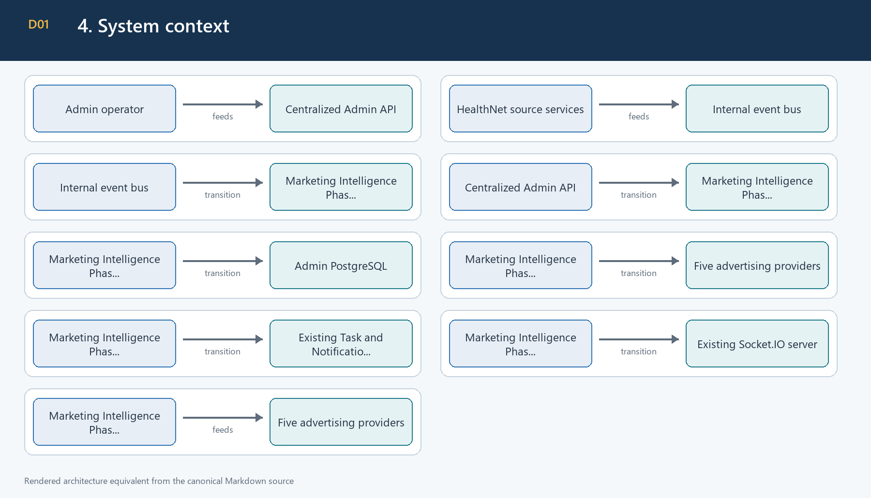
Figure 1. 4. System context
The Admin API is the trust boundary for manual operations. Internal funnel events enter through authenticated service routes/event producers. Provider APIs are read-only sources. PostgreSQL is the durable system of record. Task, Notification, audit, and WebSocket delivery reuse existing modules.

5. Component architecture
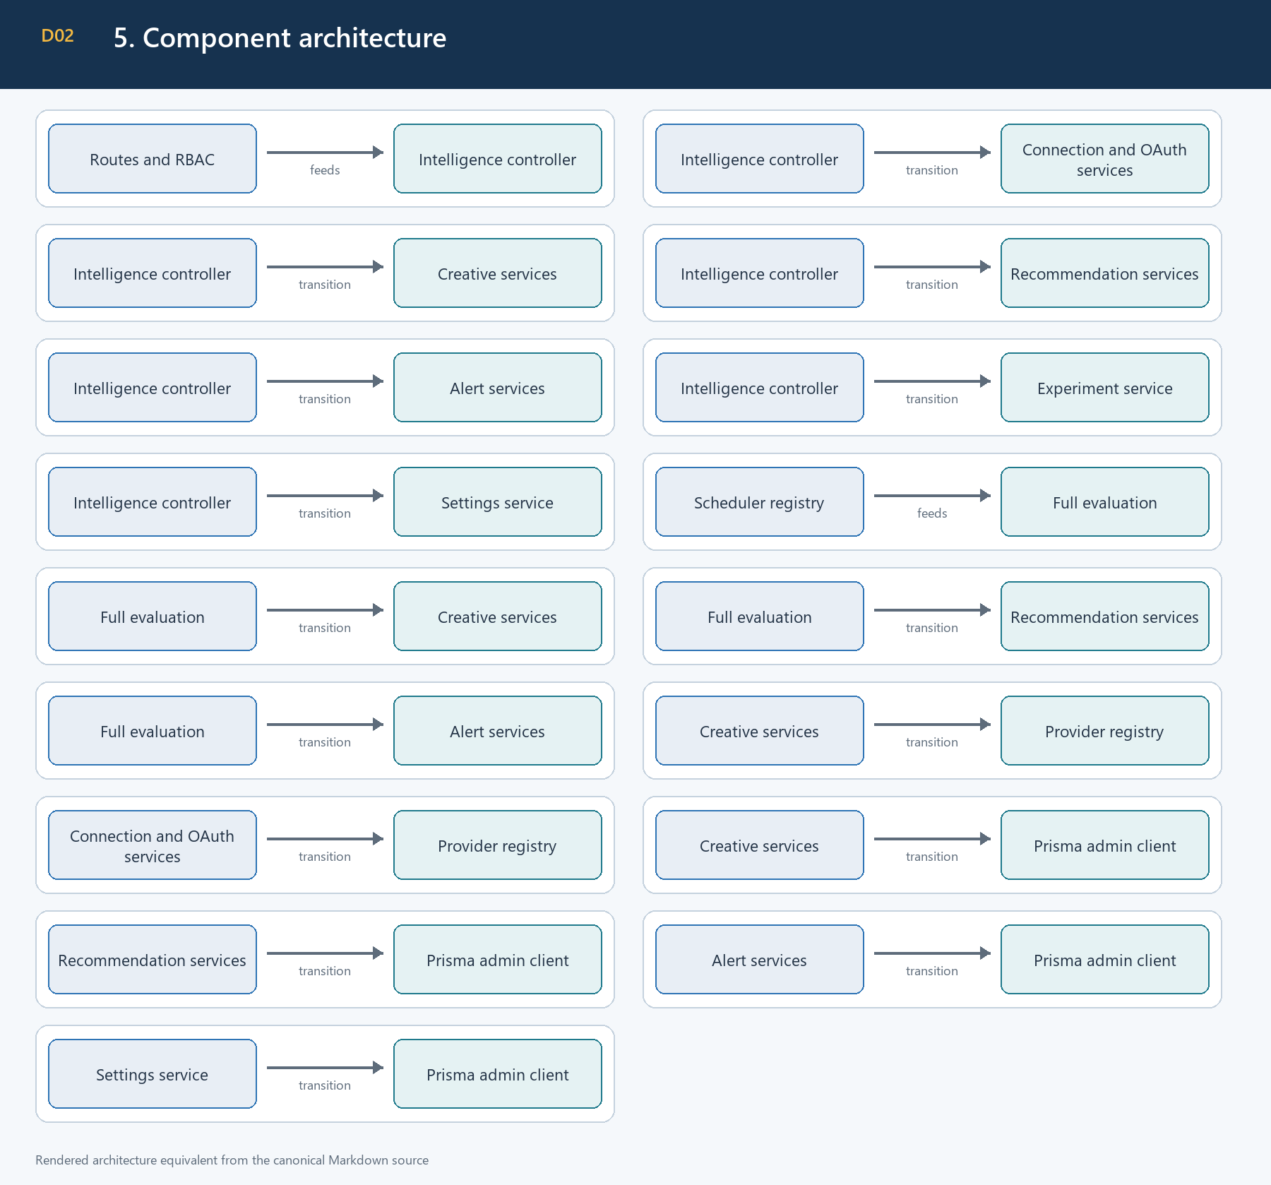
Figure 2. 5. Component architecture
Major module roots are src/modules/marketing/intelligence, src/shared/events, src/shared/middlewares, src/shared/utils, and the generated Admin Prisma client. Social Operations remains a sibling subsystem, not a provider implementation dependency.

6. Data architecture
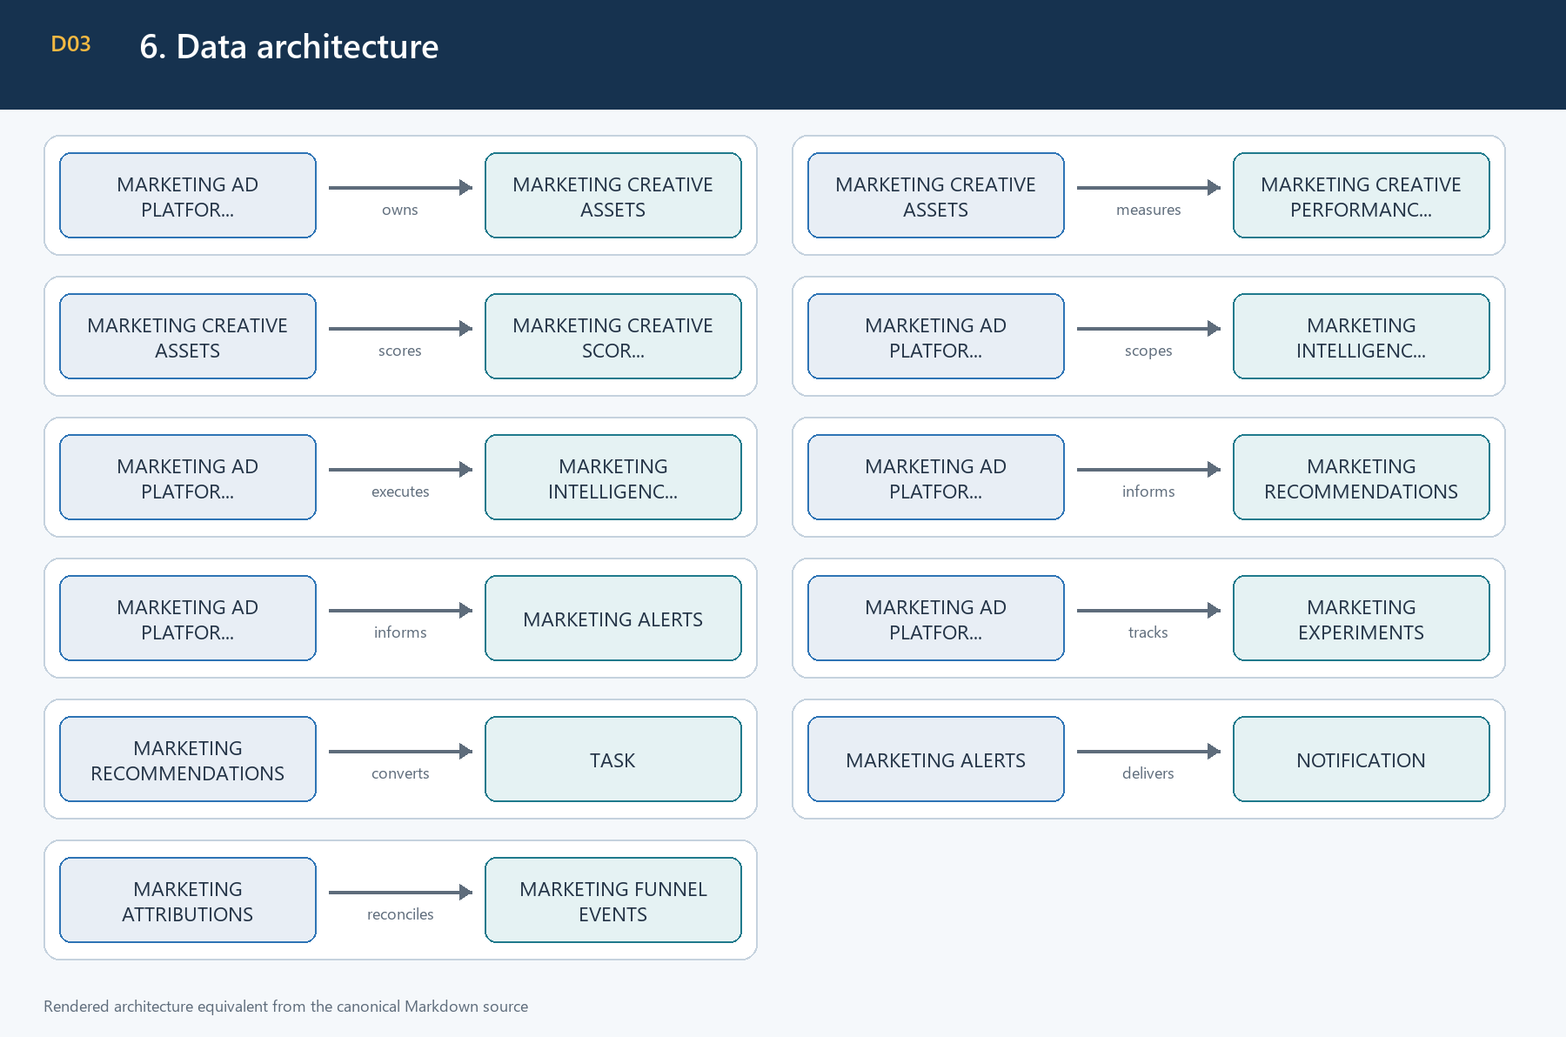
Figure 3. 6. Data architecture

Persistence invariants
- Connection/platform account identities are unique.
- Creative sourceKey and metric identities make re-fetches idempotent.
- Scores are unique by asset, analysis window, and rule version.
- Recommendation/alert dedupe keys preserve active lifecycle identity.
- Historical connection relationships generally use SetNull or Restrict; deleting a connection does not erase analytical history.
- Task conversion is one-to-one through convertedToTaskId.
- Run summaries and provider-derived JSON are bounded and sanitized before persistence.

Migration ownership
Phase 2A is the WP0 correction migration. Phase 2B comprises Sections 7, 8, and 9. Phase 2C comprises Sections 10-13, their audit correction, and Sections 14-17. Sections 18-26 require no corrective schema migration.

7. Provider capability architecture
META — OAuth token / encrypted connection
Platform | META
Credential mode | OAuth token / encrypted connection
Catalog grain | Ad with creative metadata
Insights | Daily ad insights
Pagination | Graph cursor
Refresh | OAuth reauthorization
Currency/micro-units | Major-unit spend; connection currency
Stable creative identity | native creative ID or ad:<id>
Current live status | CREDENTIALS_REQUIRED
TIKTOK — Access/refresh token
Platform | TIKTOK
Credential mode | Access/refresh token
Catalog grain | Ad with optional creative ID
Insights | Auction-ad daily report
Pagination | Page number
Refresh | Supported
Currency/micro-units | Major-unit spend; connection currency
Stable creative identity | creative ID, otherwise ad ID
Current live status | CREDENTIALS_REQUIRED
X — OAuth 1.0a plus Ads approval
Platform | X
Credential mode | OAuth 1.0a plus Ads approval
Catalog grain | Promoted entity
Insights | Daily billing/engagement
Pagination | Cursor
Refresh | Credential rotation
Currency/micro-units | Billing micro-units converted once
Stable creative identity | tweet/promoted entity ID
Current live status | CREDENTIALS_REQUIRED
LINKEDIN — OAuth token/refresh token
Platform | LINKEDIN
Credential mode | OAuth token/refresh token
Catalog grain | Full creative URN
Insights | Creative-pivot analytics
Pagination | Start/count
Refresh | Supported
Currency/micro-units | Local-currency spend
Stable creative identity | full creative URN
Current live status | CREDENTIALS_REQUIRED
GOOGLE_ADS — OAuth refresh plus developer token
Platform | GOOGLE_ADS
Credential mode | OAuth refresh plus developer token
Catalog grain | Ad/resource name
Insights | GAQL ad metrics
Pagination | Page token
Refresh | Supported
Currency/micro-units | cost_micros converted once
Stable creative identity | ad resource name/ID
Current live status | CREDENTIALS_REQUIRED

Provider records are normalized into bounded DTOs. Raw response bodies may be encrypted/sanitized for approved ingestion tables but are not returned by public APIs, run summaries, documents, or logs.

8. Provider ingestion
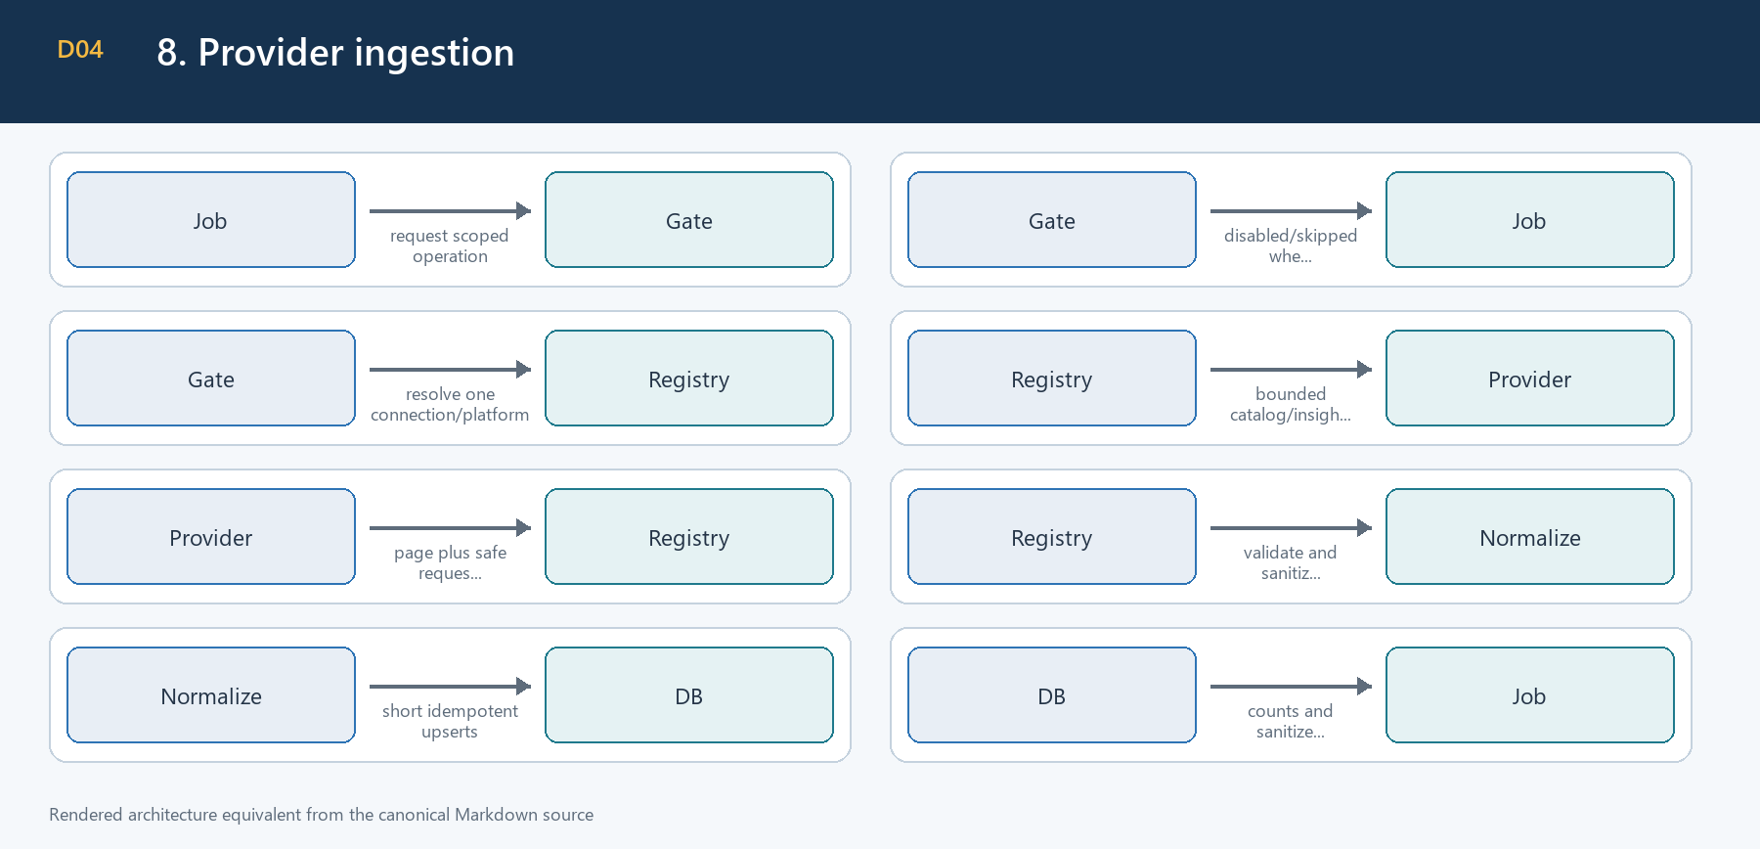
Figure 4. 8. Provider ingestion
Ingestion validates one provider account and bounded date range per connection. Pagination is explicit. Retry is limited to retryable timeout, rate-limit, and temporary-provider failures. Token refresh is connector-specific and refreshed values are re-encrypted through the connection service. Provider writes do not exist.

9. Attribution and funnel reconciliation
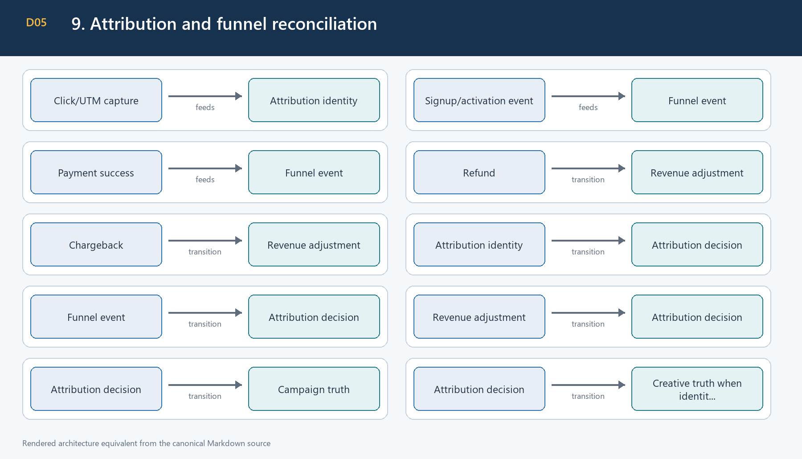
Figure 5. 9. Attribution and funnel reconciliation
Event identities are deduplicated. A repeated immutable external ID with conflicting immutable facts returns DUPLICATE_ACTION. Refunds and chargebacks reduce internal net revenue without rewriting the original payment. Campaign-only evidence is not duplicated into creative attribution. Provider conversions remain informational.
Attribution uses documented deterministic precedence and window boundaries, not probabilistic multi-touch allocation. When evidence is ambiguous, the record remains campaign-only or unavailable.

10. Creative synchronization and scoring
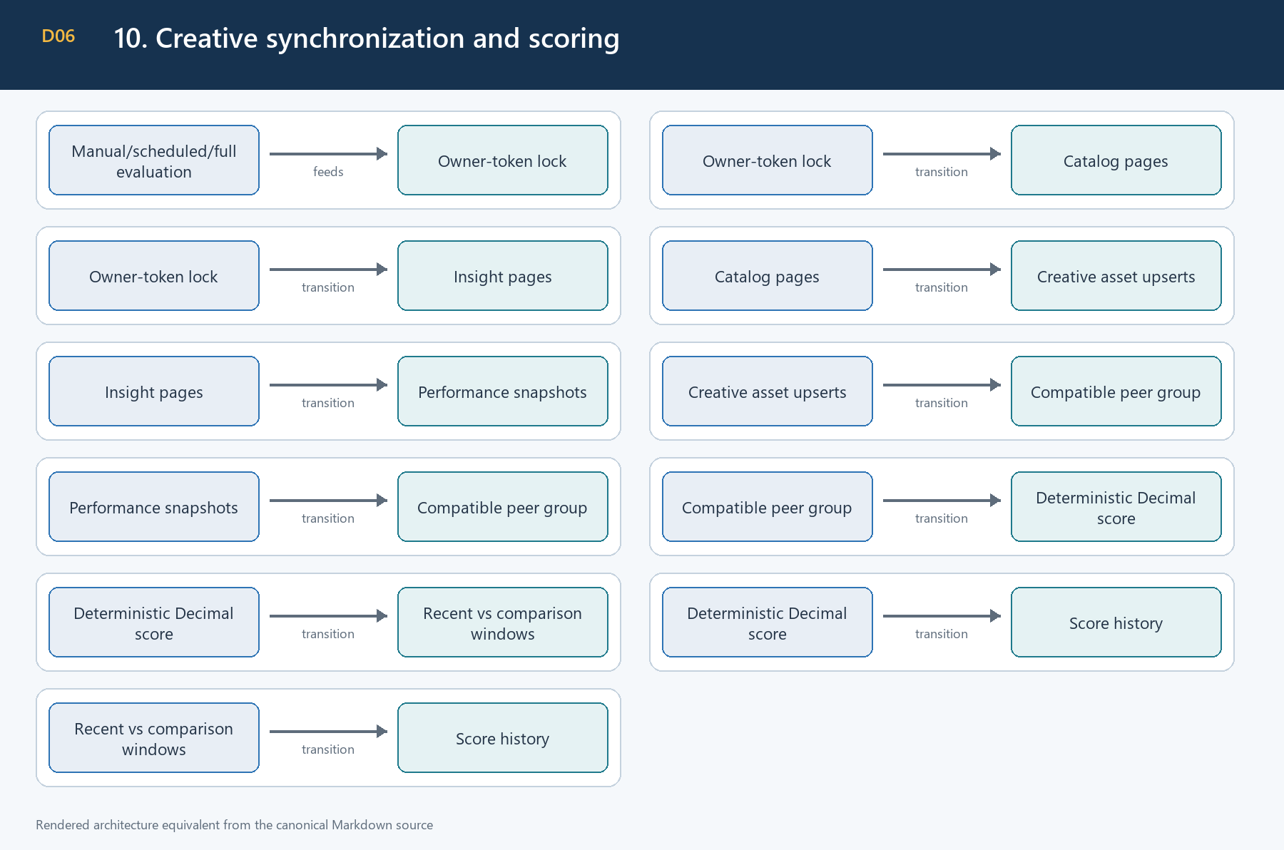
Figure 6. 10. Creative synchronization and scoring
Creative synchronization never fabricates a missing metric. Scores use compatible peers or configured targets, renormalize only available components, and cap metadata modifiers. Data sufficiency is INSUFFICIENT, LIMITED, SUFFICIENT, or STRONG. Fatigue requires sufficient volume and consecutive confirming windows; rerunning the same window does not advance a streak.

11. Calculation and currency policy
Metric | Definition | Unavailable when
CTR | clicks / impressions | impressions is zero/missing
CPC | spend / clicks | clicks zero or currency unavailable
CPM | spend / impressions x 1,000 | impressions zero or currency unavailable
Conversion rate | trustworthy internal goals / clicks | denominator/evidence unavailable
CPA | spend / trustworthy internal goals | denominator/currency unavailable
ROAS | net trustworthy attributed revenue / spend | spend zero or currencies incompatible

Prisma Decimal is used for money, ratios, thresholds, confidence, and score math. Division by zero yields unavailable, not infinity or an invented zero. Google Ads and X micro-unit values are converted exactly once at the adapter boundary. Monetary totals are never combined across currencies. There is no FX service.

12. Recommendation architecture
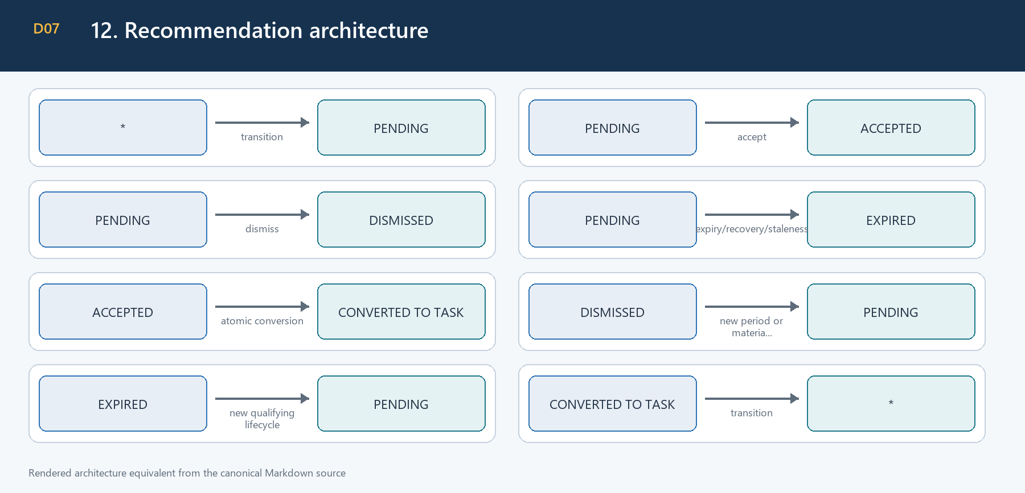
Figure 7. 12. Recommendation architecture
Rules create PAUSE, SCALE, REALLOCATE_BUDGET, and CREATE_CONTENT advice only. Confidence is deterministic and evidence-backed. Canonical condition identities, period buckets, evidence fingerprints, recovery streaks, and expiry prevent duplicate or stale advice. Accept/dismiss transitions validate active actors and current status in the service, not only the route.
No recommendation calls a provider mutation API. suggestedAction describes operator review and remains capped by maximumRecommendedScalePct=0.20.

13. Alert architecture
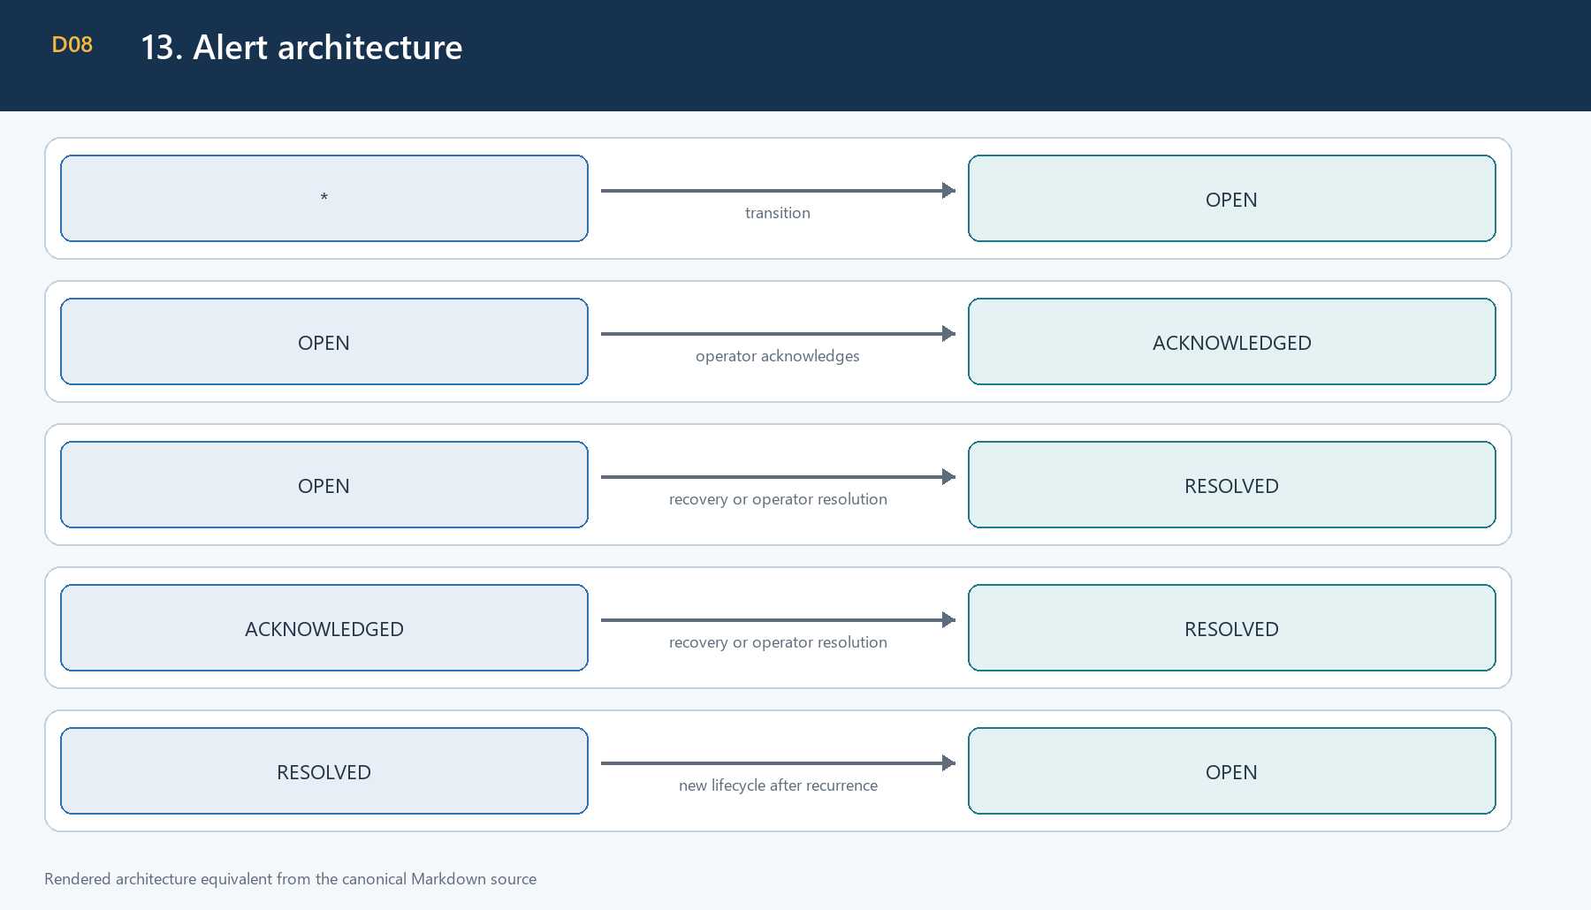
Figure 8. 13. Alert architecture
Alert types cover CPA breach, spend without conversion, conversion-rate decline, creative fatigue, campaign deterioration/high performance, stale sync, token refresh, degraded connection, and provider permission failures. Active dedupe identity, cooldown, occurrence count, severity escalation, persistence evaluation, and recovery evaluation prevent spam.
Persistence succeeds before Notification and realtime delivery. Delivery failure is sanitized and does not remove the alert. Health and performance rule groups have independent schedules and locks.

14. Task integration architecture
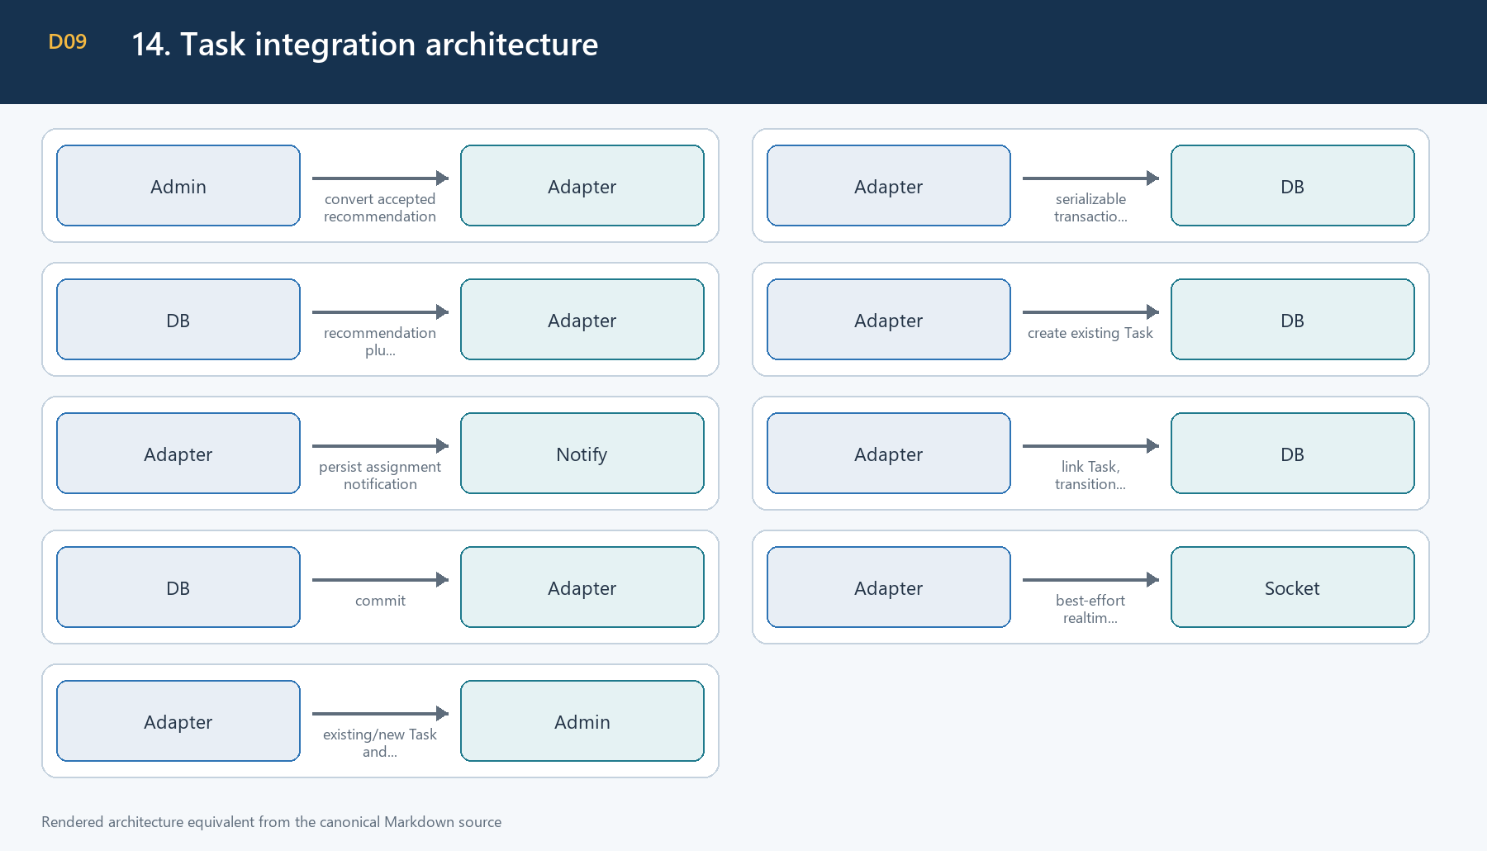
Figure 9. 14. Task integration architecture
The real schema has Task.assigneeId. There is no TaskAssignee model, Task priority field, or Task metadata field. Operational urgency is a bounded line in the Task description, not an invented database property.
Assignee order is request override, connection setting, global setting, then deterministic eligible Marketing fallback. A repeat returns the linked Task without another Task, Notification, or transition audit. A missing linked Task is an integrity conflict.

Task conversion request
{
"assigneeAdminUserId": "11111111-1111-4111-8111-111111111111",
"dueDate": "2026-07-25T17:00:00.000Z"
}
Both fields are optional. dueDate is an ISO-8601 timestamp with an explicit timezone.

15. Experiment architecture
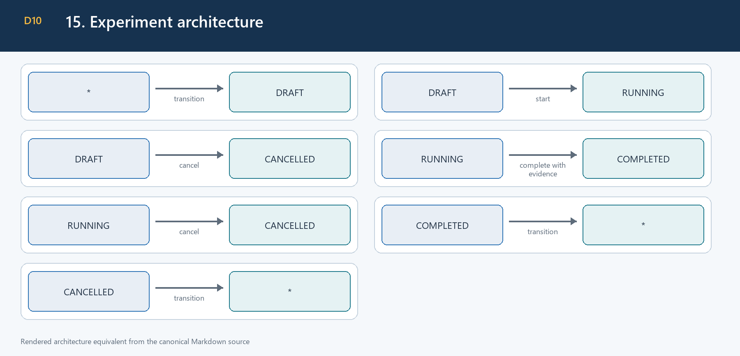
Figure 10. 15. Experiment architecture
Experiments track CTR, CPC, CPA, and CONVERSION_RATE. Variant JSON is bounded, plain, distinct, and rejects secret/prototype/executable/provider-command fields. Only drafts are editable. Completion requires structured samples, metric values, winner classification, source, and analysis window. Statistical significance may be claimed only with an explicitly supplied method and evidence. Experiments do not execute provider changes.

16. Settings architecture
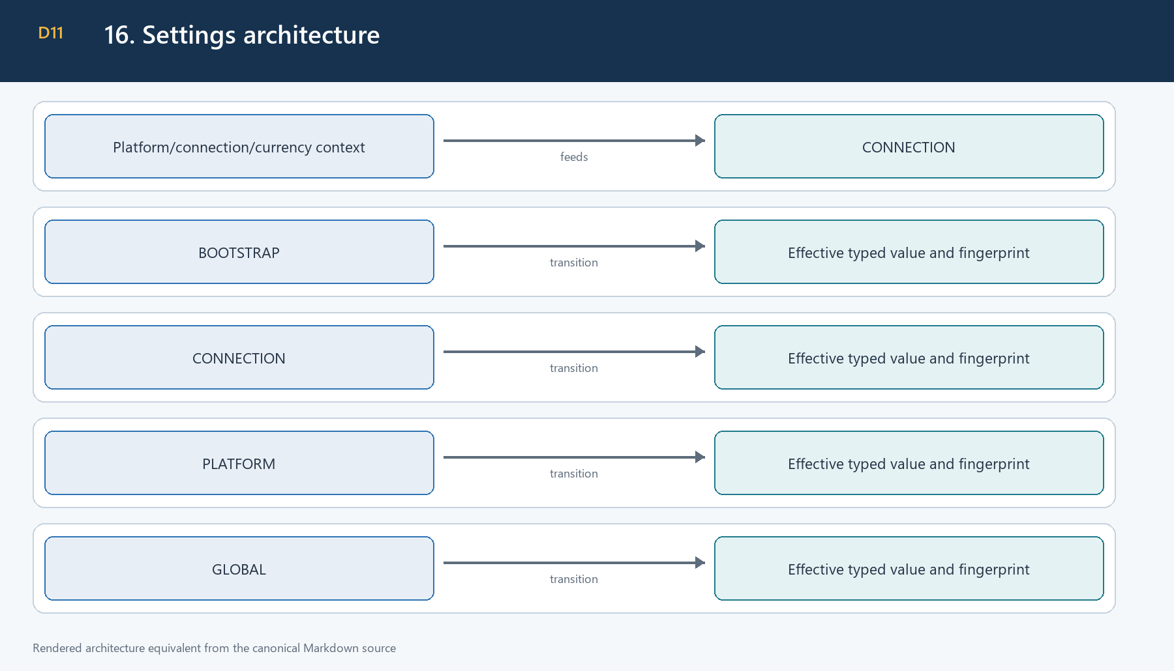
Figure 11. 16. Settings architecture

Approved canonical bootstrap defaults
Setting | Type/scope | Currency-aware | Default | Main consumers
attributionWindowDays | Integer, GLOBAL | No | 30 | attribution
recommendationLookbackDays | Integer, GLOBAL/PLATFORM | No | 14 | recommendations
comparisonLookbackDays | Integer, GLOBAL/PLATFORM | No | 14 | recommendations
creativeMinimumImpressions | Integer, GLOBAL/PLATFORM | No | 1000 | scoring/fatigue
minimumClicks | Integer, GLOBAL/PLATFORM | No | 30 | sufficiency/rules
minimumSignups | Integer, GLOBAL/PLATFORM | No | 3 | recommendations
minimumPayments | Integer, GLOBAL/PLATFORM | No | 3 | recommendations
underperformThresholdPct | Decimal 0-1 | No | 0.30 | rules
scaleThresholdPct | Decimal 0-1 | No | 0.20 | rules
creativeFatigueThresholdPct | Decimal 0-1 | No | 0.25 | fatigue
maximumRecommendedScalePct | Decimal 0-1 | No | 0.20 | recommendation cap
alertCooldownMinutes | Integer 5-10080 | No | 1440 | general alert cooldown
recommendationEvaluationEnabled | Boolean, all scopes | No | false | recommendation gate
alertEvaluationEnabled | Boolean, all scopes | No | false | alert gate
creativeSyncEnabled | Boolean, all scopes | No | false | creative sync gate
llmCommentaryEnabled | Boolean, GLOBAL | No | false | reserved only
targetCpa | Decimal or null | Yes | null | target rules
minimumSpend | Decimal or null | Yes | null | sufficiency
defaultMarketingAssigneeAdminUserId | UUID or null | No | null | Task assignment

Settings writes are atomic and require expectedVersion. Stale writes return the established version-conflict code. Monetary settings require an explicit compatible currency. Invalid higher-precedence rows are skipped with bounded warnings. Component toggles cannot override the deployment master flag.

17. Scheduler and evaluation architecture
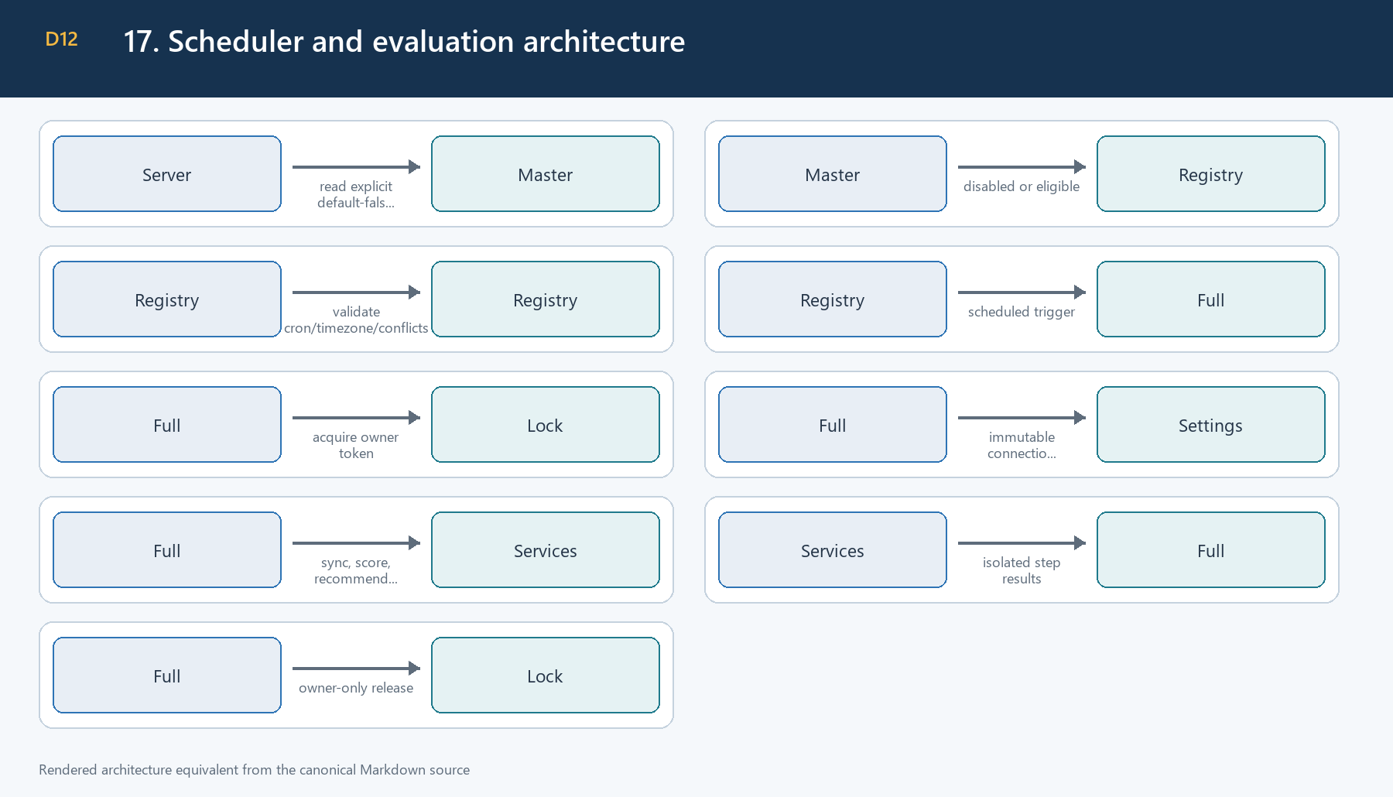
Figure 12. 17. Scheduler and evaluation architecture
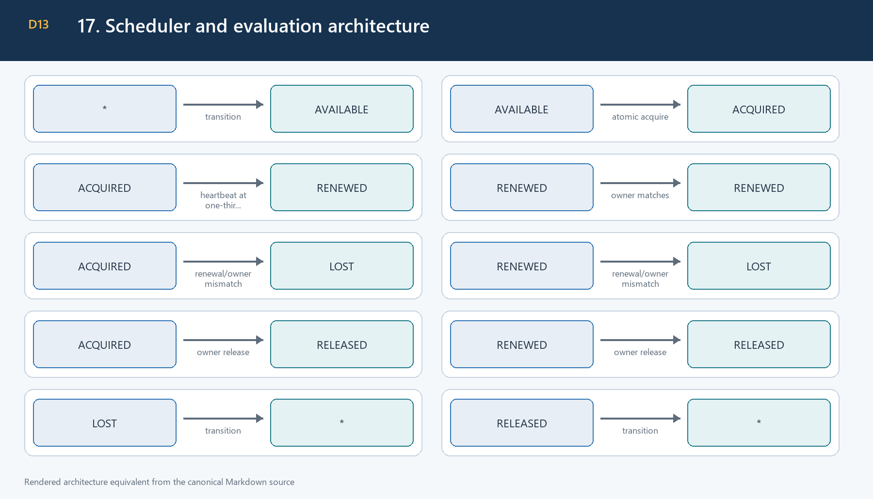
Figure 13. 17. Scheduler and evaluation architecture

Eligibility precedence
master flag AND scheduler registration flag AND effective connection/platform setting AND provider capability AND required live gate.

Scheduler flags
Job | Flag | Default cron/timezone | Lock
Recommendations | MARKETING_RECOMMENDATION_SCHEDULER_ENABLED | 15 */6 * * *, UTC | recommendations
Alert health | MARKETING_ALERT_HEALTH_SCHEDULER_ENABLED | 5 * * * *, UTC | alerts:health
Alert performance | MARKETING_ALERT_PERFORMANCE_SCHEDULER_ENABLED | 30 2 * * *, UTC | alerts:performance
Creative sync | MARKETING_CREATIVE_SYNC_SCHEDULER_ENABLED | 30 */6 * * *, UTC | creative-sync
Creative scoring | MARKETING_CREATIVE_SCORE_SCHEDULER_ENABLED | 0 1 * * *, UTC | creative-score
Recommendation expiry | MARKETING_RECOMMENDATION_EXPIRY_SCHEDULER_ENABLED | 30 2 * * *, UTC | recommendation-expiry
Full evaluation | MARKETING_FULL_EVALUATION_SCHEDULER_ENABLED | 0 3 * * *, UTC | full-evaluation

Full evaluation and component schedules are mutually exclusive. SKIPPED_LOCKED, heartbeat failure, partial success, failure isolation, sanitized summaries, and graceful stop are durable operational behaviors.

18. API architecture
The base path is /api/v1/marketing/intelligence. There are 26 required Phase 2 endpoints plus 18 legitimate Phase 1/earlier extensions, for 44 total routes.

Required 26 endpoints
Method/path | Purpose | RBAC | Master-disabled behavior | Idempotency/errors
GET /creatives | list creative assets | VIEW | available | paginated
GET /creatives/:id | creative detail | VIEW | available | UUID/not found
POST /creatives/sync | manual creative sync | EDIT | blocked | lock/partial/provider errors
POST /creatives/score | manual scoring | EDIT | blocked | lock/partial
GET /recommendations | list recommendations | VIEW | available | paginated
GET /recommendations/:id | recommendation detail | VIEW | available | UUID/not found
POST /recommendations/evaluate | manual evaluation | EDIT | blocked | lock/partial
PATCH /recommendations/:id/accept | accept pending advice | EDIT | blocked | equivalent repeat safe
PATCH /recommendations/:id/dismiss | dismiss with reason | EDIT | blocked | transition conflict
POST /recommendations/:id/convert-to-task | atomic Task conversion | EDIT | blocked | returns existing linked Task
GET /alerts | list alerts | VIEW | available | paginated
GET /alerts/:id | alert detail | VIEW | available | UUID/not found
POST /alerts/evaluate | manual alert evaluation | EDIT | blocked | lock/partial
PATCH /alerts/:id/acknowledge | acknowledge alert | EDIT | blocked | lifecycle validated
PATCH /alerts/:id/resolve | resolve with reason | EDIT | blocked | lifecycle validated
GET /experiments | list experiments | VIEW | available | paginated
GET /experiments/:id | experiment detail | VIEW | available | UUID/not found
POST /experiments | create draft | EDIT | blocked | strict bounded body
PATCH /experiments/:id | update draft | EDIT | blocked | version/status checked
POST /experiments/:id/start | start draft | EDIT | blocked | transition conflict
POST /experiments/:id/complete | complete running experiment | EDIT | blocked | evidence required
POST /experiments/:id/cancel | cancel draft/running | EDIT | blocked | reason required
GET /settings | configured/effective settings | VIEW | available | warnings in metadata
PATCH /settings | atomic versioned settings | EDIT + ADMIN | available | stale version 409
GET /evaluation-runs | list run ledger | VIEW | available | strict filters/sorts
GET /evaluation-runs/:id | run detail | VIEW | available | sanitized summary

Approved 18 extensions
Method/path | Purpose/RBAC | Master-disabled behavior
POST /attribution/clicks | public rate-limited attribution | available
GET /oauth/:platform/callback | rate-limited OAuth callback | available
GET /performance | stored Phase 1 performance, VIEW | available
GET /creatives/:id/scores/latest | latest score, VIEW | available
GET /creatives/:id/scores | score history, VIEW | available
GET /provider-validation | validation status, VIEW | available
GET /connections | connection administration, EDIT | available
GET /connections/:id | connection detail, EDIT | available
POST /connections | connection setup, EDIT | available
PATCH /connections/:id | connection configuration, EDIT | available
POST /connections/bootstrap | env preparation, EDIT | available
POST /connections/:id/disable | disable one connection, EDIT | available
POST /connections/:id/enable | enable one connection, EDIT | available
POST /connections/:id/test | bounded connection validation, EDIT | available
POST /connections/:id/validation-evidence | record operator evidence, EDIT | available
DELETE /connections/:id | safe connection removal, EDIT | available
GET /oauth/:platform/start | OAuth preparation, EDIT | available
POST /sync | independent Phase 1 campaign sync, EDIT | available

Operationally blocked requests receive HTTP 503 with MARKETING_INTELLIGENCE_PHASE2_DISABLED. Authentication and RBAC are evaluated before the feature gate.

19. RBAC and audit
Reads use marketing/intelligence VIEW; mutations use EDIT; settings mutation additionally uses the repository ADMIN-tier policy. Services independently validate active actors for lifecycle, Task, settings, and manual operations.
Audit family | Trigger | Atomicity | Safe metadata
Manual sync/evaluation | operator action | run mutation plus audit as applicable | IDs, scope, counts, status
Recommendation lifecycle | accept/dismiss/convert | transactionally paired | previous/new state, reason code, IDs
Alert lifecycle | acknowledge/resolve | transactionally paired | state, actor, bounded reason
Experiment lifecycle | create/update/start/complete/cancel | transactionally paired | version/state/changed fields
Settings | atomic batch | same serializable transaction | keys/scopes/versions, not values containing secrets
Connection validation | operator evidence | durable update plus audit | validation booleans/timestamps

Audit metadata excludes credentials, raw provider bodies, complete payment references, lock owners, arbitrary request bodies, stacks, and full variant/evidence JSON. Idempotent repeats do not create duplicate transition audits.

20. Validation, security, and privacy
- Canonical UUIDs are checked before Prisma access.
- Enums constrain platform, state, rule, metric, sort, direction, and filter values.
- Date-only fields are exact calendar dates; timestamps require explicit timezone.
- UTC queries use start-inclusive/end-exclusive boundaries.
- Pagination and sort fields are bounded allowlists; client input cannot become arbitrary Prisma filters.
- Decimal helpers handle money and ratios; unsafe Number-based money calculations are not used.
- Plain JSON limits are 64 KiB, depth 8, 100 fields, 200 array entries, and 4,000 Unicode characters per string by default.
- Secret/prototype keys, executable metadata, HTML/script/control content, buffers, and oversized values are rejected or sanitized.
- Response serialization recursively excludes tokens, credential envelopes, authorization material, raw provider payloads, lock owners/hashes, stacks, and database URLs.
- Public ingestion remains rate-limited; internal funnel ingestion remains authenticated.
- Optional LLM commentary cannot send data or alter deterministic recommendations because no LLM adapter exists.

21. Error handling and observability
Code/family | HTTP | Retryable | Use
MARKETING_INTELLIGENCE_PHASE2_DISABLED | 503 | No | deployment kill switch
PROVIDER_UNAVAILABLE | 503 | Yes | timeout/temporary provider failure
PROVIDER_PERMISSION_DENIED | 403 | No | provider permission
TOKEN_REFRESH_FAILED | 503 | Yes | authorization refresh
LOCK_CONFLICT | 409 | Yes | existing owner
LOCK_OWNERSHIP_LOST | 409 | Yes | heartbeat/owner mismatch
INSUFFICIENT_DATA | 422 | No | evidence boundary
INVALID_TRANSITION | 409 | No | lifecycle state
DUPLICATE_ACTION | 409 | No | immutable identity conflict
PARTIAL_SUCCESS | 200 | Yes | independent scope failures
VALIDATION_ERROR | 400 | No | request contract
NOT_FOUND | 404 | No | resource missing
FORBIDDEN | 403 | No | actor/RBAC
RATE_LIMITED | 429 | Yes | request/provider limit
STALE_VERSION | 409 | No | settings concurrency
SETTING_INVALID | 400 | No | setting bounds/scope
TASK_INTEGRITY_CONFLICT | 409 | No | missing linked Task

Structured events cover sync start/completion, provider failures, lock outcomes, scoring, recommendation/alert evaluation, Task conversion, provider fetch/token refresh, run completion, and scheduler status. Records contain timestamp, stable event, safe IDs/scope/status/counts/duration, provider category, retryability, and validated request IDs where available. Secrets and raw bodies are excluded.
Provider categories are AUTHENTICATION, PERMISSION, RATE_LIMIT, TIMEOUT, UNAVAILABLE, INVALID_REQUEST, PROVIDER_DATA, and UNKNOWN.

22. Testing architecture
Suite | Main coverage
Attribution | identity, windows, signup/payment/refund/chargeback, dedupe
Connectors | five contracts, pagination, refresh, micro-units, sanitization
Creative | upserts, normalization, scoring, sufficiency, fatigue
Recommendations | rules, confidence, lifecycle, dedupe, expiry
Tasks | transaction, row lock, assignee, idempotency, audit, delivery
Alerts | rules, cooldown, persistence, recovery, delivery/no-spam
Experiments | bounded variants, lifecycle, immutability, no execution
Settings | types, scopes, currency, defaults, versions, actor policy
Jobs | master flag, schedules, locks, heartbeat, full evaluation, runs
Security | privacy, redaction, strict validation, provider-write absence
Migrations | manifest canonicalization, ordering, safety, replay/drift
Network | blocks live provider/DNS/socket access in tests
Documentation | canonical files, diagrams, WP/provider/default/Task accuracy

Provider tests use injected mocks. The runtime network guard blocks external HTTP, HTTPS, fetch, axios transports, DNS, public IPs, provider hosts, metadata endpoints, and unregistered sockets while allowing registered local test services and the configured local database.

23. Deployment architecture

Environment controls
- MARKETING_INTELLIGENCE_PHASE2_ENABLED=false is the master default.
- MARKETING_LIVE_VALIDATION_ENABLED=false protects the manual validation CLI.
- Every scheduler registration flag defaults false.
- Provider credentials remain encrypted/configured outside documentation.
- Phase 1 MARKETING_INTELLIGENCE_SYNC_ENABLED is independent.

Deployment sequence
- Validate the admin database target.
- Verify the canonical migration manifest.
- Deploy the 21 ordered manual migrations.
- Run schema assertions and empty-database replay in the release environment.
- Deploy code with master false and schedulers false.
- Confirm reads/settings/connection preparation and Phase 1 behavior.
- Perform one explicit provider live gate.
- Advance only that connection through rollout stages.
Graceful shutdown stops Social workers, Phase 2 registry jobs, and Phase 1 sync, waits for tracked callbacks, disconnects databases, and preserves run/lock evidence. Rollback first disables the master and component scheduler flags; historical data is not deleted or migration-reversed.

24. Six-stage rollout
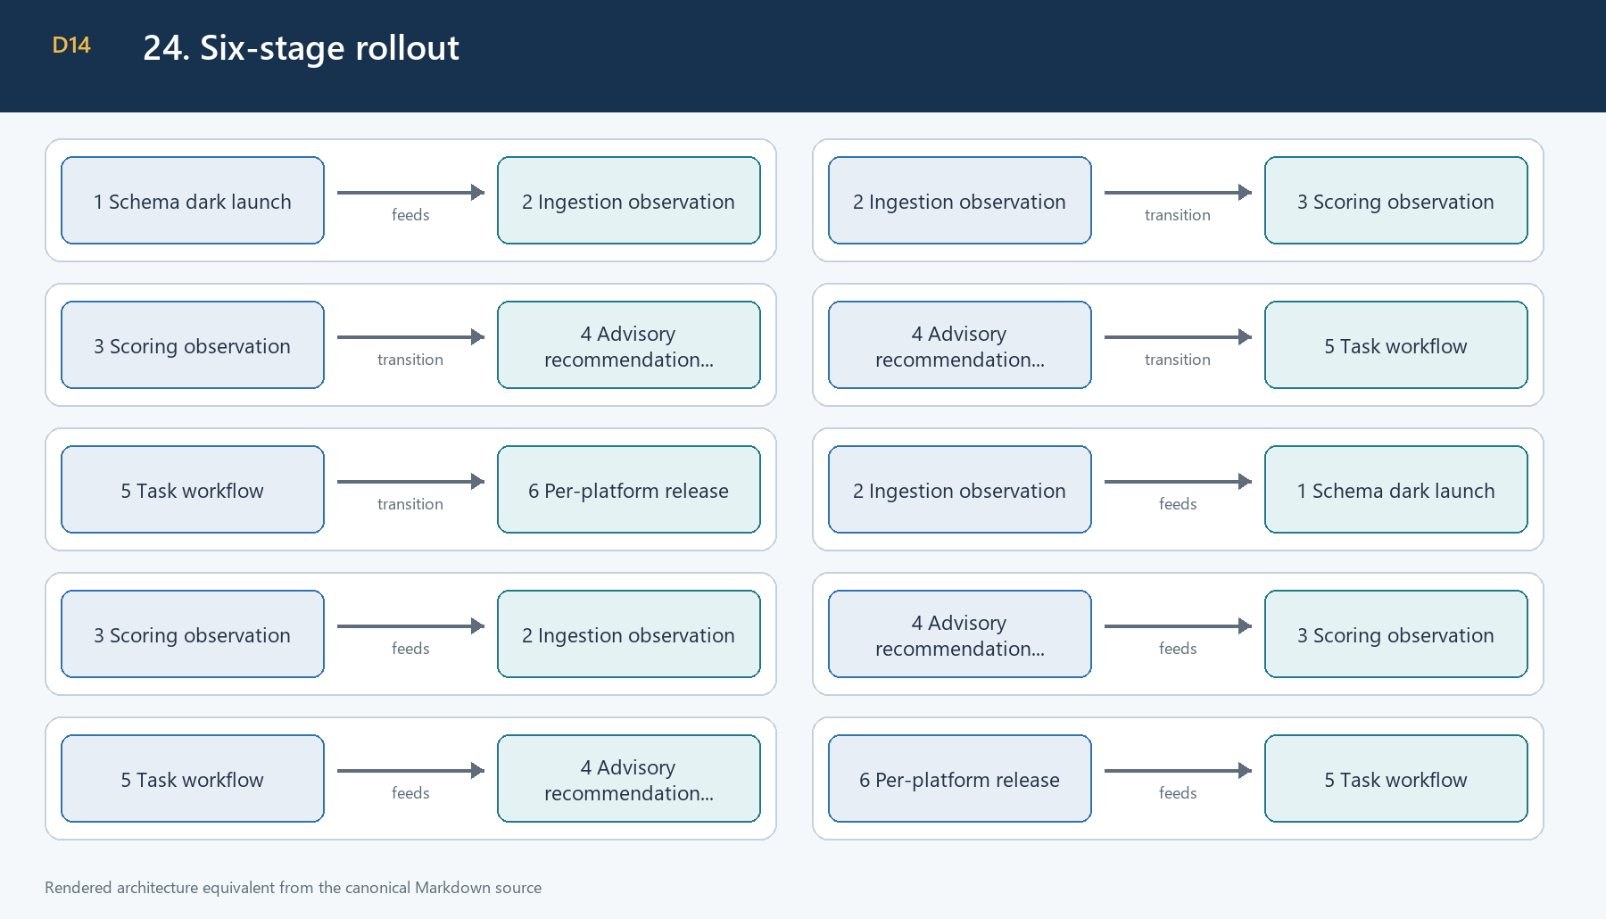
Figure 14. 24. Six-stage rollout
Stage | Enabled | Prerequisites/exit criteria | Rollback | Owner/status
1 Schema dark launch | migrations; master/schedulers false; reads/settings/setup | replay, no drift/leaks, Phase 1 unaffected | keep master false | Platform + DBA / READY
2 Ingestion observation | master true; one validated connection creative sync | stable IDs/currency/counts/pagination/no duplicates | disable connection or creative sync | Marketing Ops / PENDING
3 Scoring observation | sync and scoring only | sufficiency/score/fatigue review; no fabricated metrics | disable scoring schedule | Analytics / PENDING
4 Advisory | recommendations/alerts; no provider writes | currency targets, quality, cooldown/no-spam review | disable business toggles | Marketing + Support / PENDING
5 Task workflow | accepted recommendations may create Task | eligible assignee, transaction/idempotency/audit/delivery | disable conversion via master or connection | Operations / PENDING
6 Platform release | only platforms with passed live gate | no critical blocker; monitoring/rollback active | disable affected connection/platform | Release owner / PENDING

25. Live-provider validation
No live provider was contacted while producing this document. Automated mocks do not satisfy a live gate. Current machine-readable status is docs/marketing-intelligence-phase2-live-validation-status.json.

Safety command
$env:MARKETING_LIVE_VALIDATION_ENABLED='true'
npm run marketing:live-validate -- --confirm-live --platform=META --connection-id=11111111-1111-4111-8111-111111111111 --from=2026-07-01 --to=2026-07-02 --account=act_123
Replace values only after an authorized operator confirms provider, connection, bounded account, maximum seven-day range, read-only operation, redacted destination, and incident owner. Run one provider at a time. Never run under NODE_ENV=test.

Gate checklist
- Connection test.
- One bounded account/date range.
- Pagination behavior.
- Rate-limit classification from safe evidence, never by intentionally exhausting quota.
- Campaign totals reconciled with Phase 1 and documented provider definitions.
- Repeated stable creative/ad identities.
- Currency and micro-unit reconciliation.
- Sanitized raw-storage review.
- Normalized catalog/insight row counts.
- Removed-provider assets remain historical.
- Scoring observation review.
- Recommendations/alerts only after sufficient history.
- Approval/capability limitation recorded.
The CLI records only bounded counts, statuses, categories, and blockers. It does not persist credentials, headers, raw bodies, or encrypted credential envelopes. A successful CLI subset remains LIVE_VALIDATION_IN_PROGRESS until operator reconciliation and approval complete the entire gate.

26. Operations runbook

Start and verify
- Run configuration validation.
- Confirm master and scheduler values without printing secrets.
- Start the existing server process.
- Inspect structured scheduler registration events.
- Query evaluation runs and provider validation status.

Stop and rollback
- Set MARKETING_INTELLIGENCE_PHASE2_ENABLED=false.
- Set all Phase 2 scheduler flags false.
- Restart or gracefully stop the process so registrations are removed.
- Disable an affected connection through its existing endpoint when isolation is sufficient.
- Keep Phase 1 sync enabled if healthy.
- Preserve all settings, runs, scores, recommendations, alerts, experiments, Tasks, Notifications, and audits.

Incident evidence
Collect run ID, connection/platform ID, trigger, status, safe provider category/code, retryability, counts, duration, lock outcome, scheduler configuration source, deployment version, and operator timeline. Do not collect credentials, headers, raw responses, payment PII, stack dumps, or lock-owner tokens.

Credential rotation
Disable the connection, rotate/re-authorize using provider setup, run the controlled connection/live gate, record evidence, then re-enable only after approval. Do not copy credential values into tickets or documents.

Alert-spam response
Disable alert evaluation for the scoped connection/platform, inspect dedupe/cooldown/occurrence data, correct settings if necessary with optimistic concurrency, and re-enable in observation mode. Do not delete historical alerts.

27. Troubleshooting guide
Symptom | Diagnosis | Safe response
Feature disabled | master false | confirm intended stage; do not bypass with component flag
Authentication failed | provider category AUTHENTICATION | disable connection and rotate/re-authorize
Permission denied | provider category PERMISSION | confirm account/app approval
Rate limited | RATE_LIMIT/retryable | respect backoff; reduce page/range frequency
Token refresh failed | refresh category/code | rotate credentials; preserve sanitized evidence
Sync stale | latest successful fetch outside threshold | inspect scheduler/master/connection/run ledger
Lock conflict | another valid owner | wait; inspect run; do not delete lock blindly
Lock ownership lost | heartbeat failure/owner mismatch | stop unsafe continuation; inspect duration/DB health
Partial success | independent scope failure | retain successes; retry only failed idempotent scope
No eligible data | sufficiency/target/currency unavailable | configure data/target; never invent zero
Missing target CPA | currency-specific target absent | create scoped currency setting
No eligible assignee | request/config/fallback unavailable | configure active eligible admin
Notification failure | alert/Task persisted, delivery failed | retry operational delivery; do not roll back history
Realtime failure | post-commit delivery failed | inspect Socket.IO health; durable record remains
Manifest mismatch | migration content/order changed | stop release; reconcile without rewriting applied SQL
Schema drift | replay/assertion differs | stop rollout; determine additive corrective migration

28. Risk register
Creative API unavailable/approval-limited — High/High
Risk | Creative API unavailable/approval-limited
Likelihood/impact | High/High
Owner | Platform owner
Early warning | permission/capability status
Controls/mitigation | explicit capability matrix, isolated provider failure
Contingency | keep platform disabled
Residual/current state | High / pending live gate
Attribution ambiguity — High/High
Risk | Attribution ambiguity
Likelihood/impact | High/High
Owner | Analytics
Early warning | campaign-only/unknown evidence
Controls/mitigation | deterministic precedence, no creative duplication
Contingency | report unavailable
Residual/current state | Medium / controlled
Cross-currency misuse — Medium/High
Risk | Cross-currency misuse
Likelihood/impact | Medium/High
Owner | Finance/Analytics
Early warning | mixed-currency flag/null metric
Controls/mitigation | currency identity, Decimal, no FX
Contingency | disable monetary rule
Residual/current state | Low / controlled
Provider API version drift — High/Medium
Risk | Provider API version drift
Likelihood/impact | High/Medium
Owner | Platform owner
Early warning | provider data/error category
Controls/mitigation | version config, normalized contract, mocks
Contingency | disable affected connector
Residual/current state | Medium / monitored
Rate limits/pagination — High/Medium
Risk | Rate limits/pagination
Likelihood/impact | High/Medium
Owner | Platform owner
Early warning | 429/cursor/retry telemetry
Controls/mitigation | bounded pages/ranges, retry policy
Contingency | reduce frequency
Residual/current state | Medium / live pending
Duplicate recommendations/Tasks — Medium/High
Risk | Duplicate recommendations/Tasks
Likelihood/impact | Medium/High
Owner | Backend
Early warning | uniqueness/serializable conflicts
Controls/mitigation | dedupe keys, row lock, one-to-one Task link
Contingency | return existing record
Residual/current state | Low / tested
Alert spam — Medium/High
Risk | Alert spam
Likelihood/impact | Medium/High
Owner | Marketing Ops
Early warning | occurrence/delivery volume
Controls/mitigation | active dedupe, cooldown, persistence/recovery
Contingency | disable scoped alerts
Residual/current state | Low / observation pending
Lock expiry during long run — Medium/High
Risk | Lock expiry during long run
Likelihood/impact | Medium/High
Owner | SRE
Early warning | renewal failure
Controls/mitigation | one-third TTL heartbeat, owner checks
Contingency | stop run, increase reviewed TTL
Residual/current state | Low / tested
PII/secret logging — Medium/Critical
Risk | PII/secret logging
Likelihood/impact | Medium/Critical
Owner | Security
Early warning | secret scan/redaction alert
Controls/mitigation | bounded structured logs/serializers
Contingency | disable workload, rotate credentials
Residual/current state | Low / scans clean
Organic/paid coupling — Medium/High
Risk | Organic/paid coupling
Likelihood/impact | Medium/High
Owner | Architecture
Early warning | cross-module imports/actions
Controls/mitigation | separate domains and schedules
Contingency | disable affected module
Residual/current state | Low / enforced
Sparse data — High/Medium
Risk | Sparse data
Likelihood/impact | High/Medium
Owner | Analytics
Early warning | insufficiency distribution
Controls/mitigation | sufficiency states/null metrics
Contingency | extend observation window
Residual/current state | Medium / expected
Mock-only confidence — High/Medium
Risk | Mock-only confidence
Likelihood/impact | High/Medium
Owner | Release owner
Early warning | live status not passed
Controls/mitigation | honest status artifact/live gate
Contingency | stage 1 only
Residual/current state | High / current blocker
Migration conflict — Low/High
Risk | Migration conflict
Likelihood/impact | Low/High
Owner | DBA
Early warning | manifest/replay failure
Controls/mitigation | immutable ordered manifest and replay
Contingency | stop deploy/add correction
Residual/current state | Low / verified
Phase 3 scope creep — Medium/Medium
Risk | Phase 3 scope creep
Likelihood/impact | Medium/Medium
Owner | Product/Architecture
Early warning | new mutation/model/LLM dependency
Controls/mitigation | locked non-goals/static tests/review
Contingency | remove or separately approve
Residual/current state | Low / absent

Risk-to-control examples
Risk | Code control | Operational control | Test/monitoring | Remaining exposure
Alert spam | dedupe/cooldown/recovery | scoped disable and review | alert tests/evaluation telemetry | live thresholds
Secret logging | redaction/bounded serializer | credential handling policy | secret scan/log tests | provider SDK changes
Duplicate Task | row lock/unique link | idempotent operator retry | Task concurrency tests/audit | database outage race
Rate limit | classifier/retry cap | bounded validation window | connector mocks/provider failure logs | actual quota
Mock-only confidence | status gate | per-provider approval | network guard + live artifact | external credentials

Review risks before each rollout-stage exit and after any provider API/version, schema, credential, or incident change.

29. Final Definition of Done
Requirement | Status | Code/test evidence | Live evidence/blocker
Mandatory Phase 1 corrections | COMPLETE | WP0/attribution/revenue tests | source-app coverage remains external
Five creative connector contracts | LIVE_VALIDATION_PENDING | registry/provider mock tests | credentials/approval required
Durable/account-aware/idempotent creative history | COMPLETE | schema/upsert/scoring tests | observation pending
Deterministic configurable classification | COMPLETE | settings/rule/Decimal tests | quality review pending
Recommendation lifecycle and atomic Task conversion | COMPLETE_WITH_CONFIGURATION | recommendation/Task tests | assignee/operational verification
Alert lifecycle/delivery/no-spam | COMPLETE_WITH_CONFIGURATION | alert tests | cooldown observation
Tracking-only experiments | COMPLETE | experiment/security tests | no live execution applicable
Lock-safe isolated evaluation | COMPLETE | scheduler/lock/run tests | stage observation pending
RBAC/audit/privacy/rate limits/Decimal | COMPLETE | security/network suites | none
Prisma/migrations/manifest/quality gates | COMPLETE | release commands | deployment environment must repeat
Documentation reflects five platforms/policies | COMPLETE | documentation tests and this document | none
No Phase 3 model/provider mutation | COMPLETE | static tests/source audit | none

Final engineering verdict: PHASE2_ENGINEERING_COMPLETE_LIVE_VALIDATION_PENDING.
Lint is SCRIPT_NOT_DEFINED; the repository has no configured lint framework. Build is NOT_APPLICABLE for this plain-JavaScript backend; Prisma generation, syntax checks, static security checks, and tests are the build-equivalent gates.

30. Appendices

30.1 State and enum summary
- Platforms: META, TIKTOK, X, LINKEDIN, GOOGLE_ADS.
- Recommendation states: PENDING, ACCEPTED, DISMISSED, EXPIRED, CONVERTED_TO_TASK.
- Alert states: OPEN, ACKNOWLEDGED, RESOLVED; severities INFO, WARNING, CRITICAL.
- Experiment states: DRAFT, RUNNING, COMPLETED, CANCELLED.
- Run outcomes include STARTED, SUCCEEDED, PARTIAL_SUCCESS/PARTIALLY_SUCCEEDED, FAILED, SKIPPED_LOCKED, and lock-renewal failure.
- Creative sufficiency: INSUFFICIENT, LIMITED, SUFFICIENT, STRONG; fatigue: NONE, WATCH, FATIGUED, RECOVERED.

30.2 Migration inventory
- 20260705_add_marketing_campaigns_content.sql
- 20260705_add_marketing_email_templates_social.sql
- 20260705_add_marketing_promotions_banners_analytics.sql
- 20260714_add_marketing_intelligence_phase1.sql
- 20260715_add_marketing_connection_token_expiry.sql
- 20260716_add_marketing_attributions_phase1.sql
- 20260716_add_social_operations_section_5.sql
- 20260717_212000_migrate_legacy_marketing_social_records.sql
- 20260717_extend_marketing_ad_platforms.sql
- 20260717_make_task_assignee_nullable_for_safety.sql
- 20260718_add_marketing_connection_credentials_currency.sql
- 20260718_ensure_social_operations_partial_indexes.sql
- 20260719_finalize_marketing_intelligence_connections.sql
- 20260720_fix_marketing_intelligence_currency_width.sql
- 20260721_marketing_intelligence_wp0_corrections.sql
- 20260722_marketing_intelligence_phase2_section7_schema.sql
- 20260723_marketing_intelligence_phase2_section8_raw_ingestion.sql
- 20260724_marketing_intelligence_phase2_section9_scoring_enums.sql
- 20260725_marketing_intelligence_phase2_sections10_13.sql
- 20260726_marketing_intelligence_sections10_13_audit_corrections.sql
- 20260727_marketing_intelligence_sections14_17.sql

30.3 Major file inventory
Area | Actual path | Responsibility | Principal tests
Routing/controller | src/modules/marketing/intelligence/intelligence.routes.js, intelligence.controller.js | API, RBAC, validation, envelopes | route/authz tests
Master flag | src/modules/marketing/intelligence/phase2-feature.js | deployment kill switch and stable disabled results | Sections 22-26
Connections/connectors | provider-connections.service.js, connectors/ | credentials, OAuth, campaign reads | provider tests
Creative | creative/ | registry, normalization, sync, snapshots, scoring, fatigue | creative tests
Attribution | attribution/funnel/listener/event files | internal truth and adjustments | attribution/WP0 tests
Recommendations | recommendations/ | settings, inputs, rules, confidence, lifecycle, Tasks | recommendation/Task tests
Alerts | alerts/ | rules, lifecycle, delivery, recovery | alert tests
Experiments | experiments/ | tracking lifecycle | experiment tests
Settings | setting registry/service/validators | typed precedence/versioning | Sections 14-17/22-26
Scheduling | scheduling/, full evaluation, run ledger | jobs, orchestration, locks, summaries | scheduler/lock tests
Security/observability | validation, serializer, errors, observability | privacy and stable operations | Sections 18-21
Live validation | scripts/marketing-intelligence/live-validate-provider.js | explicit one-provider read-only gate | Sections 22-26

30.4 Quality commands
npx prisma validate --schema=prisma/schema.prisma
npx prisma generate --schema=prisma/schema.prisma
npm run db:manifest:generate
npm run db:manifest:verify
npm run migrations:safety
npm run db:admin:guard
npm run db:schema:assert
npm run db:replay:verify
npm run config:validate
npm run security:secret-scan
npm run security:audit-policy
npm run security:network-guard-static
npm run test:network-guard
npm run security:static-social
npm run test:social-operations
npm test
git diff --check

30.5 Final checklist
- ☑ Git baseline recorded; staging branch preserved.
- ☑ Correct Admin Prisma client and existing infrastructure reused.
- ☑ WP0-WP12 reconciled.
- ☑ Master flag default false and tested.
- ☑ Approved defaults reconciled.
- ☑ Five provider code capabilities documented.
- ☑ Controlled live-validation tool and sanitized status artifact created.
- ☑ Provider writes and Phase 3 models absent.
- ☑ Six-stage rollout, rollback, operations, troubleshooting, and risks documented.
- ☐ Meta live gate passed.
- ☐ TikTok live gate passed.
- ☐ X live gate passed.
- ☐ LinkedIn live gate passed.
- ☐ Google Ads live gate passed.

30.6 Glossary
- Capability: A connector operation demonstrably implemented in code; it is not proof of provider approval.
- Live gate: Authorized evidence that one configured connection works against the real provider within a bounded read-only scope.
- Observation mode: Data collection/scoring without downstream recommendation, alert, or Task activation.
- Provider conversion: Provider-reported informational conversion, distinct from trustworthy internal funnel truth.
- Run ledger: Durable sanitized operational history for manual and scheduled evaluations.
- Master flag: Deployment kill switch that cannot be bypassed by scheduler or business toggles.

