Selecting Recommender Systems When Fairness Rankings Are Unstable
  - Project Proposal
Project 9 Conflicting recommender fairness metrics
Team PHANTOM TROUPE

Submitted by
Tony Nicholas Panneer Jesuraja
Parvesh Kumar
M.Sc. Data Science 60 ECTS
University of Europe for Applied Sciences, Potsdam

Module PW26 Interdisciplinary Elective
AI, Power & Responsibility – Governing Intelligence

Project supervisor: Dr. Raja Hashim Ali

Submission Date: 2 November 2026

Table of Contents
Abstract 3
1 Introduction and Background 4
2 Problem Statement and Research Gap 5
3 Research Objectives 6
4 Research Questions 7
5 Theoretical Framework 8
6 Methodology 9
7 Expected Contributions 14
8 Target Journal 14
9 Expected Results and Planned Outputs 15
10 References 26
Appendix A Experimental Specification 28
Appendix B Governance and Feasibility 30

Abstract
Recommender systems allocate user benefit and item attention. A model that reduces demographic utility gaps may produce recommendations that fit individual genre histories less closely or concentrate exposure on a smaller part of the catalogue. Selecting a model therefore depends on the objectives used and on whether observed differences are stable enough to support a decision.
This proposal develops and evaluates a bootstrap-supported Pareto shortlist for relevance-constrained recommender selection. MovieLens 1M will provide the main benchmark using a fixed sample of at most 3,000 users, and MovieLens 100K will provide a pilot and related-benchmark replication. Popularity, item-neighbour collaborative filtering and low-rank matrix factorisation will be evaluated with genre-calibrated reranking. A global chronological training, validation and test split will separate selection from later evaluation.
Five research questions distinguish metric disagreement, simultaneous uncertainty in apparent gains, shortlist stability and selectivity, audit composition, and observed preference change. Candidates within 2% of the best validation NDCG@10 will be screened using 1,000 paired user bootstrap replicates. A provisional 80% nondominance-support threshold will define the shortlist. Support is an empirical stability statistic and does not provide an 80% confidence guarantee. Evaluation will report overlap together with shortlist size, abstention, test-period dominance and relevance loss.
The intended contribution is a bounded selection procedure and a reproducible evaluation of when it adds value over simpler selectors. Existing calibration, Pareto, bootstrap and model-set methods provide its foundations. The supplied executed pilot and coverage audit establish initial implementation feasibility but reveal substantial warm-start exclusions and small demographic cells. Temporal and intersectional conclusions will therefore be conditional on available evidence. All twenty expected-result exhibits in this proposal use synthetic examples rather than measured outcomes.
Keywords: recommender systems; fairness auditing; model selection; Pareto nondominance; paired user bootstrap; chronological evaluation; AI governance.

1 Introduction and Background
Movie recommendation is a useful setting for studying how algorithmic evaluation influences institutional decisions. Recommenders prioritise some films and some forms of user benefit. An auditor must decide whether to prioritise equal ranking utility across recorded groups, alignment with each user’s historical preferences, or a less concentrated allocation of item exposure. These criteria describe different values and should remain interpretable as separate objectives.
Calibration compares the distribution of features in a user’s history with the features represented in recommendations. Da Silva and Durão benchmark 57 calibration measures and alternative distribution formulations in movie recommendation [1]. Their work establishes that metric and implementation choices can affect the apparent quality of a calibrated recommender.
Pareto evaluation also precedes this study. Rampisela et al. propose Distance to Pareto Frontier (DPFR) for joint relevance and item-fairness evaluation [2]. The 2026 accepted author manuscript extends this work with robustness experiments [3]. The present proposal builds on these foundations while examining the reliability of retaining a small set of fitted candidates when the audited users or evaluation period changes.
Sampling and uncertainty are relevant to that decision. Work on recommender evaluation studies how sampling affects comparisons [4]; simultaneous fairness auditing [11], post-selection performance bounds [6] and model confidence sets [12] demonstrate that uncertainty-aware evaluation and set-valued selection are established ideas. Time-aware calibration is also established [5]. The research opportunity is to test a specific combination of these ideas against meaningful alternatives under an explicit temporal protocol.
The project is designed for a two-person CPU workflow. It focuses on the quality of an audit decision rather than a new recommendation architecture. Reusing fitted scores for resampling limits repeated computation. CPU time and memory will be logged; no carbon-emission reduction will be claimed without an appropriate energy measurement.
For AI governance, an inconclusive comparison can be informative. A small defensible shortlist may better represent the available evidence than a forced winner. That benefit is a hypothesis: retaining all candidates can create apparent stability without providing useful guidance, so stability must be evaluated with selectivity and later quality.

2 Problem Statement and Research Gap
The central problem is whether a relevance-constrained, bootstrap-supported Pareto shortlist can make recommender selection more repeatable across user audits and later ratings without retaining an uninformatively large set or losing useful candidates.
A disagreement between fairness objectives may represent a real trade-off. A change in the winner within one objective may instead reflect limited evaluation data. The study separates these sources of instability and asks whether the selection procedure helps an auditor distinguish them. It will also examine who is excluded by the warm-start evaluation and where the available demographic cells provide too little resolution.

2.1 Closest prior work and intended distinctions
Calibration benchmarking [1] establishes sensitivity to the chosen measure. DPFR [2] and its robustness extension [3] establish joint evaluation and model disagreement. Consequently, neither disagreement nor using a Pareto frontier is an original contribution. Our proposed distinction is a user-bootstrap-supported shortlist assessed on later data with explicit size-matched controls and abstention reporting.
Sampling reliability [4] motivates separability and stability checks. Our primary resampling unit is the evaluation user with all candidate outcomes kept paired. We will rank the fixed training catalogue rather than sample evaluation negatives. This distinction will be preserved in both the implementation and the discussion.
Simultaneous fairness inference [11] and post-selection inference [6] motivate adjusted comparisons. Model confidence sets [12] provide prior art for reporting a set when a unique best model is not established. Our nondominance-frequency rule is an empirical procedure; it does not inherit those papers’ coverage guarantees.
Time-aware profile construction [5] is prior art. RQ5 therefore tests whether observed history change predicts later selection reversals and whether existing profiles improve that decision, rather than claiming to invent recency weighting. Small repeat-user cohorts may limit this extension.

2.2 Novelty assessment and scope of the claim
A targeted literature check conducted on 2 November 2026 considered calibration benchmarking, Pareto evaluation and its 2026 extension, evaluation sampling, time-aware calibration, simultaneous auditing and model-set selection [1–12]. It supports a plausible incremental contribution for this project. It does not establish universal priority or guarantee journal acceptance.
The refined questions make RQ3 the central contribution and separate the remaining questions by endpoint: cross-objective disagreement in RQ1, inferential support and aggregate directional reversals in RQ2, composition sensitivity in RQ4, and within-user temporal mechanisms in RQ5. Before final submission of a manuscript, record a full-paper comparison with page or section evidence, particularly for the 2026 DPFR extension whose full text was not retrievable during this check.

3 Research Objectives
Overall objective: develop and evaluate an auditable procedure for retaining a small, useful set of recommenders when competing fairness objectives and limited user data make a unique selection uncertain.
- O1 — Metric disagreement: Quantify disagreement between objective-specific choices and distinguish it from resampling variability within each objective.
- O2 — Supported gains: Assess prespecified candidate-pair fairness improvements with simultaneous intervals and examine whether later ordering reverses.
- O3 — Selection reliability: Test the bootstrap-supported Pareto shortlist against simpler selectors, using stability, size, abstention and retained-model quality together.
- O4 — Audit resolution: Determine how subgroup composition, activity and available cell sizes affect conclusions under clearly stated sampling targets.
- O5 — Temporal explanation: Investigate whether observed genre-profile change predicts later within-user calibration reversals and whether existing time-aware profiles improve selection reliability.

3.1 Evidence required for a useful contribution
The main procedure will be considered useful only if stability improvements remain credible after accounting for set size and test-period quality. We will compare stability at common set sizes where possible, report relevance loss separately from fairness outcomes, and retain negative results. A shortlist that is stable because it contains almost everything will not be presented as an improvement.
RQ1 and RQ2 establish the decision problem. RQ3 evaluates the proposed response. RQ4 identifies the populations for which an audit is informative. RQ5 is a conditional extension because sparse repeated observations may prevent a reliable temporal analysis. These roles prevent routine descriptive questions from being presented as five independent methodological inventions.

4 Research Questions

RQ1 Metric disagreement
Among candidates within 2% of the best validation NDCG@10, how often do group utility parity, genre-preference calibration and item-exposure concentration favour different models, and which within-objective rankings remain stable under paired user resampling?

RQ2 Supported gains and later reversals
Among prespecified base-model versus reranker comparisons, how often do apparent validation fairness gains remain supported after simultaneous adjustment across pairs and objectives, and how often do supported and unsupported aggregate gains reverse direction in the later test window?

RQ3 Stability with selectivity
Does a bootstrap-supported Pareto shortlist improve selection stability across user audits and later periods compared with single-metric selection, point-estimate Pareto selection and a compatible DPFR comparison, after accounting for shortlist size, abstention and retained-model quality?

RQ4 Audit composition and resolution
With fitted models fixed, how do controlled audit composition, training activity and age-by-gender subgroup size affect ranking and shortlist stability, and how do ordinary and composition-fixed stratified resampling differ for their stated target populations?

RQ5 Preference change and temporal selection
Among repeat users with sufficient observed histories, does training-to-validation genre-profile change predict later within-user reversals in candidate-pair calibration ordering, and do established recent-history or time-weighted profiles improve selection stability without a supported increase in test-period group utility gaps?
The 2% relevance screen is applied on validation only. Test relevance loss is measured as an outcome and may exceed 2%. Absence of a supported worsening is not evidence of equivalence or a guarantee of no harm.

5 Theoretical Framework

5.1 Distinct evaluation objectives
Ranking utility measures relevant films near the top of a list. Group utility parity compares demographic mean utility; calibration measures historical genre alignment; exposure concentration describes catalogue attention. These criteria have different stakeholder meanings, and no one measure establishes fairness in every sense [7].
Let R(m) be mean NDCG@10 and F(m) = (G(m), C(m), E(m)) the group gap, mean genre divergence and exposure Gini. Minimise each F component without combining them into one fairness score.

5.2 Relevance constrained Pareto selection
Using only validation users, define the eligible set Mε = {m : R(m) ≥ (1 − ε) maxj R(j)}, with ε = 0.02. If all candidates have zero relevance, treat screening as uninformative and abstain. Dominance is assessed only within this fixed eligible set.
Candidate a dominates b when Fj(a) ≤ Fj(b) for every objective j and the inequality is strict for at least one objective. Use a fixed numerical tie tolerance of 10⁻¹² for computational equality. Pareto membership is relative to the tested candidates and the stated metrics; it is not global optimality.

5.3 Paired user resampling
Resample users with replacement, preserving each user’s complete records and identical multiplicities across candidates and metrics. Recompute group means and catalogue exposure in every draw. Fitted models remain fixed, so this measures evaluation-user uncertainty conditional on training.
Let Bc be the number of bootstrap draws for which all required objectives and groups are defined. Define support s(m) = Bc⁻¹ Σb I[m is nondominated in draw b]. The proposed shortlist is Sτ = {m in Mε : s(m) ≥ τ}, with τ = 0.80 and sensitivities at 0.70 and 0.90. The relevance screen is fixed before the inner bootstrap.

5.4 Abstention and statistical interpretation
An empty shortlist is abstention. Require at least 900 complete draws out of 1,000; otherwise report insufficient evidence. Never drop a missing group to redefine its gap. The 80% threshold measures resampling persistence rather than confidence-set coverage.

5.5 Simultaneous contrasts and temporal change
Define gain Δj = Fj(base) − Fj(reranker), so positive values favour reranking. Opposite nonzero validation and test signs indicate reversal. An interval crossing zero indicates lack of support, which is a different outcome.
Observed genre change may reflect exposure, sampling noise or changing interests. RQ5 tests predictive association and profile sensitivity rather than causal preference change.

6 Methodology

6.1 Research design and datasets
We will compare frozen recommenders on chronological validation and test windows. MovieLens 1M is the main benchmark; complete 100K provides the pilot and related replication. Analyse releases separately without merging user identities [13–15].
Dataset | Contents | Planned use
MovieLens 100K | 100,000 ratings; 943 users; 1,682 rated movies | Complete archive for pilot and replication
MovieLens 1M | 1,000,209 ratings; 6,040 users; 3,706 rated movies | Fixed uniform 3,000-user sample for models; full-data coverage audit only

MovieLens 100K page: https://grouplens.org/datasets/movielens/100k/
Direct ZIP: https://files.grouplens.org/datasets/movielens/ml-100k.zip
MovieLens 1M page: https://grouplens.org/datasets/movielens/1m/
Direct ZIP: https://files.grouplens.org/datasets/movielens/ml-1m.zip
Official pages and README files were checked on 2 November 2026 [14,15]. The supplied audit records successful downloads, fingerprints and counts [17]; it was not rerun for this proposal. Public research access remains subject to the original reuse terms.
Retain ratings, timestamps, recorded gender and age, and genres. Map 100K ages to the seven published 1M bands and fix the genre vocabulary. Demographics are audit variables, not model inputs; postal codes and occupations are unused.

6.2 Chronology and eligibility
Fix global boundaries at the 70th and 85th event percentiles in each full archive, keeping equal timestamps together. Reuse those boundaries for the 1M sample. The primary uniform user sample uses seed 20261101 and retains complete user histories. It must not be replaced by a more favourable seed. Temporal splitting affects the evaluation task and model rankings [8].
Fit recommenders on the first window only. At the start of validation or test, recommend training-observed items not previously rated by that user. At test time, seen-item filtering additionally includes validation interactions. Fit parameters and training catalogue remain frozen. Validation labels are unavailable to validation-time recommendations.
An evaluation user must have at least five training ratings, at least one liked training movie and at least one relevant held-out item that is train-observed and unseen at the decision time. Ratings of four or five stars are relevant. Apply one common cohort to all candidates in a window and report exclusions in a fixed order. This defines a conditional warm-start task rather than all-user performance.

6.3 Candidates and recommendation lists
The study contains three base recommenders and a fourth modelling component, genre-calibrated reranking. Reranking is a transformation of a base list rather than a separately trained architecture. Applying three nonzero strengths to each base yields twelve prespecified candidate configurations per training seed.
Family or component | Specification | Role
Popularity | Rank by count of training ratings ≥4; item-ID tie break | Simple CPU reference
Item-neighbour CF | Cosine similarity on positive interactions; 50 positive neighbours per item | Personalised neighbourhood baseline
Matrix factorisation | Regularised explicit-rating factors; training-only objective; validation-selected setting | Low-rank personalised baseline
Genre reranking | Greedy relevance/calibration trade-off; λ = 0.1, 0.3, 0.5 | Three variants per base list

Rank the full fixed training catalogue for each user and retain the top 100 unseen items. Rerank only those 100 items and evaluate K = 5, 10 and 20. These are retrieval candidates, not randomly sampled evaluation negatives. All base models use the same catalogue and cohort; their retrieved top-100 lists may differ. Report candidate recall and retrieval coverage.
For factorisation, pilot ranks {16,32}, L2 penalties {0.01,0.1} and a fixed 20-epoch budget; record the implementation, optimiser and learning-rate setting before running. Choose by mean validation NDCG@10, with deterministic lower-rank then higher-regularisation tie breaking. Report the full search and retain the chosen configuration for fairness comparisons. This tuning is not repeated inside each audit bootstrap.
At each reranking step, maximise (1 − λ) times the user-specific min–max-normalised base score minus λ times the resulting prefix genre JSD. Use equally shared mass over each movie’s genre labels. A constant base-score list receives zero normalised scores. Apply deterministic item-ID tie breaking. The primary profile is liked training history.
Use training seeds 20261101, 20261102 and 20261103 for stochastic fitting. Compare selectors separately within each seed, then report variation across the three fits. The seeds do not become additional models in the same Pareto pool. Reuse deterministic baselines and cache per-user predictions. Reproducibility concerns in recommendation motivate explicit tuning and preprocessing logs [9].

6.4 Evaluation metric definitions
NDCG@K uses binary relevance and discounts d(r) = 1/log₂(r+1). Divide DCG by the ideal ranking of all eligible held-out positives up to K, including positives absent from the retrieved 100. Mean NDCG uses the common eligible cohort. Empty eligible-positive sets are excluded under the declared cohort rule and counted.
Group utility gap G is the larger of two marginal ranges: the maximum minus minimum mean NDCG across recorded gender groups, and the corresponding range across original age bands. Publish both marginal ranges separately. Every predefined group must have observations for its range to be defined. Original age-by-gender cells are reported separately, with under-50 cells exploratory.
Genre calibration C is mean base-2 Jensen–Shannon divergence between the user’s liked-history genre distribution and the rank-discounted recommendation distribution. Each film’s unit genre mass is shared equally across its labels. With M = (P + Q)/2, JSD(P,Q) = 0.5 KL₂(P‖M) + 0.5 KL₂(Q‖M), using 0 log 0 = 0. This is divergence in [0,1], not its square-root distance.
Item exposure for item i is ei = Σu Σr d(r) I[item at rank r equals i], using the bootstrap user multiplicity where relevant. Gini E = Σi Σj |ei − ej| / (2 N Σi ei), where N is the size of the entire frozen training catalogue, including zero-exposure items. Use an equivalent sorted implementation for efficiency. Zero total exposure is undefined.
Group gaps address utility disparities, calibration measures historical alignment, and Gini measures concentration. Their desirable directions are lower, but none alone proves fairness in every stakeholder sense. Ratings and exposure are observational. The study cannot infer causal discrimination or user satisfaction.

6.5 Uncertainty and prespecified comparisons
RQ1 uses winner-disagreement rates, Kendall rank agreement with ties, and objective-specific winner frequencies. Report ties explicitly and undefined draws separately. RQ2 predeclares nine base-versus-own-reranker comparisons across three fairness objectives, producing 27 contrasts per dataset, K and training seed. The primary family is K = 10; other K and seed results are labelled replications or sensitivity analyses rather than pooled into an unreported family.
For each estimable contrast, use shared bootstrap user weights. Let ŝc be its bootstrap standard deviation. The 95th percentile of maxc |(Δ*c − Δ̂c)/ŝc| gives a common max-deviation critical value; form intervals Δ̂c ± q ŝc. Flag zero-variance contrasts and replicates with undefined components. Pilot simulations will assess coverage for tied or near-tied extrema and small cells. If calibration is poor, report these intervals as exploratory and retain descriptive contrasts; do not claim inherited theoretical guarantees [6,10,11].

6.6 Shortlist evaluation and ablations
Apply the validation relevance filter once and compute nondominance support on the three fairness objectives. Retain support ≥80%, subject to the complete-replicate rule in Section 5.4. Simultaneous intervals describe pairwise evidence in RQ2; they do not enter the support-based selection rule. Ablate resampling in RQ3 and interval adjustment in RQ2 separately.
Compare with the best candidate on each individual objective and the point-estimate Pareto set from the same validation-eligible pool. Resolve a single-metric tie by higher validation NDCG then fixed candidate ID. For DPFR, reproduce the published reference-frontier construction and supported relevance/item-fairness pair [2,3]. Do not replace it with Euclidean distance to our candidate frontier. Report a separate two-objective comparison using the same objectives and pool; do not label it a comparison with the full three-objective rule.
Use 50 prespecified outer user audits with common sample weights across selectors. Each audit recomputes the relevance screen and runs an inner 1,000-draw paired bootstrap, conditional on that screen. Outer repeats describe sensitivity to the empirical cohort rather than 50 independent populations. Log the runtime pilot; any reduced repeat count must be fixed and documented before test analysis.
Primary stability is mean pairwise Jaccard overlap |Sa ∩ Sb|/|Sa ∪ Sb| for nonempty audit pairs. Report both-empty and one-empty pairs separately rather than coding abstention as perfect agreement. Publish shortlist size distributions, empty-set rates, candidate selection frequencies and test-period objective values. Compare with random subsets and deterministic validation-ranking subsets matched to each observed shortlist size. Add size-conditioned analyses and coverage of the later nondominated set.
For frozen validation choices, report test NDCG loss relative to the best candidate from the same eligible pool and the proportion of retained candidates dominated on test within that pool. Neither metric certifies future quality. For temporal set turnover, reapply the frozen rule to later data only as a retrospective diagnostic, keeping the validation-eligible pool fixed. Never use that later shortlist to revise the actual validation decision.
Report full-window evaluation and a separate same-user temporal analysis restricted to users eligible in both windows. The latter conditions on later observability and may be selective. Document cohort attrition and recompute paired descriptive validation metrics on those same users without revising the original shortlist. This separates some composition effects from temporal changes.

6.7 Composition and preference change experiments
RQ4 fixes fitted scores, catalogue and audit size while changing recorded gender composition and training-activity strata. Use 100-user audits where feasible with provisional F shares 0.40, 0.25 and 0.10. Declare sampling weights and report distinct users alongside multiplicities. Sparse age and intersectional analyses remain descriptive.
Ordinary bootstrap varies empirical group counts; stratified bootstrap conditions on fixed counts. Compare them at matched target weights using simulated coverage, undefined draws and selection changes. Narrower intervals alone do not establish reliability. Coarse ages <25, 25–44 and 45+ are a labelled sensitivity alongside original bands.
RQ5 measures training-to-validation genre divergence among repeat users. Its outcome is a change in the sign of a within-user candidate-pair calibration difference between validation and test. RQ2 instead concerns aggregate gains. Fix drift strata from validation quantiles.
Fit a descriptive logistic association model with standardised prior genre divergence, log training count and pair indicators. Resample whole users for repeated pair outcomes. Report coefficients, intervals, stratum reversals and ties. Require two liked movies in each prior history and publish minimum-history sensitivity.
Compare full history, the latest 20 liked items and a 90-day half-life profile. At validation use training only; at test profiles may include preceding validation events. Keep fitted recommenders and current retrieval candidates fixed. Evaluate all strategies against the same full available-history profile, with recent-profile calibration reported separately to avoid rewarding each strategy against its own target.
If fewer than 50 distinct repeat users qualify or any drift stratum has fewer than 20, restrict RQ5 to descriptive feasibility. These thresholds are not power guarantees. Preserve time splits after test inspection and disclose inadequate histories.

6.8 Existing pilot evidence and remaining implementation
The supplied executed 100K pilot evaluated 103 of 247 validation users [16]. Popularity and item-neighbour CF scored 0.12371 and 0.12525 NDCG@10. The paired difference was 0.00153, with pointwise 95% interval [−0.03083, 0.02861]. This demonstrates pilot execution, not simultaneous inference or novelty.
The audit records 234/663 eligible validation users in the fixed 1M sample and 471/1,352 in the full archive [17]. Thirteen of fourteen sampled age-by-gender cells were below 50. In 100K, 134 users lacked training history; relaxing five ratings cannot solve that exclusion. Factorisation, reranking, simultaneous inference and final test evaluation remain planned.

7 Expected Contributions
The main intended contribution is an explicit, reproducible bootstrap-supported shortlist whose decision value is evaluated jointly through stability, selectivity, abstention and later quality. Size-matched controls test whether any apparent gain is simply caused by returning more models.
- An empirical separation of disagreement between normative objectives and sampling instability within an objective.
- A paired comparison record showing which apparent validation gains survive simultaneous adjustment and which later reverse direction.
- A bounded audit of composition and subgroup resolution, including exclusions and conditions in which selection must remain inconclusive.
- A conditional temporal extension connecting observed profile change to within-user calibration ordering and existing profile strategies.
- A reproducible CPU notebook, frozen configurations, metric definitions, aggregate CSV outputs and figure-generation scripts.
Negative findings are part of the contribution. The study may show that simple point-estimate rules perform similarly after matching set sizes, that the support threshold causes excessive abstention, or that the available histories cannot support temporal claims. None of these outcomes will be replaced by an unsupported novelty claim.

8 Target Journal
Target journal: Expert Systems with Applications, Elsevier. The directly relevant calibration benchmark by da Silva and Durão appears in volume 269, article 126380 (2025), DOI 10.1016/j.eswa.2025.126380 [1]. This supplies a concrete application and evaluation precedent.
The proposed manuscript would extend that line of work toward auditable selection reliability across user samples and later periods. It will need a completed closest-work comparison, convincing size-matched results and a reproducible implementation. Journal suitability does not imply acceptance. The module proposal remains a research plan.

9 Expected Results and Planned Outputs
Each of the five research questions has exactly four sample exhibits: two figures and two tables, giving twenty outputs. Their purpose is to specify the analysis and reporting format. Every numerical value in Sections 10.1–10.5 is invented. No sample exhibit reports an actual model result, estimated uncertainty, measured reversal or demonstrated advantage.
The synthetic values are internally illustrative at the exhibit level and should not be pooled across exhibits or confused with the measured pilot values in Section 6.8. The actual study will regenerate every output from one versioned results registry. Positive, null, adverse and inconclusive patterns are all possible.
Candidate letters denote hypothetical configurations after relevance screening. Lower utility gaps, JSD and Gini are desirable under the stated definitions. Bootstrap support denotes nondominance frequency. Error bars in sample figures are graphical examples rather than calculated intervals. DPFR panels represent a separately matched metric-pair experiment.
Question | First page | Second page | Total
RQ1 | Disagreement figure; eligibility table | Winner-support figure; objective table | 4
RQ2 | Interval figure; contrast table | Reversal figure; evidence table | 4
RQ3 | Stability–size figure; selector table | Threshold figure; matched-pair table | 4
RQ4 | Composition figure; representation table | Resolution figure; resampling table | 4
RQ5 | Drift figure; repeat-user table | Profile trade-off figure; quality table | 4

These outputs will answer the questions through estimates, denominators and uncertainty rather than a predetermined ordering of methods. The primary comparison is RQ3. RQ4 and RQ5 will display feasibility limitations prominently when the observed cohort is too small.

9.1 RQ1 Metric disagreement
Question: Among candidates within 2% of the best validation NDCG@10, how often do group utility parity, genre-preference calibration and item-exposure concentration favour different models, and which within-objective rankings remain stable under paired user resampling?
Hypothesis to investigate: different objectives may retain different winners even when relevance is similar. Winner variation within one objective will identify sampling sensitivity separately from cross-objective trade-offs.
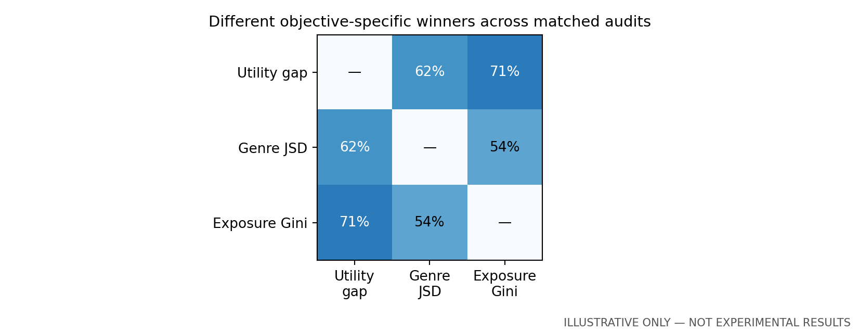
Figure 1.1. Frequency of different objective-specific winners across hypothetical matched audits. The diagonal is not a comparison. Illustrative only—not experimental results.
Table 1.1. Example validation relevance screen. The best score is 0.200, so the 2% relative cutoff is 0.196. Illustrative only—not experimental results.
Candidate | Validation NDCG@10 | Eligible
A | 0.200 | Yes
B | 0.198 | Yes
C | 0.197 | Yes
D | 0.190 | No

Final reporting will add the number of valid audits, tie frequency and ranking agreement. Excluded candidates will remain visible in the relevance table.

RQ1 Planned visual analyses
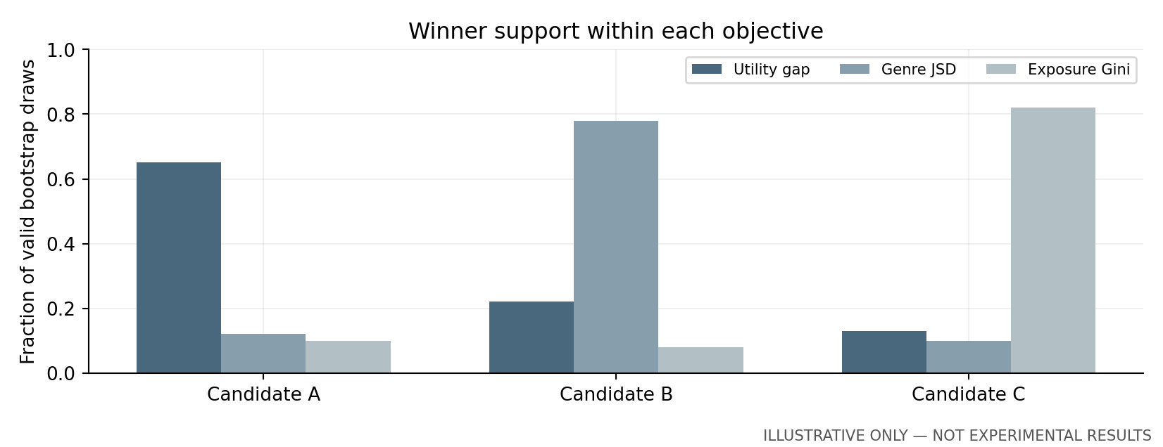
Figure 1.2. Objective-specific winner frequencies across hypothetical paired bootstrap draws. Ties and invalid draws will be reported separately in the final analysis. Illustrative only—not experimental results.
Table 1.2. Three distinct objectives among relevance-eligible hypothetical candidates. No candidate dominates all alternatives. Illustrative only—not experimental results.
Candidate | Utility gap ↓ | Genre JSD ↓ | Exposure Gini ↓
A | 0.080 | 0.160 | 0.910
B | 0.100 | 0.120 | 0.900
C | 0.110 | 0.150 | 0.870

Interpretation plan: persistent different winners across objectives would indicate a substantive trade-off under the chosen measures. Low within-objective winner support would instead show uncertainty about that objective’s ranking. These patterns can coexist and will not be collapsed into one fairness score.

9.2 RQ2 Supported gains and later reversals
Question: Among prespecified base-model versus reranker comparisons, how often do apparent validation fairness gains remain supported after simultaneous adjustment across pairs and objectives, and how often do supported and unsupported aggregate gains reverse direction in the later test window?
Hypothesis to investigate: some apparent gains may be unsupported after adjusting the comparison family, and later ordering may differ even for supported gains.
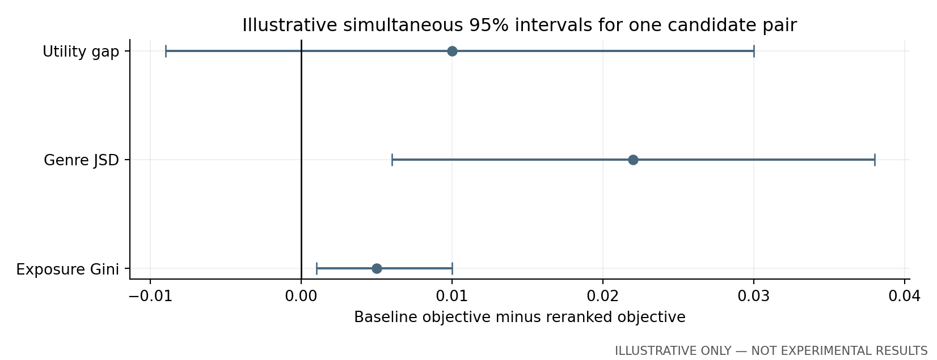
Figure 2.1. Invented gains and simultaneous interval shapes for one base-versus-reranker pair. Positive values favour reranking. Illustrative only—not experimental results.
Table 2.1. Example signed validation contrasts. Each interval belongs to the full planned family, not just the three contrasts shown. Illustrative only—not experimental results.
Objective | Estimated gain | Simultaneous 95% interval
Group utility gap | 0.010 | [−0.009, 0.030]
Genre JSD | 0.022 | [0.006, 0.038]
Exposure Gini | 0.005 | [0.001, 0.010]

The final comparison will distinguish pointwise from simultaneous intervals and disclose calibration failures, undefined draws and zero-variance contrasts.

RQ2 Planned visual analyses
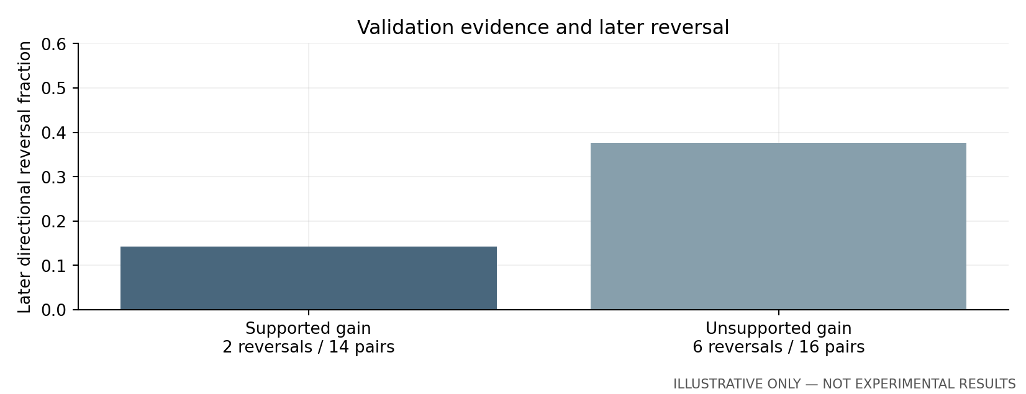
Figure 2.2. Hypothetical aggregate directional reversal fractions by validation evidence class. Denominators refer to planned contrasts, which may be dependent. Illustrative only—not experimental results.
Table 2.2. Example validation support and later outcome categories. Loss of support is distinguished from a sign reversal. Illustrative only—not experimental results.
Validation evidence | Contrasts | Test opposite sign | Test interval includes zero
Supported gain | 14 | 2 / 14 | 4 / 14
Unsupported gain | 16 | 6 / 16 | 11 / 16

Interpretation plan: a larger fraction of reversals among unsupported gains would support caution in acting on point estimates. It would not show that adjustment prevents distribution shift. Test intervals and signs will be evaluated separately, with the shared-user and changed-cohort analyses clearly labelled.

9.3 RQ3 Stability with selectivity
Question: Does a bootstrap-supported Pareto shortlist improve selection stability across user audits and later periods compared with single-metric selection, point-estimate Pareto selection and a compatible DPFR comparison, after accounting for shortlist size, abstention and retained-model quality?
Hypothesis to investigate: bootstrap support may improve audit repeatability, but any benefit could disappear after controlling shortlist size or accounting for abstention and later quality.
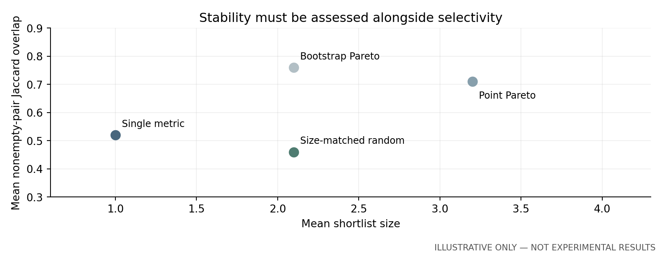
Figure 3.1. Hypothetical stability versus mean shortlist size. The size-matched random reference exposes stability caused by returning a larger set. Illustrative only—not experimental results.
Table 3.1. Example selector outcomes over 100 hypothetical audits. Test-dominated rate is the fraction of retained members dominated in the same eligible pool. Illustrative only—not experimental results.
Rule | Mean size | Empty sets | Test-dominated members
Single metric | 1.0 | 0 / 100 | 21%
Point Pareto | 3.2 | 0 / 100 | 17%
Bootstrap Pareto | 2.1 | 4 / 100 | 12%
Size-matched random | 2.1 | 4 / 100 | 29%

This preview uses 100 audits to illustrate denominators; the planned primary experiment uses 50 outer audits. Final outputs will use actual counts consistently.

RQ3 Planned visual analyses
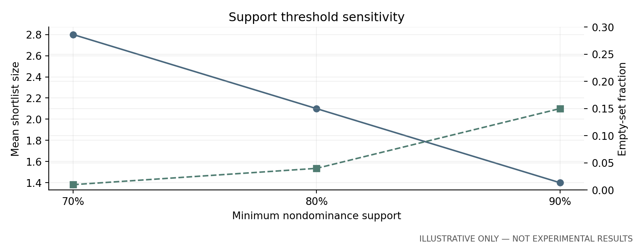
Figure 3.2. Hypothetical effects of 70%, 80% and 90% support thresholds. A smaller shortlist can coexist with more abstention. Illustrative only—not experimental results.
Table 3.2. Example separately matched relevance/item-fairness comparison. Reproduce the published DPFR measure and reference frontier before filling this table. Illustrative only—not experimental results.
Rule on common metric pair | Mean size | Nonempty overlap | Median test NDCG loss
DPFR winner | 1.0 | 0.60 | 2.4%
Bootstrap Pareto on pair | 1.6 | 0.67 | 2.5%
Size-matched subset | 1.6 | 0.55 | 2.7%

Interpretation plan: report size-conditioned overlap, empty-pair counts and later quality together. A 2.5% test loss is compatible with a 2% validation screen. If the bootstrap selector provides no additional benefit at comparable size, the simpler method remains a defensible choice.

9.4 RQ4 Audit composition and resolution
Question: With fitted models fixed, how do controlled audit composition, training activity and age-by-gender subgroup size affect ranking and shortlist stability, and how do ordinary and composition-fixed stratified resampling differ for their stated target populations?
Hypothesis to investigate: changes in audit composition and sparse cells may alter rankings. Fixed-stratum resampling may remove missing-group draws while answering a narrower conditional question.
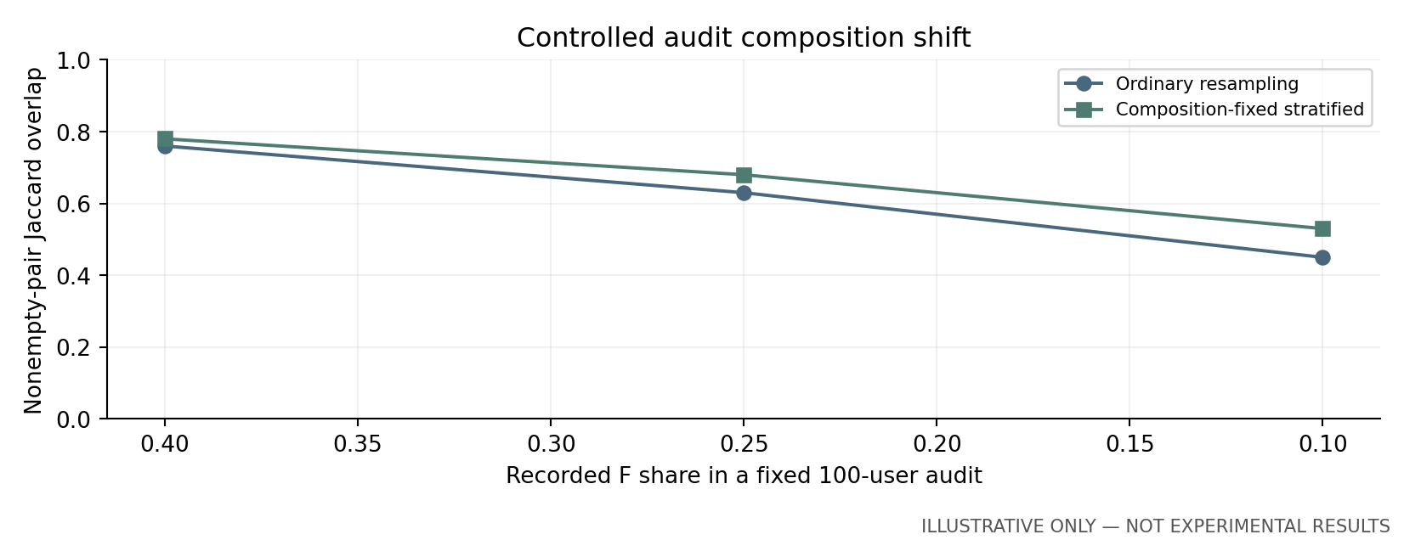
Figure 4.1. Hypothetical shortlist overlap under a fixed-size composition shift. Ordinary and stratified procedures have different sampling targets. Illustrative only—not experimental results.
Table 4.1. Example target counts for 100-user audits. Counts are sampling targets; the number of distinct observed users will also be disclosed. Illustrative only—not experimental results.
Composition | Recorded F | Recorded M | Total
Reference | 40 | 60 | 100
Moderate shift | 25 | 75 | 100
Large shift | 10 | 90 | 100

Keep catalogue, fitted models and audit size fixed. Do not interpret duplicated users in a resample as new demographic evidence.

RQ4 Planned visual analyses
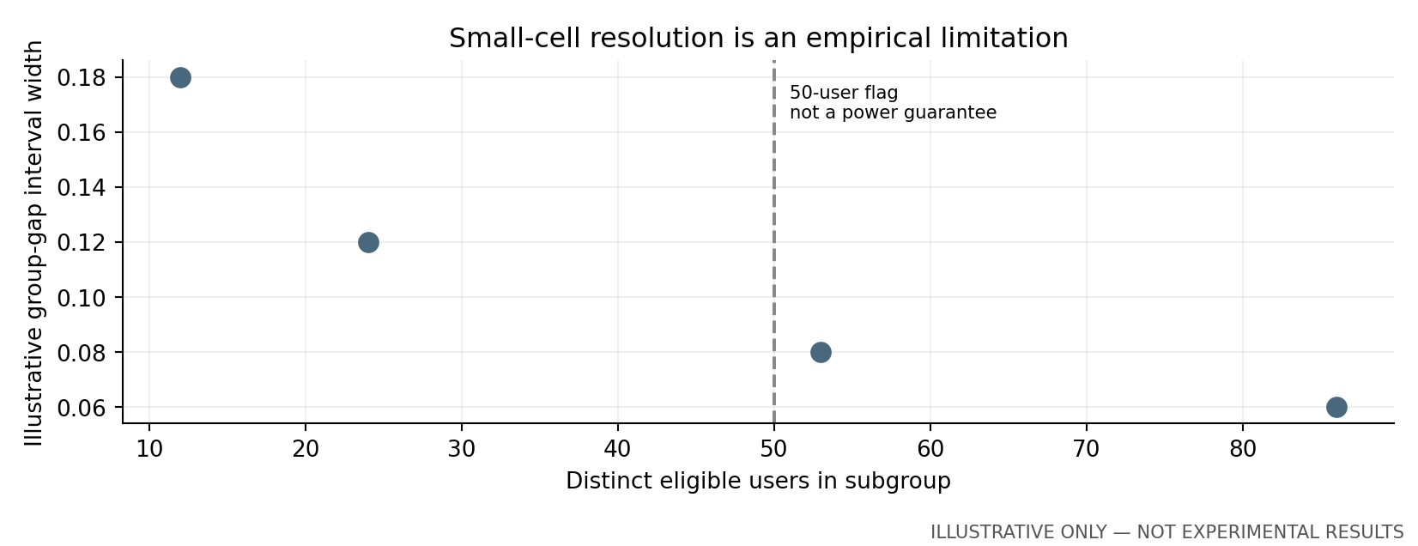
Figure 4.2. Invented relationship between distinct subgroup count and interval width. The 50-user line is a reporting flag, not a demonstrated validity boundary. Illustrative only—not experimental results.
Table 4.2. Example resampling diagnostics at the same reference composition. Composition-fixed uncertainty is conditional on declared counts. Illustrative only—not experimental results.
Resampling target | Undefined gap draws | Median size | Distinct users in smallest cell
Ordinary empirical mix | 18 / 1,000 | 2 | 12
Fixed group counts | 0 / 1,000 | 2 | 12

Interpretation plan: zero missing-group replicates does not repair the twelve original observations. Primary tables will show original marginal age and gender counts, exploratory intersections and labelled coarse-band sensitivities. Coverage exclusions are part of the substantive governance finding.

9.5 RQ5 Preference change and temporal selection
Question: Among repeat users with sufficient observed histories, does training-to-validation genre-profile change predict later within-user reversals in candidate-pair calibration ordering, and do established recent-history or time-weighted profiles improve selection stability without a supported increase in test-period group utility gaps?
Hypothesis to investigate: larger observed genre-profile change may predict more within-user calibration reversals. Sparse histories may make this association too imprecise to establish.
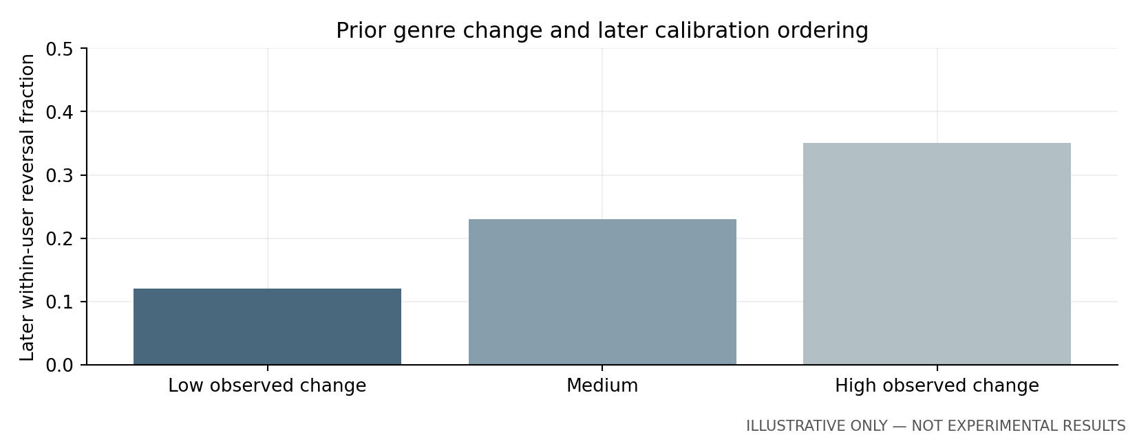
Figure 5.1. Invented later within-user calibration reversal fractions by prior genre-change stratum. Prior strata are defined before test analysis. Illustrative only—not experimental results.
Table 5.1. Example repeat-user analysis funnel. These counts are invented and are unrelated to the measured eligibility counts in Section 6.8. Illustrative only—not experimental results.
Stage | Distinct users | Required observation
Validation eligible | 234 | Warm-start validation positive
Usable prior change | 100 | At least two liked items per prior history
Later paired analysis | 72 | Test eligibility and calibration outcome

Report every exclusion and the distribution of liked-history counts. If the feasibility threshold is unmet, retain the question as a limitation and provide exploratory summaries.

RQ5 Planned visual analyses
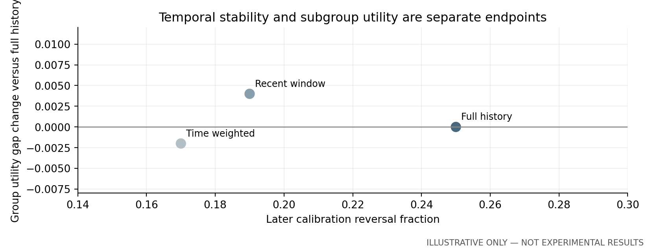
Figure 5.2. Hypothetical profile strategies on reversal fraction and group-gap change. No strategy is assumed to improve both endpoints. Illustrative only—not experimental results.
Table 5.2. Example profile comparison using a common evaluation profile. Intervals are placeholders rather than estimated uncertainty. Illustrative only—not experimental results.
Profile strategy | Reversal rate | Group-gap change | 95% interval for gap change
Full history | 25% | Reference | —
Recent window | 19% | +0.004 | [−0.008, 0.016]
Time weighted | 17% | −0.002 | [−0.012, 0.009]

Interpretation plan: a lower reversal rate will be assessed with later relevance, objective values and subgroup uncertainty. An interval including zero cannot establish that utility gaps did not worsen. Changes in observed genre distributions will be described as associations rather than causal evidence of changing interests.

11 References
References [1–10] are 2025–2026 research publications or an accepted author manuscript. Reference [3] is explicitly cited as the accepted manuscript rather than a final journal issue. References [11–13] provide statistical and dataset foundations; [14,15] document access; [16,17] identify the supplied project evidence. URLs and publication metadata were checked on 2 November 2026 where accessible.
[1] da Silva, D. C., and Durão, F. A. (2025). Benchmarking fairness measures for calibrated recommendation systems on movies domain. Expert Systems with Applications, 269, 126380. https://doi.org/10.1016/j.eswa.2025.126380
[2] Rampisela, T. V., Ruotsalo, T., Maistro, M., and Lioma, C. (2025). Joint Evaluation of Fairness and Relevance in Recommender Systems with Pareto Frontier. Proceedings of the ACM Web Conference, 1548–1566. https://doi.org/10.1145/3696410.3714589
[3] Rampisela, T. V., Maistro, M., Ruotsalo, T., and Lioma, C. (2026). Robustness Analysis of Pareto-based Joint Evaluation of Fairness and Relevance in Recommender Systems. Accepted author manuscript, ACM Transactions on Recommender Systems; arXiv:2610.27850. https://arxiv.org/abs/2610.27850. Status verified through the University of Copenhagen Research Portal; full text not retrieved in this check.
[4] Pereira, B. L., Said, A., and Santos, R. L. T. (2025). On the Reliability of Sampling Strategies in Offline Recommender Evaluation. Proceedings of RecSys, 360–369. https://doi.org/10.1145/3705328.3748086
[5] da Silva, D. C., Jannach, D., and Durão, F. A. (2025). Considering Time and Feature Entropy in Calibrated Recommendations. ACM Transactions on Intelligent Systems and Technology, 16(3), article 62. https://doi.org/10.1145/3716858
[6] Rink, P., and Brannath, W. (2025). Post-selection confidence bounds for prediction performance. Machine Learning, 114, article 82. https://doi.org/10.1007/s10994-024-06632-w
[7] Rampisela, T. V., Maistro, M., Ruotsalo, T., Scholer, F., and Lioma, C. (2026). Relevance-aware Individual Item Fairness Measures for Recommender Systems: Limitations and Usage Guidelines. ACM Transactions on Recommender Systems, 4(3), article 37, 1–45. https://doi.org/10.1145/3765624
[8] Gusak, D., Volodkevich, A., Klenitskiy, A., Vasilev, A., and Frolov, E. (2025). Time to Split: Exploring Data Splitting Strategies for Offline Evaluation of Sequential Recommenders. Proceedings of RecSys, 874–883. https://doi.org/10.1145/3705328.3748164
[9] Shehzad, F., Ferrari Dacrema, M., and Jannach, D. (2025). A Worrying Reproducibility Study of Intent-Aware Recommendation Models. Proceedings of SIGIR, 3155–3164. https://doi.org/10.1145/3726302.3730307
[10] Roy, A., and Mohapatra, P. (2026). Fairness Uncertainty Quantification: A Constrained Stochastic Optimization Perspective. Proceedings of UAI, PMLR 337, 5845–5865. https://proceedings.mlr.press/v337/roy26b.html
[11] Cherian, J. J., and Candès, E. J. (2024). Statistical Inference for Fairness Auditing. Journal of Machine Learning Research, 25(149), 1–49. https://jmlr.org/papers/v25/23-0739.html
[12] Hansen, P. R., Lunde, A., and Nason, J. M. (2011). The Model Confidence Set. Econometrica, 79(2), 453–497. https://doi.org/10.3982/ECTA5771
[13] Harper, F. M., and Konstan, J. A. (2015). The MovieLens Datasets: History and Context. ACM Transactions on Interactive Intelligent Systems, 5(4), article 19. https://doi.org/10.1145/2827872
[14] GroupLens. MovieLens 100K Dataset and original README. https://grouplens.org/datasets/movielens/100k/ and https://files.grouplens.org/datasets/movielens/ml-100k-README.txt (accessed 2 November 2026).
[15] GroupLens. MovieLens 1M Dataset and original README. https://grouplens.org/datasets/movielens/1m/ and https://files.grouplens.org/datasets/movielens/ml-1m-README.txt (accessed 2 November 2026).
[16] Team Phantom Troupe (2026). Phantom_Troupe_Project9_Initial_Pilot(1).ipynb. Supplied executed project notebook; MovieLens 100K pilot outputs. Unpublished project artifact.
[17] Team Phantom Troupe (2026). Phantom_Troupe_Project9_Coverage_Audit.ipynb. Supplied executed coverage and subgroup audit. Unpublished project artifact.

Appendix A Experimental Specification

A1 Provisional settings and reporting conventions
Freeze this specification after development checks and before final test performance is inspected. Changes must state the reason, date and affected analyses. The current proposal preserves the 3,000-user fitting cap despite the coverage notebook’s recommendation to consider expansion.
Item | Planned rule
Data | MovieLens 100K complete; fixed 3,000-user 1M model sample; separate analyses
Time split | Full-archive 70th and 85th timestamp percentiles; no split timestamp ties
Primary users | ≥5 training ratings; ≥1 liked training item; ≥1 eligible held-out positive
Catalogue | Training-observed items; no previously rated items; fixed zero-exposure universe
Candidates | 3 base models × 4 reranking states including λ = 0; 12 candidates per seed
Ranking | Retrieve top 100; K = 10 primary; K = 5 and 20 sensitivities
Relevance screen | Validation NDCG@10 ≥ 0.98 × best; fixed within inner bootstrap
Objectives | Marginal group utility gap composite; mean base-2 JSD; discounted exposure Gini
Bootstrap | 1,000 paired user draws; ≥900 complete required for primary shortlist
Support | ≥80%; 70% and 90% sensitivity; no confidence-set guarantee
Audit repeats | 50 outer draws per dataset and training seed; common random weights
Inference family | 9 planned pairs × 3 objectives = 27 primary contrasts
Seeds | 20261101–20261103; primary 1M sampling seed 20261101
Small cells | <50 distinct users exploratory; preserve original group count tables
RQ5 feasibility | ≥50 repeat users overall and ≥20 per drift stratum for planned association analysis
Release | Configuration, code, aggregate metrics, CSVs and 20 regenerated exhibits

A2 Evaluation definitions
- Selection stability: Jaccard overlap of nonempty sets from paired audits; empty pairs and set sizes reported separately.
- Validation relevance loss: 1 − R(m)/maxj R(j), evaluated on validation. The 2% filter constrains only this quantity.
- Test relevance loss: the same relative loss on test within the original validation-eligible pool; not constrained to 2%.
- Later dominated-member fraction: number of retained models dominated on test divided by retained models, with denominator zero reported as abstention.
- Retention quality: test objective values and coverage of the test nondominated set within the original eligible pool; use as retrospective diagnostics.
- Aggregate gain reversal for RQ2: a validation and test pairwise objective gain with opposite nonzero signs.
- Within-user calibration reversal for RQ5: a sign change in the individual candidate-pair JSD difference between validation and test.
- Complete bootstrap draw: all predefined marginal groups and all three objectives are available for every candidate in the relevant pool.
- Activity: number of training ratings; define strata from training only and preserve them when changing audit composition.
- Group-resolution flag: count of distinct observed users, not bootstrap multiplicity, and not a substitute for a power calculation.

A3 Required reproducibility record
Record archive hashes, environment versions, sample algorithm, timestamp cutoffs, exclusion counts, group counts, candidate IDs, hyperparameters, tie rules, training seeds, cached list versions, bootstrap weights or reproducible seeds, valid-replicate counts, interval families and all protocol amendments. Separate measured pilot outputs from proposed settings and from synthetic examples.
Do not infer publication-level novelty from working code or from one favourable seed. Final results require the complete candidate comparison and the uninspected held-out outcomes.

Appendix B Governance and Feasibility

B1 Data and research governance
- Use the original GroupLens terms and attribution requirements. Release code and permitted aggregates; do not redistribute raw ratings or demographics without the required permission.
- Historical binary recorded gender and banded age do not represent all identities or current populations. Do not infer missing demographic categories or reinterpret recorded labels as verified present identity.
- Report warm-start exclusions and group-specific coverage. A fairness audit of eligible repeat users is not an audit of all MovieLens participants.
- No new human participants or personal-data collection are planned. Confirm applicable university review and data-handling requirements rather than declaring automatic ethics exemption.
- Keep raw files local or access-controlled; avoid exposing user-level ratings, identifiers or small-cell records in public outputs. Preserve internal audit counts while applying the university’s disclosure rules to public summaries.
- Document AI assistance according to module policy. Team members must understand and verify the text, code, citations and synthetic illustrations before submission.

B2 Risks and mitigations
Risk | Mitigation and consequence
Sparse intersections | Report original counts and exploratory status; coarse-band sensitivity is separately labelled.
Insufficient repeat users | Restrict RQ5 to feasibility; retain chronology and do not manufacture temporal evidence.
Poor interval calibration | Simulate tied and small-cell cases; downgrade unsupported inference and report limitations.
Large or empty shortlists | Report size and abstention; apply size-matched controls and threshold sensitivity.
Expensive nested audits | Cache predictions; benchmark CPU stages; fix any reduced scope before test analysis.
Closest work overlaps | Review full 2026 extension and log distinctions; narrow claims or report a replication finding.

B3 Working title requiring confirmation
The working title describes the decision problem without promising a performance improvement. Requires Final Confirmation from Supervisor.

