**Project title (War On The Sea)**

**Author (Farcas Cosmin Catalin)**

**Affiliation:<Faculty of Automatic Control and Computer Engineering, Iasi>**

**Email:** [**cosmin-catalin.farcas@student.tuiasi.ro**](mailto:cosmin-catalin.farcas@student.tuiasi.ro)

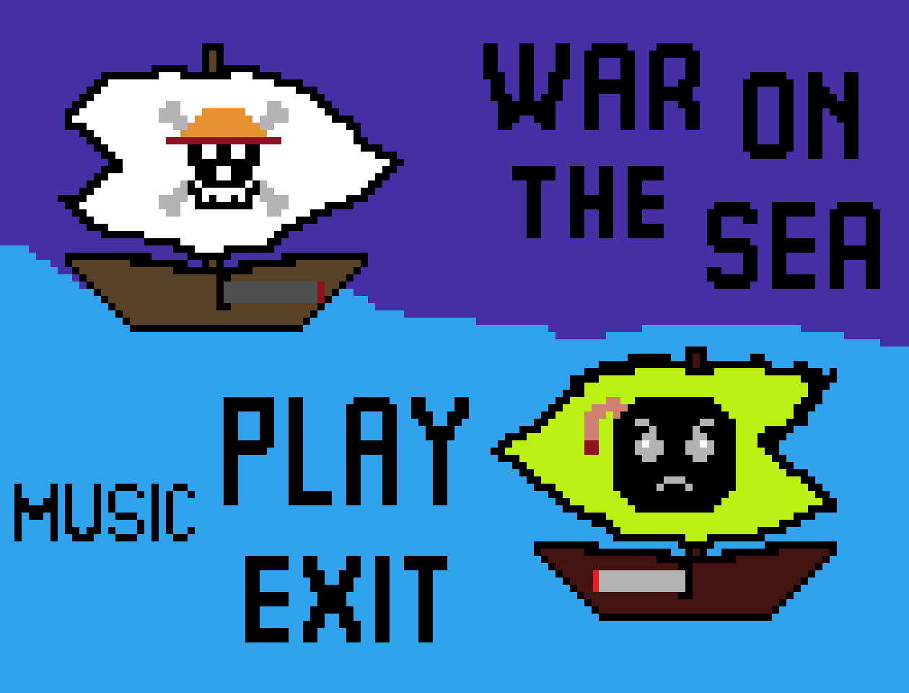 **Academic year:<2021-2022>**

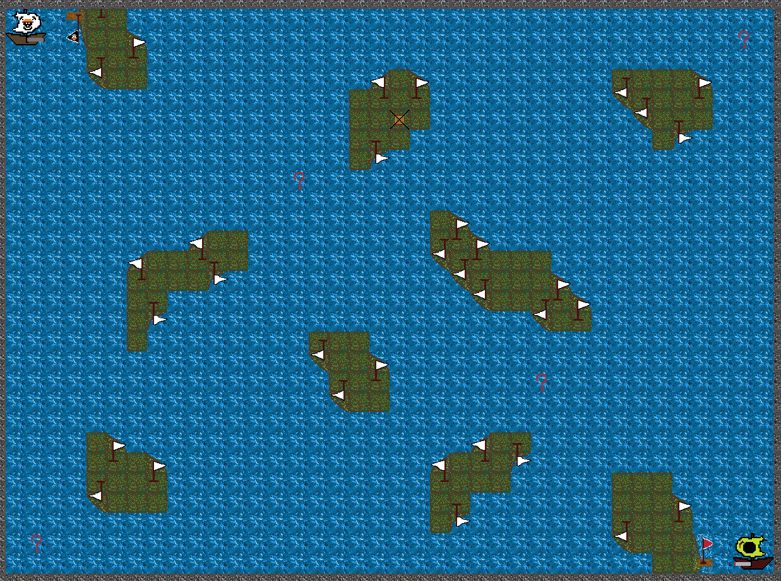

**Gameplay:…(War On The Sea it’s a 1v1 game where the players try to eliminate each other projectiles from the ship’s cannon. On the map there are some mysterious power-ups that will significantly improve their chances of winning the battle in order to conquer the sea.)**

**Plot:…(The Strawhat Pirates and their arch nemesis The Cannonball Pirates will finally put and end to their long battle and the survivor will remain in history as the Conquerer of the deadly sea)**

**Mechanics:…(First Player moves using W,A,S,D and shots with G, while the**

**Second Player moves with the ARROWS and shots with the keypad PLUS button,**

**also by pressing M you can turn the music ON/OFF);**