ABSTRACT

The purpose of this thesis is to investigate the patient-doctor relationship in the context of technological progress in last decades and how this relationship can be facilitated through a web application. The first part is focused on the evolution of this interaction throughout history, but also on the main types of relationship between a doctor and a patient. After the problem has been put in context, the role of technology in the development of this interaction is presented, continuing with a description of the web applications.
The second part of the thesis pursues its main purpose, the development of a web application that meets the essential conditions for putting the patient-doctor relationship in a technological context. In this way, the stages and principles of application’s development together with the used technologies are presented. The final part focuses on the obtained results, but also on the improvements that can be made to the developed application.

Contents
1 Introduction 3
2 Theoretical Background 4
2.1 Patient Doctor Relationship 4
2.1.1 Brief History 4
2.1.2 Different Types of Patient-Doctor Relationship 6
2.2 Technology in Patient-Doctor Relationship 9
2.2.1 Why and How to Use Technology in Patient-Doctor Relationship? 9
2.2.2 Disadvantages of technology in managing the relationship 9
2.2.3 Analyze of solutions for managing patient-doctor relationship 9
2.3 Web applications 10
2.3.1 Brief history 10
2.3.2 Structure 11
3 Application Description 14
3.1 Requirements 14
3.2 Implementation and Design 17
3.3 Testing 17
3.4 Deployment 17
4 Conclusions 17

Introduction

The problem that this thesis brings up is a well-known one globally, how the patient-doctor relationship could be implemented in a software system in such a way to facilitate the interaction process between these two parts. We have all noticed the technological progress that has been made lately and we can state that the time when the only way a patient could ask for a doctor’s help was by visiting his office is a thing of the past. In the last decades, web applications have developed continuously and become a great option to digitize tasks that in the past required various resources. Thus, we can use this progress in web applications to develop such a solution that meets the main requirements of patient-doctor interaction.
My inspiration behind this work comes from the fact that, at this time, an important problem among the population is given by misinformation about different kind of health problems, people being trapped looking for answers on their own and not asking advice from someone’s expert advice. In the same time, other argument is represented by the fact that digital tracking of the progress of a treatment could improve the current situation and be easier to follow. These being the reasons behind my thesis idea, I intend to develop a web application that can be easily used by patients and doctors, without special training in advance. This application should come in support of an ordinary person who needs the opinion of a doctor or wants to make an appointment for a consultation, while also helping the doctor in organizing his or her work.

Objectives

- Describe the main types of patient-doctor relationship and how does them affect the development of the application
- Why and how to develop a web application in order to facilitate this interaction? Present existing approaches in this domain
- Present how web application have developed, what is their structure and how a real-time communication be achieved
- Develop a web application to facilitate the patient-doctor relationship
- Present the technologies used in the process of development

Thesis outline

The content of this thesis is structured in three parts:
The first part is represented by Chapter 2 – Theoretical Background and presents at the beginning the evolution of relationship between patient and doctor through history and a classification of this interaction. Furthermore, there is described the link between the patient-doctor relationship and web applications: what are the advantages, disadvantages of this approach, how such a system should be developed. In the end of the chapter, there is a part dedicated to web applications, focusing on how they have improved over the years, what is their structure and also there is section dedicated to websockets.
The second part, Chapter 3 – Application Description, shows the process of application’s development. Firstly, there are presented the features and the requirements of the application. Furthermore, there is described the design, how should the pages of the application look and behave, followed by the process of implementation, offering explanations for the choices that were made. The last section is dedicated to the testing process of the application.
The last part, Chapter 4 – Conclusions, as the name suggests, presents the obtained results of this working and how the developed application can be improved.

Theoretical Background

Patient Doctor Relationship

Brief History

From ancient times, people have sought the help of doctors to solve a medical problem, but the relationship between the two entities has not always been similar to that of today. [1] Prior to the last two decades, the relationship was predominantly between a patient seeking help and a doctor whose decisions were silently complied with by the patient. We can consider as reference points in the evolution of this relationship, the periods:
- Ancient Egypt (approximately 4000 to 1000 B.C)
- Greek enlightenment (approximately 600 to 100 B.C)
- Medieval Europe and the inquisition (approximately 1200 to 1600 A.D)
- The French revolution (late 18th century)
- Patient-doctor relationship 1700-to present day
The period of ancient Egypt shows the position of the doctor through that of the healer, who explains the unknown through magic and mysticism, but who still uses rational methods of healing diseases or wounds. The patient did not necessarily have a say in the practices used to heal him/her, the doctor making all the decisions. [1] The Greeks developed a system of medicine based on an empirico-rational approach, such that they relied ever more on naturalistic observation, enhanced by practical trial and error experience, abandoning magical and religious justifications of human bodily dysfunction. Thus guidance-co-operation and to a lesser degree mutual-participation were the distinguishing patterns of the doctor-patient relationship.
During medieval Europe, there was a regression both in terms of healing techniques and the actual interaction between doctor and patient. The practice of magic has taken shape again and the status of patient is that of a man without opinions, who is just waiting to be saved. The French Revolution and its aftermath seem to prove that history is repeating itself. In this way, a correlation can be noticed between the scientific progression and the guidance-co-operation of doctors and patients.
Since 1700s, thanks to impressive medical advances, the development of technology and of society in general, the patient doctor relationship has evolved through multiple intermediate phases (as example, to treat the sick one as a person, and not as a human experiment) to the one we know today, of patient-oriented. This assumes that the doctor is aware of the patient’s personality, informs him/her of the possible treatments and the two jointly decided on which one to use. In 1955, Michael Balint firstly stated that the communication between doctor and patient is as important as the medicine: [2] by far the most frequently used drug in general practice was the doctor himself. It was not only the medicine in the bottle, or the pills in the box, that mattered, but the way the doctor gave them to his patient-in fact the whole atmosphere in which the drug was given and taken.
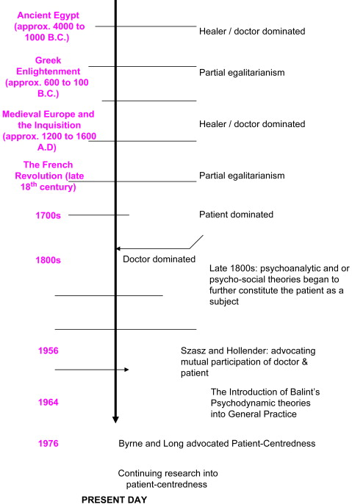
Figure 2-1 Evolution of patient doctor relationship [1]

Different Types of Patient-Doctor Relationship

In order to understand the importance of technology in patient-doctor relationship nowadays, we need to have a clearer view in this domain and that implies knowing the main types of this interaction, but also which ones have the best results and what are the trends in this field.
Doctors Ezekiel and Linda Emanuel proposed in 1992 a classification of physician-patient relationship based on the following criteria: [3] (1) the goals of the physician-patient interaction, (2) the physician’s obligations, (3) the role of patient values, and (4) the conception of patient autonomy. This classification contains four models: the paternalistic, the informative, the interpretive and the deliberative one, but as the authors themselves suggest, there could be also more models.
The paternalistic model involves that doctor establishes what the best option for the patient’s health is and tries, with the help of the acquired medical knowledge, to apply the necessary practices for healing. The patient receives the information regarding the practices that suits best his or her needs and it is possible to disagree initially with the doctor’s approach, but later he or she will be satisfied with the taken decisions. This model has as counter-argument the fact that doctor and patient don’t share the same view in every situation; sometimes the patient can have different interests than its health (for example, a future grandmother chose a safe but not so effective treatment before the birth of her first grandchild, which will take place in a few months, instead of a more effective practice but still not sufficiently tested). Of course, there are special cases in which this type of interaction is justified, like in critical situations where time is a crucial factor in taking a decision.
In the informative model, doctor presents to patient all medical information that is required for this to take a decision about what treatment should be used. In this way, the doctor is just a tool; his or her impressions about the case don’t matter and have as only purpose to provide facts for the patient, like [3] the disease state, the nature of possible diagnostic and therapeutic interventions, the nature and probability of risks and benefits associated with the interventions. Important to notice, this model is more a theoretical one because in real-life situations there are a few chances that a person only wants to know the scientific information and don’t need at all the subjective impression of the doctor.
The interpretive model is similar to the informative one to an extent, because it implies that doctor comes to the patient with all required technical information, but in this case also helps the person in need to understand what are his or her real intentions. The patient can be unsure regarding what he or she really wants or needs and the doctor has the mission to clarify what are the goals of the respective person and how they could be achieved. This model encounters difficulties due to the lack of proper training of the doctor in interpreting the patient’s wishes, but also of the time-limited interaction between the two.
In the last model, the deliberative one, the aim of the doctor is to determine the best medical solutions for the patient’s problem, but also to convince through moral persuasion the sick person to choose the required interventions to improve his or her health. If the patient does not agree with the doctor’s recommendations, then they deliberate about other alternative healing approaches according to the patient’s interests, after all being about his or her own life. From the all four presented models, the deliberative model seems to be the most successful option from multiple reasons. One of them is the fact that it respects the autonomy of the patient; even if the doctor has the goal to promote the practices with best results from the point of view of health-related values, the patient is still free to choose what is better for his or her interests. Also, the doctor is seen as a caring person, who wants to heal the sick one and not just presenting multiple facts about disease state and risk degree of possible interventions, this role approaching the general perception of society towards doctor.
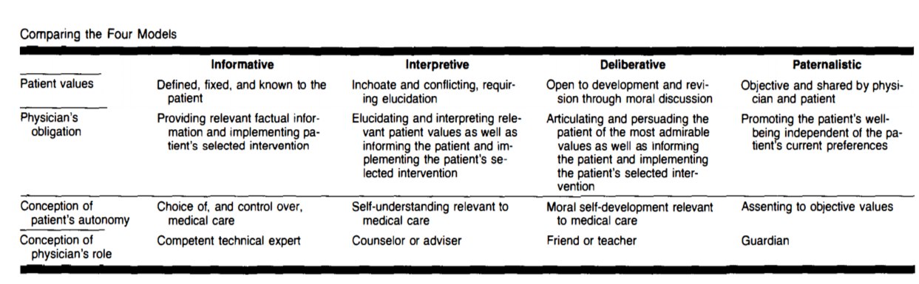
Figure 2-2 Comparison between the Four Models [3]
Important to notice, the classification made by Ezekiel and Linda Emanuel is based on two dimensions, the autonomy and respectively the values of the patient, and these two dimensions are considered to be strongly-connected, which is not really the case in all real-life scenarios as Agarwal and Murinson stated, observing that the medical knowledge of the patient can represent a third dimension. Also, they made an axis interpretation of the four models: [4] a shift from completely unformed to fully formed values - and a corresponding shift from low patient autonomy to high patient autonomy - occurs as one progresses from the paternalistic approach to an informative one. Visually, this can be represented as a single axis in which the extent of values formation and patient autonomy are mutually varying.
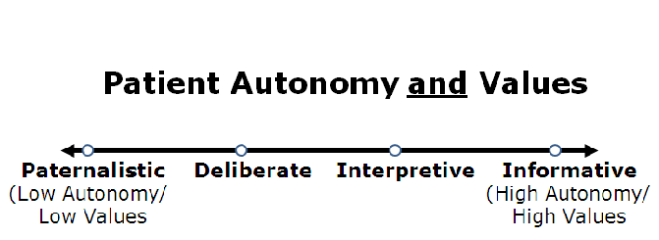
Figure 2-3 Axis interpretation of Emanuel and Emanuel Models [4]

The trend in patient-doctor relationship domain has undergone major changes throughout history, but as it is pointed by many specialists, [5] over the past few decades, there has been a shift from a paternalistic approach to patients towards an emphasis on patient autonomy. Most certainly no model is perfect; on the one hand, each model has objections, on the other hand, there are situations for each one in which its use is justified. If we were to choose one as the best option in a digital age in which the right to opinion in extremely important, then the deliberative model comes closest to meeting all the criteria of specialists. [5] Such a model, which is based on open dialogue, joint deliberation and mutual understanding, would be the balanced alternative between the two extremes represented by the paternalism and the informative model, as it overcomes the imbalance of decision making power between patient and physician.

Technology in Patient-Doctor Relationship

Why and How to Use Technology in Patient-Doctor Relationship?

Disadvantages of technology in managing the relationship

Analyze of solutions for managing patient-doctor relationship

Web applications

Brief history

Web applications are part of our daily life thanks to their ease of use by a regular user, who does not need programming knowledge, but also to their applicability in various fields, starting from e-commerce, social networks and ending with the domain that attracts our attention, the medical one. Web applications started to develop to develop in the 90s, being initially only static HTML pages, after that being possible to add media files, but they were still static. An important element in making dynamic pages as we know them today was the invention of JavaScript in 1995, allowing animations to be displayed. In 1999, there was introduced the term of “web application” in the specification of Java Servlet version 2.2 [6]. The move from static web-pages to dynamic ones was materialized in 2005 with the invention of Ajax (Asynchronous JavaScript And XML) technology. In fact, the problem with the traditional web applications was that they used a synchronous request-response protocol which leaded to a delay between pages. [7] On the contrary, Ajax applications are based on asynchronous requests, which leave the user interface active and responsive. After the point where Ajax technology was introduced, the domain of web applications has developed continuously, both on backend and frontend sides. Modern web applications are considered to provide multiple benefits like flexibility, scalability, interactivity and also they should be cloud-based and compatible across different platforms.

Structure

Web applications have a specific architecture, consisting of several logical and physical divisions named tiers, the most common architecture being the three-tier one, consisting of the following tiers: the presentation tier, the application tier and the data tier. The main advantage of the three-tier architecture is the fact that each tier runs on a separate infrastructure, this being extremely important in the development process. In this way, a separate team can be assigned to each tier and all three teams can work simultaneously. Also, any required update on a specific tier can be implemented easily because the changes do not impact the other tiers. Not to forget, the user can’t access directly the database and this guarantees a certain degree of security, but which can still present problems. Related to problems, the three-tier architecture is not perfect and the main disadvantages are its complexity to build (in comparison with a two tier architecture, in which the connection between the client side and the database is made directly) and the fact that it is more costly in terms of time (an example is that even a small update has to be tested in multiple places).

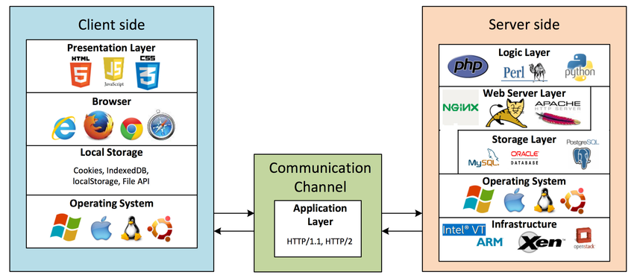
Figure 2-4 Structure of a three-tier web application [8]

As it can be seen in figure 2-4, there are two sides of a distributed web application, the client side and the server side, the link between them being made by the application tier. The client side deals with the interaction between the user and the computer, being [8] responsible for converting the HTTP responses from the server into actionable graphical interface for the user. It consists of multiple components:
- The presentation layer - deals with the logic on front-end side, it represents the code of the top tier of the architecture
- The browser – takes the presentation layer code and interprets it in order to be displayed and to behave accordingly to its purpose
- The local storage – [8] used by the presentation layer to store data. Examples include cookies, localStorage, IndexedDB and File APIs
- The operating system – the system on which the browser is running

The client side communicates with the application tier through HTTP protocol. The client makes requests with the purpose to access servers’ resources and receives a response for each of them. A well-defined HTTP request contains 3 elements: a request line, a variable number of HTTP headers and optionally a message body. The request line consist of its method, which should identify the type of request by the purpose in which the resources from server will be used, and its path, but can contain other elements like a query string, which provides information that can be used by application tier in different ways (for example, to extract specific information from database). HTTP headers have the purpose to inform the recipient about the message, the sender and the way in which the communication should happen.
The application tier represents the place where the data that comes from the presentation tier or the database tier is processed, being the center of the architecture. It can be seen as an intermediary tier between the other two. The communication between the application tier and the database tier is made also through HTTP protocol, using API calls.
The server side, as it can be seen in figure 2-4, consists of the following components:
- The logic layer – implements the business logic of the data tier in a high-level programming language like Java or C#
- The web server layer – [8] receives HTTP requests from clients, parses them, and passes the request to the appropriate server-side program. Examples of web servers include Apache web server, Windows IIS, and Nginx
- The data storage layer – in fact, this layer is the real database, the place where the whole information of the application is stored
- The operating system – necessary for the other layers to run on
Other type of architecture is the two-tier one, based on the client-server model, in which the logic of the application tier is included in the data tier. In this way, the communication between the client and the server is directly made, increasing the execution speed of the application. The problems with this architecture are represented by its lack of scalability in case of a high number of users and its weak security.

Application Description

Requirements

As we have seen up to this point in thesis, the relationship between the doctor and the patient can unfold in different ways depending on the patient’s autonomy, his life values and his medical knowledge. The most commonly used model in this interaction nowadays is the deliberative one, in which the doctor has the purpose to morally persuade the patient to choose the best health-related medical interventions. In case the patient disagrees with the presented method, the two deliberate on other treatments. Web applications have developed considerably in recent years, making possible an interactive online communication between the doctor and the patient. They are able to solve problems like in the case in which people prefer to look themselves for information on the internet that is not necessarily verified instead of resorting to the knowledge of a specialist. Of course, web applications can’t completely replace face-to-face interaction between a patient and a doctor, but they can facilitate the process before the respective meeting and save time when it comes to just a little advice, or even an encouragement.
That being said, we can further formulate the requirements and specifications of the web application of our approach. Both doctors and patients will have accounts in which their important data are present like their first name, second name and email address. The patients can optionally specify their address, but the office address for the doctors is mandatory. Also, the doctors should have a specialization in order to make it easier for the patients to identify the doctors they should go to for their problem. Anyone can make a regular patient account, but the doctors must be introduced by an account with administrator privileges, which would receive on email the documents attesting his or her profession. The administrator account can perform multiple operations beside this, like adding new medicines or updating existing ones, adding new specializations or removing accounts. Each person can update its own account, set a profile picture and will log-in with his or her email address and a password (for doctors, they would have a default password chosen by the administrator and must change it as soon as possible). A medicine is characterized by its name and a description, same in the case of a disease. A treatment is given by a specific doctor to a specific patient, it contains one or more medicines, it is recommended for a disease and the start date must be specified.
A patient account has the following features: he or she can schedule an appointment by consulting a doctor’s calendar, can communicate directly with any doctor and can give his or her feedback about evolution in case of a disease. The calendar will show a doctor’s program over a week, the consultations having the standard duration of half an hour. In first phase, the program is also standard, from 9 am to 5 pm, but in a next phase it should be changeable by the doctor. The patient can select any week from a certain period of time (three months would be a reasonable amount of time). In order to be easier to patient to select the disease that he or she wants to give a feedback about its evolution, a list with all diseases for which there exist a current treatment will be shown on the page of this feature.
After the patient makes an appointment on a free slot from calendar, the doctor receives an email with this information. The doctor account has as features the fact that can prescribe recipes, see his or her schedule over a week, communicate directly with the patients and writes his or her observations about evolution of a disease in case of a specific patient that he consulted (the feedback of the patient is visible for the doctor in order to understand what are patient’s life-values over the time, but the observations of the doctor are not visible for the patient). Each presented feature should be on a separate page. They will be accessible always from a horizontal menu placed on top of the screen.

Implementation and Design

Testing

Deployment

Conclusions

Bibliography
[1] Kaba R, Sooriakumaran P, The evolution of the doctor-patient relationship, International Journal of Surgery, 2007-02-01, Volume 5, Pages 57-65.
[2] Balint M, The Doctor, His Patient, and the Illness, The Lancet, 1955-04-02, Volume 265, Pages 683-688
[3] Emanuel E, Emanuel L, Four Models of the Physician-Patient Relationship, JAMA: the Journal of the American Medical Association, 1992-09-16, Volume 267, Pages 2221-2226
[4] Agarwal AK, Murinson BB, New dimensions in Patient-Physician Interaction: Values, Autonomy, and Medical Information in the Patient-Centered Clinical Encounter, Rambam Maimonides Med. J., 2012-07-31, 3(3): e0017
[5] Borza L, Gavrilovici C, Stockman R, Ethical models of physician-patient relationship revisited with regard to patient autonomy, values and patient education, Rev. Med. Chir. Soc. Med. Nat., Iasi, 2015, Volume 119, No 2, Pages 496-501
[6] Davidson JD, Coward D (1999-12-17). Java Servlet Specification ("Specification") Version: 2.2 Final Release, Sun Microsystems, 1999-12-17, pp. 43–46. Retrieved 2008-07-27
[7] Marchetto A, Tonella P, Ricca F, “State-based testing of ajax web applications” in 1st Int. Conf. on SoftwareTesting, Veriﬁcation, and Validation, Lillehammer, Norway, pp. 121–130, 2008
[8] Vadlamudi S G, Sengupta S, Taguinod M, et al., Moving target defense for web applications using Bayesian stackelberg games, in Proc. of the 15th International Conference on Autonomous Agents and Multiagent Systems, 1377-1378, 2016

