PROIECT LA SECURITATEA DATELOR

Drăgușin Ioan Cosmin

Blank Name

244/1

Topologia logica:

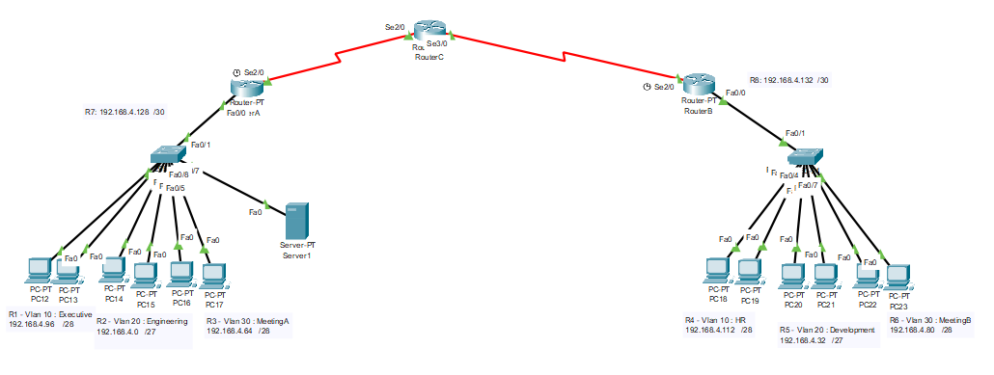

X=4=>retea de 192.168.4.0 /24

R2 (26 utilizatori) : 192.168.4.0 – 192.168.4.31 /27

R5 (18 utilizatori) : 192.168.4.32 – 192.168.4.63 /27

R3 (12 utilizatori) : 192.168.4.64 – 192.168.4.79 /28

R6 (12 utilizatori) : 192.168.4.80 – 192.168.4.95 /28

R1 (10 utilizatori) : 192.168.4.96 – 192.168.4.111 /28

R4 (8 utilizatori + adresa de retea +adresa de broadcast => e nevoie de 10 adrese ) : 192.168.4.112 – 192.168.4.127 /28

R7 (RouterA-RouterC) : 192.168.4.128 – 192.168.4.131 /30

R8 (RouterB-RouterC) : 192.168.4.132 – 192.168.4.135 /30

Configurare interfete RouterA:

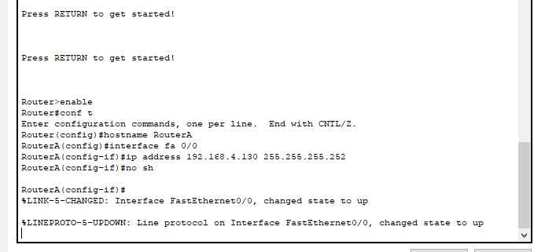

Configurare interfete RouterB:

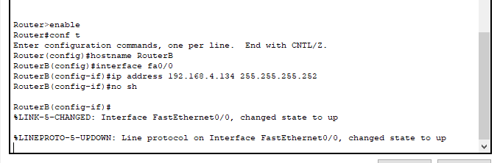

Configurare interfete RouterC + ruta statica default spre interfata loopback :

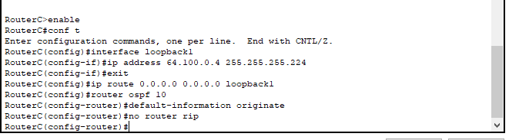

Configurare vlan-uri SwitchA:

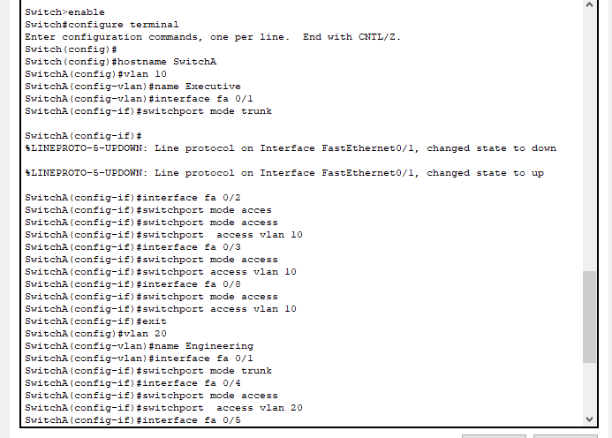

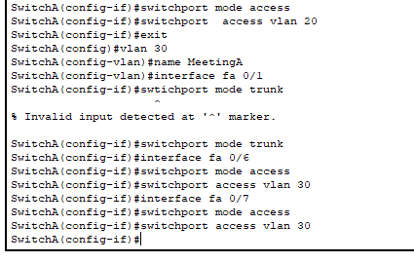

Configurare vlan-uri SwitchB:

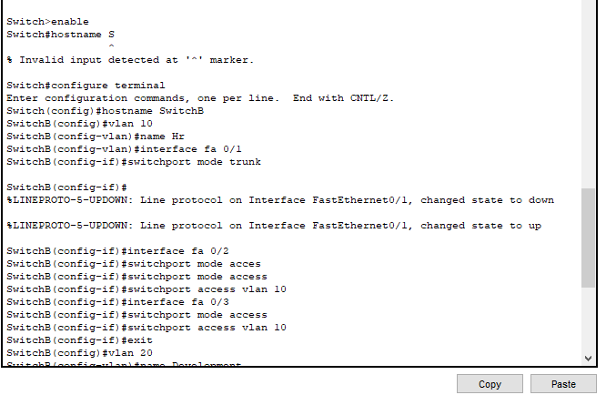

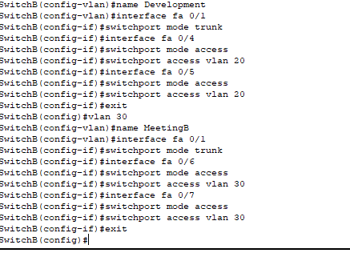

Routare dinamica RouterA +configurare dhcp

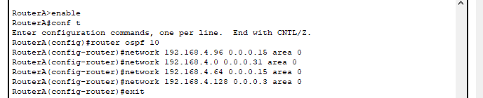

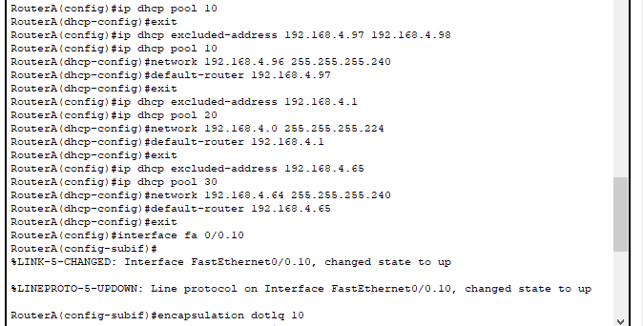

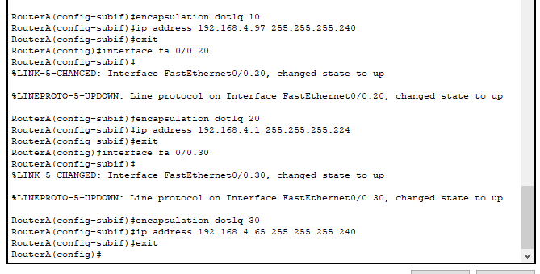

Routare dinamica RouterB + Configurare dhcp RouterB:

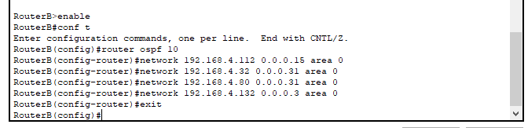

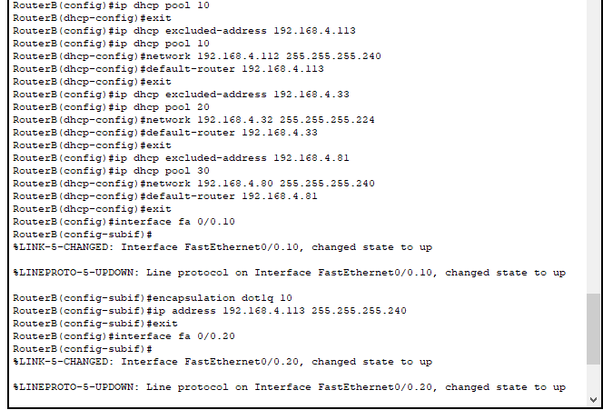

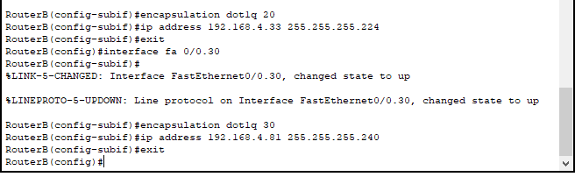

Restrictii :

- vlan-ul MeetingA nu are acces la vlan-ul Executive :

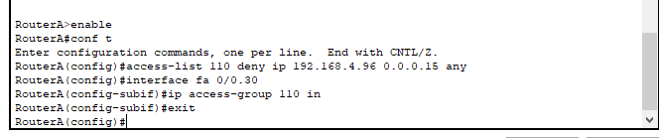

- vlan-ul MeetingB nu are acces la vlan-ul Executive :

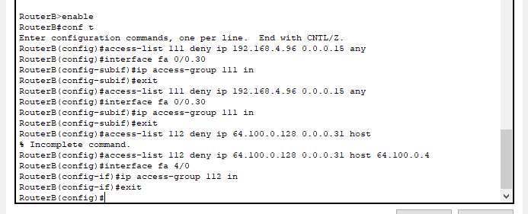

- vlan-ul HR nu are acces la ISP :



Bibliografie youtube:

<https://www.youtube.com/watch?v=XYC_SkcZTKQ>

<https://www.youtube.com/watch?v=kQmHbLHUc3o>

<https://www.youtube.com/watch?v=7nQgADDQlfw>

<https://www.youtube.com/watch?v=98EZgcEuL68>

<https://www.youtube.com/watch?v=fTTfbxrYRE4>

<https://www.youtube.com/watch?v=QFY0ioXrZR8>

<https://www.youtube.com/watch?v=mtYy-4oo53s>

Bibliografie google:

<https://itexamanswers.net/encapsulation-dot1q-command-on-cisco-router-switch.html>

<https://www.cisco.com/c/en/us/td/docs/ios/12_4/interface/configuration/guide/inb_virt.html>

<https://search.yahoo.com/search?fr=mcafee&type=E210US91105G91724&p=switchport+mode+trunk>

<https://www.orbit-computer-solutions.com/how-to-configure-switch-trunk-ports/#:~:text=Switchport%20trunk%20means%20when%20you%20have%20a%20trunk,the%20neighboring%20switch%20or%20links%20into%20trunk%20links>.

<https://www.ibm.com/docs/en/guardium/10.6?topic=cli-network-configuration-commands>