Glioma Post-Treatment Surveillance Report
Patient: PatientID_0019 | Timepoint: Timepoint_6 | Generated: AI Agent Pipeline v1.0

Section 1 — Fixed Clinical & Volumetric Metrics

Patient Demographics & Timeline
Field | Value
Patient ID | PatientID_0019
Current Timepoint | Timepoint_6 (Timepoint #6)
Days from Diagnosis to MRI | 379 days
Ground Truth Label | Progression (1)

Molecular Profile
Note: Molecular profile values are sourced from `measurements.py` (currently being finalized). Placeholder values shown below — to be populated from EHR in production.
Biomarker | Status | Clinical Significance
IDH1 Mutation | Wild-type (0) | Associated with worse prognosis
MGMT Methylation | Unknown (4) | Affects pseudoprogression risk
EGFR Amplification | Amplified (2) | Aggressive phenotype marker
1p/19q Codeletion | Intact (0) | Not oligodendroglial
TERT Promoter Mutation | Mutated (2) | Poor prognostic marker
WHO Grade | 4 | Highest malignancy grade

Longitudinal Risk Score Trajectory
The table below shows the evolution of the LightGBM molecular risk score across all available timepoints. Delta values capture the rate of change — the clinically informative signal.
Timepoint | Days from Dx | Mol Score | Δ from Prior | Δ% from Prior | Δ from Nadir | Label
Timepoint_4 | 268 | 0.2151 | — | — | +0.0000 | Stable
Timepoint_5 | 317 | 0.3692 | +0.1541 | +71.6% | +0.1541 | Stable
Timepoint_6 ◀ Current | 379 | 0.5665 | +0.1973 | +53.5% | +0.3514 | PD

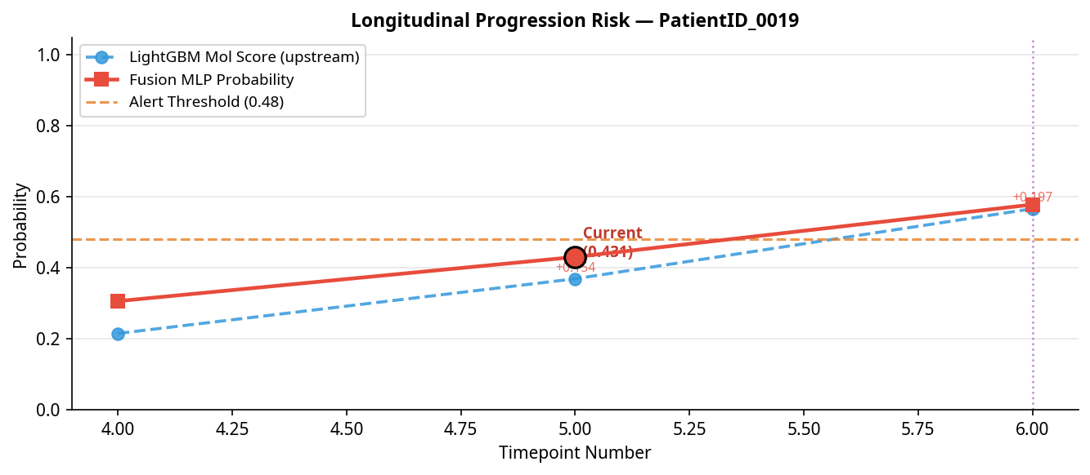
Longitudinal Trend

Section 2 — RANO 2.0 Rule Engine
Criterion | Value | Threshold | Triggered?
Bidimensional (BD) Product Change | +53.5% | +25% | YES
New Independent Lesion | Detected | Any | YES

RANO 2.0 Verdict: Progressive Disease (PD)

Section 3 — Confounder Check (Weighted Pseudoprogression Risk)
Total Risk Score: 0.0 / 5.5
Risk Classification: LOW Pseudoprogression Risk
Confounder Factor | Score Contribution | Rationale
Time Post Rt | +0.0 | (> 12 months post-RT — pseudoprogression less likely but not excluded)
Mgmt | N/A | (MGMT status not provided)
Steroid | +0.0 | (Steroid dose change +0% — within normal range)
Rc Adjacent | +0.0 | (No RC-adjacent enhancement)

Note: MGMT methylation status is the single strongest predictor of pseudoprogression risk. When MGMT status is unknown, risk should be treated conservatively.

Section 4 — AI Interpretation: Fusion MLP & SHAP Analysis
Metric | Value
Unified Fusion Probability | 0.5782
Alert Threshold | 0.48
AI Verdict | 🟠 MODERATE — CLOSE FOLLOW-UP WARRANTED
RANO-AI Concordance | ✅ CONCORDANT

SHAP Top Feature Contributions
SHAP values explain the model's prediction, not direct causality. Features marked 'Novel Signal' should be interpreted with caution and cross-referenced with clinical findings.
Rank | Feature | SHAP Value | Direction | Clinical Status
1 | upstream_mol_score | +0.3329 | ↑ Increases risk | Clinically Validated
2 | vision_dim_32 | -0.0018 | ↓ Decreases risk | Novel Signal
3 | vision_dim_27 | +0.0016 | ↑ Increases risk | Novel Signal
4 | vision_dim_0 | -0.0014 | ↓ Decreases risk | Novel Signal
5 | vision_dim_2 | -0.0014 | ↓ Decreases risk | Novel Signal

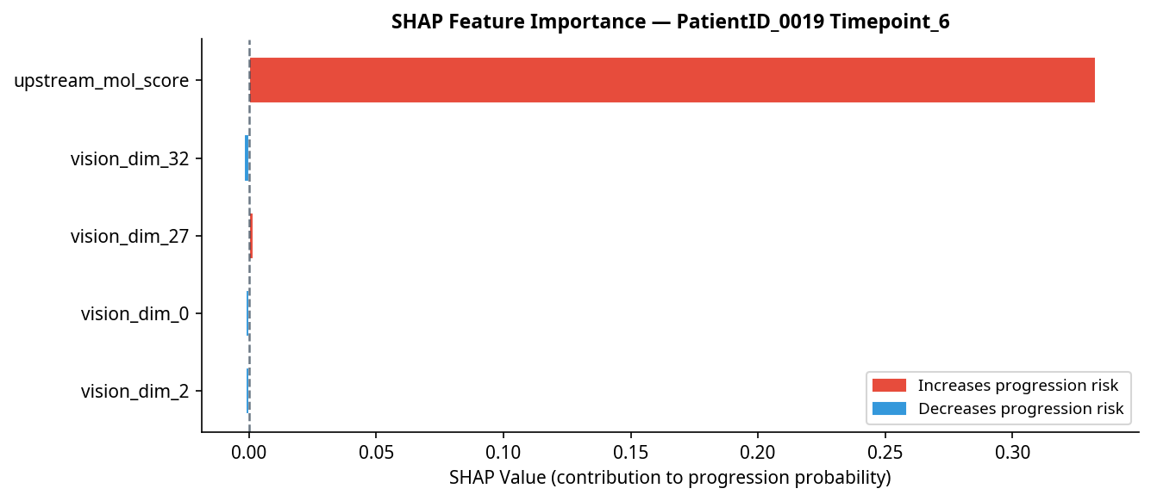
SHAP Feature Importance

Section 5 — LLM-Generated Clinical Summary
At 379 days post-diagnosis, PatientID_0019 demonstrates a significant longitudinal increase in molecular risk score, with a delta of +0.1973 from the prior timepoint and +0.3514 from the nadir, indicating a notable upward trajectory. The RANO 2.0 assessment confirms progressive disease, evidenced by a 53.5% increase in bidimensional measurements and the appearance of a new lesion. Concordantly, the AI fusion model issues a progression alert with a unified fusion probability of 0.5782, which is above the predefined threshold yet within a moderate range, consistent with progression but warranting close follow-up. The low pseudoprogression risk score, given the time elapsed since radiotherapy and stable steroid dosing, reduces the likelihood of treatment-related imaging changes confounding interpretation. The AI’s conclusion is primarily driven by the upstream molecular score (SHAP=+0.3329), a clinically validated feature strongly favoring progression, supplemented by minor contributions from novel imaging-derived signals. Given the concordance between RANO criteria and AI assessment, the findings support a diagnosis of true progression. It is recommended that the patient undergo multidisciplinary team review with consideration for short-interval MRI to closely monitor disease evolution and guide timely therapeutic decisions.

This report was generated automatically by the Glioma Post-Treatment Surveillance AI Agent. It is intended as a decision-support tool and does not replace clinical judgment. All findings should be reviewed by a qualified neuro-oncologist.

