Game Design Document

Fill up the following document

Write the title of your project.

VISION

What is the goal of the game?

attack and kill the enimies overcome the obstacles get the spaceship destroy the

Write a brief story of your game.

this game is based on the theory of simulation the whole mankind have been controlled by extra terrastial civilisation from the birth to their death and everything a human faces in his life is predefined but when humans have got it to their knowledge they plan to standback against their act and they form a team of 5 and appoint a mastermind named Goutham as the head of the team and executed by a group of cyborgs and humans directly come out of the simulatery universe by interpreting the illutions caused by the and see the orginal universe for the first time and for their surprise the orginal universe is exactly opposite to what the imlatery universe is. and humans get to highly secured place to get a spaceship to get to the headquartres to destroy the head of the civilisation and humns find him and destroy him.

1. Which are the playing characters of this game?

* Playing characters are the ones who respond to the user based on the input from the user.
* Cars, monkeys, dinos, wizards, etc., are the playing characters in the game.

|  |  |  |
| --- | --- | --- |
| Number | Character Name | What can this character do? |
| 1 | Protagonist | Move accordingly to the movement of the arrow key and shoot if space bar is pressed |
| 2 | Spaceship | Move accordignly to the input of the player and shoot if space bar is pressed |
| 3 |  |  |
| 4 |  |  |
| 5 |  |  |
| 6 |  |  |
| 7 |  |  |
| 8 |  |  |

1. Which are the Non-Playing Characters of this game?

* Non-Playing characters are the ones that don't have an action or behavior when the user interacts with the game.
* Hurdles, stones, bananas, coins, etc., are non-playing characters in the game.

|  |  |  |
| --- | --- | --- |
| Number | Character Name | What can this character do? |
| 1 | Aliens | Attack the protagonist |
| 2 | Comets | Blow up the spaceship when it hits the spaceship |
| 3 | Special element | Increse the life if it hits the spaceship |
| 4 | Goutham | Give commands in between the game (voice) |
| 5 |  |  |
| 6 |  |  |
| 7 |  |  |
| 8 |  |  |

Draw your imagination of this game. What does this game look like?

* Draw the game either on your computer or on paper.
* Add images of the game scenes to show each of the playing and non-playing characters at least once.

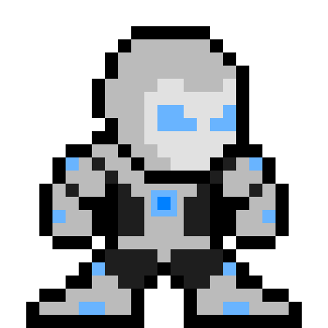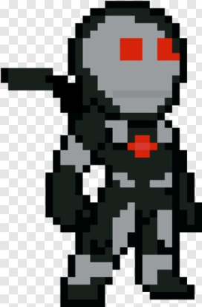

This is how the the protagonist of the game are going to look(1st-initial)(2nd-Upgraded suit)

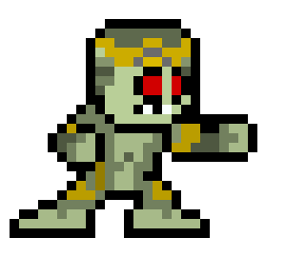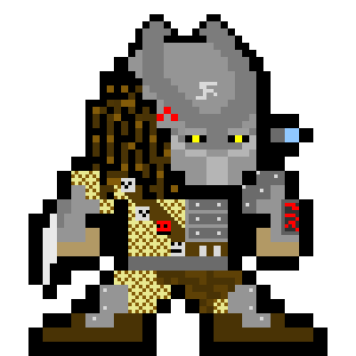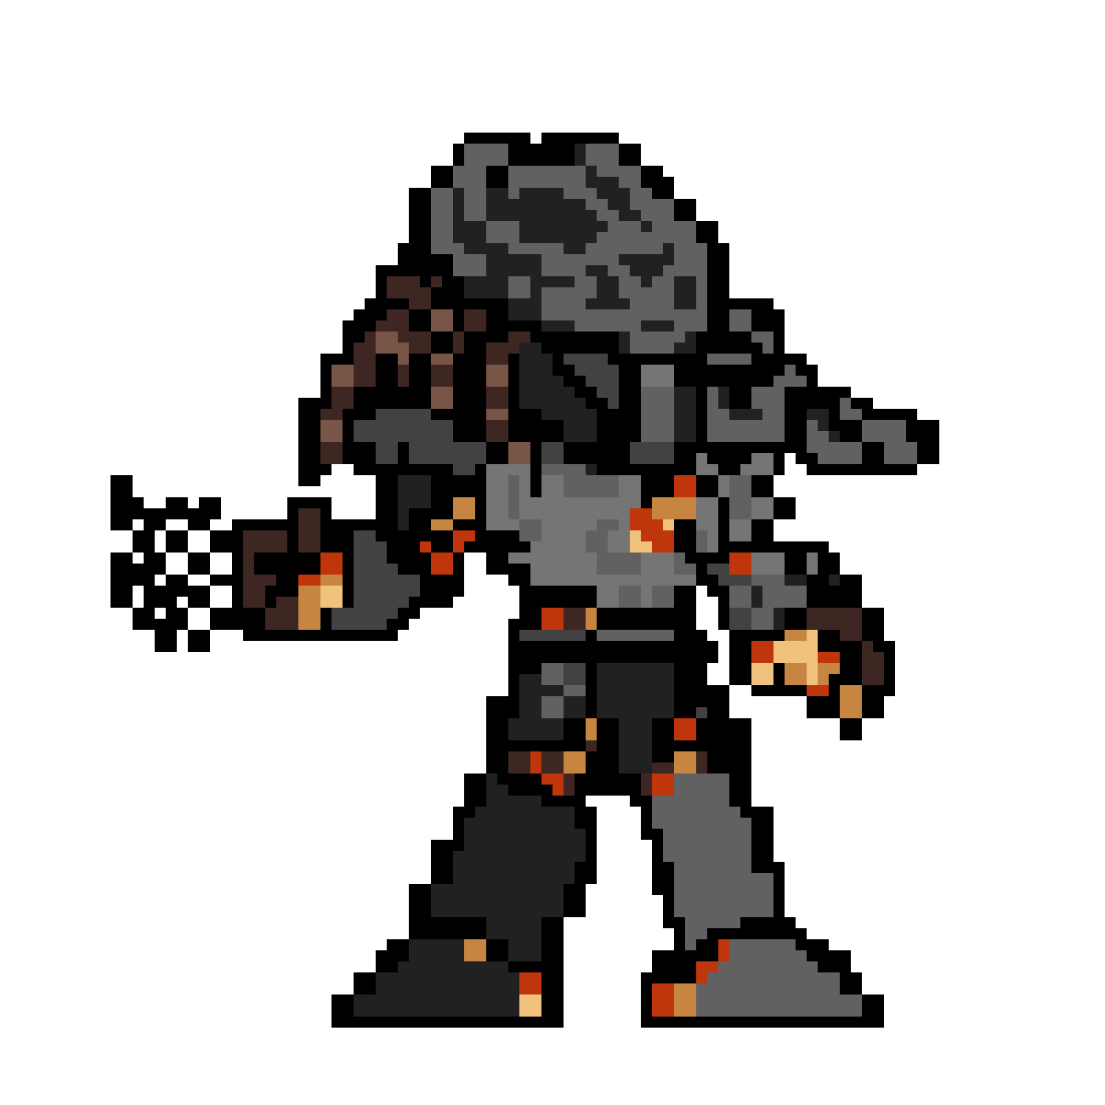

This is the alien of the game is going to look

How do you plan to make your game engaging?

As this game is based on the real life theory the simulation theory and as the characters are going to be based on superhero character of movies this game will also attract the people who love superhero and hypothetical theories as well.