**AMAN BHARDWAJ**

**2019SIY7580**

COL780 Computer Vision: Assignment 1

Gall Bladder Binary Mask Creation.

CONTENT

1. Introduction
2. Literature Review: Methods Utilized
3. Steps followed
4. Figures of Each Step
5. Results: Validation Set
6. **Introduction**

**Medical imaging** refers to techniques and processes used to create images of various parts of the human body for diagnostic and treatment purposes within digital health. As a discipline and in its widest sense, it is part of biological imaging and incorporates radiology, which uses the imaging technologies of X-ray radiography, magnetic resonance imaging, ultrasound, endoscopy, elastography, tactile imaging, thermography, medical photography, nuclear medicine functional imaging techniques as positron emission tomography (PET) and single-photon emission computed tomography (SPECT).

**Image Masking** is a process of image processing to hide some portions of an image and to reveal some portions. It is a non-destructive process of image editing. It is used to extract a particular information from the image hiding the rest of the image portion.

**Binary Image Mask** is the one in which the region of interest is assigned intensity of 1 and rest of the image is assigned 0 or vice versa as per the requirements of the application.

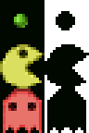

Fig. Shows binary mask (Right) of the objects in the image on the LHS

Source: <https://en.wikipedia.org/wiki/Mask_(computing)#Image_masks>

1. **Literature Review: Methods Utilized**

In this section, the overview of the image processing techniques has been given which have been used in for the assignment.

1. **Convert to Grayscale:**

a **grayscale** image is one in which the value of each pixel is a single sample representing only an amount of light; that is, it carries only intensity information. Grayscale images, a kind of black-and-white or gray monochrome, are composed exclusively of shades of gray. The contrast ranges from black at the weakest intensity to white at the strongest.

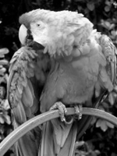

Fig. Grayscale Image. Source: <https://en.wikipedia.org/wiki/Grayscale>

1. **Bilateral Filter:**

A bilateral filter is used for **smoothening images** and **reducing noise**, while preserving edges.

**Reason** to use this over other smoothing filters like Gaussian filter, Median filter etc, is that it preserves the edges while other type of noise reduction techniques results in blurred edges.

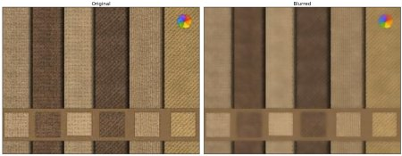

Fig. Bilateral Blur (source: <https://docs.opencv.org/master/d4/d13/tutorial_py_filtering.html> )

1. **CLAHE (Contrast Limited Adaptive Histogram Equalization):**

**Histogram equalization** is a method in image processing of contrast adjustment using the image's histogram. This method usually increases the global contrast of many images, especially when the usable data of the image is represented by close contrast values. Through this adjustment, the intensities can be better distributed on the histogram. This allows for areas of lower local contrast to gain a higher contrast. Histogram equalization accomplishes this by effectively spreading out the most frequent intensity values.

**CLAHE** is a variant of Adaptive histogram equalization (AHE) which takes care of over-amplification of the contrast. CLAHE operates on small regions in the image, called tiles, rather than the entire image. The neighboring tiles are then combined using bilinear interpolation to remove the artificial boundaries. This algorithm can be applied to improve the contrast of images.

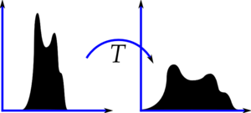

Fig. Histogram equalization. (Source: <https://docs.opencv.org/master/d5/daf/tutorial_py_histogram_equalization.html> )

1. **Image Thresholding:**

For every pixel, the same threshold value is applied. If the pixel value is smaller than the threshold, it is set to 0, otherwise it is set to a maximum value.

Following are the types of thresholding modes are available in OpenCV: I have used **BINARY_INV** Mode to meet the requirement of below threshold area to be 1 and rest to be zero.

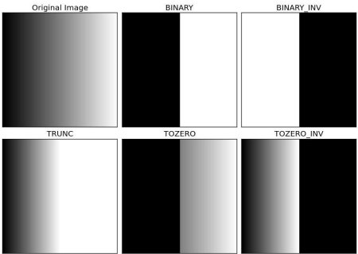

Fig. Modes of thresholding (source: <https://docs.opencv.org/master/d7/d4d/tutorial_py_thresholding.html> )

1. **Morphological Transformations:**

Morphological transformation is basically some simple operations performed on a binary image. And the binary image is basically an image that contains two colors usually black and white.

**There are main two operations in Morphological Transformation: Erosion & Dilation**

And using the above two in different combinations, they result in two other transformations known as: **Opening & Closing**

**Gradient and Tophat** can also be implemented but I have not used them for the assignment**.**

1. **Erosion:**

In erosion, we are just omitting the boundaries of the front image or the object image that is in the process we are **thinning the object**.

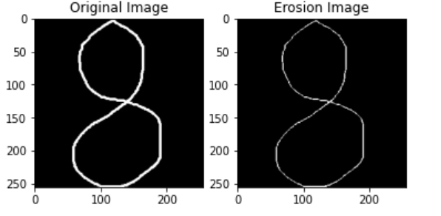

Fig source: <https://medium.com/@ravjot03/morphological-transformations-of-images-using-opencv-image-processing-part-2-f64b14af2a38>

1. **Dilation:**

In the dilation process we are just going to **thicken the boundaries** of a binary image. The bright area of the binary image dilates around the black regions of the background. It’s actually the reverse process of Erosion.

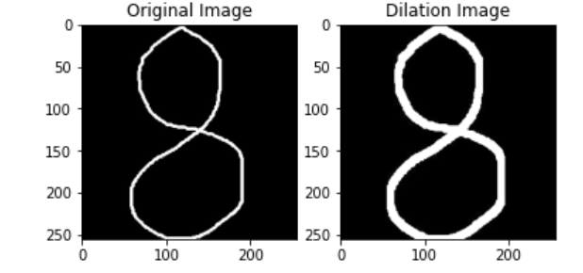

Fig source: <https://medium.com/@ravjot03/morphological-transformations-of-images-using-opencv-image-processing-part-2-f64b14af2a38>

1. **Opening:** Opening is just another name of **Erosion followed by Dilation**. It is useful in removing noise.

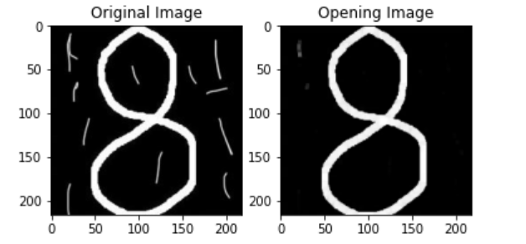

Fig source: <https://medium.com/@ravjot03/morphological-transformations-of-images-using-opencv-image-processing-part-2-f64b14af2a38>

1. **Closing:** Closing is reverse of Opening, **Dilation followed by Erosion**. It is useful in closing small holes inside the foreground objects, or small black points on the object.

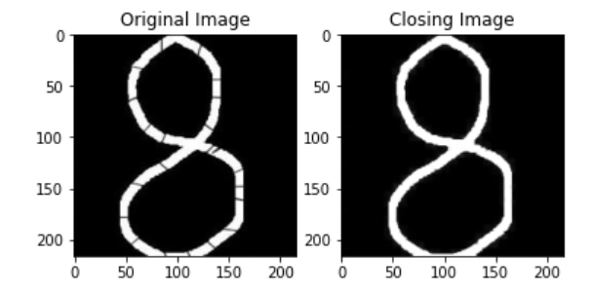

Fig source: <https://medium.com/@ravjot03/morphological-transformations-of-images-using-opencv-image-processing-part-2-f64b14af2a38>

1. **Find Contours & Draw Contours:**

**Contours** can be explained simply as a curve joining all the continuous points, having same color or intensity. The contours are a useful tool for shape analysis and object detection and recognition.

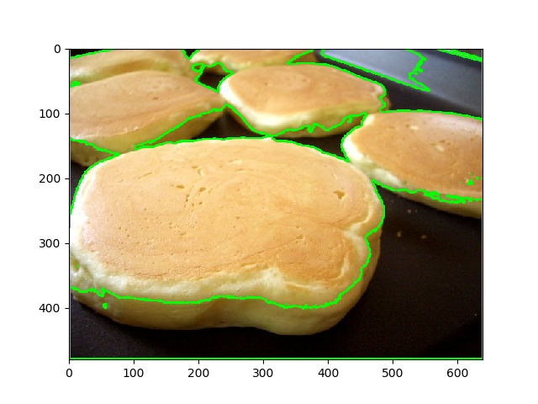

Fig source: <https://www.thepythoncode.com/article/contour-detection-opencv-python>

1. **Contour Edges Smoothing:**

Contours will be zigzag boundaries and it will return all the continuous pixels of same intensity. But our requirement is to get smooth contours in order to get the straight lines for the mask as provided in the Ground Truth Masks.

So out of the array of all the pixels a sampling has been done at an interval of every 20 indices of contour pixel array. i.e. every 20th pixel is picked. And then the mask is drawn. This gives us smooth approximation of the contour.

1. **Steps Followed**
2. **Original Image Import**
3. **Image Smoothing:** For noise removal, keeping the **edges preserved** using Bilateral Filter.
4. **Convert to Grayscale**
5. **Improve Contrast:** Using CLAHE, as explained above to improve the contrast of the image.
6. **Erosion 1:** Erosion is done on improved contrast image in order to make the dark region (Tentative ROI) even darker by reducing the amount of white noisy area in between.
7. **Image Thresholding:** Inverted Binary thresholding is done on the resulting image from previous step in order to make the pixels below threshold 255 and above threshold to 0.
8. **Erosion 2:** The threshold image is then eroded, because the raw threshold image has lots of minor connection lines to the neighboring areas. Therefore, in order to define the isolated ROI from the rest of the image this needs to be done.
9. **Closing Operation:** This is done in order to remove the exterior noise from the binary image.
10. **Find Contours:** This step includes identification of all the contours from the improved image threshold and identify the contour corresponding to Gall Bladder. Which will be our **ROI**.
11. **Draw Mask after Smoothing Gall Bladder Contour:** The contour obtained in the previous step will have irregular and zigzag boundaries. So, smoothing of the contour by sampling of boundary points as explained earlier needs to be done in order to obtain mask close to the Ground Truth.
12. **Dilation:** Since we have eroded the threshold image therefore the ROI has shrunk a bit. Therefore we dilate the final contour in order to cover maximum ROI under mask.
13. **Figures of Each Step:**

**(Numbered same as above steps respectively)**

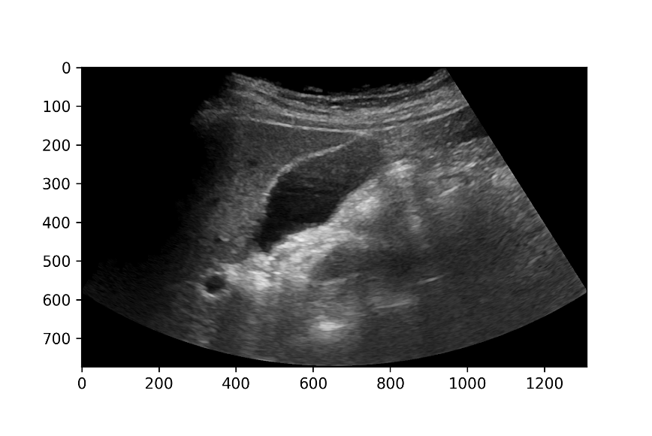

1. Original Image (2) Image Smoothing

(3,4) Contrast Improved (5) Erosion1

(6) Image Thresholding (7,8) Erosion2 & Close

(9) Find Contour and Draw ROI (10, 11) ROI Edges Smoothing and Dilation

1. **Results: Validation Set**

|  |  |  |
| --- | --- | --- |
| S. No. | Image Name | IOU SCORE |
| 1. | **0000.jpg** | **0.8116260912768827** |
| 2. | **0001.jpg** | **0.8746582047733180** |
| 3. | **0002.jpg** | **0.8738623626989465** |
| 4. | **0003.jpg** | **0.8921010794075810** |
| 5. | **0004.jpg** | **0.8237604245640637** |
| 6. | **0005.jpg** | **0.6776419558359621** |
| 7. | **0006.jpg** | **0.8276613886820149** |
| 8. | **0007.jpg** | **0.8368090750285752** |
| 9. | **0008.jpg** | **0.8764419576131529** |
| 10. | **0009.jpg** | **0.7478098252175790** |
|  | **AVERAGE IOU** | **0.8242372365098077** |

**\*\*\*\*\*\*\*\*\*\*\*\*\*\*\*\*\*\*\*\*\*\*\*\*\*\*\*\*\***