## UniqueBible.app

This is a demo **Word Docuemnt** for display in UBA.

We try several common styles below, e.g. bold, italic, underline, bullet points, ordered list, table, image, etc.

You can read Word Document with UBA.

Bible verse references are automatically parsed if you have “**parseWordDocument**” enabled.

* John 3:16
* Rm 5:8
* Gen 1:1

**Ordered list**

How to enable “parseWordDocument”?

(Take “Focus” menu layout as an example.)

1. From menu > UniqueBible.app > Config Flags.
2. Enter “parseWordDocument” in search field.
3. Tick the checkbox in front of option “parseWordDocument”.

**Images**

Image display is supported.

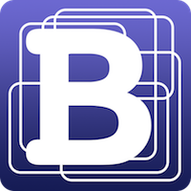

**Table**

|  |  |  |  |  |
| --- | --- | --- | --- | --- |
|  | 1 | 2 | 3 | 4 |
| A | A1 | A2 | A3 | A4 |
| B | B1 | B2 | B3 | B4 |

*Enjoy!*