NMC 5342 (Spring 2026) – Individual Assignment Report
Name: Wang Xinyang
NUS Email Address: xinyang_wang@u.nus.edu
Student ID: A0357223H
Link to Jupyter Notebook: https://github.com/Costawang/NMC5342-Individual-Assignment/blob/main/Individual_Assignment_A0357223H_notebook.ipynb
Access granted to Ze (zeningduan1995@gmail.com): Yes

Sitting Down for the Story: NiKo’s Championship and Chinese Esports Fandom on Bilibili

Introduction
A championship acquires a second life after the match: viewers retell setbacks, circulate catchphrases and remind one another why the victory matters. This study examines that afterlife in comments on three videos from FLC_NiKo, the Bilibili account associated with Counter-Strike player Nikola ‘NiKo’ Kovač. The selected uploads frame a livestream announcement before the championship and two celebrations afterwards (Table 1). They offer contrasting settings for examining how achievement becomes a shared story.
Two questions guide the analysis: how do sentiment and discussion patterns differ across these selected videos, and how do commenters construct NiKo’s competitive identity and career legacy? The aim is to understand the language through which this particular audience makes achievement meaningful.
Table 1. Selected videos. Descriptions summarise supplied titles and research context
Video / date (2026) | BVID | Content in brief
First Chinese livestream  25 May | BV1u5GR6vELU | Livestream announcement: current situation and future plans.
Thank you  24 June | BV1QSjm6wEBT | Post-championship appreciation message to viewers.
We are champions  1 July | BV1jsTi67EMC | Retrospective vlog presenting the championship experience.

Methods
The Python collection workflow used HTTP requests, cursor pagination and separate video checkpoints to retrieve 18,923 top-level comments. Nested replies and bullet-screen messages were excluded. Comment IDs prevented duplicate retrieval; identical wording was retained. Conservative cleaning removed 39 purely numerical comments and seven clear promotional messages, leaving 18,877. Emoji, slang, punctuation and repetition were preserved as potentially meaningful fan expression. The notebook documents collection, cleaning, lexical exploration and analysis without automatically repeating live requests.
Sentiment comparisons use each video’s first 168 hours, producing 17,319 comments. This avoids treating all responses to an older upload as contemporaneous: 856 comments beneath the pre-title video appeared on or after 22 June. Full-corpus and fourteen-day summaries remain available as sensitivity checks. Topic exploration uses the entire collected corpus; its video comparisons therefore describe content contexts, not matched event-time samples.
Erlangshen-RoBERTa-110M-Sentiment [1] supplied positive and negative scores. A score of at least 0.80 defined a high-confidence label; other predictions were ‘uncertain’, not a trained neutral category. Scores are not calibrated accuracy estimates. BERTopic used BGE-base-zh-v1.5 [2] embeddings, UMAP, HDBSCAN and Jieba-based c-TF-IDF. It fitted 15,566 distinct normalised texts, then restored their frequencies across all comments. The recorded run produced 38 non-outlier clusters, reduced to 15 for interpretation [3]. Full settings and long-text handling are recorded in the notebook.
Further automatic reduction to five clusters was rejected because it collapsed ten distinct clusters into one. Instead, iterative dialogue with ChatGPT examined keywords, selected comments and cross-video distributions. Researcher review and approval established five interpretive themes. This completed LLM-assisted reading was neither an independent second coder nor exhaustive five-class prediction. The themes organise meaning; numerical comparisons retain the underlying 15-cluster labels.

Findings

Emotional patterns across video contexts
Figure 1 shows a greater share of high-confidence positive labels in the two post-title videos. The appreciation video reached 54.08%, against 45.87% for the livestream announcement; the championship vlog reached 51.28%. Negative shares were 15.78%, 17.88% and 17.19%, respectively. Uncertain predictions remained substantial. The pattern is consistent with more celebratory discussion in the selected later uploads, but differences in video genre and participation prevent attributing it to victory alone.
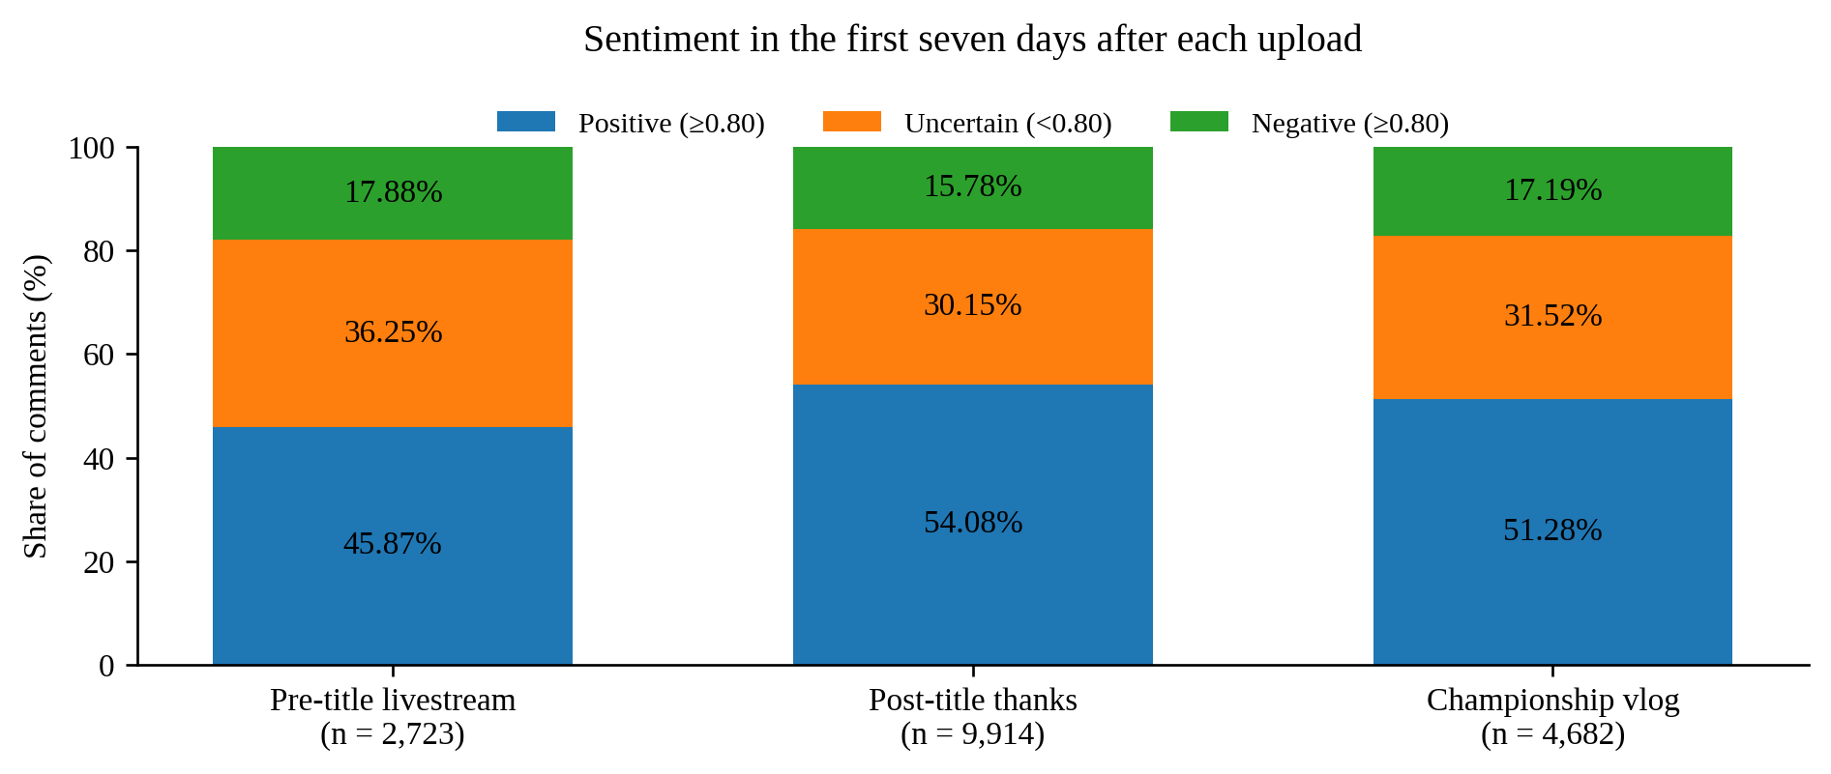
Figure 1. Model-label shares within 168 hours of each upload (N = 17,319).

Five interpretive themes
Championship & Competitive Legacy. The comments do more than acknowledge a result: they negotiate what it means for NiKo’s career. Topic 0 gathers discussion of Major titles, performance and standing, although it is internally mixed. A commenter lists a championship among their own honours, describing it as a gift from the player. This playful appropriation makes personal achievement available as a shared symbolic possession, rather than simply a statistic belonging to an athlete.
Career Redemption & Perseverance. Expressions surrounding ‘maybe not today’ and ‘today is the day’, alongside poetic comments in Topics 4 and 5, give victory a retrospective shape. One comment observes, ‘The final key to the story was hidden at its beginning.’ Another imagines Kuafu finally reaching his sun. Earlier disappointment is not erased; it becomes the reason fulfilment matters. These examples suggest a redemption narrative, without implying that every comment in either cluster carries that meaning.
Fandom & Emotional Identification. Support is also relational. Affectionate names, encouragement and kinship-like address position commenters alongside the player. Calling NiKo ‘dad’, for example, can combine parody with attachment rather than straightforward hero worship. Material in Topics 6, 7 and 10 suggests that identification is enacted through familiar ways of speaking. These expressions can be emotionally charged while revealing little about a commenter’s literal assessment of performance.

Collective Storytelling & Memes. Topic 3 contains invitations to sit down and hear the story. It represents 2.00% of the pre-title video’s full comments, compared with 10.49% and 9.79% in the two later videos (Figure 2). ‘I’m seated’ turns reading into a recognisable communal ritual. Related requests in Topic 8 exaggerate how urgently another retelling is needed. Repetition thus carries meaning: it gives participants an easy way to join a shared memory. These cluster shares are evidence of recurring forms, not validated prevalence estimates for the broader theme.
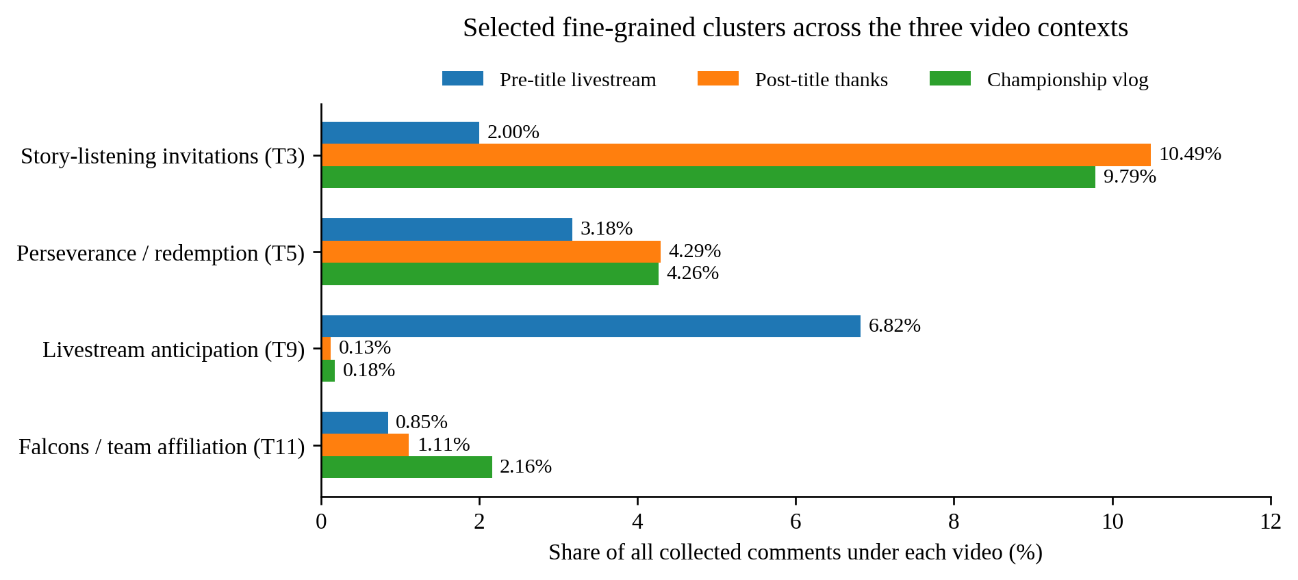
Figure 2. Selected fine-cluster shares with LLM integration in the full collected corpus (N = 18,877).
Media Engagement & Team Affiliation. Belonging extends beyond the result. Topic 9’s livestream anticipation is concentrated in the announcement video, while Topic 2 includes requests for vlogs and comments on production. Topic 11’s ‘We are Falcons’ shifts identification towards the team. This final interpretive theme retains two related dimensions—media participation and affiliation—rather than claiming they constitute one homogeneous machine-discovered cluster.

When sentiment and cultural meaning diverge
Context also complicates the sentiment output. Of 846 comments composed entirely of Bilibili bracketed emoji codes, 390 received high-confidence negative labels; cheering expressions were among the questionable examples. Topic 8 likewise contained 197 high-negative predictions out of 259 comments, despite examples playfully requesting another championship story. Neither statistic is an error rate. They show why negative wording, emotional tone and hostility towards the player should not be treated as interchangeable. No independently labelled benchmark or controlled LLM comparison establishes which model is more accurate.

Discussion & Recommendations
Taken together, the findings suggest that the championship’s significance is sustained through participation. Achievement becomes emotionally intelligible through remembered disappointment; familiar phrases allow that memory to be performed repeatedly. The five themes connect competitive history, attachment and everyday interaction without pretending to be five exhaustive boxes into which every comment belongs.
The computational analysis is useful precisely when its limits remain visible. HDBSCAN left 6,155 comments unassigned (32.61%), including the evocative Kuafu metaphor. Unassigned therefore does not mean irrelevant. Topic word lists also overemphasised English fragments and platform symbols, requiring close reading beyond machine names. The LLM-assisted interpretation is a documented analytical aid, not independent validation. Chinese-model performance on mixed-language praise, emoji and irony remains uncertain.
Only three purposefully chosen videos were studied, with one pre-title case. Content, timing and audience selection are inseparable here; unequal comment volumes and missing reply conversations further constrain generalisation. The results support an exploratory account of these video communities, not a causal claim about winning or a representative survey of fans.
For esports creators, retrospective storytelling and space for audience retellings may sustain engagement beyond the immediate result. Moderators should read playful negation and repetition in context rather than automatically treating them as hostility or spam. Future research should examine more videos and reply threads, and use independently annotated examples to separate emotional tone from player-directed stance.
Moreover, a particularly noteworthy point about the large language model (GPT-6 Astra Agent) is that, due to the use of model-assisted clustering for five topic categories in this assignment, the black box nature of prompts cannot guarantee the quantitative uniformity of reproduced results. Therefore, I hereby define the role of LLM as exploratory language topic category aggregation.
(Word Count: 1,294)

References
[1] IDEA-CCNL. Erlangshen-Roberta-110M-Sentiment. https://huggingface.co/IDEA-CCNL/Erlangshen-Roberta-110M-Sentiment
[2] BAAI. bge-base-zh-v1.5. https://huggingface.co/BAAI/bge-base-zh-v1.5
[3] Grootendorst, M. BERTopic: https://maartengr.github.io/BERTopic/getting_started/topicreduction/topicreduction.html
AI assistance: ChatGPT/Codex supported coding, debugging, prompt-based thematic interpretation and visualization. The researcher approved the five-theme framework and remains responsible for the submission. The accompanying notebook preserves data provenance and the interpretive decision log.

