Qualitative Results and Discussion
To complement the quantitative evaluation, we examine the behaviour of the proposed detector on twenty-five challenging real-world scenes drawn from surveillance footage, film clips, product photography, and everyday imagery containing weapon-like objects. In every figure the proposed model (left) and the stock YOLOv12-s baseline (right) are shown side by side on the same frame, with predicted boxes coloured by class (blue: long_gun, green: pistol, orange: knife, red: other) and annotated with confidence scores. Across these scenes the baseline exhibits three recurring failure modes that the proposed model corrects: it misses small or partially visible weapons, it confuses the weapon type, and it raises false alarms on weapon-shaped everyday objects. We organise the discussion around these three axes and close with confidence behaviour and limitations.

A. Recovering small and hard-to-see weapons
The most safety-critical failures of a weapon detector are missed weapons, and these concentrate precisely where objects are small, distant, or degraded by motion and compression — the operating point of real surveillance. In the five scenes of Figures 1–5 the baseline produces no detection of the weapon in question (or misses the smaller of two), whereas the proposed model — whose high-resolution P3 features are reinforced by the detail-preserving enhancement modules and whose assignment favours small, well-aligned positives — recovers it. These range from a convenience-store hold-up (Figure 1) and a distant street shootout in which both a rifle and a pistol are recovered (Figure 2) to smoke-obscured, occluded, and secondary firearms in film footage (Figures 3–5).

Figure 1. Convenience-store CCTV. The proposed model (left) localises the small pistol in the suspect’s hand (0.51); the baseline (right) returns no detection.
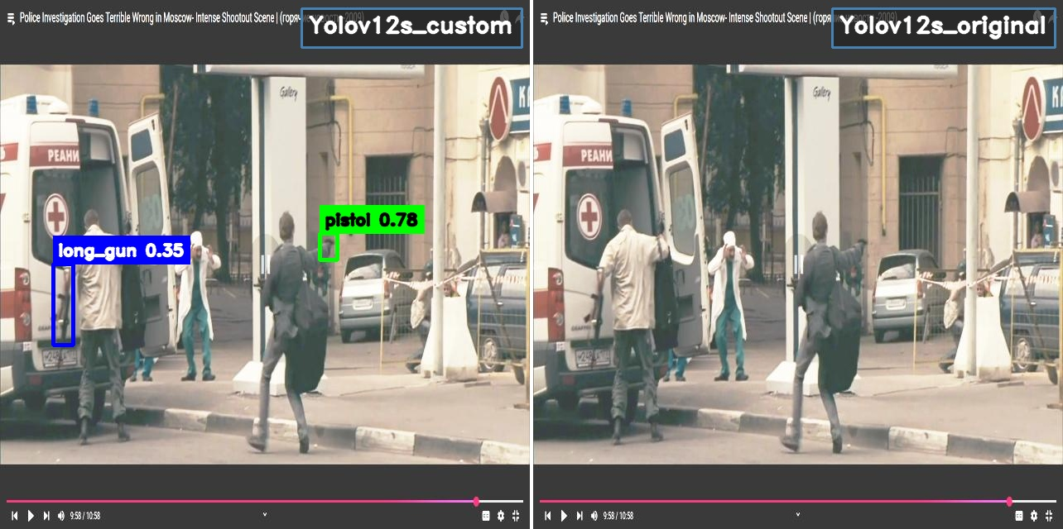
Figure 2. A distant street shootout. The proposed model detects a rifle (long_gun 0.35) and a small pistol (0.78) on figures only a few dozen pixels tall; the baseline detects neither.
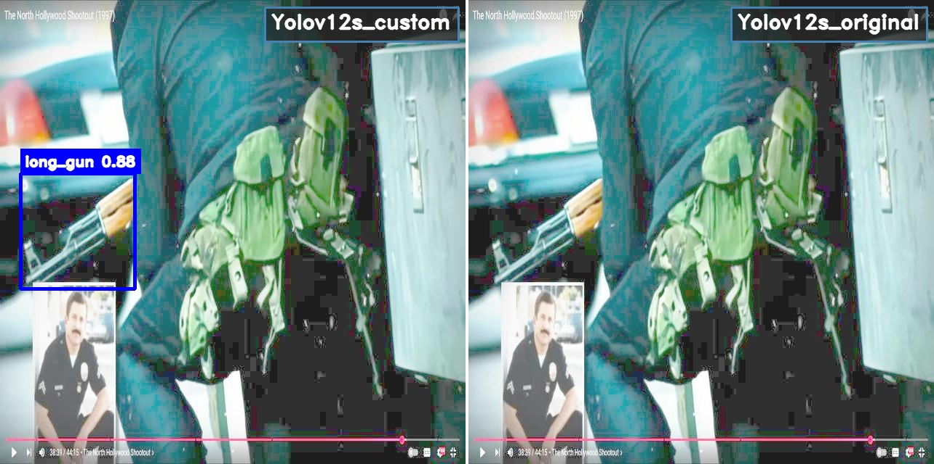
Figure 3. A partially occluded rifle in close-up. The proposed model detects the long_gun (0.88); the baseline misses it.
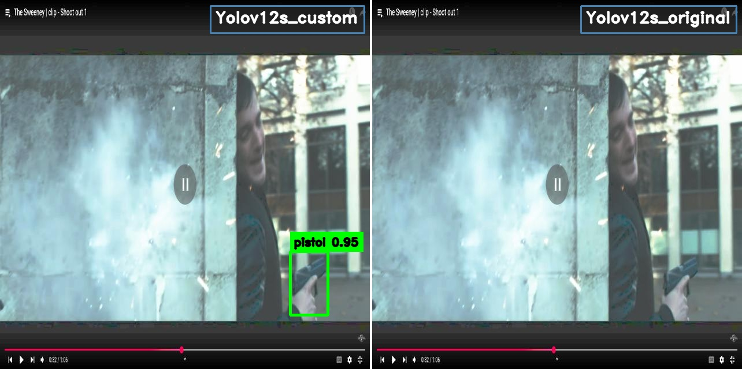
Figure 4. A film action scene obscured by gun-smoke. The proposed model detects the pistol (0.95); the baseline misses it.
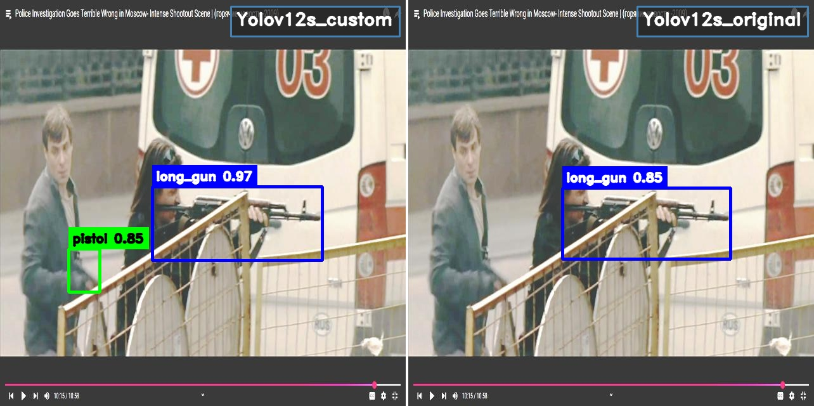
Figure 5. A film still with a rifle and a second, smaller pistol. Both models find the rifle, but only the proposed model additionally detects the small pistol (0.85).

B. Correcting weapon-type confusion
When the baseline does fire, it frequently assigns the wrong class — confusing pistols with long guns, or knives with firearms — and often at low confidence; it also tends to demote a genuine second weapon to the catch-all ‘other’ class. Because the reported weapon type drives the operational response, such errors are costly. Aided by the global-context recalibration that supplies each location with an image-wide cue, the proposed model classifies these cases correctly and more confidently. Figures 6–16 collect eleven such scenes: a composed image containing a rifle, a pistol and a knife that the baseline partly mislabels (Figure 6); a pistol-and-knife studio shot in which the baseline reads the knife as a firearm (Figure 7); handguns and knives that the baseline repeatedly assigns to the wrong firearm type (Figures 8–13); and multi-weapon scenes in which the baseline detects one weapon but demotes the second to ‘other’ (Figures 14–16).
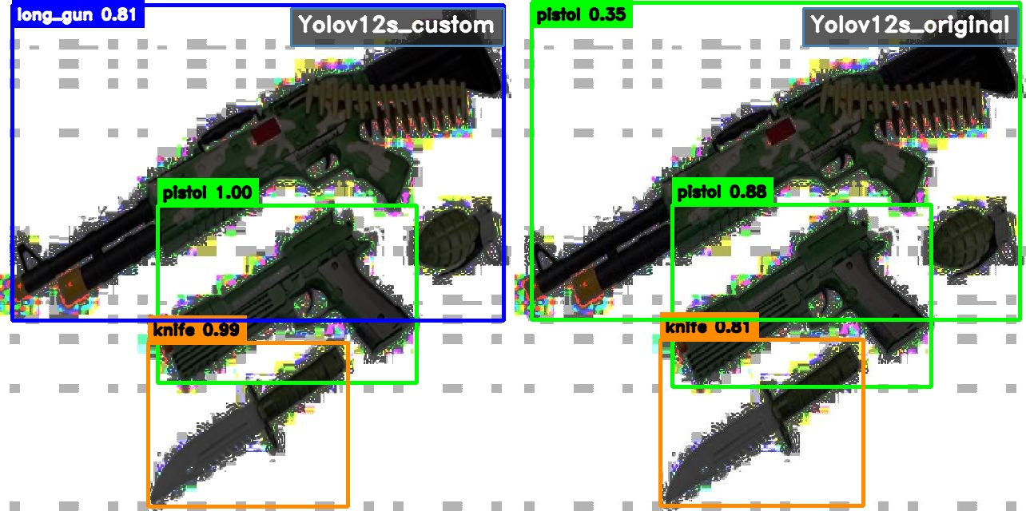
Figure 6. A composed scene with a rifle, a pistol and a knife. The proposed model detects and correctly classifies all three (long_gun 0.81, pistol 1.00, knife 0.99); the baseline mislabels the rifle as a pistol (0.35) and is less confident throughout.
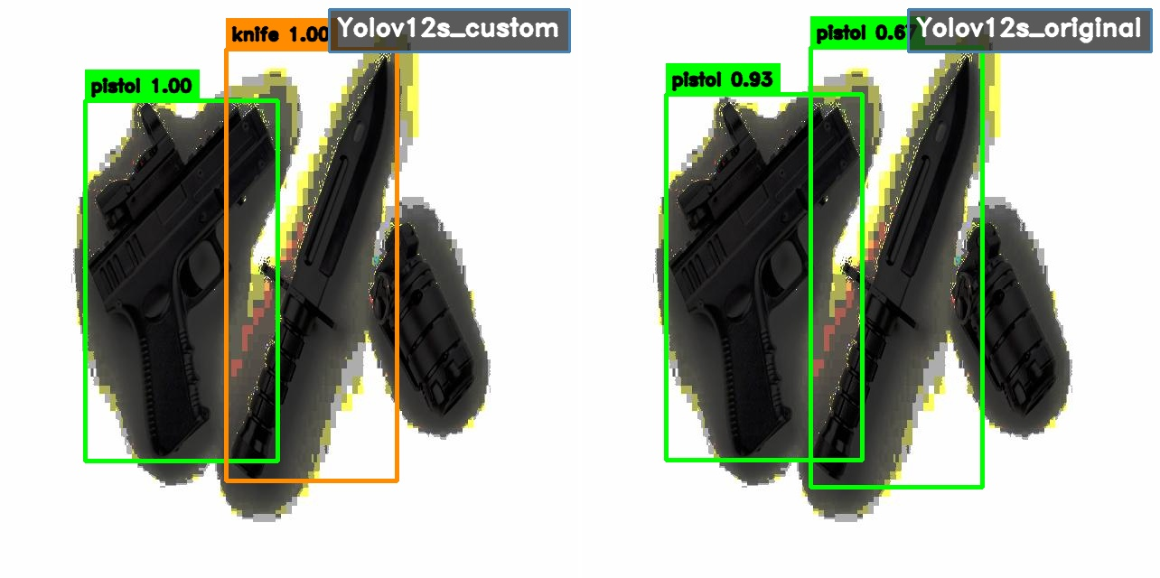
Figure 7. A studio image of a pistol and a combat knife. The proposed model detects both correctly (pistol 1.00, knife 1.00); the baseline mislabels the knife as a second pistol.
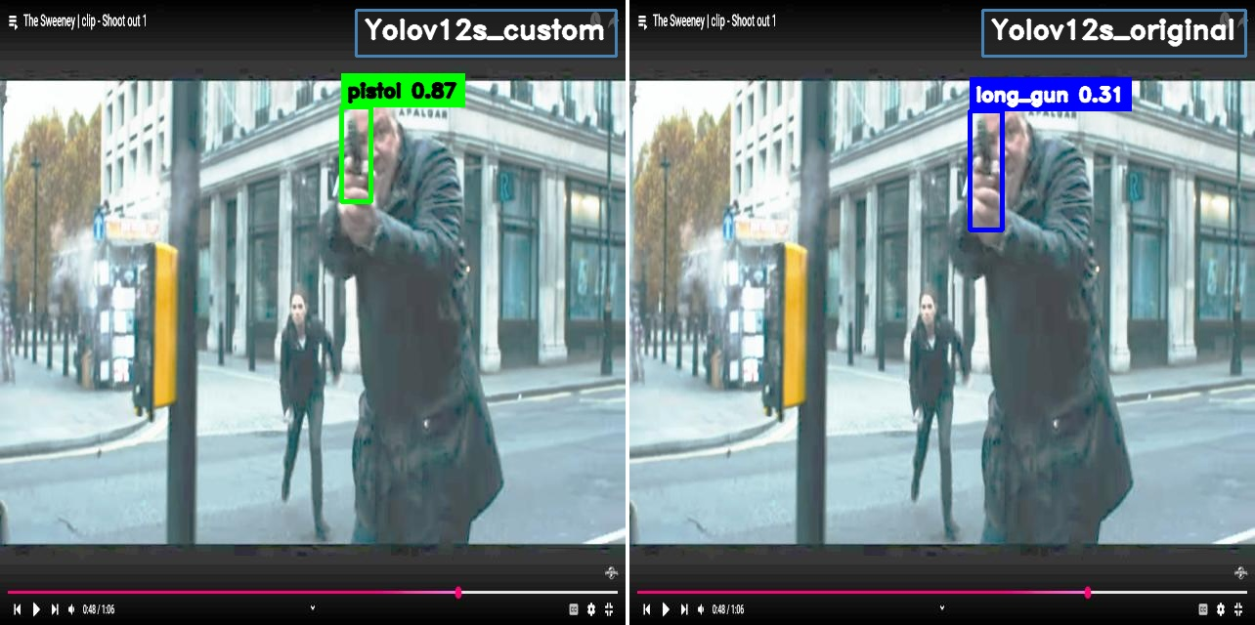
Figure 8. A film still of a handgun aimed toward the camera. The proposed model classifies it correctly as a pistol (0.87); the baseline confuses it with a long_gun (0.31).
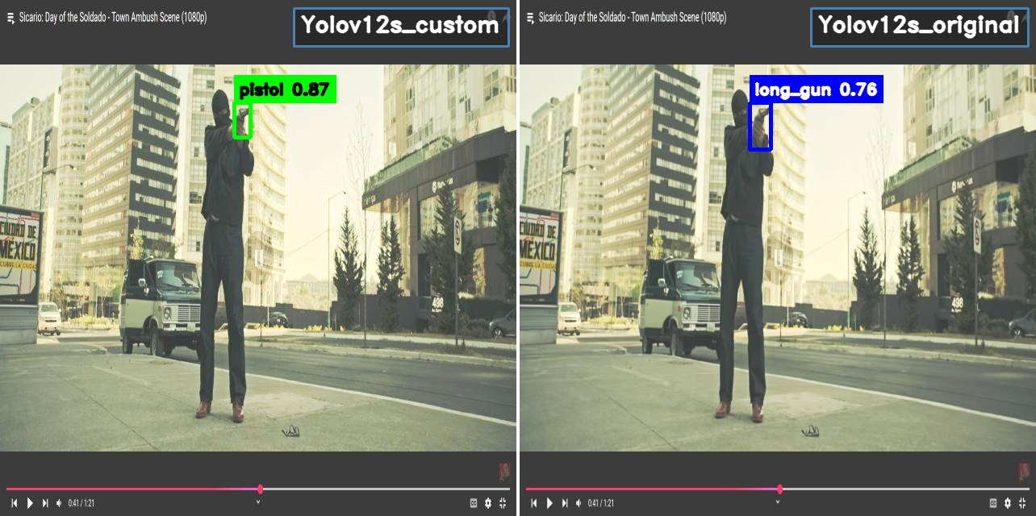
Figure 9. A cinematic long shot of a handgun aimed forward. The proposed model reports a pistol (0.87); the baseline a long_gun (0.76).
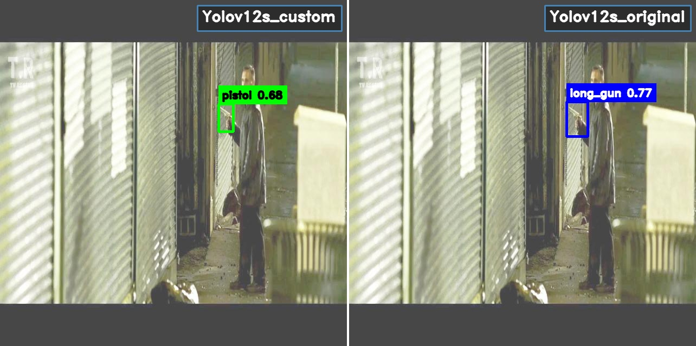
Figure 10. A film frame of a handgun in a corridor. The proposed model reports a pistol (0.68); the baseline a long_gun (0.77).
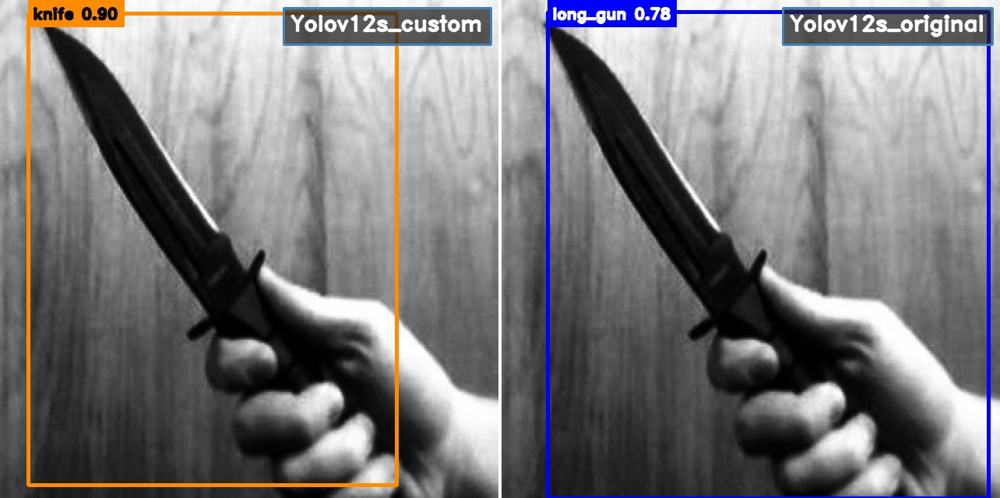
Figure 11. A knife held toward the camera (grayscale). The proposed model labels it a knife (0.90); the baseline mistakes it for a long_gun (0.78).
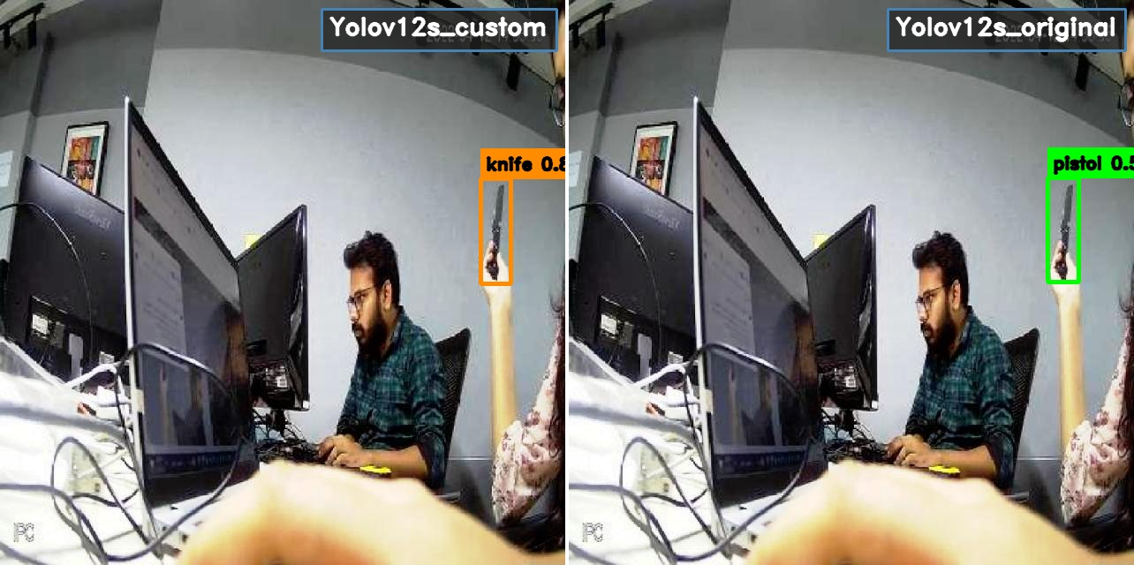
Figure 12. An office scene with a blade entering at the edge of frame. The proposed model reports a knife; the baseline mislabels it as a pistol.
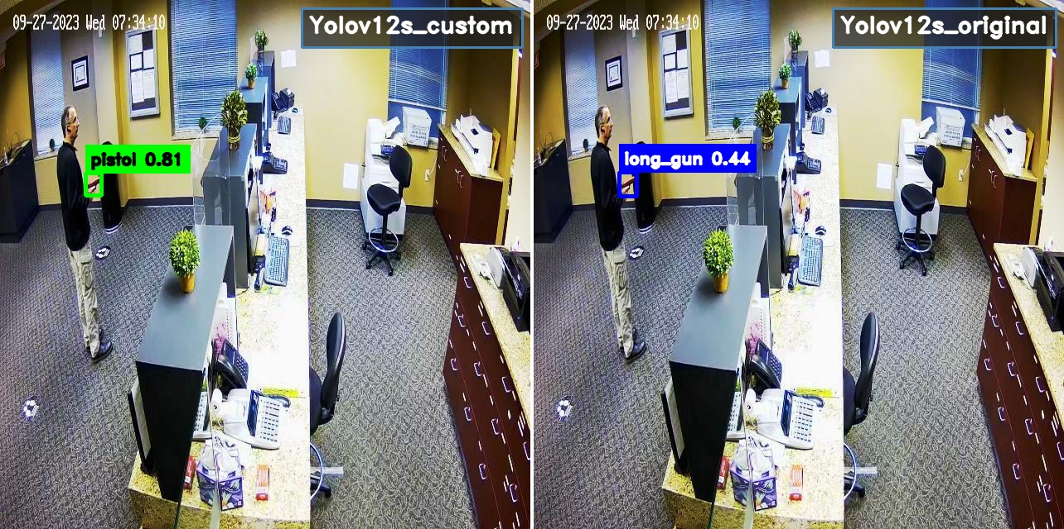
Figure 13. Office surveillance of an armed intruder. The proposed model correctly reports a pistol (0.81); the baseline a low-confidence long_gun (0.44).
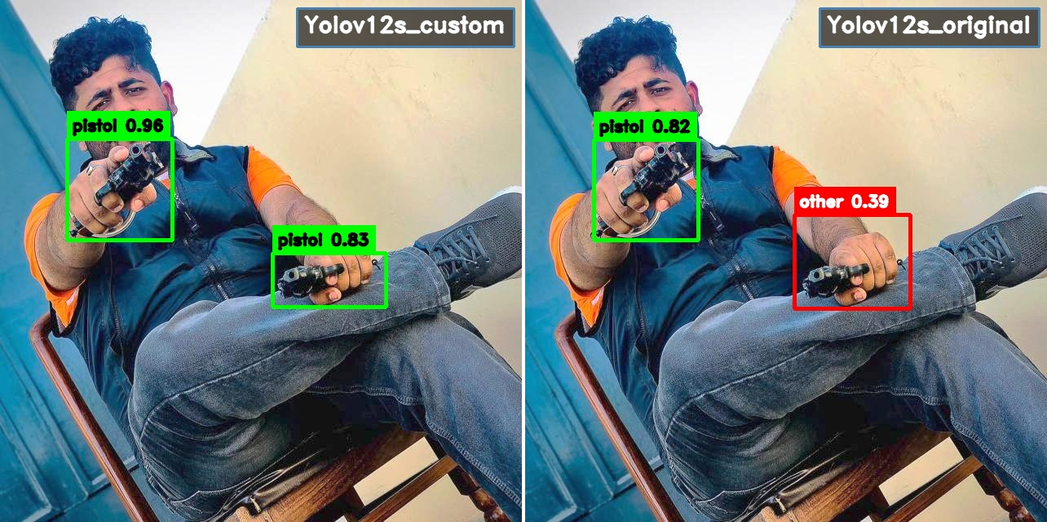
Figure 14. A subject holding two handguns. The proposed model detects both as pistols (0.96, 0.83); the baseline classifies one correctly but demotes the other to ‘other’ (0.39).
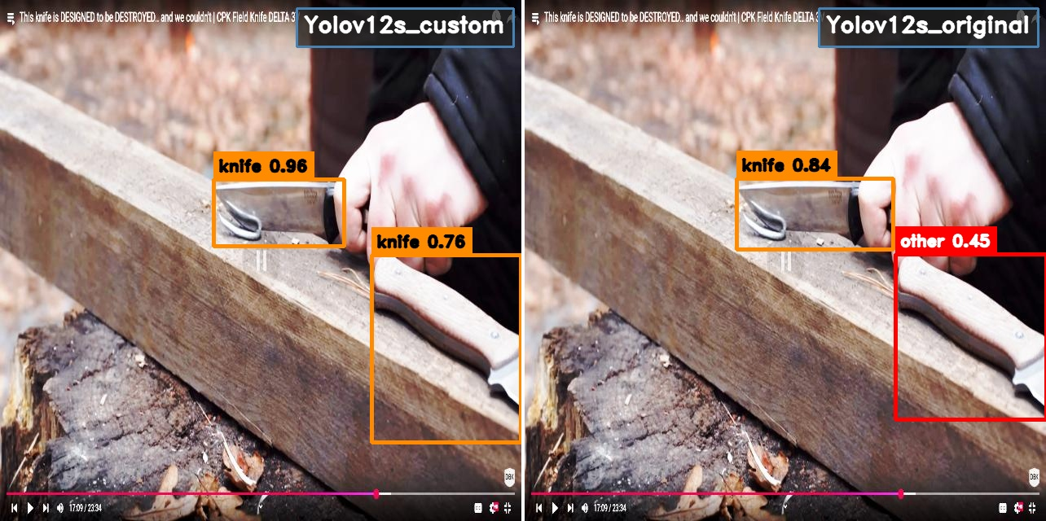
Figure 15. Two knives on a log. The proposed model detects both as knives (0.96, 0.76); the baseline detects one and demotes the second to ‘other’ (0.45).
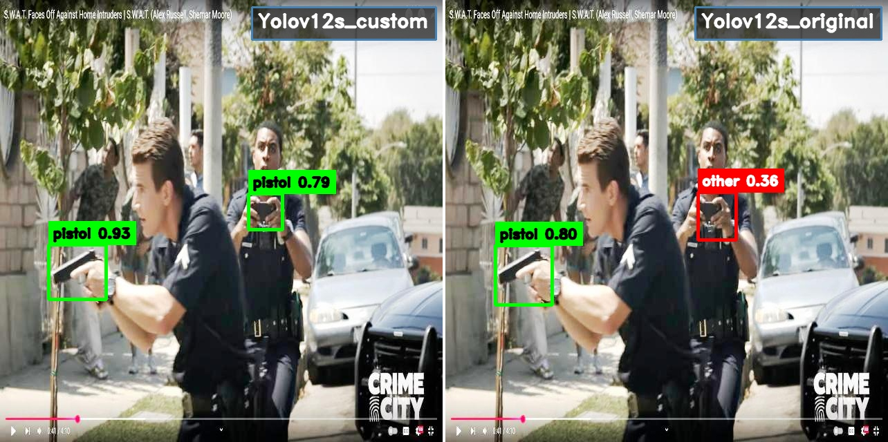
Figure 16. A television scene with two drawn handguns. The proposed model detects both pistols (0.93, 0.79); the baseline reports one pistol and demotes the other to ‘other’ (0.36).

C. Suppressing false alarms on weapon-like objects
A detector deployed in the wild must also avoid false alarms on the many everyday objects whose silhouette resembles a firearm or blade; this is the purpose of the dedicated ‘other’ hard-negative class. Figures 17–22 pair such objects — pressure washers, power drills, a metal railing, a phone case, and a walking cane — with the two models’ responses. The proposed model consistently assigns these objects to ‘other’, suppressing the alarm, whereas the baseline reports them as weapons with high confidence. Figure 20 is particularly telling: the baseline simultaneously under-detects the real firearm and false-alarms the adjacent railing as a long gun, while the proposed model does the opposite on both counts.
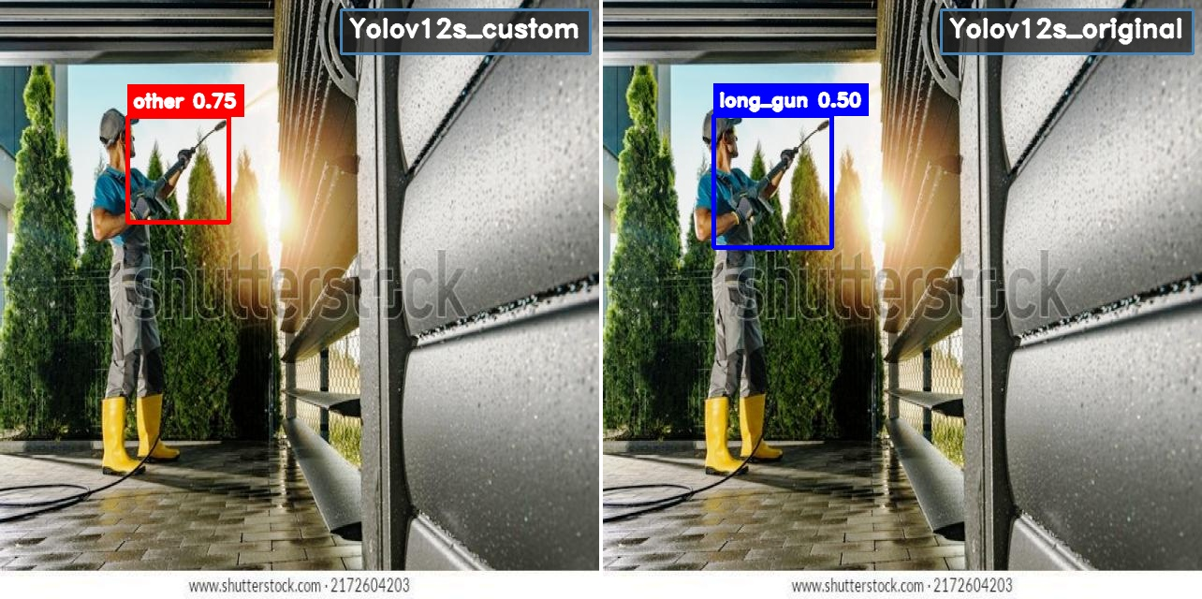
Figure 17. A worker operating a pressure washer. The proposed model correctly assigns the gun-shaped tool to ‘other’ (0.75); the baseline raises a false long_gun alarm (0.50).
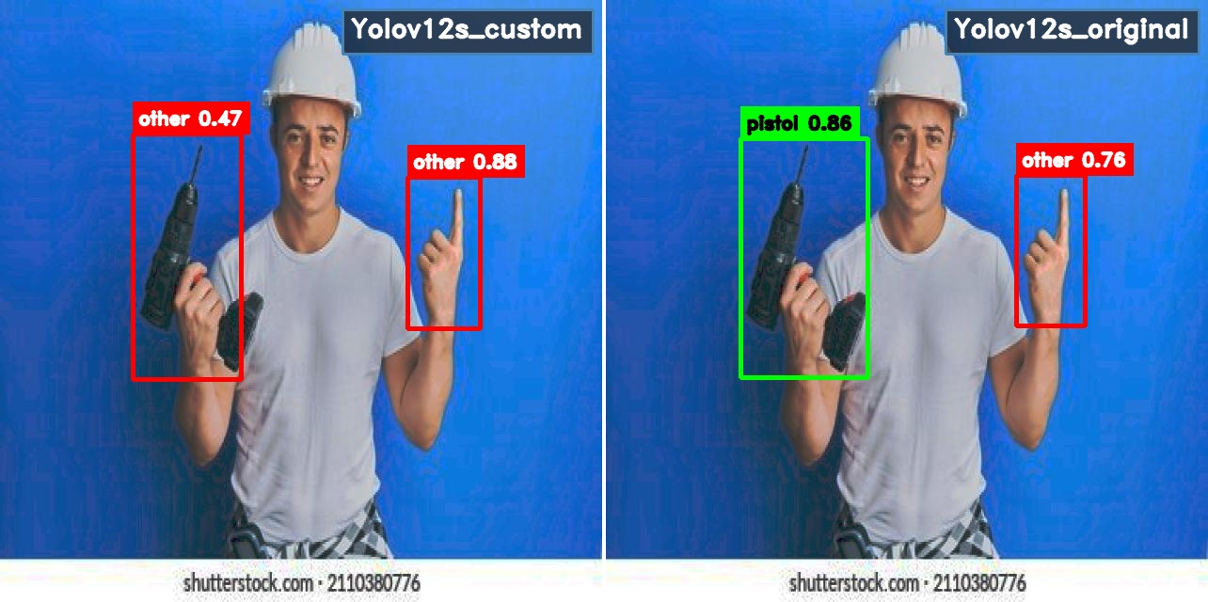
Figure 18. A construction worker holding a power drill. The proposed model classifies the drill as ‘other’; the baseline false-alarms it as a pistol (0.86).
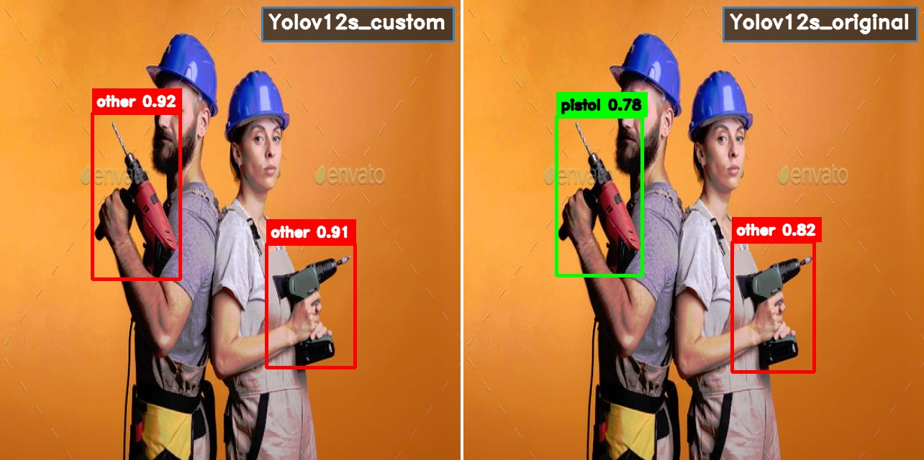
Figure 19. Two workers holding power drills. The proposed model assigns both to ‘other’ (0.92, 0.91); the baseline false-alarms one as a pistol (0.78).
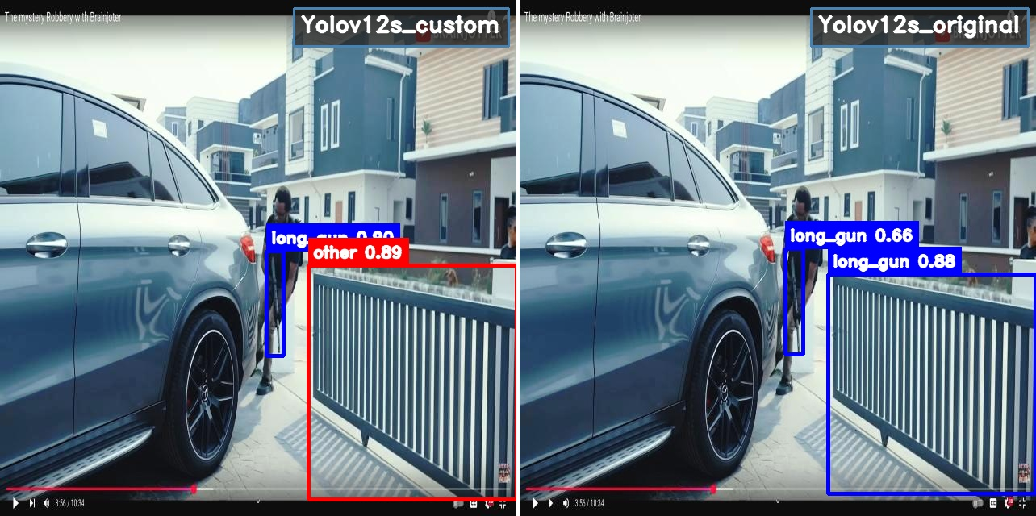
Figure 20. An armed figure beside a metal railing. The proposed model detects the firearm (long_gun 0.90) and assigns the railing to ‘other’ (0.89); the baseline under-detects the weapon and false-alarms the railing as a long_gun (0.88).
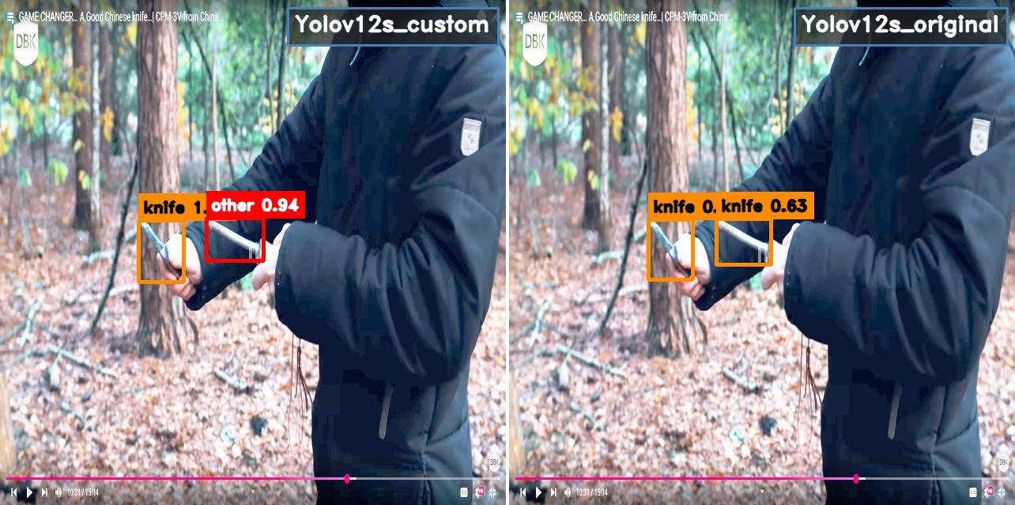
Figure 21. A knife-review clip in which the subject also holds a case. The proposed model detects the knife and assigns the case to ‘other’ (0.94); the baseline false-alarms the case as a second knife.
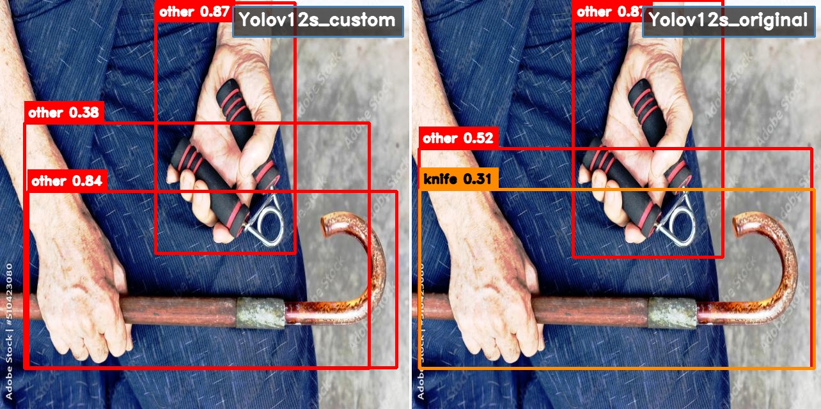
Figure 22. Hands holding a wallet, keys and a walking cane. The proposed model assigns every object to ‘other’; the baseline false-alarms the cane as a knife (0.31).

D. Confidence behaviour and limitations
Beyond correcting outright errors, the proposed model is systematically more confident on true weapons. In Figure 23, a dual-suspect CCTV frame, both models detect the two pistols, but the proposed model does so at 0.92 and 0.83 against the baseline’s 0.79 and a marginal 0.41 — a gap that directly affects reliability at any fixed operating threshold. For completeness we note the limits of this comparison: on a small number of cluttered frames (Figures 24–25) the two models disagree on a secondary, ambiguous object — an item that could be read as either a blade or a benign tool — and without ground truth neither prediction can be declared correct. Such disagreements were rare among the scenes examined and never involved the primary weapon, which the proposed model consistently detected.
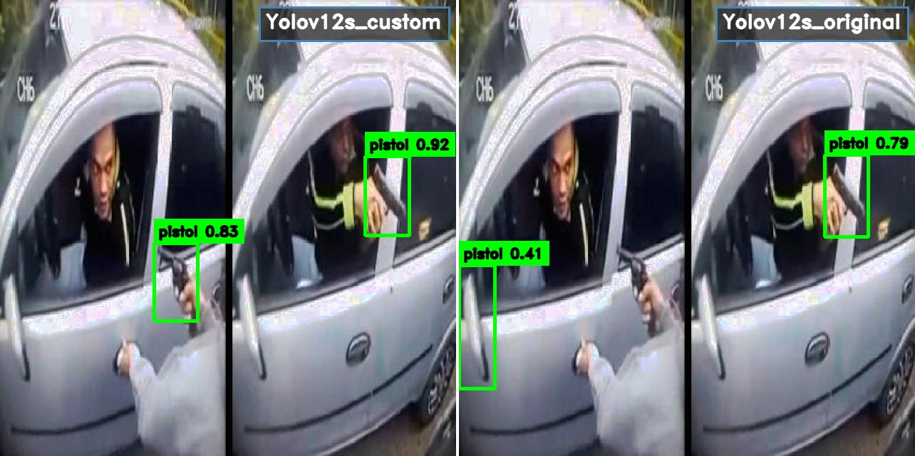
Figure 23. A dual-suspect CCTV scene. Both models detect the two pistols, but the proposed model is markedly more confident (0.92 / 0.83 vs. 0.79 / 0.41).
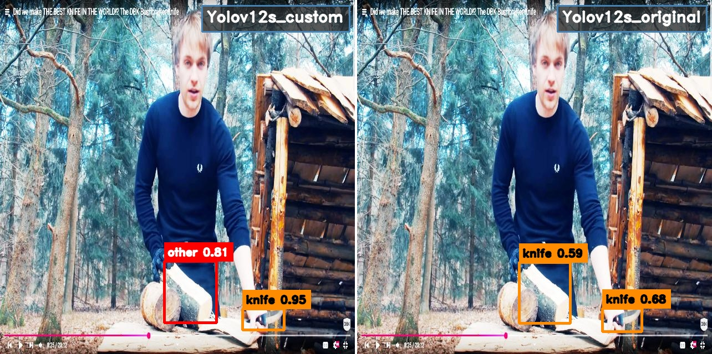
Figure 24. A bushcraft clip with an ambiguous secondary object. Both models detect the knife — more confidently for the proposed model (0.95) — but disagree on a second, unlabeled item that the proposed model assigns to ‘other’.
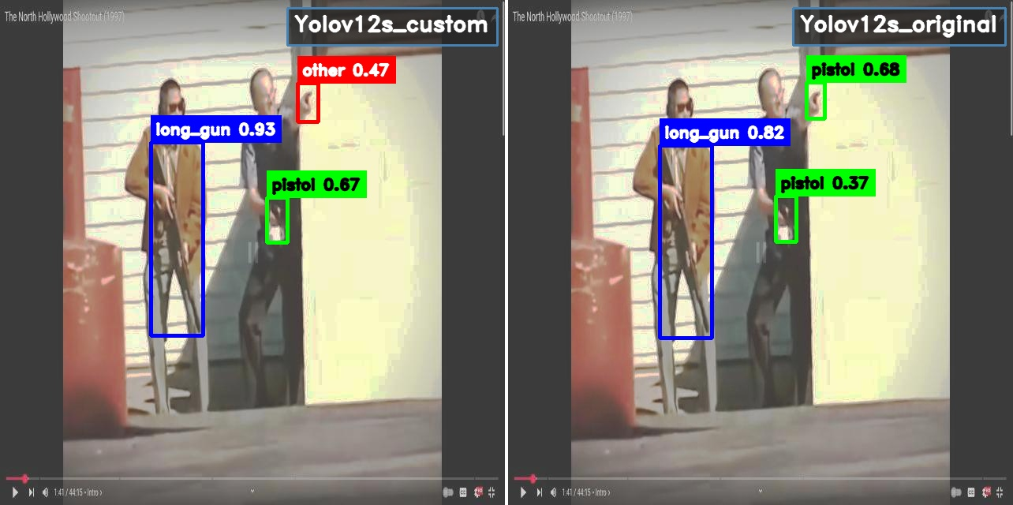
Figure 25. A period-film shootout. The proposed model is more confident on the clearly visible weapons (long_gun 0.93, pistol 0.67); the two models disagree on a small object near the second figure, for which no ground truth is available.
Taken together, the qualitative evidence mirrors the quantitative results: the baseline’s failures cluster into missed small weapons, weapon-type confusion, and false alarms on weapon-like objects, and the proposed model addresses all three. This is consistent with the design intent — higher-resolution, detail-preserving features and small-object-aware assignment for recall; global context for correct typing; and an explicit hard-negative class for precision — and indicates that the improvements are not confined to the benchmark but transfer to diverse, realistic footage.

