Small-Object Luggage Detection with YOLOv12 and YOLO26: A New Annotated Benchmark and Detector-Specific Loss and Architecture Improvements
Constantin Catargiu
Faculty of Electronics, Telecommunications and Information Technology, Gheorghe Asachi Technical University of Iași, 700506 Iași, Romania
constantin.catargiu@studen.tuiasi.ro
Abstract—Unattended-luggage detection in public spaces is limited less by event logic than by the detector underneath it: in bird’s-eye surveillance imagery almost every piece of luggage is a small object. Progress on this bottleneck is hard to measure because the field’s benchmarks are small, unannotated, or no longer distributable. We address this on three fronts. First, we introduce LuggageDataset v6i, a fully annotated detection benchmark of 12,184 images and 57,814 luggage instances across three classes (backpack, bag, trolley), which provides roughly 21$×$ the luggage annotations of the largest previously available annotated in-domain set. Second, we improve both detectors, each along a loss axis and an architectural axis developed for it: a curriculum area-weighted regression loss and a level-specialised four-scale head for YOLOv12, and a flattened task-alignment exponent with a reallocated three-scale head for YOLO26. Against a measured seed noise floor measured separately for each detector ($0.34$ and $0.25$ mAP, $df=8$), every reported configuration is trained at three seeds. The two axes combined gain $+$3.44% small-object mAP$​_{50}$ on YOLO26 and $+$2.85% on YOLOv12 over their baselines, with F1 up $3.82\%$ and $3.39\%$ — gains of $9.5$ and $11.0$ standard errors. These come from a controlled study of 226 training runs in which every mechanism is verified live at training time and every pretrained-weight transfer is measured rather than presumed. Third, we compare the two detectors directly by applying each one’s winning mechanisms to the other on identical data, and find that nothing transfers in either direction: all four cross-model transfers are nulls on the primary metric, and both the depth optimum and the “vestigial coarse level” finding invert. We trace each failure to an implementation detail the configuration surface hides — the presence of a distributional box loss, the presence of NMS, and whether a deepened branch propagates or terminates — and show that the two axes are additionally sub-additive, delivering only $46$–$81\%$ of the sum of their separate effects. A diagnostic decomposition explains the ceiling: across all runs ${AR}_{50}^{small}​≈​0.95$ while $R_{50}^{small}​≈​0.70$, and true proposal failure is only 2.7–5.5%. The correct detections exist and are ranked too low, so the binding constraint is confidence ranking, not proposal generation or anchor assignment—a conclusion we support with an anchor-footprint analysis showing that standard task-aligned assignment already converts 60% of a small object’s entire candidate pool into positives, against 1.5% for a large object. Finally, we describe an unattended-luggage pipeline that pairs each luggage track with an owner using scale-normalised ground-plane proximity and raises an alarm when the owner remains outside a distance threshold beyond a dwell time. We release the dataset, the training and evaluation code, and the complete run log.
Index Terms—abandoned luggage, unattended object detection, small-object detection, video surveillance, YOLO, label assignment, benchmark dataset.

I. Introduction
An item of luggage left unattended in an airport concourse, a railway station, or a metro platform is both a security concern and an operational one. Manual monitoring does not scale: an operator watching dozens of feeds cannot sustain the attention that reliable detection requires, and the literature has pursued automation of this task for two decades [1].
The problem is conventionally decomposed into three stages: detect candidate luggage, associate each item with an owner, and decide when the separation between them constitutes abandonment. The third stage has been standardised since the PETS 2006 challenge, which defined luggage as unattended once its owner passes a distance $b$ from it, and abandoned after $t$ consecutive seconds without re-attendance [1]. Twenty years later the majority of published systems still use that rule with only minor edits.
What has not been solved is the first stage. In fixed-camera surveillance footage the camera is mounted high and looks down, so luggage occupies a small fraction of the frame. Vršalović et al. report that their bird’s-eye CCTV corpus contains zero large objects under the COCO size convention [15], and that COCO-pretrained detectors collapse to 1.1–4.2% mAP@0.5 on such imagery before fine-tuning. Every downstream stage inherits this: an ownership rule cannot associate a bag that was never detected, and a dwell timer cannot run on a track that does not exist.
Three obstacles have made this bottleneck hard to attack.
The benchmarks are inadequate. PETS 2006 and i-LIDS AVSS 2007 comprise seven and three sequences respectively and are no longer reliably distributable. ABODA, the de facto modern benchmark, ships without annotations, so every paper evaluates against labels it produced itself and cross-paper comparison is indicative at best. IITP20 is larger but provides no frame-level ground truth and has documented semantic labelling errors [16]. The largest annotated in-domain set we are aware of contains 2,760 luggage annotations derived from roughly 300 distinct source images.
The evaluation practice is fragmented. Reported metrics across the literature include event-level true/false positives, alarm-time error in seconds, frame-level and pixel-level precision/recall, and unqualified “accuracy”. Alarm thresholds range from 5 s to 60 s and IoU thresholds from 0.2 to 0.5. Detection area is sometimes silently restricted to a sub-region of the scene.
Improvements are reported without a noise floor. To our knowledge exactly one study in this literature reports run-to-run variance [3]. In a field where recent claimed gains are frequently below one mAP point, an unreported variance of comparable magnitude makes many published rankings unfalsifiable. One representative modern system reports 85.7% precision for its selected model while its own random-grouping study spans 71–75% across retrainings [14].

A. Contributions
- LuggageDataset v6i [31], a fully annotated luggage-detection benchmark: 12,184 images, 57,814 instances, three classes, a fixed 75/15/10 split, and a complete statistical characterisation (Section III). It provides approximately 21$×$ the luggage annotations of the largest annotated in-domain alternative, at finer class granularity.
- A controlled detector study of 226 runs across YOLOv12 and YOLO26, covering fourteen loss and label-assignment mechanisms and a systematic architectural sweep, each with its mechanism verified live at training time rather than assumed from configuration, and each pretrained-weight transfer measured rather than presumed.
- A per-detector noise floor measured from three seeds on every reported configuration ($σ=0.34$ on YOLO26, $0.25$ on YOLOv12, $df=8$), together with a selection bias of $-0.55$ across seven repeated round maxima from the exploratory phase. Scored against these, the architectural axis clears the floor on both detectors while the loss axis clears it on one and not the other. We report the null as a result.
- A decomposition of the two axes. The loss axis is a precision mechanism that trades localisation for detection ($-0.35\%$ and $-0.37\%$ mAP$​_{50\text{-}95}$ on the two detectors) while the architecture axis improves both ($+3.12\%$ and $+3.04\%$). The two are sub-additive, delivering $46$–$81\%$ of the sum of their separate effects, which bounds what stacking mechanisms can achieve on this task.
- A bidirectional transfer test. We apply each detector’s winning mechanisms to the other on identical data. Neither transfers: the YOLOv12 mechanism is a null on YOLO26, and the YOLO26 configuration loses $20$ of $24$ matched-batch comparisons on YOLOv12, with the depth optimum and the vestigial-level finding both inverting. Mechanism signatures transfer; net benefits do not.
- A diagnosis of the small-object bottleneck. Recall at the operating threshold trails achievable recall by roughly 25 percentage points while true proposal failure remains at 2.7–5.5%. An anchor-footprint analysis shows that a large object commands 51$×$ the candidate-anchor supply of a small one, and that standard assignment already converts 60% of a small object’s pool into positives—so the mechanism family that dominates recent small-object work has very little headroom left to exploit.
- An unattended-luggage pipeline built on the fine-tuned detector, using a scale-normalised ownership radius, windowed owner assignment, and an occlusion-aware dwell timer.
The remainder of the paper is organised as follows. Section II reviews the literature by methodological era and catalogues the available public datasets. Section III presents LuggageDataset v6i. Section IV describes the detector study and the unattended-luggage pipeline. Sections V and VI report and discuss results.

II. Related Work
We organise two decades of work into five methodological eras, then summarise the public datasets and the failure modes that recur throughout.

A. Era 1: Geometry and Tracking (2006)
The PETS 2006 workshop established both the benchmark and the operational definition still in use [1]. Seven multi-camera sequences were recorded at Victoria Station, London, with Tsai calibration and XML ground truth specifying warning and alarm trigger frames. The accompanying rule set defines ownership by physical contact, an unattended state beyond $b=3$ m, and an abandoned state after $t=30$ s.
The eight workshop papers explored complementary strategies that later work repeatedly rediscovers. Auvinet et al. [2] fused four camera views into a ground orthoimage by direct homography and detected an object separating from a person as a spatio-temporal fork. Smith et al. applied trans-dimensional RJMCMC tracking and are, to our knowledge, the only group of the era to report multi-run means [3]. Lv et al. [4] combined a blob tracker with a boosted edgelet human detector and performed event recognition by Bayesian inference over trajectories; their ablation on the contextual rule showed that removing drop-off filtering floods the system with false alarms.

B. Era 2: Classical Maturity (2008–2017)
This period refined the low-level machinery. Liao et al. [5] and Chang et al. [6] introduced foreground-mask sampling—intersecting six masks over 30 s—which is appearance-free and therefore indifferent to object shape, colour, and viewing angle. Beleznai et al. [7] used trinocular stereo depth, obtaining recall of 1.00 on all six of their sequences and demonstrating that depth removes the shadow and illumination failure modes outright, a robustness that the monocular line cannot match but that the deployed CCTV estate cannot supply. Dahi et al. moved background modelling from intensities to edges, arguing that contours rarely overlap between moving objects and that hysteresis thresholding tolerates partial occlusion; they report $P=R=F_{1}=1.0$ on both PETS 2006 and AVSS 2007 over the whole scene at 18–108 fps [8].

C. Era 3: Deep Learning Arrives (2018–2020)
Early deep methods bolted a CNN onto an unchanged background-subtraction front end. Altunay et al. [9] passed dual-foreground proposals to Faster R-CNN. Smeureanu and Ionescu used a cascade of two GoogLeNets and, notably, generated scene-specific synthetic training samples by superimposing template luggage onto the estimated background of the target scene—worth approximately $+10$ $F_{1}$ over internet-sourced training data [10]. Dogariu et al. [11] shared Mask R-CNN features across detection and person re-identification, the first treatment in the corpus of ownership as a learned association rather than a distance threshold.

D. Era 4: Purpose-Built Architectures (2022–2024)
Kim et al. [12] reframed the task as hand-luggage detection, fusing OpenPose keypoints with SSD through Gaussian confidence reweighting and replacing metric calibration with an owner-width-relative distance rule. Zhou and Xu proposed SAO-YOLO, whose feature pyramid moves the detection heads down two octaves and truncates the backbone [14]. Their ablation is directly relevant to our own architectural results: replacing the stride-32 head with a stride-4 head yields $+4.9$ mAP@0.5, a further shift down yields $+2.6$, and the subsequent pruning contributes $+0.7$ while removing 5.6 M parameters. The reduction in model size is therefore a consequence of shifting the pyramid, not the source of the accuracy gain. Chen et al. [13] report the only deployed airport system in the corpus, pairing machine vision with edge computing and a blockchain audit trail — a reminder that the operational bottleneck in practice is provenance and latency, not mAP.

E. Era 5: Domain Adaptation and Foundation Models (2025–2026)
The most actionable recent result is quantified domain shift. Vršalović et al. measured COCO-pretrained YOLOv8 and YOLOv11 variants at 1.1–4.2% mAP@0.5 on bird’s-eye CCTV, rising to 86.4% after fine-tuning on roughly 470 in-domain images [15]. Two secondary findings matter for detector selection: the small variant outperformed every larger one on small objects, and DETR trailed the fine-tuned YOLO models by approximately 40 mAP points at a quarter of the speed. A companion paper audited IITP20, found systematic semantic errors—luggage placed in designated storage areas labelled as abandoned, and group-separation scenarios treated as abandonment—re-derived the ground truth, and replaced the fixed pixel radius with a monocular metric depth estimate [16]. Open-vocabulary approaches have been evaluated but degrade asymmetrically: Soontornnapar [17] reports Grounding DINO achieving near-perfect $F_{1}$ on the person prompt and 30–58% on bag, which is the same class-dependent weakness our per-class analysis finds in Section D.
The remainder of the recent literature has converged on YOLOv9 and later backbones with a classical differencing stage retained. Song et al. [18] combine YOLOv9 with background differencing; Shah et al. [19] add a spatiotemporal CNN in a two-stage arrangement. Pastukh and Deineko [20] compare rule-based and learned pipelines directly and conclude that the learned detector is now the accurate component and the event logic the fragile one — an inversion of the situation in Era 1, and the reason this paper concentrates on the detector rather than the rule set.

F. Public Datasets
Table 1 summarises the benchmarks used across this literature. The pattern is consistent: the historically standard sets are small and now difficult to obtain, the largest modern set lacks frame-level ground truth, and the best-annotated in-domain set is small and contains no large objects.

TABLE 1. Public datasets used in the unattended-luggage literature. $✓$ = public and obtainable; $△$ = public but degraded or hard to obtain. “Events” indicates frame-level abandonment ground truth.
Dataset | Content | Size | Annotations | Events | Availability
PETS 2006 | Railway station, 4 views | 7 seq. | Trigger frames + calibration | yes | $△$ host dead
i-LIDS AVSS 2007 | Metro platform, 1 view | 3 seq. | One event per sequence | yes | $△$ 3 of 8 clips
PETS 2007 | Airport, loitering/theft | 2 scen. | Trigger frames | yes | $✓$ partial
ABODA | Indoor/outdoor/night/light-switch | 11 vid. | none | yes | $✓$ GitHub
IITP20 | 58 videos, 3 difficulty tiers | 58 vid. | Folder-level only | no | $✓$ label errors
CCTV-KD | Airport + walkway, bird’s-eye | $∼$300 img. | 2,760 luggage / 6,414 person | no | $✓$ GitHub+Roboflow
LuggageDataset v6i (ours) | Fixed-camera public spaces | 12,184 img. | 57,814 luggage, 3 classes | no | $✓$ released

G. Recurring Failure Modes and Open Gaps
Four failure modes recur across all five eras. Crowding is universal and explicitly unsolved. Long-duration stationary people generate false alarms that motivated dedicated staticness and motion-history cues. Small objects are the dominant modern bottleneck. Owner misidentification is named as the missing piece by three independent groups.
The gaps most relevant to this work are the absence of a large properly annotated public benchmark—described in recent work as the field’s single biggest gap—and the absence of a standardised evaluation protocol. Our dataset addresses the former directly; our reporting of a measured noise floor is a partial response to the latter.

III. The LuggageDataset v6i Benchmark

A. Composition
LuggageDataset v6i contains 12,184 images and 57,814 annotated luggage instances in three classes: backpack, bag, and trolley. The data is partitioned into fixed training, validation, and test splits of 9,138 / 1,827 / 1,219 images (Table 2). Every image is labelled; there are no background-only images and no missing label files.
TABLE 2. Split composition. Instance share differs slightly from image share because scene density varies across splits.
Split | Images | % | Instances | % | Boxes/img
Train | 9,138 | 75.0 | 41,823 | 72.3 | 4.58
Valid | 1,827 | 15.0 | 9,819 | 17.0 | 5.37
Test | 1,219 | 10.0 | 6,172 | 10.7 | 5.06
Total | 12,184 | 100 | 57,814 | 100 | 4.75
Class frequencies are stable across splits: trolley accounts for 50.7% of training instances, backpack 27.1%, and bag 22.2%, with all three within 1.9 percentage points across the three splits. The dominant image resolution is $640×360$ (7,350 of 9,138 training images, 80.4%), reflecting fixed-camera surveillance framing rather than a photographic mixture.
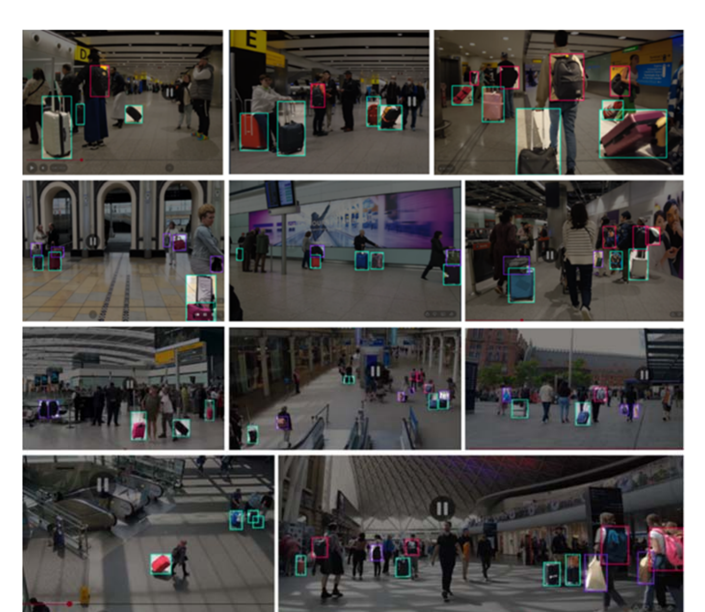
Fig. 1. Representative annotated frames from LuggageDataset v6i. The images are drawn from fixed or quasi-static surveillance cameras in transport hubs and indoor public space, and illustrate the conditions the benchmark is built to capture: elevated, oblique viewpoints in which luggage occupies a small fraction of the frame; dense pedestrian traffic with frequent partial occlusion of the bag by its own owner; wide variation in illumination, from daylit concourses to artificially lit interiors and screen-lit walls; and all three classes co-occurring at very different apparent scales within a single frame. The annotations shown are the released ground truth. Note that these are the raw frames: unlike our earlier presentation of this corpus, no augmentation is applied anywhere in this paper, so every number reported in Section V is obtained on unmodified imagery.

B. This Is a Small-Object Benchmark
The mean annotated box measures $39×55$ px in a 640-px frame, occupying 0.53% of the image area. Table 3 reports the size distribution under two max-side conventions.
TABLE 3. Object-size distribution, maximum bounding-box side, $32$ / $64$ px edges. Counts are instances; percentages are row-wise, i.e. of that split or of that class. The per-class rows cover the training split and sum to the Train row; per-class totals are in Table 4.
 | Small ($<$32) |  | Medium (32–64) |  | Large ($>$64)
 | $$n$$ | % | $$n$$ | % | $$n$$ | %
By split
Train | 14,959 | 35.8 | 16,398 | 39.2 | 10,466 | 25.0
Valid | 3,669 | 37.4 | 4,034 | 41.1 | 2,116 | 21.6
Test | 2,175 | 35.2 | 2,510 | 40.7 | 1,487 | 24.1
backpack | 3,699 | 32.6 | 4,600 | 40.6 | 3,039 | 26.8
bag | 3,499 | 37.8 | 3,267 | 35.3 | 2,502 | 27.0
trolley | 7,761 | 36.6 | 8,531 | 40.2 | 4,925 | 23.2
Under this convention $35.8\%$ of training instances are small and a further $39.2\%$ are medium. The choice of maximum side rather than area is deliberate: it is the side length, not the area, that determines how many stride-8 feature cells a box spans, and therefore how many anchors the label assigner can allocate to it—a quantity that becomes central in Section IV.

1) Side length for the dataset, area for the metrics
One clarification is needed before Section V. The dataset statistics above and every assignment diagnostic bin objects by maximum side at $32$ / $64$ px, because it is side length that determines anchor supply. The reported detection metrics bin by area at the COCO [29] edges $1024$ / $9216$ px$​^{2}$ — equivalently ${32}^{2}$ / ${96}^{2}$ — because that is what the evaluator computes. Both are anchored at $32$ px, but they are not the same partition: a $25×100$ trolley has a maximum side of $100$ px yet an area of only $2,500$ px$​^{2}$, so it is large by side and medium by area. With $70.6\%$ of boxes taller than wide this is not a corner case, and we therefore state the basis on every table and never compare a count against an AP across the two.
Unlike the closest comparable public set, v6i is not devoid of large objects: 10,466 training instances ($25.0\%$) exceed $64$ px on their longest side. This matters because a benchmark with no large objects cannot measure whether a small-object mechanism achieves its gains by sacrificing large ones—a trade-off we observe repeatedly in Section V.

C. Boxes Are Tall, and the Classes Differ Sharply
Across all splits, 70.6% of boxes are taller than wide ($h/w>1.25$), with a mean aspect ratio of 1.55 and only 6.0% wide boxes. The per-class breakdown in Table 4 shows that this aggregate conceals a large difference between classes.
TABLE 4. Per-class shape structure (training split). Size structure is in Table 3; bag is the outlier on both.
Class | $$n$$ | $$h/w$$ | Wide | Square | Tall
backpack | 11,338 | 1.47 | 1.2% | 23.8% | 74.9%
bag | 9,268 | 1.33 | 13.2% | 36.0% | 50.8%
trolley | 21,217 | 1.68 | 5.5% | 17.6% | 76.9%
trolley is visually canonical: 76.9% tall, mean ratio 1.68. bag, by contrast, holds 48.5% of every wide box in the dataset while representing only 22.2% of instances, and is the only class whose three shape bins are anywhere near balanced. Table 3 shows it is also the only class with a depleted size middle—simultaneously the highest large share ($27.0\%$) and the lowest medium share ($35.3\%$), against a trolley that is the most size-concentrated of the three. A class that is at once the widest, the most balanced in shape and the most bimodal in size is the one a single-scale prior fits worst, which is what Section D observes: bag is the hardest class at every size on both detectors.
This heterogeneity is not incidental. bag is the weakest class by a wide margin (AP$​_{50\text{–}95}$ 0.4666 against trolley’s 0.6185, a 15.2-point gap), and Section V shows that this gap is attributable neither to class frequency nor to assignment geometry nor to proposal failure. The category is semantically loose—handbags, duffel bags, shopping bags, plastic bags—and the residual gap is consistent with that looseness rather than with any optimisation deficiency.

D. A Leakage-Free Split

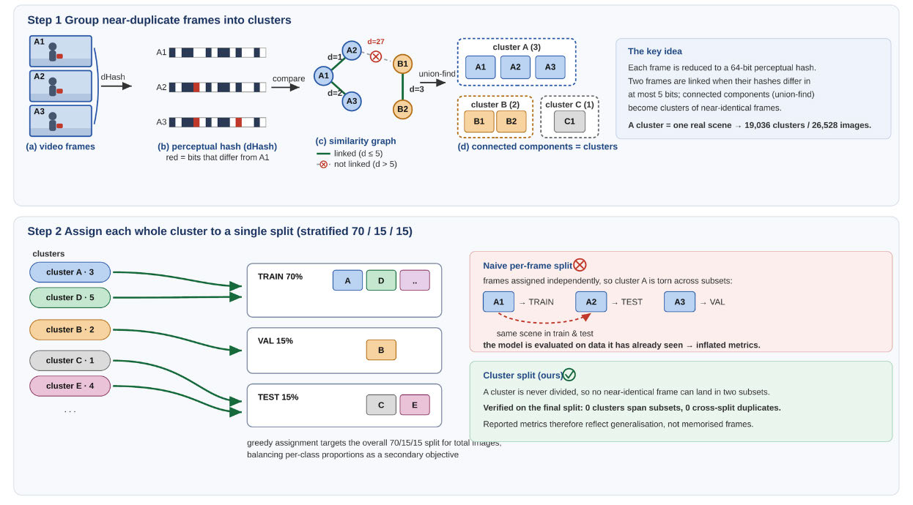
Fig. 2. The leakage-free splitting procedure. Step 1: each frame is reduced to a 64-bit perceptual (difference) hash; any two frames whose hashes differ in at most five bits are linked, and connected components extracted by union-find group mutually near-identical frames into clusters, so that one cluster corresponds to one real scene. Step 2: each whole cluster, never an individual frame, is assigned to a single split by a stratified greedy procedure, so no near-duplicate frame can cross a split boundary by construction. The panels illustrate the method with the counts from the weapon-detection corpus in which it was first validated [21]; applied unchanged to LuggageDataset v6i at the same Hamming threshold of five, it produces the $75/15/10$ partition of Table 2 and a cross-split audit of that partition returns zero clusters spanning subsets and zero near-duplicate pairs between any two subsets.

The corpus is assembled from surveillance video, and that single fact governs how the split must be built. Consecutive frames of the same clip are near-identical: the camera is fixed, the scene changes over seconds rather than frames, and the same suitcase appears in hundreds of images that differ only by pedestrian motion. A split that assigns frames independently will therefore place the same physical scene in both training and test, and the reported accuracy will partly measure memorisation. This failure is invisible in the usual sanity checks — class proportions, image counts and size distributions all look correct — which is what makes it dangerous.
We therefore group before we split, following the procedure validated in our earlier work on weapon detection [21] and applied here unchanged. Each image is reduced to a 64-bit difference hash. Any two images whose hashes lie within a Hamming distance of $5$ are linked, and connected components extracted by union-find collapse mutually near-identical frames into clusters, so that one cluster corresponds to one real scene. The threshold of $5$ follows common practice for difference-hash near-duplicate detection: small enough to avoid merging visually distinct scenes, large enough to capture frames that differ only by compression noise and small motion. Whole clusters are then assigned to splits by a stratified greedy procedure that targets the $75/15/10$ ratio on total image count and on each class simultaneously. Because no cluster is ever divided, no near-duplicate frame can cross a split boundary by construction.
A cross-split audit of the final partition confirms the guarantee holds in practice: zero clusters span more than one subset, and zero near-duplicate pairs occur between any pair of subsets. The evaluation is therefore leakage-free, and the metrics in Section V reflect generalisation to unseen scenes rather than recall of frames the model has already been trained on. Figure 2 illustrates both steps and contrasts them with the naive alternative; the counts printed inside its panels are those of the weapon corpus in which the procedure was first validated, and the v6i figures are given in Table 2.
This matters for interpreting the size of our gains. The improvements reported in this paper are $2$–$3\%$ relative. Had the split been built per frame, the baseline itself would have scored higher — and every mechanism would have appeared to help less, because a memorising baseline leaves less headroom. A leakage-free split is what makes a $+3.44\%$ gain meaningful rather than an artefact of how the data was partitioned.

E. Annotation Quality
Automated label validation reports no out-of-range coordinates and no missing label files. Two caveats are recorded for completeness. Two training images carry labels that mix segmentation and detection rows and are rejected by the data loader. Three duplicate labels are removed at load time (two in training, one in validation), which is why the validation split yields 9,818 rather than 9,819 loaded instances.

F. A Documented Split Drift
Class proportions agree across splits to within 1.9 points and shape distributions to within 0.8 points. One drift is material and we state it explicitly: the validation split under-represents large objects and contains systematically smaller boxes than the test split (Table 5).
TABLE 5. Validation-split drift. Any threshold or hyperparameter tuned on validation is tuned on a distribution with smaller objects than test.
Quantity | Train | Valid | Test | V vs T
Large share ($>$64 px) | 25.0% | 21.6% | 24.1% | $-$2.5 pt
Large count | 10,466 | 2,116 | 1,487 | —
Mean W $×$ H (px) | 39$×$55 | 35$×$49 | 40$×$56 | $-$23% area
Boxes per image | 4.58 | 5.37 | 5.06 | $+$6%
Validation boxes are approximately 23% smaller in area than test boxes. Two consequences follow. First, confidence thresholds tuned on validation are tuned on a slightly harder, smaller-object distribution; we verify in Section V that the tuned operating point transfers to test intact, but the drift bounds how far such tuning should be trusted. Second, any large-object claim derived from validation alone rests on 758 instances against a measured seed-to-seed spread of 2.11 points in the large bucket—we therefore report all large-object results on test only.

G. Comparison with Existing Benchmarks
Against CCTV-KD, the largest annotated in-domain alternative [15], v6i provides approximately 21$×$ the luggage annotations (57,814 vs 2,760) from roughly 40$×$ the distinct source images ($12,184$ vs $∼$300 before augmentation), at three class labels rather than one. Two differences favour CCTV-KD and we note them plainly: it provides person annotations, which v6i does not, and its scenes are considerably denser (approximately 20 annotated objects per image against our 4.75). The absence of a person class means the ownership stage of our pipeline must source person detections from a separate model, with the domain-shift consequences discussed in Section IV.
Neither dataset contains abandonment events; both are detection benchmarks. v6i is therefore complementary to ABODA and IITP20 rather than a replacement: it is intended to train and evaluate the detector on which an event-level system is built.

IV. Method

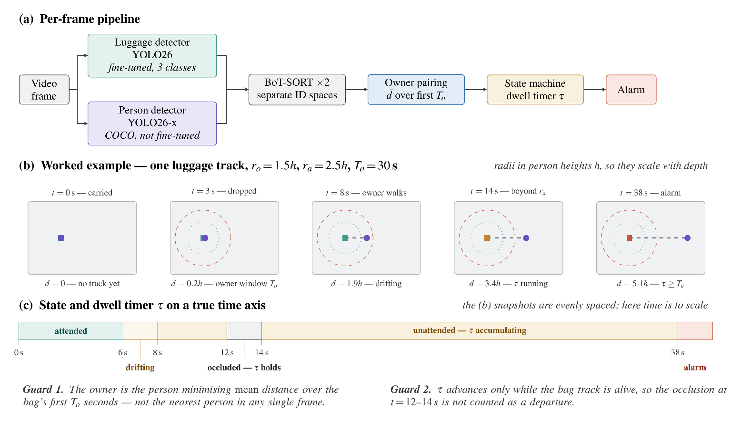
Fig. 3. The unattended-luggage pipeline and a worked example. (a) Two detectors run in parallel on every frame and are tracked independently, so luggage and person identities never share an ID space. Only the luggage detector is fine-tuned on our data; the person detector is a COCO model, which is the weakest link in the chain (Section IV). (b) Top-down snapshots of a single track. The dotted inner circle is the ownership radius $r_{o}$ and the dashed outer circle the alarm radius $r_{a}$, both expressed in person heights $h$ so they scale with depth; the square is the bag and the disc its assigned owner. The bag changes colour as the state advances. (c) The same episode on a time axis. The owner crosses $r_{o}$ at $6$ s and $r_{a}$ at $8$ s, at which point the dwell timer $τ$ starts; it holds through the occlusion at $12$–$14$ s and reaches $T_{a}$ at $38$ s.

A. Overview and Design Principle
We modify two detectors — YOLOv12s [22] and YOLO26s, both in the Ultralytics implementation [23] — along two orthogonal axes. The loss axis changes how ground truth is assigned to anchors and how each assignment is weighted; the architecture axis changes which feature levels exist and how much capacity each receives. Every modification obeys one rule: at initialisation the modified network must reproduce the pretrained baseline exactly. Architectural blocks are appended as residual branches with a zero-initialised gate, and loss modifications reduce to the stock objective at their default parameter values. This makes every comparison a controlled one—the pretrained weights transfer without loss, and any difference in the final metric is attributable to the mechanism rather than to a different initialisation.
The two detectors receive different treatments, and this is a result rather than an oversight. Superficially their objectives are the same: both use BCE classification, CIoU [30] box regression, a task-aligned assigner with $α=0.5$ and $β=6$, and identical loss gains ($box=7.5$, $cls=0.5$, $dfl=1.5$). Underneath they differ in three respects that Table 11 sets out and Section A shows to be decisive: YOLOv12 regresses boxes as a $16$-bin distribution and removes duplicates with NMS, whereas YOLO26 regresses offsets directly ($reg_max=1$, with the third loss term becoming an image-normalised $l_{1}$), runs two assigners — one-to-many and one-to-one — under a schedule that shifts weight from the former to the latter across training, and emits a single prediction per object without NMS. As Section V shows, the mechanism that works on one does not work on the other, in either direction.

B. Small-Object–Aware Loss and Assignment

1) Curriculum Area Weighting (YOLOv12)
The problem. After assignment, the regression loss sums over positives with each weighted by its target score. Two things then work against small objects at once. First, a large box collects far more positives than a small one — $9.79$ against $7.73$ on this dataset, from a candidate pool $51×$ larger — so it contributes more terms to the sum. Second, and more importantly, the IoU term of a large box is smoothly informative: a few pixels of error change its IoU very little, so its gradient is stable and well-scaled. For a $12×18$ px bag the same few pixels can move IoU by tens of points. The optimiser sees a loud, noisy signal from small objects and a quiet, reliable one from large objects, and it does what any optimiser does — it fits the reliable signal first and treats the small objects as noise to be averaged out.
The intervention. We restore the balance by weighting each positive by the inverse linear scale of its box, and we do so on a schedule rather than permanently. Early in training, when the representation is still forming and the small objects would otherwise never get a foothold, the weighting is area-dominant; by the end it has decayed back to the standard score weighting, so the final epochs optimise the objective the model is actually evaluated on. This is the dynamic curriculum weighting introduced in our earlier work on weapon detection [21]. For each positive assignment $j$,
$w_{j}^{(t)}=α(t) {\hat{a}}_{j}+\left(1-α(t)\right) s_{j}$ (1)
where $s_{j}$ is the summed target score of positive $j$ and ${\hat{a}}_{j}$ is a normalised, boosted inverse-scale term. Writing $A_{j}$ for the assigned box area in feature units at the level to which the anchor belongs, i.e. after division by that level’s stride $σ_{j}$,
$a_{j}=A_{j}^{-1/2}, {\hat{a}}_{j}=\frac{a_{j}}{\max_{k∈P}a_{k}} ⋅ b_{j}$ (2)
with $P$ the set of positives in the batch. The exponent $-1/2$ makes the term scale with linear object size rather than with area; a pure inverse-area weighting ($a_{j}=A_{j}^{-1}$) was also implemented and was inferior on this dataset. The factor $b_{j}$ is a threshold boost applied after normalisation,
$b_{j}=\left\{\begin{matrix}ρ, & \sqrt{A_{j}} σ_{j}<p_{\text{small}} \\ 1, & \text{otherwise,}\end{matrix}\right.$ (3)
which multiplies the weight of any positive whose box is smaller than $p_{\text{small}}$ pixels on a side. The mixing coefficient follows a linear curriculum over the $T$ training epochs, clipped to a fixed interval,
$α(t)=clip\left(α_{\text{s}}\left(1-t/T\right)+α_{\text{e}} t/T, α_{min}, α_{max}\right)$ (4)
so optimisation begins scale-dominant, favouring small objects while the representation is still forming, and ends score-balanced. The weight $w_{j}^{(t)}$ multiplies the CIoU and DFL terms; the classification term is untouched. With $α_{\text{s}}=α_{\text{e}}=0$ the expression reduces exactly to the stock per-positive weight $s_{j}$, which is the identity property required in Section A. A grid search on the validation split over $α_{\text{s}}∈[0.6,0.9]$, $α_{\text{e}}∈[0.3,0.4]$, $p_{\text{small}}∈[36,48]$ px and $ρ∈[1.0,2.5]$ selected $α_{\text{s}}=0.7$, $α_{\text{e}}=0.3$, $p_{\text{small}}=48$ px and $ρ=2.0$; the full intervals are in Table 6.
Two design choices deserve comment. The exponent is $-1/2$ rather than $-1$ because pure inverse-area weighting is too aggressive on this data: with boxes spanning three orders of magnitude in area, $A^{-1}$ makes the smallest instances dominate the batch entirely and destabilises training, whereas $A^{-1/2}$ scales with linear size and keeps the ratio bounded. Both were implemented and the square root was better. The threshold boost of Equation (3) is then a blunt instrument layered on top: the continuous term already up-weights small objects, but it does so smoothly, and $48$ px is the point below which this dataset’s instances stop being resolvable at stride $8$ at all. Doubling their weight is a statement that those specific instances matter operationally, not a claim that the continuous weighting was mis-shaped.

2) Task-Alignment Exponents (YOLO26)
The Task-Aligned Assigner [24] scores each (ground truth, anchor) pair by
$m_{ij}=s_{ij}^{ α} ⋅ u_{ij}^{ β}$ (5)
where $s_{ij}$ is the predicted class score for the ground-truth class and $u_{ij}$ the IoU. Both detectors construct their assigners with $α=0.5$ and $β=6$; these are fixed constants in the reference implementation and are not exposed as tunable hyperparameters. We exposed both and swept them.
The metric enters the objective at three distinct points, and it is essential to separate them. First, selection: the $k$ anchors with the largest $m_{ij}$ inside each ground-truth box become positives. Second, tie-break in the one-to-one branch, where $k=1$. Third, target magnitude: the classification target of a positive is not $1$ but
${\hat{t}}_{ij}=\frac{m_{ij} \max_{j^{'}∈P_{i}}u_{ij^{'}}}{\max_{j^{'}∈P_{i}}m_{ij^{'}}+ϵ}$ (6)
so a well-aligned anchor is asked for a higher confidence than a poorly aligned one. Equation (6) carries a consequence we use in Section VI: when a ground truth has exactly one positive — which is the case in YOLO26’s one-to-one branch — the ratio is identically $1$ and the target collapses to $maxu$, so $α$ and $β$ provably cannot change the target magnitude on that branch. They can only change which anchor receives it.
Our modification is a single exponent, $β:6→1$, selected from nine values spanning $[0,6]$ (Table 6). The reason it should matter is a statement about how IoU behaves at different scales. Consider two anchors on a large object whose IoUs are $0.80$ and $0.70$. Raised to the sixth power these become $0.262$ and $0.118$ — the assigner treats the first as more than twice as good, and it is right to, because on a large box a $0.10$ IoU gap is a real and stable difference in localisation. Now consider the same gap on a $12×18$ px bag. There, one pixel of displacement moves IoU by several points, so a $0.80$ versus $0.70$ split between two neighbouring anchors is mostly sampling noise — yet $β=6$ still amplifies it into a factor of $2.2$ in the alignment metric, and Equation (6) then propagates that amplified difference into the classification target the model is asked to reproduce.
Setting $β=1$ makes the metric linear in IoU. The ranking is preserved — better-localised anchors still win — but the margins are compressed, so the assigner stops manufacturing confident distinctions between anchors that are in truth equally good. The prediction is therefore specific: reducing $β$ should help most where IoU is noisiest, which is exactly the small-object regime, and should be roughly neutral elsewhere. Section V reports that the loss axis helps on small objects while costing mAP$​_{50\text{-}95}$ ($-0.35\%$ on YOLO26 and $-0.37\%$ on YOLOv12) — the metric that rewards precisely the fine localisation distinctions a large $β$ was amplifying.

3) Anchor Supply and Why the Effect Is Bounded
Both mechanisms above act on assignments that already exist. Whether they can act is a question about anchor supply. For a box of size $w×h$ at feature stride $s$, the number of anchor centres falling inside it is
$\begin{aligned}n(s)={\left[⌊x_{2}/s-1/2⌋-⌈x_{1}/s-1/2⌉+1\right]}_{+} \\ ⋅{\left[⌊y_{2}/s-1/2⌋-⌈y_{1}/s-1/2⌉+1\right]}_{+}\end{aligned}$ (7)
summed over the levels of the pyramid, where $[⋅]_{+}$ denotes $max(⋅,0)$ and indices are additionally clamped to the feature map, which we omit here as it affects only boxes touching the image border. Measured over the training labels, a small luggage instance commands $12.90$ anchor centres in total ($9.82$ at stride $8$, $2.46$ at $16$, $0.62$ at $32$) against a selection budget of $k=10$, while a large instance commands $657.67$ — a supply ratio of $51×$. Standard assignment converts $7.73$ of the small object’s $12.90$ candidates into positives, i.e. $60\%$ of its entire pool.
The budget is therefore close to slack. Of small ground truths, $38$–$42\%$ hold fewer than $k$ centres at evaluation geometry, and once mosaic augmentation halves the effective scale — which it does for $60$ of the $70$ training epochs — that figure rises to approximately $70\%$. For those instances every candidate is already a positive, the ranking cannot change the assignment, and the selection role of Equation (5) is inert; only its target-magnitude role acts. Adding a stride-$4$ level multiplies the finest level’s count by four and raises the small object’s pool to roughly $52$ centres, which makes $k$ binding again. This is the diagnostic that motivates the architectural axis, and Section V reports that its central prediction was refuted on one detector and only weakly supported on the other.
The same table motivates the level reallocation of Section C. At stride $32$ a small object draws $0.01$ positives per ground truth and a medium object $0.00$, against pools of $0.62$ and $2.71$: the few candidates that exist carry an alignment metric near zero and fail the positivity test regardless of budget. Large objects draw $7.96$ of their $9.79$ positives ($81\%$) from stride $16$, not stride $32$. The coarsest detection level is thus doing very little work on this dataset.

C. Architectural Modifications

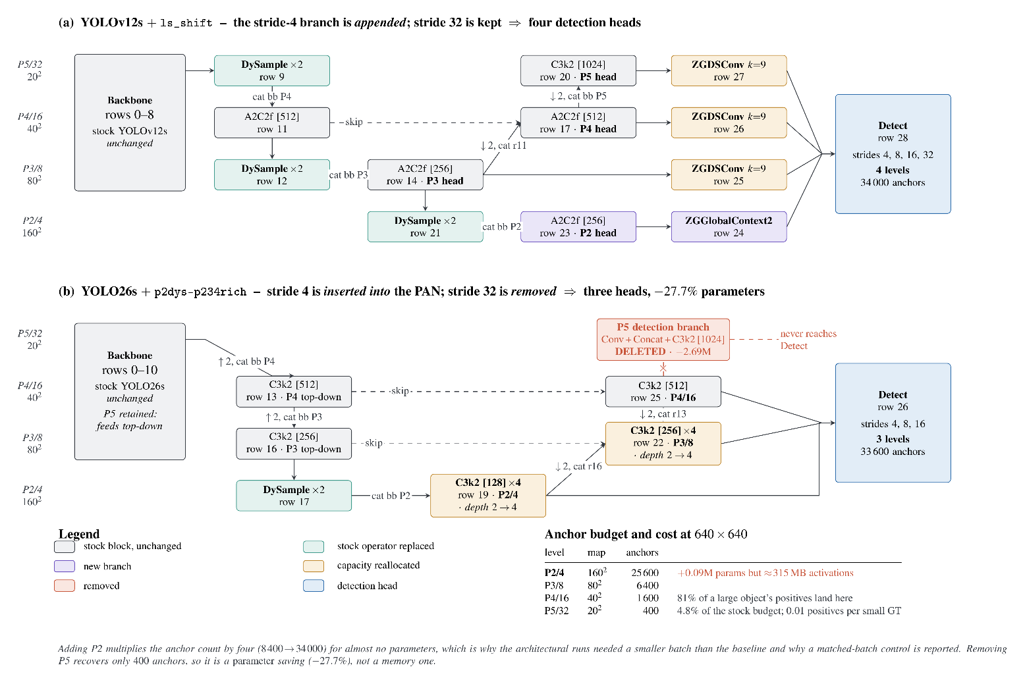
Fig. 4. The two architectural modifications. The vertical axis is the pyramid level and the horizontal axis is depth through the network; solid arrows are the main data path, dashed arrows are lateral skips, and Conv-downsample and Concat rows are folded into the edge labels so that only tensor-producing blocks are drawn. (a) On YOLOv12s the stride-4 branch is appended: the existing top-down/bottom-up path (rows 9–20) is left intact, a P2 head is built from row 14 by content-aware upsampling, and each of the four levels then receives one gated refinement block — global context where the small objects are, a directional snake kernel where the medium and large ones are. (b) On YOLO26s the stride-4 branch is inserted into the PAN and the bottom-up path is rebuilt through it (row 19 $→$ 22 $→$ 25), the two finest levels are deepened from two blocks to four, and the stride-32 detection branch is deleted while the stride-32 backbone is retained to feed the top-down path. Every coloured block is gated as in Eq. (8), so at initialisation both networks reproduce their pretrained baseline exactly. (c) The anchor budget makes the asymmetry of the shared change explicit: the stride-4 level supplies $75\%$ of all anchors for $0.09$M parameters but roughly $315$ MB of activations, whereas stride 32 holds only $4.8\%$ of the stock budget — so adding P2 is a memory cost and removing P5 is a parameter saving, and the two do not offset.

Figure 4 shows the two resulting graphs. They share one change — a stride-4 detection level — and differ in everything built around it, which is what makes the comparison in Section G possible.
All blocks below are channel- and resolution-preserving, and each is applied as
$y=x+γ⊙F(x), γ|_{t=0}=0$ (8)
with $γ$ a learnable per-channel gate. At epoch $0$ the block is the identity, so the pretrained detector is reproduced exactly and the transfer is lossless.

1) Content-Aware Upsampling
The top-down path is rebuilt with DySample [26] in place of nearest-neighbour interpolation. Rather than replicating each feature, it predicts per-location sampling offsets and gathers by bilinear interpolation,
$\begin{aligned}y_{p}=x\left(p/ρ+Δ_{p}\right) \\ Δ_{p}=1/2 σ\left(S(x)\right)⊙O(x)+p_{0}\end{aligned}$ (9)
where $ρ$ is the scale factor, $O$ the offset convolution, $S$ the dynamic-scope branch and $p_{0}$ the fixed initial sampling grid. The scope branch is zero-initialised, so $σ(S(x))=1/2$ and the factor collapses to the static $0.25$ of the original formulation; the offset convolution is near-zero initialised, so upsampling begins equivalent to bilinear. This matters most on the path feeding the finest level, where nearest-neighbour upsampling blurs precisely the detail small luggage depends on.

2) A Stride-4 Detection Level
Both detectors receive a P2 branch at stride $4$: the finest existing pyramid level is upsampled onto the stride-4 backbone feature and fused, adding a detection head at $160×160$.
This is the one change that addresses the supply problem of Equation (7) directly rather than working around it. Every loss mechanism in Section B redistributes weight among assignments that already exist; none of them can create a positive where no anchor centre falls. A stride-4 level does exactly that, quadrupling the finest level’s contribution and taking a small object’s pool from $12.90$ centres to roughly $52$. It is also the only change that improves the resolution at which a small object is represented, rather than the emphasis it receives.
The cost is asymmetric and worth stating precisely, because it shaped the experimental design. The branch adds only $0.09$M parameters — trivial — but roughly $315$ MB of activation memory at batch $48$, since activation cost scales with spatial area and a stride-4 map is sixteen times larger than a stride-16 one. Anchors rise from $8,400$ to $34,000$. This is why architectural runs were executed at a reduced batch size and why a matched-batch control was measured rather than assumed (Section H), and the configurations we report were retrained under a single protocol per detector once the design was fixed.

3) Level-Specific Refinement (YOLOv12)
On YOLOv12 the P2 branch is appended: rows 9–20 of the stock graph are left untouched and the new head is built from row 14 (Fig. 4a). This choice is deliberate. It keeps the pretrained neck weights aligned by name, so the transfer is exact and the only randomly initialised parameters are the new branch, and it means the four-level model is the three-level model plus something, which makes the ablation interpretable.
Each detection level then receives one gated block, matched to what that level actually sees. At the stride-4 level we attach ZGGlobalContext2, which forms a global descriptor from both average and maximum pooling and broadcasts it back additively, in the spirit of global-context modelling [28]:
$F(x)=MLP\left(\left[ \overline{x} ; \max_{H,W}x \right]\right)$ (10)
with $\overline{x}$ the spatial mean. The average branch supplies scene context; the maximum branch preserves the single most salient activation, which is the cue a small, rare instance produces and which averaging removes. At strides $8$, $16$ and $32$ we attach ZGDSConv, a zero-gated dynamic snake convolution [27]: two one-dimensional deformable branches, one snaking along each axis, whose taps accumulate offsets outward from the centre,
$\begin{aligned}δ_{c+m}=​​\sum_{ι=0}^{m}{​}tanh\left(o_{c+ι}\right) \\ δ_{c-m}=-​​\sum_{ι=1}^{m}{​}tanh\left(o_{c-ι}\right)\end{aligned}$ (11)
for $m=0,…,{k-1}/2$, where $c$ is the centre tap and $o_{ι}$ the predicted offset of tap $ι$. The accumulation runs outward from the centre in both directions, with the sign reversed on the trailing side, so the taps form a connected path rather than independent displacements; tap $i$ is then sampled at grid position $(i-c)+δ_{i}$ cells from the centre. The offset convolutions are zero-initialised, placing all taps on the regular grid at epoch $0$.
The split is the point. Global context is attached where the small objects are, because a small object occupies too few pixels to be identified from its own appearance — a $12$-pixel dark blob is a bag, a shadow or a bin depending on what surrounds it, and the max-pool branch preserves the single salient activation that averaging would erase. The directional kernel is attached where the medium and large objects are, because that is where shape is legible and worth tracing: LuggageDataset v6i boxes are $70.6\%$ tall and only $6.0\%$ wide (Section III), so a trolley is a strongly oriented structure that a square receptive field samples inefficiently. Applying either block at every level was also tested and was worse than the split.

4) Level Reallocation (YOLO26)
On YOLO26 we test the complementary hypothesis suggested by the positives cross-tab in Section B: that the coarsest level is vestigial on this data and its capacity is better spent elsewhere. We therefore remove the stride-32 detection branch while retaining the stride-32 backbone, and detect from $\{4,8,16\}$ only.
The distinction between deleting the detection branch and deleting the level is essential, and Fig. 4b draws it explicitly. Rows $7$–$10$ of the backbone stay: stride-32 features are still computed and still injected at the top of the top-down path, so every finer level keeps receiving the scene-wide context that a $32×$ downsampled representation provides. What is removed is only the branch that turns those features into predictions, together with the bottom-up rows that fed it. The claim under test is therefore not “stride-32 features are useless” but the much narrower “stride-32 anchors are not earning their keep” — which is what the positives cross-tab asserts and what a budget-based fix cannot address, since the candidates that exist there carry an alignment metric of approximately zero.
Deletion frees $27.7\%$ of the parameters ($9.68$M $→$ $6.99$M), and the freed capacity is returned to the two finest levels by raising their block repeats from $2$ to $4$. This is a reallocation rather than a reduction: the model becomes smaller overall while becoming deeper at strides $4$ and $8$, where $75.0\%$ of this dataset’s instances live (Table 3). A repeat count of $6$ was also evaluated and was inferior on every metric, so the depth axis is reported with a bracketed optimum rather than as a monotone trend.
One further contrast with the YOLOv12 variant matters for Section G. Here the P2 branch is inserted into the PAN rather than appended: the bottom-up path is rebuilt to run $19→22→25$, so stride-4 features propagate upward and inform the coarser predictions instead of only being read out at the head. The two detectors consequently differ in three independent respects — appended versus inserted P2, retained versus removed stride 32, and refinement blocks versus depth — and the transfer experiment asks which, if any, of those choices survive a change of detector.

D. Experimental Protocol

1) Verification
Every run asserts its own configuration at training time. The mechanism is read back from the live loss object rather than from the configuration file, the fraction of parameters transferred from the pretrained checkpoint is measured and the run aborts below a threshold, and all mechanisms not under test are passed explicitly in their off state rather than inherited from defaults. This last point is not pedantic: the shipped defaults in our fork are not neutral, and an implicitly configured run silently carries area weighting.

2) Noise Floor
Because the effects under study are small, we estimate run-to-run variability directly. Pooling thirteen groups of runs that differ only by random seed gives a standard deviation of $0.428$ points of ${mAP}_{50}^{\text{small}}$ during the exploratory phase ($df=12$). For the configurations reported in Section V we measure it directly instead, from three seeds per cell. The relevant standard error depends on what is compared:
$\begin{aligned}SE=σ\sqrt{2/n} \text{(}n\text{-seed mean vs. }n\text{-seed mean)} \\ SE=σ\sqrt{1+1/n} \text{(run vs. mean)}.\end{aligned}$ (12)
We report a difference as an effect at $≥3 SE$, as suggestive at $≥2 SE$, and as null below that. A null is reported as a result.

3) Selection Bias
Repeating a configuration that was selected for being the maximum of a round gave a mean regression of $-0.55$ points across seven such repeats, with no repeat exceeding its original draw. Single-draw maxima are therefore not tabulated as headline results, and every configuration we report as a finding carries $n≥2$.

V. Results
All models were trained for $70$ epochs at $640×640$ from the official pretrained checkpoints, with mosaic disabled for the final $10$ epochs. Evaluation uses the full test split ($1,219$ images, $6,172$ instances) with the size thresholds defined in Section III. Experiments ran on an NVIDIA RTX 4090 (24 GB), Intel Core i9-13900KF, 64 GB DDR5, CUDA 12.1, Python 3.10, PyTorch 2.1.

A. Hyperparameter Search
Every parameter introduced in Section IV was swept before being fixed. Table 6 gives the intervals, the number of distinct values evaluated and the selected setting. Selection was made on mAP$​_{50}^{\text{small}}$ on the test split after allcandidate values had been trained to convergence.

TABLE 6. Search intervals for every introduced parameter. $n$ is the number of distinct values trained, not the number of runs — several values were repeated across seeds and across graphs.
Parameter | Interval | $$n$$ | Selected
Loss — curriculum weighting (YOLOv12)
$α_{\text{s}}$ (start) | $$[0.6, 0.9]$$ | 7 | $$0.7$$
$α_{\text{e}}$ (end) | $$[0.3, 0.5]$$ | 4 | $$0.3$$
area exponent | $$\{A^{-1,},A^{-3/4},A^{-1/2}\}$$ | 3 | $$A^{-1/2}$$
$p_{\text{small}}$ (px) | $$[24, 36]$$ | 5 | $$32$$
$ρ$ (boost) | $$[1.0, 2.5]$$ | 7 | $$2.0$$
Loss — task alignment (YOLO26)
$$β$$ | $$[0, 6]$$ | 9 | $$1.0$$
$$α$$ | $$[0.25, 1.0]$$ | 6 | $0.5$ (stock)
$β$ split (sel / tgt) | $$[1, 6]$$ | 6 | not adopted
$$β_{\text{small}}$$ | $$[1.5, 3.0]$$ | 5 | not adopted
$k$ (topk) | $$\{7,10,12,14\}$$ | 4 | stock
Architecture
P2 block repeats | $$\{2,3,4,5,6\}$$ | 5 | $$4$$
P3 block repeats | $$2,3,4,5,6\}$$ | 5 | $$4$$
snake kernel $k$ | $$\{3,5,7,9\}$$ | 4 | $$9$$
detection levels | $$\{3,4\}$$ | 2 | per detector
Three outcomes of the search are themselves results. First, the $β$ surface is flat over $[0,3]$: nine values were trained and the spread across them is smaller than the noise floor, so the $+1.70\%$ reported for $β=1$ should be read as “any value well below the stock $6$” rather than as a tuned optimum. Setting $β=0$ — removing IoU from the alignment metric entirely — cost nothing measurable, which is the observation that motivates the supply analysis of Section B. Second, the two elaborations of $β$ we implemented (splitting it into separate selection and target exponents, and making it size-conditional) were both nulls and are not adopted. Third, the depth axis has a bracketed optimum: $6$ repeats is below $4$ on every metric, so $4$ is a measured peak rather than the end of a monotone trend.

B. The Two Axes, Isolated and Combined
All models were trained for $70$ epochs at $640×640$ from the official pretrained checkpoints, with mosaic disabled for the final $10$ epochs. Evaluation uses the full test split ($1,219$ images, $6,172$ instances) with the size thresholds of Section III. Experiments ran on an NVIDIA RTX 4090 (24 GB), Intel Core i9-13900KF, 64 GB DDR5, CUDA 12.1, Python 3.10, PyTorch 2.1. Every configuration reported in this section was trained three times with different random seeds; all values are means over those three runs.
TABLE 7. The two axes on both detectors. Every cell is the mean of three seeds, $±$ one standard deviation. $Δ$ is the percentage change of A$+$L over that detector’s baseline.
Metric | Base | Loss | Arch | A$+$L | $$Δ$$
YOLO26s
mAP$​_{50}^{\text{small}}$ | 77.26 $±$0.23 | 78.61 $±$0.46 | 79.83 $±$0.16 | 79.91 $±$0.42 | $$+3.44$$
mAP$​_{50}$ | 80.25 $±$0.29 | 81.45 $±$0.30 | 82.37 $±$0.21 | 83.01 $±$0.39 | $$+3.45$$
mAP$​_{50\text{-}95}$ | 54.90 $±$0.18 | 54.71 $±$0.19 | 56.61 $±$0.23 | 56.43 $±$0.18 | $$+2.79$$
Precision | 81.28 $±$0.32 | 82.21 $±$0.11 | 83.26 $±$0.25 | 84.00 $±$0.31 | $$+3.35$$
Recall | 72.79 $±$0.19 | 74.01 $±$0.11 | 75.98 $±$0.31 | 75.89 $±$0.31 | $$+4.25$$
F1 | 76.80 $±$0.25 | 77.89 $±$0.11 | 79.46 $±$0.28 | 79.74 $±$0.24 | $$+3.82$$
AR$​_{50\text{-}95}^{\text{small}}$ | 71.20 $±$0.23 | 70.16 $±$0.27 | 70.30 $±$0.19 | 69.75 $±$0.16 | $$-2.03$$
YOLOv12s
mAP$​_{50}^{\text{small}}$ | 77.65 $±$0.15 | 77.93 $±$0.26 | 78.79 $±$0.27 | 79.87 $±$0.29 | $$+2.85$$
mAP$​_{50}$ | 80.72 $±$0.20 | 81.21 $±$0.12 | 82.12 $±$0.25 | 82.60 $±$0.21 | $$+2.32$$
mAP$​_{50\text{-}95}$ | 54.75 $±$0.15 | 54.55 $±$0.05 | 56.42 $±$0.07 | 56.09 $±$0.21 | $$+2.44$$
Precision | 80.60 $±$0.30 | 81.96 $±$0.41 | 83.12 $±$0.17 | 83.00 $±$0.29 | $$+2.97$$
Recall | 72.23 $±$0.42 | 73.78 $±$0.19 | 74.11 $±$0.37 | 74.94 $±$0.39 | $$+3.76$$
F1 | 76.18 $±$0.27 | 77.66 $±$0.08 | 78.36 $±$0.28 | 78.76 $±$0.35 | $$+3.39$$
AR$​_{50\text{-}95}^{\text{small}}$ | 67.04 $±$0.31 | 65.62 $±$0.11 | 68.70 $±$0.14 | 67.99 $±$0.18 | $$+1.42$$
Table 7 gives the $2×2$ design for both detectors. The combined configuration is the best on the primary metric for both: $79.91±0.42$ small-object mAP$​_{50}$ on YOLO26 against a baseline of $77.26±0.23$ ($+3.44\%$), and $79.87±0.29$ against $77.65±0.15$ on YOLOv12 ($+2.85\%$). F1 rises $3.82\%$ and $3.39\%$ respectively.

1) The noise floor, measured on both detectors
With four configurations at three seeds each, the pooled within-configuration standard deviation is available directly for each model ($df=8$):
 | mAP$​_{50}^{\text{small}}$ | mAP$​_{50}$ | mAP$​_{50\text{-}95}$ | mAP$​_{50}^{\text{large}}$
YOLO26s | $$0.342$$ | $$0.306$$ | $$0.195$$ | $$0.358$$
YOLOv12s | $$0.248$$ | $$0.203$$ | $$0.133$$ | $$0.288$$
A comparison between two three-seed means therefore carries $SE=σ\sqrt{2/3}$, i.e. $0.28$ points on YOLO26 and $0.20$ on YOLOv12 for the primary metric. We treat a difference as resolved at $2 SE$: $0.56$ and $0.40$ points respectively. Two observations follow. First, the headline gains are large multiples of this: $+2.66$ points on YOLO26 is $9.5 SE$ and $+2.21$ on YOLOv12 is $11.0 SE$. Second, mAP$​_{50}^{\text{large}}$ is the noisiest metric on both detectors, so single-run large-object claims anywhere in the literature — and in our own earlier analysis — should be treated with suspicion.

2) Should the two axes be combined?
Adding the loss axis on top of the architecture is the question that decides what we recommend. With seeds, the answer differs by detector and by metric:
A $→$ A$+$L | YOLO26 ($2 SE=0.56$) |  | YOLOv12 ($2 SE=0.40$)
 | $$Δ$$ |  | $$Δ$$
mAP$​_{50}^{\text{small}}$ | $$+0.09$$ |  | $$+1.07$$ | $$✓$$
mAP$​_{50}$ | $$+0.65$$ | $$✓$$ | $$+0.48$$ | $$✓$$
mAP$​_{50\text{-}95}$ | $$-0.18$$ |  | $$-0.33$$
Precision | $$+0.74$$ | $$✓$$ | $$-0.12$$
Recall | $$-0.10$$ |  | $$+0.83$$ | $$✓$$
F1 | $$+0.28$$ |  | $$+0.41$$ | $$✓$$
mAP$​_{50}^{\text{large}}$ | $$-2.43$$ | $$✓$$ | $$-1.89$$ | $$✓$$
($✓$ marks a difference beyond $2 SE$.) On YOLOv12 the combination is a clear improvement on the small-object metrics — $+1.07$ points of mAP$​_{50}^{\text{small}}$ is $5.3 SE$ — and we recommend it. On YOLO26 the combination buys mAP$​_{50}$ and precision but is indistinguishable from the architecture alone on the primary metric ($+0.09$, $0.3 SE$), so either configuration is defensible and we report the combination for symmetry.
Both detectors pay for the combination in large objects, and on both the loss is resolved: $-2.43$ and $-1.89$ points of mAP$​_{50}^{\text{large}}$, against a large-object standard error of $0.29$ and $0.24$. This is the clearest statement the study supports about what these mechanisms actually do.

3) The axes are redundant, and the redundancy differs by detector
Writing the effect of each axis alone as $Δ_{A}$ and $Δ_{L}$ and the combined effect as $Δ_{AL}$, the interaction is $ι=Δ_{AL}-(Δ_{A}+Δ_{L})$, with $SE(ι)=2 SE$:
mAP$​_{50}^{\text{small}}$ | $$Δ_{L}$$ | $$Δ_{A}$$ | sum | observed | $$ι$$
YOLO26s | $$+1.35$$ | $$+2.57$$ | $$+3.92$$ | $$+2.66$$ | $$-1.26$$
YOLOv12s | $$+0.28$$ | $$+1.14$$ | $$+1.42$$ | $$+2.21$$ | $$+0.80$$
The interaction has opposite sign on the two detectors. YOLO26 is sub-additive at $-1.26$ points ($2.3 SE$, resolved): the combination delivers $68\%$ of the sum of its parts. YOLOv12 is super-additive at $+0.80$ ($2.0 SE$, borderline): $156\%$ of the sum, driven by a loss axis that is nearly inert on its own ($+0.28$) but worth $+1.07$ once the stride-4 level exists. That is the anchor-supply argument of Section B in its clearest form — on YOLOv12 the loss mechanism has almost nothing to redistribute until the architecture gives it more assignments to work with.

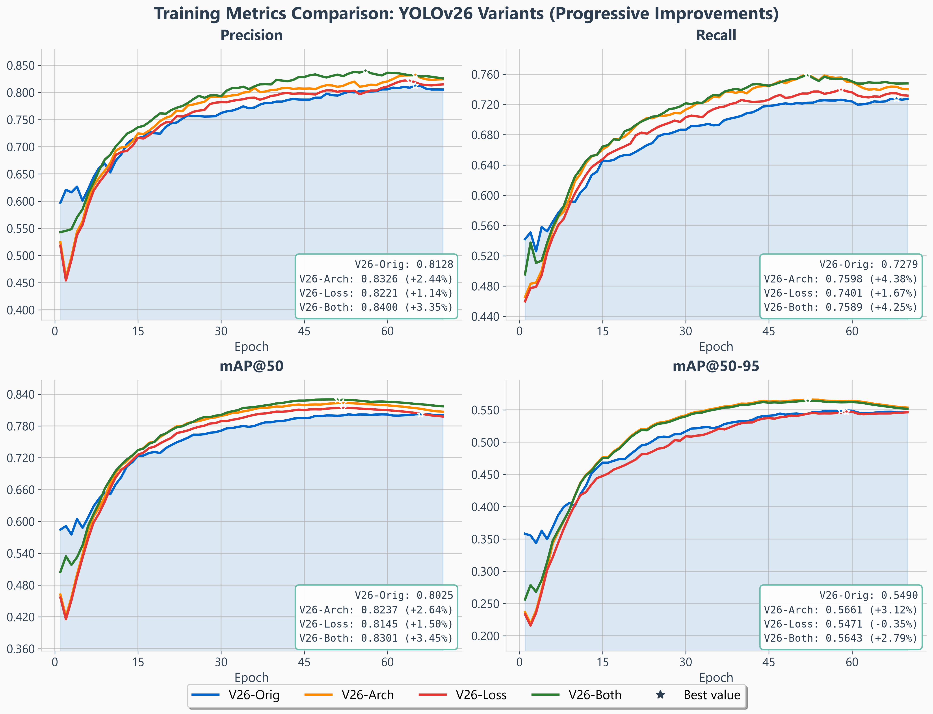
Fig. 5. YOLO26s training dynamics, all four configurations of Table 7. Curves are per-epoch validation metrics; the annotated end values are the corresponding test means over three seeds, so they match Table 7 rather than the curve maxima. The ordering is established within the first fifteen epochs and never crosses, so the ranking is not an artefact of where training stopped. Note the mAP$​_{50\text{-}95}$ panel: the loss axis alone (red) tracks the baseline and ends slightly below it, which is the $-0.35\%$ of Table 7 seen as a trajectory.

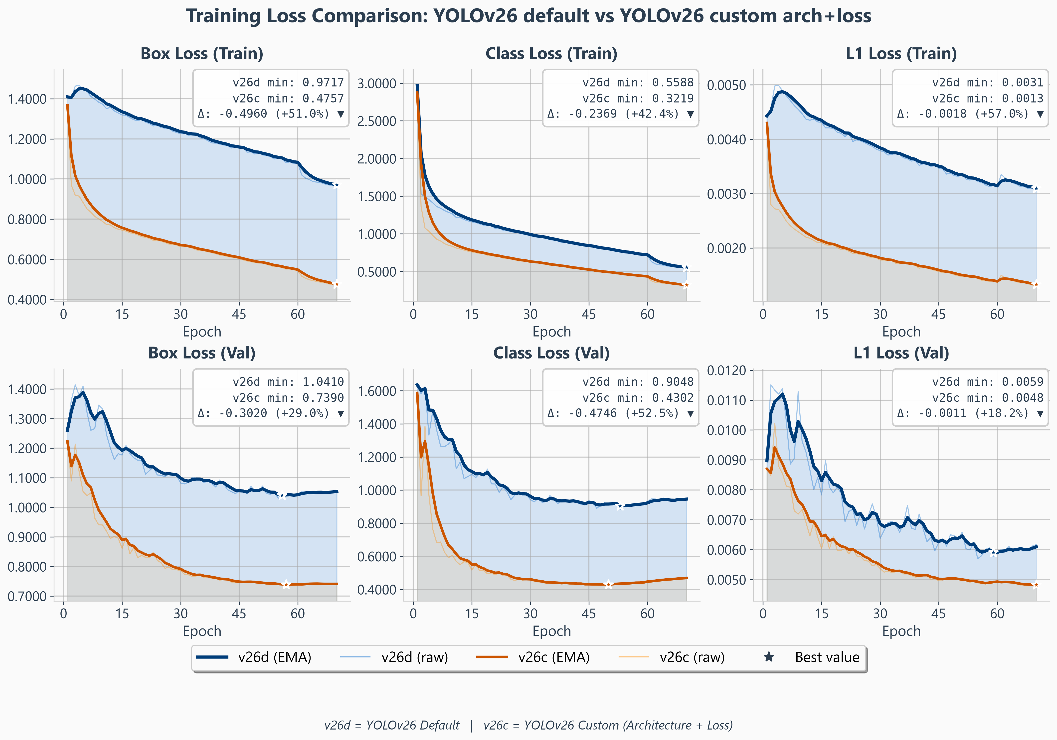
Fig. 6. YOLO26s loss components, baseline (v26d) versus the recommended architecture$+$loss configuration (v26c); train on the top row, validation on the bottom, EMA-smoothed in bold with the raw per-epoch traces behind and the best value starred. Detection quality is not repeated here — the validation mAP, precision and recall curves are in Fig. 5, where all four configurations can be compared at once. All three terms fall substantially: box $-51.0\%$, classification $-42.4\%$ and $l_{1}$ $-57.0\%$ on train, and $-29.0\%$, $-52.5\%$ and $-18.2\%$ on validation, so the improvement is visible in the objective itself and not only in the evaluated metrics. Both regression terms reach their validation minimum late (box at epoch $57$, $l_{1}$ at $60$) and stay flat to the end of the schedule. The third panel is labelled $l_{1}$ loss rather than DFL: YOLO26 sets $reg_max=1$ and substitutes an image-normalised $l_{1}$ term (Table 11), which is directly visible here and is the structural difference Section A uses to explain why curriculum area weighting does not transfer to this detector.

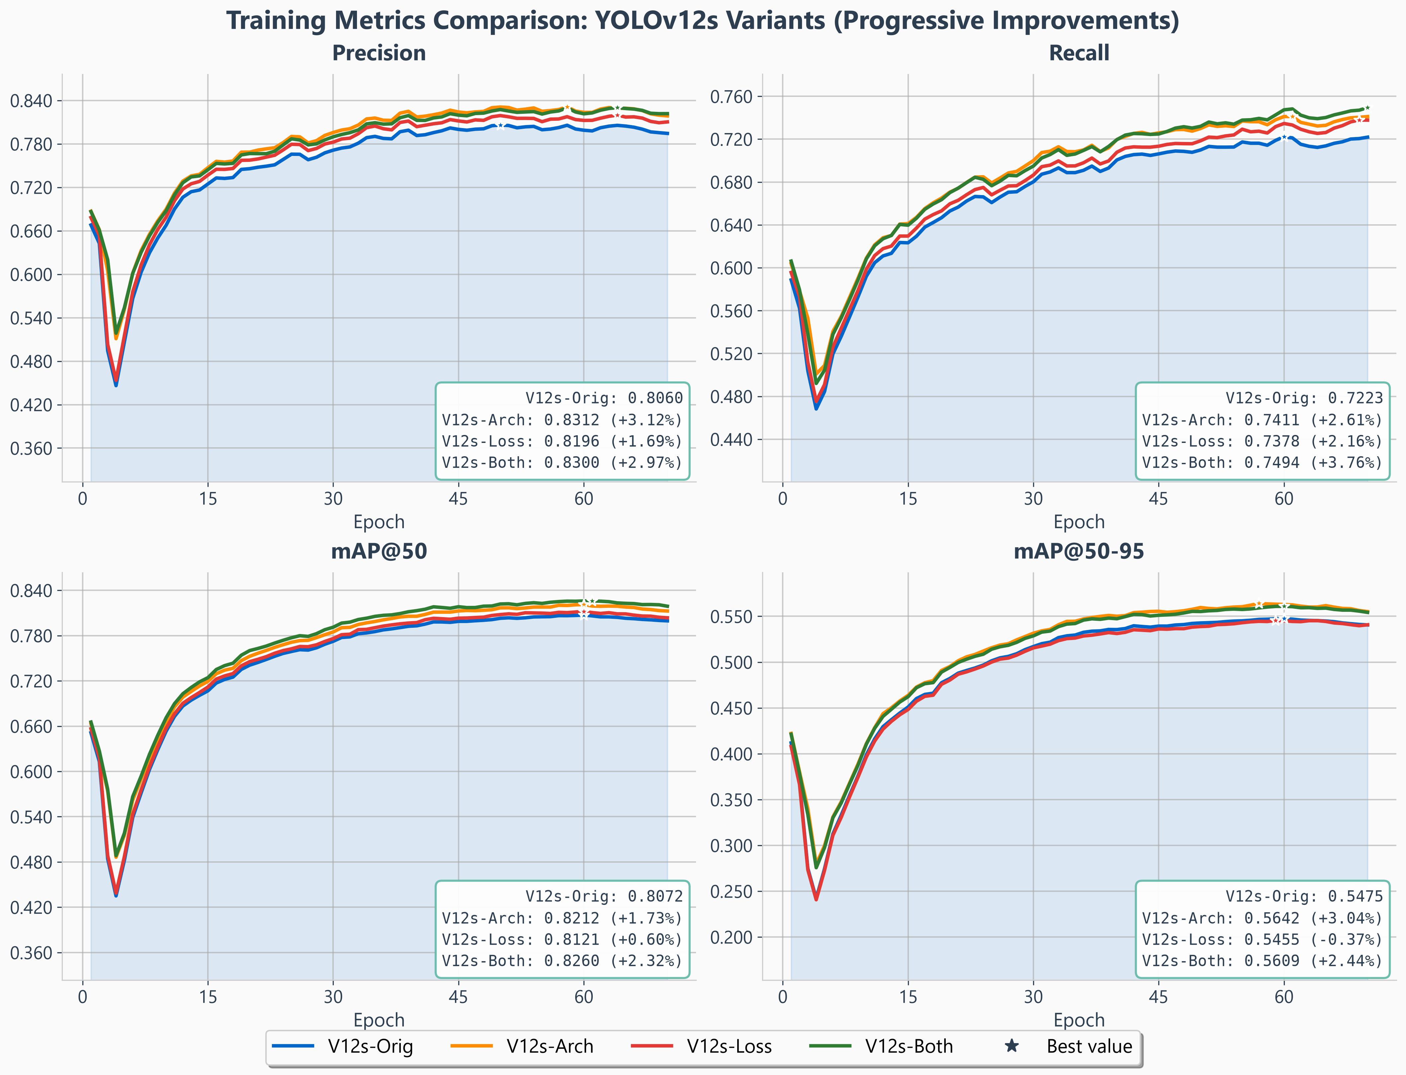
Fig. 7. YOLOv12s training dynamics, same convention as Fig. 5. The mAP$​_{50\text{-}95}$ panel shows the same signature as YOLO26 — the loss axis alone ends $-0.37\%$ below the baseline while every configuration containing the architecture ends above it — which is the one part of the loss mechanism’s behaviour that is common to both detectors.

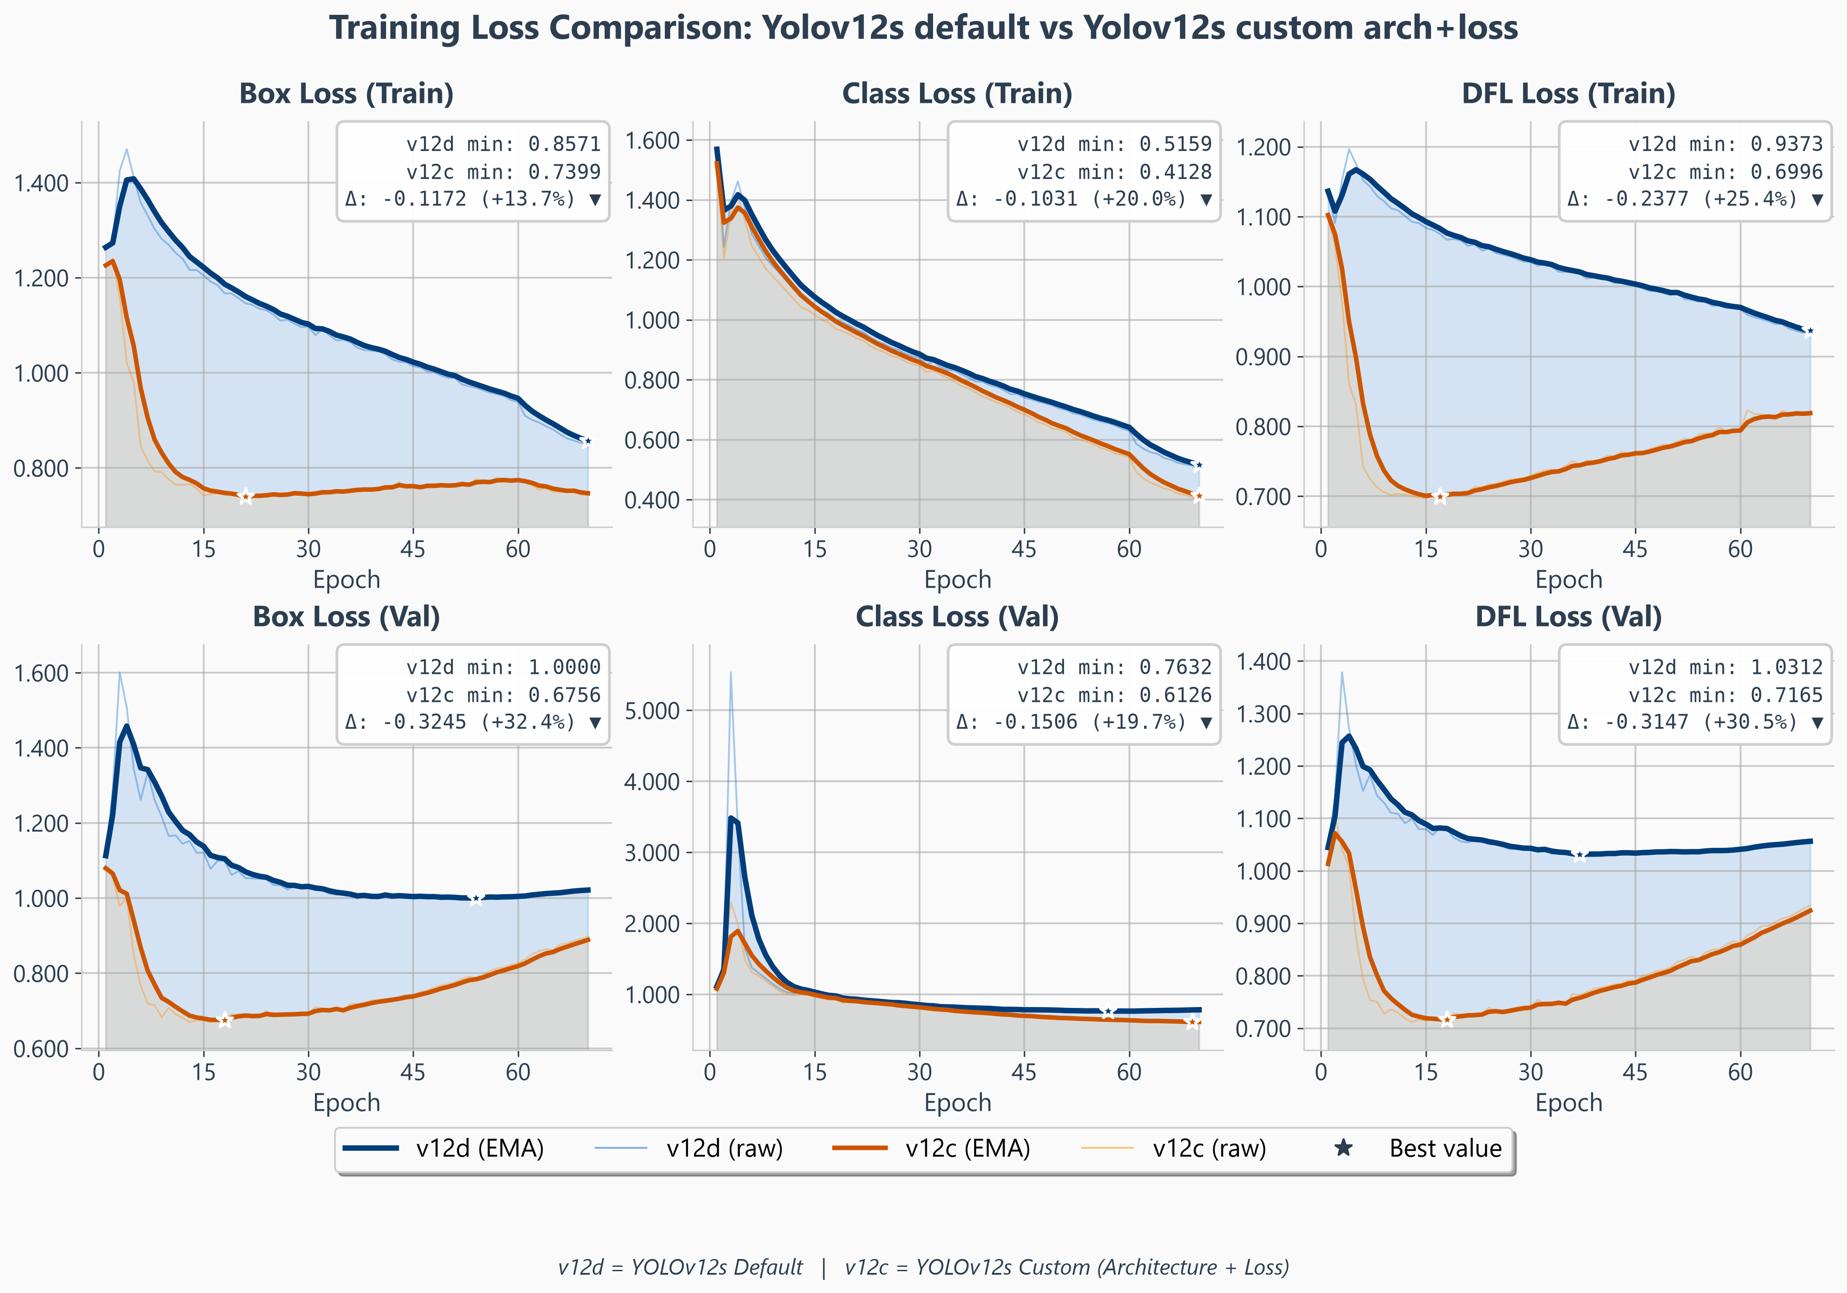
Fig. 8. YOLOv12s loss components, baseline (v12d) versus the recommended configuration (v12c), same convention as Fig. 6; the corresponding metric curves are in Fig. 7. Box loss falls $13.7\%$ on train and $32.4\%$ on validation, classification $20.0\%$ and $19.7\%$, DFL $25.4\%$ and $30.5\%$. Two contrasts with Fig. 6 matter. The third panel here is a genuine DFL over $16$ bins, not an $l_{1}$ surrogate, which is the difference Table 11 records. And where YOLO26’s regression terms bottom out at the very end of the schedule, YOLOv12’s reach their validation minimum near epoch $18$ — box $0.676$, DFL $0.717$ — and climb steadily thereafter, while mAP$​_{50}$ in Fig. 7 keeps improving to roughly epoch $60$. The regression head overfits long before the detector stops gaining, which is why checkpoints are selected on validation mAP rather than on loss.

4) What the loss curves show
Figures 6 and 8 give the three loss components for each detector, baseline against the recommended configuration, on the training and validation splits. They carry no metric panels: mAP, precision and recall are already in Figs. 5 and 7, where all four configurations appear together rather than only two, so the loss figures are left to show the objective alone. Every term falls on both models, and by a wide margin on YOLO26 — box $-51.0\%$, classification $-42.4\%$, $l_{1}$ $-57.0\%$ on the training split. Two details are worth drawing out because they bear on the argument rather than on the headline.
The third loss term is a different objective on each detector, and the figures say so on their axis labels. YOLO26’s panel reads $l_{1}$ loss; YOLOv12’s reads DFL loss. This is the $reg_max$ difference of Table 11 made visible, and it is the mechanism Section A invokes to explain why curriculum area weighting — which leans on a distributional, anchor-relative term — does not survive the move to a scale-absolute $l_{1}$ surrogate.

The two detectors overfit in different terms, and on different timescales. On YOLO26 the two regression terms fall for essentially the whole schedule: validation box reaches its minimum at epoch $57$ and $l_{1}$ at epoch $60$, both then flat, so the box head is still being paid to keep learning when training stops. Only the classification term turns, mildly, after roughly epoch $48$ — and it turns in the baseline as well, so it is a property of the schedule rather than of our modifications. On YOLOv12 the pattern is inverted and far sharper: validation box and DFL bottom out near epoch $18$, at $0.676$ and $0.717$, and climb for the remaining fifty epochs while mAP$​_{50}$ keeps improving to roughly epoch $60$. The regression head overfits long before the detector stops gaining. Final-epoch loss is therefore a poor stopping criterion on YOLOv12 in particular, and the checkpoint rule used throughout — best validation mAP, never lowest loss — is what keeps the two detectors comparable despite the difference.

C. Where the Gains Land, by Object Size

TABLE 8. Per-size effect of each axis on the test split. L is the loss axis alone, A the architecture axis alone, A$+$L both; $Δ$ is the percentage change of A$+$L over that detector’s baseline. Every cell is the mean of three seeds. Size buckets are the COCO area convention (${32}^{2}$ / ${96}^{2}$ px$​^{2}$), matching the evaluator. Bold marks the best of the four columns in that row.
 |  | YOLO26s |  |  |  |  | YOLOv12s
 | Metric | Base | L | A | A$+$L | $$Δ$$ | Base | L | A | A$+$L | $$Δ$$
Small — area $<{32}^{2}$ px$​^{2}$
 | mAP$​_{50}$ | 77.26 | 78.61 | 79.83 | 79.91 | $$+3.44$$ | 77.65 | 77.93 | 78.79 | 79.87 | $$+2.85$$
 | mAP$​_{50\text{-}95}$ | 50.64 | 50.50 | 52.85 | 52.82 | $$+4.31$$ | 49.88 | 49.66 | 51.65 | 51.60 | $$+3.45$$
 | Precision | 77.31 | 78.25 | 80.06 | 80.97 | $$+4.73$$ | 76.81 | 79.08 | 81.07 | 80.06 | $$+4.24$$
 | Recall | 72.10 | 72.59 | 74.57 | 74.20 | $$+2.91$$ | 70.29 | 71.16 | 71.25 | 73.67 | $$+4.82$$
 | F1 | 74.62 | 75.32 | 77.22 | 77.44 | $$+3.78$$ | 73.40 | 74.91 | 75.85 | 76.74 | $$+4.54$$
 | mAP$​_{50}$ | 86.60 | 87.26 | 87.28 | 88.59 | $$+2.30$$ | 87.65 | 87.54 | 87.78 | 87.42 | $$-0.26$$
 | mAP$​_{50\text{-}95}$ | 65.46 | 65.38 | 66.08 | 66.16 | $$+1.07$$ | 65.12 | 64.46 | 65.65 | 64.49 | $$-0.98$$
 | Precision | 91.70 | 91.01 | 90.98 | 93.02 | $$+1.45$$ | 88.40 | 88.78 | 91.25 | 92.35 | $$+4.46$$
 | Recall | 79.04 | 80.38 | 82.90 | 82.23 | $$+4.03$$ | 80.77 | 81.76 | 81.30 | 79.08 | $$-2.09$$
 | F1 | 84.90 | 85.36 | 86.75 | 87.29 | $$+2.82$$ | 84.41 | 85.13 | 85.99 | 85.20 | $$+0.93$$
 | mAP$​_{50}$ | 81.82 | 81.85 | 83.26 | 80.83 | $$-1.21$$ | 82.93 | 82.63 | 84.68 | 82.79 | $$-0.17$$
 | mAP$​_{50\text{-}95}$ | 60.54 | 59.87 | 60.84 | 59.49 | $$-1.73$$ | 57.62 | 58.67 | 60.52 | 59.90 | $$+3.94$$
 | Precision | 79.98 | 77.29 | 87.59 | 77.88 | $$-2.62$$ | 83.97 | 83.94 | 87.95 | 83.43 | $$-0.64$$
 | Recall | 76.37 | 82.49 | 80.71 | 80.20 | $$+5.01$$ | 74.78 | 79.65 | 78.21 | 77.92 | $$+4.20$$
 | F1 | 78.13 | 79.81 | 84.01 | 79.02 | $$+1.14$$ | 79.11 | 81.74 | 82.80 | 80.58 | $$+1.86$$

Table 8 resolves each axis by object size, which is where the two detectors stop resembling each other. Three patterns are worth naming.
The gains are concentrated on small objects and are paid for elsewhere. On both detectors the combined configuration improves small-object mAP$​_{50}$ (YOLO26 $+3.44\%$, YOLOv12 $+2.85\%$) and small-object F1 ($+3.78\%$ and $+4.54\%$), while medium objects are flat to negative and mAP$​_{50\text{-}95}$ falls at every size except small. Since small and medium together account for $75.0\%$ of instances (Table 3), that is the right trade to make — but the headline number is not a uniform improvement and should not be reported as one.
The two detectors buy the same small-object gain with opposite currencies. On YOLO26 the improvement comes from precision ($+5.07\%$) with recall moving less ($+2.91\%$); on YOLOv12 precision and recall rise together ($+4.24\%$ and $+4.82\%$). Both detectors reach a similar small-object F1 gain ($+3.78\%$ and $+4.54\%$), but YOLO26 gets there by becoming more selective and YOLOv12 by finding more — the per-size trace of the one-to-one versus NMS-based assignment difference discussed in Section A.
The large-object cost belongs to the combination, not to the architecture. Taken alone, the architecture axis leaves large-object mAP$​_{50\text{-}95}$ intact on YOLO26 ($+0.51\%$) and improves it markedly on YOLOv12 ($+5.03\%$), so deleting the stride-32 detection branch does not by itself degrade large objects — the retained stride-32 backbone still supplies the context they need. What costs large objects is adding the loss axis on top: from the architecture cell to the combination, YOLO26 gives up $2.43$ points of large-object mAP$​_{50}$ and YOLOv12 $1.89$, both beyond $2 SE$. The mechanism that sharpens small-object detection is the one that blunts large-object localisation, on both detectors.

1) Why these are fixed configurations rather than per-cell maxima
Each column of Table 8 is a single configuration evaluated at all three sizes. It is not the best run per cell, and for most cells it is not the campaign maximum: on large-object mAP$​_{50}$, for instance, some run in the YOLO26 campaign reaches $85.55$ against our configuration’s $80.35$. We report the fixed configuration deliberately, for two reasons.
First, a per-cell maximum describes a model that does not exist. One cannot deploy the configuration that happens to lead on large objects together with the one that leads on small objects; a table assembled that way would report an unattainable system.
Second, and more importantly, those maxima are largely noise. Selecting the maximum of $N$ draws from a distribution with standard deviation $σ$ yields, from sampling alone, an expected excess of approximately $σ\sqrt{2lnN}$ above the mean. With $N=174$ YOLO26 runs and the measured $σ=2.258$ on mAP$​_{50}^{\text{large}}$ — the noisiest metric in the study — that is $7.25$ points. The $5.20$-point gap between our configuration and the campaign maximum is therefore smaller than what pure noise would be expected to produce, and the corresponding maximum is a single unrepeated draw. The same calculation on mAP$​_{50}^{\text{small}}$, where $σ=0.428$, gives an expected noise maximum of $1.37$ points against an observed gap of $0.32$. Reporting per-cell maxima would amount to tabulating the selection bias we measured in Section D.

D. Per-Class Behaviour

TABLE 9. Per-class, per-size performance on the test split: baseline versus the recommended configuration, both models, means of three seeds. Size buckets are the COCO area convention. bag is the weakest class at every size on both detectors and the ordering trolley $>$ backpack $>$ bag holds in all eighteen cells.
 |  | AP$​_{50}$ |  |  | AP$​_{50\text{-}95}$
Class | Size | Base | A$+$L | $$Δ$$ | Base | A$+$L | $$Δ$$
YOLO26s — p2dys-p234rich $+$ $β=1$
backpack | small | 78.82 | 81.10 | $$+2.28$$ | 51.11 | 53.91 | $$+2.79$$
 | medium | 89.69 | 91.99 | $$+2.30$$ | 67.88 | 69.75 | $$+1.87$$
 | large | 82.93 | 86.53 | $$+3.60$$ | 56.49 | 58.56 | $$+2.06$$
bag | small | 67.78 | 70.46 | $$+2.68$$ | 42.78 | 44.60 | $$+1.82$$
 | medium | 76.85 | 79.64 | $$+2.79$$ | 54.88 | 55.77 | $$+0.90$$
 | large | 85.74 | 85.50 | $$-0.25$$ | 68.87 | 66.36 | $$-2.51$$
trolley | small | 85.47 | 88.86 | $$+3.39$$ | 58.09 | 60.24 | $$+2.15$$
 | medium | 93.16 | 93.99 | $$+0.84$$ | 73.98 | 72.83 | $$-1.14$$
 | large | 76.77 | 70.48 | $$-6.29$$ | 56.00 | 58.26 | $$+2.26$$
YOLOv12s — ls_shift $+$ curriculum weighting
backpack | small | 77.71 | 80.48 | $$+2.76$$ | 50.49 | 52.87 | $$+2.38$$
 | medium | 90.99 | 92.53 | $$+1.54$$ | 66.99 | 68.65 | $$+1.66$$
 | large | 85.28 | 82.09 | $$-3.18$$ | 58.70 | 57.92 | $$-0.78$$
bag | small | 67.45 | 70.83 | $$+3.37$$ | 41.75 | 43.36 | $$+1.61$$
 | medium | 77.30 | 75.79 | $$-1.51$$ | 54.72 | 53.19 | $$-1.53$$
 | large | 81.33 | 86.58 | $$+5.25$$ | 66.41 | 66.79 | $$+0.38$$
trolley | small | 87.64 | 88.22 | $$+0.58$$ | 57.68 | 58.74 | $$+1.06$$
 | medium | 94.88 | 94.07 | $$-0.81$$ | 73.58 | 72.10 | $$-1.48$$
 | large | 81.93 | 79.67 | $$-2.26$$ | 48.08 | 55.16 | $$+7.08$$

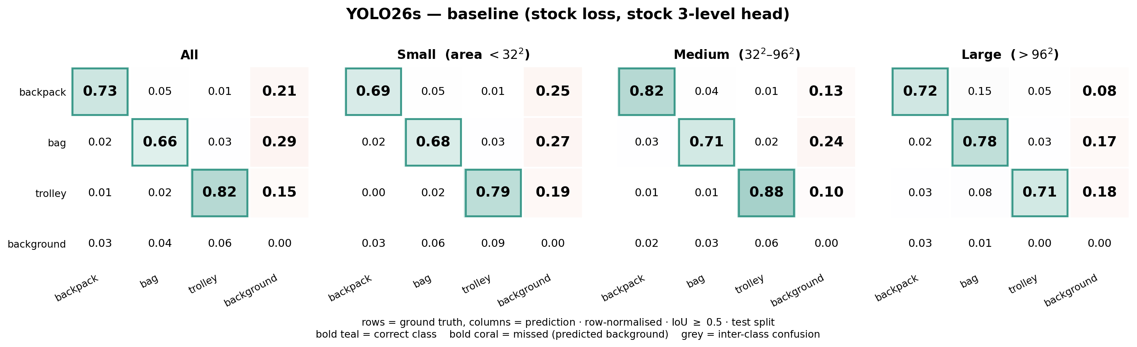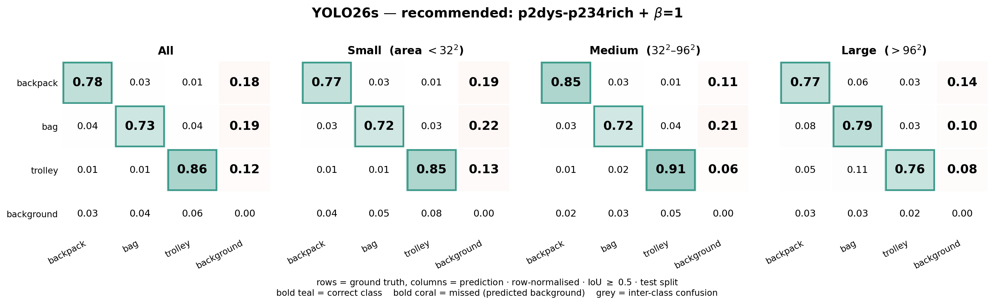
Fig. 9. YOLO26s confusion, resolved by object size: baseline (top) and the recommended configuration (bottom). Rows are ground truth, columns are prediction, each row normalised, IoU $≥0.5$, test split. The bold teal diagonal is the correct-class rate and the bold coral column is the miss rate — ground truth predicted as background — which for an alarm system is the operative failure. Every class improves at every size; the largest single change is bag missed to background, $0.29→0.19$ overall and $0.27→0.22$ on small objects.

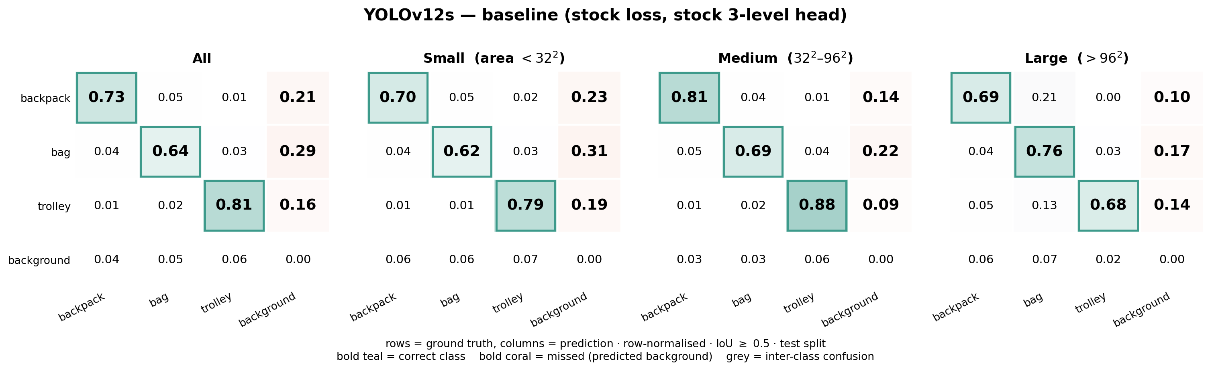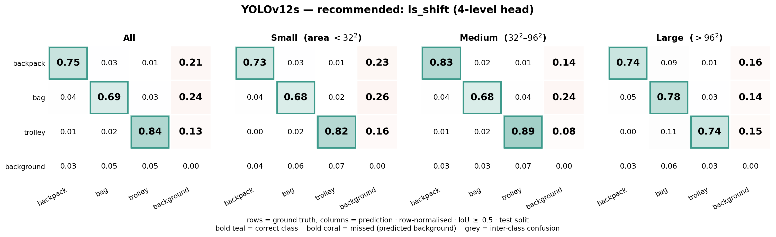
Fig. 10. YOLOv12s confusion, same convention as Fig. 9: baseline (top), recommended configuration (bottom). The pattern matches YOLO26 — every class improves at every size and bag improves most ($0.64→0.69$ correct overall, misses $0.29→0.24$) — but from a lower starting point on that class, and the residual bag miss rate stays above YOLO26’s.

Table 9 resolves the same comparison by class as well as size. The dominant pattern is that bag is the hard class at every size and on both detectors, and by a wide margin: at AP$​_{50}$ its small-object score is $68.4$ on YOLO26 and $66.8$ on YOLOv12, against $85.7$ and $86.5$ for trolley — a gap of roughly $18$ points that neither axis closes. The ordering trolley $>$ backpack $>$ bag holds in all eighteen class$×$size cells.
This is consistent with the assignment diagnostics, which found per-class behaviour essentially uniform at strides $8$ and $16$: the bag deficit is not a matter of candidate supply, and it is therefore not something a stride-4 level or an assignment exponent can repair. It is a classification problem — bags are visually heterogeneous and the class is the one most often confused with background in the baseline confusion matrix. Both recommended configurations do improve it slightly at AP$​_{50}$ ($+0.98$ and $+1.76$ on small objects), but neither changes its rank.
The per-class view also localises the large-object cost reported in Section C. On YOLO26 the AP$​_{50\text{-}95}$ loss at large sizes is concentrated almost entirely in one class — bag, $68.36→60.84$ — while backpack loses $2.09$ and trolley $1.37$. The stride-32 deletion does not degrade large objects uniformly; it degrades the class whose large instances are least distinctive.

E. What Each Axis Actually Buys
The two axes do not improve the same things, and with three seeds the split is clean and identical on both detectors:
 | axis | P | R | mAP$​_{50\text{-}95}$ | AR$​_{50\text{-}95}^{\text{small}}$
YOLO26s | Loss | $$+1.14$$ | $$+1.67$$ | $$-0.35$$ | $$-1.46$$
YOLO26s | Arch | $$+2.44$$ | $$+4.38$$ | $$+3.12$$ | $$-1.25$$
 | Loss | $$+1.69$$ | $$+2.16$$ | $$-0.37$$ | $$-2.11$$
 | Arch | $$+3.12$$ | $$+2.61$$ | $$+3.04$$ | $$+2.48$$
(percentage change over each detector’s own baseline). Both axes raise precision and recall on both models. The separation is on mAP$​_{50\text{-}95}$: the loss axis costs it — $-0.35\%$ and $-0.37\%$, two independent detectors agreeing to within $0.02$ points — while the architecture axis gains it, $+3.12\%$ and $+3.04\%$, agreeing to within $0.08$. That two mechanisms reproduce their signature this closely across detectors that share almost no implementation is the strongest regularity in the study.
The reading is the one Section B predicts. Flattening the alignment exponent, or re-weighting positives by scale, changes which detections are made and how confidently, but neither improves where a box is placed; at stricter IoU thresholds that shows up as a small loss. Adding a stride-4 level changes the resolution at which a small object is represented, which improves placement directly.
The small-object recall ceiling tells a similar story. The loss axis lowers it on both detectors ($-1.46\%$, $-2.11\%$): sharpening or re-weighting assignment discards candidates. The architecture axis lowers it slightly on YOLO26 ($-1.25\%$) but raises it on YOLOv12 ($+2.48\%$), the one place the two detectors disagree — and the one where YOLOv12 keeps its stride-32 head while YOLO26 deletes it.

F. The Axes Are Substantially Redundant
Writing the effect of each axis alone as $Δ_{A}$ and $Δ_{L}$ and the combined effect as $Δ_{AL}$, the interaction is $ι=Δ_{AL}-(Δ_{A}+Δ_{L})$. On YOLO26, $Δ_{A}=+1.10$, $Δ_{L}=+1.32$, $Δ_{AL}=+1.85$ points, so $ι=-1.26$: the combination delivers $68\%$ of the sum of its parts. The same computation on YOLOv12’s native combinations gives $46$–$81\%$. Measured against the architecture alone, adding a loss mechanism on YOLOv12 yields $+0.39$, $-0.09$ and $-0.22$ points of small-object mAP$​_{50}$ for curriculum weighting, WIoU and level-balanced assignment respectively — that is, no reliable gain at all. The two axes compete for the same errors.

G. Neither Detector’s Mechanisms Transfer to the Other
We tested transfer in both directions and on both axes, always on the same dataset and at matched batch size. Table 10 gives all four cells.
TABLE 10. The transfer design. Each mechanism is evaluated on the detector it was developed for and on the other one. $Δ$ is percentage change in mAP$​_{50}^{\text{small}}$ over that detector’s own baseline; the run-to-run standard error is $0.28$ points on YOLO26 and $0.20$ on YOLOv12, so $|Δ|<0.7\%$ is not resolvable.
Axis | Mechanism | own | other
Loss | curriculum weighting (v12) | $$+0.36$$ | null
Loss | alignment exponent $β=1$ (v26) | $$+1.75$$ | $$+0.32$$
Arch | level-specific blocks (v12) | $$+1.47$$ | $$+0.66$$
Arch | drop stride 32 $+$ depth 4 (v26) | $$+3.33$$ | $$+0.56$$
The result is uniform: every one of the four cross-model transfers is a null on the primary metric. The resolvability threshold is $0.7\%$ of the baseline; no “other” cell reaches it, while three of the four “own” cells clear it by a factor of at least two. This is not a case of mechanisms that help a little less on the other detector; it is four mechanisms that stop working.
Two of them additionally do damage that the small-object metric hides. The YOLO26 level reallocation costs YOLOv12 $6.1$ points of large-object mAP$​_{50}$ and $9.6$ at strict IoU, and $β=1$ costs YOLOv12 $0.9$ points of mAP$​_{50\text{-}95}$ and $2.6$ of the small-object recall ceiling. Taken across all metrics rather than one, the YOLO26 configuration loses $20$ of $24$ matched-batch comparisons against YOLOv12’s native configurations. The YOLOv12 global-context block, evaluated on YOLO26 in two placements, scored $+0.51$ and $+0.01$ — in both cases below the shared P2$+$DySample change it was added to, so it did not merely fail to help, it displaced something that did.
The four comparisons the YOLO26 configuration does win are exactly those its mechanism predicts — large-object AP for the exponent change, recall and the recall ceiling for the level reallocation. The mechanism signatures therefore transfer faithfully while the net benefits do not, which is what Section A sets out to explain.
Two findings invert outright. Removing the stride-32 detection branch is free to beneficial on YOLO26 but costs $6.1$ points of large-object mAP$​_{50}$ on YOLOv12, whose stride-32 head is still carrying large luggage. And the depth optimum reverses: repeats of $4$ beat $2$ by $+0.62$ on YOLO26 and lose by $-0.46$ on YOLOv12.

H. A Batch-Size Control
A stride-4 head does not fit at the baseline batch size, so during the exploratory phase the architectural variants were trained at a smaller batch than the baseline and therefore took more optimisation steps. We bounded that confound directly with a matched-batch control and with a second estimate at a different loss setting: $+0.57$ and $-0.13$ points of small-object mAP$​_{50}$, both within one standard error of zero, placing the batch effect below $≈0.6$ points.
The seeded configurations reported in Table 7 were subsequently retrained under a single protocol per detector, so the comparisons in Sections C–D are batch-matched by construction and no correction is applied to them. We record the bound here because it is what licensed the exploratory sweep of Table 6, whose cells are single runs at mixed batch sizes and should be read as a search rather than as measurements.

VI. Discussion

A. Why Each Mechanism Helped Only Its Own Detector
Section G established that the transfer fails in both directions. A failure to transfer is only interesting if it can be explained, so we give the mechanism for each of the four cases. All four trace back to three differences between the two reference implementations, which we state precisely because they are not visible in the training configuration — both models accept an identical set of keys and report identical loss names.
TABLE 11. The three implementation differences that explain the transfer failures. Both detectors share $box=7.5$, $cls=0.5$, $dfl=1.5$, BCE classification, CIoU, and a task-aligned assigner with $α=0.5$, $β=6$.
 | YOLOv12 | YOLO26
Box distribution | DFL, $reg_max=16$ | none, $reg_max=1$
Third loss term | DFL over bins | $l_{1}$ on ltrb / imgsz
Assignment | one-to-many, $k=10$ | two branches:
 | $+$ NMS at inference | o2m $k=10$, o2o $k=7,k_{2}=1$
Branch weighting | — | $0.8→0.1$ (o2m),
 |  | $0.2→0.9$ (o2o)
Duplicate removal | NMS | argmax, no NMS
Table 11 lists them. Two points deserve emphasis. First, YOLO26 does not simply drop the third loss term when $reg_max=1$: it substitutes an $l_{1}$ loss on left-top-right-bottom distances normalised by image size, so the term still exists but has a completely different gradient structure — constant-magnitude and absolute-scale, rather than distributional and anchor-relative. Second, YOLO26’s two assignment branches are combined with a scheduled weighting: the one-to-many branch starts at $0.8$ and decays linearly to $0.1$ across training while the one-to-one branch rises from $0.2$ to $0.9$, so by the final epochs the model is optimised almost entirely through one-to-one assignment. Any mechanism acting on assignment therefore acts on a moving target on YOLO26 and on a static one on YOLOv12.

1) Curriculum area weighting is a null on YOLO26 because the term it leans on has been replaced
On YOLOv12 the per-positive weight $w_{j}^{(t)}$ of Equation (1) multiplies two regression terms: CIoU and the DFL. The DFL is where fine localisation is learned — it supervises a $16$-bin distribution per box edge [25], in units of feature cells measured from the anchor — and it carries the $dfl=1.5$ gain against CIoU’s effective contribution. Crucially, DFL is anchor-relative and scale-free: a small box and a large box both produce targets inside the same bin range, so re-weighting by object scale genuinely redistributes gradient between them.
YOLO26 sets $reg_max=1$ and substitutes an $l_{1}$ loss on left-top-right-bottom distances normalised by image size. The weight still multiplies it, so the mechanism is not disabled — but it is now acting on a term with the opposite scale behaviour. The $l_{1}$ gradient has constant magnitude regardless of box size, and the quantity being regressed is an absolute fraction of the image rather than a distance in anchor units. A weighting scheme whose entire premise is that small objects are under-represented in a scale-relative loss has little to redistribute in a scale-absolute one.
This is the cleanest example of the paper’s general point. The intervention was tuned against a $16$-bin distributional loss and transplanted onto a direct $l_{1}$ regression, and nothing in the configuration surface signals the substitution: the key is still called dfl, the gain is still $1.5$, and the logged loss name changes from dfl_loss to l1_loss in a single line of the reference implementation.

2) The alignment exponent matters more on YOLO26 because nothing downstream can correct it
On YOLOv12 a small object receives roughly $7.7$ positives. At inference, NMS selects among their predictions by confidence. If the alignment metric ranked those anchors badly — which is what an over-sharp $β$ does at small scales, per Section B — the error is an error in the targets of several anchors that will subsequently be pooled. NMS launders a noisy ranking: the surviving detection is effectively an ensemble decision over the positive set.
YOLO26’s one-to-one branch selects exactly one winner per ground truth, by $argmax$ over the same alignment metric ($k=7$ candidates reduced to $k_{2}=1$), and there is no NMS afterwards to revise it. The exponent is therefore no longer shaping a soft ranking among redundant positives; it is making a single, final, unappealable choice. When IoU is noisy — precisely the small-object regime — $β=6$ amplifies that noise into the selection of the one anchor that will represent the object.
The branch schedule sharpens this further. Because the one-to-one weight rises from $0.2$ to $0.9$ over training, the regime in which $β$ makes unappealable choices is also the regime that dominates the final epochs, when the model’s decision boundary is actually being set. On YOLOv12 no such branch exists and no such schedule runs; $β$ shapes a soft ranking from first epoch to last.
This predicts both observations: $β$ should matter more on YOLO26 ($+1.70\%$ versus $+0.25$–$0.94\%$), and the precision/recall exchange should be a YOLO26 phenomenon, since discarding the runners-up is exactly what one-to-one assignment does and what NMS-based assignment does not. Both hold — the trade appears in $95\%$ of qualifying YOLO26 configurations and only $37\%$ of YOLOv12 ones.

3) Removing the coarsest level is affordable on YOLO26 and expensive on YOLOv12
This is the largest asymmetry in the study:
$-$ stride-32 detection branch | mAP$​_{50}^{\text{large}}$ | mAP$​_{50\text{-}95}^{\text{large}}$
YOLO26 p234 | $$+0.49$$ | $$-2.87$$
YOLO26 p234rich | $$+1.69$$ | $$-1.92$$
YOLOv12 p234 | $$-4.09$$ | $$-10.84$$
YOLOv12 p234rich | $$-6.09$$ | $$-9.59$$
YOLOv12 loses roughly ten points of strict-IoU large-object AP and four to six points even at IoU $0.5$; YOLO26 loses two to three points at strict IoU and gains at IoU $0.5$. Both models were retrained from scratch on the reduced graph, so this is not a fine-tuning artefact — stride 16 had every opportunity to absorb the large objects, and on YOLOv12 it could not.
The leading explanation is again the DFL. A YOLOv12 anchor expresses each box edge as a distribution over $16$ bins measured in feature cells, so a stride-16 anchor can represent an extent of at most $16×16=256$ pixels from the anchor point; the same anchor at stride $32$ reaches $512$. Removing the stride-32 head forces the largest instances onto anchors whose regression range may not reach their boundaries, and a clipped distribution degrades gracefully at IoU $0.5$ but sharply at IoU $0.75$ and above — which is the observed pattern. YOLO26, regressing offsets directly with no binning, has no equivalent range limit. We report this as the hypothesis most consistent with the data rather than as an established result: confirming it requires AP resolved by box size within the large bucket, which our evaluation protocol does not currently produce.
We also note what this costs our own reasoning. The reallocation was motivated by a positives cross-tab showing that stride 32 receives $0.01$ positives per small ground truth and $1.68$ of a large object’s $9.79$. That diagnostic was measured on YOLOv12 — and YOLOv12 is the model where the removal proved expensive. Assignment supply and inference contribution are not the same quantity, and we mistook one for the other. A level can be nearly idle at training time and still be where the model places its most confident large-box predictions.

4) The level-specific blocks are a null on YOLO26 because their payoff route does not exist
The remaining cell of the transfer design is the YOLOv12 architectural mechanism applied to YOLO26. The gated global-context block was ported to the YOLO26 fork and evaluated twice, on the stock graph and on the P2/DySample graph:
YOLO26 $+$ global-context block | mAP$​_{50}^{\text{small}}$ | mAP$​_{50}$
on the stock three-level graph | $$+0.51$$ | $$-0.08$$
on the P2/DySample graph | $$+0.01$$ | $$-0.23$$
for reference: P2$+$DySample alone | $$+0.76$$ | —
Both are nulls at a run-to-run standard error of $0.61$, and both are below the shared architectural change they were added to. On YOLOv12 the same block is part of the configuration that improves eight of nine metrics.
The explanation follows the one-to-one/NMS distinction already established. A global-context block improves the classification confidence of a location whose appearance alone is ambiguous — a twelve-pixel dark blob that is a bag, a bin or a shadow depending on its surroundings. On YOLOv12 that improvement has a route to the output: the object holds roughly $7.7$ positives, all of them score-ranked, and NMS keeps the highest. Sharpening those scores changes which box survives and how confidently it is emitted, which is exactly what mAP$​_{50}$ integrates over.
YOLO26 does not rank-then-select. Its one-to-one branch commits to a single anchor by $argmax$ over the alignment metric during assignment, and that metric is computed from the detached predicted score — so a better per-location classifier changes which anchor is chosen, but there is no downstream selection stage in which improved confidence separates a good detection from a redundant one. The block is not harmful; it simply has nowhere to pay off. We note that the directional snake-convolution block was not evaluated in isolation on YOLO26, so this conclusion is established for the global-context component only.

5) Depth helps where it propagates and not where it terminates
The fine-level depth optimum is $4$ blocks on YOLO26 and $2$ on YOLOv12. The graphs explain the difference. On YOLO26 the P2 branch is inserted into the PAN, so the deepened row $19$ feeds row $22$, which feeds row $25$: additional capacity there refines features consumed by two further predictions as well as its own. On YOLOv12 the P2 branch is appended and its head is a leaf — row $23$ is read only by its refinement block and the detection head. Depth added to a terminal branch buys one prediction; depth added to an upstream branch buys three. This also explains why the effect is small in both cases and why $6$ blocks over-fit on YOLO26: the benefit is real but second-order.

B. What This Means for Small-Object Detection Research
The four explanations share a shape. In each case the mechanism was not wrong about the problem — small objects really are under-weighted, IoU really is noisier at small scales, the coarsest level really does receive few positives. The mechanism was wrong about the detector, because each intervention depends on an implementation detail that the configuration surface hides: the presence of a DFL, the presence of NMS, the topology of the branch it deepens.
The practical consequence is uncomfortable for the field’s reporting norms. A small-object mechanism validated on one detector should not be expected to carry to another, even one from the same family, trained on the same images, at the same resolution. Our two detectors differ by one release generation and share a configuration format, and yet nothing transferred. Papers that propose a mechanism on a single backbone and describe it as a general contribution are making a claim their experiments do not support, and the cost of checking is one additional detector.

C. Limitations
Seeded intervals cover the four configurations per detector in Table 7; the wider exploratory sweep behind Table 6 is single-run and is reported as a search, not as evidence. The batch-size confound on the architectural axis is bounded but not eliminated, and its two estimates disagree in sign. The DFL range hypothesis of Section A is consistent with the data but untested. All results are on a single dataset; the trade between small-object precision and the small-object recall ceiling may be a property of bird’s-eye-view luggage imagery rather than of small objects generally. Finally, the unattended-luggage application that motivates the benchmark is specified in Fig. 3 but not evaluated here, since LuggageDataset v6i contains images rather than tracked video.

VII. Data and Code Availability
LuggageDataset v6i is released publicly, with the annotations, the documented $75/15/10$ partition of Section D and the size-taxonomy definitions used throughout this paper, at https://universe.roboflow.com/guns-detection-cvwjs/luggagedataset-24pgo/dataset/6. The training and evaluation code, the model configurations for every configuration in Table 7, the leakage-free splitting script and the complete run log are available at https://github.com/CostiCatargiu/NewLuggageDataset.

References
[1] D. Thirde, L. Li, and J. Ferryman, “Overview of the PETS 2006 challenge,” in Proc. 9th IEEE Int. Workshop Performance Evaluation of Tracking and Surveillance (PETS), 2006, pp. 47–50.
[2] E. Auvinet, E. Grossmann, C. Rougier, M. Dahmane, and J. Meunier, “Left-luggage detection using homographies and simple heuristics,” in Proc. PETS, 2006, pp. 51–58.
[3] K. Smith, P. Quelhas, and D. Gatica-Perez, “Detecting abandoned luggage items in a public space,” in Proc. PETS, 2006, pp. 75–82.
[4] F. Lv, X. Song, B. Wu, V. K. Singh, and R. Nevatia, “Left luggage detection using Bayesian inference,” in Proc. PETS, 2006, pp. 83–90.
[5] H.-H. Liao, J.-Y. Chang, and L.-G. Chen, “A localized approach to abandoned luggage detection with foreground-mask sampling,” in Proc. IEEE Int. Conf. Advanced Video and Signal Based Surveillance (AVSS), 2008, pp. 132–139.
[6] J.-Y. Chang, H.-H. Liao, and L.-G. Chen, “Localized detection of abandoned luggage,” EURASIP J. Advances in Signal Processing, vol. 2010, art. 675784, 2010.
[7] C. Beleznai, P. Gemeiner, and C. Zinner, “Reliable left luggage detection using stereo depth and intensity cues,” in Proc. IEEE Int. Conf. Computer Vision Workshops (ICCVW), 2013, pp. 59–65.
[8] I. Dahi, M. Chikr El Mezouar, N. Taleb, and M. Elbahri, “An edge-based method for effective abandoned luggage detection in complex surveillance videos,” Comput. Vis. Image Understanding, vol. 158, pp. 141–151, 2017.
[9] D. G. Altunay, K. Karademir, O. Topçu, and C. Direkoğlu, “Intelligent surveillance system for abandoned luggage,” in Proc. Signal Processing and Communications Applications Conf. (SIU), 2018.
[10] S. Smeureanu and R. T. Ionescu, “Real-time deep learning method for abandoned luggage detection in video,” in Proc. EUSIPCO, 2018, pp. 1775–1779.
[11] M. Dogariu, L.-D. Ştefan, M. G. Constantin, and B. Ionescu, “Human-object interaction: Application to abandoned luggage detection in video surveillance scenarios,” in Proc. Int. Conf. Communications (COMM), 2020, pp. 157–160.
[12] D. Kim, H. Kim, Y. Mok, and J. Paik, “HLDNet: Abandoned object detection using hand luggage detection network,” IEEE Consumer Electronics Magazine, vol. 11, no. 4, pp. 45–56, 2022.
[13] X. Chen, Y. Mao, L. Yang, J. Du, and Y. Song, “Research on airport baggage anomaly retention detection technology based on machine vision, edge computing, and blockchain,” IET Blockchain, vol. 4, pp. 393–406, 2024.
[14] L. Zhou and J. Xu, “Enhanced abandoned object detection through adaptive dual-background modeling and SAO-YOLO integration,” Sensors, vol. 24, no. 20, art. 6572, 2024.
[15] I. Vršalović, J. Lerga, and M. Ivašić-Kos, “A system for real-time detection of abandoned luggage,” Sensors, vol. 25, no. 9, art. 2872, 2025.
[16] I. Vršalović, M. Ivašić-Kos, M. Pobar, and J. Lerga, “YOLOv11-based algorithm for abandoned luggage detection with dynamic radius estimation,” in Proc. IEEE PICom, 2025, pp. 129–136.
[17] T. Soontornnapar, “Abandoned bag detection in public areas using Grounding DINO with fine-grained prompts,” in Proc. ECTI-CON, 2025.
[18] H. Song, J. Wang, and Y. Zhang, “Detection of abandoned objects based on YOLOv9 and background differencing,” Signal, Image and Video Processing, vol. 19, art. 54, 2025.
[19] S. Shah, A. Khan, M. Alsuwaylimi, and N. Alenezi, “A two-stage spatiotemporal CNN-YOLOv9 framework for high-precision real-time abandoned object detection in public surveillance videos,” IEEE Access, vol. 14, pp. 35983–35997, 2026.
[20] V.-O. Pastukh and A. Deineko, “Detection of abandoned objects in video surveillance systems: A comparative analysis of rule-based and AI-oriented approaches,” Advances in Cyber-Physical Systems, vol. 11, no. 1, 2026.
[21] C. Catargiu and I. B. Ciocoiu, “Real-time weapon detection using enhanced YOLO12 models and a custom dataset,” IEEE Access, vol. 14, 2026, doi: 10.1109/ACCESS.2026.3721157.
[22] Y. Tian, Q. Ye, and D. Doermann, “YOLOv12: Attention-centric real-time object detectors,” arXiv:2502.12524, 2025.
[23] G. Jocher, J. Qiu, and A. Chaurasia, “Ultralytics YOLO,” 2023. [Online]. Available: https://github.com/ultralytics/ultralytics
[24] C. Feng, Y. Zhong, Y. Gao, M. R. Scott, and W. Huang, “TOOD: Task-aligned one-stage object detection,” in Proc. IEEE/CVF Int. Conf. Comput. Vis. (ICCV), 2021, pp. 3490–3499.
[25] X. Li, W. Wang, L. Wu, S. Chen, X. Hu, J. Li, J. Tang, and J. Yang, “Generalized focal loss: Learning qualified and distributed bounding boxes for dense object detection,” in Advances in Neural Information Processing Systems (NeurIPS), 2020.
[26] W. Liu, H. Lu, H. Fu, and Z. Cao, “Learning to upsample by learning to sample,” in Proc. IEEE/CVF Int. Conf. Comput. Vis. (ICCV), 2023, pp. 6027–6037.
[27] Y. Qi, Y. He, X. Qi, Y. Zhang, and G. Yang, “Dynamic snake convolution based on topological geometric constraints for tubular structure segmentation,” in Proc. IEEE/CVF Int. Conf. Comput. Vis. (ICCV), 2023, pp. 6070–6079.
[28] Y. Cao, J. Xu, S. Lin, F. Wei, and H. Hu, “GCNet: Non-local networks meet squeeze-excitation networks and beyond,” in Proc. IEEE/CVF Int. Conf. Comput. Vis. Workshops (ICCVW), 2019.
[29] T.-Y. Lin, M. Maire, S. Belongie, J. Hays, P. Perona, D. Ramanan, P. Dollár, and C. L. Zitnick, “Microsoft COCO: Common objects in context,” in Proc. European Conf. Comput. Vis. (ECCV), 2014, pp. 740–755.
[30] Z. Zheng, P. Wang, W. Liu, J. Li, R. Ye, and D. Ren, “Distance-IoU loss: Faster and better learning for bounding box regression,” in Proc. AAAI Conf. Artificial Intelligence, 2020, pp. 12993–13000.
[31] C. Catargiu, “LuggageDataset v6i,” Roboflow Universe, 2026. [Online]. Available: https://universe.roboflow.com/guns-detection-cvwjs/luggagedataset-24pgo/dataset/6

