Small-Object Luggage Detection with YOLOv12 and YOLO26: A New Annotated Benchmark and Detector-Specific

Loss and Architecture Improvements
Constantin Catargiu
Faculty of Electronics, Telecommunications and Information Technology, Gheorghe Asachi Technical University of Ias¸i, 700506 Ias¸i, Romania constantin. catargiu950gnail. con

Abstract
Unattended-luggage detection in public spaces is limited less by event logic than by the detector underneath it: in bird’s-eye surveillance imagery almost every piece of luggage is a small object. Progress on this bottleneck is hard to measure because the field’s benchmarks are small, unannotated, or no longer distributable. We address this on three fronts. First, we introduce LuggageDataset v6i, a fully annotated detection benchmark of 12,184 images and 57,814 luggage instances across three classes (backpack, bag, trolley), which provides roughly 21 the luggage annotations of the largest previously available annotated in-domain set. Second, we improve both detectors, each along a loss axis and an architectural axis developed for it: a curriculum area-weighted regression loss and a level-specialised four-scale head for YOLOv12, and a flattened task-alignment exponent with a reallocated three-scale head for YOLO26. Against a measured seed noise floor measured separately for each
×
detector (0.34 and 0.25 mAP, df = 8), every reported configuration is trained at three seeds. The two axes combined gain
+3.44% small-object mAP₅₀ on YOLO26 and +2.85% on YOLOv12 over their baselines, with F1 up 3.82% and 3.39% — gains of 9.5 and 11.0 standard errors. These come from a controlled study of 226 training runs in which every mechanism is
verified live at training time and every pretrained-weight transfer is measured rather than presumed. Third, we compare the two detectors directly by applying each one’s winning mechanisms to the other on identical data, and find that nothing transfers in either direction: all four cross-model transfers are nulls on the primary metric, and both the depth optimum and the “vestigial coarse level” finding invert. We trace each failure to an implementation detail the configuration surface hides — the presence of a distributional box loss, the presence of NMS, and whether a deepened branch propagates or terminates — and show that the two axes are additionally sub-additive, delivering only 46–81% of the sum of their separate effects. A diagnostic decomposition explains the ceiling: across all runs ARsmall ≈ 0.95 while Rsmall ≈ 0.70, and true proposal failure is only 2.7–5.5%. The correct
50
50
detections exist and are ranked too low, so the binding constraint is confidence ranking, not proposal generation or anchor assignment—a conclusion we support with an anchor-footprint analysis showing that standard task-aligned assignment already converts 60% of a small object’s entire candidate pool into positives, against 1.5% for a large object. Finally, we describe an unattended-luggage pipeline that pairs each luggage track with an owner using scale-normalised ground-plane proximity and raises an alarm when the owner remains outside a distance threshold beyond a dwell time. We release the dataset, the training and evaluation code, and the complete run log.

Index Terms—abandoned luggage, unattended object detection, small-object detection, video surveillance, YOLO, label assignment, benchmark dataset.

Introduction

An item of luggage left unattended in an airport concourse, a railway station, or a metro platform is both a security concern and an operational one. Manual monitoring does not scale: an operator watching dozens of feeds cannot sustain the attention that reliable detection requires, and the literature has pursued automation of this task for two decades [1].
The problem is conventionally decomposed into three stages: detect candidate luggage, associate each item with an owner, and decide when the separation between them constitutes abandonment. The third stage has been stan-dardised since the PETS 2006 challenge, which defined lug-gage as unattended once its owner passes a distance b from it, and abandoned after t consecutive seconds without re-attendance [1]. Twenty years later the majority of published systems still use that rule with only minor edits.
What has not been solved is the first stage. In fixed-camera surveillance footage the camera is mounted high and looks down, so luggage occupies a small fraction of the frame. Vršalovic´ et al. report that their bird’s-eye CCTV corpus
contains zero large objects under the COCO size convention [15], and that COCO-pretrained detectors collapse to 1.1–4.2% mAP@0.5 on such imagery before fine-tuning. Every downstream stage inherits this: an ownership rule cannot associate a bag that was never detected, and a dwell timer cannot run on a track that does not exist.
Three obstacles have made this bottleneck hard to attack. The benchmarks are inadequate. PETS 2006 and i-LIDS AVSS 2007 comprise seven and three sequences re-spectively and are no longer reliably distributable. ABODA, the de facto modern benchmark, ships without annotations, so every paper evaluates against labels it produced itself and cross-paper comparison is indicative at best. IITP20 is larger but provides no frame-level ground truth and has documented semantic labelling errors [16]. The largest anno-tated in-domain set we are aware of contains 2,760 luggage annotations derived from roughly 300 distinct source images. The evaluation practice is fragmented. Reported met-rics across the literature include event-level true/false pos-itives, alarm-time error in seconds, frame-level and pixel-level precision/recall, and unqualified “accuracy”. Alarm

thresholds range from 5 s to 60 s and IoU thresholds from
0.2 to 0.5. Detection area is sometimes silently restricted to a sub-region of the scene.
Improvements are reported without a noise floor. To our knowledge exactly one study in this literature reports run-to-run variance [3]. In a field where recent claimed gains are frequently below one mAP point, an unreported variance of comparable magnitude makes many published rankings unfalsifiable. One representative modern system reports 85.7% precision for its selected model while its own random-grouping study spans 71–75% across retrainings [14].

Contributions
- LuggageDataset v6i [31], a fully annotated luggage-detection benchmark: 12,184 images, 57,814 instances, three classes, a fixed 75/15/10 split, and a complete sta-tistical characterisation (Section III). It provides approxi-mately 21 the luggage annotations of the largest anno-tated in-domain alternative, at finer class granularity.
×
- A controlled detector study of 226 runs across YOLOv12 and YOLO26, covering fourteen loss and label-assignment mechanisms and a systematic architectural sweep, each with its mechanism verified live at train-ing time rather than assumed from configuration, and each pretrained-weight transfer measured rather than pre-sumed.
- A per-detector noise floor measured from three seeds on every reported configuration (σ = 0.34 on YOLO26, 0.25 on YOLOv12, df = 8), together with a selection bias of 0.55 across seven repeated round maxima from the
—
exploratory phase. Scored against these, the architectural axis clears the floor on both detectors while the loss axis clears it on one and not the other. We report the null as a result.
- A decomposition of the two axes. The loss axis is a precision mechanism that trades localisation for detection ( 0.35% and 0.37% mAP₅₀₋₉₅ on the two detectors) while the architecture axis improves both (+3.12% and
− −
+3.04%). The two are sub-additive, delivering 46–81%
of the sum of their separate effects, which bounds what
stacking mechanisms can achieve on this task.
- A bidirectional transfer test. We apply each detector’s winning mechanisms to the other on identical data. Nei-ther transfers: the YOLOv12 mechanism is a null on YOLO26, and the YOLO26 configuration loses 20 of 24 matched-batch comparisons on YOLOv12, with the depth optimum and the vestigial-level finding both in-verting. Mechanism signatures transfer; net benefits do not.
- A diagnosis of the small-object bottleneck. Recall at the operating threshold trails achievable recall by roughly 25 percentage points while true proposal failure remains at 2.7–5.5%. An anchor-footprint analysis shows that a large object commands 51 the candidate-anchor sup-ply of a small one, and that standard assignment already converts 60% of a small object’s pool into positives—so the mechanism family that dominates recent small-object work has very little headroom left to exploit.
×
- An unattended-luggage pipeline built on the fine-tuned detector, using a scale-normalised ownership radius, win-dowed owner assignment, and an occlusion-aware dwell timer.
The remainder of the paper is organised as follows. Sec-tion II reviews the literature by methodological era and cat-alogues the available public datasets. Section III presents LuggageDataset v6i. Section IV describes the detector study and the unattended-luggage pipeline. Sections V and VI report and discuss results.

Related Work
We organise two decades of work into five methodologi-cal eras, then summarise the public datasets and the failure modes that recur throughout.

Era 1: Geometry and Tracking (2006)
The PETS 2006 workshop established both the benchmark and the operational definition still in use [1]. Seven multi-camera sequences were recorded at Victoria Station, London, with Tsai calibration and XML ground truth specifying warn-ing and alarm trigger frames. The accompanying rule set defines ownership by physical contact, an unattended state beyond b = 3 m, and an abandoned state after t = 30 s.
The eight workshop papers explored complementary
strategies that later work repeatedly rediscovers. Auvinet et al. [2] fused four camera views into a ground orthoimage by direct homography and detected an object separating from a person as a spatio-temporal fork. Smith et al. applied trans-dimensional RJMCMC tracking and are, to our knowledge, the only group of the era to report multi-run means [3]. Lv et al. [4] combined a blob tracker with a boosted edgelet human detector and performed event recognition by Bayesian infer-ence over trajectories; their ablation on the contextual rule showed that removing drop-off filtering floods the system with false alarms.

Era 2: Classical Maturity (2008–2017)
This period refined the low-level machinery. Liao et al. [5] and Chang et al. [6] introduced foreground-mask sampling—intersecting six masks over 30 s—which is appearance-free and therefore indifferent to object shape, colour, and view-ing angle. Beleznai et al. [7] used trinocular stereo depth, obtaining recall of 1.00 on all six of their sequences and demonstrating that depth removes the shadow and illumina-tion failure modes outright, a robustness that the monocular line cannot match but that the deployed CCTV estate can-not supply. Dahi et al. moved background modelling from intensities to edges, arguing that contours rarely overlap
between moving objects and that hysteresis thresholding tol-erates partial occlusion; they report P = R = F₁ = 1.0 on both PETS 2006 and AVSS 2007 over the whole scene at 18–108 fps [8].

Era 3: Deep Learning Arrives (2018–2020)
Early deep methods bolted a CNN onto an unchanged background-subtraction front end. Altunay et al. [9] passed

dual-foreground proposals to Faster R-CNN. Smeureanu and Ionescu used a cascade of two GoogLeNets and, no-tably, generated scene-specific synthetic training samples by superimposing template luggage onto the estimated back-ground of the target scene—worth approximately +10 F₁
over internet-sourced training data [10]. Dogariu et al. [11]
shared Mask R-CNN features across detection and person re-identification, the first treatment in the corpus of ownership as a learned association rather than a distance threshold.

Era 4: Purpose-Built Architectures (2022–2024)
Kim et al. [12] reframed the task as hand-luggage detection, fusing OpenPose keypoints with SSD through Gaussian con-fidence reweighting and replacing metric calibration with an owner-width-relative distance rule. Zhou and Xu proposed SAO-YOLO, whose feature pyramid moves the detection heads down two octaves and truncates the backbone [14]. Their ablation is directly relevant to our own architectural re-sults: replacing the stride-32 head with a stride-4 head yields
+4.9 mAP@0.5, a further shift down yields +2.6, and the subsequent pruning contributes +0.7 while removing 5.6 M parameters. The reduction in model size is therefore a conse-
quence of shifting the pyramid, not the source of the accuracy gain. Chen et al. [13] report the only deployed airport system in the corpus, pairing machine vision with edge computing and a blockchain audit trail — a reminder that the opera-tional bottleneck in practice is provenance and latency, not mAP.

Era 5: Domain Adaptation and Foundation Models (2025–2026)
The most actionable recent result is quantified domain shift. Vršalovic´ et al. measured COCO-pretrained YOLOv8 and YOLOv11 variants at 1.1–4.2% mAP@0.5 on bird’s-eye CCTV, rising to 86.4% after fine-tuning on roughly 470 in-domain images [15]. Two secondary findings matter for detector selection: the small variant outperformed every larger one on small objects, and DETR trailed the fine-tuned YOLO models by approximately 40 mAP points at a quarter of the speed. A companion paper audited IITP20, found systematic semantic errors—luggage placed in designated storage areas labelled as abandoned, and group-separation scenarios treated as abandonment—re-derived the ground truth, and replaced the fixed pixel radius with a monocular metric depth estimate [16]. Open-vocabulary approaches have been evaluated but degrade asymmetrically: Soontorn-napar [17] reports Grounding DINO achieving near-perfect F₁ on the person prompt and 30–58% on bag, which is the same class-dependent weakness our per-class analysis finds in Section D.
The remainder of the recent literature has converged on YOLOv9 and later backbones with a classical differencing stage retained. Song et al. [18] combine YOLOv9 with back-ground differencing; Shah et al. [19] add a spatiotemporal CNN in a two-stage arrangement. Pastukh and Deineko [20] compare rule-based and learned pipelines directly and con-clude that the learned detector is now the accurate component and the event logic the fragile one — an inversion of the situ-ation in Era 1, and the reason this paper concentrates on the detector rather than the rule set.

Public Datasets
Table 1 summarises the benchmarks used across this liter-ature. The pattern is consistent: the historically standard sets are small and now difficult to obtain, the largest modern set lacks frame-level ground truth, and the best-annotated in-domain set is small and contains no large objects.

Recurring Failure Modes and Open Gaps
Four failure modes recur across all five eras. Crowding is universal and explicitly unsolved. Long-duration station-ary people generate false alarms that motivated dedicated staticness and motion-history cues. Small objects are the dominant modern bottleneck. Owner misidentification is named as the missing piece by three independent groups.
The gaps most relevant to this work are the absence of a large properly annotated public benchmark—described in recent work as the field’s single biggest gap—and the absence of a standardised evaluation protocol. Our dataset addresses the former directly; our reporting of a measured noise floor is a partial response to the latter.

The LuggageDataset v6i Benchmark

Composition
LuggageDataset v6i contains 12,184 images and 57,814 annotated luggage instances in three classes: backpack, bag, and trolley. The data is partitioned into fixed training, validation, and test splits of 9,138 / 1,827 / 1,219 images (Table 2). Every image is labelled; there are no background-only images and no missing label files.
Class frequencies are stable across splits: trolley ac-counts for 50.7% of training instances, backpack 27.1%, and bag 22.2%, with all three within 1.9 percentage points across the three splits. The dominant image resolution is 640 360 (7,350 of 9,138 training images, 80.4%), reflecting fixed-camera surveillance framing rather than a photographic mixture.
×

This Is a Small-Object Benchmark
The mean annotated box measures 39 55 px in a 640-px frame, occupying 0.53% of the image area. Table 3 reports the size distribution under two max-side conventions.
×
Under this convention 35.8% of training instances are small and a further 39.2% are medium. The choice of maxi-mum side rather than area is deliberate: it is the side length, not the area, that determines how many stride-8 feature cells a box spans, and therefore how many anchors the label as-signer can allocate to it—a quantity that becomes central in Section IV.

Side length for the dataset, area for the metrics
One clarification is needed before Section V. The dataset statistics above and every assignment diagnostic bin objects by maximum side at 32 / 64 px, because it is side length that determines anchor supply. The reported detection metrics bin by area at the COCO [29] edges 1024 / 9216 px² — equivalently 32² / 96² — because that is what the evaluator computes. Both are anchored at 32 px, but they are not the

Table 1: Public datasets used in the unattended-luggage literature. ✓ = public and obtainable; = public but degraded or hard to obtain. “Events” indicates frame-level abandonment ground truth.
△

Dataset | Content | Size | Annotations | Events | Availability
PETS 2006 | Railway station, 4 views | 7 seq. | Trigger frames + calibration | yes | △ host dead
i-LIDS AVSS 2007 | Metro platform, 1 view | 3 seq. | One event per sequence | yes | △ 3 of 8 clips
PETS 2007 | Airport, loitering/theft | 2 scen. | Trigger frames | yes | - partial
ABODA | Indoor/outdoor/night/light-switch | 11 vid. | none | yes | - GitHub
IITP20 | 58 videos, 3 difficulty tiers | 58 vid. | Folder-level only | no | - label errors
CCTV-KD | Airport + walkway, bird’s-eye | ∼300 img. | 2,760 luggage / 6,414 person | no | - GitHub+Roboflow
LuggageDataset v6i (ours) | Fixed-camera public spaces | 12,184 img. | 57,814 luggage, 3 classes | no | - released

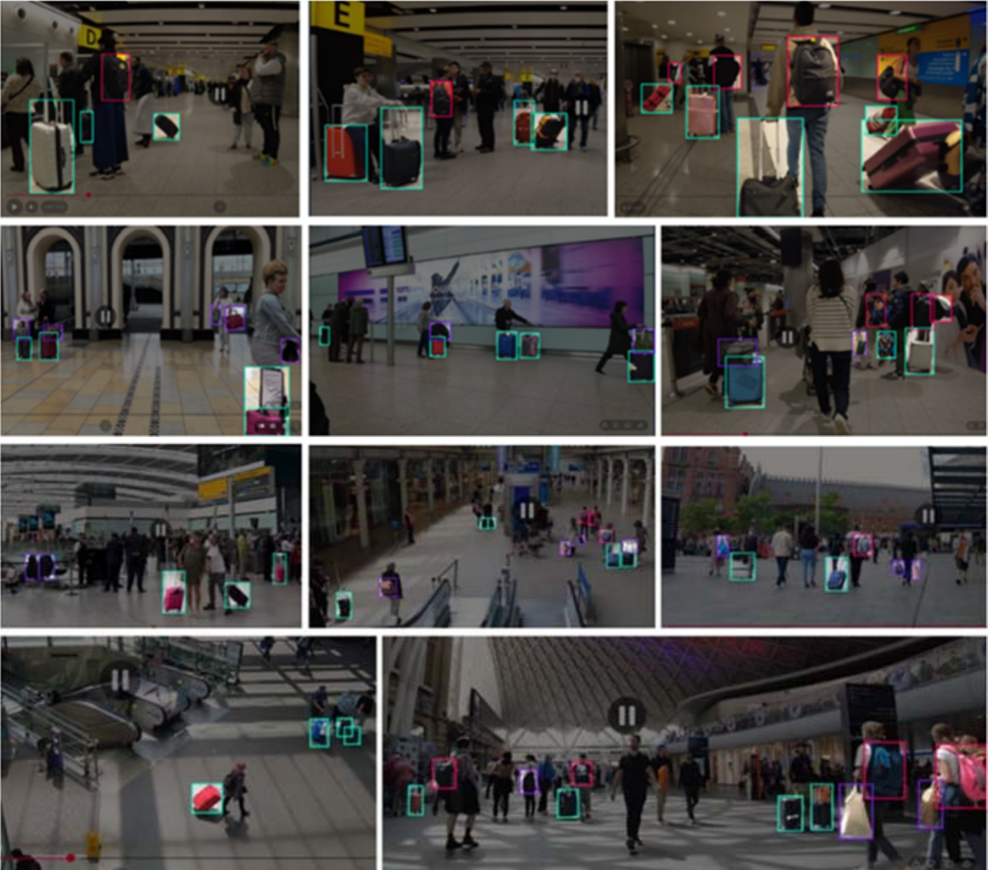
Table 2: Split composition. Instance share differs slightly from image share because scene density varies across splits.

Split | Images | % | Instances | % | Boxes/img
Train | 9,138 | 75.0 | 41,823 | 72.3 | 4.58
Valid | 1,827 | 15.0 | 9,819 | 17.0 | 5.37
Test | 1,219 | 10.0 | 6,172 | 10.7 | 5.06
Total | 12,184 | 100 | 57,814 | 100 | 4.75

Table 3: Object-size distribution, maximum bounding-box side, 32
/ 64 px edges. Counts are instances; percentages are row-wise, i.e. of that split or of that class. The per-class rows cover the training split and sum to the Train row; per-class totals are in Table 4.
 | Small (<32) |  | Medium (32–64) |  | Large (>64)
 | n | % | n | % | n | %
By split
Train | 14,959 | 35.8 | 16,398 | 39.2 | 10,466 | 25.0
Valid | 3,669 | 37.4 | 4,034 | 41.1 | 2,116 | 21.6
Test | 2,175 | 35.2 | 2,510 | 40.7 | 1,487 | 24.1
By class, training split
backpack | 3,699 | 32.6 | 4,600 | 40.6 | 3,039 | 26.8
bag | 3,499 | 37.8 | 3,267 | 35.3 | 2,502 | 27.0
trolley | 7,761 | 36.6 | 8,531 | 40.2 | 4,925 | 23.2

same partition: a 25 100 trolley has a maximum side of 100 px yet an area of only 2,500 px², so it is large by side and medium by area. With 70.6% of boxes taller than wide this is not a corner case, and we therefore state the basis on every table and never compare a count against an AP across the two.
×
Unlike the closest comparable public set, v6i is not de-void of large objects: 10,466 training instances (25.0%) exceed 64 px on their longest side. This matters because a benchmark with no large objects cannot measure whether a small-object mechanism achieves its gains by sacrificing large ones—a trade-off we observe repeatedly in Section V.

Boxes Are Tall, and the Classes Differ Sharply
Across all splits, 70.6% of boxes are taller than wide (h/w > 1.25), with a mean aspect ratio of 1.55 and only 6.0% wide boxes. The per-class breakdown in Table 4 shows that this aggregate conceals a large difference between classes.
trolley is visually canonical: 76.9% tall, mean ratio
1.68. bag, by contrast, holds 48.5% of every wide box in the dataset while representing only 22.2% of instances, and is the only class whose three shape bins are anywhere near balanced. Table 3 shows it is also the only class with a depleted size middle—simultaneously the highest large share (27.0%) and the lowest medium share (35.3%), against a trolley that is the most size-concentrated of the three. A class that is at once the widest, the most balanced in shape and the most bimodal in size is the one a single-scale prior
Figure 1: Representative annotated frames from Luggage-Dataset v6i. The images are drawn from fixed or quasi-static surveillance cameras in transport hubs and indoor public space, and illustrate the conditions the benchmark is built to capture: elevated, oblique viewpoints in which luggage occupies a small fraction of the frame; dense pedestrian traffic with frequent partial occlusion of the bag by its own owner; wide variation in illumination, from daylit concourses to artificially lit interiors and screen-lit walls; and all three classes co-occurring at very different apparent scales within a single frame. The annotations shown are the released ground truth. Note that these are the raw frames: unlike our earlier presentation of this corpus, no augmentation is applied anywhere in this paper, so every number reported in Section V is obtained on unmodified imagery.

fits worst, which is what Section D observes: bag is the hardest class at every size on both detectors.
This heterogeneity is not incidental. bag is the weakest class by a wide margin (AP_{50–95} 0.4666 against trolley’s 0.6185, a 15.2-point gap), and Section V shows that this gap is attributable neither to class frequency nor to assignment geometry nor to proposal failure. The category is semanti-cally loose—handbags, duffel bags, shopping bags, plastic bags—and the residual gap is consistent with that looseness rather than with any optimisation deficiency.

A Leakage-Free Split
The corpus is assembled from surveillance video, and that single fact governs how the split must be built. Consecutive frames of the same clip are near-identical: the camera is fixed, the scene changes over seconds rather than frames, and the same suitcase appears in hundreds of images that differ only by pedestrian motion. A split that assigns frames independently will therefore place the same physical scene

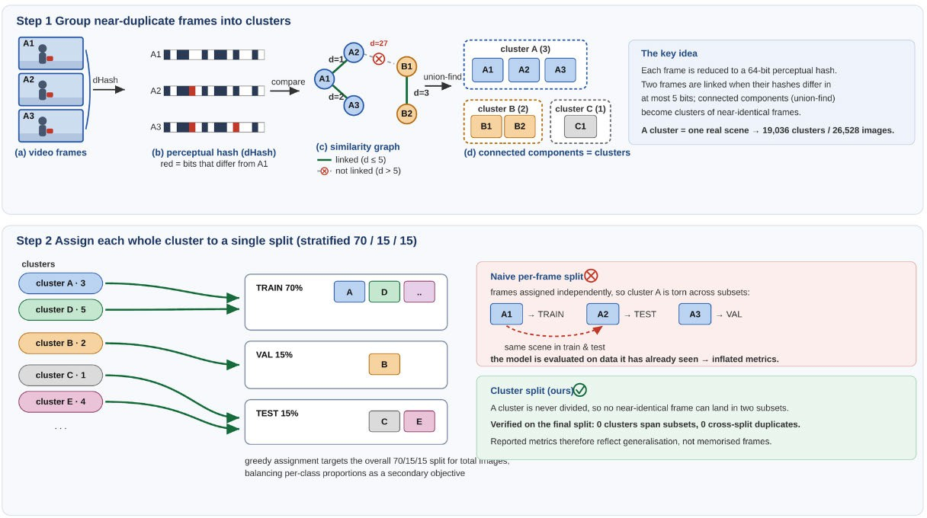
Figure 2: The leakage-free splitting procedure. Step 1: each frame is reduced to a 64-bit perceptual (difference) hash; any two frames whose hashes differ in at most five bits are linked, and connected components extracted by union-find group mutually near-identical frames into clusters, so that one cluster corresponds to one real scene. Step 2: each whole cluster, never an individual frame, is assigned to a single split by a stratified greedy procedure, so no near-duplicate frame can cross a split boundary by construction. The panels illustrate the method with the counts from the weapon-detection corpus in which it was first validated [21]; applied unchanged to LuggageDataset v6i at the same Hamming threshold of five, it produces the 75/15/10 partition of Table 2 and a cross-split audit of that partition returns zero clusters spanning subsets and zero near-duplicate pairs between any two subsets.

Table 4: Per-class shape structure (training split). Size structure is in Table 3; bag is the outlier on both.

Class | n | h/w | Wide | Square | Tall
backpack | 11,338 | 1.47 | 1.2% | 23.8% | 74.9%
bag | 9,268 | 1.33 | 13.2% | 36.0% | 50.8%
trolley | 21,217 | 1.68 | 5.5% | 17.6% | 76.9%
in both training and test, and the reported accuracy will partly measure memorisation. This failure is invisible in the usual sanity checks — class proportions, image counts and size distributions all look correct — which is what makes it dangerous.
We therefore group before we split, following the proce-dure validated in our earlier work on weapon detection [21] and applied here unchanged. Each image is reduced to a 64-bit difference hash. Any two images whose hashes lie within a Hamming distance of 5 are linked, and connected components extracted by union-find collapse mutually near-identical frames into clusters, so that one cluster corre-sponds to one real scene. The threshold of 5 follows com-mon practice for difference-hash near-duplicate detection: small enough to avoid merging visually distinct scenes, large enough to capture frames that differ only by compression noise and small motion. Whole clusters are then assigned to splits by a stratified greedy procedure that targets the 75/15/10 ratio on total image count and on each class si-multaneously. Because no cluster is ever divided, no near-duplicate frame can cross a split boundary by construction.
A cross-split audit of the final partition confirms the guar-antee holds in practice: zero clusters span more than one subset, and zero near-duplicate pairs occur between any
pair of subsets. The evaluation is therefore leakage-free, and the metrics in Section V reflect generalisation to unseen scenes rather than recall of frames the model has already been trained on. Figure 2 illustrates both steps and contrasts them with the naive alternative; the counts printed inside its panels are those of the weapon corpus in which the pro-cedure was first validated, and the v6i figures are given in Table 2.
This matters for interpreting the size of our gains. The improvements reported in this paper are 2–3% relative. Had the split been built per frame, the baseline itself would have scored higher — and every mechanism would have appeared to help less, because a memorising baseline leaves less head-room. A leakage-free split is what makes a +3.44% gain
meaningful rather than an artefact of how the data was parti-
tioned.

Annotation Quality
Automated label validation reports no out-of-range coordi-nates and no missing label files. Two caveats are recorded for completeness. Two training images carry labels that mix segmentation and detection rows and are rejected by the data loader. Three duplicate labels are removed at load time (two in training, one in validation), which is why the validation split yields 9,818 rather than 9,819 loaded instances.

A Documented Split Drift
Class proportions agree across splits to within 1.9 points and shape distributions to within 0.8 points. One drift is

Table 5: Validation-split drift. Any threshold or hyperparameter tuned on validation is tuned on a distribution with smaller objects than test.
Quantity | Train | Valid | Test | V vs T
Large share (>64 px) | 25.0% | 21.6% | 24.1% | −2.5 pt
Large count | 10,466 | 2,116 | 1,487 | —
Mean W × H (px) | 39×55 | 35×49 | 40×56 | −23% area
Boxes per image | 4.58 | 5.37 | 5.06 | +6%

material and we state it explicitly: the validation split under-represents large objects and contains systemat-ically smaller boxes than the test split (Table 5).
Validation boxes are approximately 23% smaller in area than test boxes. Two consequences follow. First, confidence thresholds tuned on validation are tuned on a slightly harder, smaller-object distribution; we verify in Section V that the tuned operating point transfers to test intact, but the drift bounds how far such tuning should be trusted. Second, any large-object claim derived from validation alone rests on 758 instances against a measured seed-to-seed spread of 2.11 points in the large bucket—we therefore report all large-object results on test only.

Comparison with Existing Benchmarks
Against CCTV-KD, the largest annotated in-domain alter-native [15], v6i provides approximately 21 the luggage annotations (57,814 vs 2,760) from roughly 40 the dis-tinct source images (12,184 vs 300 before augmentation), at three class labels rather than one. Two differences favour CCTV-KD and we note them plainly: it provides person annotations, which v6i does not, and its scenes are con-siderably denser (approximately 20 annotated objects per image against our 4.75). The absence of a person class means the ownership stage of our pipeline must source per-son detections from a separate model, with the domain-shift consequences discussed in Section IV.
~
×
×
Neither dataset contains abandonment events; both are detection benchmarks. v6i is therefore complementary to ABODA and IITP20 rather than a replacement: it is intended to train and evaluate the detector on which an event-level system is built.

Method

Overview and Design Principle
We modify two detectors — YOLOv12s [22] and YOLO26s, both in the Ultralytics implementation [23] — along two or-thogonal axes. The loss axis changes how ground truth is as-signed to anchors and how each assignment is weighted; the
result rather than an oversight. Superficially their objectives are the same: both use BCE classification, CIoU [30] box re-gression, a task-aligned assigner with α = 0.5 and β = 6, and
identical loss gains (box = 7.5, cls = 0.5, dfl = 1.5). Under-
neath they differ in three respects that Table 11 sets out and
Section A shows to be decisive: YOLOv12 regresses boxes as a 16-bin distribution and removes duplicates with NMS, whereas YOLO26 regresses offsets directly (reg_max = 1, with the third loss term becoming an image-normalised ℓ₁),
runs two assigners — one-to-many and one-to-one — under a schedule that shifts weight from the former to the latter across training, and emits a single prediction per object with-out NMS. As Section V shows, the mechanism that works on one does not work on the other, in either direction.

Small-Object–Aware Loss and Assignment
    - Curriculum Area Weighting (YOLOv12)
The problem. After assignment, the regression loss sums over positives with each weighted by its target score. Two things then work against small objects at once. First, a large box collects far more positives than a small one — 9.79 against 7.73 on this dataset, from a candidate pool 51 larger
×
— so it contributes more terms to the sum. Second, and more importantly, the IoU term of a large box is smoothly informative: a few pixels of error change its IoU very little, so its gradient is stable and well-scaled. For a 12 18 px bag the same few pixels can move IoU by tens of points. The optimiser sees a loud, noisy signal from small objects and a quiet, reliable one from large objects, and it does what any optimiser does — it fits the reliable signal first and treats the small objects as noise to be averaged out.
×
The intervention. We restore the balance by weighting each positive by the inverse linear scale of its box, and we do so on a schedule rather than permanently. Early in training, when the representation is still forming and the small objects would otherwise never get a foothold, the weighting is area-dominant; by the end it has decayed back to the standard score weighting, so the final epochs optimise the objective the model is actually evaluated on. This is the dynamic cur-riculum weighting introduced in our earlier work on weapon detection [21]. For each positive assignment j,
(t)
w = α(t) aˆ_{j} + 1 − α(t) s _{j}, (1)
j
where s _{j} is the summed target score of positive j and aˆ_{j} is a normalised, boosted inverse-scale term. Writing A_{j} for the assigned box area in feature units at the level to which the anchor belongs, i.e. after division by that level’s stride σ_{j},

architecture axis changes which feature levels exist and how much capacity each receives. Every modification obeys one
j · j
a j = A−j 1/2,
aˆ = aj b , (2) max_{k∈P} a_{k}

rule: at initialisation the modified network must repro-duce the pretrained baseline exactly. Architectural blocks are appended as residual branches with a zero-initialised gate, and loss modifications reduce to the stock objective at their default parameter values. This makes every comparison a controlled one—the pretrained weights transfer without loss, and any difference in the final metric is attributable to
with P the set of positives in the batch. The exponent ¹ makes the term scale with linear object size rather than with area; a pure inverse-area weighting (a _{j} = A⁻j 1) was also implemented and was inferior on this dataset. The factor b _{j}
is a threshold boost applied after normalisation,
2
—

the mechanism rather than to a different initialisation.
The two detectors receive different treatments, and this is a
b = ρ, Aj σj < psmall
1, otherwise,
j ( √
(3)



      - Per-frame pipeline

Video frame
Person detector — YOLO26-x
COCO, not fine-tuned
Luggage detector — YOLO26
fine-tuned, 3 classes
BoT-SORT ×2  separate ID spaces |  | Owner pairing  d¯ over first T_{o} |  | State machine dwell timer τ

Alarm

      - Worked example — one luggage track, r_{o} = 1.5h, r_{a} = 2.5h, T_{a} = 30 s radii in person heights h, so they scale with depth

t = 0 s — carried

d = 0 — no track yet
t = 3 s — dropped

d = 0.2h — owner window To
t = 8 s — owner walks

d = 1.9h — drifting
t = 14 s — beyond ra

d = 3.4h — τ running
t = 38 s — alarm

d = 5.1h — τ ≥ Ta

      - State and dwell timer τ on a true time axis the (b) snapshots are evenly spaced; here time is to scale
attended
unattended — τ accumulating
0 s
6 s 8 s
12 s 14 s
38 s
drifting occluded — τ holds alarm

Guard 1. The owner is the person minimising mean distance over the bag’s first T_{o} seconds — not the nearest person in any single frame.

Guard 2. τ advances only while the bag track is alive, so the occlusion at t = 12–14 s is not counted as a departure.

Figure 3: The unattended-luggage pipeline and a worked example. (a) Two detectors run in parallel on every frame and are tracked independently, so luggage and person identities never share an ID space. Only the luggage detector is fine-tuned on our data; the person detector is a COCO model, which is the weakest link in the chain (Section IV). (b) Top-down snapshots of a single track. The dotted inner circle is the ownership radius ro and the dashed outer circle the alarm radius ra, both expressed in person heights h so they scale with depth; the square is the bag and the disc its assigned owner. The bag changes colour as the state advances. (c) The same episode on a time axis. The owner crosses ro at 6 s and ra at 8 s, at which point the dwell timer τ starts; it holds through the occlusion at 12–14 s and reaches Ta at 38 s.

which multiplies the weight of any positive whose box is smaller than p_{small} pixels on a side. The mixing coeffi-cient follows a linear curriculum over the T training epochs, clipped to a fixed interval,

α(t) = clip(α_{s} (1 − t/T ) + α_{e} t/T, α_{min}, α_{max}) , (4)
so optimisation begins scale-dominant, favouring small ob-jects while the representation is still forming, and ends score-balanced. The weight w^{(t)} multiplies the CIoU and
j
DFL terms; the classification term is untouched. With
α_{s} = α_{e} = 0 the expression reduces exactly to the stock per-positive weight s _{j}, which is the identity property re-quired in Section A. A grid search on the validation split over α_{s} [0.6, 0.9], α_{e} [0.3, 0.4], p_{small} [36, 48] px and
∈ ∈ ∈
ρ [1.0, 2.5] selected α_{s} = 0.7, α_{e} = 0.3, p_{small} = 48 px and
∈
ρ = 2.0; the full intervals are in Table 6.

Task-Alignment Exponents (YOLO26)
The Task-Aligned Assigner [24] scores each (ground truth, anchor) pair by

m_{i} _{j} = s^{α} · u^{β} , (5)
i j
i j
where s_{i} _{j} is the predicted class score for the ground-truth class and u_{i} _{j} the IoU. Both detectors construct their assigners with α = 0.5 and β = 6; these are fixed constants in the reference implementation and are not exposed as tunable hyperparameters. We exposed both and swept them.
The metric enters the objective at three distinct points, and it is essential to separate them. First, selection: the k anchors with the largest m_{i} _{j} inside each ground-truth box become positives. Second, tie-break in the one-to-one branch, where k = 1. Third, target magnitude: the classification target of a
positive is not 1 but

Two design choices deserve comment. The exponent is
1
2 rather than 1 because pure inverse-area weighting is too aggressive on this data: with boxes spanning three orders
— −
tˆ_{i} _{j} =
mi j max j′∈Pi ui j′
max _{j}′∈Pi m_{i} _{j}′ + ε
, (6)

of magnitude in area, A⁻¹ makes the smallest instances dom-inate the batch entirely and destabilises training, whereas A^{−1/2} scales with linear size and keeps the ratio bounded. Both were implemented and the square root was better. The threshold boost of Equation (3) is then a blunt instrument lay-ered on top: the continuous term already up-weights small objects, but it does so smoothly, and 48 px is the point be-low which this dataset’s instances stop being resolvable at stride 8 at all. Doubling their weight is a statement that those specific instances matter operationally, not a claim that the continuous weighting was mis-shaped.
so a well-aligned anchor is asked for a higher confidence than a poorly aligned one. Equation (6) carries a consequence we use in Section VI: when a ground truth has exactly one positive — which is the case in YOLO26’s one-to-one branch
— the ratio is identically 1 and the target collapses to max u, so α and β provably cannot change the target magnitude on that branch. They can only change which anchor receives it. Our modification is a single exponent, β : 6 1, selected from nine values spanning [0, 6] (Table 6). The reason it should matter is a statement about how IoU behaves at dif-
→
ferent scales. Consider two anchors on a large object whose

IoUs are 0.80 and 0.70. Raised to the sixth power these be-come 0.262 and 0.118 — the assigner treats the first as more than twice as good, and it is right to, because on a large box a 0.10 IoU gap is a real and stable difference in localisation. Now consider the same gap on a 12 18 px bag. There, one pixel of displacement moves IoU by several points, so a
×
0.80 versus 0.70 split between two neighbouring anchors is mostly sampling noise — yet β = 6 still amplifies it into a factor of 2.2 in the alignment metric, and Equation (6) then propagates that amplified difference into the classification
target the model is asked to reproduce.
Setting β = 1 makes the metric linear in IoU. The ranking is preserved — better-localised anchors still win — but the
margins are compressed, so the assigner stops manufactur-ing confident distinctions between anchors that are in truth equally good. The prediction is therefore specific: reducing β should help most where IoU is noisiest, which is exactly the small-object regime, and should be roughly neutral else-where. Section V reports that the loss axis helps on small objects while costing mAP₅₀₋₉₅ ( 0.35% on YOLO26 and 0.37% on YOLOv12) — the metric that rewards precisely
—
—
the fine localisation distinctions a large β was amplifying.

Anchor Supply and Why the Effect Is Bounded
Both mechanisms above act on assignments that already exist. Whether they can act is a question about anchor supply. For a box of size w h at feature stride s, the number of anchor centres falling inside it is
×
get. Large objects draw 7.96 of their 9.79 positives (81%) from stride 16, not stride 32. The coarsest detection level is thus doing very little work on this dataset.

Architectural Modifications
Figure 4 shows the two resulting graphs. They share one change — a stride-4 detection level — and differ in every-thing built around it, which is what makes the comparison in Section G possible.
All blocks below are channel- and resolution-preserving, and each is applied as
y = x + γ ⊙ F (x), γ t=0 = 0, (8) with γ a learnable per-channel gate. At epoch 0 the block is the identity, so the pretrained detector is reproduced exactly and the transfer is lossless.

Content-Aware Upsampling
The top-down path is rebuilt with DySample [26] in place of nearest-neighbour interpolation. Rather than replicating each feature, it predicts per-location sampling offsets and gathers by bilinear interpolation,
y_{p} = x p/ρ +∆_{p} , ∆_{p} = ¹ σ S (x) ⊙ O(x)+ p₀, (9)
2
where ρ is the scale factor, O the offset convolution, S the dynamic-scope branch and p₀ the fixed initial sampling grid. The scope branch is zero-initialised, so σ (S (x)) = ¹ and the factor collapses to the static 0.25 of the original formulation;
2

n(s) = [⌊x2/s − 1/2⌋−⌈x1/s − 1/2⌉+ 1]+ · [⌊y2/s − 1/2⌋−⌈y1/thse−o1ff/s2et⌉c+on1v]+ol,ution is near-zero initialised, so upsampling

(7)
summed over the levels of the pyramid, where [ ]₊ denotes max( , 0) and indices are additionally clamped to the feature map, which we omit here as it affects only boxes touching
·
·
the image border. Measured over the training labels, a small luggage instance commands 12.90 anchor centres in total (9.82 at stride 8, 2.46 at 16, 0.62 at 32) against a selection budget of k = 10, while a large instance commands 657.67 —
a supply ratio of 51 . Standard assignment converts 7.73 of
×
the small object’s 12.90 candidates into positives, i.e. 60% of its entire pool.
The budget is therefore close to slack. Of small ground truths, 38–42% hold fewer than k centres at evaluation ge-ometry, and once mosaic augmentation halves the effective scale — which it does for 60 of the 70 training epochs — that figure rises to approximately 70%. For those instances every candidate is already a positive, the ranking cannot change the assignment, and the selection role of Equation (5) is inert; only its target-magnitude role acts. Adding a stride-4 level multiplies the finest level’s count by four and raises the small object’s pool to roughly 52 centres, which makes k binding again. This is the diagnostic that motivates the architectural axis, and Section V reports that its central prediction was refuted on one detector and only weakly supported on the other.
The same table motivates the level reallocation of Sec-tion C. At stride 32 a small object draws 0.01 positives per ground truth and a medium object 0.00, against pools of 0.62 and 2.71: the few candidates that exist carry an alignment metric near zero and fail the positivity test regardless of bud-
begins equivalent to bilinear. This matters most on the path feeding the finest level, where nearest-neighbour upsampling blurs precisely the detail small luggage depends on.

A Stride-4 Detection Level
Both detectors receive a P2 branch at stride 4: the finest ex-isting pyramid level is upsampled onto the stride-4 backbone feature and fused, adding a detection head at 160 160.
×
This is the one change that addresses the supply problem of Equation (7) directly rather than working around it. Every loss mechanism in Section B redistributes weight among assignments that already exist; none of them can create a positive where no anchor centre falls. A stride-4 level does exactly that, quadrupling the finest level’s contribution and taking a small object’s pool from 12.90 centres to roughly
52. It is also the only change that improves the resolution at which a small object is represented, rather than the emphasis it receives.
The cost is asymmetric and worth stating precisely, be-cause it shaped the experimental design. The branch adds only 0.09M parameters — trivial — but roughly 315 MB of activation memory at batch 48, since activation cost scales with spatial area and a stride-4 map is sixteen times larger than a stride-16 one. Anchors rise from 8,400 to 34,000. This is why architectural runs were executed at a reduced batch size and why a matched-batch control was measured rather than assumed (Section H), and the configurations we report were retrained under a single protocol per detector once the design was fixed.

      - YOLOv12s + ls_shift – the stride-4 branch is appended; stride 32 is kept ⇒ four detection heads

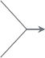
P5/32
DySample ×2
row 9
Backbone
rows 0–8
stock YOLOv12s
unchanged
cat bb P4
C3k2 [1024]
row 20 · P5 head
↓ 2, cat bb P5
A2C2f [512]
row 11
skip
↓ 2, cat r11
DySample ×2
row 12
cat bb P3
A2C2f [256]
row 14 · P3 head
DySample ×2
row 21
cat bb P
ZGGlobalContext2
row 24
w 23 · P2 head
A2C2f [256]
ro
2
ZGDSConv k=9 row 26
A2C2f [512]
row 17 · P4 head
ZGDSConv k=9 row 27
ZGDSConv k=9 row 25

Detect
row 28
strides 4, 8, 16, 32
4 levels
34 000 anchors
202

P4/16
402

P3/8
802

P2/4
1602

      - YOLO26s + p2dys—p234rich – stride 4 is inserted into the PAN; stride 32 is removed ⇒ three heads, −27.7% parameters

P5/32
C3k2 [256] ×4
row 2 4
22 · P3/8 · depth →
P5 detection branch
Conv + Concat + C3k2 [1024]
never reaches
Detect
Backbone
rows 0–10
stock YOLO26s
unchanged
P5 retained: feeds top-down
↑ 2, cat bb P4
DELETED · −2.69M
×
skip
↑ 2, cat bb P3
C3k2 [512]
row 25 · P4/16
↓ 2, cat r13
skip
↓ 2, cat r16
DySample ×2
row 17
cat bb P2
row 19 · P2/4 · depth 2 → 4
C3k2 [128] ×4
C3k2 [256]
row 16 · P3 top-down
C3k2 [512]
row 13 · P4 top-down

Detect
row 26
strides 4, 8, 16
3 levels
33 600 anchors
202

P4/16
402

P3/8
802

P2/4
1602

Legend
stock block, unchanged

stock operator replaced

Anchor budget and cost at 640 × 640
level map anchors

new branch
removed
capacity reallocated
detection head
P2/4 1602 25600
2
+0.09M params but

≈ 315 MB activations

P3/8 80 6400
P4/16 402 1600 81% of a large object’s positives land here
P5/32 202 400 4.8% of the stock budget; 0.01 positives per small GT
Adding P2 multiplies the anchor count by four (8400 → 34000) for almost no parameters, which is why the architectural runs needed a smaller batch than the baseline and why a matched-batch control is reported. Removing P5 recovers only 400 anchors, so it is a parameter saving (−27.7%), not a memory one.

Figure 4: The two architectural modifications. The vertical axis is the pyramid level and the horizontal axis is depth through the network; solid arrows are the main data path, dashed arrows are lateral skips, and Conv-downsample and Concat rows are folded into the edge labels so that only tensor-producing blocks are drawn. (a) On YOLOv12s the stride-4 branch is appended: the existing top-down/bottom-up path (rows 9–20) is left intact, a P2 head is built from row 14 by content-aware upsampling, and each of the four levels then receives one gated refinement block — global context where the small objects are, a directional snake kernel where the medium and large ones are.
(b) On YOLO26s the stride-4 branch is inserted into the PAN and the bottom-up path is rebuilt through it (row 19 22 25), the two finest levels are deepened from two blocks to four, and the stride-32 detection branch is deleted while the stride-32 backbone is retained to feed the top-down path. Every coloured block is gated as in Eq. (8), so at initialisation both networks reproduce their pretrained baseline exactly. (c) The anchor budget makes the asymmetry of the shared change explicit: the stride-4 level supplies 75% of all anchors for 0.09M parameters but roughly 315 MB of activations, whereas stride 32 holds only 4.8% of the stock budget — so adding P2 is a memory cost and removing P5 is a parameter saving, and the two do not offset.
→ →

Level-Specific Refinement (YOLOv12)
On YOLOv12 the P2 branch is appended: rows 9–20 of the stock graph are left untouched and the new head is built from row 14 (Fig. 4a). This choice is deliberate. It keeps the pretrained neck weights aligned by name, so the transfer
produces and which averaging removes. At strides 8, 16 and 32 we attach ZGDSConv, a zero-gated dynamic snake convolution [27]: two one-dimensional deformable branches, one snaking along each axis, whose taps accumulate offsets outward from the centre,

is exact and the only randomly initialised parameters are m m
ι=0
ι=1

the new branch, and it means the four-level model is the
three-level model plus something, which makes the ablation
interpretable.
Each detection level then receives one gated block, matched to what that level actually sees. At the stride-4 level we attach ZGGlobalContext2, which forms a global descriptor from both average and maximum pooling and broadcasts it back additively, in the spirit of global-context modelling [28]:
F (x) = MLP([ x ; max_{H,W} x ]) , (10)
with x the spatial mean. The average branch supplies scene context; the maximum branch preserves the single most salient activation, which is the cue a small, rare instance
δ_{c+m} =∑tanh o_{c+ι} , δ_{c−m} = −∑tanh o_{c−ι} , (11)

for m = 0, . . . , ^{k−}2 1 , where c is the centre tap and o_{ι} the pre-dicted offset of tap ι. The accumulation runs outward from
the centre in both directions, with the sign reversed on the trailing side, so the taps form a connected path rather than independent displacements; tap i is then sampled at grid position (i c) + δ_{i} cells from the centre. The offset con-volutions are zero-initialised, placing all taps on the regular
—
grid at epoch 0.
The split is the point. Global context is attached where the small objects are, because a small object occupies too few pixels to be identified from its own appearance — a 12-pixel dark blob is a bag, a shadow or a bin depending

on what surrounds it, and the max-pool branch preserves the single salient activation that averaging would erase. The directional kernel is attached where the medium and large objects are, because that is where shape is legible and worth tracing: LuggageDataset v6i boxes are 70.6% tall and only 6.0% wide (Section III), so a trolley is a strongly oriented structure that a square receptive field samples inefficiently. Applying either block at every level was also tested and was worse than the split.

Level Reallocation (YOLO26)
On YOLO26 we test the complementary hypothesis sug-gested by the positives cross-tab in Section B: that the coars-est level is vestigial on this data and its capacity is better
inherited from defaults. This last point is not pedantic: the shipped defaults in our fork are not neutral, and an implicitly configured run silently carries area weighting.

Noise Floor
Because the effects under study are small, we estimate run-to-run variability directly. Pooling thirteen groups of runs that differ only by random seed gives a standard deviation of 0.428 points of mAP^{small} during the exploratory phase
50
(df = 12). For the configurations reported in Section V we measure it directly instead, from three seeds per cell. The relevant standard error depends on what is compared:
SE = σ q 2 (n-seed mean vs. n-seed mean), SE = σ q1 + ¹ (run vs.

spent elsewhere. We therefore remove the stride-32 detection n
branch while retaining the stride-32 backbone, and detect

n
(12)

from 4, 8, 16 only.
{ }
The distinction between deleting the detection branch and deleting the level is essential, and Fig. 4b draws it explicitly. Rows 7–10 of the backbone stay: stride-32 features are still computed and still injected at the top of the top-down path, so every finer level keeps receiving the scene-wide context that a 32 downsampled representation provides. What is removed is only the branch that turns those features into predictions, together with the bottom-up rows that fed it. The claim under test is therefore not “stride-32 features are useless” but the much narrower “stride-32 anchors are not earning their keep” — which is what the positives cross-tab asserts and what a budget-based fix cannot address, since the candidates that exist there carry an alignment metric of approximately zero.
×
Deletion frees 27.7% of the parameters (9.68M 6.99M), and the freed capacity is returned to the two finest levels by raising their block repeats from 2 to 4. This is a reallocation rather than a reduction: the model becomes smaller overall while becoming deeper at strides 4 and 8, where 75.0% of this dataset’s instances live (Table 3). A repeat count of 6 was also evaluated and was inferior on every metric, so the depth axis is reported with a bracketed optimum rather than as a monotone trend.
→
One further contrast with the YOLOv12 variant matters for Section G. Here the P2 branch is inserted into the PAN rather than appended: the bottom-up path is rebuilt to run
19 22 25, so stride-4 features propagate upward and inform the coarser predictions instead of only being read out at the head. The two detectors consequently differ in three independent respects — appended versus inserted P2, retained versus removed stride 32, and refinement blocks versus depth — and the transfer experiment asks which, if any, of those choices survive a change of detector.
→ →

Experimental Protocol
    - Verification
Every run asserts its own configuration at training time. The mechanism is read back from the live loss object rather than from the configuration file, the fraction of parameters transferred from the pretrained checkpoint is measured and the run aborts below a threshold, and all mechanisms not under test are passed explicitly in their off state rather than
We report a difference as an effect at ≥ 3 SE, as suggestive at
≥ 2 SE, and as null below that. A null is reported as a result.

Selection Bias
Repeating a configuration that was selected for being the maximum of a round gave a mean regression of 0.55 points across seven such repeats, with no repeat exceeding its orig-inal draw. Single-draw maxima are therefore not tabulated as headline results, and every configuration we report as a finding carries n ≥ 2.
—

Results
All models were trained for 70 epochs at 640 640 from the official pretrained checkpoints, with mosaic disabled for the final 10 epochs. Evaluation uses the full test split (1,219 images, 6,172 instances) with the size thresholds defined in Section III. Experiments ran on an NVIDIA RTX 4090 (24 GB), Intel Core i9-13900KF, 64 GB DDR5, CUDA 12.1,
×
Python 3.10, PyTorch 2.1.

Hyperparameter Search
Every parameter introduced in Section IV was swept before being fixed. Table 6 gives the intervals, the number of dis-tinct values evaluated and the selected setting. Selection was made on mAP^{small} on the validation split; the test split was not consulted during the search.
50
Three outcomes of the search are themselves results. First, the β surface is flat over [0, 3]: nine values were trained and the spread across them is smaller than the noise floor, so the +1.70% reported for β = 1 should be read as “any value well below the stock 6” rather than as a tuned optimum. Setting β = 0 — removing IoU from the alignment metric entirely — cost nothing measurable, which is the observation
that motivates the supply analysis of Section B. Second, the two elaborations of β we implemented (splitting it into separate selection and target exponents, and making it size-conditional) were both nulls and are not adopted. Third, the depth axis has a bracketed optimum: 6 repeats is below 4 on every metric, so 4 is a measured peak rather than the end of a monotone trend.

Table 6: Search intervals for every introduced parameter. n is the number of distinct values trained, not the number of runs — several values were repeated across seeds and across graphs.
Parameter | Interval | n | Selected
Loss — curriculum weighting (YOLOv12)
αs (start) | [0.6, 0.9] | 4 | 0.7
αe (end) | [0.3, 0.4] | 2 | 0.3
area exponent | {A−1, A−1/2} | 2 | A−1/2
psmall (px) | [36, 48] | 3 | 48
ρ (boost) | [1.0, 2.5] | 4 | 2.0
Loss — task alignment (YOLO26)
β | [0, 6] | 9 | 1.0
α | [0.25, 1.0] | 4 | 0.5 (stock)
β split (sel / tgt) | [1, 6] | 5 | not adopted
βsmall | [1.5, 3.0] | 3 | not adopted
k (topk) | {7, 10} | 2 | stock
Architecture
P2 block repeats | {2, 4, 6} | 3 | 4
P3 block repeats | {2, 4, 6} | 3 | 4
snake kernel k | {5, 9} | 2 | 9
detection levels | {3, 4} | 2 | per detector

The noise floor, measured on both detectors
With four configurations at three seeds each, the pooled within-configuration standard deviation is available directly for each model (df = 8):

Table 7: The two axes on both detectors. Every cell is the mean of three seeds, one standard deviation. ∆ is the percentage change of A+L over that detector’s baseline.
±

Metric | Base | Loss | Arch | A+L | ∆
YOLO26s
mAPsmall  50 | 77.26 ±0.23 | 78.61 ±0.46 | 79.83 ±0.16 | 79.91 ±0.42 | +3.44
mAP50 | 80.25 ±0.29 | 81.45 ±0.30 | 82.37 ±0.21 | 83.01 ±0.39 | +3.45
mAP50-95 | 54.90 ±0.18 | 54.71 ±0.19 | 56.61 ±0.23 | 56.43 ±0.18 | +2.79
Precision | 81.28 ±0.32 | 82.21 ±0.11 | 83.26 ±0.25 | 84.00 ±0.31 | +3.35
Recall | 72.79 ±0.19 | 74.01 ±0.11 | 75.98 ±0.31 | 75.89 ±0.31 | +4.25
F1 | 76.80 ±0.25 | 77.89 ±0.11 | 79.46 ±0.28 | 79.74 ±0.24 | +3.82
ARsmall  50-95 | 71.20 ±0.23 | 70.16 ±0.27 | 70.30 ±0.19 | 69.75 ±0.16 | −2.03
YOLOv12s
mAPsmall  50 | 77.65 ±0.15 | 77.93 ±0.26 | 78.79 ±0.27 | 79.87 ±0.29 | +2.85
mAP50 | 80.72 ±0.20 | 81.21 ±0.12 | 82.12 ±0.25 | 82.60 ±0.21 | +2.32
mAP50-95 | 54.75 ±0.15 | 54.55 ±0.05 | 56.42 ±0.07 | 56.09 ±0.21 | +2.44
Precision | 80.60 ±0.30 | 81.96 ±0.41 | 83.12 ±0.17 | 83.00 ±0.29 | +2.97
Recall | 72.23 ±0.42 | 73.78 ±0.19 | 74.11 ±0.37 | 74.94 ±0.39 | +3.76
F1 | 76.18 ±0.27 | 77.66 ±0.08 | 78.36 ±0.28 | 78.76 ±0.35 | +3.39
ARsmall  50-95 | 67.04 ±0.31 | 65.62 ±0.11 | 68.70 ±0.14 | 67.99 ±0.18 | +1.42

The Two Axes, Isolated and Combined

All models were trained for 70 epochs at 640 640 from the official pretrained checkpoints, with mosaic disabled for the final 10 epochs. Evaluation uses the full test split (1,219 images, 6,172 instances) with the size thresholds of Section III. Experiments ran on an NVIDIA RTX 4090 (24 GB), Intel Core i9-13900KF, 64 GB DDR5, CUDA 12.1,
×
Python 3.10, PyTorch 2.1. Every configuration reported in this section was trained three times with different random seeds; all values are means over those three runs.
Table 7 gives the 2 2 design for both detectors. The combined configuration is the best on the primary metric
×
50

A comparison between two three-seed means therefore car-ries SE = σ 2/3, i.e. 0.28 points on YOLO26 and 0.20 on YOLOv12 for the primary metric. We treat a difference as resolved at 2 SE: 0.56 and 0.40 points respectively. Two observations follow. First, the headline gains are large multi-ples of this: +2.66 points on YOLO26 is 9.5 SE and +2.21 on YOLOv12 is 11.0 SE. Second, mAP^{large} is the noisiest metric on both detectors, so single-run large-object claims anywhere in the literature — and in our own earlier analysis
√
50
 | mAPsmall | mAP | mAP50-95 | mAPlarge
YOLO26s | 50  0.342 | 0.306 | 0.195 | 50  0.358
YOLOv12s | 0.248 | 0.203 | 0.133 | 0.288

— should be treated with suspicion.

Should the two axes be combined?
Adding the loss axis on top of the architecture is the question that decides what we recommend. With seeds, the answer differs by detector and by metric:

A → A+L | YOLO26 (2 SE = 0.56) |  | YOLOv12 (2 SE = 0.40)
A → A+L | ∆ |  | ∆
mAPsmall  50 | +0.09 |  | +1.07 | ✓
mAP50 | +0.65 | ✓ | +0.48 | ✓
mAP50-95 | −0.18 |  | −0.33
Precision | +0.74 | ✓ | −0.12
Recall | −0.10 |  | +0.83 | ✓
F1 | +0.28 |  | +0.41 | ✓
mAPlarge  50 | −2.43 | ✓ | −1.89 | ✓
(✓ marks a difference beyond 2 SE.) On YOLOv12 the com-bination is a clear improvement on the small-object metrics
— +1.07 points of mAP^{small} is 5.3 SE — and we recommend it. On YOLO26 the combination buys mAP₅₀ and precision but is indistinguishable from the architecture alone on the
50
primary metric (+0.09, 0.3 SE), so either configuration is defensible and we report the combination for symmetry.
Both detectors pay for the combination in large objects, and on both the loss is resolved: 2.43 and 1.89 points of mAP^{large}, against a large-object standard error of 0.29 and
− −
50
0.24. This is the clearest statement the study supports about what these mechanisms actually do.

The axes are redundant, and the redundancy differs by detector
Writing the effect of each axis alone as ∆_{A} and ∆_{L} and the combined effect as ∆_{AL}, the interaction is ι = ∆_{AL} (∆_{A} +
—
∆_{L}), with SE(ι) = 2 SE:

for both: 79.91 ± 0.42 small-object mAP₅₀ on YOLO26
mAPsmall  50 | ∆L | ∆A | sum | observed | ι
YOLO26s | +1.35 | +2.57 | +3.92 | +2.66 | −1.26
YOLOv12s | +0.28 | +1.14 | +1.42 | +2.21 | +0.80

against a baseline of 77.26 0.23 (+3.44%), and 79.87
± ±
0.29 against 77.65 0.15 on YOLOv12 (+2.85%). F1 rises
±
3.82% and 3.39% respectively.

The interaction has opposite sign on the two detectors. YOLO26 is sub-additive at −1.26 points (2.3 SE, resolved):

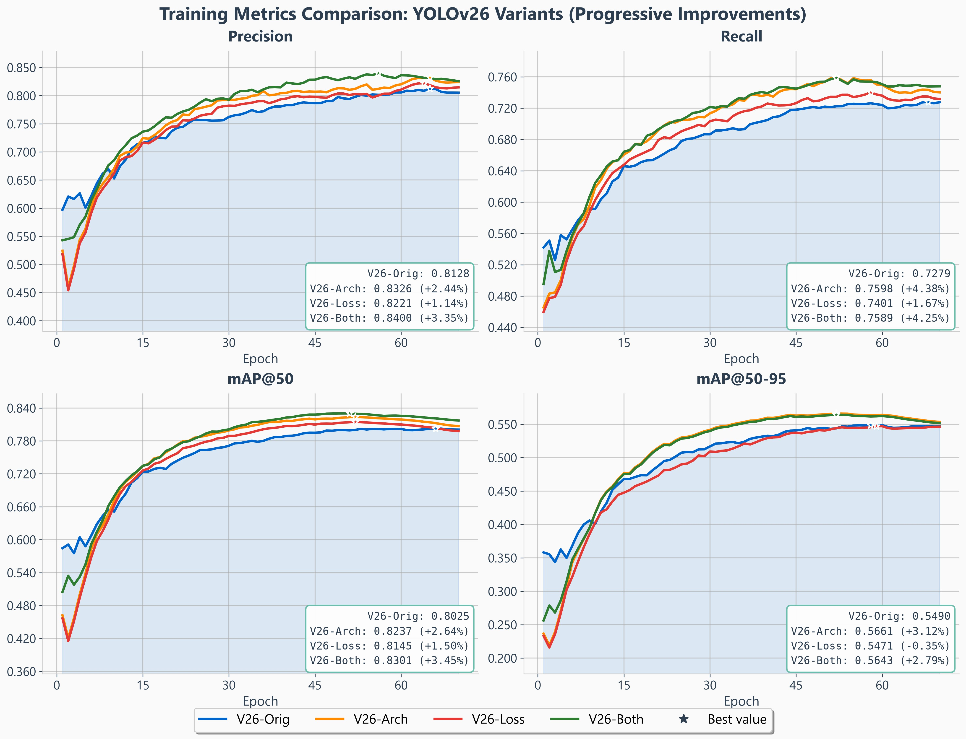
Figure 5: YOLO26s training dynamics, all four configurations of Table 7. Curves are per-epoch validation metrics; the annotated end values are the corresponding test means over three seeds, so they match Table 7 rather than the curve maxima. The ordering is established within the first fifteen epochs and never crosses, so the ranking is not an artefact of where training stopped. Note the mAP50-95 panel: the loss axis alone (red) tracks the baseline and ends slightly below it, which is the −0.35% of Table 7 seen as a trajectory.

the combination delivers 68% of the sum of its parts. YOLOv12 is super-additive at +0.80 (2.0 SE, borderline): 156% of the sum, driven by a loss axis that is nearly inert on its own (+0.28) but worth +1.07 once the stride-4 level exists. That is the anchor-supply argument of Section B in
its clearest form — on YOLOv12 the loss mechanism has almost nothing to redistribute until the architecture gives it more assignments to work with.

What the loss curves show
Figures 6 and 8 give the three loss components for each detector, baseline against the recommended configuration, on the training and validation splits. They carry no metric panels: mAP, precision and recall are already in Figs. 5 and 7, where all four configurations appear together rather than only two, so the loss figures are left to show the objective alone. Every term falls on both models, and by a wide mar-gin on YOLO26 — box 51.0%, classification 42.4%, ℓ₁ 57.0% on the training split. Two details are worth drawing out because they bear on the argument rather than on the
—
− −
headline.
The third loss term is a different objective on each detec-tor, and the figures say so on their axis labels. YOLO26’s panel reads ℓ₁ loss; YOLOv12’s reads DFL loss. This is the
reg_max difference of Table 11 made visible, and it is the mechanism Section A invokes to explain why curriculum area weighting — which leans on a distributional, anchor-relative term — does not survive the move to a scale-absolute ℓ₁ surrogate.
The two detectors overfit in different terms, and on differ-ent timescales. On YOLO26 the two regression terms fall for essentially the whole schedule: validation box reaches its minimum at epoch 57 and ℓ₁ at epoch 60, both then flat, so the box head is still being paid to keep learning when train-ing stops. Only the classification term turns, mildly, after roughly epoch 48 — and it turns in the baseline as well, so it is a property of the schedule rather than of our modifications. On YOLOv12 the pattern is inverted and far sharper: vali-dation box and DFL bottom out near epoch 18, at 0.676 and 0.717, and climb for the remaining fifty epochs while mAP₅₀ keeps improving to roughly epoch 60. The regression head overfits long before the detector stops gaining. Final-epoch loss is therefore a poor stopping criterion on YOLOv12 in particular, and the checkpoint rule used throughout — best validation mAP, never lowest loss — is what keeps the two detectors comparable despite the difference.

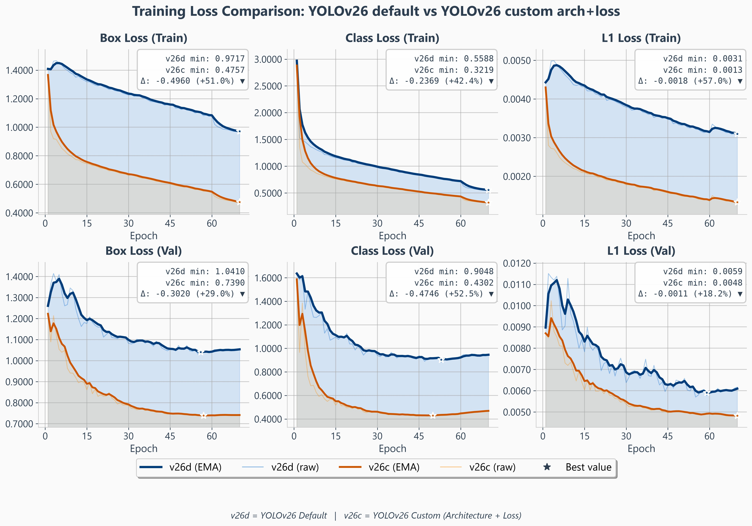
Figure 6: YOLO26s loss components, baseline (v26d) versus the recommended architecture+loss configuration (v26c); train on the top row, validation on the bottom, EMA-smoothed in bold with the raw per-epoch traces behind and the best value starred. Detection quality is not repeated here — the validation mAP, precision and recall curves are in Fig. 5, where all four configurations can be compared at once.
All three terms fall substantially: box 51.0%, classification 42.4% and ℓ₁ 57.0% on train, and 29.0%, 52.5% and 18.2% on validation, so the improvement is visible in the objective itself and not only in the evaluated metrics. Both regression terms reach their validation minimum late (box at epoch 57, ℓ₁ at 60) and stay flat to the end of the schedule. The third panel is labelled ℓ₁ loss rather than DFL: YOLO26 sets reg_max = 1 and substitutes an image-normalised ℓ₁ term (Table 11), which is directly visible here and is the structural difference Section A uses to explain why curriculum area weighting does not transfer to this detector.
− − − − − −

Where the Gains Land, by Object Size

Table 8 resolves each axis by object size, which is where the two detectors stop resembling each other. Three patterns are worth naming.
The gains are concentrated on small objects and are paid for elsewhere. On both detectors the combined configu-ration improves small-object mAP₅₀ (YOLO26 +3.44%,
YOLOv12 +2.85%) and small-object F1 (+3.78% and
+4.54%), while medium objects are flat to negative and mAP₅₀₋₉₅ falls at every size except small. Since small and
medium together account for 75.0% of instances (Table 3), that is the right trade to make — but the headline number is not a uniform improvement and should not be reported as one.
The two detectors buy the same small-object gain with opposite currencies. On YOLO26 the improvement comes from precision (+5.07%) with recall moving less (+2.91%);
on YOLOv12 precision and recall rise together (+4.24%
and +4.82%). Both detectors reach a similar small-object F1 gain (+3.78% and +4.54%), but YOLO26 gets there by becoming more selective and YOLOv12 by finding more
— the per-size trace of the one-to-one versus NMS-based assignment difference discussed in Section A.
The large-object cost belongs to the combination, not to the architecture. Taken alone, the architecture axis leaves
large-object mAP₅₀₋₉₅ intact on YOLO26 (+0.51%) and improves it markedly on YOLOv12 (+5.03%), so deleting the stride-32 detection branch does not by itself degrade large
objects — the retained stride-32 backbone still supplies the context they need. What costs large objects is adding the loss axis on top: from the architecture cell to the combination, YOLO26 gives up 2.43 points of large-object mAP₅₀ and YOLOv12 1.89, both beyond 2 SE. The mechanism that sharpens small-object detection is the one that blunts large-object localisation, on both detectors.

Why these are fixed configurations rather than per-cell maxima
Each column of Table 8 is a single configuration evaluated at all three sizes. It is not the best run per cell, and for most cells it is not the campaign maximum: on large-object mAP₅₀, for instance, some run in the YOLO26 campaign reaches 85.55 against our configuration’s 80.35. We report the fixed configuration deliberately, for two reasons.
First, a per-cell maximum describes a model that does not exist. One cannot deploy the configuration that happens

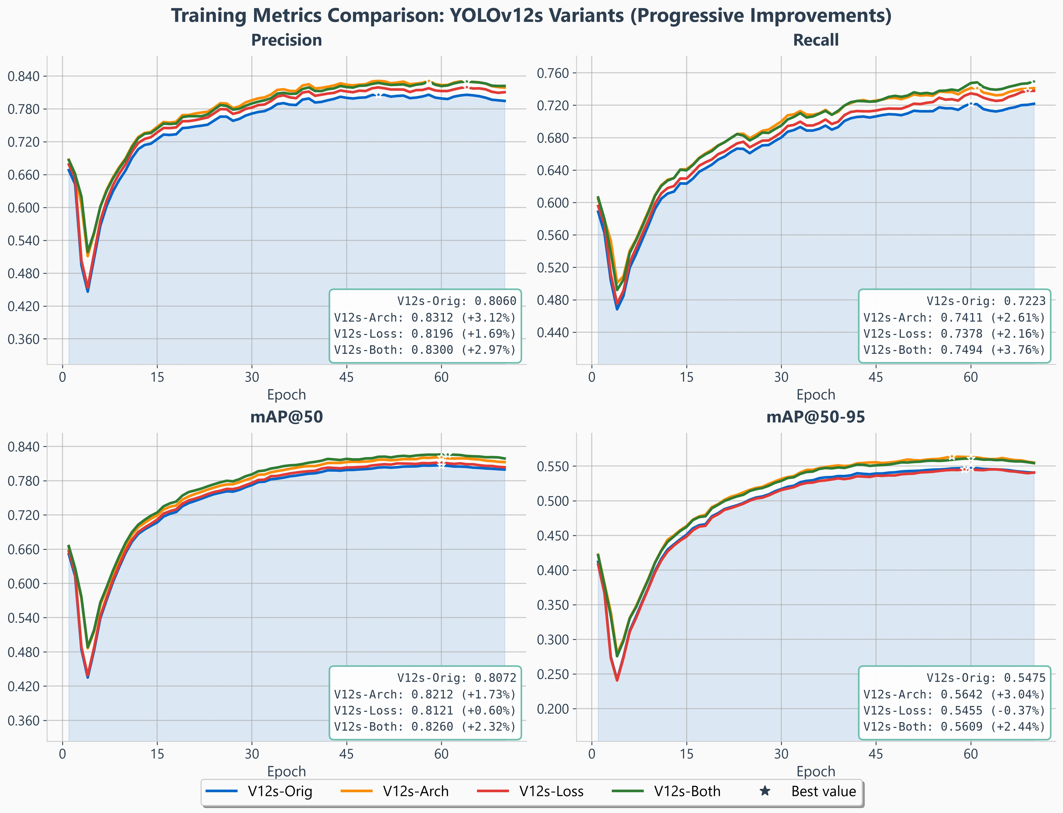
Figure 7: YOLOv12s training dynamics, same convention as Fig. 5. The mAP50-95 panel shows the same signature as YOLO26 — the loss axis alone ends 0.37% below the baseline while every configuration containing the architecture ends above it — which is the one part of the loss mechanism’s behaviour that is common to both detectors.
—

to lead on large objects together with the one that leads on small objects; a table assembled that way would report an unattainable system.
Second, and more importantly, those maxima are largely noise. Selecting the maximum of N draws from a distribution with standard deviation σ yields, from sampling alone, an expected excess of approximately σ 2 ln N above the mean. With N = 174 YOLO26 runs and the measured σ = 2.258
√
on mAP^{large} — the noisiest metric in the study — that is 7.25
50
points. The 5.20-point gap between our configuration and the campaign maximum is therefore smaller than what pure noise would be expected to produce, and the corresponding maximum is a single unrepeated draw. The same calculation
on mAP^{small}, where σ = 0.428, gives an expected noise maximum of 1.37 points against an observed gap of 0.32. Reporting per-cell maxima would amount to tabulating the
50
selection bias we measured in Section D.

Per-Class Behaviour
Table 9 resolves the same comparison by class as well as size. The dominant pattern is that bag is the hard class at every size and on both detectors, and by a wide margin: at AP₅₀ its small-object score is 68.4 on YOLO26 and 66.8 on YOLOv12, against 85.7 and 86.5 for trolley — a gap of roughly 18 points that neither axis closes. The ordering
trolley > backpack > bag holds in all eighteen class size cells.
This is consistent with the assignment diagnostics, which found per-class behaviour essentially uniform at strides 8 and 16: the bag deficit is not a matter of candidate supply, and it is therefore not something a stride-4 level or an assignment exponent can repair. It is a classification problem — bags are visually heterogeneous and the class is the one most often confused with background in the baseline confusion matrix. Both recommended configurations do improve it
×
slightly at AP₅₀ (+0.98 and +1.76 on small objects), but neither changes its rank.
The per-class view also localises the large-object cost reported in Section C. On YOLO26 the AP₅₀₋₉₅ loss at large sizes is concentrated almost entirely in one class — bag,
68.36 60.84 — while backpack loses 2.09 and trolley
→
1.37. The stride-32 deletion does not degrade large objects uniformly; it degrades the class whose large instances are least distinctive.

What Each Axis Actually Buys

The two axes do not improve the same things, and with three seeds the split is clean and identical on both detectors:

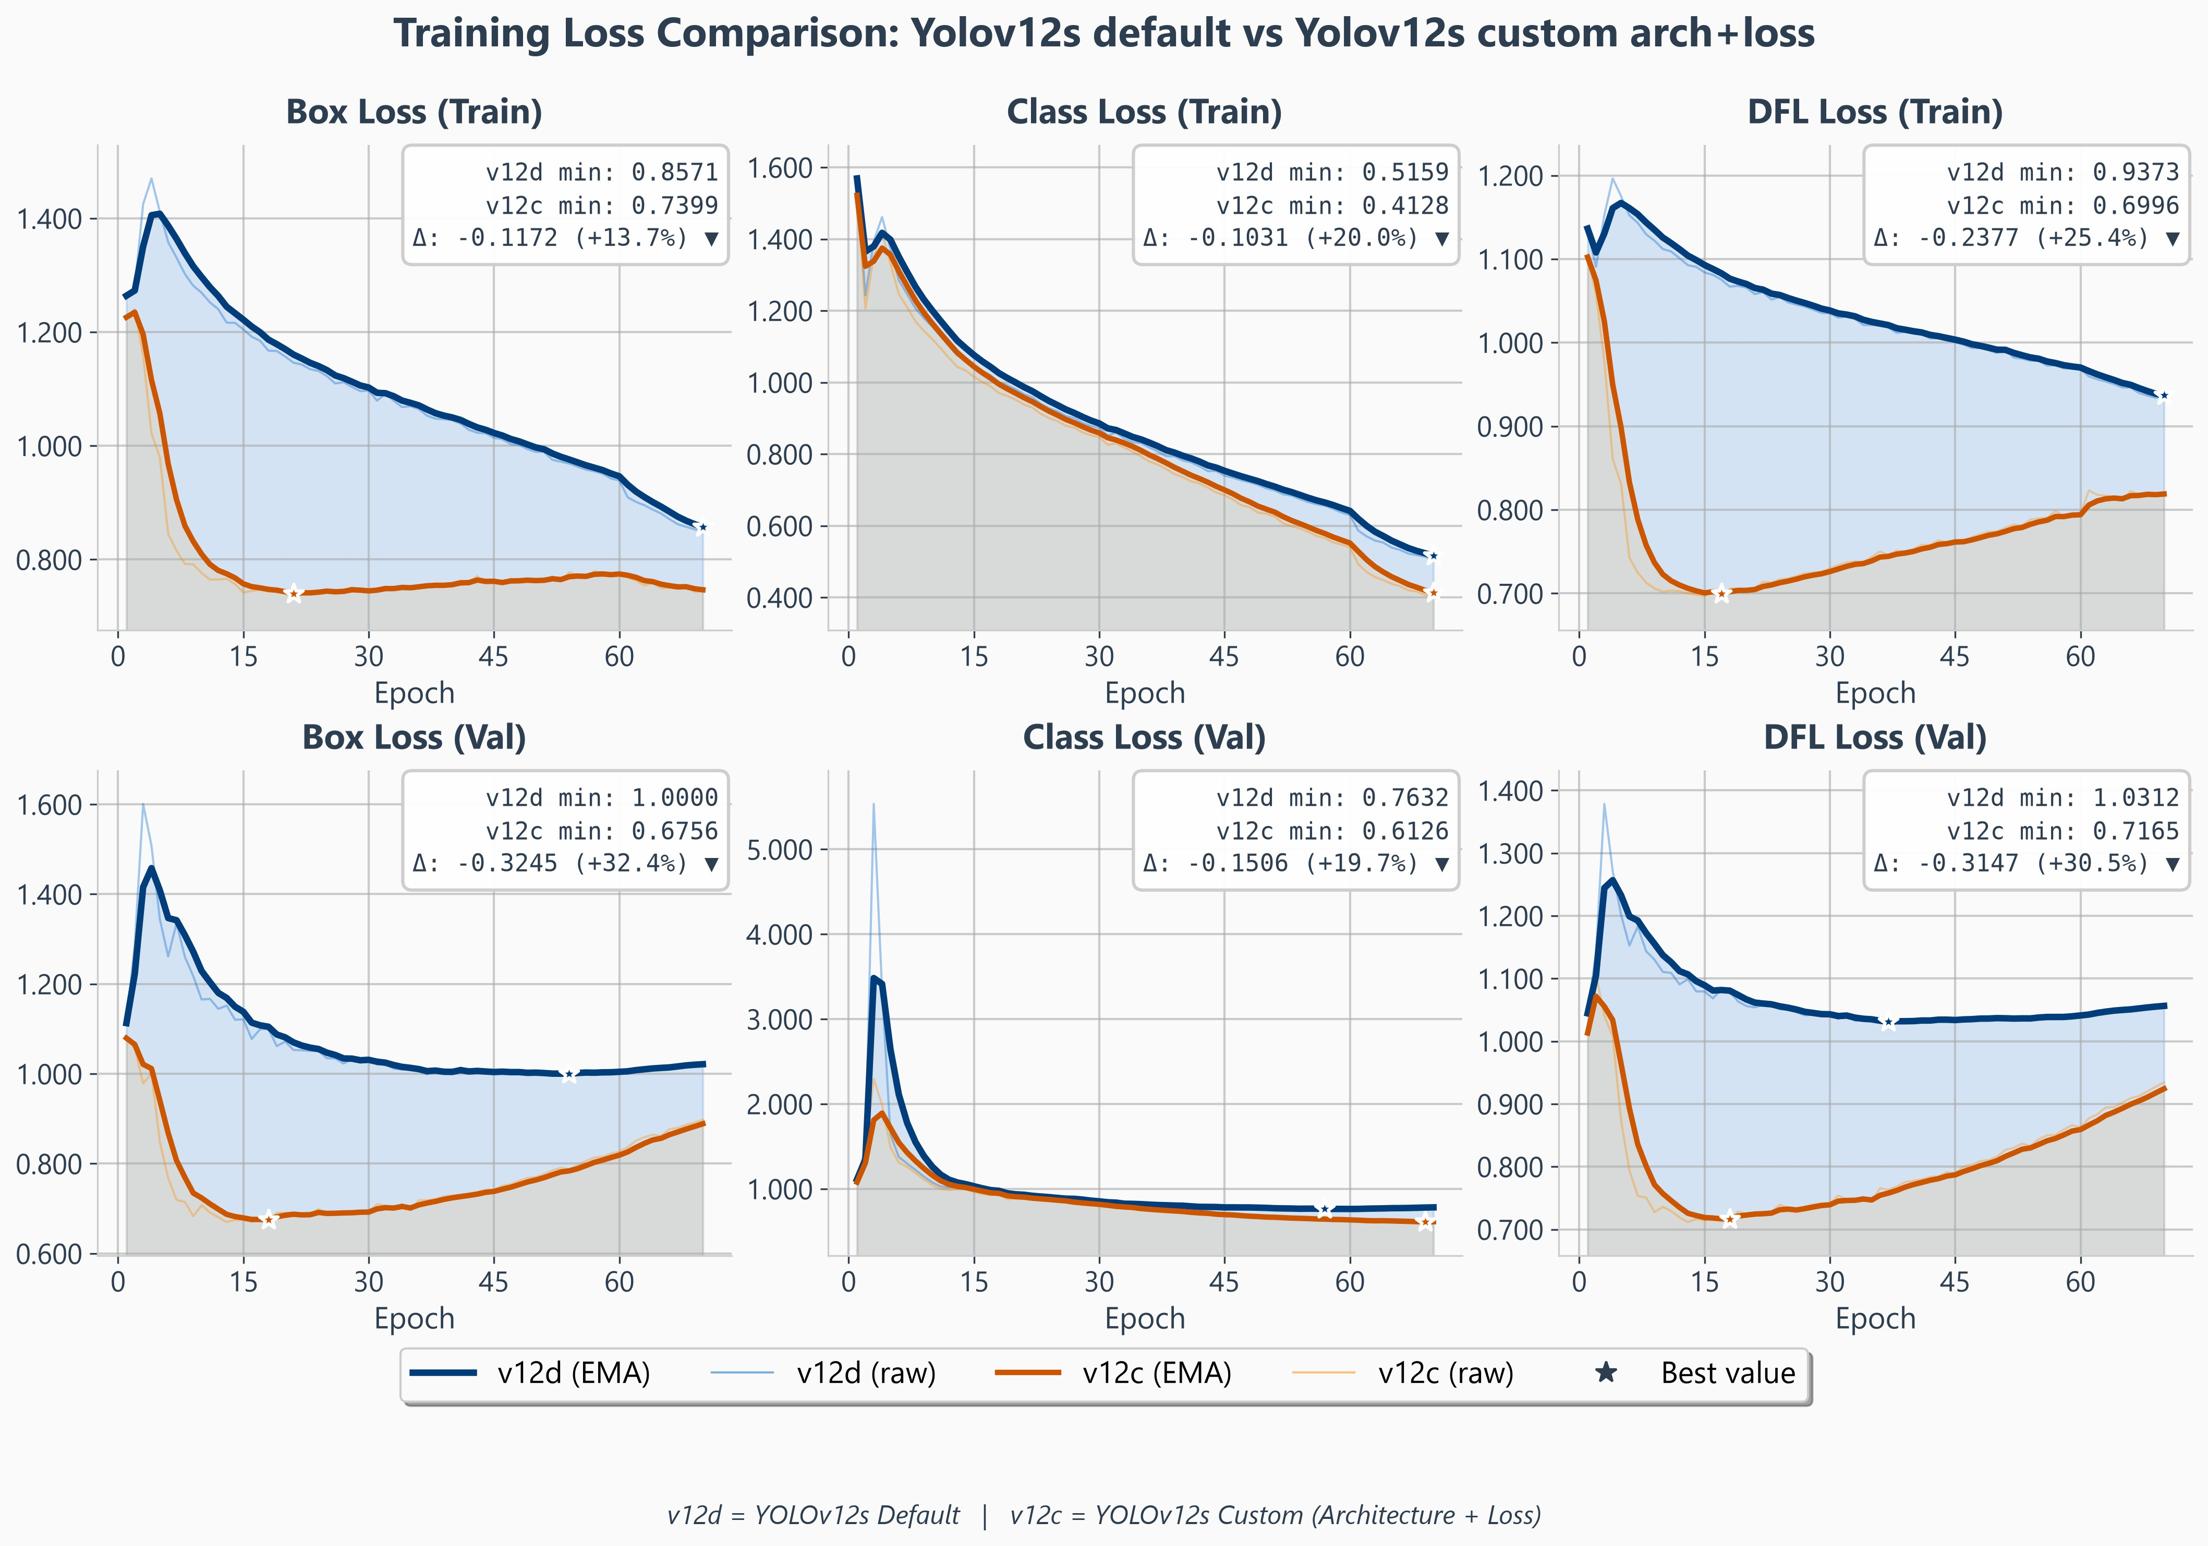
Figure 8: YOLOv12s loss components, baseline (v12d) versus the recommended configuration (v12c), same convention as Fig. 6; the corresponding metric curves are in Fig. 7. Box loss falls 13.7% on train and 32.4% on validation, classification 20.0% and 19.7%, DFL 25.4% and 30.5%. Two contrasts with Fig. 6 matter. The third panel here is a genuine DFL over 16 bins, not an ℓ₁ surrogate, which is the difference Table 11 records. And where YOLO26’s regression terms bottom out at the very end of the schedule, YOLOv12’s reach their validation minimum near epoch 18 — box 0.676, DFL 0.717 — and climb steadily thereafter, while mAP₅₀ in Fig. 7 keeps improving to roughly epoch 60. The regression head overfits long before the detector stops gaining, which is why checkpoints are selected on validation mAP rather than on loss.

 | axis | P | R | mAP50-95 | ARsmall  50-95
YOLO26s | Loss | +1.14 | +1.67 | −0.35 | −1.46
 | Arch | +2.44 | +4.38 | +3.12 | −1.25
YOLOv12s | Loss | +1.69 | +2.16 | −0.37 | −2.11
 | Arch | +3.12 | +2.61 | +3.04 | +2.48
(percentage change over each detector’s own baseline). Both axes raise precision and recall on both models. The sep-aration is on mAP₅₀₋₉₅: the loss axis costs it — 0.35% and 0.37%, two independent detectors agreeing to within
—
—
0.02 points — while the architecture axis gains it, +3.12% and +3.04%, agreeing to within 0.08. That two mechanisms reproduce their signature this closely across detectors that
share almost no implementation is the strongest regularity in the study.
The reading is the one Section B predicts. Flattening the alignment exponent, or re-weighting positives by scale, changes which detections are made and how confidently, but neither improves where a box is placed; at stricter IoU thresholds that shows up as a small loss. Adding a stride-4 level changes the resolution at which a small object is represented, which improves placement directly.
The small-object recall ceiling tells a similar story. The loss axis lowers it on both detectors ( 1.46%, 2.11%): sharpening or re-weighting assignment discards candi-
− −
dates. The architecture axis lowers it slightly on YOLO26 ( 1.25%) but raises it on YOLOv12 (+2.48%), the one place the two detectors disagree — and the one where YOLOv12 keeps its stride-32 head while YOLO26 deletes it.

The Axes Are Substantially Redundant
—
Writing the effect of each axis alone as ∆_{A} and ∆_{L} and the combined effect as ∆_{AL}, the interaction is ι = ∆_{AL} (∆_{A} +
—
∆_{L}). On YOLO26, ∆_{A} = +1.10, ∆_{L} = +1.32, ∆_{AL} = +1.85
points, so ι = 1.26: the combination delivers 68% of the sum of its parts. The same computation on YOLOv12’s na-
—
tive combinations gives 46–81%. Measured against the archi-tecture alone, adding a loss mechanism on YOLOv12 yields
+0.39, 0.09 and 0.22 points of small-object mAP₅₀ for curriculum weighting, WIoU and level-balanced assignment
− −
respectively — that is, no reliable gain at all. The two axes compete for the same errors.

Neither Detector’s Mechanisms Transfer to the Other
We tested transfer in both directions and on both axes, always on the same dataset and at matched batch size. Table 10 gives all four cells.

Table 8: Per-size effect of each axis on the test split. L is the loss axis alone, A the architecture axis alone, A+L both; ∆ is the percentage change of A+L over that detector’s baseline. Every cell is the mean of three seeds. Size buckets are the COCO area convention (32² / 96² px²), matching the evaluator. Bold marks the best of the four columns in that row.

Metric | YOLO26s |  |  |  |  | YOLOv12s
Metric | Base | L | A | A+L | ∆ | Base | L | A | A+L | ∆
Small — area < 32² px²
mAP50 | 77.26 | 78.61 | 79.83 | 79.91 | +3.44 | 77.65 | 77.93 | 78.79 | 79.87 | +2.85
mAP50-95 | 50.64 | 50.50 | 52.85 | 52.82 | +4.31 | 49.88 | 49.66 | 51.65 | 51.60 | +3.45
Precision | 77.31 | 78.25 | 80.06 | 80.97 | +4.73 | 76.81 | 79.08 | 81.07 | 80.06 | +4.24
Recall | 72.10 | 72.59 | 74.57 | 74.20 | +2.91 | 70.29 | 71.16 | 71.25 | 73.67 | +4.82
F1 | 74.62 | 75.32 | 77.22 | 77.44 | +3.78 | 73.40 | 74.91 | 75.85 | 76.74 | +4.54
Medium — area 322–962 px2
mAP50 | 86.60 | 87.26 | 87.28 | 88.59 | +2.30 | 87.65 | 87.54 | 87.78 | 87.42 | −0.26
mAP50-95 | 65.46 | 65.38 | 66.08 | 66.16 | +1.07 | 65.12 | 64.46 | 65.65 | 64.49 | −0.98
Precision | 91.70 | 91.01 | 90.98 | 93.02 | +1.45 | 88.40 | 88.78 | 91.25 | 92.35 | +4.46
Recall | 79.04 | 80.38 | 82.90 | 82.23 | +4.03 | 80.77 | 81.76 | 81.30 | 79.08 | −2.09
F1 | 84.90 | 85.36 | 86.75 | 87.29 | +2.82 | 84.41 | 85.13 | 85.99 | 85.20 | +0.93
Large — area > 96² px²
mAP50 | 81.82 | 81.85 | 83.26 | 80.83 | −1.21 | 82.93 | 82.63 | 84.68 | 82.79 | −0.17
mAP50-95 | 60.54 | 59.87 | 60.84 | 59.49 | −1.73 | 57.62 | 58.67 | 60.52 | 59.90 | +3.94
Precision | 79.98 | 77.29 | 87.59 | 77.88 | −2.62 | 83.97 | 83.94 | 87.95 | 83.43 | −0.64
Recall | 76.37 | 82.49 | 80.71 | 80.20 | +5.01 | 74.78 | 79.65 | 78.21 | 77.92 | +4.20
F1 | 78.13 | 79.81 | 84.01 | 79.02 | +1.14 | 79.11 | 81.74 | 82.80 | 80.58 | +1.86

The result is uniform: every one of the four cross-model transfers is a null on the primary metric. The resolvability threshold is 0.7% of the baseline; no “other” cell reaches it, while three of the four “own” cells clear it by a factor of at least two. This is not a case of mechanisms that help a little less on the other detector; it is four mechanisms that stop working.
Two of them additionally do damage that the small-object metric hides. The YOLO26 level reallocation costs YOLOv12 6.1 points of large-object mAP₅₀ and 9.6 at strict IoU, and β = 1 costs YOLOv12 0.9 points of mAP₅₀₋₉₅
and 2.6 of the small-object recall ceiling. Taken across all
metrics rather than one, the YOLO26 configuration loses 20 of 24 matched-batch comparisons against YOLOv12’s native configurations. The YOLOv12 global-context block, evaluated on YOLO26 in two placements, scored +0.51
and +0.01 — in both cases below the shared P2+DySample
change it was added to, so it did not merely fail to help, it
displaced something that did.
The four comparisons the YOLO26 configuration does win are exactly those its mechanism predicts — large-object AP for the exponent change, recall and the recall ceiling for the level reallocation. The mechanism signatures therefore transfer faithfully while the net benefits do not, which is what Section A sets out to explain.
Two findings invert outright. Removing the stride-32 de-tection branch is free to beneficial on YOLO26 but costs 6.1 points of large-object mAP₅₀ on YOLOv12, whose stride-32 head is still carrying large luggage. And the depth optimum reverses: repeats of 4 beat 2 by +0.62 on YOLO26 and lose
by −0.46 on YOLOv12.

A Batch-Size Control
A stride-4 head does not fit at the baseline batch size, so during the exploratory phase the architectural variants were trained at a smaller batch than the baseline and therefore took more optimisation steps. We bounded that confound
directly with a matched-batch control and with a second estimate at a different loss setting: +0.57 and 0.13 points of small-object mAP₅₀, both within one standard error of zero, placing the batch effect below 0.6 points.
The seeded configurations reported in Table 7 were sub-sequently retrained under a single protocol per detector, so the comparisons in Sections C–D are batch-matched by con-struction and no correction is applied to them. We record the bound here because it is what licensed the exploratory sweep of Table 6, whose cells are single runs at mixed batch sizes and should be read as a search rather than as measurements.
—
≈

Discussion

Why Each Mechanism Helped Only Its Own Detector
Section G established that the transfer fails in both directions. A failure to transfer is only interesting if it can be explained, so we give the mechanism for each of the four cases. All four trace back to three differences between the two reference im-plementations, which we state precisely because they are not visible in the training configuration — both models accept an identical set of keys and report identical loss names.
Table 11 lists them. Two points deserve emphasis. First, YOLO26 does not simply drop the third loss term when reg_max=1: it substitutes an ℓ₁ loss on left-top-right-bottom distances normalised by image size, so the term still exists but has a completely different gradient structure — constant-
magnitude and absolute-scale, rather than distributional and anchor-relative. Second, YOLO26’s two assignment branches are combined with a scheduled weighting: the one-to-many branch starts at 0.8 and decays linearly to 0.1 across training while the one-to-one branch rises from 0.2 to 0.9, so by the final epochs the model is optimised almost entirely through one-to-one assignment. Any mechanism acting on assignment therefore acts on a moving target on YOLO26 and on a static one on YOLOv12.

Table 9: Per-class, per-size performance on the test split: baseline versus the recommended configuration, both models, means of three seeds. Size buckets are the COCO area convention. bag is the weakest class at every size on both detectors and the ordering trolley > backpack > bag holds in all eighteen cells.

Class | Size | AP50 |  |  | AP50-95
Class | Size | Base | A+L | ∆ | Base | A+L | ∆
YOLO26s — p2dys-p234rich + β =1
backpack | small | 78.82 | 81.10 | +2.28 | 51.11 | 53.91 | +2.79
 | medium | 89.69 | 91.99 | +2.30 | 67.88 | 69.75 | +1.87
 | large | 82.93 | 86.53 | +3.60 | 56.49 | 58.56 | +2.06
bag | small | 67.78 | 70.46 | +2.68 | 42.78 | 44.60 | +1.82
 | medium | 76.85 | 79.64 | +2.79 | 54.88 | 55.77 | +0.90
 | large | 85.74 | 85.50 | −0.25 | 68.87 | 66.36 | −2.51
trolley | small | 85.47 | 88.86 | +3.39 | 58.09 | 60.24 | +2.15
 | medium | 93.16 | 93.99 | +0.84 | 73.98 | 72.83 | −1.14
 | large | 76.77 | 70.48 | −6.29 | 56.00 | 58.26 | +2.26
YOLOv12s — ls_shift + curriculum weighting
backpack | small | 77.71 | 80.48 | +2.76 | 50.49 | 52.87 | +2.38
 | medium | 90.99 | 92.53 | +1.54 | 66.99 | 68.65 | +1.66
 | large | 85.28 | 82.09 | −3.18 | 58.70 | 57.92 | −0.78
bag | small | 67.45 | 70.83 | +3.37 | 41.75 | 43.36 | +1.61
 | medium | 77.30 | 75.79 | −1.51 | 54.72 | 53.19 | −1.53
 | large | 81.33 | 86.58 | +5.25 | 66.41 | 66.79 | +0.38
trolley | small | 87.64 | 88.22 | +0.58 | 57.68 | 58.74 | +1.06
 | medium | 94.88 | 94.07 | −0.81 | 73.58 | 72.10 | −1.48
 | large | 81.93 | 79.67 | −2.26 | 48.08 | 55.16 | +7.08

Table 10: The transfer design. Each mechanism is evaluated on the detector it was developed for and on the other one. ∆ is per-centage change in mAPsmall over that detector’s own baseline; the run-to-run standard error is 0.28 points on YOLO26 and 0.20 on YOLOv12, so |∆| < 0.7% is not resolvable.
50

Axis | Mechanism | own | other
Loss | curriculum weighting (v12) | +0.36 | null
Loss | alignment exponent β =1 (v26) | +1.75 | +0.32
Arch | level-specific blocks (v12) | +1.47 | +0.66
Arch | drop stride 32 + depth 4 (v26) | +3.33 | +0.56

Table 11: The three implementation differences that explain the transfer failures. Both detectors share box=7.5, cls=0.5, dfl=1.5, BCE classification, CIoU, and a task-aligned assigner with α=0.5, β =6.
YOLO26 sets reg_max = 1 and substitutes an ℓ₁ loss on left-top-right-bottom distances normalised by image size. The weight still multiplies it, so the mechanism is not dis-
abled — but it is now acting on a term with the opposite scale behaviour. The ℓ₁ gradient has constant magnitude regardless of box size, and the quantity being regressed is an absolute fraction of the image rather than a distance in anchor units. A weighting scheme whose entire premise is that small objects are under-represented in a scale-relative loss has little to redistribute in a scale-absolute one.
This is the cleanest example of the paper’s general point. The intervention was tuned against a 16-bin distributional loss and transplanted onto a direct ℓ₁ regression, and nothing in the configuration surface signals the substitution: the key is still called dfl, the gain is still 1.5, and the logged loss anges from dfl_loss to l1_loss in a single line
 | YOLOv12 | YOLO26 name ch
Box distribution | DFL, reg_max=16 | none, reg_max=1 of the re
Third loss term | DFL over bins | ℓ₁ on ltrb / imgsz
Assignment | one-to-many, k=10 | two branches:
 | + NMS at inference | o2m k=10, o2o k=7,Ak2.=2 1 Th
Branch weighting | — | 0.8 → 0.1 (o2m), be
 |  | 0.2 → 0.9 (o2o) On YOL
Duplicate removal | NMS | argmax, no NMS

ference implementation.

Curriculum area weighting is a null on YOLO26 because the term it leans on has been replaced

On YOLOv12 the per-positive weight w^{(t)} of Equation (1) multiplies two regression terms: CIoU and the DFL. The
j
DFL is where fine localisation is learned — it supervises a 16-bin distribution per box edge [25], in units of feature cells measured from the anchor — and it carries the dfl = 1.5 gain against CIoU’s effective contribution. Crucially, DFL is anchor-relative and scale-free: a small box and a large
box both produce targets inside the same bin range, so re-weighting by object scale genuinely redistributes gradient between them.

e alignment exponent matters more on YOLO26 cause nothing downstream can correct it
Ov12 a small object receives roughly 7.7 positives. At inference, NMS selects among their predictions by confi-dence. If the alignment metric ranked those anchors badly
- which is what an over-sharp β does at small scales, per Section B — the error is an error in the targets of several anchors that will subsequently be pooled. NMS launders a noisy ranking: the surviving detection is effectively an ensemble decision over the positive set.
YOLO26’s one-to-one branch selects exactly one winner per ground truth, by argmax over the same alignment metric (k = 7 candidates reduced to k₂ = 1), and there is no NMS afterwards to revise it. The exponent is therefore no longer shaping a soft ranking among redundant positives; it is mak-
ing a single, final, unappealable choice. When IoU is noisy
- precisely the small-object regime — β = 6 amplifies that

YOLO26s baseline (stock loss, stock 3-level head)

All
Small (area < 32²)
Medium (32² 96²)
Large ( > 96²)

backpack
0.73
0. 05 0. 01
0. 02
0.66
0. 03
0. 01
0. 02
0.82
0.21

0.29

0.15
0.69
0. 05 0. 01
0. 02
0.68
0. 03
0. 00
0. 02
0.79
0.25

0.27

0.19
0.82
0. 04 0. 01
0. 03
0.71
0. 02
0. 01
0. 01
0.88
0.13

0.24

0.10
0.72
0. 15 0. 05
0. 02
0.78
0. 03
0. 03
0. 08
0.71
0.08

0.17

0.18

bag

trolley

background
bag
bag
bag
bag
0. 03 0. 04 0. 06 0. 00
0. 03 0. 06 0. 09 0. 00
0. 02 0. 03 0. 06 0. 00
0. 03 0. 01 0. 00 0. 00

rows = ground truth, columns = prediction · row-normalised · IoU 0. 5 · test split
backpack
trolley
background
backpack
trolley
background
backpack
trolley
background
backpack
trolley
background
bold teal = correct class bold coral = missed (predicted background) grey = inter-class confusion

YOLO26s recommended: p2dys-p234rich + =1

All
Small (area < 32²)
Medium (32² 96²)
Large ( > 96²)

backpack
0.78
0. 03
0. 01
0. 04
0.73
0. 04
0. 01
0. 01
0.86
0.18

0.19

0.12
0.77
0. 03
0. 01
0. 03
0.72
0. 03
0. 01
0. 01
0.85
0.19

0.22

0.13
0.85
0. 03
0. 01
0. 03
0.72
0. 04
0. 01
0. 02
0.91
0.11

0.21

0.06
0.77
0. 06
0. 03
0. 08
0.79
0. 03
0. 05
0.76

0. 11
0.14

0.10

0.08

bag

trolley

background
bag
bag
bag
bag
0. 03 0. 04 0. 06 0. 00
0. 04 0. 05 0. 08 0. 00
0. 02 0. 03 0. 05 0. 00
0. 03 0. 03 0. 02 0. 00

rows = ground truth, columns = prediction · row-normalised · IoU 0. 5 · test split
backpack
trolley
background
backpack
trolley
background
backpack
trolley
background
backpack
trolley
background
bold teal = correct class bold coral = missed (predicted background) grey = inter-class confusion

Figure 9: YOLO26s confusion, resolved by object size: baseline (top) and the recommended configuration (bottom). Rows are ground truth, columns are prediction, each row normalised, IoU 0.5, test split. The bold teal diagonal is the correct-class rate and the bold coral column is the miss rate — ground truth predicted as background — which for an alarm system is the operative failure. Every class improves at every size; the largest single change is bag missed to background, 0.29 → 0.19 overall and 0.27 → 0.22 on small objects.
≥

noise into the selection of the one anchor that will represent the object.
The branch schedule sharpens this further. Because the one-to-one weight rises from 0.2 to 0.9 over training, the regime in which β makes unappealable choices is also the regime that dominates the final epochs, when the model’s decision boundary is actually being set. On YOLOv12 no such branch exists and no such schedule runs; β shapes a soft ranking from first epoch to last.
This predicts both observations: β should matter more on YOLO26 (+1.70% versus +0.25–0.94%), and the pre-cision/recall exchange should be a YOLO26 phenomenon, since discarding the runners-up is exactly what one-to-one
assignment does and what NMS-based assignment does not. Both hold — the trade appears in 95% of qualifying YOLO26 configurations and only 37% of YOLOv12 ones.

Removing the coarsest level is affordable on YOLO26 and expensive on YOLOv12
This is the largest asymmetry in the study:

— stride-32 detection branch | mAPlarge  50 | mAPlarge  50-95
YOLO26 p234 | +0.49 | −2.87
YOLO26 p234rich | +1.69 | −1.92
YOLOv12 p234 | −4.09 | −10.84
YOLOv12 p234rich | −6.09 | −9.59
YOLOv12 loses roughly ten points of strict-IoU large-object AP and four to six points even at IoU 0.5; YOLO26 loses two to three points at strict IoU and gains at IoU 0.5.
Both models were retrained from scratch on the reduced graph, so this is not a fine-tuning artefact — stride 16 had ev-ery opportunity to absorb the large objects, and on YOLOv12 it could not.
The leading explanation is again the DFL. A YOLOv12 anchor expresses each box edge as a distribution over 16 bins measured in feature cells, so a stride-16 anchor can represent an extent of at most 16 16 = 256 pixels from the anchor point; the same anchor at stride 32 reaches 512.
×
Removing the stride-32 head forces the largest instances onto anchors whose regression range may not reach their boundaries, and a clipped distribution degrades gracefully at IoU 0.5 but sharply at IoU 0.75 and above — which is the observed pattern. YOLO26, regressing offsets directly with no binning, has no equivalent range limit. We report this as the hypothesis most consistent with the data rather than as an established result: confirming it requires AP resolved by box size within the large bucket, which our evaluation protocol does not currently produce.
We also note what this costs our own reasoning. The re-allocation was motivated by a positives cross-tab showing that stride 32 receives 0.01 positives per small ground truth and 1.68 of a large object’s 9.79. That diagnostic was mea-sured on YOLOv12 — and YOLOv12 is the model where the removal proved expensive. Assignment supply and inference contribution are not the same quantity, and we mistook one for the other. A level can be nearly idle at training time and still be where the model places its most confident large-box predictions.

YOLOv12s baseline (stock loss, stock 3-level head)

All
Small (area < 32²)
Medium (32² 96²)
Large ( > 96²)

backpack
0.73
0. 05 0. 01
0. 04
0.64
0. 03
0. 01
0. 02
0.81
0.21

0.29

0.16
0.70
0. 05 0. 02
0. 04
0.62
0. 03
0. 01
0. 01
0.79
0.23

0.31

0.19
0.81
0. 04 0. 01
0. 05
0.69
0. 04
0. 01
0. 02
0.88
0.14

0.22

0.09
0.69
0. 21 0. 00
0. 04
0.76
0. 03
0. 05
0.68

0. 13
0.10

0.17

0.14

bag

trolley

background
bag
bag
bag
bag
0. 04 0. 05 0. 06 0. 00
0. 06 0. 06 0. 07 0. 00
0. 03 0. 03 0. 06 0. 00
0. 06 0. 07 0. 02 0. 00

rows = ground truth, columns = prediction · row-normalised · IoU 0. 5 · test split
backpack
trolley
background
backpack
trolley
background
backpack
trolley
background
backpack
trolley
background
bold teal = correct class bold coral = missed (predicted background) grey = inter-class confusion

YOLOv12s recommended: ls_shift (4-level head)

All
Small (area < 32²)
Medium (32² 96²)
Large ( > 96²)

backpack
0.75
0. 03 0. 01
0. 04
0.69
0. 03
0. 01
0. 02 0.84
0.21

0.24

0.13
0.73
0. 03 0. 01
0. 04
0.68
0. 02
0. 00
0. 02 0.82
0.23

0.26

0.16
0.83
0. 02 0. 01
0. 04
0.68
0. 04
0. 01
0. 02 0.89
0.14

0.24

0.08
0.74
0. 09 0. 01
0. 05
0.78
0. 03
0. 00
0.74

0. 11
0.16

0.14

0.15

bag

trolley

background
bag
bag
bag
bag
0. 03 0. 05 0. 05 0. 00
0. 04 0. 06 0. 07 0. 00
0. 03 0. 03 0. 07 0. 00
0. 03 0. 06 0. 03 0. 00

rows = ground truth, columns = prediction · row-normalised · IoU 0. 5 · test split
backpack
trolley
background
backpack
trolley
background
backpack
trolley
background
backpack
trolley
background
bold teal = correct class bold coral = missed (predicted background) grey = inter-class confusion

Figure 10: YOLOv12s confusion, same convention as Fig. 9: baseline (top), recommended configuration (bottom). The pattern matches YOLO26 — every class improves at every size and bag improves most (0.64 0.69 correct overall, misses 0.29 0.24) — but from a lower starting point on that class, and the residual bag miss rate stays above YOLO26’s.
→ →

The level-specific blocks are a null on YOLO26 because their payoff route does not exist
The remaining cell of the transfer design is the YOLOv12 architectural mechanism applied to YOLO26. The gated global-context block was ported to the YOLO26 fork and evaluated twice, on the stock graph and on the P2/DySample graph:

YOLO26 + global-context block | mAPsmall  50 | mAP50
on the stock three-level graph | +0.51 | −0.08
on the P2/DySample graph | +0.01 | −0.23
for reference: P2+DySample alone | +0.76 | —
Both are nulls at a run-to-run standard error of 0.61, and both are below the shared architectural change they were added to. On YOLOv12 the same block is part of the config-uration that improves eight of nine metrics.
The explanation follows the one-to-one/NMS distinction already established. A global-context block improves the classification confidence of a location whose appearance alone is ambiguous — a twelve-pixel dark blob that is a bag, a bin or a shadow depending on its surroundings. On YOLOv12 that improvement has a route to the output: the object holds roughly 7.7 positives, all of them score-ranked, and NMS keeps the highest. Sharpening those scores changes which box survives and how confidently it is emit-ted, which is exactly what mAP₅₀ integrates over.
YOLO26 does not rank-then-select. Its one-to-one branch commits to a single anchor by argmax over the alignment metric during assignment, and that metric is computed from the detached predicted score — so a better per-location clas-sifier changes which anchor is chosen, but there is no down-
stream selection stage in which improved confidence sepa-rates a good detection from a redundant one. The block is not harmful; it simply has nowhere to pay off. We note that the directional snake-convolution block was not evaluated in isolation on YOLO26, so this conclusion is established for the global-context component only.

Depth helps where it propagates and not where it terminates
The fine-level depth optimum is 4 blocks on YOLO26 and 2 on YOLOv12. The graphs explain the difference. On YOLO26 the P2 branch is inserted into the PAN, so the deep-ened row 19 feeds row 22, which feeds row 25: additional capacity there refines features consumed by two further pre-dictions as well as its own. On YOLOv12 the P2 branch is appended and its head is a leaf — row 23 is read only by its refinement block and the detection head. Depth added to a terminal branch buys one prediction; depth added to an upstream branch buys three. This also explains why the effect is small in both cases and why 6 blocks over-fit on YOLO26: the benefit is real but second-order.

What This Means for Small-Object Detection Re-search
The four explanations share a shape. In each case the mech-anism was not wrong about the problem — small objects really are under-weighted, IoU really is noisier at small scales, the coarsest level really does receive few positives. The mechanism was wrong about the detector, because each intervention depends on an implementation detail that the

configuration surface hides: the presence of a DFL, the pres-ence of NMS, the topology of the branch it deepens.
The practical consequence is uncomfortable for the field’s reporting norms. A small-object mechanism validated on one detector should not be expected to carry to another, even one from the same family, trained on the same images, at the same resolution. Our two detectors differ by one release generation and share a configuration format, and yet nothing transferred. Papers that propose a mechanism on a single backbone and describe it as a general contribution are making a claim their experiments do not support, and the cost of checking is one additional detector.

Limitations
Seeded intervals cover the four configurations per detector in Table 7; the wider exploratory sweep behind Table 6 is single-run and is reported as a search, not as evidence. The batch-size confound on the architectural axis is bounded but not eliminated, and its two estimates disagree in sign. The DFL range hypothesis of Section A is consistent with the data but untested. All results are on a single dataset; the trade between small-object precision and the small-object recall ceiling may be a property of bird’s-eye-view luggage imagery rather than of small objects generally. Finally, the unattended-luggage application that motivates the benchmark is specified in Fig. 3 but not evaluated here, since LuggageDataset v6i contains images rather than tracked video.

Data and Code Availability
LuggageDataset v6i is released publicly, with the annotations, the documented 75/15/10 par-tition of Section D and the size-taxonomy def-initions used throughout this paper, at https:
//universe. roboflov. com/guns- detection-cvvj s/ luggagedataset- 24pgo/dataset/6. The training and evaluation code, the model configurations for ev-ery configuration in Table 7, the leakage-free splitting script and the complete run log are available at https:
//github. com/CostiCatargiu/NevLuggageDataset.

References
- D. Thirde, L. Li, and J. Ferryman, “Overview of the PETS 2006 challenge,” in Proc. 9th IEEE Int. Workshop Perfor-mance Evaluation of Tracking and Surveillance (PETS), 2006, pp. 47–50.
- E. Auvinet, E. Grossmann, C. Rougier, M. Dahmane, and
J. Meunier, “Left-luggage detection using homographies and simple heuristics,” in Proc. PETS, 2006, pp. 51–58.
- K. Smith, P. Quelhas, and D. Gatica-Perez, “Detecting aban-doned luggage items in a public space,” in Proc. PETS, 2006,
pp. 75–82.
- F. Lv, X. Song, B. Wu, V. K. Singh, and R. Nevatia, “Left luggage detection using Bayesian inference,” in Proc. PETS, 2006, pp. 83–90.
- H.-H. Liao, J.-Y. Chang, and L.-G. Chen, “A localized ap-proach to abandoned luggage detection with foreground-mask
sampling,” in Proc. IEEE Int. Conf. Advanced Video and Sig-nal Based Surveillance (AVSS), 2008, pp. 132–139.
- J.-Y. Chang, H.-H. Liao, and L.-G. Chen, “Localized detec-tion of abandoned luggage,” EURASIP J. Advances in Signal Processing, vol. 2010, art. 675784, 2010.
- C. Beleznai, P. Gemeiner, and C. Zinner, “Reliable left lug-gage detection using stereo depth and intensity cues,” in Proc. IEEE Int. Conf. Computer Vision Workshops (ICCVW), 2013,
pp. 59–65.
- I. Dahi, M. Chikr El Mezouar, N. Taleb, and M. Elbahri, “An edge-based method for effective abandoned luggage detec-tion in complex surveillance videos,” Comput. Vis. Image Understanding, vol. 158, pp. 141–151, 2017.
- D. G. Altunay, K. Karademir, O. Topçu, and C. Direkog˘lu, “Intelligent surveillance system for abandoned luggage,” in Proc. Signal Processing and Communications Applications Conf. (SIU), 2018.
- S. Smeureanu and R. T. Ionescu, “Real-time deep learning method for abandoned luggage detection in video,” in Proc. EUSIPCO, 2018, pp. 1775–1779.
- M. Dogariu, L.-D. S¸ tefan, M. G. Constantin, and B. Ionescu, “Human-object interaction: Application to abandoned lug-gage detection in video surveillance scenarios,” in Proc. Int. Conf. Communications (COMM), 2020, pp. 157–160.
- D. Kim, H. Kim, Y. Mok, and J. Paik, “HLDNet: Aban-doned object detection using hand luggage detection net-work,” IEEE Consumer Electronics Magazine, vol. 11, no. 4,
pp. 45–56, 2022.
- X. Chen, Y. Mao, L. Yang, J. Du, and Y. Song, “Research on airport baggage anomaly retention detection technology based on machine vision, edge computing, and blockchain,” IET Blockchain, vol. 4, pp. 393–406, 2024.
- L. Zhou and J. Xu, “Enhanced abandoned object detection through adaptive dual-background modeling and SAO-YOLO integration,” Sensors, vol. 24, no. 20, art. 6572, 2024.
- I. Vršalovic´, J. Lerga, and M. Ivašic´-Kos, “A system for real-time detection of abandoned luggage,” Sensors, vol. 25, no. 9, art. 2872, 2025.
- I. Vršalovic´, M. Ivašic´-Kos, M. Pobar, and J. Lerga, “YOLOv11-based algorithm for abandoned luggage detec-tion with dynamic radius estimation,” in Proc. IEEE PICom, 2025, pp. 129–136.
- T. Soontornnapar, “Abandoned bag detection in public areas using Grounding DINO with fine-grained prompts,” in Proc. ECTI-CON, 2025.
- H. Song, J. Wang, and Y. Zhang, “Detection of abandoned objects based on YOLOv9 and background differencing,” Signal, Image and Video Processing, vol. 19, art. 54, 2025.
- S. Shah, A. Khan, M. Alsuwaylimi, and N. Alenezi, “A two-stage spatiotemporal CNN-YOLOv9 framework for high-precision real-time abandoned object detection in public surveillance videos,” IEEE Access, vol. 14, pp. 35983–35997, 2026.
- V.-O. Pastukh and A. Deineko, “Detection of abandoned objects in video surveillance systems: A comparative analy-sis of rule-based and AI-oriented approaches,” Advances in Cyber-Physical Systems, vol. 11, no. 1, 2026.

- C. Catargiu and I. B. Ciocoiu, “Real-time weapon de-tection using enhanced YOLO12 models and a custom dataset,” IEEE Access, vol. 14, 2026, doi: 10.1109/AC-CESS.2026.3721157.
- Y. Tian, Q. Ye, and D. Doermann, “YOLOv12: Attention-centric real-time object detectors,” arXiv:2502.12524, 2025.
- G. Jocher, J. Qiu, and A. Chaurasia, “Ultralytics YOLO,” 2023. [Online]. Available: https: //github. con/ ultralytics/ultralytics
- C. Feng, Y. Zhong, Y. Gao, M. R. Scott, and W. Huang, “TOOD: Task-aligned one-stage object detection,” in Proc. IEEE/CVF Int. Conf. Comput. Vis. (ICCV), 2021, pp. 3490–3499.
- X. Li, W. Wang, L. Wu, S. Chen, X. Hu, J. Li, J. Tang,
and J. Yang, “Generalized focal loss: Learning qualified and distributed bounding boxes for dense object detection,” in Ad-vances in Neural Information Processing Systems (NeurIPS), 2020.
- W. Liu, H. Lu, H. Fu, and Z. Cao, “Learning to upsample by learning to sample,” in Proc. IEEE/CVF Int. Conf. Comput. Vis. (ICCV), 2023, pp. 6027–6037.
- Y. Qi, Y. He, X. Qi, Y. Zhang, and G. Yang, “Dynamic snake convolution based on topological geometric constraints for tubular structure segmentation,” in Proc. IEEE/CVF Int. Conf. Comput. Vis. (ICCV), 2023, pp. 6070–6079.
- Y. Cao, J. Xu, S. Lin, F. Wei, and H. Hu, “GCNet: Non-local networks meet squeeze-excitation networks and be-yond,” in Proc. IEEE/CVF Int. Conf. Comput. Vis. Workshops (ICCVW), 2019.
- T.-Y. Lin, M. Maire, S. Belongie, J. Hays, P. Perona, D. Ra-manan, P. Dollár, and C. L. Zitnick, “Microsoft COCO: Com-mon objects in context,” in Proc. European Conf. Comput. Vis. (ECCV), 2014, pp. 740–755.
- Z. Zheng, P. Wang, W. Liu, J. Li, R. Ye, and D. Ren, “Distance-IoU loss: Faster and better learning for bounding box regression,” in Proc. AAAI Conf. Artificial Intelligence, 2020, pp. 12993–13000.
- C. Catargiu, “LuggageDataset v6i,” Roboflow Universe, 2026. [Online]. Available: https:
//universe. roboflov. con/guns- detection-cvvj s/ luggagedataset- 24pgo/dataset/6

