Network Architecture

A. Design overview
The detector is built on YOLOv12s. We keep the stock YOLOv12s backbone and PAN neck entirely unchanged and add a small set of lightweight modules in the head, between the neck outputs and the detection layer. The design follows three principles that together make the additions safe, cheap and effective.
Append-only, zero-gated. Every new module is inserted as a residual branch scaled by a learnable gate gamma that is initialised to zero. At the start of training each module therefore computes the identity, and the network reproduces the pretrained YOLOv12s exactly; the pretrained detection weights are remapped to the new layer index. The gates can only open as training proceeds, so the modules can improve the strong pretrained initialisation but cannot destabilise it. This makes each addition a strict, low-risk superset of the baseline.
Scale-matched enhancement. Different pyramid levels need different things, so each level receives a module tuned to its scale: the high-resolution P3 level (stride 8, small objects) receives a fine-detail module, while the deeper P4 and P5 levels (stride 16 and 32) receive wide-receptive-field context-fusion modules. A global-context module is then applied at every enhanced level, and a dual-head detection layer closes the design.
Zero inference overhead where possible. The auxiliary detection branch is used only during training and is removed at inference, and the enhancement modules use only depthwise and 1x1 convolutions, so the added parameters and latency are small.
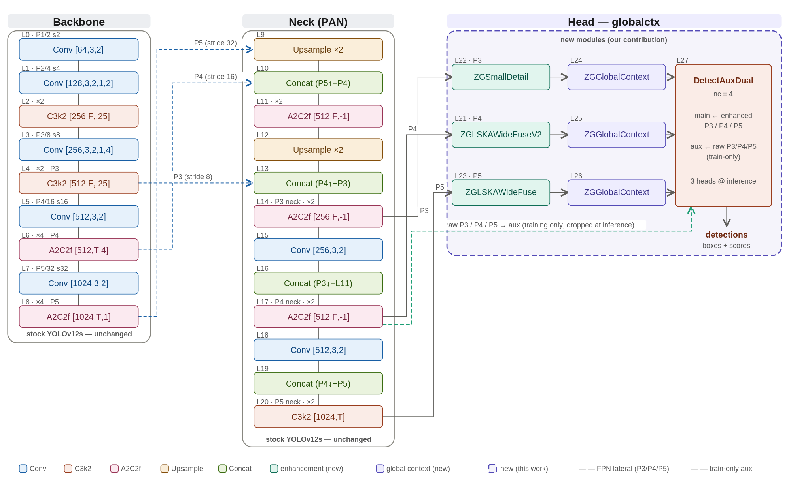
Figure 1. The globalctx architecture. The stock YOLOv12s backbone and PAN neck (grey) are unchanged; the dashed purple region marks the new modules added in this work: per-level scale-matched enhancement (ZGSmallDetail at P3, ZGLSKAWideFuseV2 at P4, ZGLSKAWideFuse at P5), a ZGGlobalContext module at each enhanced level, and a DetectAuxDual head whose auxiliary branch is dropped at inference.

B. Naming and notation
Module names combine a common prefix with descriptive suffixes; a few suffixes are established acronyms from the literature, while most are plain descriptions of the operation. Table 1 expands every term used in this and the following sections.
Term | Stands for | What it is
ZG- | Zero-Gated | Prefix for our custom append-only modules. Each is a residual branch scaled by a learnable gate gamma initialised to 0, so at start the module is an identity and the network reproduces pretrained YOLOv12s exactly.
LSKA | Large Separable Kernel Attention | Attention built from large separable (depthwise) kernels, giving a wide receptive field cheaply; adapted from the large-kernel-attention literature.
LKA | Large Kernel Attention | The large-kernel attention design that LSKA separates into cheaper depthwise factors.
WideFuse | descriptive (not an acronym) | A multi-branch fusion block that combines large-receptive-field and small-receptive-field paths.
SmallDetail | descriptive | Small-object detail enhancement using two small depthwise kernels.
GlobalContext / GC | descriptive | Global channel-context recalibration (squeeze-and-excitation style).
GatherContext | descriptive | Gathers multi-level context into one pyramid level.
AuxDual | Dual Auxiliary head | A main detection head plus an auxiliary head used only during training.
SE | Squeeze-and-Excitation | Channel attention computed from global pooling.
DW / PW | Depthwise / Pointwise (1x1) conv | Lightweight convolution primitives.
GN / SiLU | Group Normalization / Sigmoid Linear Unit | Normalization and activation (x * sigmoid(x)).
DySample | Dynamic Sampling | Content-aware (learned) upsampling operator.
FPN / PAN | Feature Pyramid / Path Aggregation Network | Standard multi-scale neck designs.
P3 / P4 / P5 | Pyramid levels | Feature maps at stride 8 / 16 / 32 (small / medium / large objects).
RF | Receptive Field | Spatial extent of input that influences one output location.
AP / AR / mAP | Average Precision / Recall / mean AP | Standard detection accuracy metrics.
DFL / TAL | Distribution Focal Loss / Task-Aligned Learning | Box-regression loss and the label-assignment strategy.
C3k2 / A2C2f / Conv | YOLOv12 blocks | Stock backbone and neck building blocks.
nc | number of classes | Equal to 4 here (knife, long_gun, other, pistol).
Table 1. Naming and abbreviations. The ZG- prefix marks our zero-gated modules; LSKA/LKA and SE are established techniques adapted here, while WideFuse, SmallDetail and GlobalContext are descriptive names.

C. The new modules and how they work
Figure 2 shows, for each new module, the problem it addresses (left), the exact internal operations (centre) and the resulting effect (right). The internals are op-exact; the problem and effect statements are interpretive.
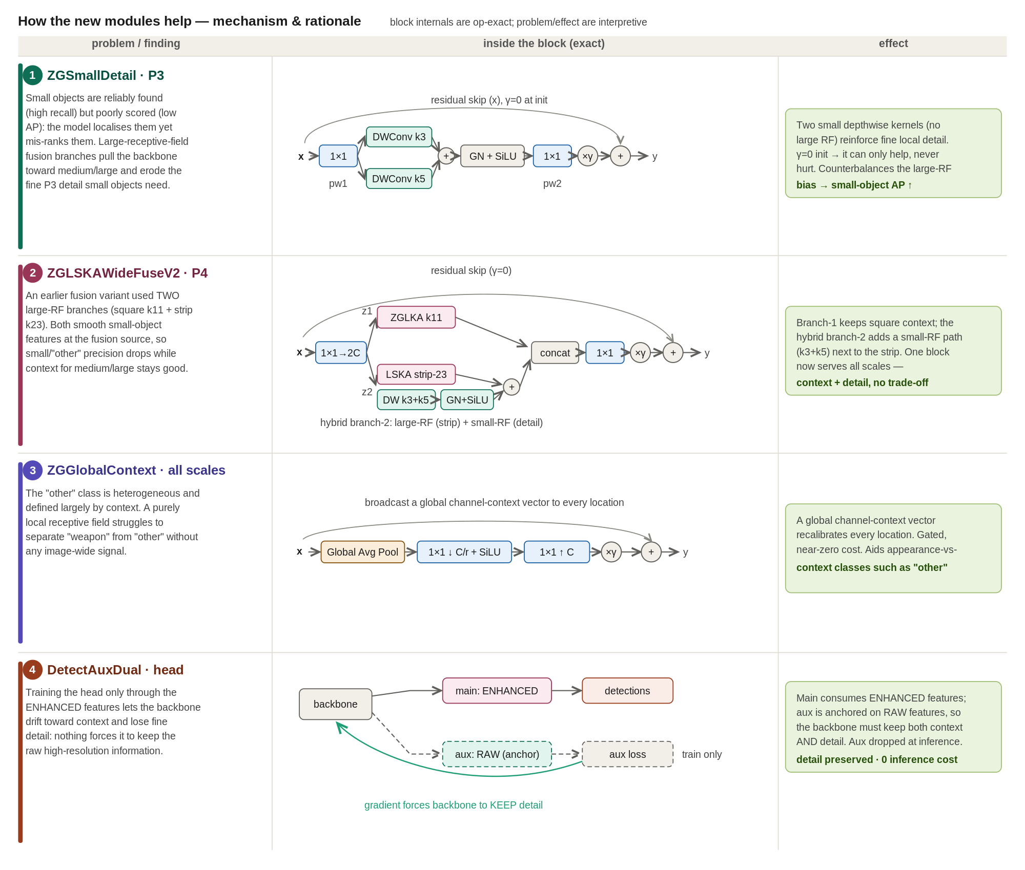
Figure 2. Mechanism of the new modules. Each module is a zero-gated residual branch (gamma = 0 at initialisation), so it can only refine the pretrained features.
ZGSmallDetail (P3). Small objects are reliably found but poorly scored, and the wide-receptive-field branches used elsewhere erode the fine P3 detail they depend on. This module adds two small depthwise kernels (3x3 and 5x5) as a zero-gated residual, reinforcing local detail without introducing large-kernel smoothing, which improves small-object precision.
ZGLSKAWideFuseV2 (P4). A pure large-kernel fusion smooths small-object features at the fusion source. This block expands the input with a 1x1 to two branches: branch 1 keeps square large-kernel context (a large-kernel attention path), while branch 2 is a hybrid that places a small-detail path (depthwise 3x3 + 5x5, with GroupNorm and SiLU) next to a large strip kernel. The branches are concatenated and projected, so one block serves both context and detail without a trade-off.
ZGLSKAWideFuse (P5). At the deepest level, where context dominates, a wide large-receptive-field fusion supplies broad scene context to the largest-stride features.
ZGGlobalContext (all levels). A purely local receptive field cannot separate the context-defined other class from genuine weapons. This module performs a squeeze-and-excitation-style global recalibration: global average pooling, a 1x1 bottleneck with SiLU, a 1x1 expansion, then a gated add. It broadcasts a global channel-context vector to every location at near-zero cost, helping appearance-versus-context classes such as other.
DetectAuxDual (head). Training the head only through the enhanced features lets the backbone drift toward context and lose fine detail. We attach an auxiliary head to the raw (pre-enhancement) features alongside the main head on the enhanced features. The auxiliary gradient forces the backbone to keep the raw high-resolution information; the auxiliary head is dropped at inference, so it costs nothing at test time.

D. What we improved over stock YOLOv12s
Relative to the unmodified YOLOv12s baseline, the architecture (i) preserves the strong pretrained initialisation through zero-gating, so every addition is a safe superset of the baseline; (ii) specialises the enhancement per scale, adding fine detail where small objects live (P3) and broad context where they do not (P4/P5), which addresses small-object scoring without sacrificing context; (iii) injects global scene context at every level to help the heterogeneous, context-defined other class; and (iv) preserves backbone detail through a dual-head training signal that is free at inference. All additions rely on depthwise and 1x1 operations, keeping the parameter and latency overhead small.

E. Architectures explored
The final design is the outcome of a broad architecture search. We explored several families of modules and head designs; Table 2 summarises them and which were retained. The search converged on the combination in Figure 1, and later variants (deeper P3 auxiliaries, decoupled and multi-prototype heads, deformable and self-attention operators, and additional fusion designs) produced neutral or negative changes, indicating that the design had saturated.
Family explored | Representative variants | Outcome
Large-kernel attention fusion | ZGLSKA, ZGLSKAStripFuse, ZGLSKAMultiDil, ZGLSKAWideFuse, ZGLSKAWideFuse3, ZGLSKACompactFuse, ZGLSKASelectFuse, ZGLSKAWideFuseV2, ZGLSKARefine, ZGLSKAExpand, ZGLSKAGCFuse, ZGLSKASG | WideFuse (P5) and WideFuseV2 (P4) retained; the other fusion variants were neutral or harmful.
Small-object detail | ZGSmallDetail | Retained at P3.
Global context | ZGGlobalContext, ZGGlobalContext2, ZGGatherContext, ZGGC, ZGSE | ZGGlobalContext retained at every enhanced level; the heavier/alternative variants gave no benefit.
Alternative operators | ZGMHSA, ZGDCN, ZGStar, ZGDSConv, ZGStrip, ZGP2Fuse, DySample, WeightedConcat | Not adopted: neutral or negative, or added cost without gain.
Detection heads | DetectAux, DetectAuxDual, DetectAuxDualDeepP3, DetectDecoupled, DetectDecoupledAux, DetectMultiProto | DetectAuxDual retained; deeper-P3, decoupled and multi-prototype heads gave no improvement.
Table 2. Architecture variants explored and their outcome. Only the retained modules appear in the final globalctx design (Figure 1).
Across the search we implemented and evaluated more than forty module and head variants. For completeness, Table 3 enumerates every feature-enhancement and context module we tried and Table 4 every detection-head variant, each with the mechanism it implements. Only the five entries marked Adopted appear in the final globalctx design; the remainder were neutral or harmful and were not retained.
Module | Mechanism (zero-gated residual y = x + gamma * f(x)) | Outcome
ZGLSKA | 1x1 -> SiLU -> decomposed large-kernel attention -> 1x1, added as a gated residual. | Not retained
ZGLSKAStripFuse | Fuses a square large-kernel branch with a separable strip-kernel branch. | Not retained
ZGLSKAMultiDil | Large-kernel attention with two parallel dilated depthwise convs (multiple receptive fields). | Not retained
ZGLSKASG | Large-kernel attention with an added spatial gate. | Not retained
ZGLSKARefine | Sequential local refinement applied after the large-kernel (k11) branch. | Not retained
ZGLSKAExpand | Large-kernel attention with channel expansion before the attention. | Not retained
ZGLSKAGCFuse | Fuses a large-kernel branch with a global-context branch. | Not retained
ZGLSKAWideFuse3 | Three-branch wide fusion across multiple receptive fields. | Not retained
ZGLSKACompactFuse | Reduced-channel (compact) wide fusion. | Not retained
ZGLSKASelectFuse | Attention-weighted (selective) fusion of branches. | Not retained
ZGLSKAWideFuse | Wide fusion of large-RF square + strip context branches. | Adopted (P5)
ZGLSKAWideFuseV2 | Hybrid fusion: square large-kernel branch + (strip + small-detail) branch, concatenated and projected. | Adopted (P4)
ZGSmallDetail | Two small depthwise kernels (3x3, 5x5) added as a gated residual to restore fine detail. | Adopted (P3)
ZGGlobalContext | Global channel context: global average pool -> 1x1 bottleneck + SiLU -> 1x1 -> gated add. | Adopted (all levels)
ZGGlobalContext2 | Global-context variant using both average and max pooling. | Not retained
ZGGC | GCNet-style global context: softmax-pooled global vector -> bottleneck -> broadcast-add. | Not retained
ZGGatherContext | Gathers multi-level features (P3/P4/P5) into an enhanced P3. | Not retained
ZGSE | Zero-gated squeeze-and-excitation channel gate. | Not retained
ZGMHSA | Zero-gated multi-head self-attention (P5 tokens); depthwise 3x3 on V as positional encoding. | Not retained
ZGStrip | Separable strip-kernel attention (1xk + kx1) for elongated objects. | Not retained
ZGDCN | Zero-gated deformable-convolution branch. | Not retained
ZGStar | Zero-gated star (element-wise multiplicative) feature-mixing branch. | Not retained
ZGDSConv | Zero-gated depthwise-separable convolution branch. | Not retained
ZGP2Fuse | Injects high-resolution backbone P2 (160x160) features into the P3 head for small objects. | Not retained
DySample | Dynamic content-aware upsampler replacing nearest-neighbour upsampling in the FPN top-down path. | Not retained
WeightedConcat | Learnable weighted feature concatenation (BiFPN-style). | Not retained
Table 3. Complete list of feature-enhancement and context modules explored. Every module is a zero-gated residual branch (gamma = 0 at initialisation). Adopted modules form the final design; the rest were not retained.
Detection head | Mechanism | Outcome
DetectAuxDual | Main head on enhanced features + auxiliary head on raw features (training only, dropped at inference). | Adopted
DetectAux | Single auxiliary detection head for extra training supervision. | Not retained
DetectAuxDualDeepP3 | DetectAuxDual with a deeper P3 branch. | Not retained
DetectDecoupled | Separate classification and regression towers. | Not retained
DetectDecoupledObj | Decoupled towers plus a separate objectness branch. | Not retained
DetectDecoupledAux | Decoupled towers plus an auxiliary head. | Not retained
DetectDecoupledCosine | Decoupled towers plus cosine (angular) classification. | Not retained
DetectObj | Detect with an added objectness branch. | Not retained
DetectCosine | Cosine / prototype (angular) classifier replacing the linear cls layer. | Not retained
DetectMultiProto | Multiple prototypes per class for classification. | Not retained
DetectWideCls | Wider classification tower (2x cls channels). | Not retained
DetectDeepCls | Deeper classification tower. | Not retained
DetectSmallCls | Classification branch specialised for small objects. | Not retained
DetectLKACls | Large-kernel-attention classification branch. | Not retained
DetectCGC | Class-guided context classification head. | Not retained
Table 4. Complete list of detection-head variants explored. DetectAuxDual was adopted; the others gave no improvement.
The design did not arrive in one step. It is the result of roughly forty rounds of incremental, diagnosis-driven search, each round testing one hypothesis on top of the previous best. Table 5 is a condensed log of that search, giving the idea behind each round and its qualitative outcome (per-run accuracy is omitted here because the early rounds predate the leakage-free split; the final quantitative ablation is reported on that split in the Results section). The log shows the path from the first large-kernel-attention finding (R6), through WideFuse (R11) and the auxiliary head (R20-R21), to the dual-path supervision (R32B), the scale-matched p5context design (R35) and the final globalctx (R38), after which further changes (R39-R41) no longer helped.
Round | Idea explored | Outcome
Early | Six bold architecture explorations for small-object detection. | Informed the search direction
R2 | Zero-init gated (ZG) modules: never replace a pretrained block, only add gated residuals. | Established the append-only / zero-gated principle
R3 | Small-object mAP recovery. | Diagnosed small-object scoring gap
R4 | Targeting the heterogeneous other class (the main bottleneck). | Identified other as the key weakness
R5 | Head architecture with class-guided context (DetectCGC). | No decisive gain
R6 | LSKA at P4, zero-gated (kernel 7/11/15). | Large-kernel attention at P4 = best pure-arch signal
R7 | Context family at P4 (global context, SE, etc.). | Modest; no clear winner
R8 | Non-SKA mechanisms at P4 (self-attention, strip, deformable, star). | None beat LSKA
R9 | Spatial gating on the k11 winner. | No gain
R10 | Three variations on the k11 winner. | Marginal
R11 | WideFuse and three further ideas. | WideFuse became the new best
R12 | Small-object recovery on WideFuse. | Partial
R13 | Head-level classification-branch gating. | No gain
R14 | Overnight batch of four designs. | Exploratory
R15 | Three-branch fusion (WideFuse3). | No gain over WideFuse
R16 | Two architectures for the other-class small-object gap. | No decisive gain
R17 | Spatially-routed (selective) receptive-field fusion. | No gain
R18 | Deeper / wider classification towers. | No gain
R19 | Learnable weighted neck (BiFPN topology). | No gain
R20 | Train-only auxiliary head (deep supervision). | Promising new lever
R21 | Auxiliary-weight dose-response on WideFuse. | WideFuse + aux = strong best
R22 | High auxiliary-weight dose-response. | Dose-response confirmed
R23 | Best architecture x best TAL/loss recipe (first combination). | Combined gain
R24 | Attack ranking quality rather than object finding. | Mixed
R25 | Ranking-targeted heads on the WideFuse backbone. | Decoupled head a modest positive
R26 | Softened objectness + decoupled/objectness synthesis. | Partial
R27 | Dual-neck decoupled head. | No decisive gain
R28 | Cosine / prototype classifier (change the scoring). | No gain
R29 | Extensions of the project-best (r21) architecture. | Incremental
R30 | P3 detail guard for small-object recovery. | Motivated a dedicated P3 detail module
R31 | Hybrid-branch WideFuseV2 (+ best TAL). | New fusion adopted at P4
R32B | Dual-path auxiliary supervision (raw-feature detail teacher). | Large jump; DetectAuxDual adopted
R33 | Detail-enhanced auxiliary P3. | Refinement
R34 | Detail enhancement on the main-head P3. | Best small-object architecture
R35 | Merge strongest cells; scale-matched P3/P4/P5 enhancement (p5context). | p5context became the winner
R36 | Refine and combine the p5context winners. | Confirmed p5context
R37 | Four new structural axes. | No gain (search converging)
R38 | Four neck paradigms. | globalctx the best paradigm
R39 | Stack the two R38 winners (globalctx + DySample). | No added gain
R40 | Deeper P3 head towers. | No gain (scoring, not features, is the limit)
R41 | avg+max global context; single DySample. | Saturated; final design = globalctx
Table 5. Round-by-round architecture search log. Outcomes are qualitative; the design saturates after the globalctx paradigm (R38).
Quantitative ablations and final accuracy for the retained design are reported in the Results section on the leakage-free split; this chapter describes the architecture and the mechanisms, not the numbers.

