Network Architecture

A. Design overview
The detector is built on YOLOv12s. We keep the stock YOLOv12s backbone and PAN neck entirely unchanged and add a small set of lightweight modules in the head, between the neck outputs and the detection layer. The design follows three principles that together make the additions safe, cheap and effective.
Append-only, zero-gated. Every new module is inserted as a residual branch scaled by a learnable gate gamma that is initialised to zero. At the start of training each module therefore computes the identity, and the network reproduces the pretrained YOLOv12s exactly; the pretrained detection weights are remapped to the new layer index. The gates can only open as training proceeds, so the modules can improve the strong pretrained initialisation but cannot destabilise it. This makes each addition a strict, low-risk superset of the baseline.
Scale-matched enhancement. Different pyramid levels need different things, so each level receives a module tuned to its scale: the high-resolution P3 level (stride 8, small objects) receives a fine-detail module, while the deeper P4 and P5 levels (stride 16 and 32) receive wide-receptive-field context-fusion modules. A global-context module is then applied at every enhanced level, and a dual-head detection layer closes the design.
Zero inference overhead where possible. The auxiliary detection branch is used only during training and is removed at inference, and the enhancement modules use only depthwise and 1x1 convolutions, so the added parameters and latency are small.
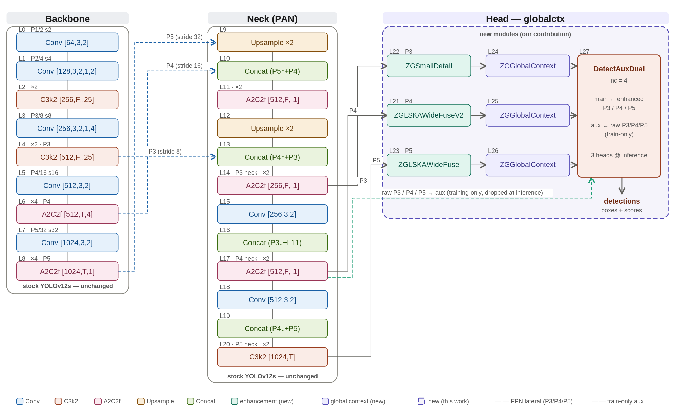
Figure 1. The globalctx architecture. The stock YOLOv12s backbone and PAN neck (grey) are unchanged; the dashed purple region marks the new modules added in this work: per-level scale-matched enhancement (ZGSmallDetail at P3, ZGLSKAWideFuseV2 at P4, ZGLSKAWideFuse at P5), a ZGGlobalContext module at each enhanced level, and a DetectAuxDual head whose auxiliary branch is dropped at inference.

B. Naming and notation
Module names combine a common prefix with descriptive suffixes; a few suffixes are established acronyms from the literature, while most are plain descriptions of the operation. Table 1 expands every term used in this and the following sections.
Term | Stands for | What it is
ZG- | Zero-Gated | Prefix for our custom append-only modules. Each is a residual branch scaled by a learnable gate gamma initialised to 0, so at start the module is an identity and the network reproduces pretrained YOLOv12s exactly.
LSKA | Large Separable Kernel Attention | Attention built from large separable (depthwise) kernels, giving a wide receptive field cheaply; adapted from the large-kernel-attention literature.
LKA | Large Kernel Attention | The large-kernel attention design that LSKA separates into cheaper depthwise factors.
WideFuse | descriptive (not an acronym) | A multi-branch fusion block that combines large-receptive-field and small-receptive-field paths.
SmallDetail | descriptive | Small-object detail enhancement using two small depthwise kernels.
GlobalContext / GC | descriptive | Global channel-context recalibration (squeeze-and-excitation style).
GatherContext | descriptive | Gathers multi-level context into one pyramid level.
AuxDual | Dual Auxiliary head | A main detection head plus an auxiliary head used only during training.
SE | Squeeze-and-Excitation | Channel attention computed from global pooling.
DW / PW | Depthwise / Pointwise (1x1) conv | Lightweight convolution primitives.
GN / SiLU | Group Normalization / Sigmoid Linear Unit | Normalization and activation (x * sigmoid(x)).
DySample | Dynamic Sampling | Content-aware (learned) upsampling operator.
FPN / PAN | Feature Pyramid / Path Aggregation Network | Standard multi-scale neck designs.
P3 / P4 / P5 | Pyramid levels | Feature maps at stride 8 / 16 / 32 (small / medium / large objects).
RF | Receptive Field | Spatial extent of input that influences one output location.
AP / AR / mAP | Average Precision / Recall / mean AP | Standard detection accuracy metrics.
DFL / TAL | Distribution Focal Loss / Task-Aligned Learning | Box-regression loss and the label-assignment strategy.
C3k2 / A2C2f / Conv | YOLOv12 blocks | Stock backbone and neck building blocks.
nc | number of classes | Equal to 4 here (knife, long_gun, other, pistol).
Table 1. Naming and abbreviations. The ZG- prefix marks our zero-gated modules; LSKA/LKA and SE are established techniques adapted here, while WideFuse, SmallDetail and GlobalContext are descriptive names.

C. The new modules and how they work
Figure 2 shows, for each new module, the problem it addresses (left), the exact internal operations (centre) and the resulting effect (right). The internals are op-exact; the problem and effect statements are interpretive.
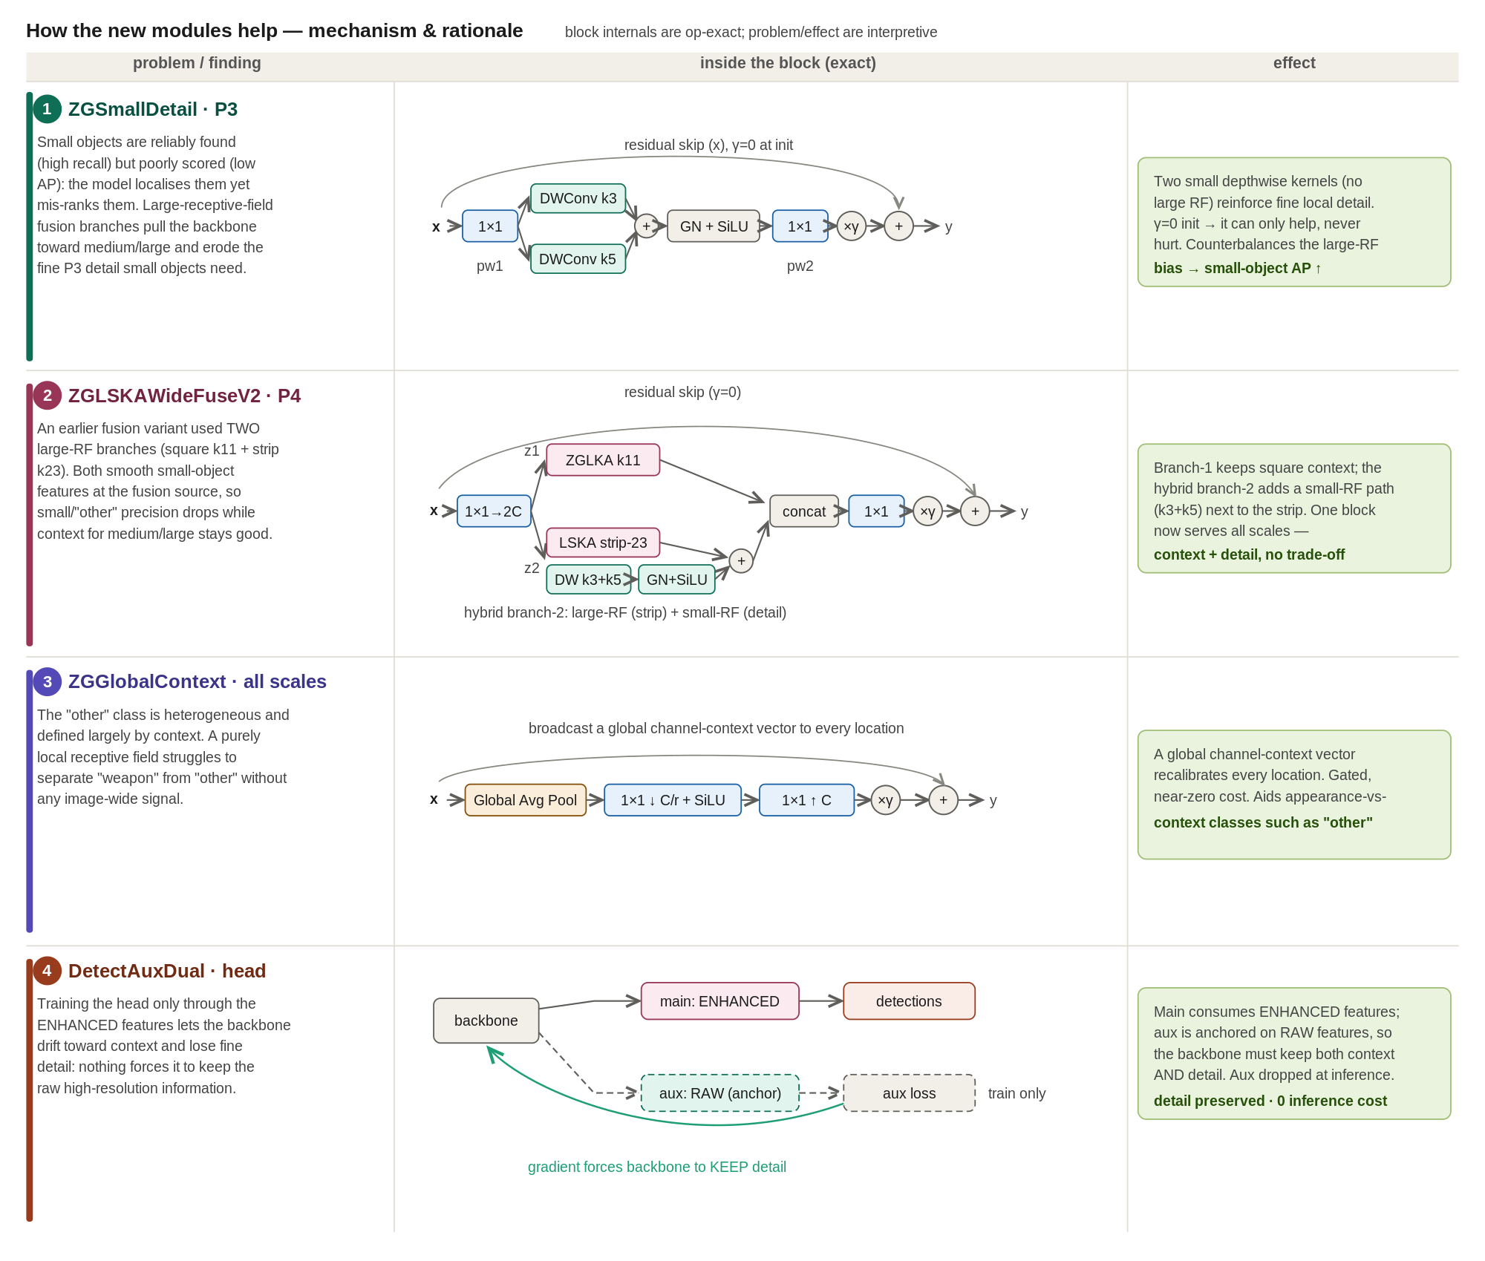
Figure 2. Mechanism of the new modules. Each module is a zero-gated residual branch (gamma = 0 at initialisation), so it can only refine the pretrained features.
ZGSmallDetail (P3). Small objects are reliably found but poorly scored, and the wide-receptive-field branches used elsewhere erode the fine P3 detail they depend on. This module adds two small depthwise kernels (3x3 and 5x5) as a zero-gated residual, reinforcing local detail without introducing large-kernel smoothing, which improves small-object precision.
ZGLSKAWideFuseV2 (P4). A pure large-kernel fusion smooths small-object features at the fusion source. This block expands the input with a 1x1 to two branches: branch 1 keeps square large-kernel context (a large-kernel attention path), while branch 2 is a hybrid that places a small-detail path (depthwise 3x3 + 5x5, with GroupNorm and SiLU) next to a large strip kernel. The branches are concatenated and projected, so one block serves both context and detail without a trade-off.
ZGLSKAWideFuse (P5). At the deepest level, where context dominates, a wide large-receptive-field fusion supplies broad scene context to the largest-stride features.
ZGGlobalContext (all levels). A purely local receptive field cannot separate the context-defined other class from genuine weapons. This module performs a squeeze-and-excitation-style global recalibration: global average pooling, a 1x1 bottleneck with SiLU, a 1x1 expansion, then a gated add. It broadcasts a global channel-context vector to every location at near-zero cost, helping appearance-versus-context classes such as other.
DetectAuxDual (head). Training the head only through the enhanced features lets the backbone drift toward context and lose fine detail. We attach an auxiliary head to the raw (pre-enhancement) features alongside the main head on the enhanced features. The auxiliary gradient forces the backbone to keep the raw high-resolution information; the auxiliary head is dropped at inference, so it costs nothing at test time.

D. What we improved over stock YOLOv12s
Relative to the unmodified YOLOv12s baseline, the architecture (i) preserves the strong pretrained initialisation through zero-gating, so every addition is a safe superset of the baseline; (ii) specialises the enhancement per scale, adding fine detail where small objects live (P3) and broad context where they do not (P4/P5), which addresses small-object scoring without sacrificing context; (iii) injects global scene context at every level to help the heterogeneous, context-defined other class; and (iv) preserves backbone detail through a dual-head training signal that is free at inference. All additions rely on depthwise and 1x1 operations, keeping the parameter and latency overhead small.

E. Architectures explored
The final design is the outcome of a broad architecture search. We explored several families of modules and head designs; Table 2 summarises them and which were retained. The search converged on the combination in Figure 1, and later variants (deeper P3 auxiliaries, decoupled and multi-prototype heads, deformable and self-attention operators, and additional fusion designs) produced neutral or negative changes, indicating that the design had saturated.
Family explored | Representative variants | Outcome
Large-kernel attention fusion | ZGLSKA, ZGLSKAStripFuse, ZGLSKAMultiDil, ZGLSKAWideFuse, ZGLSKAWideFuse3, ZGLSKACompactFuse, ZGLSKASelectFuse, ZGLSKAWideFuseV2, ZGLSKARefine, ZGLSKAExpand, ZGLSKAGCFuse, ZGLSKASG | WideFuse (P5) and WideFuseV2 (P4) retained; the other fusion variants were neutral or harmful.
Small-object detail | ZGSmallDetail | Retained at P3.
Global context | ZGGlobalContext, ZGGlobalContext2, ZGGatherContext, ZGGC, ZGSE | ZGGlobalContext retained at every enhanced level; the heavier/alternative variants gave no benefit.
Alternative operators | ZGMHSA, ZGDCN, ZGStar, ZGDSConv, ZGStrip, ZGP2Fuse, DySample, WeightedConcat | Not adopted: neutral or negative, or added cost without gain.
Detection heads | DetectAux, DetectAuxDual, DetectAuxDualDeepP3, DetectDecoupled, DetectDecoupledAux, DetectMultiProto | DetectAuxDual retained; deeper-P3, decoupled and multi-prototype heads gave no improvement.
Table 2. Architecture variants explored and their outcome. Only the retained modules appear in the final globalctx design (Figure 1).
Quantitative ablations and final accuracy for the retained design are reported in the Results section on the leakage-free split; this chapter describes the architecture and the mechanisms, not the numbers.

