Dataset

A. Source and composition
The dataset targets four object categories relevant to weapon screening: knife, long_gun, other, and pistol. Images were extracted as frames from video footage, which has a direct consequence for split construction discussed in Section C. After curation and splitting, the dataset comprises 26,528 images containing 38,167 annotated instances (Table 1). The class distribution is moderately imbalanced - pistol (34.7% of instances) and long_gun (27.7%) are the most frequent, followed by other (21.5%) and knife (16.1%). The split preserves a 70/15/15 ratio for both images and every individual class (each class is within roughly 1% of 70/15/15 across the three subsets).
Split | Images | Instances | knife | long_gun | other | pistol
train | 18,579 (70.0%) | 26,614 (69.7%) | 4,247 (68.9%) | 7,375 (69.8%) | 5,692 (69.4%) | 9,300 (70.2%)
val | 3,978 (15.0%) | 5,665 (14.8%) | 950 (15.4%) | 1,537 (14.6%) | 1,240 (15.1%) | 1,938 (14.6%)
test | 3,971 (15.0%) | 5,888 (15.4%) | 966 (15.7%) | 1,647 (15.6%) | 1,271 (15.5%) | 2,004 (15.1%)
Total | 26,528 (100%) | 38,167 (100%) | 6,163 (16.1%) | 10,559 (27.7%) | 8,203 (21.5%) | 13,242 (34.7%)
Table 1. Dataset composition. For the split rows, the class percentages are the split's share of that class (showing the ~70/15/15 balance); in the Total row the class percentage is the class's share of all instances.

B. Annotation correction
An initial analysis revealed that the other category - a heterogeneous catch-all for non-weapon objects - was systematically under-annotated: many genuine instances were left unlabelled, so a detector correctly localising them was penalised as producing false positives. We therefore applied a model-assisted annotation-correction pass, in which a trained detector proposed candidate other instances that were then human-reviewed and merged back into the labels. All results in this paper use the corrected annotations.

C. Leakage-free splitting by near-duplicate clustering
Because the images are video frames, temporally adjacent frames are near-identical, and a naive per-frame split would place near-duplicates in different subsets - leaking evaluation content into training and overstating accuracy. To prevent this we adopt a near-duplicate-aware splitting procedure. Each image is encoded by a 64-bit perceptual hash (difference hash); any two images within a Hamming distance of five are linked, and connected components are extracted with a union-find, grouping mutually near-identical frames into clusters. This yields 19,036 clusters over the 26,528 images (15,549 singletons; largest cluster 188 frames).
Each entire cluster is then assigned to a single split by a stratified greedy that targets the 70/15/15 ratio for the total image count and for every class simultaneously (Figure 1). Because no cluster is divided across subsets, no near-duplicate frame can cross a split boundary. We confirmed this with a cross-split near-duplicate audit of the final split: there are zero near-duplicate images between any pair of subsets (Table 4). The evaluation is therefore leakage-free, and the reported metrics reflect genuine generalisation rather than memorised near-duplicates.
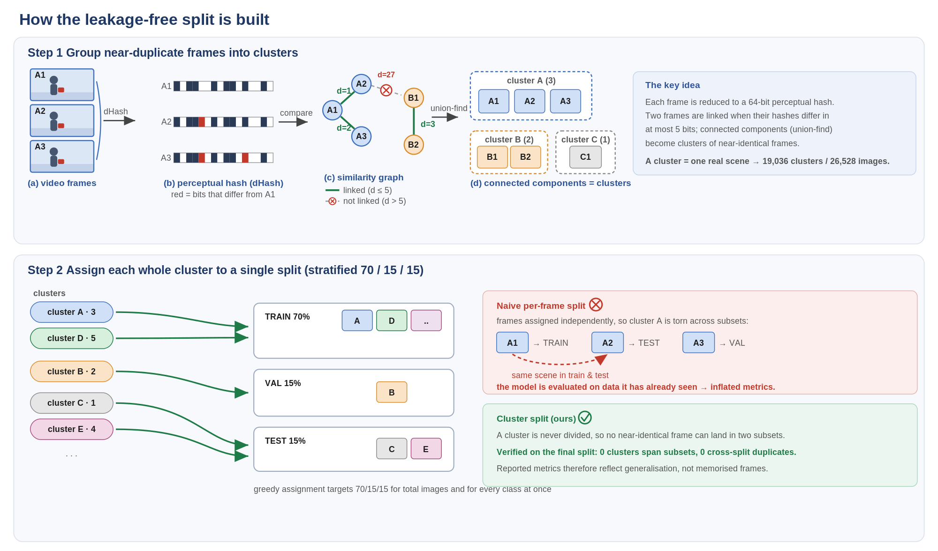
Figure 1. The leakage-free splitting procedure. Step 1: each frame is reduced to a 64-bit perceptual hash; frames within Hamming distance 5 are linked, and connected components (union-find) form clusters of mutually near-identical frames. Step 2: each whole cluster is assigned to a single split, with a greedy targeting 70/15/15 for the total image count and for every class. Because a cluster is never divided, no near-duplicate frame can appear in two subsets - unlike a naive per-frame split, which would place the same scene in both train and test.
Split pair | near-duplicate images | leakage rate
train - val | 0 | 0.0%
train - test | 0 | 0.0%
val - test | 0 | 0.0%
Table 4. Cross-split near-duplicate audit of the final split (difference hash, Hamming <= 5). No near-duplicate images occur across any pair of subsets - the split is leakage-free.

D. Object-size distribution
To characterise detection difficulty we categorise every instance by absolute scale, defined as the square root of the bounding-box area in pixels at the image's native resolution: small (< 48 px), medium (48-96 px) and large (>= 96 px). The dataset is dominated by large objects (70.2%), with 22.0% medium and only 7.8% small instances (Table 2). The distribution is consistent across the three splits, confirming the split does not bias object scale.
Split | Small (< 48 px) | Medium (48-96 px) | Large (>= 96 px)
train | 2,132 (8.0%) | 5,845 (22.0%) | 18,637 (70.0%)
val | 414 (7.3%) | 1,179 (20.8%) | 4,072 (71.9%)
test | 442 (7.5%) | 1,355 (23.0%) | 4,091 (69.5%)
Total | 2,988 (7.8%) | 8,379 (22.0%) | 26,800 (70.2%)
Table 2. Object-size distribution per split (scale = sqrt of box area in pixels; percentages are within each split). Small objects are scarce (~7.8%), making small-object accuracy the hardest and most informative metric.
The scarcity of small objects is strongly class-dependent (Table 3): pistol is by far the smallest class, with 13.6% of its instances small (1,801 of 13,242), reflecting that handguns frequently appear small and distant. The remaining classes are predominantly large (74-79%). This concentration of small, hard instances in the pistol class - together with the heterogeneous other class - is what the architecture and loss design in the following sections specifically target.
Class | Small | Medium | Large | Total (% of all)
knife | 294 (4.8%) | 1,289 (20.9%) | 4,580 (74.3%) | 6,163 (16.1%)
long_gun | 429 (4.1%) | 1,843 (17.5%) | 8,287 (78.5%) | 10,559 (27.7%)
other | 464 (5.7%) | 1,728 (21.1%) | 6,011 (73.3%) | 8,203 (21.5%)
pistol | 1,801 (13.6%) | 3,519 (26.6%) | 7,922 (59.8%) | 13,242 (34.7%)
Table 3. Per-class object-size breakdown over the full dataset. Small/Medium/Large percentages are within each class; the Total column is the class's share of all instances.

