Network Architecture

A. Design overview
The detector is built on YOLOv12s. We keep the stock YOLOv12s backbone and PAN neck entirely unchanged and add a small set of lightweight modules in the head, between the neck outputs and the detection layer. The design follows three principles that together make the additions safe, cheap and effective.
Append-only, zero-gated. Every new module is inserted as a residual branch scaled by a learnable gate gamma that is initialised to zero. At the start of training each module therefore computes the identity, and the network reproduces the pretrained YOLOv12s exactly; the pretrained detection weights are remapped to the new layer index. The gates can only open as training proceeds, so the modules can improve the strong pretrained initialisation but cannot destabilise it. This makes each addition a strict, low-risk superset of the baseline.
Scale-matched enhancement. Different pyramid levels need different things, so each level receives a module tuned to its scale: the high-resolution P3 level (stride 8, small objects) receives a fine-detail module, while the deeper P4 and P5 levels (stride 16 and 32) receive wide-receptive-field context-fusion modules. A global-context module is then applied at every enhanced level, and a dual-head detection layer closes the design.
Zero inference overhead where possible. The auxiliary detection branch is used only during training and is removed at inference, and the enhancement modules use only depthwise and 1x1 convolutions, so the added parameters and latency are small.
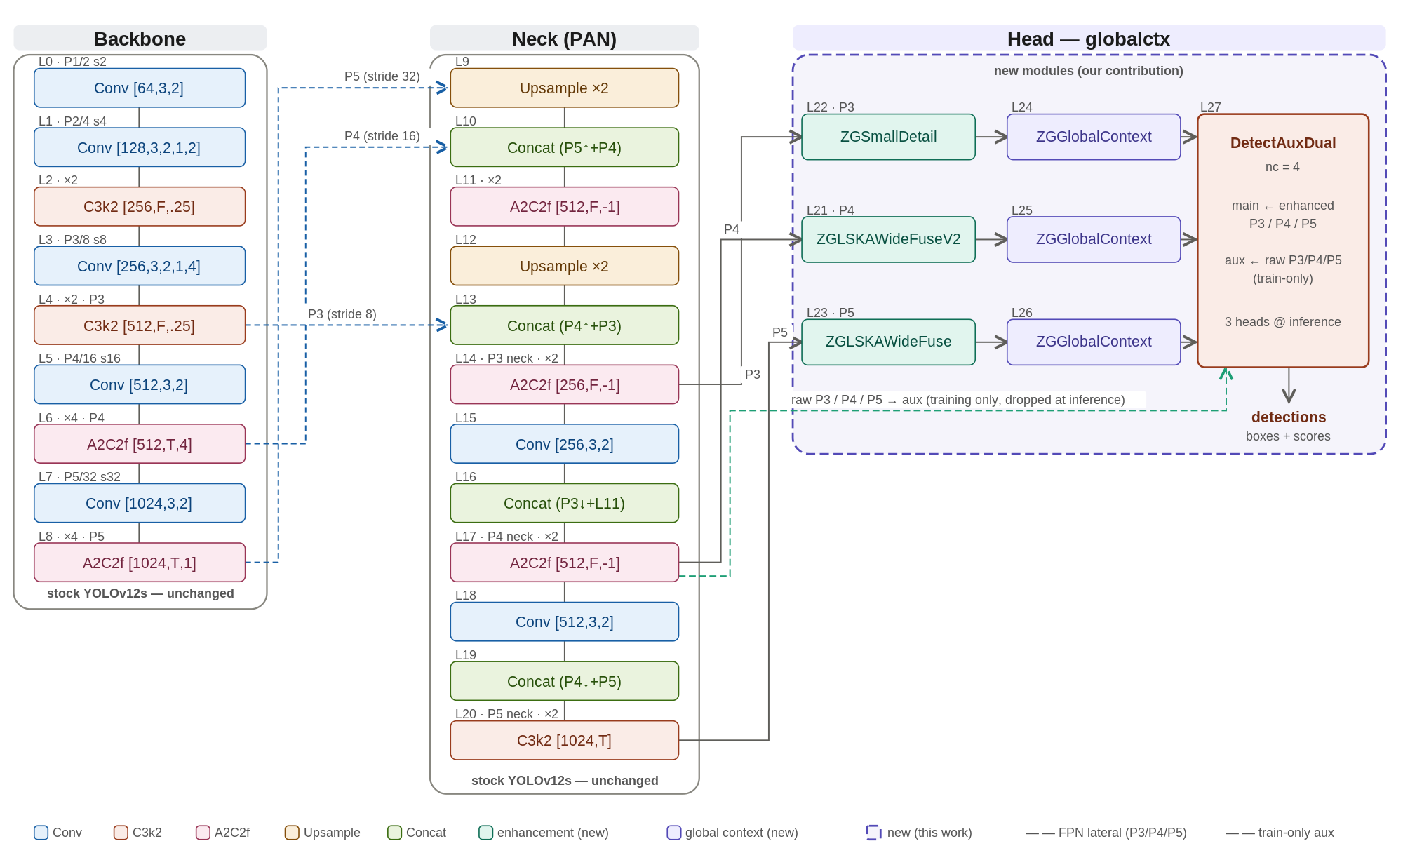
Figure 1. The globalctx architecture. The stock YOLOv12s backbone and PAN neck (grey) are unchanged; the dashed purple region marks the new modules added in this work: per-level scale-matched enhancement (ZGSmallDetail at P3, ZGLSKAWideFuseV2 at P4, ZGLSKAWideFuse at P5), a ZGGlobalContext module at each enhanced level, and a DetectAuxDual head whose auxiliary branch is dropped at inference.

B. Naming and notation
Module names combine a common prefix with descriptive suffixes; a few suffixes are established acronyms from the literature, while most are plain descriptions of the operation. Table 1 expands every term used in this chapter.
Term | Stands for | What it is
ZG- | Zero-Gated | Prefix for our custom append-only modules. Each is a residual branch scaled by a learnable gate gamma initialised to 0, so at start the module is an identity and the network reproduces pretrained YOLOv12s exactly.
LSKA | Large Separable Kernel Attention | Attention built from large separable (depthwise) kernels, giving a wide receptive field cheaply; adapted from the large-kernel-attention literature.
LKA | Large Kernel Attention | The large-kernel attention design that LSKA separates into cheaper depthwise factors.
WideFuse | descriptive (not an acronym) | A multi-branch fusion block combining large-receptive-field and small-receptive-field paths.
SmallDetail | descriptive | Small-object detail enhancement using two small depthwise kernels.
GlobalContext / GC | descriptive | Global channel-context recalibration (squeeze-and-excitation style).
GatherContext | descriptive | Gathers multi-level context into one pyramid level.
AuxDual | Dual Auxiliary head | A main detection head plus an auxiliary head used only during training.
SE | Squeeze-and-Excitation | Channel attention computed from global pooling.
DW / PW | Depthwise / Pointwise (1x1) conv | Lightweight convolution primitives.
GN / SiLU | Group Normalization / Sigmoid Linear Unit | Normalization and activation (x * sigmoid(x)).
DySample | Dynamic Sampling | Content-aware (learned) upsampling operator.
FPN / PAN | Feature Pyramid / Path Aggregation Network | Standard multi-scale neck designs.
P3 / P4 / P5 | Pyramid levels | Feature maps at stride 8 / 16 / 32 (small / medium / large objects).
RF | Receptive Field | Spatial extent of input that influences one output location.
AP / AR / mAP | Average Precision / Recall / mean AP | Standard detection accuracy metrics.
DFL / TAL | Distribution Focal Loss / Task-Aligned Learning | Box-regression loss and label-assignment strategy.
C3k2 / A2C2f / Conv | YOLOv12 blocks | Stock backbone and neck building blocks.
nc | number of classes | Equal to 4 here (knife, long_gun, other, pistol).
Table 1. Naming and abbreviations. The ZG- prefix marks our zero-gated modules; LSKA/LKA and SE are established techniques adapted here, while WideFuse, SmallDetail and GlobalContext are descriptive names.

C. The new modules and how they work
Figure 2 shows, for each new module, the problem it addresses (left), the exact internal operations (centre) and the resulting effect (right). The internals are op-exact; the problem and effect statements are interpretive.
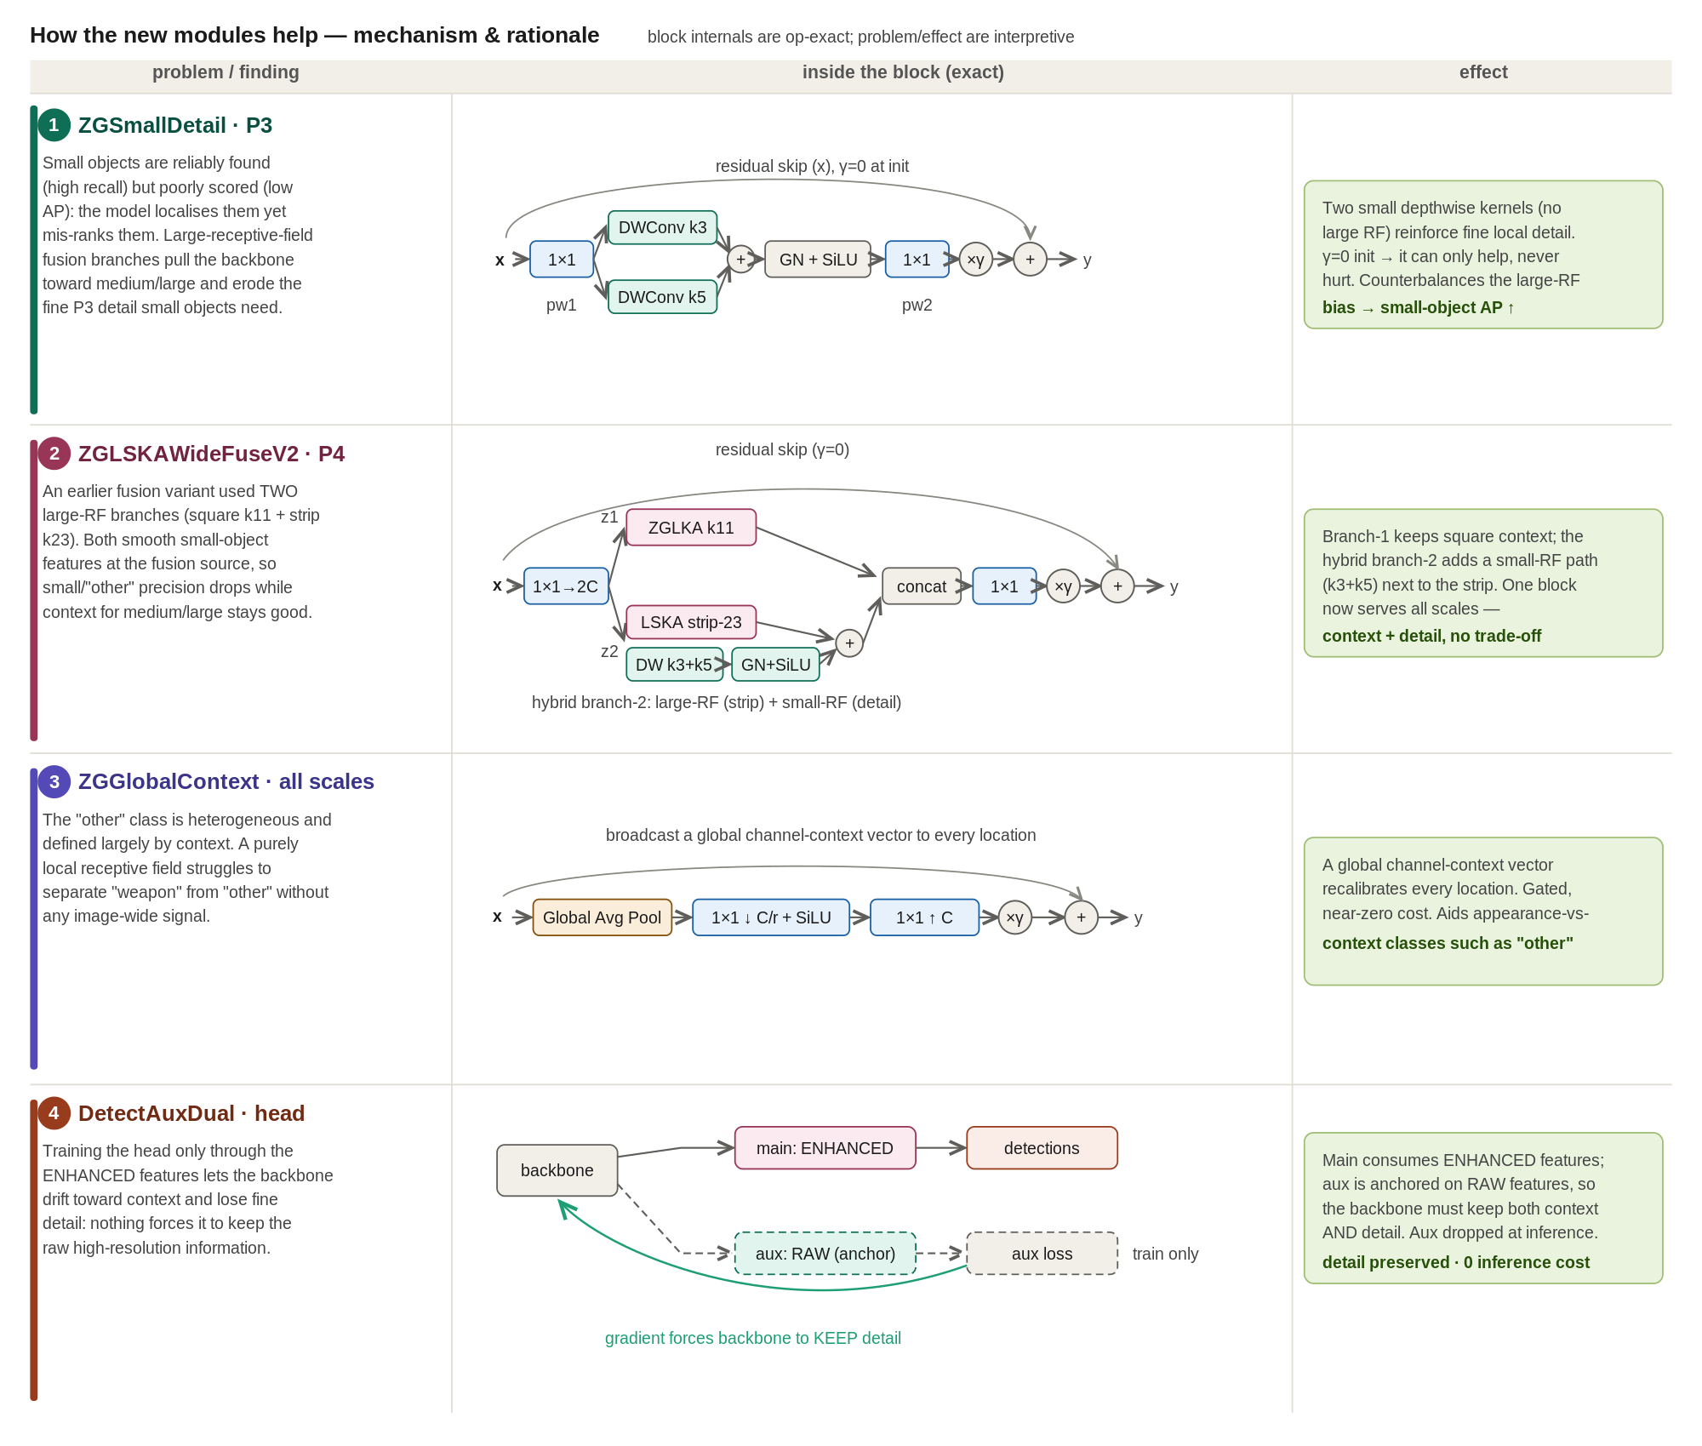
Figure 2. Mechanism of the new modules. Each module is a zero-gated residual branch (gamma = 0 at initialisation), so it can only refine the pretrained features.
ZGSmallDetail (P3). Small objects are reliably found but poorly scored, and wide-receptive-field branches erode the fine P3 detail they depend on. This module adds two small depthwise kernels (3x3 and 5x5) as a zero-gated residual, reinforcing local detail without large-kernel smoothing, which improves small-object precision.
ZGLSKAWideFuseV2 (P4). A pure large-kernel fusion smooths small-object features at the fusion source. This block expands the input with a 1x1 to two branches: branch 1 keeps square large-kernel context, while branch 2 is a hybrid that places a small-detail path (depthwise 3x3 + 5x5 with GroupNorm and SiLU) next to a large strip kernel. The branches are concatenated and projected, so one block serves both context and detail.
ZGLSKAWideFuse (P5). At the deepest level, where context dominates, a wide large-receptive-field fusion supplies broad scene context to the largest-stride features.
ZGGlobalContext (all levels). A purely local receptive field cannot separate the context-defined other class from genuine weapons. This module performs a squeeze-and-excitation-style global recalibration (global average pooling, a 1x1 bottleneck with SiLU, a 1x1 expansion, then a gated add), broadcasting a global channel-context vector to every location at near-zero cost.
DetectAuxDual (head). Training the head only through the enhanced features lets the backbone drift toward context and lose fine detail. We attach an auxiliary head to the raw features alongside the main head on the enhanced features; the auxiliary gradient forces the backbone to keep the raw high-resolution information. The auxiliary head is dropped at inference, so it costs nothing at test time.

D. What we improved over stock YOLOv12s
Relative to the unmodified YOLOv12s baseline, the architecture (i) preserves the strong pretrained initialisation through zero-gating, so every addition is a safe superset of the baseline; (ii) specialises the enhancement per scale, adding fine detail where small objects live (P3) and broad context where they do not (P4/P5); (iii) injects global scene context at every level to help the heterogeneous, context-defined other class; and (iv) preserves backbone detail through a dual-head training signal that is free at inference. All additions rely on depthwise and 1x1 operations, keeping the parameter and latency overhead small.

E. Approaches explored
The final design is the outcome of a broad architecture search spanning roughly forty incremental rounds. Rather than list every run, Table 2 summarises, at the proposal level, the mechanisms we explored, the specific variants tried under each, and whether they were adopted. The search covered where and at which kernel size to insert attention, wide-receptive-field fusion, global and channel context, self-attention, spatial pyramid pooling, deformable and dynamic-sampling operators, capacity redistribution and P3 depth/path changes, neck topology, input resolution, and a range of detection-head ideas (auxiliary supervision, decoupling, alternative classifiers and tower capacity). Only the five modules marked adopted appear in the final globalctx design; the remainder were neutral or harmful, indicating that the design had saturated.
Mechanism / approach | Variants we tried | Outcome
Large-kernel attention (LKA / LSKA / SKA) | ZGLSKA, ZGLKA, ZGLSKASG (spatial gate), ZGLSKAExpand, ZGLSKARefine; original SKA/LSKA at P3, SKA-residual, SKA-multiscale (5x5+9x9), SKA-weapon | Core wide-context mechanism, adopted at the deep levels
Insertion point, kernel size, replace-vs-gate | large-kernel attention at P3 / P4 (bottom-up & top-down) / P5; kernels 5 / 7 / 11 / 15; block-replacement vs zero-gated add; A2C2f attention swapped in at P5 | Settled on gated large-kernel attention at P4 (k11), bottom-up
Multi-branch / wide fusion | ZGLSKAWideFuse, ZGLSKAWideFuse3, ZGLSKAStripFuse, ZGLSKACompactFuse, ZGLSKASelectFuse (per-pixel spatial routing), ZGLSKAGCFuse, ZGLSKAWideFuseV2 | WideFuse (P5) and WideFuseV2 (P4) adopted; the rest not retained
Strip / elongated kernels | ZGStrip (1x23 + 23x1) | Retained only as a branch inside WideFuseV2
Multi-dilation receptive fields | ZGLSKAMultiDil (k7/dil2 + k11/dil3) | Not retained
Global / channel context | ZGGlobalContext, ZGGlobalContext2 (avg+max), ZGGC (GCNet), ZGSE (squeeze-excite), SE at P3 | ZGGlobalContext adopted at every enhanced level
Cross-scale context gather | ZGGatherContext (global cross-scale context into P3) | Not retained
Self-attention | ZGMHSA (multi-head self-attention at P5) | Not retained
Pyramid pooling at P3 | SPP / SPPF, ASPP (atrous spatial pyramid) | Not retained
Deformable / snake operators | ZGDCN (deformable conv), ZGDSConv (dynamic snake conv) | Not retained
Other operators | ZGStar (StarNet multiplicative feature mixing) | Not retained
Dynamic upsampling | DySample (content-aware upsampling, P3 / all levels) | Not retained
Capacity redistribution | P5 -> P3 capacity shift (LD-redistribute), P3-attention + redistribute | Not retained
P3 depth & path topology | deeper-P3 head (3 reps), deeper-P3 backbone (4 reps), dual-path P3, bidirectional P3, dense P3<->P4 skip, P3 attention | Not retained
High-resolution / small-object detail | ZGSmallDetail, ZGP2Fuse (inject backbone P2 into P3), P2 (stride-4) detection head | ZGSmallDetail adopted at P3
Neck topology | WeightedConcat (BiFPN-style weighted fusion), doubled PAN, dual-neck (separate box/cls pyramids) | Not retained
Auxiliary / deep-supervision heads | DetectAux (weight sweep 0.25-1.0), DetectAuxDual, DetectAuxDualDeepP3, backbone-anchored aux ([4,6,8]) | DetectAuxDual adopted (auxiliary branch train-only)
Decoupled heads | DetectDecoupled, DetectDecoupledObj, DetectDecoupledAux, DetectDecoupledCosine, dual-neck decoupled | Not retained
Objectness | DetectObj (softened objectness, beta 0.3 / 0.5) | Not retained
Classifier scoring | DetectCosine (cosine/prototype), DetectMultiProto, DetectCGC (class-guided context) | Not retained
Classification-tower capacity | DetectDeepCls (2->4 blocks), DetectWideCls (2x width), DetectSmallCls, DetectLKACls | Not retained
Input resolution | 640 vs 800 vs 960 px | Not retained (kept 640)
Table 2. Mechanisms and approaches explored during the architecture search, grouped by idea. Adopted entries (ZGSmallDetail, ZGLSKAWideFuse, ZGLSKAWideFuseV2, ZGGlobalContext, DetectAuxDual) form the final design in Figure 1.
Quantitative ablations and final accuracy for the adopted design are reported in the Results section on the leakage-free split; this chapter describes the architecture, the mechanisms, and the space of approaches that were explored.

