Dataset

A. Source and composition
The dataset was assembled from a wide range of real and cinematic sources to maximise scenario diversity. Frames were extracted from more than 1,200 YouTube videos spanning surveillance (CCTV) footage, action films containing weapon scenarios, firearm tutorials, and shooting-range and tactical-training recordings; these were supplemented with images collected manually through web image search. This sourcing strategy deliberately mixes viewpoints, resolutions, lighting conditions, and weapon-handling contexts, so the detector is exposed to both everyday and adversarial situations. The resulting dataset contains 26,528 images and 38,167 annotated instances - substantially larger than most publicly available weapon-detection datasets we surveyed, which typically comprise on the order of 5,000 to 10,000 images.
Four object categories are annotated: knife, long_gun (rifles, shotguns and other long firearms), pistol (handguns), and other. The other category is a deliberately curated set of objects that are visually confusable with weapons - for example phones, selfie sticks, and similarly shaped hand-held items. Rather than denoting a weapon, its purpose is to suppress false positives: by learning these hard negatives explicitly, the detector is discouraged from predicting a weapon where none is present.
After curation and splitting, the class distribution is moderately imbalanced - pistol (34.7% of instances) and long_gun (27.7%) are the most frequent, followed by other (21.5%) and knife (16.1%) (Table 1). Because the images originate from video frames, the split is constructed to avoid near-duplicate leakage (Section C); it preserves a 70/15/15 ratio for both the image count and every individual class, with each class within roughly 1% of 70/15/15 across the three subsets.
Split | Images | Instances | knife | long_gun | other | pistol
train | 18,579 (70.0%) | 26,614 (69.7%) | 4,247 (68.9%) | 7,375 (69.8%) | 5,692 (69.4%) | 9,300 (70.2%)
val | 3,978 (15.0%) | 5,665 (14.8%) | 950 (15.4%) | 1,537 (14.6%) | 1,240 (15.1%) | 1,938 (14.6%)
test | 3,971 (15.0%) | 5,888 (15.4%) | 966 (15.7%) | 1,647 (15.6%) | 1,271 (15.5%) | 2,004 (15.1%)
Total | 26,528 (100%) | 38,167 (100%) | 6,163 (16.1%) | 10,559 (27.7%) | 8,203 (21.5%) | 13,242 (34.7%)
Table 1. Dataset composition. For the split rows, the class percentages are the split's share of that class (showing the ~70/15/15 balance); in the Total row the class percentage is the class's share of all instances.

B. The other class: explicit hard negatives
A distinctive feature of this dataset is that it contains no pure background images - frames with no annotations - which object detectors conventionally rely on to learn what is not a target and so curb false positives. Instead, the objects most likely to be mistaken for weapons are themselves annotated as the other class. This turns passive empty-scene supervision into an explicit, localised signal: the model is shown exactly which look-alike items - phones, remote controls, selfie sticks, tools, and similar hand-held objects - it must not report as weapons.
Annotating confusable distractors as a dedicated class, rather than leaving them unlabelled or relying on background images, is uncommon among publicly available weapon datasets. It directly targets the dominant failure mode of weapon detectors in the wild - high false-positive rates on weapon-shaped everyday objects - by forcing the model to learn a decision boundary between genuine weapons and their visual twins. We adopt this explicit hard-negative supervision specifically to reduce false positives, and we regard the inclusion of confusable distractors as a dedicated class - a design choice absent from most existing weapon datasets - as an important and practically valuable property for real-world deployment. All categories, including other, were labelled with axis-aligned bounding boxes in YOLO format on the Roboflow platform, where the dataset is publicly available.

C. Leakage-free splitting by near-duplicate clustering
Because the images are video frames, temporally adjacent frames are near-identical, and a naive per-frame split would place near-duplicates in different subsets - leaking evaluation content into training and overstating accuracy. To prevent this we adopt a near-duplicate-aware splitting procedure. Each image is encoded by a 64-bit perceptual hash (difference hash); any two images within a Hamming distance of five are linked, and connected components are extracted with a union-find, grouping mutually near-identical frames into clusters. This yields 19,036 clusters over the 26,528 images (15,549 singletons; largest cluster 188 frames).
Each entire cluster is then assigned to a single split by a stratified greedy that targets the 70/15/15 ratio for the total image count and for every class simultaneously (Figure 1). Because no cluster is divided across subsets, no near-duplicate frame can cross a split boundary. We confirmed this with a cross-split near-duplicate audit of the final split: there are zero near-duplicate images between any pair of subsets (Table 4). The evaluation is therefore leakage-free, and the reported metrics reflect genuine generalisation rather than memorised near-duplicates.
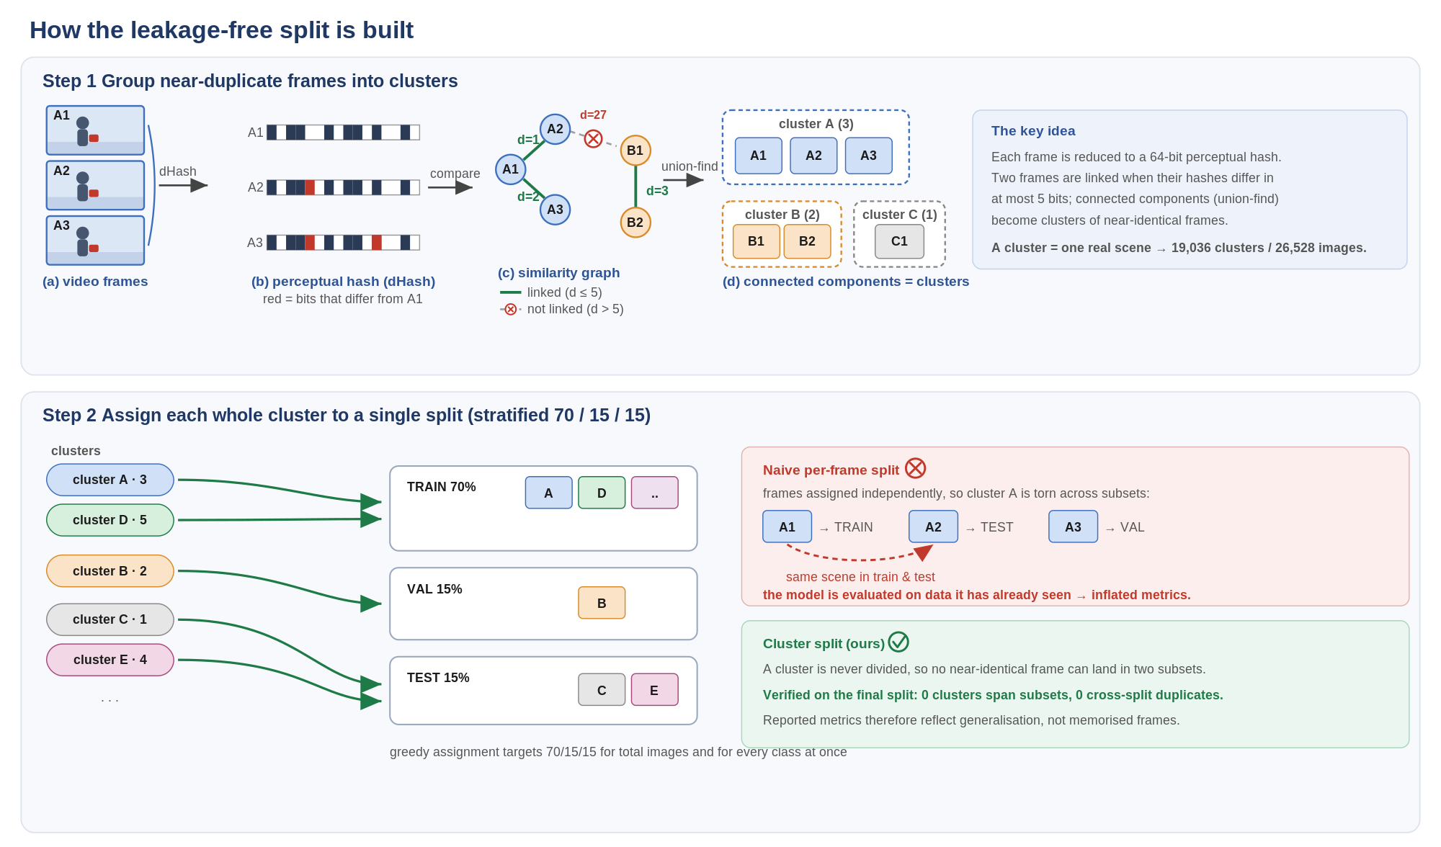
Figure 1. The leakage-free splitting procedure. Step 1: each frame is reduced to a 64-bit perceptual hash; frames within Hamming distance 5 are linked, and connected components (union-find) form clusters of mutually near-identical frames. Step 2: each whole cluster is assigned to a single split, with a greedy targeting 70/15/15 for the total image count and for every class. Because a cluster is never divided, no near-duplicate frame can appear in two subsets - unlike a naive per-frame split, which would place the same scene in both train and test.
Split pair | near-duplicate images | leakage rate
train - val | 0 | 0.0%
train - test | 0 | 0.0%
val - test | 0 | 0.0%
Table 4. Cross-split near-duplicate audit of the final split (difference hash, Hamming <= 5). No near-duplicate images occur across any pair of subsets - the split is leakage-free.

D. Object-size distribution
To characterise detection difficulty we categorise every instance by absolute scale, defined as the square root of the bounding-box area in pixels at the image's native resolution: small (< 48 px), medium (48-96 px) and large (>= 96 px). The dataset is dominated by large objects (70.2%), with 22.0% medium and only 7.8% small instances (Table 2). The distribution is consistent across the three splits, confirming the split does not bias object scale.
Split | Small (< 48 px) | Medium (48-96 px) | Large (>= 96 px)
train | 2,132 (8.0%) | 5,845 (22.0%) | 18,637 (70.0%)
val | 414 (7.3%) | 1,179 (20.8%) | 4,072 (71.9%)
test | 442 (7.5%) | 1,355 (23.0%) | 4,091 (69.5%)
Total | 2,988 (7.8%) | 8,379 (22.0%) | 26,800 (70.2%)
Table 2. Object-size distribution per split (scale = sqrt of box area in pixels; percentages are within each split). Small objects are scarce (~7.8%), making small-object accuracy the hardest and most informative metric.
The scarcity of small objects is strongly class-dependent (Table 3): pistol is by far the smallest class, with 13.6% of its instances small (1,801 of 13,242), reflecting that handguns frequently appear small and distant. The remaining classes are predominantly large (74-79%). This concentration of small, hard instances in the pistol class - together with the heterogeneous other class - is what the architecture and loss design in the following sections specifically target.
Class | Small | Medium | Large | Total (% of all)
knife | 294 (4.8%) | 1,289 (20.9%) | 4,580 (74.3%) | 6,163 (16.1%)
long_gun | 429 (4.1%) | 1,843 (17.5%) | 8,287 (78.5%) | 10,559 (27.7%)
other | 464 (5.7%) | 1,728 (21.1%) | 6,011 (73.3%) | 8,203 (21.5%)
pistol | 1,801 (13.6%) | 3,519 (26.6%) | 7,922 (59.8%) | 13,242 (34.7%)
Table 3. Per-class object-size breakdown over the full dataset. Small/Medium/Large percentages are within each class; the Total column is the class's share of all instances.

