Date of publication xxxx 00, 0000, date of current version xxxx 00, 0000.
Digital Object Identifier 10.1109/ACCESS.2024.Doi Number
Real-Time Weapon Detection Using Enhanced YOLO12 Models and a Custom Dataset
CONSTANTIN CATARGIU¹ AND IULIAN B. CIOCOIU¹
¹Faculty of Electronics, Telecommunications and Information Technology, Gheorghe Asachi Technical University of Iasi, Iasi 700506, Romania
Corresponding author: Iulian B. Ciocoiu (e-mail: iciocoiu@etti.tuiasi.ro).

ABSTRACT The paper presents a customized version of the YOLOv12 model that enables better detection of small, occluded, and low-contrast weapons in video sequences while maintaining high precision and real-time inference speed. The new model integrates (i) a loss reweighting strategy that emphasizes small objects' contributions during training, and (ii) a set of lightweight, append-only enhancement modules placed in the detection head of the baseline architecture. A large-scale custom dataset has been developed, including more than 26,528 images and 38,167 labeled instances, extracted from about 1,200 YouTube videos and curated web images. The dataset includes three weapon types (knife, pistol, long-gun) and an additional no_weapon class (showing images prone to being easily confused with true instances) to reduce false-positive detections. When benchmarked against the baseline YOLOv12s model, our customized version demonstrated a 4.9% increase in mAP@50, 7.2% in mAP@50-95, 3.8% and 7.1% improvements in Precision and Recall, respectively, while maintaining real-time inference speed.
INDEX TERMS Weapons detection, custom dataset, small objects, YOLO12s, detection head, loss reweighting.

- INTRODUCTION
Gun violence remains one of the most alarming public safety concerns worldwide. Over the last decade, mass shootings and armed attacks have frequently occurred in spaces once considered sanctuaries (schools, churches, concert halls), leading to devastating loss of life and deep societal trauma. Civilians around the world collectively own approximately 857 million firearms, with nearly 393 million of them in the United States alone—surpassing the country’s population [1]. 46,000 firearm-related deaths have been reported in the United States during 2023, including 656 mass shootings [2]. The growing accessibility of firearms and modern security challenges require intelligent systems capable of identifying and reacting to threats in real time. Those should be directly applicable to smart-city monitoring, school safety, and public transport surveillance, where both accuracy and real-time operation are indispensable. While many surveillance setups may still rely on human operators monitoring camera feeds for threat identification, this approach is inherently flawed—suffering from fatigue, blind spots, and delayed reaction times. The burden of detecting weapons in real-time across dozens of feeds is both stressful and error-prone, especially in fast-paced or crowded environments.
The problem of detecting firearms and other weapons in images and video has been approached from many angles over the past two decades, reflecting the evolution of computer vision techniques. Research has progressed from classical feature-based methods, through sensor-driven approaches such as thermal and millimeter-wave imaging, into the deep learning era, with a particular emphasis on lightweight architectures for real-time deployment. More specifically, Convolutional Neural Networks (CNNs) [3] proved particularly well-suited for object detection tasks due to their ability to automatically learn hierarchical feature representations directly from raw image data. Through layers of convolutions, pooling, and non-linear activations, CNNs can capture both low-level visual patterns (e.g., edges, textures) and high-level semantic information (e.g., shapes, object parts) essential for identifying and localizing objects in highly varying scenes. This end-to-end learning capability eliminates the need for handcrafted features and makes CNNs highly adaptable to very diverse visual environments, even under challenging conditions such as occlusion, lighting variation, and cluttered backgrounds.
The introduction of the YOLO (You Only Look Once) model in 2016 [4] revolutionized real-time object detection by offering a practical balance between speed and accuracy. Its efficiency and simplicity have positioned it as a leading solution for video surveillance, autonomous systems, and public safety monitoring applications. Since the release of the first version, the architecture has evolved significantly. Each new version has introduced improvements in bounding-box localization, class-confidence estimation, feature extraction across multiple scales, and robustness to overlapping objects. As a result, the YOLO family has continually maintained its signature speed, making it a strong candidate for deployment in time-critical applications.
The recent YOLOv12 [5] iteration represents a major advancement in the evolution of those models. Building on the proven key advantages of the previous versions, YOLOv12 delivers a well-balanced architecture optimized for both accuracy and efficiency in complex environments. It introduces the Residual Efficient Layer Aggregation Network (R-ELAN), which improves feature fusion and employs novel attention mechanisms to reduce computational complexity and increase operating speed. The use of decoupled detection heads yields more precise predictions, while transformer-inspired components enhance global scene understanding. These improvements make YOLOv12 particularly well-suited for real-time weapon detection, offering high precision and speed in challenging surveillance scenarios.
The present paper proposes several modifications to the original YOLOv12-s architecture that have proven effective for weapon detection in surveillance footage. The main contributions of the study include:
- A comparative evaluation of the baseline vs. customized YOLOv12s model. The novel configuration introduces (i) small object–aware loss function reweighting and (ii) a set of lightweight, append-only enhancement modules placed in the detection head of the baseline architecture. As a result, a clear increase in detection performance over the baseline model was obtained: the mAP@50 metric increased from 0.812 to 0.852, marking a +4.9% relative improvement. The more stringent mAP@50-95 improved from 0.516 to 0.553 (+7.2%), confirming better localization accuracy across multiple IoU thresholds. Precision improved from 0.833 to 0.865 (+3.8%), while Recall increased from 0.747 to 0.800 (+7.1%). Consequently, the overall F1-score reached 0.831, compared to 0.788 for the baseline (+5.5%).
- A large, realistic, publicly accessible dataset has been developed. It includes 26,528 images with 38,167 instances across four classes (knife, pistol, long-gun, no_weapon) captured from more than 1,200 YouTube videos and curated images spanning diverse, challenging conditions (motion blur, varied lighting, occlusion, dense crowds). Considering the no_weapon class is particularly important, as it helps reduce false positives by teaching the model to distinguish weapons from visually similar but safe objects and backgrounds. The dataset is publicly available on the Roboflow platform [6, 7] to support reproducibility.
- An extensive supplementary material including results on hyperparameter tuning, variants of architectural modifications that have been tested, and many examples of images and weapon instances missed or erroneously detected by the YOLO12 baseline model, while successfully tackled by the proposed solution.
The paper is organized as follows. Section II provides an overview of previous work on weapons detection, including feature-based approaches before the deep learning era. Section III describes the new weapon/no_weapon dataset and the data split details. Section IV presents the proposed approach, focusing on the architectural enhancements for small-object detection. Experimental comparative results between the original and modified models are reported in Section V, while Conclusions are finally outlined, suggesting additional topics worth further study.
RELATED WORK
A plethora of solutions have been proposed during the last few decades to tackle the weapon detection task. Those vary widely in terms of handcrafted or learned feature types, sensing modalities, and classification approaches. Tiwari and Verma [8] proposed a color-segmentation plus feature-matching pipeline: images were clustered using k-means to isolate gun-colored regions, refined with morphological processing, and then described using Harris corner detection and FREAK descriptors. Guns were detected if more than 50% of a blob’s features matched a stored descriptor. Tested on a small dataset of 89 images, the system achieved 84.26% accuracy and was robust to scale, rotation, and partial occlusion. However, performance degraded under variable lighting, limiting real-world applicability. Ben Halima and Hosam [9] employed a Bag-of-Visual-Words (BoW) framework with SVM-based classification. SIFT features extracted from training images were clustered via k-means to form a visual vocabulary, and each image was represented as a histogram of “visual word” occurrences. Outliers were pruned using the RANSAC algorithm, enabling detection and localization of weapons. Their system performed well on a dataset of 200 weapon and non-weapon images in cluttered scenes, but suffered from slow clustering and histogram computation, restricting real-time deployment.
To overcome limitations of visible-light imagery, researchers explored new sensing modalities. Xiao et al. [10] used Passive Millimeter Wave (PMMW) imaging, which can detect concealed, even non-metallic, weapons. They enhanced the traditional Haar-like feature set with four new “half-surrounded” features tailored for pistols, using integral images for efficiency. Features were fed into a cascaded AdaBoost classifier, which demonstrated strong detection across different pistol shapes, sizes, and orientations. Muñoz et al. [11] proposed a two-stage framework to detect concealed handguns in thermal imagery. A lightweight variant of YOLOv3 first detected firearms and people in thermal frames, then a logical-association strategy checked for spatial overlap with human silhouettes, triggering alerts only when a gun was near a person. It is worth noting that the system was deployed on a chest-mounted Android smartphone connected to a miniature thermal camera, enabling low-power wearable operation. On their customized UCLM Thermal Imaging Dataset of annotated videos of concealed objects under various clothing conditions, the proposed model achieved 64.52% mAP@50, outperforming earlier approaches, although results were limited by clothing thickness, concealment duration, and dataset diversity. Gosain et al. [12] combined sensing modalities by fusing infrared and RGB imagery using the Discrete Wavelet Transform (DWT). Their pipeline included preprocessing, image fusion, Otsu’s thresholding, and contour analysis, followed by logistic regression classification. On 1,759 images, they reported 90.62% accuracy, 86.66% Precision, and 92.85% Recall. While effective, the method required precise alignment between the IR and RGB streams and struggled under inconsistent lighting.
With the advent of CNNs, object detection accuracy improved significantly. Jain et al. [13] compared the efficiency of Single-Shot Detectors (SSD) and Faster R-CNN models. SSD offered faster inference (0.736 s/frame) but lower accuracy (73.8%), while Faster R-CNN achieved 84.6% accuracy but slower performance (1.606 s/frame). Olmos et al. [14] built one of the first real-time handgun alarm systems. Using a VGG-16 CNN fine-tuned on handgun datasets and a Faster R-CNN, they compared sliding-window and region-proposal approaches. The latter achieved 100% Recall and an F1-score of 91.43%, even with low-quality YouTube video footage. Their system activated alarms only after five consecutive detections to reduce false alerts, achieving a response time of 0.2s in most cases. They introduced a novel metric, Alarm Activation Time per Interval (AATpI), to evaluate alert responsiveness. Later, Olmos et al. [15] extended their work with binocular fusion, pre-selecting regions of interest using disparity maps. This reduced false positives by ~49% and boosted F1-scores by ~10.9%, especially in cluttered environments, though false negatives increased when disparity failed. Lim et al. [16] developed MLFPNet, a deep multi-level feature pyramid network specifically designed for non-canonical firearm detection. Their custom dataset included unusual firearm orientations and cluttered backgrounds. MLFPNet improved scale awareness and accuracy compared to baselines, but increased computational cost limited deployment in resource-constrained environments.
Other researchers sought to incorporate contextual cues. Maligireddy et al. [17] built a two-branch hybrid framework: YOLOv5 detected guns, while HRNet estimated human keypoints. Features were fused via a Multi-Layer Perceptron, enabling the model to reason about posture and weapon appearance together. On 9,500 images from CCTV footage, AI-generated samples, and movie scenes, their model achieved 90.7% accuracy, 93.2% Precision, 87.8% Recall, and 90.4% F1 score. However, computational overhead and pose estimation errors under occlusion limited real-time use. Xu and Verma [18] similarly integrated Human–Object Interaction (HOI) cues to predict weapon locations based on hip and body posture, achieving 74% accuracy on their PHW dataset. Egiazarov et al. [19] decomposed firearms into components (barrel, stock, magazine, receiver) and trained separate CNNs for each. Component-wise accuracies of 76–88% were achieved, improving robustness to occlusion, but confusion with clothing or ambiguous shapes remained.
False alarms are particularly challenging in surveillance, and weapon detection is no exception. Pérez-Hernández et al. [20] introduced ODeBiC (Object Detection with Binary Classifiers), a two-level Faster R-CNN framework that uses binary classifiers to distinguish between confusing classes (e.g., pistols vs. phones). Results reported on a custom dataset showed up to a 19.57% increase in precision and a 56.5% decline in false-positive decisions, however, complexity and inference speed were subject to difficult trade-offs. Castillo et al. [21] addressed lighting variation in reflective knives using DaCoLT preprocessing (darkening + CLAHE enhancement during both training and testing). On their Database-4, R-FCN (ResNet101) reached F1 = 93.97%, 100% Precision, and 88.62% Recall at 10 fps. DaCoLT reduced brightness-related performance drops from 15% to only 3%, though sudden blur still hurt performance. Bhatti et al. [22] investigated CCTV footage, collecting 8,300 images. They tested multiple CNNs and object detectors, with YOLOv4 performing best (mAP@50 = 91.73%, F1 = 91%). A key contribution was the introduction of a “Not-Pistol” class (wallet, mobile, selfie stick), which reduced both false positives and false negatives. Amado-Garfias et al. [23] extended this to armed-person identification, using YOLOv4 to detect people, weapons, and faces, then applying spatial heuristics and machine learning classifiers to infer which person was armed. Random Forest classification models achieved 85.44% accuracy and an F1 score of 87.87%, though performance declined in crowded or occluded scenes.
Given the need for efficiency, several works targeted lightweight or embedded systems. Žigulić et al. [24] trained the YOLOv10n model on 9,464 images, achieving 93.8% Precision, 86.3% Recall, mAP@50 = 0.91, mAP@50–95 = 0.739, running at 20 FPS on a Raspberry Pi 4 in ONNX format. Despite feasibility, results degraded in the presence of blur or poor lighting. Kaya et al. [25] proposed a custom CNN for seven weapon classes (5,214 images), achieving 98.4% accuracy and outperforming VGG-16, ResNet-50, and ResNet-101. Park et al. [26] introduced MSA-YOLOv5, a YOLOv5n variant with Multi-SpatialLite Attention, achieving 97.6% Precision, 99% Recall, F1 = 97%, mAP@50 = 98.3% with only 1.79M parameters, making it highly suitable for edge deployment. Finally, Sumi and Dey [27] applied YOLOv9 to a small dataset (500 images) and reported near-perfect performance (Precision 99.6%, Recall 99%, mAP@50 = 99.2%). However, the tiny, single-class dataset raised concerns about overfitting and limited generalization.
THE CUSTOM WEAPONS DATASET
We introduce a new large-scale dataset, publicly hosted on the Roboflow platform [6, 7], specifically developed for the weapon detection task. The dataset was assembled from a wide range of real and cinematic sources to maximize scenario diversity. Frames were extracted from more than 1,200 YouTube videos spanning surveillance (CCTV) footage, action films containing weapon scenarios, firearm tutorials, and shooting-range and tactical-training recordings; these were supplemented with images collected manually through web image search. This sourcing strategy deliberately mixes viewpoints, resolutions, lighting conditions, and weapon-handling contexts, exposing the detector to a diverse range of realistic situations. The resulting dataset contains 26,528 images and 38,167 manually annotated instances, making it one of the largest open-access weapon-related resources.
The dataset comprises four classes: knife, pistol, long-gun (e.g., rifles, shotguns), and a separate no_weapon category, introduced as a dedicated negative class to reduce false positives by explicitly teaching the model to distinguish weapons from visually similar non-threatening objects. Such objects represent a curated set of visually confusable items such as phones, remote controls, selfie sticks, and similarly shaped hand-held tools. By forcing the model to learn a decision boundary between genuine weapons and possible confounders, this design directly targets the dominant failure mode of weapon detectors deployed in the wild: high false-positive rates on weapon-shaped common objects. All categories were labeled with axis-aligned bounding boxes in YOLO format on the Roboflow platform, where the dataset is publicly available. To enhance performance in realistic deployments, the images span a wide variety of conditions, including different scales (close vs. distant views), lighting (day, night, artificial), occlusions, motion blur, and crowded backgrounds.
Before training, all images underwent preprocessing to standardize format and enhance quality, according to:
• auto-orient: corrected image orientation based on metadata (e.g., data that specifies the intended image orientation). Sometimes the underlying pixel data may remain stored in an uncorrected orientation. The auto-orientation step rotates the pixel matrix based on the metadata to produce an upright image. This correction prevents the model from learning misleading pose variations (e.g., sideways weapons or rotated people) and ensures that feature extraction occurs on properly oriented objects, improving robustness during training.
• resize: uniform resizing to 640×640 pixels, consistent with the YOLO model training requirements
• auto-adjust contrast: adaptive histogram equalization by redistributing pixel intensities across the full dynamic range to improve visibility and emphasize object boundaries, particularly in low-light or high-glare conditions. This step is particularly important for small-object detection, where critical features (e.g., the outline of a handgun or the straps of a backpack) may get lost in shadows or low-contrast regions.
Examples of image samples are provided in Figure 1, showing a broad diversity of firearm appearances across different classes, as well as variations in illumination, background complexity, and object scale. In particular, small and partially occluded weapons are included to reflect real-world surveillance challenges. Such visual examples provide an intuitive understanding of the dataset complexity and underscore the need for architectures and loss functions that are robust to scale variation and cluttered environments.
The dataset was divided into three non-overlapping subsets: training, validation, and test. The training set was used for model optimization, the validation set for hyperparameter tuning and early stopping, and the test set for the final performance evaluation. Because most of the images originate from video footage, the split was constructed to avoid near-duplicate leakage between subsets (since successive video frames are almost identical, a naive per-frame split may place much similar images in the training and test subsets, yielding an over-optimistic detection accuracy). As indicated in Figure 2, each image is encoded with a 64-bit perceptual hash (difference hash) [28]. Any two images within a Hamming distance of 5 are linked, and connected components are extracted via union-find, grouping mutually near-identical frames into clusters. A threshold of 5 is consistent with common practice for difference-hash-based near-duplicate detection, where small distances in this range are typically sufficient to capture near-identical frames while avoiding the merging of visually distinct images. This procedure yields 19,036 clusters over the 26,528 images. Every whole cluster, rather than each individual frame, is then assigned to a single split using a stratified greedy procedure that targets a 70/15/15 training/validation/test ratio for the total image count and for every class simultaneously. Because no cluster is ever divided across subsets, no near-duplicate frame can cross a split boundary. A cross-split audit of the final split confirmed zero near-duplicate images between any pair of subsets, indicating that the chosen threshold is sufficiently conservative for this data and that the evaluation is leakage-free, with reported metrics reflecting genuine generalization rather than memorized near-duplicates.
Table 1 presents the detailed composition of the splits, including the number of images, instances, and per-class distribution, balanced across splits to prevent bias during model training. We additionally analyzed the distribution of the object sizes based on the normalized bounding box areas (w×h in YOLO format). Objects were categorized into three groups: small (area < 32x32 pixels), medium (32x32 < area ≤ 96x96 pixels), and large (area > 96x96 pixels), as indicated in Table 2. The dataset is dominated by large objects (72%), with 20% medium and only 8% small instances, a distribution that is consistent across all three splits. Table 3 presents the data distribution per class according to the object size. The presence of small objects is strongly class-dependent: most of the instances classified as small belong to the pistol class (15.3%), reflecting that handguns frequently appear small and distant in the source footage, while the remaining classes are predominantly large (75–80%). This concentration of small, hard instances within the pistol class, together with the heterogeneous no_weapon class, is what the architecture and the loss-function design described in the following sections specifically target.
THE PROPOSED MODEL
The proposed model builds on lessons learned from the limitations revealed by previous solutions to the weapon detection task. More specifically, traditional handcrafted features struggle with scene variability, and thermal or infrared imagery may reduce false positives but rely on specialized hardware. Standard CNN-based object detectors improve accuracy but often sacrifice speed, while contextual methods add pose or human–object interaction cues but involve a high computational cost. Finally, lightweight YOLO variants offer improved efficiency but still face limitations with small, occluded firearms.

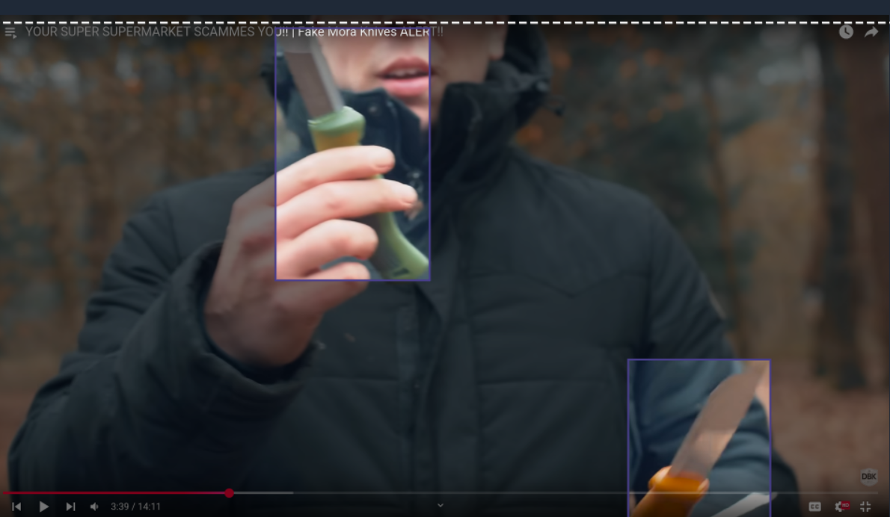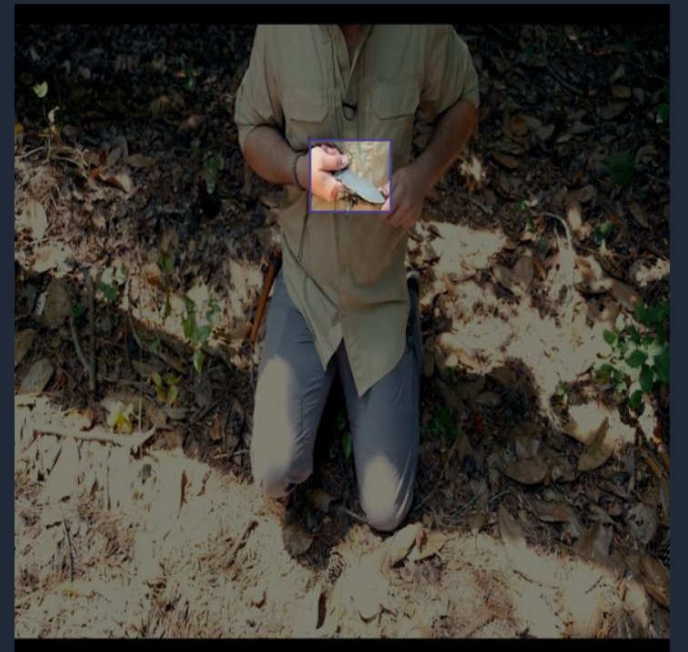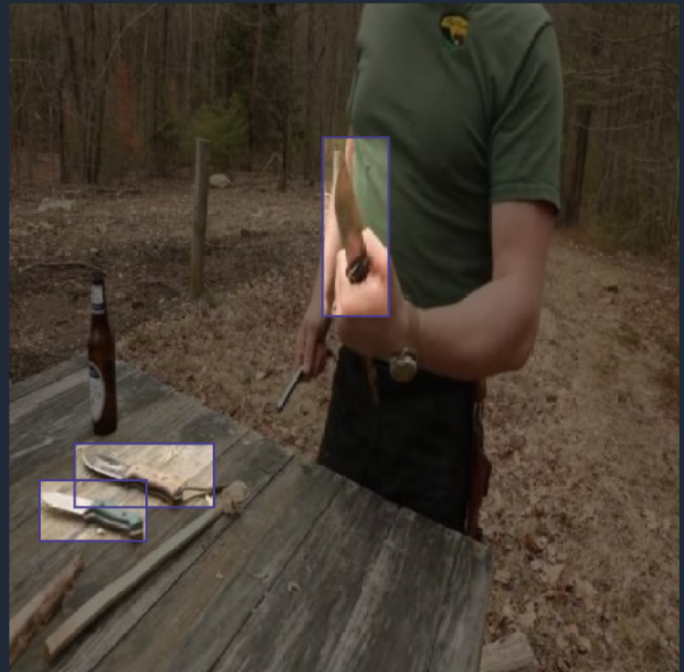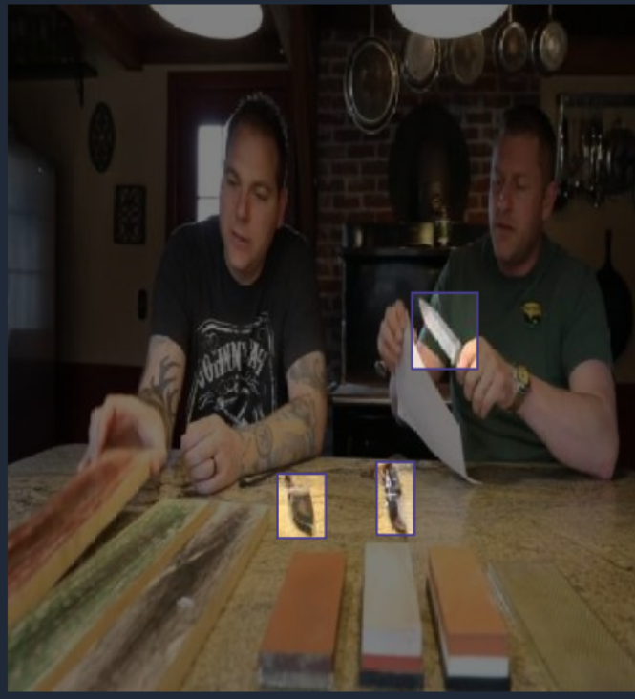
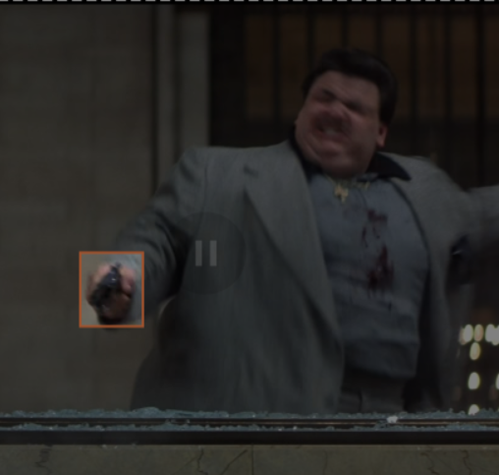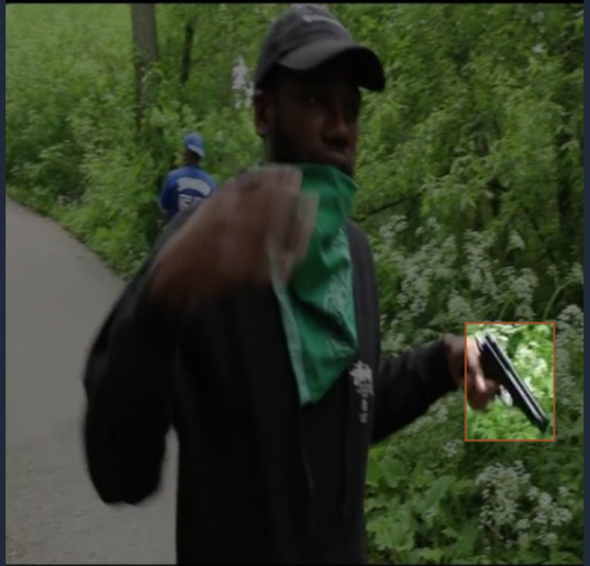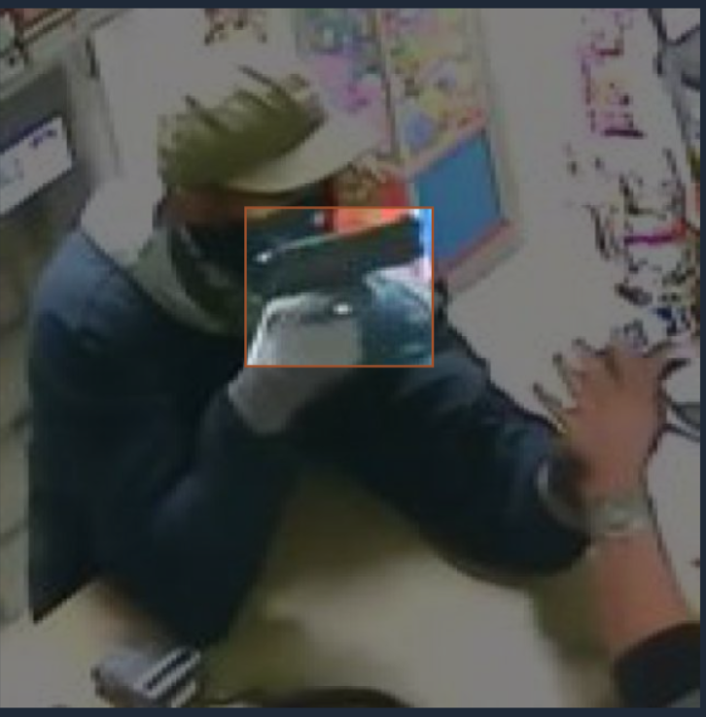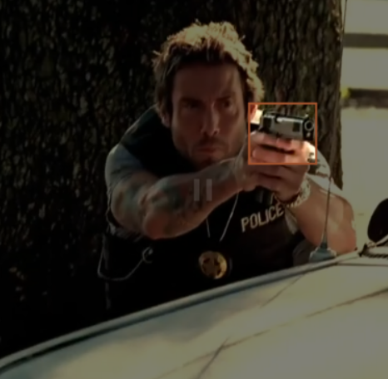
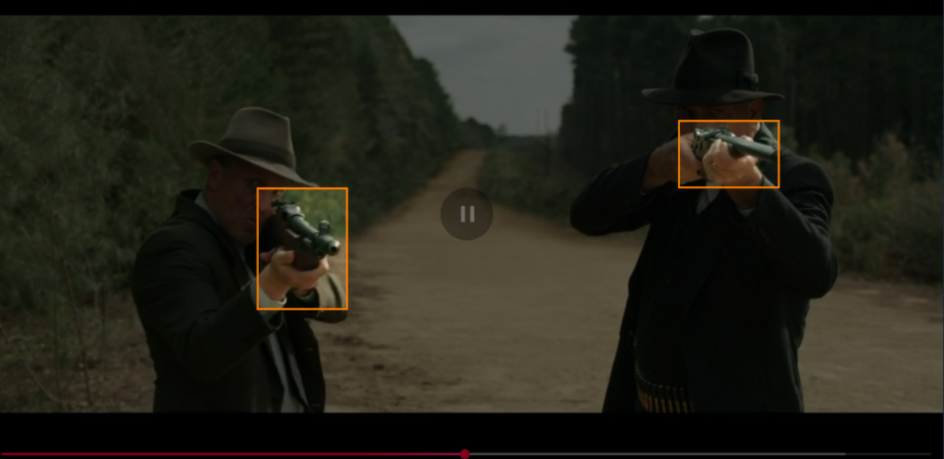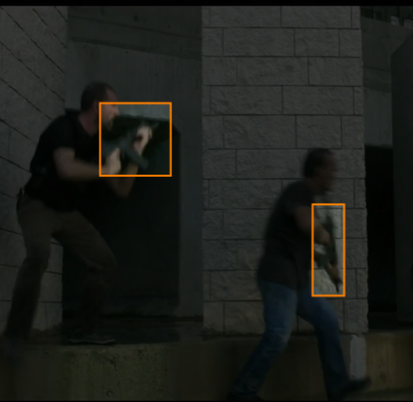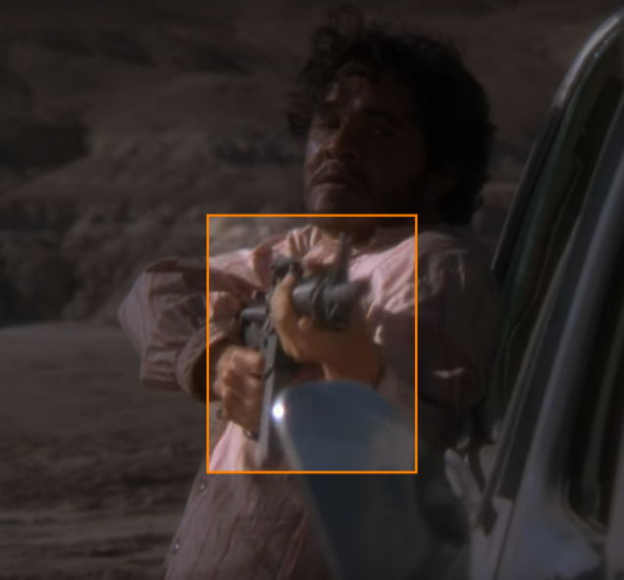
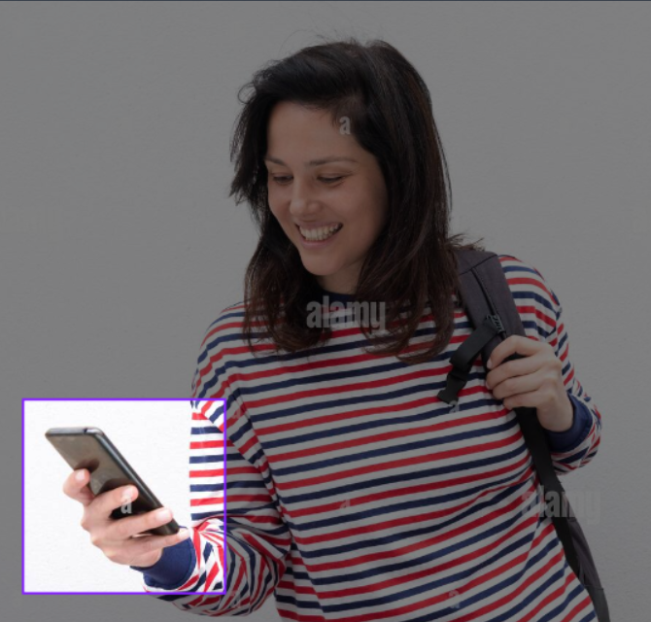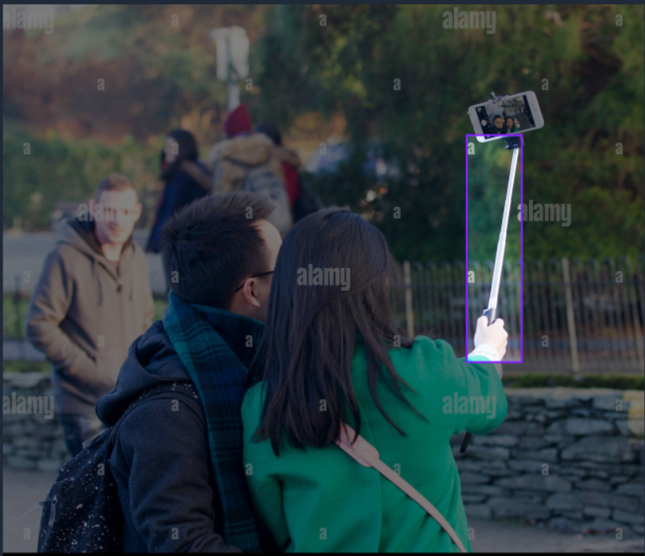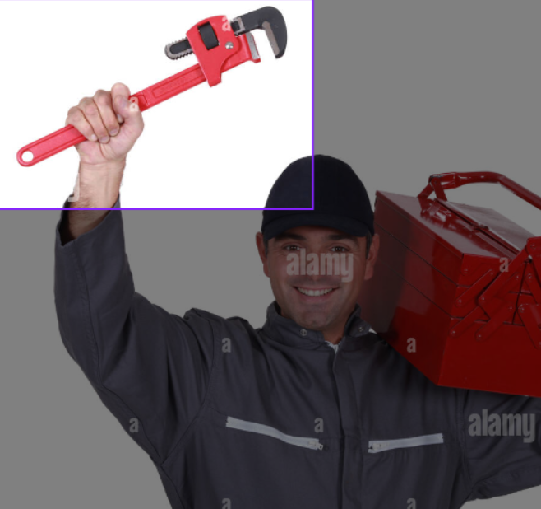
- Sample images from the dataset (from top to bottom: knife, pistol, long-gun, no_weapon classes).

TABLE 1. Dataset split and class distribution.
 | Images | Instances | knife | long-gun | pistol | no_weapon
Train | 18,577 (70.0%) | 26,103 | 4,294 (16.5%) | 7,337 (28.1%) | 9,187 (35.2%) | 5,285 (20.2%)
Validation | 3,973 (15.0%) | 5,853 | 923 (15.8%) | 1,561 (26.7%) | 1,985 (33.9%) | 1,384 (23.6%)
Test | 3,978 (15.0%) | 6,111 | 941 (15.4%) | 1,643 (26.9%) | 2,060 (33.7%) | 1,467 (24.0%)
Total | 26,528 | 38,067 | 6,158 (16.2%) | 10,541 (27.7%) | 13,232 (34.8%) | 8,136 (21.4%)

TABLE 2. Bounding box size distribution.
 | Total # boxes | Small | Medium | Large
Train | 26,103 | 2,198 (8.4%) | 5,312 (20.4%) | 18,593 (71.2%)
Validation | 5,853 | 475 (8.1%) | 1,087 (18.6%) | 4,291 (73.3%)
Test | 6,111 | 499 (8.2%) | 1,167 (19.1%) | 4,445 (72.7%)
Total | 38,067 | 3,172 (8.3%) | 7,566 (19.9%) | 27,329 (71.8%)

TABLE 3. Bounding box size distribution per class
 | Total boxes | Small | Medium | Large
knife | 6,158 | 225 (3.7%) | 1,065 (17.3%) | 4,868 (79.1%)
long-gun | 10,541 | 482 (4.6%) | 1,542 (14.6%) | 8,517 (80.8%)
pistol | 13,232 | 2,023 (15.3%) | 3,414 (25.8%) | 7,795 (58.9%)
no_weapon | 8,136 | 442 (5.4%) | 1,545 (19.0%) | 6,149 (75.6%)
Total | 38,067 | 3,172 (8.3%) | 7,566 (19.9%) | 27,329 (71.8%)

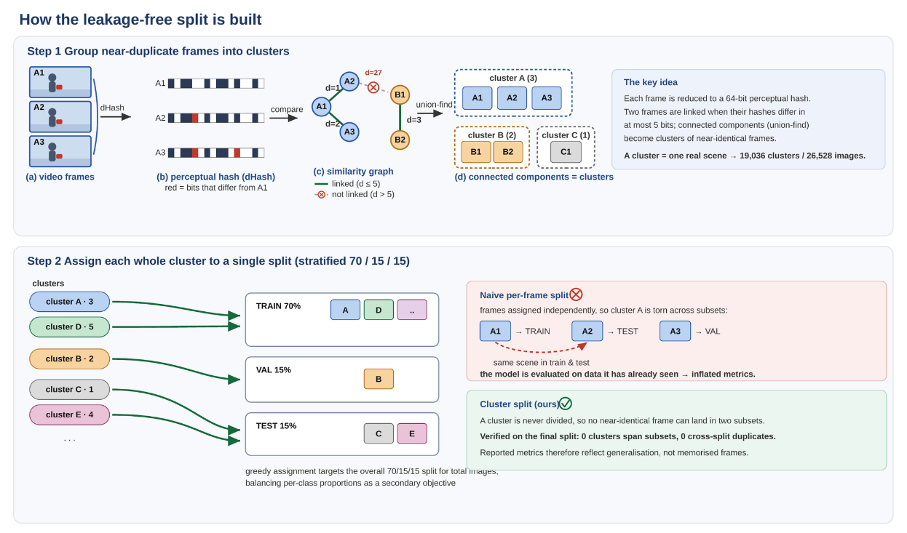

- The leakage-free splitting procedure. Step 1: each frame is reduced to a 64-bit perceptual hash; frames within Hamming distance 5 are linked, and connected components form clusters of mutually near-identical frames. Step 2: each cluster is assigned to a single split.

The YOLO12 model introduces a hybrid CNN+Transformer architecture [5], including several innovative ideas such as Area Attention (AA; provides reduced complexity of self-attention by novel spatial regions partitioning), Residual-Efficient Layer Aggregation Networks (R-ELAN; enables better gradient flow by introducing residual shortcuts), and FlashAttention (yields higher speed by reducing memory access overhead). Those enhancements improve computational efficiency, enable real-time operation, and surpass the performance of object detectors based on separate CNN or transformer models [29].
We developed a customized YOLOv12s variant with two key modifications compared to the baseline model, aiming at improving small-object detection:
a) loss function reweighting strategy, giving higher importance to small-object contributions during training to address class imbalance and improve recall
b) architectural modifications of the head module in the baseline model, by including scale-specific feature enhancement procedures and global-context driven calibration.
Both the original and modified models were trained under similar hyperparameter settings to ensure fair comparison.
- SMALL OBJECT–AWARE LOSS AND ASSIGNMENT
The standard YOLOv12 loss is effective for general-purpose detection, but it suffers when applied to small, cluttered, or occluded targets such as firearms in surveillance footage. Our contributions address exactly these limitations and propose a new definition of the overall loss function, as described below.
A1. Dynamic curriculum weighting
In the standard YOLO12 model all positives are weighted roughly equally after assignment, hence large boxes dominate because their Intersection over Union (IoU) gradients are stronger. We introduce a dynamic curriculum weighting that combines inverse-area scaling with confidence-score weighting. Small objects, therefore, start with greater influence, preventing them from being ignored in early optimization.
For each positive (foreground) assignment j, we compute a combined weight:
(1)
where t is the training epoch,is the target score, and is a normalized inverse-area term:
(2)
withthe ground-truth area (in input pixel coordinates), , and P the set of positives in the batch. The mixing coefficient α^{(t)} follows a curriculum:
(3)
enabling the transition from early area-dominant (favoring small objects) to later balanced learning (T is the total number of training epochs). α₁ and α₂ are hyperparameters optimally tuned via grid search.
We applyto both the Intersection over Union (IoU) and the Distribution Focal Loss (DFL) terms used in the baseline model, defined as:
(4)
whereis a normalization term, b_{j} and are the ground-truth and predicted boxes, respectively.
(5)
where CE is the cross-entropy loss, with p_{j} representing the predicted logits over discrete bins, applied per edge and averaged in our implementation. For each box edge, the ground-truth continuous coordinate (e.g., y) is rounded to its two adjacent integer bins l = floor(y) and r = l + 1, weighted by linear interpolation coefficients w_{r} = r - y and w_{l} = y - l.
A2. Auxiliary center loss for small objects
YOLO12 models use IoU-based regression losses, which are small for tiny boxes because small shifts cause IoU to collapse, even when centers are close. To compensate for that, we added a lightweight L1 penalty on box centers applied only to small objects, scaled with a decaying schedule:
(6)
scaled by a decaying weight given by, where the binary mask 1_{small} isolates the small targets (area lower than 32×32 pixels), c_{j} and are the ground-truth and predicted bounding box centers, respectively. α₃ and α₄ are hyperparameters optimally tuned via grid search. The center alignment loss stabilizes training, especially during the early epochs, and improves the precision of localizing small handguns/knives, reducing “miss by a few pixels” errors.
A3. Adaptive loss clipping
The YOLO12 training procedure occasionally produces unstable spikes (e.g., mislabeled data or hard positives) that can destabilize optimization, especially in cluttered security footage. To alleviate this, we propose the per-batch clipping of the IoU and DFL losses with epoch-dependent ceilings:
(7)
where the introduction of clipping thresholds for MIoU and MDFL prevents gradient explosions during early training, yielding smoother loss curves and more stable convergence. α₅-α₈ are hyperparameters optimally tuned via grid search.
A4. Assignment tuned towards small objects
The Task-Aligned Assigner (TAL) module in the standard YOLO12 model uses a small top-k candidate pool (e.g., k=10), which may cause false negatives in small-object detection, since none of the anchors may overlap with the target. To prevent this, we increased the candidate pool dimensionality to k = 13, which may yield more anchor candidates per bounding box, improving recall performance, especially in small-gun scenarios. We additionally tuned the Task-Aligned metric’s exponents — the score exponent (0.7) and the IoU exponent (4.0), versus the YOLOv12 defaults of 0.5 and 6.0, respectively — to better balance the classification confidence and the localization quality during assignment.
The overall detection objective is given by:
(8)
with the λ_{box}, λ_{DFL}, and λ_{cls} weights set as in the original YOLO12 model, while λ^{(t)}_{center} is indicated in section A2.
The experimental results reported in the next sections confirm that the combined effect of dynamic curriculum weighting, the new center-oriented loss, adaptive clipping, and an expanded assignment target improve small-object detection performance and lead to more stable training behavior.
- ARCHITECTURAL ENHANCEMENTS FOR SMALL-OBJECT DETECTION
The baseline YOLOv12 architecture is primarily optimized for medium and large-scale objects, with detection heads operating at feature strides of 8 (P3), 16 (P4), and 32 (P5). Such a design is suboptimal for detecting small objects, which often occupy fewer than 20–30 pixels in real-world surveillance imagery.
The intuitive remedy based on increasing the detection resolution - extending the feature pyramid to a stride-4 P2 level - did not deliver the expected gains: the additional head sharply increased the computational load and the memory footprint (160×160 feature maps), while producing no consistent improvement over the 3-scale design. We therefore retained the standard P3/P4/P5 layout and improved small-object detection performance by including a set of lightweight, append-only enhancement modules placed in the detection head, as illustrated in Figure 3.
B1. Append-only, gated enhancement modules
Every module is inserted as a residual branch scaled by a learnable per-channel gate γ, initialized to zero, so that each module computes a mapping of the form y = x + γ F(x). The gate is a standard trainable parameter, updated by backpropagation together with all other weights. At the start of the training phase each module simply transfers the input data, the network reproduces the pretrained YOLOv12 baseline exactly, and the detection parameters transfer cleanly after a one-time remap of the detection-head index. As the training proceeds, the gate coefficients are modified such that each branch reduces the training loss. Each block preserves the channel width and spatial resolution, so it drops into the existing P3-P5 streams without altering the rest of the network.
B2. Scale-specific feature enhancement
Different pyramid levels need different receptive fields, so we attach a different enhancement block to each scale of the detection neck. At P3 (stride 8, the level that is most responsible for small object detection), we add ZGSmallDetail: two parallel depth-wise convolutions with small 3×3 and 5×5 kernels whose outputs are summed, group-normalized, and projected back as a gated residual. Using only small-kernel operators, it reinforces the fine, high-frequency detail that large-receptive-field fusion tends to wash out, directly targeting the features small firearms depend on. At P4 (stride 16) we use ZGLSKAWideFuseV2, a two-branch block that expands the channels and fuses a square large-kernel attention path (11×11) with a hybrid path that combines a 23-tap strip attention for elongated objects and the same small-kernel detail extractor preserving medium/large-object context while keeping small-object detail at the fusion source. At P5 (stride 32) we use ZGLSKAWideFuse, which fuses the square and strip large-kernel paths to model the broad spatial context appropriate for the coarsest scale.
B3. Global-context recalibration
Per-location features lack whole-image context, which is exactly what the heterogeneous no_weapon class needs in order to be separated from genuine weapons. After the scale-specific enhancement, each of the three levels passes through a ZGGlobalContext block. It computes a single global descriptor by average-pooling the feature map, transforms it through a small two-layer channel bottleneck (reduction factor 8) with a SiLU non-linearity, and broadcasts it back additively to every spatial location through a zero-initialized gate. At near-zero cost this recalibrates each location with an image-wide signal, improving discrimination for appearance-versus-context classes without disturbing the per-location detail produced upstream.
B4. Dual-head auxiliary supervision
To keep the backbone from drifting toward coarse, context-dominated features at the expense of fine detail, the detector uses a dual-path head, DetectAuxDual. The main head is supervised on the three context-enhanced feature maps (the outputs of B2–B3), while a parallel auxiliary head is supervised on the raw, pre-enhancement P3/P4/P5 neck features. The auxiliary head is active only during training, where it provides a short, direct gradient path that rewards the backbone for preserving high-resolution detail; it is dropped at inference, so the deployed model runs the three main heads at strides 8, 16, and 32 with no added latency. The main path specializes in context while the auxiliary path targets details.
Figure 3 shows, for each new module, the problem it addresses, the block diagrams of the proposed solutions, and the resulting effect. More specifically: a) ZGSmallDetail (P3): in the baseline YOLO12 model small objects are reliably found but poorly scored, and wide-receptive-field branches erode the fine P3 detail they depend on. The new module adds two small depth-wise kernels (3x3 and 5x5) as a zero-gated residual, reinforcing local detail without large-kernel smoothing, which improves small-object detection; b) ZGLSKAWideFuseV2 (P4): a pure large-kernel fusion smooths small-object features. The new block expands the input with 1x1 filters into two branches: branch 1 keeps square large-kernel context, while branch 2 is a hybrid that places a small-detail path (depth-wise 3x3 + 5x5 with GroupNorm and SiLU) next to a large strip kernel. The branches are concatenated and projected, so one
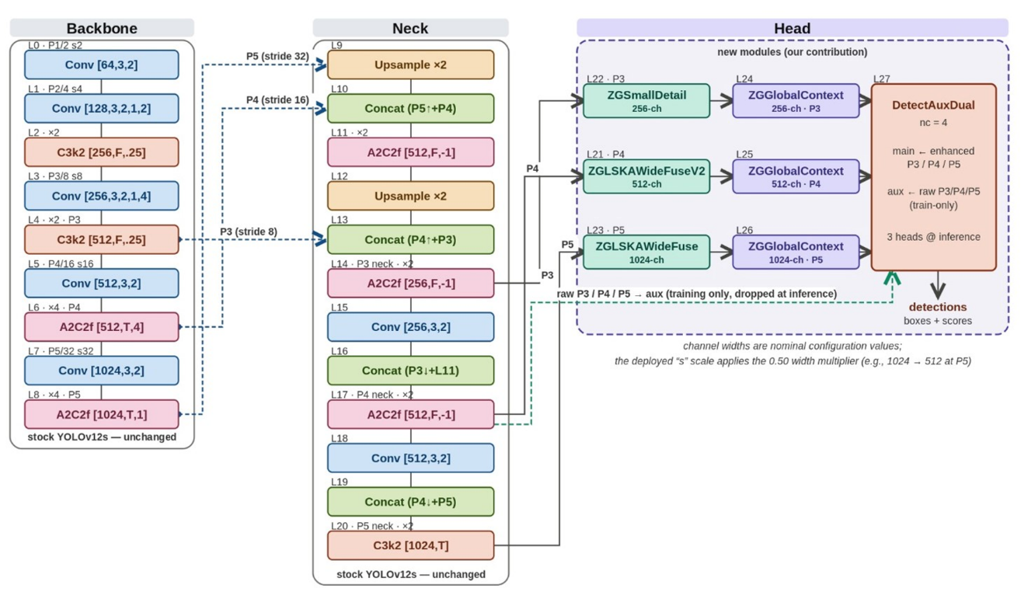

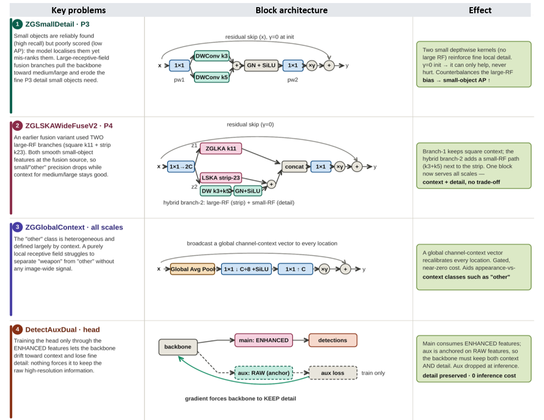

- Modified YOLOv12s architecture. Block diagram (top) and structure of the new head modules (bottom).

block serves both context and detail; c) ZGLSKAWideFuse (P5): at the deepest level, where context dominates, a large-receptive-field fusion supplies broad scene context to the largest-stride features; d) ZGGlobalContext (all levels): a purely local receptive field cannot separate the context-defined no_weapon class from genuine weapons. The new module performs a squeeze-and-excitation-style global recalibration (global average pooling, a 1x1 bottleneck with SiLU, a 1x1 expansion, then a gated add), broadcasting a global channel-context vector to every location at near-zero cost; e) DetectAuxDual (head): training the head only through the enhanced features lets the backbone drift toward context and lose fine detail. We attach an auxiliary head to the raw features alongside the main head on the enhanced features; the auxiliary gradient forces the backbone to keep the raw high-resolution information. The auxiliary head is dropped at inference, so it costs nothing at test time.
Relative to the unmodified YOLOv12s baseline, the proposed architecture: (i) preserves the strong pretrained initialization through zero-gating, so every addition is a safe superset of the baseline; (ii) specializes the enhancement per scale, adding fine detail where small objects live (P3) and broad context where they do not (P4/P5); (iii) injects global scene context at every level to help the heterogeneous, context-defined no_weapon class; and (iv) preserves the backbone detail through a dual-head training signal that is free at inference. All additions rely on depth-wise and 1x1 operations, limiting the parameter and latency overhead.
EXPERIMENTAL RESULTS
All experiments were conducted on a high-performance workstation, ensuring consistent, reproducible results across all training and evaluation runs. The hardware configuration included an Intel Core i9-13900KF CPU (5.8 GHz) paired with 64 GB of DDR5 RAM (6000 MHz), providing efficient data loading and preprocessing for large-scale image datasets. Model training and inference were accelerated using an NVIDIA GeForce RTX 4090 GPU (24 GB VRAM running with CUDA 12.1. The experimental framework was implemented in Python 3.10.2, using the PyTorch 2.1.2 deep learning library. This configuration enabled optimized utilization of Tensor Cores and ensured compatibility with advanced training features, such as mixed-precision computation and parallel data loading.
To evaluate the impact of the proposed architectural modifications, we trained both the custom and the official YOLOv12-s baseline models on the same dataset with identical hyperparameters and training settings (learning rate, batch size, image size, optimization procedure, number of training epochs). The plots in Figure 4 report the main performance metrics used in equation (8), namely the training box loss L_{IoU}, the training Distribution Focal Loss L_{DFL}, the training classification loss L_{cls}, as well as the validation metrics, mAP@0.5, mAP@0.5-0.95, Precision, and Recall.

A. Hyperparameters tuning
The proposed modifications related to small object–aware loss and assignment described in Section IV-A include several hyperparameters that were optimally set via a grid search on a validation set comprising around 15% of the whole dataset, with a balanced number of samples from all weapon types.
More specifically, the search range for the parameters α₁ and α₂ in equation (3) was [0.1, 1.0], yielding the best values α₁ = 0.7 and α₂ = 0.4, respectively. The factor weights the L1 penalty on box centers defined in equation (6) that depends on parameters α₃ and α₄. Optimal values of those have been searched in the [0-0.1] interval, but brought no measurable improvement and the term was switched off in the final model. Clipping-based IoU and DFL losses in equation (7) were optimized for α₅ = 50, α₆ = 30, α₇ = 25, and α₈ = 15, respectively, while conducting the search procedure in the [10-50] range with a unity step. Finally, for the Task-Aligned Assigner (TAL) module defined in Section IV-A4, the optimal candidate pool dimensionality was set to k = 13 after searching over the [2-25] interval.
Detailed experimental results on hyperparameter tuning are available in the project's GitHub repository [35], including information on the actual data split of distinct weapon-type images into training, validation, and testing subsets.

- Ablation study
An in-depth ablation study has been performed along two directions: a) assessing the individual effect of the custom loss and architectural modifications described in Section IV and Table 3; b) a distinct evaluation of the detection performances according to the dimensionality of the object of interest, with a special emphasis on small-scale cases.
Regarding the architectural modifications described in Section IV-B, 40 distinct model variations have been tested, the characteristics of which are available in the Supplementary material and on the project's GitHub repository [35]. The search covered the kernel size for the attention head, wide-receptive-field fusion, global and channel context, self-attention, spatial pyramid pooling, deformable and dynamic-sampling operators, capacity redistribution and P3 depth/path changes, neck topology, input resolution, and a range of detection-head ideas.
The best configuration leaves the YOLOv12s backbone and neck unchanged (width scale 0.50), and enhances only the detection head with the lightweight, append-only modules described in Section IV. Notably, a higher-resolution P2/five-scale extension was also explored, but showed lower performance than the proposed one.
To evaluate the impact of the proposed architectural modifications, we trained both the custom and the official YOLOv12s baseline models on the same dataset under identical hyperparameters and training settings (Adam optimizer, learning rate = 0.01, weight decay = 0.0005, momentum = 0.9, batch size = 64, image size = 640x640 pixels). The plots in Figure 4 report the individual effect of

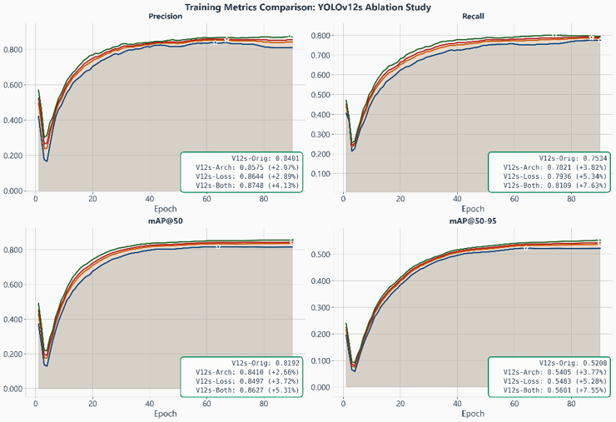
- Training metrics ablation study: original YOLOv12s model (blue); YOLOv12s + (B1-B5) architectural enhancements (orange); YOLOv12s + (A1-A4) custom loss modifications (red); new model - YOLOv12s + combined proposed modifications (green).
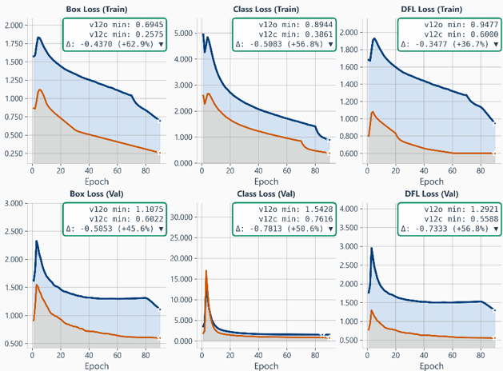
- Learning dynamics on the train and validation sets: original YOLOv12s model (blue); YOLOv12s + (A1-A4) custom loss modifications (orange).

the (custom loss function and architectural) proposed modifications in terms of the main performance metrics. Figure 5 shows the learning dynamics on the train and validation sets, respectively. Figure 6 exhibits the confusion matrices on the test set for the classes under study for varying object dimensionality, for both original and modified models.
Tables 4 and 5 report comparative per-class performance analysis results on the test set for the original YOLOv12s model and the proposed one. The analysis is further extended in Table 6, showing the individual effect of each of the proposed modifications according to the dimensionality of the objects of interest.
To better understand the performance of the new model, we
present in Table 7 a comparison between the original and modified YOLOv12s architectures versus YOLO2026, the most recent member of the YOLO family [36]. For a fair and reproducible comparison, all models were trained under the same setup conditions.
One key analysis refers to external dataset validation. As such, we present in Table 8 the performance of the proposed model trained on the custom dataset described in Section III and tested on several publicly available weapon datasets.
Examples of false-positive and false-negative detections using the baseline and new YOLOv12s models are illustrated in Figures 7-9, demonstrating the superiority of the latter.
DISCUSSION AND CONCLUSIONS
Overall, when compared with the baseline version, the custom model exhibits faster convergence in the early training stage, lower final training and validation losses, higher mAP@0.5 and mAP@0.5-0.95, confirming better localization, classification accuracy, and recall stability.
The baseline YOLOv12s model exhibits stable behavior, but reaches slightly lower plateau values for the mAP metrics and exhibits a slower reduction in the individual loss components. Tables 4-6 summarize the comparative analysis between the official YOLOv12s architecture and our custom model on the test set. The proposed solution clearly outperforms the official model across all key metrics.
The mAP@50 metric increased from 0.812 to 0.852, marking a +4.9% relative improvement. The more stringent mAP@50-95 improved from 0.516 to 0.553 (+7.2%), confirming better localization accuracy across multiple IoU thresholds. Precision improved from 0.833 to 0.865 (+3.8%), while Recall increased from 0.747 to 0.800 (+7.1%). Consequently, the overall F1-score reached 0.831, compared to 0.788 for the baseline (+5.5%), indicating a better balance between detection sensitivity and reliability.
Despite the architectural enhancements, the custom model preserves real-time performance: benchmarking on an NVIDIA RTX 4090 GPU showed about 220 FPS for the baseline model and 205–210 FPS for the proposed one, a modest overhead that leaves a wide real-time margin. This is expected by design: the enhancement modules rely only on depth-wise and 1×1 convolutions, and the auxiliary head is removed at inference (9.10M vs. 11.68M deployed parameters), so the added latency is marginal.
Examples presented in Figures 7-9 illustrate the limitations of the original YOLOv12 model when applied to the test dataset. Several instances of false positives and false negatives can be observed across all weapon classes—particularly for pistol, long gun, and knife categories. The model frequently misclassifies partially occluded or small-scale weapons, as well as objects with similar visual patterns (e.g., metallic tools or elongated shapes), leading to incorrect detections. In contrast, some no-weapon images trigger false positives, highlighting the model's sensitivity to background clutter or human poses that resemble weapon handling. These results confirm that the baseline detector struggles with challenging edge cases involving low resolution, motion blur, and complex backgrounds. The novel enhanced model mitigates these issues by incorporating improved feature extraction and attention mechanisms.
Results presented in Tables 4-6 and Figures 7-9 clearly demonstrate that the proposed enhancements to the baseline YOLOv12s model led to more complete and stable detections, particularly for small or partially occluded targets.
By integrating a new small-object–aware loss function and a set of lightweight, append-only enhancement modules placed in the detection head, the proposed model achieved notable performance improvements over the official YOLOv12s baseline, showing gains on all key metrics. The strong gain for the no_weapon class shows reduced confusion between weapon-like objects and true positives, improving overall system reliability in real surveillance scenarios. Finally, while the Recall performances rose more sharply, Precision remained high, confirming that the custom architecture did not sacrifice stability for sensitivity. Interestingly, the modified YOLOv12 model outperforms the recent YOLO2026 architecture, regardless of the dimensionality of the objects of interest.
The results presented in Table 8 demonstrate the consistent evolution of weapon detection accuracy across modern deep learning models. Earlier approaches, such as YOLOv5 and YOLOv7, achieved moderate Precision and Recall values, primarily constrained by smaller datasets and limited class diversity. Classical detectors like VGG-SSD (mAP@50 = 0.87) and Faster R-CNN (mAP@50 = 0.81) perform reliably, but lack scalability for real-world surveillance scenarios. In contrast, newer models such as YOLOv10-n and YOLOv12-s show significant improvements in both accuracy and robustness. While YOLOv10-n reached the highest mAP (0.91), our proposed YOLOv12-s achieved mAP@50 = 0.852 with Precision = 0.865 and Recall = 0.8, trained on the largest dataset.
The confusion matrices in Figure 6 show steady performance improvements for the new model across all object dimensions—most prominently for small objects—, while indicating that the no_weapon class is the most difficult to discriminate accurately, given the diversity of real-life items to be mistaken for weapons.

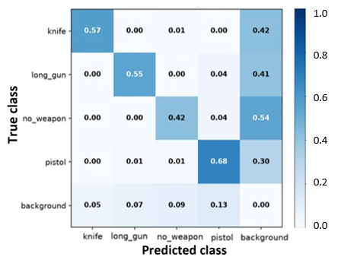 | 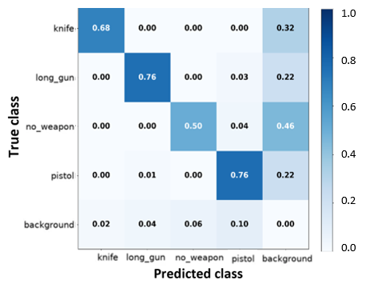
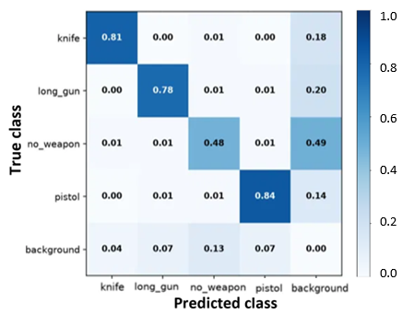 | 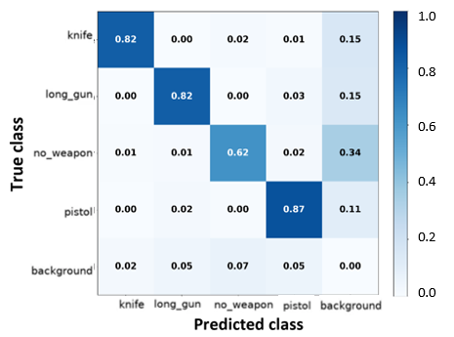
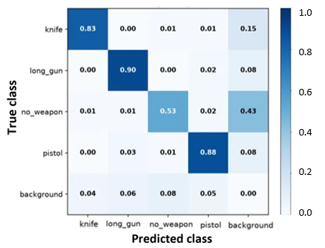 | 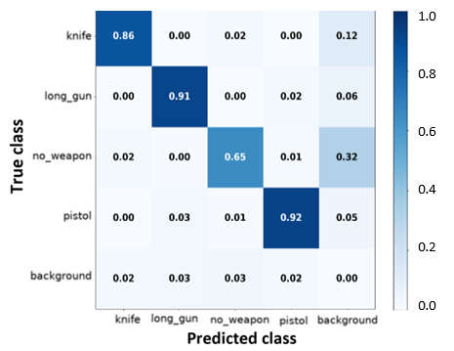
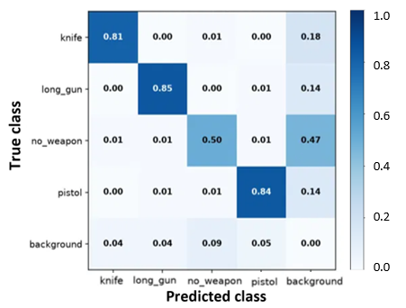 | 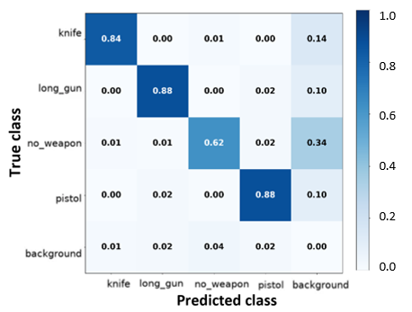

- Confusion matrices on the test set for the baseline (left column) and new model (right column). From top to bottom: small; medium; large; all objects. The “background” class counts the false positives and false negatives.
TABLE 4. Comparative per-class performance analysis on the test dataset.
Class | mAP@50 |  | mAP@50-95 |  | Precision |  | Recall |  | F1-score
 | Custom | Baseline | Custom | Baseline | Custom | Baseline | Custom | Baseline | Custom | Baseline
knife | 0.9000 | 0.8670 | 0.6460 | 0.6090 | 0.8760 | 0.8480 | 0.8410 | 0.8070 | 0.8590 | 0.8280
pistol | 0.9160 | 0.8820 | 0.6090 | 0.5690 | 0.8970 | 0.8620 | 0.8790 | 0.8400 | 0.8880 | 0.8510
long-gun | 0.9030 | 0.8810 | 0.5750 | 0.5540 | 0.8800 | 0.8590 | 0.8830 | 0.8480 | 0.8820 | 0.8530
no_weapon | 0.6890 | 0.6170 | 0.3850 | 0.3320 | 0.8070 | 0.7610 | 0.5820 | 0.5000 | 0.6780 | 0.6090
All | 0.8520 | 0.8120 | 0.5530 | 0.5160 | 0.8650 | 0.8330 | 0.8000 | 0.7470 | 0.8310 | 0.7880
TABLE 5. Comparative per-class improvements between the baseline and the proposed model on the test set.
Class | mAP@50 | Precision | Recall | F1-score | Comments
knife | +3.8% | +3.3% | +4.2% | +3.7% | ZGSmallDetail (B2) and the size-aware curriculum weighting (A1) preserve thin metallic edge features
pistol | +3.9% | +4.0% | +4.6% | +4.3% | TAL tuning improves detection for the largest small-object class
long-gun | +2.5% | +3.80% | +2.4% | +3.4% | Already strong at baseline; the strip-kernel attention (B2) tightens elongated bounding-box fits
no_weapon | +11.6% | +6.0% | +16.4% | +11.3% | ZGGlobalContext (B3) and DetectAuxDual (B4) separate confounders from real weapons more reliably
All | +4.9% | +3.8% | +7.1% | +5.5% | Combined gains from the custom loss (A1-A4) and the head modules (B1–B4)

TABLE 6. The effect of the proposed modifications on classification performance on the test set, by object dimensionality.
Dimension | Model (baseline YOLO12s + proposed modifications)
 | Baseline | +A1 | +A2 | +A3 | +A4 | + Custom loss (A1-A4) | +Architecture (B1-B5) | New model
Small objects  (area less than 32x32 pixels) | mAP@50
Small objects  (area less than 32x32 pixels) | 0.640 | 0.669 | 0.631 | 0.665 | 0.674 | 0.681 | 0.664 | 0.708 (+10.63%)
Small objects  (area less than 32x32 pixels) | mAP@50-95
Small objects  (area less than 32x32 pixels) | 0.324 | 0.336 | 0.319 | 0.341 | 0.339 | 0.348 | 0.334 | 0.354 (+9.26%)
Small objects  (area less than 32x32 pixels) | Precision
Small objects  (area less than 32x32 pixels) | 0.758 | 0.770 | 0.762 | 0.766 | 0.778 | 0.783 | 0.769 | 0.790 (+4.22%)
Small objects  (area less than 32x32 pixels) | Recall
Small objects  (area less than 32x32 pixels) | 0.585 | 0.622 | 0.572 | 0.628 | 0.625 | 0.648 | 0.611 | 0.660 (+12.82%)
Small objects  (area less than 32x32 pixels) | F1-score
Small objects  (area less than 32x32 pixels) | 0.662 | 0.692 | 0.653 | 0.694 | 0.697 | 0.708 | 0.682 | 0.719 (+8.61%)

Medium objects  (area between 32x32 and 96x96 pixels) | mAP@50
Medium objects  (area between 32x32 and 96x96 pixels) | 0.781 | 0.811 | 0.773 | 0.807 | 0.814 | 0.818 | 0.797 | 0.826 (+5.76%)
Medium objects  (area between 32x32 and 96x96 pixels) | mAP@50-95
Medium objects  (area between 32x32 and 96x96 pixels) | 0.445 | 0.464 | 0.439 | 0.467 | 0.465 | 0.472 | 0.457 | 0.480 (+7.87%)
Medium objects  (area between 32x32 and 96x96 pixels) | Precision
Medium objects  (area between 32x32 and 96x96 pixels) | 0.816 | 0.838 | 0.820 | 0.833 | 0.845 | 0.851 | 0.832 | 0.860 (+5.39%)
Medium objects  (area between 32x32 and 96x96 pixels) | Recall
Medium objects  (area between 32x32 and 96x96 pixels) | 0.723 | 0.751 | 0.714 | 0.754 | 0.752 | 0.763 | 0.741 | 0.775 (+7.19%)
Medium objects  (area between 32x32 and 96x96 pixels) | F1-score
Medium objects  (area between 32x32 and 96x96 pixels) | 0.767 | 0.792 | 0.758 | 0.791 | 0.796 | 0.805 | 0.784 | 0.815 (+6.26%)

Large objects  (area greater than 96x96 pixels) | mAP@50
Large objects  (area greater than 96x96 pixels) | 0.848 | 0.858 | 0.853 | 0.854 | 0.862 | 0.866 | 0.856 | 0.872 (+2.83%)
Large objects  (area greater than 96x96 pixels) | mAP@50-95
Large objects  (area greater than 96x96 pixels) | 0.574 | 0.583 | 0.578 | 0.585 | 0.582 | 0.591 | 0.582 | 0.595 (+3.66%)
Large objects  (area greater than 96x96 pixels) | Precision
Large objects  (area greater than 96x96 pixels) | 0.844 | 0.867 | 0.851 | 0.862 | 0.873 | 0.880 | 0.861 | 0.893 (+5.81%)
Large objects  (area greater than 96x96 pixels) | Recall
Large objects  (area greater than 96x96 pixels) | 0.808 | 0.822 | 0.815 | 0.825 | 0.823 | 0.831 | 0.818 | 0.838 (+3.71%)
Large objects  (area greater than 96x96 pixels) | F1-score
Large objects  (area greater than 96x96 pixels) | 0.825 | 0.843 | 0.832 | 0.842 | 0.846 | 0.854 | 0.839 | 0.864 (+4.73%)
TABLE 7. Comparative performance analysis against the YOLO2026 model on the test set (average values on 5 distinct trials; standard deviations less than 0.3% for all cases).
Metric | Objects dimension | YOLOv12s | YOLO12s + Custom loss | YOLOv12s + Custom loss + Custom architecture | YOLO2026
mAP@50 | Small | 0.640 | 0.681 | 0.708 | 0.615
mAP@50 | Medium | 0.781 | 0.818 | 0.826 | 0.780
mAP@50 | Large | 0.848 | 0.866 | 0.872 | 0.843
mAP@50 | All | 0.812 | 0.839 | 0.852 | 0.807
mAP@50-95 | Small | 0.324 | 0.348 | 0.354 | 0.317
mAP@50-95 | Medium | 0.445 | 0.472 | 0.480 | 0.466
mAP@50-95 | Large | 0.574 | 0.591 | 0.595 | 0.588
mAP@50-95 | All | 0.516 | 0.539 | 0.553 | 0.521
Precision | All | 0.833 | 0.852 | 0.865 | 0.845
Recall | All | 0.747 | 0.782 | 0.800 | 0.753
F1-score | All | 0.788 | 0.816 | 0.831 | 0.796

Nevertheless, the inclusion of this category proved effective in minimizing false positives, enabling the model to distinguish actual threats from harmless objects better. This is evident from Figure 9, which presents examples of dangerous misclassification of actual weapons as belonging to the no_weapon class.
The broad diversity of the new custom dataset, combined with YOLOv12s' enhanced backbone and improved small-object representation, ensures more stable performance across complex environments. Overall, these findings confirm that the new YOLOv12s model, trained on a large, comprehensive dataset, delivers a superior balance between Precision, Recall, and generalization—making it particularly suitable for real-time, low-false-alarm weapon detection in surveillance applications.
Future research will focus on extending this framework to multimodal perception by incorporating thermal and depth sensing for low-light or occluded conditions, and on developing temporally aware detection modules to enhance motion consistency across video frames. Additional topics worth studying include lightweight model compression, cross-dataset generalization, and domain adaptation to ensure robustness in diverse operational scenarios and edge-device deployments. Extending the proposed approach towards other applications (e.g., medical imaging) is currently under investigation.
The complete implementation, training configurations, and experimental scripts supporting this work are publicly available in the authors’ GitHub repository [34]. The supplementary material includes an extensive list of images and weapon instances that the YOLOv12 baseline model fails to detect correctly, while the proposed model succeeds.

TABLE 8. Performance comparison of state-of-the-art detectors on weapon datasets.
 | Precision | Recall | mAP@50 | Dataset
YOLOV7 [30] | 0.852 | 0.617 | 0.33 | 400 images (guns and knives)
YOLOV5l [31] | 0.715 | 0.614 | 0.641 | 2986 images (pistols)
YOLOV8m [32] | 0.85 | 0.80 | 0.82 | 1000 images (weapon, no_weapon)
VGG SSD [33] | 0.87 | 0.866 | 0.87 | 872 images (normal, knife, gun)
Faster R-CNN [34] | - | - | 0.81 | 3831 images (gun)
YOLOV10n [24] | 0.938 | 0.863 | 0.91 | 9464 images (pistol/handgun)
New YOLOV12s (ours) on custom dataset | 0.865 | 0.800 | 0.852 | 26,528 images (knife, pistol, long-gun, no_weapon)
New YOLOV12s (ours) on dataset from [37] | 0.833 | 0.778 | 0.792 | 8478 images (machete, knife, baseball bat, rifle, gun)
New YOLOV12s (ours) on dataset from [38] | 0.854 | 0.781 | 0.805 | 5000 images (gun)
New YOLOV12s (ours) on dataset from [39] | 0.828 | 0.760 | 0.776 | 5859 images (pistol, smartphone, knife, coin purse, ticket, card)
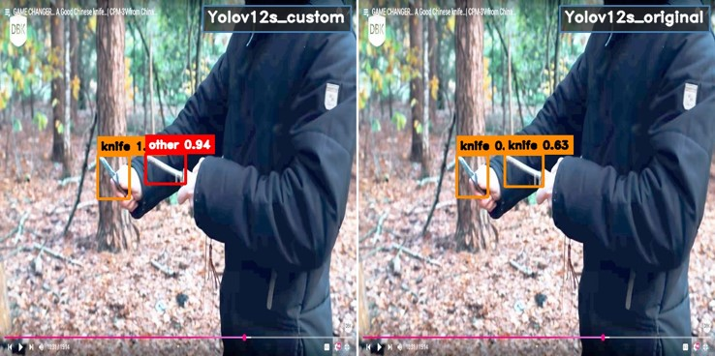
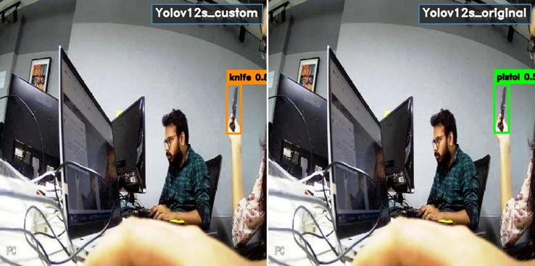
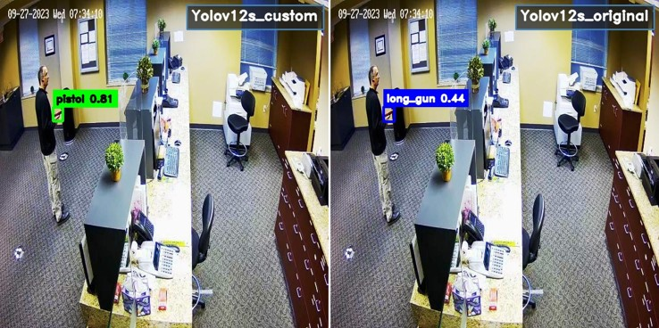
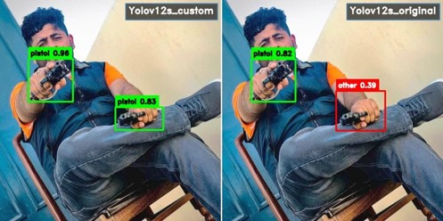
- Comparative analysis between the baseline and modified models on the test set: false-positive detections (from top to bottom: knife, pistol, long-gun, no_weapon classes).
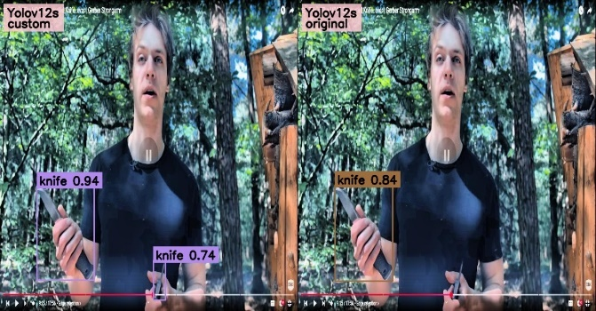
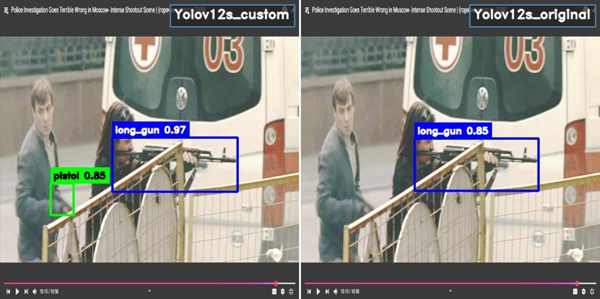
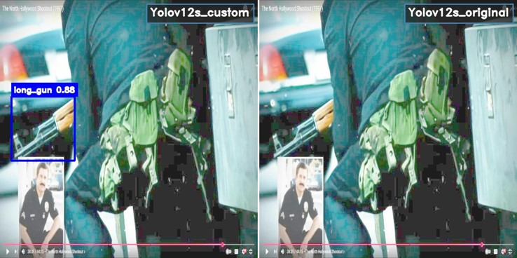
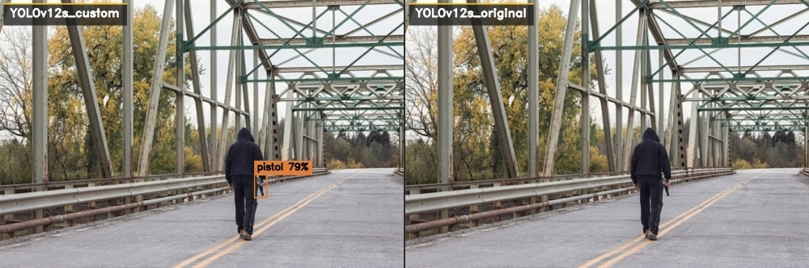
- Comparative analysis between the baseline and modified models on the test set: false-negative detections (from top to bottom: knife, pistol, long-gun, no_weapon classes).

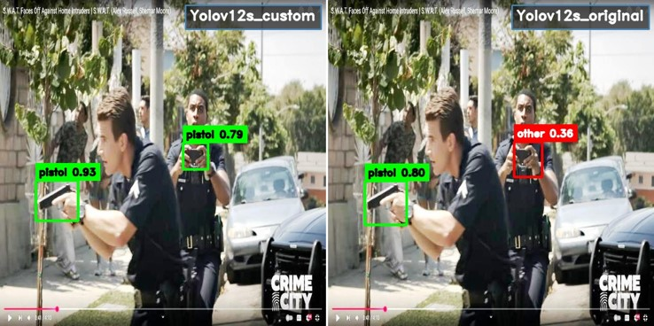

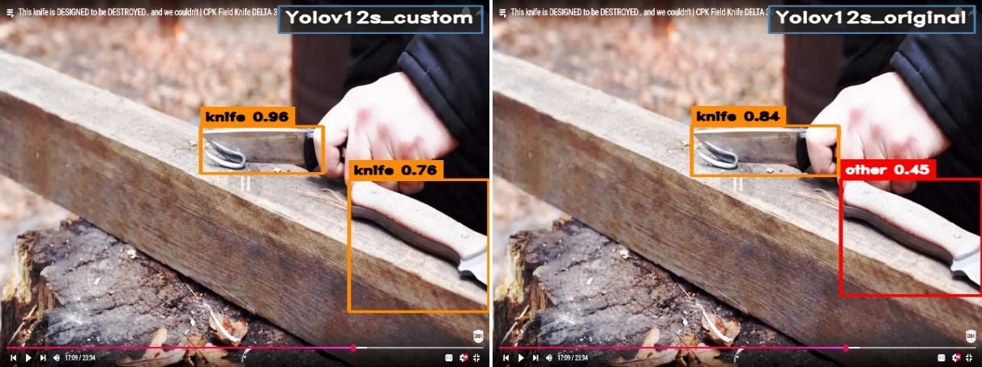

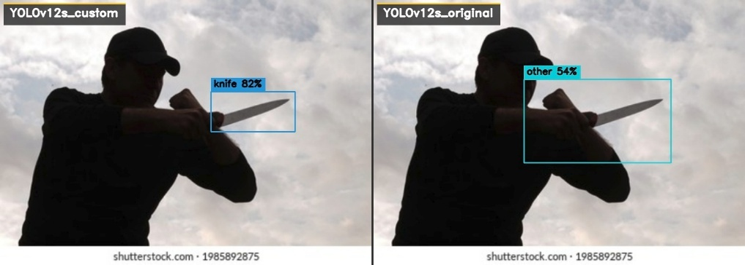

- Comparative analysis between the baseline and modified models on the test set: weapons misclassified as no_weapon.

REFERENCES
- Small Arms Survey, Global Civilian Firearm Holdings, 2018. [Online]. Available: http://www.smallarmssurvey.org.
- Pew Research Center, What the data says about gun deaths in the U.S., 2025. [Online]. Available: https://www.pewresearch.org.
- I. Goodfellow, Y. Bengio, and A. Courville, Deep Learning. Cambridge, MA, USA: The MIT Press, 2016.
- J. Redmon, S. Divvala, R. Girshick, and A. Farhadi, “You Only Look Once: Unified, real-time object detection,” in Proc. IEEE/CVF Conf. Comput. Vis. Pattern Recognit. (CVPR), June 2016, pp. 779-788.
- Y. Tian, Q. Ye, and D. Doermann, “YOLOv12: Attention-centric real-time object detectors,” 2025, arXiv:2502.12524.
- The NewWeapon dataset, 2025. [Online]. Available: https://universe.roboflow.com/gundetectiondataset/weapondataset-oi2g3/dataset/8.
- The No-weapon dataset, 2025. [Online]. Available: https://universe.roboflow.com/gundetectiondataset/nogun/dataset/2.
- R. K. Tiwari and G. K. Verma, “A computer vision-based framework for visual gun detection using Harris interest point detector,” Procedia Computer Science, vol. 54, pp. 703–712, 2015.
- N. B. Halima and O. Hosam, “Bag of words based surveillance system using Support Vector Machines,” Int. J. Security Appl., vol. 10, no. 4, pp. 331–346, 2016.
- Z. Xiao, X. Lu, J. Yan, L. Wu, and L. Ren, “Automatic detection of concealed pistols using passive millimeter wave imaging,” in Proc. IEEE Int. Conf. Imaging Systems and Techniques (IST), Sep. 2015, pp. 1–4.
- J. D. Muñoz, J. Ruiz-Santaquiteria, O. Deniz, and G. Bueno, "Concealed weapon detection using thermal cameras," J. of Imaging, vol. 11, no. 72, pp. 1-25, 2025.
- S. Gosain, A. Sonare, and S. Wakodkar, “Concealed weapon detection using image processing and machine learning,” Int. J. Res. Appl. Sci. Eng. Technol., vol. 9, no. 12, pp. 1374–1384, Dec. 2021.
- H. Jain, A. Vikram, Mohana, A. Kashyap, and A. Jain, "Weapon detection using artificial intelligence and deep learning for security applications," in Proc. Internat. Conf. Electronics and Sustainable Comm. Syst. (ICESC), 2020, pp. 193-198.
- R. Olmos, S. Tabik, and F. Herrera, “Automatic handgun detection alarm in videos using deep learning,” Neurocomputing, vol. 275, pp. 66–72, 2018.
- R. Olmos, S. Tabik, A. Lamas, F. Pérez-Hernández, and F. Herrera, “A binocular image fusion approach for minimizing false positives in handgun detection with deep learning,” Information Fusion, vol. 49, pp. 271–280, 2019.
- J. Lim, M. I. Al Jobayer, V. Baskaran, J. Lim, J. See, and K. Wong, "Deep multi-level feature pyramids: Application for non-canonical firearm detection in video surveillance," Eng. Appl. Artif. Intell., vol. 97, pp. 1-18, 2021.
- A. P. Maligireddy, M. R. Uppula, N. Rastogi, Y. R. Parla, “Gun detection using combined human pose and weapon appearance,” 2025, arXiv:2503.12215.
- Z. Xu, Y. Tian, X. Hu, and F. Pu, “Dangerous human event understanding using human-object interaction model,” in Proc. Int. Conf. Signal Processing, Communications and Computing (ICSPCC), Sep. 2015, pp. 1–5.
- A. Egiazarov, F. M. Zennaro, V. Mavroeidis, and K. Vishi, “Firearm detection and segmentation using an ensemble of semantic neural networks,” in Proc. European Intell. and Security Inf. Conf. (EISIC), Nov. 2019, pp. 70–77.
- F. Pérez-Hernández, S. Tabik, A. Lamas, R. Olmos, H. Fujita, and F. Herrera, “Object detection binary classifiers methodology based on deep learning to identify small objects handled similarly: Application in video surveillance,” Knowledge-Based Syst., vol. 194, pp. 1-10, 2020.
- A. Castillo, S. Tabik, F. Pérez, R. Olmos, and F. Herrera, “Brightness guided preprocessing for automatic cold steel weapon detection in surveillance videos with deep learning,” Neurocomputing, vol. 330, pp. 151–161, 2019.
- M. T. Bhatti, M. G. Khan, M. Aslam, and M. J. Fiaz, “Weapon detection in real-time CCTV videos using deep learning,” IEEE Access, vol. 9, pp. 34366–34382, Mar. 2021.
- A. J. Amado-Garfias, S. E. Conant-Pablos, J. C. Ortiz-Bayliss, and H. Terashima-Marín, “Improving armed people detection on video surveillance through heuristics and machine learning models,” IEEE Access, vol. 12, pp. 111818–111831, Aug. 2024.
- N. Žigulić, M. Glučina, D. Frank, I. Lorencin, Z. Šverko, and D. Matika, “Deploying YOLOv10 for affordable real-time handgun detection,” in Proc. IEEE Internat. Symp. Intell. Syst. and Informatics (SISY), 2024, pp. 000283-000288.
- V. Kaya, S. Tuncer, and A. Baran, “Detection and classification of different weapon types using deep learning,” Applied Sciences, vol. 11, pp. 1-13, 2021.
- J.-C. Park, M. Kim, and G.-W. Kim, “MSA-YOLOv5: An improved light-weight YOLOv5 model for small object detection,” in Proc. 15th Int. Conf. Inf. and Comm. Tech. Convergence (ICTC), 2024, pp. 658–663.
- L. Sumi and S. Dey, “A deep learning approach to gun detection in surveillance system using YOLOv9,” in Proc. Control Instrum. Syst. Conf. (CISCON), 2024, pp. 1-5.
- L. Du, A.T.S. Ho, and R. Cong, “Perceptual hashing for image authentication: A survey,” Signal Proc.: Image Comm., vol. 81, Article 115713, 2020.
- R. Khanam and M. Hussain, “A review of YOLOv12: Attention-based enhancements vs. previous versions,” 2025, arXiv:2504.11995v1.
- Y. Y. Aung and K. Z. Oo, “Detection of guns and knives images based on YOLO v7,” in Proc. 3rd IEEE Internat. Conf. on Artif. Intell. for Internet of Things (AIIoT), 2024, pp. 1–6.

- R. Garg and S. Singh, “Intelligent video surveillance based on YOLO: A comparative study,” in Proc. Internat. Conf. on Adv. in Comp., Comm. and Control (ICAC), 2021, pp. 1–6.
- A. Thakur, A. Shrivastav, R. Sharma, T. Kumar, and K. Puri, “Real-time weapon detection using YOLOv8 for enhanced safety,” arXiv:2410.19862.
- P. R. K. Varma, K. K. Raju, R. K. Chaitanya, G. N. V. G. Sirisha, and D. N. Varma, “VGG-SSD model for weapon detection using image processing,” in Proc. 3rd IEEE Int. Conf. on Appl. Artif. Intell. and Comp. (ICAAIC), 2024, pp. 890-894.
- R. M. Alaqil, B. A. Alhumaidi, R. D. Alotaibi, J. A. Alsuhaibani, R. A. Alnasser, and H. Benhidour, “Automatic gun detection from images using Faster R-CNN,” in Proc. 1st IEEE Int. Conf. on Smart Syst. and Emerging Tech.s (SMARTTECH), 2020, pp. 149–154.
- GitHub repository, 2025. [Online]. Available: https://github.com/CostiCatargiu/Yolov12_WeaponDetection.
- YOLO2026, Ultralytics. [Online]. Available: https://docs.ultralytics.com/models/yolo26/.
- Z. Omiotek, “Effectiveness of modern models belonging to the YOLO and Vision Transformer architectures in dangerous items detection,” Electronics, vol. 14, no. 17, 3540.
- Y. Gu, X. Liao, and X. Qin, “YouTube-GDD: A challenging gun detection dataset with rich contextual information,”arXiv:2203.04129.
- OD-WeaponDetection dataset. [Online]. Available: https://github.com/ari-dasci/OD-WeaponDetection.


Constantin Catargiu (Student Member, IEEE) received the B.S. degree in electronics engineering and the M.S. degree from the Gheorghe Asachi Technical University of Iasi, Iasi, Romania, in 2019 and 2021, respectively, where he is currently pursuing the Ph.D. degree, working on machine learning/deep learning applications in computer vision. His research interests include surveillance applications, small-object detection, and explainable machine learning.


Iulian B. Ciocoiu (Senior Member, IEEE) received the B.S. degree from the Gheorghe Asachi Technical University of Iasi, Romania, in 1988, and the Ph.D. degree in electronics and telecommunications engineering from the Gheorghe Asachi Technical University of Iasi in 1996. He is the author of two books, three book chapters, and more than 60 articles. His research interests include deep learning applications, pattern recognition, biometrics, and biomedical signal processing. Prof. Ciocoiu is a member of the IEEE Computational Intelligence Society.

