Revision: | 1.0
Status: | Released
File: | DES-WebCA.odt
Owner: | Matej Sekoranja
Last modification: | July 31, 2007
Created: | July 29, 2007
WebCA
Design

Document History
Instructions for using the template are enclosed in a red box like this. Please read these instructions and follow them!
Make sure that you delete all template instructions before producing the final version of a document. The easiest way to do this is as follows:
- Open the Styles and Formatting pane by choosing option Format - Styles and Formatting from the menu.
- Right-click the Template Instructions style and choose Select all n instances .
- Press Delete key.
Document Format
The document should be kept in Microsoft Word format when writing it, exchanging it with reviewers, and when committing it to CVS. When sending a document to customers who do not need to edit the document, use PDF format instead.
Document Properties
Prior to starting to write a document, make sure to set its properties in File - Properties - Custom . The properties are:
- Status: the maturity status of the document. See below.
- Project: the project in the context of which the document was prepared.
- Revision: the version of the document.
- Folder: the name of the folder where the document is stored. The folder is specified relative to the root of the project, using slashes (/) as delimiters.
- Repository: the name of the repository where the document is stored.
- Confidentiality: disclosure policy of the document, which can be either Confidential or Public.
Apart from these, make sure to fill in standard properties:
- Title: the title of the document.
- Subject: the subject (subtitle) of the document.
- Manager: the owner of the document.
To ensure that document, its properties and cross-references remain consistent throughout the document, update all fields before sending the document to someone else or committing it to CVS. Do this by:
- Selecting the entire document (Ctrl + A)
- Update all fields (press F9).
- Do the same for header and footer!

Document History
The following table records all modifications, reviews, releases and retirements of the document. Whenever you make a change, make sure to record it, along with the revision, date, your name, affected sections, and a brief description of the change made.
Revisions are in format X.Y, where X is the major and Y the minor version. The major version is only incremented when the previous document has been retired.
The date should be stated in ISO 8601 format: YYYY-MM-DD, where YYYY is the year, MM the month and DD the day.
The section should be either All, indicating a global change, or a cross-reference to the section. To insert a cross-reference, use Insert - Reference - Cross Reference function.
When releasing, reviewing or retiring a document, state this in the modification column by using a bold style. Also, make sure that you change the Status custom property to either:
- Draft: the last change was either a review or a regular modification.
- Released: the last change was a release.
- Retired: the last change was a retirement.
Revision | Date | Author | Section | Modification
1.0 | 2007-07-29 | Matej Sekoranja | All | Created.
Confidentiality
This document is classified as a public document. As such, it or parts thereof are openly accessible to anyone listed in the Audience section, either in electronic or in any other form.
Scope
This document contains WebCA design.
Audience
All developers and potential users of WebCA.

Table of Contents
1. CAML XML 4
2. WebCA JavaScript Implementation 6

CAML XML
CAML is a WebCA XML display language to describe web-based GUI screens. It defines set of components to be placed on the screen, its properties (location, colors, PV to monitor/control, etc.) and relations between them (containment, macro substitutions, etc.).
CAML structure is defined by XML Schema Definition language (XSD) to allow validation. However, it should be freely extensible to allow developers to add its own components. Base schema should be predefined by its maintainer (EPICS community) and it would provide skeleton for all implemented components and base set of components. Developers implement its own components using this skeleton. Note that this skeleton will enforce developers to use standard design patterns to develop new components. This leads to cleaner code, design, less bugs and easier code sharing. Extensions can be easily included using schema include and namespace mechanisms. Skeleton consists of base interfaces to be extended (schema supports inheritance mechanism). It briefly follows well proven Java GUI Components library design pattern. Each component must extend basic Component interface. Component contains basic set of attributes each GUI widget has (position, colors, font, etc.). Components that can contain other components should extend Container interface, note that Container interface also extends Component interface and its therefore a component. A nice examples of container components are layout managers.
CAML is a display language to describe controls screens. CAML provides two basic control interfaces: Monitor interface (for components monitoring PVs; e.g. TextUpdate) and Control interface (for component controling PVs; e.g. TextEntry). A component can be both, to monitor and control a PV (e.g. TextControl).
A simple CAML should look like this:
<?xml version="1.0"?>
<?xml-stylesheet href="webca.xsl" type="text/xsl" ?>
<caml>
<title>WebCa Test</title>

<horizontalpanel>
<column>
<textupdate readbackPV="ai001_readback" />
</column>
<column>
<textentry controlPV="ai001_setpoint" color="grey" />
</column>
<horizontalpanel>

<textcontrol
readbackPV="ai002_readback"
controlPV="ai002_setpoint"
x="200" y="300"
font-size="+2" align="center" />

</caml>
CAML (XML) should be transformed to HTML using XSLT. WebCA will provide standard XSLT, but any other XSLT can be implemented (also to transform to non-HTML).
Transformation is done automatically by browser. URL will point to CAML XML file containing xml-stylesheet tag to tell browsers which XSLT to use to perform a transformation.
CAML will follow (as much as possible) W3C standards, so that code can be transformed to HTML (supporting DHTML, CCS, JavaScript technologies) as straight-forward as possible. For example, using same attribute names, value sets, syntax, etc. This makes CAML very easy to integrate with any web-based product and also makes learning curve steeper.
CAML allows users to inject their own DHTML/CCS/JavaScript code to allow users to easily use large variety their features, i.e. this makes CAML as their super-set.
Inclusion of sub-pages (e.g. external XML file implementing a common control screen) can be easily added using standard xi:include directive and PV name macro substitutions (to be presented later).
NPCA (Netscape plugin Channel Access) plugin will be used as a communication protocol implementation. Current implementation needs some additional features to implemented (e.g. CTRL get) to provide WebCA all the features it requires.
A test of automatic XML to HTML conversion using NPCA plugin was performed on supported browsers to make this design acceptable. They all passed (minor JavaScript "tweak" in XSLT is needed for Gecko engine).
CAML should use only standard, or to be more restrictive, features supported by all WebCA supported browsers.

WebCA JavaScript Implementation
XSLT will generate HTML containing JavaScript to implement internal logic. Generated code will not interact with NPCA plugin directly. An intermediate glue code (manager) will be implemented to support macro substitutions and control components lifecycle including connection state monitoring. This manager will automatically provide those features to components instead of letting developers to reimplement the same functionality over and over (hopefully in right way).
A self explanatory sequence diagram:
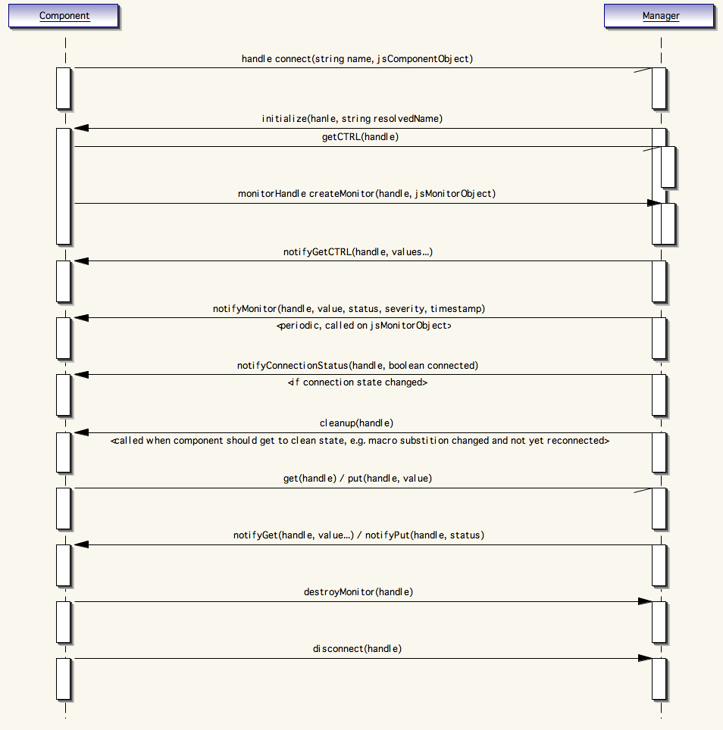
All the callback functions must be implemented by each component.
As mentioned before, manager implements macro substitution feature. A component connects to the manager calling connect(string name) method. Manager then does the macro substitutions and tries to connect to the channel. If successful, it calls back the component calling initialize(handle, string resolvedName) to notify a component that it is connected and providing it a resolved name. Macro substitution is actually not done by manager itself. The task is rather delegated to, so called, substitutors. Substitutor is an object that registers to the manager as an instance capable of doing macro substitutions. Substitutor can also be a GUI component.
A self explanatory sequence diagram:
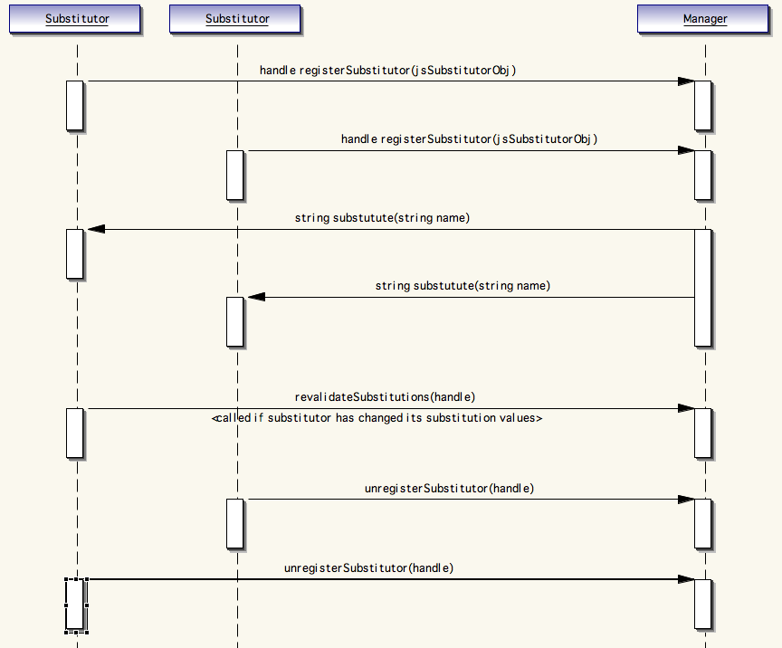
This design requires substitutors to register to the manager before any components tries to connect to a PV using macro substitutions in PV name. This requirement is taken care of by XSLT.
Complete WebCA design is based on asynchronous calls (non-blocking calls) to have responsive GUI and to avoid performance problems.

