WebCA
User manual

Revision: | 1.1
Status: | Released
Project: | WebCa
Document ID: | CSL-DOC-07-34340
File: | 0000.doc
Owner: | msekoranja
Last modification: | February 2, 2009
Created: | July 22, 2008
Document History
Revision | Date | Changed/  reviewed | Section(s) | Modification
0.1 | 2007-06-12 | gjansa | All | Created.
0.2 | 2008-01-09 | gjansa | All | Created/Modified.
0.3 | 2008-01-10 | gjansa | 1 | Web browsers version added.
0.4 | 2008-01-25 | gjansa | 8.19 | Changed attributes and elements names.
0.5 | 2008-02-13 | gjansa | All | Updated.
1.0 | 2008-07-14 | msekoranja | All. | Release.
1.1 | 2008-07-15 | ssah | 8.15 | Added BitControl component.
1.2 | 2008-08-04 | ssah | 8.22 | Added VirtualPV component.
1.3 | 2008-08-13 | ssah | 1, 2, 7, 10 | Included usage from HTML.
1.31 | 2008-08-19 | ssah | 7 | Added pluginUrl attribute.
1.32 | 2008-08-21 | ssah | 8.1 | Added readOnly attribute.
1.33 | 2008-08-25 | ssah | 8.9 | Added displayMode attribute.
1.34 | 2008-0827 | ssah | 8.9 | Added extended displayFormat, removed displayMode.
1.35 | 2008-09-02 | ssah | 4 | Added new contect menu options.
1.36 | 2008-09-08 | ssah | 10 | Updated component adding description.
1.37 | 2008-09-14 | ssah | 2, 8.3, 8.4, 8.8, 8.18 | Added include, repetition components; small changes..
1.371 | 2008-09-17 | ssah | 43 | Added xAxisSyile and numberOfPoints attributes.
1.372 | 2008-09-18 | ssah | 8.7, 8.15, 8.18 | Fixed target attribute descriptions, added href and target on BitControl.
1.373 | 2008-09-24 | ssah | 8.20, 8.13, 8.19 | Added scalar example to bar chart, direction attribute to radioButton, time formatting for xyChart.
1.374 | 2008-10-06 | ssah | 11 | Added EDL to CAML translator description.
1.3741 | 2008-11-21 | ssah | 11.1 | Update.
1.38 | 2008-11-25 | ssah | 3, 11 | Added plugin installation description, updated translator install.
1.3801 | 2009-01-16 | ssah | 8.7 | Updated parameter descriptions.
1.3802 | 2009-02-2 | ssah | 8.19 | Added “fast” flavor.
Confidentiality
This document is classified as a public document. As such, it or parts thereof are openly accessible to anyone listed in the Audience section, either in electronic or in any other form.
Scope
This document covers installation and usage of WebCA. It also covers how new components can be added to WebCA.
Audience
Users creating EPICS Channel Access clients using WebCA.
Typography
This document uses the following styles:
 | A box like this contains important information.

 | Warning!  A box like this provides information, which should not be disregarded!

Glossary of Terms

References
- NPCA plugin api documentation, Cosylab, 2007 (http://webca.cosylab.com/)
- WebCA design document, Cosylab, 2007
- Extensible Markup Language (XML) http://www.w3.org/XML/
- XML Schema http://www.w3.org/XML/Schema
- XSL Transformations, http://www.w3.org/TR/xslt
- The Yahoo! User Interface Library (YUI) http://developer.yahoo.com/yui/

Table of Contents
1. Introduction 8
2. Quick start 10
3. WebCa plugin installation 12
3.1. Firefox Installation 12
3.2. Safari Installation 12
4. Context menu 13
5. Number format 15
6. Macro substitution 16
7. Global parameters 17
8. Components 18
8.1. Standard component attributes 18
8.2. Layout components 18
8.2.1. HorizontalPanel 19
8.2.2. VerticalPanel 19
8.2.3. Column 20
8.2.4. Row 21
8.2.5. Panel 22
8.3. Include 23
8.3.1. Macro-Value Pairs 24
8.4. Repetition 24
8.5. TabView 25
8.6. Image 26
8.7. StaticText 27
8.8. Mux 28
8.9. TextUpdate 30
8.9.1. Extended displayFormat 30
8.9.2. Timestamp format 31
8.9.3. Examples of textUpdate 31
8.10. TextEntry 31
8.11. Message Button 32
8.12. MenuButton 33
8.13. RadioButton 34
8.14. WheelSwitch 36
8.15. BitControl 36
8.16. Slider 37
8.17. Gauge 38
8.18. RelatedDisplay 39
8.19. X-Y Chart 41
8.20. bar chart 42
8.21. Intensity plot 44
8.22. VirtualPV 45
8.22.1. Alarm specification 47
8.22.2. Code syntax 48
9. Complex example 50
10. Adding new component to WebCA 51
11. EDL to CAML translator 52
11.1. Known issues and limitations 52

Figures
Figure 1: WebCA 8
Figure 2: Context menu example 13
Figure 3: PV inspector example 14
Figure 4: Number format examples 15
Figure 5: Complex layout example 23
Figure 6: TabView example 26
Figure 7: StaticText example 28
Figure 8: Mux component; left in Safari, right in Firefox 29
Figure 9: TextUpdate examples 31
Figure 10: TextEntry example 32
Figure 11: MessageButton example 33
Figure 12: MenuButton example 34
Figure 13: RadioButton example 35
Figure 14: WheelSwitch example 36
Figure 15: BitControl example 37
Figure 16: Slider example 38
Figure 17: Gauge example 39
Figure 18: X-Y chart example 42
Figure 19: Bar Chart 44
Figure 20: Intensity plot 45
Figure 21: Example device control panel 50

Tables
Table 1: Supported browsers 9
Table 2: Context menu options 13
Table 3: caml:head/caml attributes 17
Table 4: Standard component attributes 18
Table 5: HorizontalPanel attributes 19
Table 6: HorizontalPanel standard attributes 19
Table 7: HorizontalPanel elements 19
Table 8: VerticalPanel attributes 20
Table 9: VerticalPanel standard attributes 20
Table 10: VerticalPanel elements 20
Table 11: Column attributes 21
Table 12: Column standard attributes 21
Table 13: Row attributes 21
Table 14: Row standard attributes 21
Table 15: Panel attributes 22
Table 16: Panel standard attributes 22
Table 17: Panel elements 22
Table 18: Include attributes 23
Table 19: Include elements 23
Table 20: macroValuePair attributes 24
Table 21: Repetition attributes 24
Table 22: Repetition elements 25
Table 23: list elements 25
Table 24: item elements 25
Table 25: TabView attributes 25
Table 26: TabView standard attributes 26
Table 27: TabView elements 26
Table 28: Tab attributes 26
Table 29: Image attributes 27
Table 30: Image standard attributes 27
Table 31: StaticText attributes 28
Table 32: StaticText standard attributes 28
Table 33: Mux standard attributes 29
Table 34: Mux elements 29
Table 35: Sequence attributes 29
Table 36: Sequence elements 29
Table 37: TextUpdate attributes 30
Table 38: TextUpdate standard attributes 30
Table 39: displayFormat forms/templates 30
Table 40: displayFormat tokens 31
Table 41: Examples of timestamp format 31
Table 42: TextEntry attributes 32
Table 43: TextEntry standard attributes 32
Table 44: MessageButton standard attributes 32
Table 45: MessageButton elements 33
Table 46: On and off attributes 33
Table 47: MenuButton standard attributes 33
Table 48: MenuButton elements 34
Table 49: MenuButtonItem attributes 34
Table 50: RadioButton attributes 35
Table 51: RadioButton standard attributes 35
Table 52: RadioButton elements 35
Table 53: RadioButtonItem attributes 35
Table 54: WheelSwitch standard attributes 36
Table 55: BitControl attributes 37
Table 56: BitControl standard attributes 37
Table 57: Slider attributes 38
Table 58: Slider standard attributes 38
Table 59: Gauge attributes 38
Table 60: Gauge standard attributes 39
Table 61: RelatedDisplay attributes 40
Table 62: RelatedDisplay standard attributes 40
Table 63: RelatedDisplay elements 40
Table 64: Display attributes 40
Table 65: Display elements 40
Table 66: MacroValuePair attributes 40
Table 67: X-Y chart attributes 41
Table 68: X-Y chart elements 41
Table 69: xySeries attributes 42
Table 70: Bar chart attributes 43
Table 71: Bar chart elements 43
Table 72: Series attributes 43
Table 73: Bar chart attributes 44
Table 74: Intensity plot standard attributes 45
Table 75: VirtualPV attributes 46
Table 76: VirtualPV elements 46
Table 77: Ctrl attributes 47
Table 78: VirtualPV standard attributes 47
Table 79: Symbols for VirtualPV init and eval attributes. 48
Table 80: Coloring rules for VirtualPV component. 49

Introduction
WebCA is a framework which allows users easy and fast creation of Channel Access (CA) Clients using web browsers.
Users create CA clients by composing WebCA components in XML ([3]) syntax and adding them to a HTML document or a standalone XML document called CAML document. The CAML document is validated against XML Schema ([4]). This concept expunges errors in CAML document.
The resulting XML document, which is either a HTML document with WebCa components (CAML components) or CAML document, is then transformed by web browser using XSL Transformation (XSLT [5]) into HTML powered by JavaScript. Web browser must have NPCA plugin [1] installed.

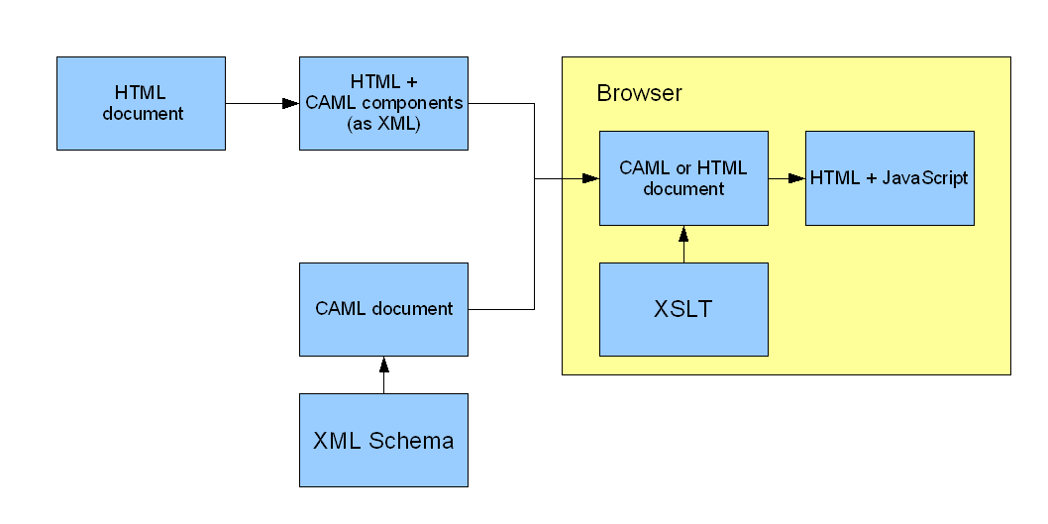
Figure 1: WebCA
To use CAML components in a HTML document, the document must be well-formed for transformation to work (XHTML). HTML can contain either CAML components or include a separate CAML/HTML document (see 2).

WebCA was tested on the following web browsers:
OS | Browser | Version | Comments
MAC OS X Leopard | Safari | 3.0.4 | WebKit nightly build was used due to SVG render problems.
MAC OS X Leopard | Firefox | 2.0.0.11 | SVG render problems.
MAC OS X Leopard | Firefox | 3 beta 2
MAC OS X Leopard | Camino | 1.5.3 | Same SVG problems as Firefox 2.0.0.11 ( due to Gecko engine)
Windows XP SP2 | Firefox | 2.0.0.10
Windows XP SP2 | Safari | 3.0.4 | WebKit r28899 was used due to SVG render problems.
Linux (SL 4) | Firefox | 2.0.0.9
Table 1: Supported browsers

Quick start
To include a CAML component into a HTML document, include the XML and CAML headers, style sheet and namespace declaration as shown below.
<?xml version=”1.0”?>
<?xml-stylesheet href=”xsl/webca.xsl” type=”text/xsl” ?>

<html xmlns:caml=”http://webca.cosylab.com”>
<head>

…

<caml:head webcaPath=”file:///D:/workspace/npca2/webca/”>

…

</head>
<body>

…

Simple example of PV monitor:
<caml:textUpdate readbackPV=”record1”/>

…

</body>
</html>
Update the webcaPath attribute of caml:head element in the head to point to WebCA installation, change the extension of the file to xml and open it in one of the supported browsers (see 1 for supported browsers, and 3 for plugin installation).
The equivalent example using CAML document:
<?xml version=”1.0”?>
<?xml-stylesheet href=”xsl/webca.xsl” type=”text/xsl” ?>
<caml
title=”WebCa Simple Example”
webcaPath=”file:///D:/workspace/npca2/webca/”>

<staticText>Simple example of PV monitor.</staticText>

<textUpdate readbackPV=”record1”/>

</caml>
HTML document can include other HTML or CAML documents by using caml:include element (see 8.3 for details).
…
<body>

…

Simple example of PV monitor:
<caml:include href=”simpleExample.xml”/>

…

The rest of this manual describes the usage of components as they were part of a CAML document. The usage in HTML document is identical, except that all elements’ names must be prefixed with caml: (<wheelSwitch …> becomes <caml:wheelSwitch …>).

WebCa plugin installation

Firefox Installation
The plugin is installed by opening an xhtml or xml document in the browser. When the bar at the top of the page appears notifying about missing plugin, click Install Missing Plugins…. The Plugin Finder Service will fail with the message No suitable plugins were found. Click on Manual Install next to Unknown Plugin (application/mozilla-npca-scriptable-plugin). Confirm the installation of the npca.xpi add-on by clicking on Install Now button. Then restart Firefox to complete the installation.
By default, the plugin is installed from http://webca.cosylab.com/npca.xpi. If this file is not up-to-date, or an offline installation is required, the plugin path can be set in the xhtml document using caml:head attribute. The following example installs the plugin from webca installation.
...
<head>
...
<caml:head webcaPath=”file:///D:/workspace/npca2/webca/” pluginUrl=”file:///D:/workspace/npca2/webca/plugin/npca.xpi”/>
...

Safari Installation
Automatic installation for Safari browser is not supported. You can install the plugin by copying the the plugin for the appropriate operating system from the webca installation to the Safari plugin folder (e.g. webca\plugin\bundle\platform\WINNT\plugins\npca.dll to C:\Program Files\Safari\Plugins for Windows platform with default Safari installation).

Context menu
If the right mouse button is pressed over a component (e.g. Slider), context menu will popup with several options to select. The function of each option is described in Table 2.
Menu option | Function
Copy PV Name | Copies the resolved name of the PV to the system clipboard.
Copy PV Value | Copies the value of the PV to the system clipboard.
Enable/Disable History | Toggles recording of PV state to a buffer. If history is enabled, value, timestamp, CA status and severity are stored each time the component is notified of a change. Disabling history clears the buffer. Recording is only available for non-array PV values.
Copy History | Copies the current history buffer to the system clipboard. This option is available only if history is enabled.
Show History | Displays the current history buffer in a new window. This option is available only if history is enabled.
Show PV Inspector | Displays the PV details in a new window.
Table 2: Context menu options
Example of context menu and PV inspector window is shown below.
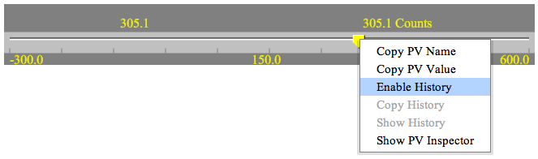
Figure 2: Context menu example
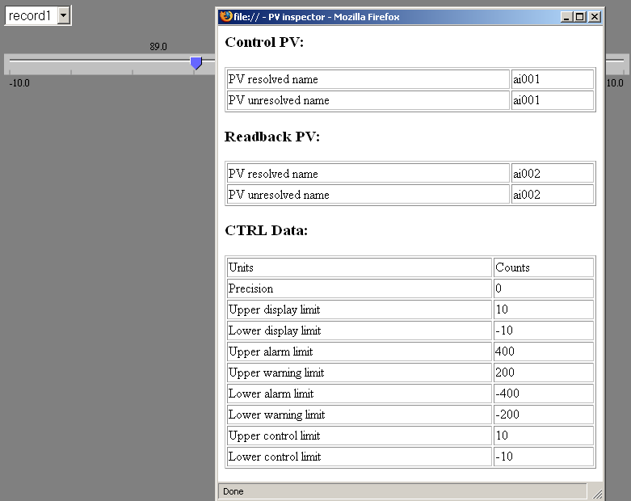
Figure 3: PV inspector example

Number format
Components which are used to display or control decimal values has numberFormat attribute which can be used to define format in which decimal value should be displayed.
Formats are specified using the following characters >#, 0, ., E, +< where meaning is the following:
- # - digit that is displayed only if not zero
- 0 – digit that is displayed also when zero
- . – used for decimal point
- E – used for exponential format
- + - used for sign

If exponential format is used >#< must not appear in format specification.

Examples of formats definitions and wheelSwitch components using these formats are shown below:
- +##000.00
- +00.000
- +00.000###
- +00.00E+00
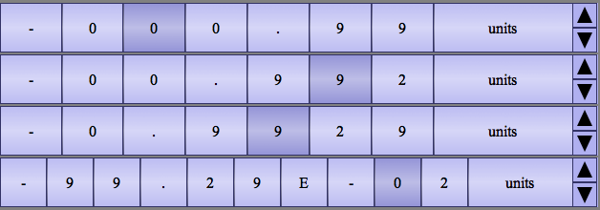
Figure 4: Number format examples

Macro substitution
Macro substitution is supported by WebCA. There are two ways of supplying macros to xml document:
- Using query string. Example is shown below:
file:///D:/workspace/npca2/webca/slider.xml?NAME=ai003&NUMBER1=1&NUMBER2=2
Slider.xml will be opened with macros NAME, NUMBER1 and NUMBER2 defined with values ai003, 1 and 2 respectively.
- Using “substitutor” component. Example of this component is mux. See 8.8 for details on mux.

Macros defined in query string have precedence from macros defined in substitutor component.

Global parameters
Global parameters are defined as attributes to the caml:head element in HTML document or root caml element in CAML document
Attribute | value | required/optional | description
webcaPath | String | required | Defines the relative path of the WebCa installation from the document.
pluginUrl | String | optional | Defines the url to the NPCA plugin. Default is http://webca.cosylab.com/npca.xpi.
extStyle | String | optional | Defines additional class of all components which can be used in CSS to define additional styles.
Title | string | optional | Defines the title of the xml document (only applicable in CAML document.)
pendEvents | decimal | optional | Defines the number of the events processed by npca plugin when npca plugin’s pendEvents function is called.  See ref [1] for details on pendEvents function.  If not defined default value is 42.
pendEventsPeriodMs | decimal | optional | Defines the time interval in ms in which plugin’s pendEvents function is called. See ref [1] for details on pendEvents function.  If not defined default value 100 ms is used.
Table 3: caml:head/caml attributes

Components

Standard component attributes
attribute | value | required/optional | description
size | enumerated type (small, medium large) | optional | Defines the size of the text.
extStyle | String | optional | Defines additional class of the component which can be used in CSS to define additional styles.
readbackPV | String | required on monitor components, optional or prohibited otherwise | Readback PV name.
controlPV | String | Required on control components, prohibited otherwise | Control PV name.
readOnly | enumerated type (true, false, auto) | Optional on control components, prohibited otherwise | Specifies whether the controlled PV can be written to. If readOnly is set to “auto”, the read-only state is specified by CA. Default is “auto”.
alarmSensitive | enumerated type (true, false, none, foreground, background) | optional | Defines whether component is sets its colors based on alarm. If alarmSensitive is true or foreground, foreground color is set, if it is background, background color is set, otherwise the colors are not set. Default is true.
displayFormat | String | optional | Defines the display format on applicable components. For details on displayFormat see 5.
Table 4: Standard component attributes

Layout components
The following layout components are available:
- horizontalPanel
- verticalPanel
- column
- row
- panel

HorizontalPanel
HorizontalPanel is used to create panel with one row and unlimited columns.
Example of xml definition is shown below
<horizontalPanel caption=”Simple horizontal Panel”
extStyle=”panelWithSomeDecorations”>
<column>
…
</column>
<column>
…
</column>
.
.
.
</horizontalPanel>

HorizontalPanel attributes:
attribute | value | required/optional | description
caption | string | optional | Defines the caption for the horizontalPanel.
Width | pixels  % | optional | Sets width of the horizontal panel.
Table 5: HorizontalPanel attributes
Standard attributes:
extStyle
Table 6: HorizontalPanel standard attributes
For a full description of standard attributes, go to 8.1

HorizontalPanel elements:
Element | min/max occurs | required/optional | description
column | 0/unbounded | optional | Defines column in horizontalPanel.
Table 7: HorizontalPanel elements

VerticalPanel
VerticalPanel is used to create panel with one column and unlimited rows.
Example of xml definition is shown below.
<verticalPanel caption=”Simple vertical Panel”
extStyle=”panelWithSomeDecorations”>
<row>
…
</row>
<row>
…
</row>
.
.
.
</verticalPanel>

VerticalPanel attributes:
attribute | value | required/optional | description
caption | string | optional | Defines the caption for the verticalPanel
width | pixels  % | optional | Sets width of the vertical panel.
Table 8: VerticalPanel attributes
Standard attributes:
extStyle
Table 9: VerticalPanel standard attributes
For a full description of standard attributes, go to 8.1

VerticalPanel elements:
Element | min/max occurs | required/optional | description
row | 0/unbounded | optional | Defines row in verticalPanel
Table 10: VerticalPanel elements

Column
Column is building block for horizontalPanel and panel.
Example of xml definition is shown below.
<column caption=”Column caption”
height=”300px” width=”50%”
extStyle=”SomeStyle”
colspan=”4”>
…
</column>

Column attributes:
attribute | value | required/optional | description
caption | string | optional | Defines the caption for the column
height | pixels  % | optional | Sets height of the column
width | pixels  % | optional | Sets width of the column
colspan | decimal | option | Defines the number of columns this column should span if used inside panel
Table 11: Column attributes
Standard attributes:
extStyle
Table 12: Column standard attributes
For a full description of standard attributes, go to 8.1.

Row
Row is building block for verticalPanel or panel.
Example of xml definition is shown below.
<row caption=”Column caption”
height=”300px” width=”50%”
extStyle=”SomeStyle”>
…
</row>

Row attributes:
attribute | value | required/optional | description
caption | string | optional | Defines the caption for the row
height | pixels  % | optional | Sets height of the row
width | pixels  % | optional | Sets width of the row
Table 13: Row attributes
Standard attributes:
extStyle
Table 14: Row standard attributes
For a full description of standard attributes, go to 8.1.

Panel
Panel is used to build complex layouts.
Example of xml definition is shown below.
<panel extStyle=”SomeStyle”>
<row>
<column>
…
</column>
</row>
<row>
…
</row>
</panel>

Panel attributes:
attribute | value | required/optional | description
caption | string | optional | Defines the caption for the panel.
Width | pixels  % | optional | Sets width of the panel.
Table 15: Panel attributes
Standard attributes:
extStyle
Table 16: Panel standard attributes
For a full description of standard attributes, go to 8.1.
Panel elements:
Element | min/max occurs | required/optional | description
row | 0/unbounded | optional | Defines row in panel
Table 17: Panel elements

Example of building layout using above components:
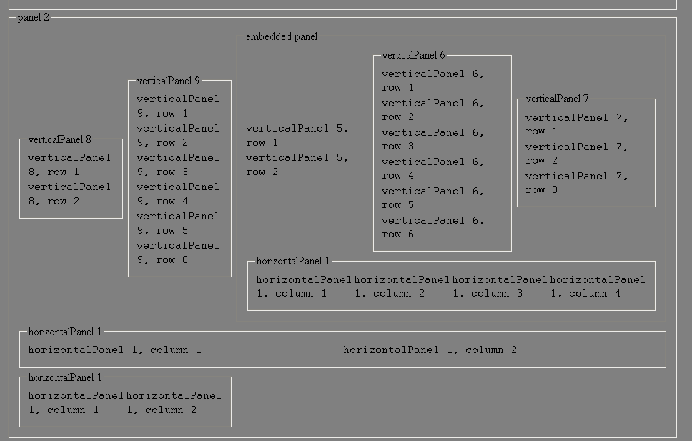
Figure 5: Complex layout example

Include
Include is used to include a separate caml or well formed html file.
Example of xml definition is shown below.
<include href=”magnetDisplay.xml”>
<macroValuePair macroName=”$(NAME)” macroValue=”magnet1”/>
</include>

<include href=”description.html”/>
In the case of the html file, only its body is included. The html file can contain caml elements.
Include attributes:
attribute | value | required/optional | description
href | string | required | The URL of the file to include.
Table 18: Include attributes
Include elements:
Element | min/max occurs | required/optional | description
macroValuePair | 0/unbounded | optional | Defines a sequence of macro value pairs (see 8.3.1).
Table 19: Include elements

Macro-Value Pairs
Macro-Value pairs are defined using macroValuePair element.
macroValuePair attributes:
Attribute | value | required/optional | description
macroName | string | required | The name of the macro.
macroValue | String | required | The value of the macro.
Table 20: macroValuePair attributes

Repetition
Repetition is used to create more instances of the same group of components.
Example of xml definition is shown below.
<caml:repetition name=”RepPV”>

<caml:list>
<caml:item>
<caml:macroValuePair macroName=”$(PV)” macroValue=”Record1”/>
</caml:item>
<caml:item>
<caml:macroValuePair macroName=”$(PV)” macroValue=”Record2”/>
</caml:item>
<caml:item>
<caml:macroValuePair macroName=”$(PV)” macroValue=”Record3”/>
</caml:item>
</caml:list>

<caml:template>
<caml:staticText>PV: $(RepPV:index)</caml:staticText> <caml:textUpdate readbackPV=”$(PV)State”/>
<caml:textUpdate readbackPV=”$(PV)Get”/>
<caml:wheelSwitch controlPV=”$(PV)Set”/>
</caml:template>

</caml:repetition>

Repetition attributes:
attribute | value | required/optional | description
name | string | optional | Defines the name of this repetition. It is used for implicit macros (see Table 23).
Table 21: Repetition attributes
Repetition elements:
Element | min/max occurs | required/optional | description
list | 1/1 | required | Defines the instance data for the template.
Template | 1/1 | required | Defines the group of components to instantiate. It can contain arbitrary component with the exception of tabs.
Table 22: Repetition elements
list elements:
Element | min/max occurs | required/optional | description
item | 1/unbounded | required | Contains the macro substitution data for a single template instance. Each item has an implicit macro with the name $(repetition name:index) and the value representing the position of the item in the list, starting with 1.
Table 23: list elements
item elements:
Element | min/max occurs | Required/optional | description
macroValuePair | 0/unbounded | Optional | Defines a macro (see 8.3.1).
Table 24: item elements

TabView
TabView is used to create tabbed view.
Example of xml definition is shown below.
<tabView extStyle=”SomeStyle” orientation=”top”>
<tab name=”Tab 1” selected=”true”>
…
</tab>
<tab name=”Tab 2”>
…
</tab>
</tabView>

TabView attributes:
attribute | value | required/optional | description
orientation | enumerated value  (top, left, right, bottom) | optional | Defines orientation of tabbed view. Default value is top.
Table 25: TabView attributes
Standard attributes:
extStyle
Table 26: TabView standard attributes
For a full description of standard attributes, go to 8.1.

TabView elements:
Element | min/max occurs | required/optional | description
tab | 1/unbounded | required | Defines a single tab in tabbed view.
Table 27: TabView elements
Tab attributes:
attribute | value | required/optional | description
name | string | required | Defines the name of the tab.
Selected | boolean | optional | Defines which tab is selected when page is opened.
Table 28: Tab attributes
Example of tabView is shown below:
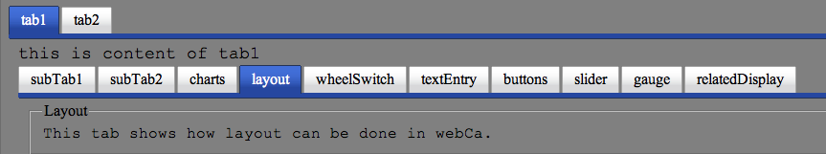
Figure 6: TabView example

Image
Example of xml definition is shown below:
<img src=”epicsLogo.gif” alt=”epics Logo”
width=”200px”
height=”200px”>
</img>
Image attributes:
attribute | value | required/optional | description
src | string | required | The URL of the image to display.
alt | string | optional | Defines a short description of the image.
Width | pixels  % | optional | Sets the width of an image.
Height | pixels  % | optional | Sets the height of an image.
Table 29: Image attributes
Standard attributes:
size, extStyle
Table 30: Image standard attributes
For a full description of standard attributes, go to 8.1

StaticText
StaticText is used to display static text.
Example of xml definition is shown below.
<staticText size=”small” extStyle=”someStyle” href=”example.xml” visibilityPV=”$(RECVIS)” visibilityMin=”0” visibilityMax=”10” visibilityInvert=”true”>
Some text to display. And macro to be displayed $(NAME).
</staticText>

StaticText attributes:
attribute | value | required/optional | description
href | string | optional | If defined staticText will act as a link.
Target | string | optional | Defines the html target attribute for the link. Default value is _blank.
align | enumerated value (left, right) | optional | Defines the content alignment. Default is left.
visibilityPV | string | optional | Defines the pv that controls visibility of the text. If visibilityPV is not set, text is always visible, otherwise it is visible depening on the visibility* parameters. If visibilityPV does not exist, or is nonnumeric value, the staticText is invisible.
visibilityMin | numeric | optional | If virtualPV value is below visibilityMin, staticText is invisible. Default is 0.
visibilityMax | numeric | optional | If virtualPV value is equal or above visibilityMin, staticText is invisible. Default is 0.
visibilityInvert | boolean | optional | If true, switches the visible and invisible state. Default is false.
Table 31: StaticText attributes

Standard attributes:
size, extStyle
Table 32: StaticText standard attributes

For a full description of standard attributes, go to 8.1

StaticText supports macro substitutions. See 6 for more information on macro substitutions.
Example of static text is shown below.
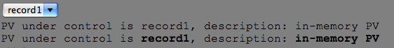
Figure 7: StaticText example

Mux
Mux is used for macro substitutions.
Example of xml definition is shown below:
<mux size=”small” extStyle=”someStyle”>
<sequence name=”record1” selected=”true”>
<macroValuePair macroName=”$(NAME)”
macroValue=”record1”/>
<macroValuePair macroName=”$(DESC)”
macroValue=”in-memory PV”/>
</sequence>
<sequence name=”record2”>
<macroValuePair macroName=”$(NAME)”
macroValue=”record2”/>
<macroValuePair macroName=”$(DESC)”
macroValue=”counter PV”/>
</sequence>
<sequence name=”enum”>
<macroValuePair macroName=”$(NAME)”
macroValue=”enum”/>
<macroValuePair macroName=”$(DESC)”
macroValue=”enumerated PV”/>
</sequence>
</mux>

Standard attributes:
size, extStyle
Table 33: Mux standard attributes
For a full description of standard attributes, go to 8.1

Mux elements:
Element | min/max occurs | required/optional | description
sequence | 1/unbounded | required | Defines a sequence of macro value pairs
Table 34: Mux elements

Sequence attributes:
attribute | value | required/optional | description
name | string | required | Defines the name of the sequence.
Selected | boolean | optional | Defines a default selected sequence
Table 35: Sequence attributes

Sequence elements:
Element | min/max occurs | required/optional | description
macroValuePair | 0/unbounded | Optional | Defines a macro (see 8.3.1).
Table 36: Sequence elements

Exampel of mux component is shown below.
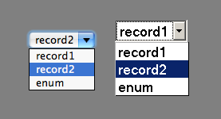
Figure 8: Mux component; left in Safari, right in Firefox
For details on macro substitutions see 6.

TextUpdate

Example of xml definition is shown below:
<textUpdate
readbackPV=”Pvname”
alarmSensitive=”true”
dataType=”numeric”
displayFormat=”v(#0.00)ua”
size=”small”
extStyle=”someStyle”/>

TextUpdate attributes:
Attribute | value | required/optional | Description
dataType | Enumerated type (numeric, text) | optional | Defines the type of data. Default value is numeric.
displayFormat | String | optional | See 8.9.1
Table 37: TextUpdate attributes
Standard attributes:
size, extStyle, readbackPV, alarmSensitive
Table 38: TextUpdate standard attributes
For a full description of standard attributes, go to 8.1

Extended displayFormat
In addition to the number format described in 5, displayFormat attribute on textUpdate can be a template or a custom display definition, detailed in Table 39 and Table 40.
Form/template | Description
numberFormat | PV is displayed with value using numberFormat and unit if defined.
Normal | PV is displayed as value and unit if defined.
Timestamp | PV is displayed as value, unit and timestamp in iso format.
Complete | PV is displayed as value, unit, timestamp, alarm severity and CA status.
Tokens | PV is displayed with custom definition (See Table 40)
Table 39: displayFormat forms/templates
Token | Description
v(numberFormat) | Includes value in the display, formatted with numberFormat. If numberFormat is omitted, the format is specified with precision received from CA.
u | Includes unit in the display.
t(format) | Includes timestamp in the display. Timestamp is formatted using format (see 8.9.2). If format is omitted, iso format (yyyy-mm-dd’T’HH:MM:ss:l) is used.
A | Includes alarm severity in the display.
s(format) | Includes CA status in the display. If format is ‘t’, the status is displayed as text. If format is ‘c’, the status is displayed as a numeric code. If format is omitted, ‘t’ is used.
‘text’ | Includes arbitrary text in the display. The quotes are omitted.
Table 40: displayFormat tokens

Timestamp format
Timestamp can be formatted using a template or a mask. Table 41 shows a list of examples.
Template | Mask | Example
default | ddd mmm dd yyyy HH:MM:ss | Wed Aug 27 2008 15:47:48
fullDate | dddd, mmmm d, yyyy | Wednesday, August 27, 2008
longTime | h:MM:ss TT Z | 3:47:48 PM GMT+0200
isoUtcDateTimeL | UTC:yyyy-mm-dd’T’HH:MM:ss:l | 2008-08-27T13:47:48:812
Table 41: Examples of timestamp format

Examples of textUpdate
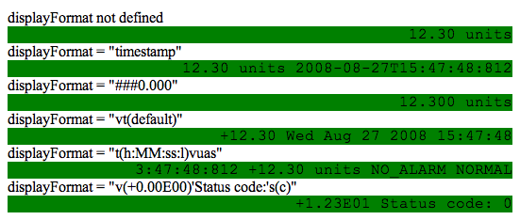
Figure 9: TextUpdate examples

TextEntry
Example of xml definition is shown below:
<textEntry
controlPV=”PVName”
alarmSensitive=”true”
dataType=”numeric”
displayFormat=”#0.00”
size=”small”
extStyle=”smoeStyle”/>

TextEntry attributes:
Attribute | value | required/optional | description
dataType | Enumerated type (numeric, text) | optional | Defines the type of data. Default value is numeric.
Table 42: TextEntry attributes
Standard attributes:
size, extStyle, controlPV, alarmSensitive, displayFormat
Table 43: TextEntry standard attributes
For a full description of standard attributes, go to 8.1

Example of textEntry is shown below.
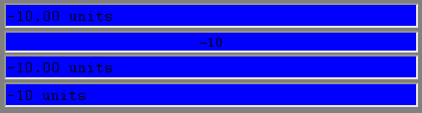
Figure 10: TextEntry example

Message Button
Example of xml definition is shown below:
<messageButton controlPV=”PVName”
alarmSensitive=”false”
size=”small”
extStyle=”someStyle”>
<on caption=”On caption” value=”on value”></on>
<off caption=”off caption” value=”off value”></off>
</messageButton>

Standard attributes:
size, extStyle, controlPV, alarmSensitive
Table 44: MessageButton standard attributes
For a full description of standard attributes, go to 8.1

MessageButton elements:
Element | min/max occurs | required/optional | description
on | 1/1 | required | Defines the ‘on’ state of the messageButton
off | 1/1 | required | Defines the ‘off’ state of the messageButton
Table 45: MessageButton elements

On and off attributes:
Attribute | value | required/optional | description
caption | string | required | State caption
value | string | required | State value
Table 46: On and off attributes

Example of messageButton is shown below.
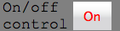
Figure 11: MessageButton example

MenuButton
Example of xml definition is shown below:
<menuButton controlPV=”controlPVName” readbackPV=”readbackPVName”
alarmSensitive=”true”>
<menuButtonItem value=”0” name=”min”/>
<menuButtonItem value=”50” name=”medium”/>
<menuButtonItem value=”100” name=”full”/>
</menuButton>
Standard attributes:
size, extStyle, controlPV, alarmSensitive, readbackPV, controlPV
Table 47: MenuButton standard attributes
For a full description of standard attributes, go to 8.1

MenuButton elements:
Element | min/max occurs | required/optional | description
menuButtonItem | 0/unbounded | optional | Defines an item of the menu. If not defined button will try to get menu from PV.
Table 48: MenuButton elements

MenuButtonItem attributes:
Element | min/max occurs | required/optional | description
value | string | required | Menu item value
name | string | required | Menu item name
Table 49: MenuButtonItem attributes
Example of menuButton is shown below.
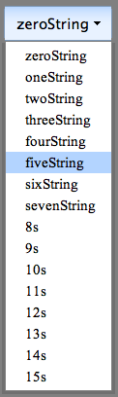
Figure 12: MenuButton example

RadioButton
Example of xml definition is shown below:
<radioButton controlPV=”controlPVName”
readbackPV=”readbackPVName”
alarmSensitive=”true”>
<radioButtonItem value=”0” name=”min”/>
<radioButtonItem value=”50” name=”medium”/>
<radioButtonItem value=”100” name=”full”/>
</radioButton>

RadioButton attributes:
Element | value | required/optional | description
type | enumerated type (radio, toggle) | optional | When radio is selected radio button is traditional HTML radio button. If toggle is selected radio button is YUI [6] radio button. Default value is radio.
direction | enumerated type (horizontal, vertical) | optional | Defines the layout of buttons; in line if horizontal and stacked if vertical. Default is horizontal.
Table 50: RadioButton attributes
Standard attributes:
size, extStyle, controlPV, alarmSensitive, readbackPV, controlPV
Table 51: RadioButton standard attributes
For a full description of standard attributes, go to 8.1

RadioButton elements:
Element | min/max occurs | required/optional | description
radioButtonItem | 0/unbounded | optional | Defines an item of the menu. If not defined button will try to get menu from PV.
Table 52: RadioButton elements

RadioButtonItem attributes:
Element | value | required/optional | description
value | string | required | Menu item value
name | string | required | Menu item name
Table 53: RadioButtonItem attributes
Example of radioButton is shown below.
Figure 13: RadioButton example

WheelSwitch
Example of xml definition is shown below:
<wheelSwitch
controlPV="PVName"
alarmSensitive="true"
displayFormat="#0.00"
size="small"
extStyle="someStyle"/>

Standard attributes:
size, extStyle, controlPV, alarmSensitive, displayFormat
Table 54: WheelSwitch standard attributes
For a full description of standard attributes, go to 8.1

Example of wheelSwitch is shown below:
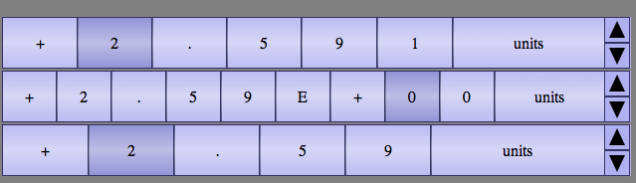
Figure 14: WheelSwitch example

BitControl
BitControl is the component that displays and controls bit values of the records. Example of xml definition is shown below:
<bitControl
controlPV="PVName"
alarmSensitive="true"
startBit="0"
endBit="31"
size="small"
extStyle="someStyle"/>

BitControl attributes:
attribute | value | required/optional | description
startBit | nonnegative integer | required | Index of the starting bit, displayed at the leftmost position in the component.
endBit | nonnegative integer | required | Index of the ending bit, displayed at the rightmost position in the component.
href | string | optional | If defined context menu will contain Open Link option which opens this link.
target | string | optional | Defines the html target attribute for the link. Default value is _blank.
Table 55: BitControl attributes
The bit indices are ordered so that the least significant bit has an index of 0. startBit can be set to a higher value than endBit; in this case more significant bits will precede less significant in the display.

Standard attributes:
size, extStyle, controlPV, alarmSensitive
Table 56: BitControl standard attributes
For a full description of standard attributes, go to 8.1

An example of 2 bitControl components with 32 bits is shown below:
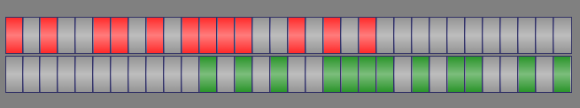
Figure 15: BitControl example

Slider
Example of xml definition is shown below:
<slider
controlPV="controlPVName"
readbackPV="readbackPVName"
maxValue="650"
minValue="-300"
increment="0.01"
displayFormat="#0.000"/>
Slider attributes:
attribute | value | required/optional | description
maxValue | string | optional | Max value to be displayed.
minValue | string | optional | Min value to be displayed.
increment | decimal | optional | Increment to be used when clicking slider area. Default value is 0.1.
Table 57: Slider attributes
Standard attributes:
size, extStyle, displayFormat, alarmSensitive, controlPV, readbackPV
Table 58: Slider standard attributes
For a full description of standard attributes, go to 8.1
Example of slider is shown below:
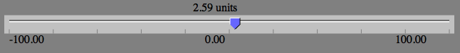
Figure 16: Slider example

Gauge
Example of xml definition is shown below:
<gauge
readbackPV="readbackPVName"
maxValue="650"
minValue="-300"
displayFormat="#0.000"/>
Gauge attributes:
attribute | value | required/optional | description
maxValue | string | optional | Max value to be displayed.
minValue | string | optional | Min value to be displayed.
Table 59: Gauge attributes
Standard attributes:
size, extStyle, displayFormat, alarmSensitive, readbackPV
Table 60: Gauge standard attributes
For a full description of standard attributes, go to 8.1
Example of gauge is shown below:
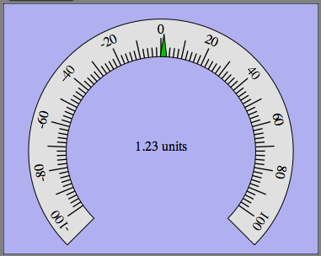
Figure 17: Gauge example

RelatedDisplay
Example of xml definition is shown below:
<relatedDisplay type="image" src="logo_cosylab.gif"
alt="alt" width="500px" height="200px" >
<display src="slider.xml" name="beamline1">
<macroValuePair macroName="$(NAME)" macroValue="val1"/>
<macroValuePair macroName="$(NAME1)" macroValue="val2"/>
<macroValuePair macroName="$(DESC)" macroValue="desc"/>
</display>
</relatedDisplay>
RelatedDisplay attributes:
Attribute | Value | required/optional | description
type | enumerated type(image, button, text) | required | Defines type of related display.
src | string | Required if image type, otherwise ignored.. | The URL of the image to display.
alt | string | Optional if image type, otherwise ignored.. | Defines a short description of the image.
width | pixels  % | Required if text type, optional if image type, otherwise ignored. | Sets the width of the component.
height | pixels  % | Required if text type, optional if image type, otherwise ignored. | Sets the height of the component.
Table 61: RelatedDisplay attributes
Standard attributes:
size, extStyle
Table 62: RelatedDisplay standard attributes
For a full description of standard attributes, go to 8.1

RelatedDisplay elements:
Element | min/max occurs | required/optional | description
display | 1/1 | required | Defines the display to launch
Table 63: RelatedDisplay elements
Display attributes:
Attribute | value | required/optional | description
src | string | required | The URL of the display to open.
name | string | required | Name of the display. Caption on the button if button is the type.
macroPropagation | boolean | optional | Defines if active macros should be propagated to opened display. Default value is false.
target | string | optional | Defines the html target attribute for the link. Default value is _blank.
Table 64: Display attributes
Display elements:
Element | min/max occurs | required/optional | description
macroValuePair | 0/unbounded | Optional | Defines a macro (see 8.3.1).
Table 65: Display elements
MacroValuePair attributes:
Attribute | value | required/optional | description
macroName | string | required | The name of the macro.
macroValue | string | required | The value of the macro.
Table 66: MacroValuePair attributes

X-Y Chart
To use X-Y Chart to plot array y against array x use the following xml definition:
<xyChart xAxisLabel=”Axis X label”
yAxisLabel=”Axis Y label”>
<xySeries Y-PVname=”waveformY” name=”energy”
X-PVname=”waveformX”/>
</xyChart>

X-Y chart component attributes:
Attribute | value | required/optional | description
xAxisLabel | string | optional | X axis label
yAxisLabel | string | optional | Y axis label
xAxisStyle | enumerated type  (index, time(format)) | optional | Used only when plotting series without x values (see Table 69). If set to index, the y values on the graph are plotted against their index in the array, and if set to time, they are plotted using their timestamps. Default is index. format specifies the formatting of timestamps on the graph (see 8.9.2). format can be omitted.
numberOfPoints | positive integer | optional | Used only when plotting series without x values (see Table 69). If xAxisStyle is index, it defines the maximum number of values plotted before discarding the oldest data. If xAxisStyle is time, it defines the maximum number of seconds displayed in the chart. Default is 100.
flavor | enumerated type  (normal, advanced, fast) | optional | The style of the graph. When set to “advanced”, the graph supports more features (zooming), but is possibly slower. With “fast”, it supports the fewest features for maximum speed. Default is “normal”.
Table 67: X-Y chart attributes
X-Y chart elements:
Element | min/max occurs | required/optional | description
xySeries | 1/unbounded | required | Defines an array of values
Table 68: X-Y chart elements
xySeries component attributes:
Attribute | value | required/optional | description
Y-PVname | string | required | PV name for y values.
X-PVname | string | optional | PV name for x values. If not defined y values are plotted against their index in the array or against timestamps, depending on xAxisStyle set on the chart.
name | string | optional | Name of series.
type | enumerated type  (scatter, line) | optional | Default value is line.
Table 69: xySeries attributes
When the flavor attribute of the X-Y chart component is set to “fast”, a minimal feature fast implementation of chart is used. The fast chart is currently implemented only for xAxisStiye=”time” with scalar y PV, which corresponds to a time trend chart.
When the flavor attribute of the X-Y chart component is set to “advanced”, the chart supports zooming. To magnify a region on the chart, select the region by pressing and dragging left mouse button. To return to starting zoom, click on the chart with the left mouse button.
Example of X-Y chart is shown below.
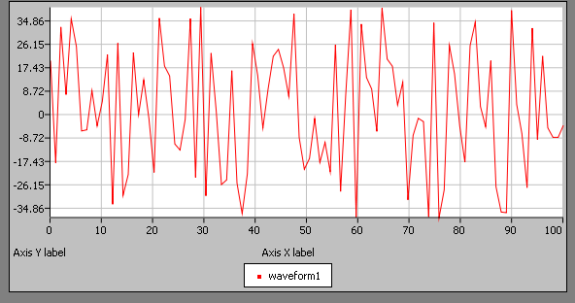
Figure 18: X-Y chart example

bar chart
Bar chart component is used to display scalars or array of values in bar chart.
Example 1. Display two arrays, barWaveform1 and barWaveform2, with labels supplied by xLabelsWaveform.
<barChart xAxisLabel=”Axis X label”
yAxisLabel=”Axis Y label”
xLabelsPV=”xLabelsWaveform”
xLabels=”[‘mon’,’tue’,’wen’]”>
<series PVname=”barWaveform1” name=”series1”/>
<series PVname=”barWaveform2”/>
</barChart>
Example 2. Display three scalar values, Rec1Val, Rec2Val and Rec3Val, with one bar for each.
<barChart>
<series PVname=”Rec1Val” name=”Rec1Val”/>
<series PVname=”Rec2Val” name=”Rec2Val”/>
<series PVname=”Rec3Val” name=”Rec3Val”/>
</barChart>
Bar chart attributes:
Attribute | value | required/optional | description
xAxisLabel | string | optional | X axis label
yAxisLabel | string | optional | Y axis label
xLabelsPV | string | optional | PV name for x axis series labels, if not defined xLabels will be used
xLabels | string | optional | Array of x series labels
flavor | enumerated type  (normal, advanced) | optional | The style of the graph. When set to “advanced”, the graph supports more features (zooming), but is possibly slower. Default is “normal”.
Table 70: Bar chart attributes

Bar chart elements:
Element | min/max occurs | required/optional | description
series | 1/unbounded | required | Defines one array of values in bar chart.
Table 71: Bar chart elements

Series attributes:
Attribute | value | required/optional | description
PVname | string | required | PV name for scalar or array of values.
name | string | optional | Name of series.
Table 72: Series attributes
When the flavor attribute of the Bar chart component is set to “advanced”, the chart supports zooming. To magnify a region on the chart, select the region by pressing and dragging left mouse button. To return to starting zoom, click on the chart with the left mouse button.

Example of bar chart component connected to two series of data is shown below
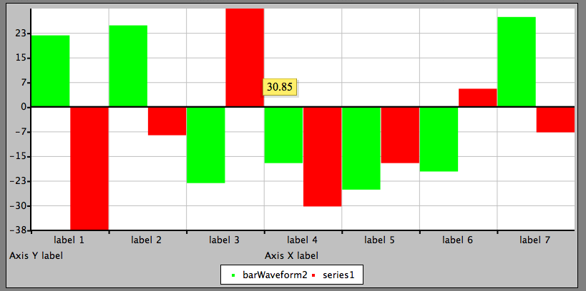
Figure 19: Bar Chart

Intensity plot
Example of xml definition is shown below.
<intensityPlot readbackPV="PVname" width="320" height="240" maxValue="256" waterfall="false"/>
Intensity plot attributes:
Attribute | value | required/optional | description
width | pixel  % | required | width of intensity plot
height | pixel  % | required | height of intensity plot
maxValue | decimal | required | Intensity plot consists of grayscale image, when minimum value (0) is represented as black pixel and maximum value element as white. This attribute defines maximum value.
waterfall | boolean | required | if true, intensity plot is shown as waterfall (rows are sequentially added one after another over the time)
Table 73: Bar chart attributes
Standard attributes:
size, extStyle, readbackPV, alarmSensitive
Table 74: Intensity plot standard attributes
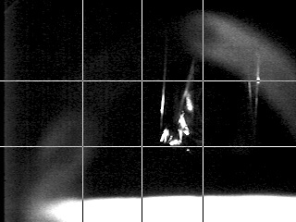
Figure 20: Intensity plot

VirtualPV
VirtualPV defines a process variable that exists in the context of the client. It can be used to perform and store calculations on other process variables similarly to a CALC record, or interact with user supplied functions by executing arbitrary Javascript code.
Example 1. Perform a calculation on a PV every 3 seconds and set minor alarm when result is over defined limits.
<virtualPV name="PVname_sin"
init="this = 0;
ctrl.upperWarningLimit = 9;
ctrl.lowerWarningLimit = -9;"
eval="sin(2*PI * pvs.PVname * pvs.PVfreq) * 10"
scan="3000">
<ctrl units="gigaquads" precision="5"/>
</virtualPV>
Example 2. Calculate a sum of a vector PV.
<virtualPV name="PVwaveform_sum" init="0"
eval="this=0;
for(var i=pvs.PVwaveform.length-1;i>=0;i--)
this+=pvs.PVwaveform[i];"
scan="1000"
/>
Example 3. Elevate minor alarms to major on a PV, refresh on PV change.
<virtualPV name="PVname_strict"
init="0”;
eval="alarm = pvs.PVname.alarm;
if (alarm == MINOR) alarm = MAJOR;
this = pvs.PVname;"
scan="passive"/>

VirtualPV attributes:
Attribute | value | required/optional | Description
name | string | required | The name of the PV.
init | string | required | Starting value of the PV. This attribute can contain Javascript code that is evaluated once at the start (see 8.22.2).
eval | string | optional | Expression to calculate the value of the PV. This is evaluated at the time that depends on the scan attribute. It can contain arbitrary Javascript code (see 8.22.2).
scan | Number of milliseconds or “passive” | optional | Defines the time when eval expression is evaluated. If the value is “passive”, the expression is evaluated each time a value of a PV in the expression is changed. If the value is an integer p, the expression is evaluated periodically at the interval of p milliseconds. Default is “passive”.
display | boolean | optional | Defines whether the component is visible. Default is false.
Table 75: VirtualPV attributes
VirtualPV elements:
Element | min/max occurs | required/optional | description
ctrl | 1/1 | optional | Defines the control data of the PV.
Table 76: VirtualPV elements
Ctrl attributes:
Attribute | value | required/optional | description
units | string | optional | The units of this PV. Default is no unit.
precision | nonnegative integer | optional | The number of trailing decimals to use when displaying this PV. Default is no specification.
upperDisplayLimit | decimal | optional | The upper limit used when displaying this PV. Default is no specification.
lowerDisplayLimit | decimal | optional | The lower limit used when displaying this PV. Default is no specification.
upperControlLimit | decimal | optional | The maximum value of this PV. The value will be set to this if larger. Default is no upper limit.
lowerControlLimit | decimal | optional | The minimum value of this PV. The value will be set to this if smaller. Default is no lower limit.
upperAlarmLimit | decimal | optional | See 8.22.1.
lowerAlarmLimit | decimal | optional | See 8.22.1.
upperWarningLimit | decimal | optional | See 8.22.1.
lowerWarningLimit | decimal | optional | See 8.22.1.
labels | [string 1, …, string n] | optional | The list of labels used to define an enum like PV.
Table 77: Ctrl attributes
Standard attributes:
size, extStyle, alarmSensitive
Table 78: VirtualPV standard attributes
VirtualPV with a given name takes precedence over PV with the same name received through Channel Access.
The data type of the VirtualPV is set to the type of the init attribute, and should not be changed later using eval attribute.

Alarm specification
By default, the alarm of the PV is set to the alarm of the greatest severity from the PVs used in eval attribute. This behavior is overridden when one of the upperAlarmLimit, lowerAlarmLimit, upperWarningLimit, or lowerWarningLimit is set. In this case, the alarm is set to MAJOR if the value of PV is larger than upperAlarmLimit or smaller than lowerAlarmLimit;, to NO_ALARM if the value is smaller or equal to upperWarningLimit and larger or equal to lowerWarningLimit, and to MINOR for the remaining values.

The alarm can also be defined arbitrarily using the eval attribute (see 8.22.2). When the alarm is referenced inside the eval code, the limits in ctrl element are ignored.

Code syntax
The code supplied to init and eval attributes can be an expression, or a series of statements. Statements must end with a semicolon (;), even if there is only a single statement used. The syntax is a regular Javascript with the special symbols listed in Table 79.
Symbol | Meaning
Objects
this | A reference to this PV.
pvs.pvName | A reference to the PV with the name pvName. pvName can be a macro.
Fields
val | The value of the PV, can be omitted.
alarm | The alarm severity of the PV.
ctrl. precision | The set precision of the PV
ctrl. upperDisplayLimit | The upper display limit of the PV.
ctrl. lowerDisplayLimit | The lower display limit of the PV.
ctrl. upperControlLimit | The upper control limit of the PV.
ctrl. lowerControlLimit | The lower control limit of the PV.
ctrl. upperAlarmLimit | The upper alarm limit of the PV.
ctrl. lowerAlarmLimit | The lower alarm limit of the PV.
ctrl. upperWarningLimit | The upper warning limit of the PV.
ctrl. lowerWarningLimit | The lower warning limit of the PV.
Constants
NO_ALARM | No alarm.
MINOR | Minor severity of the alarm.
MAJOR | Major severity of the alarm.
INVALID | Invalid state of the alarm.
Table 79: Symbols for VirtualPV init and eval attributes.
eval code can use all the symbols shown in the Table 79, while init code can use all except pvs.pvName references. If the code is an expression, it is set to the value of this PV. If statements are used, the value must be set explicitly using this = value or val = value. The value of the VirtualPV is updated after the execution of the code is completed, and at that time other components are notified of the change. The states of other PVs should not be changed in this code.
Signs that are common in CA record names such as dash and colon are treated as part of a name by default. To use them as Javascript syntax, separate them from names using spaces. E.g. use pvs.Device1-Value - pvs.Device2-Value instead of pvs.Device1-Value-pvs.Device2-Value.
Signs that are common in CA record names such as dash and colon are treated as part of a name by default. To use them as Javascript syntax, separate them with spaces. E.g. use pvs.Device1-Value - pvs.Device2-Value instead of pvs.Device1-Value-pvs.Device2-Value.
When using fields without an object, this is assumed. For functions in the Javascript Math class, Math can be omitted. Constants for the severity of the alarm can be compared, where alarm1 is greater than alarm2 if alarm1 has greater severity than alarm2.
The identifiers are colorized when the eval code it is displayed in the component using the rules in Table 80.
Identifier | Color
References to this | Cyan
PV references | The color for the severity of the PV alarm.
Math symbols and constants | Blue
Unrecognized (Javascript symbols) | Dark magenta
Table 80: Coloring rules for VirtualPV component.
If there is an error during execution of the code, the VirtualPV background is colored in dark red.

Complex example
Example device control panel created with WebCA is located in WebCA distribution under example directory. There is also EPICS application containing records to which this panel will connect.
Screenshot of this panel is shown below.
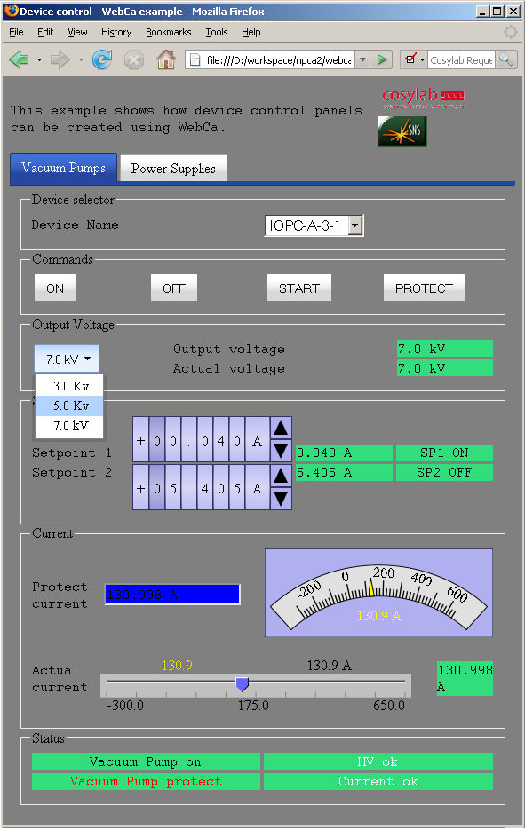
Figure 21: Example device control panel

Adding new component to WebCA
To add new component number of steps must be performed. We will use “barMeter” as an example component that will be added to WebCA.
- Create JavaScript files under js/barMeter directory which defines the behavior of the component and modify the webca.xsl file near the end.
...
<xsl:template name="jsIncludes">
...
<!—- for every added Javascript file -->
<xsl:call-template name="includeJs">
<xsl:with-param name="path" select="'js/barMeter/filename.js'"/>
</xsl:call-template>
...
</xsl:template>
- Create xsl template which defines barMeter and include it in the webca_templates.xsl file.
...
</xsl:when>
<!--
######################################################
template for barMeter
######################################################
-->
<xsl:when test="$name = 'barMeter'">
<!-- template goes here -->
</xsl:when>
...
- Optionally add barMeter component to xml schema
  - Create new file named barMeter.xsd under xmlSchema directory. This file contains barMeter xmlSchema definition.
  - Add the following two lines in file webca.xsd:
...
<xs:include schemaLocation="barMeter.xsd"/>

...

<xs:group name="components">
<xs:choice>
...

<xs:element ref="barMeter"/>
...
</xs:choice>
</xs:group>

EDL to CAML translator
A Java tool for converting Extensible Display Manager EDL files to XHTML CAML files is located under webca/tools directory.
Example of compilation and usage:
tools/src> javac com/cosylab/webca/EdmCamlConverter.java
tools/src> java com/cosylab/webca/EdmCamlConverter
Usage:
java com/cosylab/webca/EdmCamlConverter webca_installation_path edl_file1 edl_file2 ...
Example:
java com/cosylab/webca/EdmCamlConverter ../ input.edl
Alternatively the webca/tools directory can be imported as a project into Eclipse, or the tools/build.xml java ant file can be used. The ant build can be run as ant test to transform the test EDL files in tools/test directory.
The tool converts the files passed as parameters, or reads a text file named edl_list.txt containing whitespace separated list of filenames. The output files are renamed with .xhtml extension and placed in the directories containing EDL source files.

Known issues and limitations
The translator requires Java 1.5.0 or above.
It was tested with EDL files version 4.0.1. It does not work with the older versions with a different file format, such as 3.0.1.
Currently the translator does not convert any of the text-less graphics classes (Line, Rectangle, Dynamic Symbol, …), and ignores all data external to input files (color specifications).
Bar, Table, Button, Up/Down Button, Exit Button, Shell Command, and Choice Button are not converted as CAML does not yet have matching components. The functionality similar to MessageBox and PV Inspector is provided in CAML context menu. Part of StripChart functionality is available using CAML xyChart.
CAML relatedDisplay supports only a single related display. Only Embedded Window with form as display source is converted. For functionality similar to Embeded Window with menu display source a CAML tabView and include components can be used.

