**INFORME ANUAL CURSO 2021/2022** 

|  |  |
| --- | --- |
| **Alumno/a:** Alberto Álvarez Sánchez |  |
| **Profesor/a:** Eduardo Morales Mirón |
| **Clase:** 3-A |
|  |

|  |  |  |  |  |  |
| --- | --- | --- | --- | --- | --- |
| **ASIGNATURA** | **PRIMER TRIMESTRE** | **SEGUNDO TRIMESTRE** | **TERCER TRIMESTRE** | **NOTA TOTAL** | |
| BIOLOGÍA | 9.3 | 10.0 | 10.0 | **9.4** | SOBRESALIENTE |
| CULTURA CLÁSICA | 9.0 | 9.5 | 9.5 | **9.5** | SOBRESALIENTE |
| EDUCACIÓN FÍSICA | 7.9 | 9.3 | 9.3 | **8.8** | NOTABLE |
| EDUCACIÓN PLÁSTICA | 9.5 | 7.6 | 7.6 | **8.9** | NOTABLE |
| ÉTICA | 8.7 | 8.1 | 8.1 | **8.6** | NOTABLE |
| FRANCÉS | 9.3 | 8.0 | 8.0 | **8.6** | NOTABLE |
| GEOGRAFÍA E HISTORIA | 9.7 | 7.7 | 7.7 | **8.7** | NOTABLE |
| INGLÉS | 8.4 | 7.8 | 7.8 | **8.1** | NOTABLE |
| LENGUA CASTELLANA Y LITERATURA | 9.8 | 8.8 | 8.8 | **9.5** | SOBRESALIENTE |
| MATEMÁTICAS | 8.3 | 9.0 | 9.0 | **8.6** | NOTABLE |
| MÚSICA | 7.3 | 9.4 | 9.4 | **8.4** | NOTABLE |
| TECNOLOGÍA | 9.2 | 10.0 | 10.0 | **9.6** | SOBRESALIENTE |

**Progreso trimestral:**

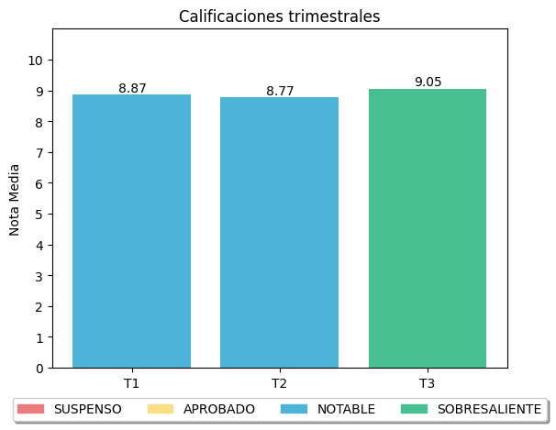

|  |
| --- |
| **COMENTARIOS** |
|  |
|