**INFORME ANUAL CURSO 2021/2022** 

|  |  |
| --- | --- |
| **Alumno/a:** Alicia Mancebo Colomer |  |
| **Profesor/a:** Eduardo Morales Mirón |
| **Clase:** 3-A |
|  |

|  |  |  |  |  |  |
| --- | --- | --- | --- | --- | --- |
| **ASIGNATURA** | **PRIMER TRIMESTRE** | **SEGUNDO TRIMESTRE** | **TERCER TRIMESTRE** | **NOTA TOTAL** | |
| BIOLOGÍA | 8.4 | 8.9 | 8.9 | **8.2** | NOTABLE |
| CULTURA CLÁSICA | 9.0 | 9.5 | 9.5 | **9.5** | SOBRESALIENTE |
| EDUCACIÓN FÍSICA | 8.1 | 7.2 | 7.2 | **7.5** | NOTABLE |
| EDUCACIÓN PLÁSTICA | 9.6 | 8.2 | 8.2 | **9.1** | SOBRESALIENTE |
| ÉTICA | 10.0 | 9.1 | 9.1 | **9.1** | SOBRESALIENTE |
| FRANCÉS | 8.1 | 10.0 | 10.0 | **8.7** | NOTABLE |
| GEOGRAFÍA E HISTORIA | 8.3 | 8.4 | 8.4 | **7.9** | NOTABLE |
| INGLÉS | 8.8 | 9.9 | 9.9 | **9.2** | SOBRESALIENTE |
| LENGUA CASTELLANA Y LITERATURA | 9.9 | 8.5 | 8.5 | **8.7** | NOTABLE |
| MATEMÁTICAS | 8.0 | 8.4 | 8.4 | **8.7** | NOTABLE |
| MÚSICA | 7.4 | 10.0 | 10.0 | **8.2** | NOTABLE |
| TECNOLOGÍA | 7.9 | 9.1 | 9.1 | **8.1** | NOTABLE |

**Progreso trimestral:**

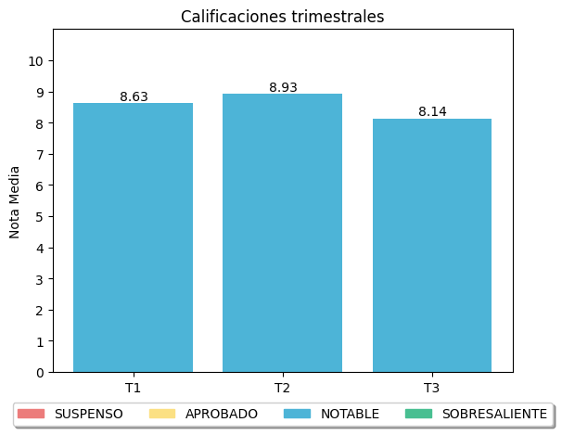

|  |
| --- |
| **COMENTARIOS** |
|  |
|