**INFORME ANUAL CURSO 2021/2022** 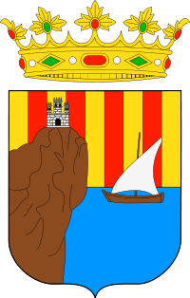

|  |  |
| --- | --- |
| **Alumno/a:** Esteban Cubillo Nicolau |  |
| **Profesor/a:** Eduardo Morales Mirón |
| **Clase:** 3-B |
|  |

|  |  |  |  |  |  |
| --- | --- | --- | --- | --- | --- |
| **ASIGNATURA** | **PRIMER TRIMESTRE** | **SEGUNDO TRIMESTRE** | **TERCER TRIMESTRE** | **NOTA TOTAL** | |
| BIOLOGÍA | 9.0 | 9.5 | 9.5 | **9.5** | SOBRESALIENTE |
| CULTURA CLÁSICA | 9.0 | 9.5 | 9.5 | **9.5** | SOBRESALIENTE |
| EDUCACIÓN FÍSICA | 4.5 | 5.7 | 5.7 | **4.9** | SUSPENSO |
| EDUCACIÓN PLÁSTICA | 6.6 | 7.9 | 7.9 | **6.8** | APROBADO |
| ÉTICA | 6.8 | 5.9 | 5.9 | **5.9** | APROBADO |
| FRANCÉS | 6.8 | 7.4 | 7.4 | **6.2** | APROBADO |
| GEOGRAFÍA E HISTORIA | 4.5 | 7.6 | 7.6 | **5.9** | APROBADO |
| INGLÉS | 9.0 | 9.5 | 9.5 | **9.5** | SOBRESALIENTE |
| LENGUA CASTELLANA Y LITERATURA | 4.1 | 5.8 | 5.8 | **4.9** | SUSPENSO |
| MATEMÁTICAS | 5.9 | 7.7 | 7.7 | **6.7** | APROBADO |
| MÚSICA | 7.7 | 6.0 | 6.0 | **6.4** | APROBADO |
| TECNOLOGÍA | 7.7 | 10.0 | 10.0 | **8.0** | NOTABLE |

**Progreso trimestral:**

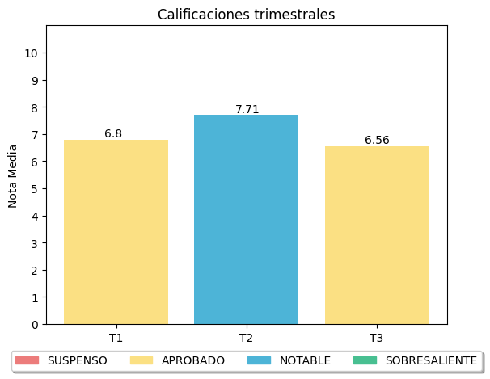

|  |
| --- |
| **COMENTARIOS** |
|  |
|