**INFORME ANUAL CURSO 2021/2022** 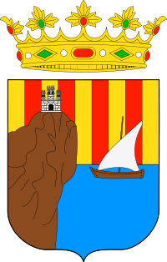

|  |  |
| --- | --- |
| **Alumno/a:** Félix Enrique Latorre |  |
| **Profesor/a:** Eduardo Morales Mirón |
| **Clase:** 3-B |
|  |

|  |  |  |  |  |  |
| --- | --- | --- | --- | --- | --- |
| **ASIGNATURA** | **PRIMER TRIMESTRE** | **SEGUNDO TRIMESTRE** | **TERCER TRIMESTRE** | **NOTA TOTAL** | |
| BIOLOGÍA | 4.9 | 7.7 | 7.7 | **5.7** | APROBADO |
| CULTURA CLÁSICA | 6.1 | 4.4 | 4.4 | **5.0** | APROBADO |
| EDUCACIÓN FÍSICA | 6.8 | 7.1 | 7.1 | **7.2** | NOTABLE |
| EDUCACIÓN PLÁSTICA | 9.0 | 9.5 | 9.5 | **9.5** | SOBRESALIENTE |
| ÉTICA | 9.0 | 9.5 | 9.5 | **9.5** | SOBRESALIENTE |
| FRANCÉS | 7.0 | 7.2 | 7.2 | **6.2** | APROBADO |
| GEOGRAFÍA E HISTORIA | 4.5 | 5.9 | 5.9 | **5.1** | APROBADO |
| INGLÉS | 4.6 | 5.6 | 5.6 | **4.8** | SUSPENSO |
| LENGUA CASTELLANA Y LITERATURA | 7.2 | 5.9 | 5.9 | **6.8** | APROBADO |
| MATEMÁTICAS | 7.9 | 5.4 | 5.4 | **7.1** | NOTABLE |
| MÚSICA | 8.0 | 5.0 | 5.0 | **6.5** | APROBADO |
| TECNOLOGÍA | 4.5 | 7.2 | 7.2 | **5.9** | APROBADO |

**Progreso trimestral:**

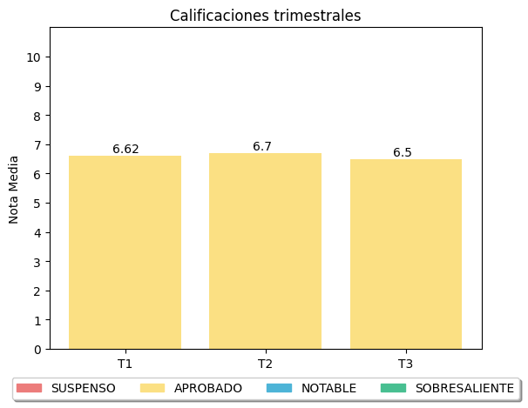

|  |
| --- |
| **COMENTARIOS** |
|  |
|